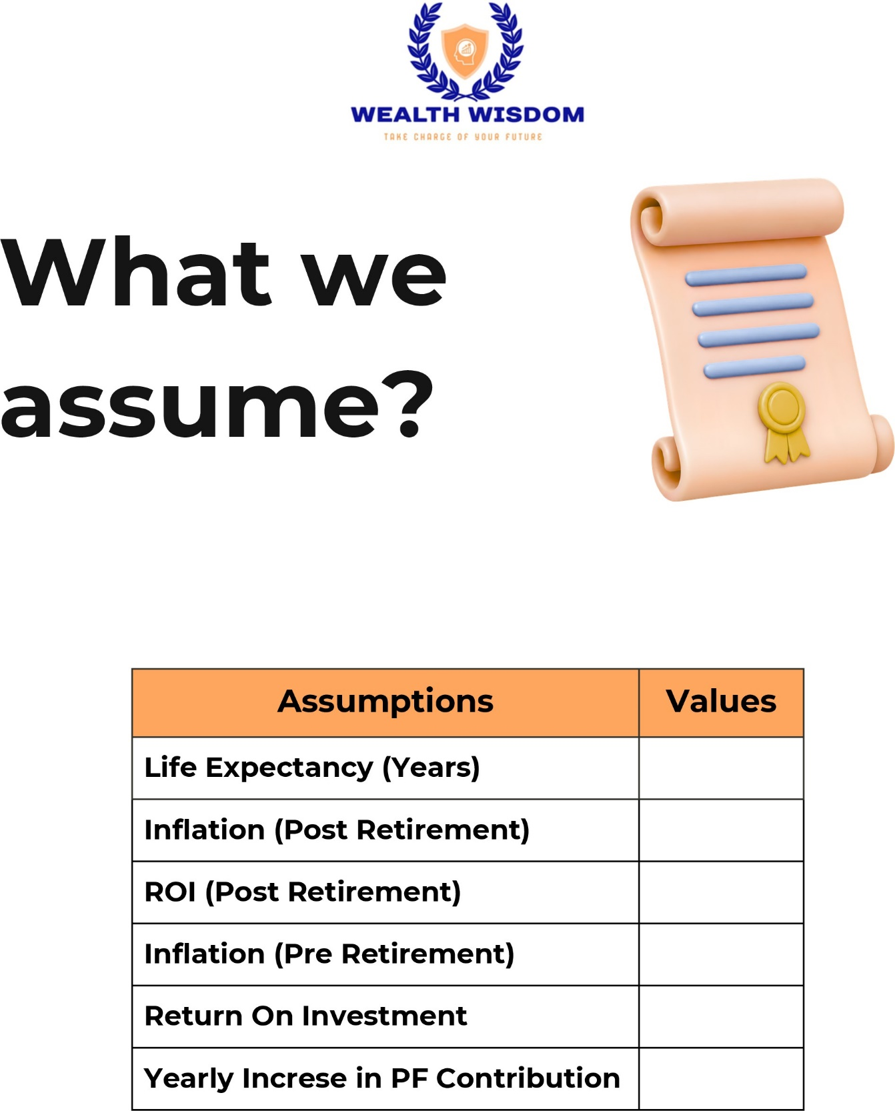
{{life_expectancy}}

{{inflation_post}}

{{roi_post}}

{{inflation_pre}}

{{roi_pre}}

{{pf_contribution_yearly_increase}}

