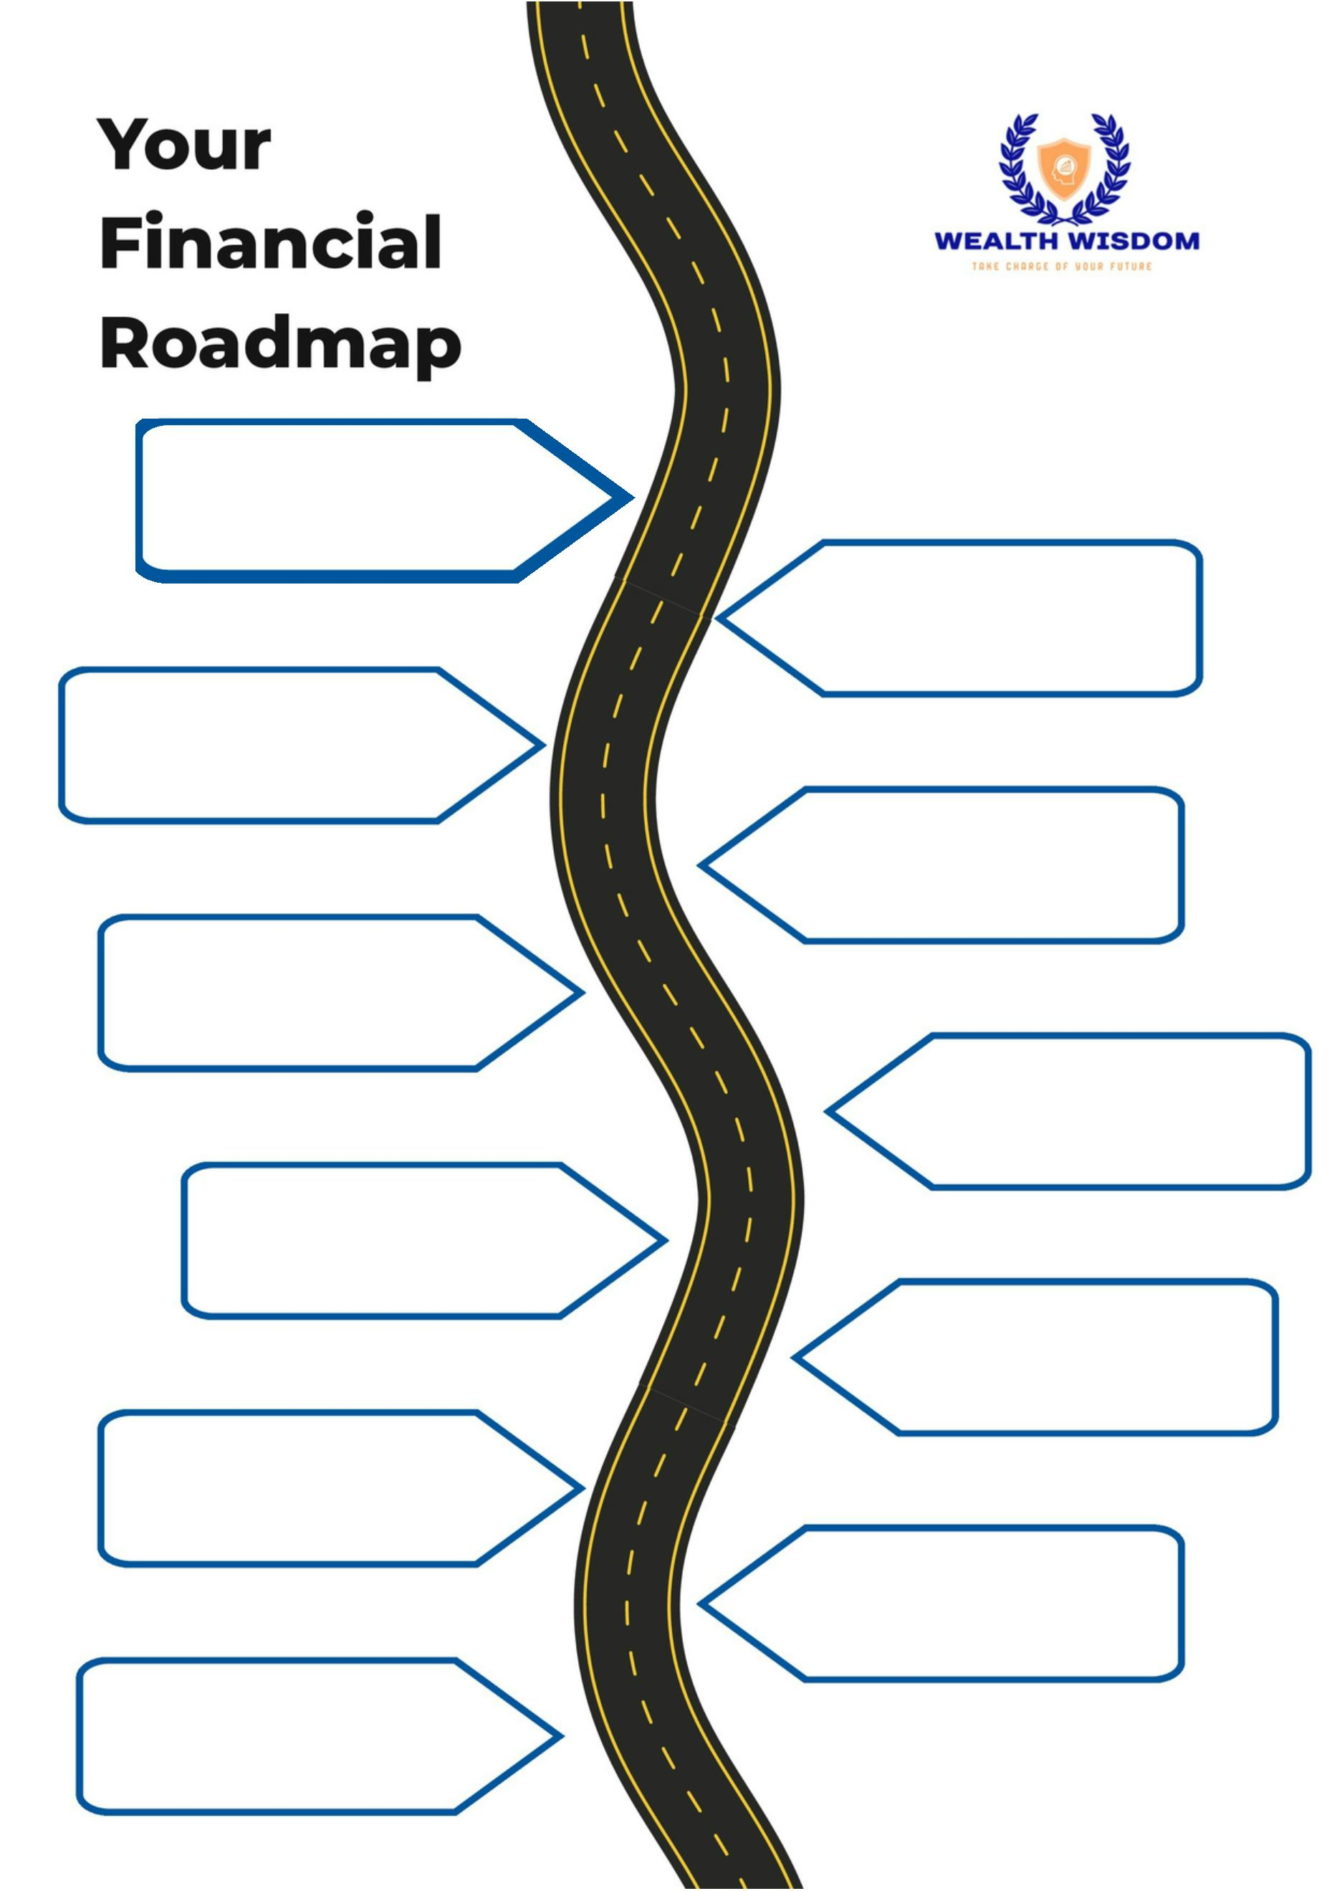
{{goals_timeline}}

{{goals_timeline}}

{{goals_timeline}}

{{goals_timeline}}

{{goals_timeline}}

{{goals_timeline}}

{{goals_timeline}}

{{goals_timeline}}

{{goals_timeline}}

{{goals_timeline}}

{{goals_timeline}}

