**Name – Ganesh Halpatrao**

**Class - TYBSc CS Roll no 2096**

**Subject - LAS Practical (sub 2 )**

**LSA Practicals**

# **Practical 1**

**Aim:** Initial settings – Network settings>change to static, IPAddress > change to IPv6, configure service

**Commands:**

|  |
| --- |
| **Initial settings – Network settings>change to static**  [root@localhost ~]# ifconfig -a  eth1 Link encap:Ethernet HWaddr 00:0C:29:3B:34:E0  inet addr:192.168.117.128 Bcast:192.168.117.255 Mask:255.255.255.0  inet6 addr: fe80::20c:29ff:fe3b:34e0/64 Scope:Link  UP BROADCAST RUNNING MULTICAST MTU:1500 Metric:1  RX packets:356 errors:0 dropped:0 overruns:0 frame:0  TX packets:93 errors:0 dropped:0 overruns:0 carrier:0  collisions:0 txqueuelen:1000  RX bytes:24509 (23.9 KiB) TX bytes:11644 (11.3 KiB)  lo Link encap:Local Loopback  inet addr:127.0.0.1 Mask:255.0.0.0  inet6 addr: ::1/128 Scope:Host  UP LOOPBACK RUNNING MTU:16436 Metric:1  RX packets:16 errors:0 dropped:0 overruns:0 frame:0  TX packets:16 errors:0 dropped:0 overruns:0 carrier:0  collisions:0 txqueuelen:0  RX bytes:960 (960.0 b) TX bytes:960 (960.0 b)  [root@localhost ~]# ifconfig eth1 192.168.1.154 netmask 255.255.255.o up  255.255.255.o: Host name lookup failure  [root@localhost ~]# ifconfig eth1 192.168.1.154 netmask 255.255.255.0 up  [root@localhost ~]# ifconfig -a  eth1 Link encap:Ethernet HWaddr 00:0C:29:3B:34:E0  inet addr:192.168.1.154 Bcast:192.168.1.255 Mask:255.255.255.0  inet6 addr: fe80::20c:29ff:fe3b:34e0/64 Scope:Link  UP BROADCAST RUNNING MULTICAST MTU:1500 Metric:1  RX packets:370 errors:0 dropped:0 overruns:0 frame:0  TX packets:110 errors:0 dropped:0 overruns:0 carrier:0  collisions:0 txqueuelen:1000  RX bytes:25349 (24.7 KiB) TX bytes:15407 (15.0 KiB)  lo Link encap:Local Loopback  inet addr:127.0.0.1 Mask:255.0.0.0  inet6 addr: ::1/128 Scope:Host  UP LOOPBACK RUNNING MTU:16436 Metric:1  RX packets:16 errors:0 dropped:0 overruns:0 frame:0  TX packets:16 errors:0 dropped:0 overruns:0 carrier:0  collisions:0 txqueuelen:0  RX bytes:960 (960.0 b) TX bytes:960 (960.0 b)  [root@localhost ~]# cd /etc  [root@localhost etc]# cd sysconfig  [root@localhost sysconfig]# cd network-scripts  [root@localhost network-scripts]# ls  ifcfg-eth0 ifdown-isdn ifup-aliases ifup-plusb init.ipv6-global  ifcfg-lo ifdown-post ifup-bnep ifup-post net.hotplug  ifdown ifdown-ppp ifup-eth ifup-ppp network-functions  ifdown-bnep ifdown-routes ifup-ippp ifup-routes network-functions-ipv6  ifdown-eth ifdown-sit ifup-ipv6 ifup-sit  ifdown-ippp ifdown-tunnel ifup-isdn ifup-tunnel  ifdown-ipv6 ifup ifup-plip ifup-wireless  [root@localhost network-scripts]# vi ifcfg-eth0  [root@localhost network-scripts]# ifconfig -a  eth1 Link encap:Ethernet HWaddr 00:0C:29:3B:34:E0  inet addr:192.168.1.154 Bcast:192.168.1.255 Mask:255.255.255.0  inet6 addr: fe80::20c:29ff:fe3b:34e0/64 Scope:Link  UP BROADCAST RUNNING MULTICAST MTU:1500 Metric:1  RX packets:455 errors:0 dropped:0 overruns:0 frame:0  TX packets:114 errors:0 dropped:0 overruns:0 carrier:0  collisions:0 txqueuelen:1000  RX bytes:30573 (29.8 KiB) TX bytes:15735 (15.3 KiB)  lo Link encap:Local Loopback  inet addr:127.0.0.1 Mask:255.0.0.0  inet6 addr: ::1/128 Scope:Host  UP LOOPBACK RUNNING MTU:16436 Metric:1  RX packets:16 errors:0 dropped:0 overruns:0 frame:0  TX packets:16 errors:0 dropped:0 overruns:0 carrier:0  collisions:0 txqueuelen:0  RX bytes:960 (960.0 b) TX bytes:960 (960.0 b)  **IPAddress >> changing to IPv6**  [root@localhost ~]# sysctl -w net.ipv6.conf.all.disable_ipv6=1  net.ipv6.conf.all.disable_ipv6 = 1  [root@localhost ~]# sysctl -w net.ipv6.conf.all.disable_ipv6=0  net.ipv6.conf.all.disable_ipv6 = 0  **configuring service**  [root@localhost ~]# service httpd status  httpd is stopped  [root@localhost ~]# service --status-all  abrtd (pid 1884) is running...  acpid (pid 1676) is running...  atd (pid 1903) is running...  auditd (pid 2163) is running...  avahi-daemon (pid 1634) is running...  Usage: /etc/init.d/bluetooth {start|stop}  Stopped  cgred is stopped  cpuspeed is stopped  crond (pid 1892) is running...  cupsd (pid 1650) is running...  dnsmasq is stopped  Usage: /etc/init.d/firstboot {start|stop}  hald (pid 1685) is running...  httpd is stopped  Table: filter  Chain INPUT (policy ACCEPT)  num target prot opt source destination  1 ACCEPT all ::/0 ::/0 state RELATED,ESTABLISHED  2 ACCEPT icmpv6 ::/0 ::/0  3 ACCEPT all ::/0 ::/0  4 ACCEPT tcp ::/0 ::/0 state NEW tcp dpt:22  5 REJECT all ::/0 ::/0 reject-with icmp6-adm-prohibited  Chain FORWARD (policy ACCEPT)  num target prot opt source destination  1 REJECT all ::/0 ::/0 reject-with icmp6-adm-prohibited  Chain OUTPUT (policy ACCEPT)  num target prot opt source destination  Table: filter  Chain INPUT (policy ACCEPT)  num target prot opt source destination  1 ACCEPT all -- 0.0.0.0/0 0.0.0.0/0 state RELATED,ESTABLISHED  2 ACCEPT icmp -- 0.0.0.0/0 0.0.0.0/0  3 ACCEPT all -- 0.0.0.0/0 0.0.0.0/0  4 ACCEPT tcp -- 0.0.0.0/0 0.0.0.0/0 state NEW tcp dpt:22  5 REJECT all -- 0.0.0.0/0 0.0.0.0/0 reject-with icmp-host-prohibited  Chain FORWARD (policy ACCEPT)  num target prot opt source destination  1 REJECT all -- 0.0.0.0/0 0.0.0.0/0 reject-with icmp-host-prohibited  Chain OUTPUT (policy ACCEPT)  num target prot opt source destination  irqbalance is stopped  Kdump is not operational  mdmonitor (pid 1589) is running...  messagebus (pid 1607) is running...  netconsole module not loaded  Configured devices:  lo eth0  Currently active devices:  lo eth1  NetworkManager (pid 1618) is running...  ntpd is stopped  portreserve is stopped  master (pid 1873) is running...  Process accounting is disabled.  rdisc is stopped  restorecond (pid 2363) is running...  rsyslogd (pid 1545) is running...  sandbox is stopped  saslauthd is stopped  smartd is stopped  snmpd is stopped  snmptrapd is stopped  openssh-daemon (pid 1755) is running...  vmtoolsd is running  Thinprint daemon is NOT running.  wpa_supplicant (pid 1653) is running...  [root@localhost ~]# chkconfig --list  NetworkManager 0:off 1:off 2:on 3:on 4:on 5:on 6:off  abrtd 0:off 1:off 2:off 3:on 4:off 5:on 6:off  acpid 0:off 1:off 2:on 3:on 4:on 5:on 6:off  atd 0:off 1:off 2:off 3:on 4:on 5:on 6:off  auditd 0:off 1:off 2:on 3:on 4:on 5:on 6:off  avahi-daemon 0:off 1:off 2:off 3:on 4:on 5:on 6:off  bluetooth 0:off 1:off 2:off 3:on 4:on 5:on 6:off  cgconfig 0:off 1:off 2:off 3:off 4:off 5:off 6:off  cgred 0:off 1:off 2:off 3:off 4:off 5:off 6:off  cpuspeed 0:off 1:on 2:on 3:on 4:on 5:on 6:off  crond 0:off 1:off 2:on 3:on 4:on 5:on 6:off  cups 0:off 1:off 2:on 3:on 4:on 5:on 6:off  dnsmasq 0:off 1:off 2:off 3:off 4:off 5:off 6:off  firstboot 0:off 1:off 2:off 3:on 4:off 5:on 6:off  haldaemon 0:off 1:off 2:off 3:on 4:on 5:on 6:off  httpd 0:off 1:off 2:off 3:off 4:off 5:off 6:off  ip6tables 0:off 1:off 2:on 3:on 4:on 5:on 6:off  iptables 0:off 1:off 2:on 3:on 4:on 5:on 6:off  irqbalance 0:off 1:off 2:off 3:on 4:on 5:on 6:off  kdump 0:off 1:off 2:off 3:on 4:on 5:on 6:off  lvm2-monitor 0:off 1:on 2:on 3:on 4:on 5:on 6:off  mdmonitor 0:off 1:off 2:on 3:on 4:on 5:on 6:off  messagebus 0:off 1:off 2:on 3:on 4:on 5:on 6:off  microcode_ctl 0:off 1:off 2:on 3:on 4:on 5:on 6:off  netconsole 0:off 1:off 2:off 3:off 4:off 5:off 6:off  netfs 0:off 1:off 2:off 3:on 4:on 5:on 6:off  network 0:off 1:off 2:on 3:on 4:on 5:on 6:off  ntpd 0:off 1:off 2:off 3:off 4:off 5:off 6:off  ntpdate 0:off 1:off 2:off 3:off 4:off 5:off 6:off  portreserve 0:off 1:off 2:on 3:on 4:on 5:on 6:off  postfix 0:off 1:off 2:on 3:on 4:on 5:on 6:off  psacct 0:off 1:off 2:off 3:off 4:off 5:off 6:off  rdisc 0:off 1:off 2:off 3:off 4:off 5:off 6:off  restorecond 0:off 1:off 2:off 3:off 4:off 5:off 6:off  rhnsd 0:off 1:off 2:on 3:on 4:on 5:on 6:off  rsyslog 0:off 1:off 2:on 3:on 4:on 5:on 6:off  saslauthd 0:off 1:off 2:off 3:off 4:off 5:off 6:off  smartd 0:off 1:off 2:off 3:off 4:off 5:off 6:off  snmpd 0:off 1:off 2:off 3:off 4:off 5:off 6:off  snmptrapd 0:off 1:off 2:off 3:off 4:off 5:off 6:off  sshd 0:off 1:off 2:on 3:on 4:on 5:on 6:off  sysstat 0:off 1:on 2:on 3:on 4:on 5:on 6:off  udev-post 0:off 1:on 2:on 3:on 4:on 5:on 6:off  vmware-tools 0:off 1:off 2:on 3:on 4:on 5:on 6:off  vmware-tools-thinprint 0:off 1:off 2:on 3:on 4:on 5:on 6:off  wpa_supplicant 0:off 1:off 2:off 3:off 4:off 5:off 6:off  [root@localhost ~]# chkconfig --list|grep httpd  httpd 0:off 1:off 2:off 3:off 4:off 5:off 6:off  [root@localhost ~]# chkconfig --list|grep 3:off  cgconfig 0:off 1:off 2:off 3:off 4:off 5:off 6:off  cgred 0:off 1:off 2:off 3:off 4:off 5:off 6:off  dnsmasq 0:off 1:off 2:off 3:off 4:off 5:off 6:off  httpd 0:off 1:off 2:off 3:off 4:off 5:off 6:off  netconsole 0:off 1:off 2:off 3:off 4:off 5:off 6:off  ntpd 0:off 1:off 2:off 3:off 4:off 5:off 6:off  ntpdate 0:off 1:off 2:off 3:off 4:off 5:off 6:off  psacct 0:off 1:off 2:off 3:off 4:off 5:off 6:off  rdisc 0:off 1:off 2:off 3:off 4:off 5:off 6:off  restorecond 0:off 1:off 2:off 3:off 4:off 5:off 6:off  saslauthd 0:off 1:off 2:off 3:off 4:off 5:off 6:off  smartd 0:off 1:off 2:off 3:off 4:off 5:off 6:off  snmpd 0:off 1:off 2:off 3:off 4:off 5:off 6:off  snmptrapd 0:off 1:off 2:off 3:off 4:off 5:off 6:off  wpa_supplicant 0:off 1:off 2:off 3:off 4:off 5:off 6:off  [root@localhost ~]# chkconfig --level 3 postfix on  [root@localhost ~]# chkconfig --list|grep postfix  postfix 0:off 1:off 2:on 3:on 4:on 5:on 6:off  [root@localhost ~]# chkconfig --level 3 postfix off  [root@localhost ~]# chkconfig --list|grep postfix  postfix 0:off 1:off 2:on 3:off 4:on 5:on 6:off |

# **Practical 2**

**Aim:** Linux System – Administration Command and Graphical config

**Commands:**

**Creating new users and setting password**

|  |
| --- |
| [root@localhost ~]# useradd newUser  [root@localhost ~]# passwd newUser  Changing password for user newUser.  New password:  BAD PASSWORD: it is based on a dictionary word  BAD PASSWORD: is too simple  Retype new password:  passwd: all authentication tokens updated successfully.  **To give privilege of root user to any user**  [root@localhost etc]# vi sudoers |

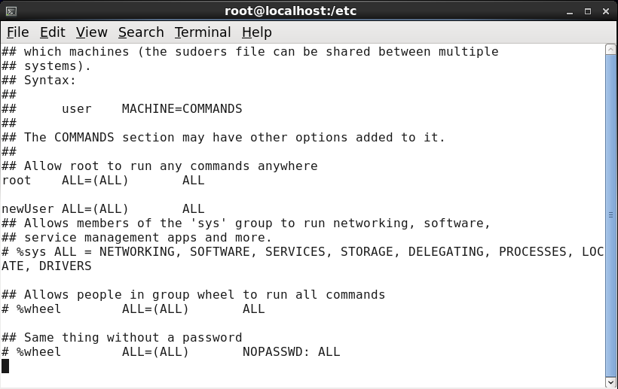

|  |
| --- |
| **To move from root to any user**  [root@localhost ~]# su - newUser  **Creating new user using sudo command**  [newUser@localhost ~]$ sudo useradd user2  We trust you have received the usual lecture from the local System  Administrator. It usually boils down to these three things:  #1) Respect the privacy of others.  #2) Think before you type.  #3) With great power comes great responsibility.  [sudo] password for newUser:  [newUser@localhost ~]$ cat /etc/passwd  root:x:0:0:root:/root:/bin/bash  bin:x:1:1:bin:/bin:/sbin/nologin  daemon:x:2:2:daemon:/sbin:/sbin/nologin  adm:x:3:4:adm:/var/adm:/sbin/nologin  lp:x:4:7:lp:/var/spool/lpd:/sbin/nologin  sync:x:5:0:sync:/sbin:/bin/sync  shutdown:x:6:0:shutdown:/sbin:/sbin/shutdown  halt:x:7:0:halt:/sbin:/sbin/halt  mail:x:8:12:mail:/var/spool/mail:/sbin/nologin  uucp:x:10:14:uucp:/var/spool/uucp:/sbin/nologin  operator:x:11:0:operator:/root:/sbin/nologin  games:x:12:100:games:/usr/games:/sbin/nologin  gopher:x:13:30:gopher:/var/gopher:/sbin/nologin  ftp:x:14:50:FTP User:/var/ftp:/sbin/nologin  nobody:x:99:99:Nobody:/:/sbin/nologin  dbus:x:81:81:System message bus:/:/sbin/nologin  usbmuxd:x:113:113:usbmuxd user:/:/sbin/nologin  avahi-autoipd:x:170:170:Avahi IPv4LL Stack:/var/lib/avahi-autoipd:/sbin/nologin  vcsa:x:69:69:virtual console memory owner:/dev:/sbin/nologin  rtkit:x:499:499:RealtimeKit:/proc:/sbin/nologin  abrt:x:498:498::/etc/abrt:/sbin/nologin  haldaemon:x:68:68:HAL daemon:/:/sbin/nologin  apache:x:48:48:Apache:/var/www:/sbin/nologin  saslauth:x:497:495:"Saslauthd user":/var/empty/saslauth:/sbin/nologin  postfix:x:89:89::/var/spool/postfix:/sbin/nologin  avahi:x:70:70:Avahi mDNS/DNS-SD Stack:/var/run/avahi-daemon:/sbin/nologin  ntp:x:38:38::/etc/ntp:/sbin/nologin  sshd:x:74:74:Privilege-separated SSH:/var/empty/sshd:/sbin/nologin  tcpdump:x:72:72::/:/sbin/nologin  pulse:x:496:494:PulseAudio System Daemon:/var/run/pulse:/sbin/nologin  gdm:x:42:42::/var/lib/gdm:/sbin/nologin  dheeraj:x:500:500:dheeraj:/home/dheeraj:/bin/bash  newUser:x:501:501::/home/newUser:/bin/bash  user2:x:502:502::/home/user2:/bin/bash  **To switch to root user**  [newUser@localhost ~]$ exit  logout  **To add user with specified info**  [root@localhost ~]# useradd -c "new User" -u 600 -s /bin/bash user3  **To change or set age limit for password**  [root@localhost ~]# chage -m 10 -M 20 -E 10/10/2022 -W 7 user3  **To lock and unlock any user**  [root@localhost ~]# passwd -l user3  Locking password for user user3.  passwd: Success  [root@localhost ~]# passwd -u user3  Unlocking password for user user3.  passwd: Warning: unlocked password would be empty.  passwd: Unsafe operation (use -f to force)  [root@localhost ~]# passwd -u -f user3  Unlocking password for user user3.  passwd: Success  **To change shell of user**  [root@localhost ~]# chsh -s /bin/bash user3  Changing shell for user3.  **To add Group and adding user to Group**  [root@localhost ~]# gpasswd -M user2,user3,newUser newgroup |

# **Practical 3**

**Aim:** GRUB Configuration

**Commands:**

|  |
| --- |
| [root@localhost ~]#vim /boot/grub/grub.conf  After running this command copy the existing grub file and paste it below to existing one and change the title.  To save hit esc , then “:x!”. |

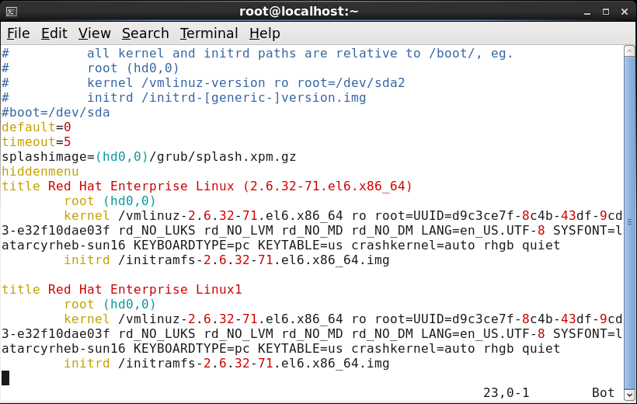

* After this restart the compute and after that you can see two bootloader on screen

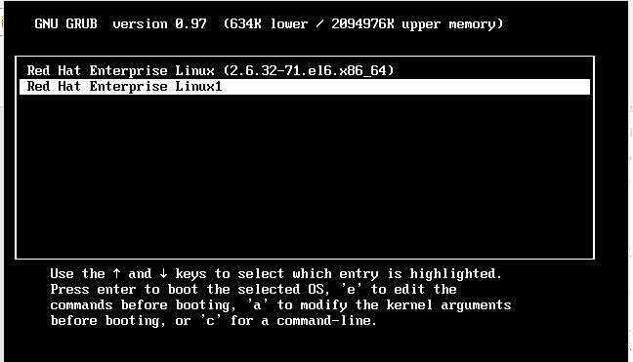

# **Practical 4**

**Aim:** Setting up Network Time Protocol (NTP) on linux server

**Commands:**

|  |
| --- |
| [root@localhost RHEL_6.0 x86_64 Disc 1]# cd Packages  [root@localhost Packages]# rpm -qa|grep ntp  ntp-4.2.4p8-2.el6.x86_64  ntpdate-4.2.4p8-2.el6.x86_64  fontpackages-filesystem-1.41-1.1.el6.noarch  [root@localhost Packages]# rpm -ivh ntp*  warning: ntp-4.2.4p8-2.el6.x86_64.rpm: Header V3 RSA/SHA256 Signature, key ID fd431d51: NOKEY  Preparing... ########################################### [100%]  package ntpdate-4.2.4p8-2.el6.x86_64 is already installed  package ntp-4.2.4p8-2.el6.x86_64 is already installed  [root@localhost Packages]# date  Mon Sep 5 22:32:46 PDT 2022  [root@localhost Packages]# date  Thu Oct 7 22:34:47 PDT 2021 |

**After this Go To system > Administration > Date and time**

**And change the date**

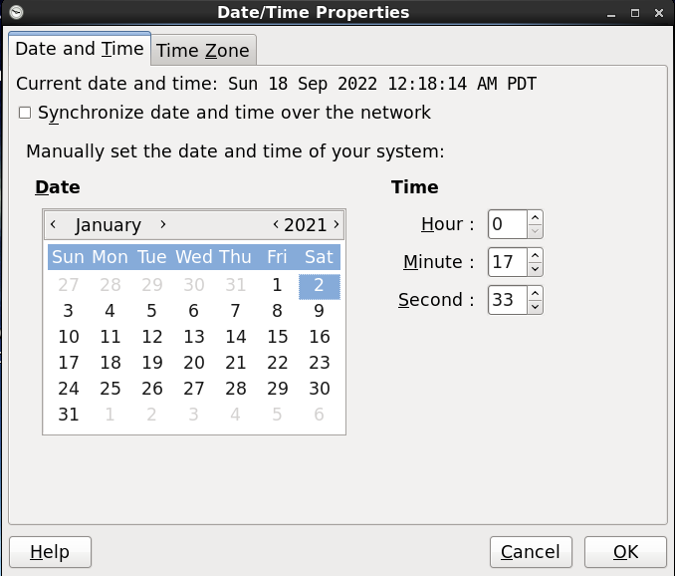

|  |
| --- |
| [root@localhost Packages]# cd /etc  [root@localhost etc]# cat ntp.conf  # For more information about this file, see the man pages  # ntp.conf(5), ntp_acc(5), ntp_auth(5), ntp_clock(5), ntp_misc(5), ntp_mon(5).  driftfile /var/lib/ntp/drift  # Permit time synchronization with our time source, but do not  # permit the source to query or modify the service on this system.  restrict default kod nomodify notrap nopeer noquery  restrict -6 default kod nomodify notrap nopeer noquery  # Permit all access over the loopback interface. This could  # be tightened as well, but to do so would effect some of  # the administrative functions.  restrict 127.0.0.1  restrict -6 ::1  # Hosts on local network are less restricted.  #restrict 192.168.1.0 mask 255.255.255.0 nomodify notrap  # Use public servers from the pool.ntp.org project.  # Please consider joining the pool (http://www.pool.ntp.org/join.html).  server 0.rhel.pool.ntp.org  server 1.rhel.pool.ntp.org  server 2.rhel.pool.ntp.org  #broadcast 192.168.1.255 autokey # broadcast server  #broadcastclient # broadcast client  #broadcast 224.0.1.1 autokey # multicast server  #multicastclient 224.0.1.1 # multicast client  #manycastserver 239.255.254.254 # manycast server  #manycastclient 239.255.254.254 autokey # manycast client  # Undisciplined Local Clock. This is a fake driver intended for backup  # and when no outside source of synchronized time is available.  #server 127.127.1.0 # local clock  #fudge 127.127.1.0 stratum 10  # Enable public key cryptography.  #crypto  includefile /etc/ntp/crypto/pw  # Key file containing the keys and key identifiers used when operating  # with symmetric key cryptography.  keys /etc/ntp/keys  # Specify the key identifiers which are trusted.  #trustedkey 4 8 42  # Specify the key identifier to use with the ntpdc utility.  #requestkey 8  # Specify the key identifier to use with the ntpq utility.  #controlkey 8  # Enable writing of statistics records.  #statistics clockstats cryptostats loopstats peerstats  [root@localhost etc]# vi ntp.conf |

**Go to Date and time, and check on “Synchronize date and time over network”**

**And then go to Advanced Option and select “Speed up initial synchronization”**

**And Click ok.**

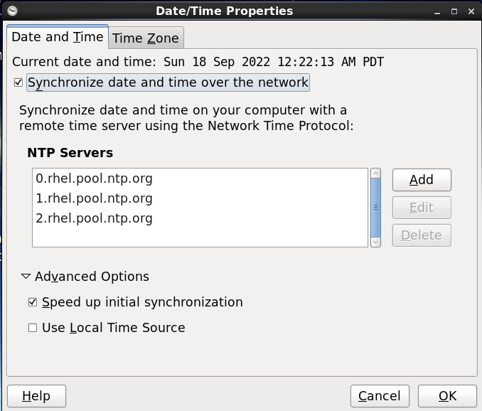

|  |
| --- |
| [root@localhost etc]# service ntpd status  ntpd is stopped  [root@localhost etc]# service ntpd start  Starting ntpd: [ OK ]  [root@localhost etc]# service ntpd status  ntpd (pid 2618) is running...  [root@localhost etc]# ping google.com  PING google.com (172.217.166.174) 56(84) bytes of data.  64 bytes from bom07s20-in-f14.1e100.net (172.217.166.174): icmp_seq=1 ttl=128 time=3.12 ms  64 bytes from bom07s20-in-f14.1e100.net (172.217.166.174): icmp_seq=2 ttl=128 time=11.5 ms  64 bytes from bom07s20-in-f14.1e100.net (172.217.166.174): icmp_seq=3 ttl=128 time=7.44 ms  64 bytes from bom07s20-in-f14.1e100.net (172.217.166.174): icmp_seq=4 ttl=128 time=4.01 ms  64 bytes from bom07s20-in-f14.1e100.net (172.217.166.174): icmp_seq=5 ttl=128 time=3.52 ms  64 bytes from bom07s20-in-f14.1e100.net (172.217.166.174): icmp_seq=6 ttl=128 time=3.61 ms  64 bytes from bom07s20-in-f14.1e100.net (172.217.166.174): icmp_seq=7 ttl=128 time=3.21 ms  64 bytes from bom07s20-in-f14.1e100.net (172.217.166.174): icmp_seq=8 ttl=128 time=4.09 ms  64 bytes from bom07s20-in-f14.1e100.net (172.217.166.174): icmp_seq=9 ttl=128 time=3.57 ms  64 bytes from bom07s20-in-f14.1e100.net (172.217.166.174): icmp_seq=10 ttl=128 time=3.44 ms  64 bytes from bom07s20-in-f14.1e100.net (172.217.166.174): icmp_seq=11 ttl=128 time=2.46 ms  64 bytes from bom07s20-in-f14.1e100.net (172.217.166.174): icmp_seq=12 ttl=128 time=3.86 ms  64 bytes from bom07s20-in-f14.1e100.net (172.217.166.174): icmp_seq=13 ttl=128 time=3.34 ms  64 bytes from bom07s20-in-f14.1e100.net (172.217.166.174): icmp_seq=14 ttl=128 time=3.20 ms  ^C  --- google.com ping statistics ---  108 packets transmitted, 108 received, 0% packet loss, time 107452ms  rtt min/avg/max/mdev = 2.255/4.573/26.827/3.144 ms  [root@localhost etc]# service network restart  Shutting down interface eth0: Device state: 3 (disconnected)  [ OK ]  Shutting down loopback interface: [ OK ]  Bringing up loopback interface: [ OK ]  Bringing up interface eth0: Active connection state: activating  Active connection path: /org/freedesktop/NetworkManager/ActiveConnection/1  state: activated  Connection activated  [ OK ]  [root@localhost etc]# services ntpd restart  bash: services: command not found  [root@localhost etc]# service ntpd restart  Shutting down ntpd: [ OK ]  Starting ntpd: [ OK ]  [root@localhost etc]# date  Mon Sep 5 22:48:18 PDT 2022 |

# **Practical 5**

**Aim:** Install and configure POP mail server

**Commands:**

|  |
| --- |
| [root@localhost RHEL_6.0 x86_64 Disc 1]# cd Packages  [root@localhost Packages]# rpm -ivh postfix*  warning: postfix-2.6.6-2.el6.x86_64.rpm: Header V3  RSA/SHA256 Signature, key ID fd431d51: NOKEY  Preparing...  ########################################### [100%]  package postfix-2:2.6.6-2.el6.x86_64 is already installed  [root@localhost Packages]# /etc/init.d/postfix restart  Shutting down postfix: [ OK ]  Starting postfix: [ OK ]  [root@localhost Packages]# chkconfig postfix on  [root@localhost Packages]# chkconfig --list postfix  postfix 0:off 1:off 2:on 3:on 4:on 5:on 6:off  [root@localhost Packages]# cd /etc  [root@localhost etc]# cd postfix  [root@localhost postfix]# ls  access canonical generic header_checks main.cf master.cf  relocated transport virtual  [root@localhost postfix]# vi main.cf |

**We have to make some changes made in main.cf**

**At line 75 we have to add server name**



**At line 98, Comment hostname**



**Uncomment line 113 and Comment line 116**



**Uncomment line 264**



Uncomment line 426



**After making change save the file using “esc + :x”**

|  |
| --- |
| [root@localhost postfix]# service postfix restart  Shutting down postfix: [ OK ]  Starting postfix: [ OK ]  [root@localhost postfix]# mail user2@server.tycs.com  Subject: This is test mail  hope u doing well  EOT  You have new mail in /var/spool/mail/root  [root@localhost postfix]# su - user2  [user2@localhost ~]$ mail  Heirloom Mail version 12.4 7/29/08. Type ? for help.  "/var/spool/mail/user2": 1 message 1 new  >N 1 root Sat Sep 17 12:46 18/603 "This is test mail"  & 1  Message 1:  From root@server.tycs.com Sat Sep 17 12:46:24 2022  Return-Path: <root@server.tycs.com>  X-Original-To: user2@server.tycs.com  Delivered-To: user2@server.tycs.com  Date: Sat, 17 Sep 2022 12:46:24 -0700  To: user2@server.tycs.com  Subject: This is test mail  User-Agent: Heirloom mailx 12.4 7/29/08  Content-Type: text/plain; charset=us-ascii  From: root@server.tycs.com (root)  Status: R  hope u doing well  & Held 1 message in /var/spool/mail/user2 |

# **Practical 6**

**Aim:** Understanding computer security, firewall and security configuration

**Commands:**

1. To start , stop or restart service of firewall
2. To unable or disable on boot
3. List the currently configured iptables rules
4. To clear all the currently configure rule
5. Save the changes
6. The iptables commands to Accept the command by default
7. Allow incoming SSH connection from specific ipaddress
8. Iptables to reject incoming SSH connection
9. Allow outgoing SSH from specific ipaddress
10. Iptables to draw incoming pick request
11. Iptables to reject incoming telnet connection
12. Iptables to reject all incoming traffic except SSH and local connection

|  |
| --- |
| [root@localhost Desktop]# cd  [root@localhost ~]# service iptables restart  iptables: Applying firewall rules: [ OK ]  [root@localhost ~]# chkconfig iptables off  [root@localhost ~]# chkconfig iptables on  [root@localhost ~]# iptables -L  Chain INPUT (policy ACCEPT)  target prot opt source destination  ACCEPT all -- anywhere anywhere state RELATED,ESTABLISHED  ACCEPT icmp -- anywhere anywhere  ACCEPT all -- anywhere anywhere  ACCEPT tcp -- anywhere anywhere state NEW tcp dpt:ssh  REJECT all -- anywhere anywhere reject-with icmp-host-prohibited  Chain FORWARD (policy ACCEPT)  target prot opt source destination  REJECT all -- anywhere anywhere reject-with icmp-host-prohibited  Chain OUTPUT (policy ACCEPT)  target prot opt source destination  [root@localhost ~]# iptables -vL  Chain INPUT (policy ACCEPT 0 packets, 0 bytes)  pkts bytes target prot opt in out source destination  6 540 ACCEPT all -- any any anywhere anywhere state RELATED,ESTABLISHED  0 0 ACCEPT icmp -- any any anywhere anywhere  0 0 ACCEPT all -- lo any anywhere anywhere  0 0 ACCEPT tcp -- any any anywhere anywhere state NEW tcp dpt:ssh  0 0 REJECT all -- any any anywhere anywhere reject-with icmp-host-prohibited  Chain FORWARD (policy ACCEPT 0 packets, 0 bytes)  pkts bytes target prot opt in out source destination  0 0 REJECT all -- any any anywhere anywhere reject-with icmp-host-prohibited  Chain OUTPUT (policy ACCEPT 9 packets, 648 bytes)  pkts bytes target prot opt in out source destination  [root@localhost ~]# iptables -F  [root@localhost ~]# /etc/init.d/iptables save  iptables: Saving firewall rules to /etc/sysconfig/iptables:[ OK ]  [root@localhost ~]# iptables -P INPUT ACCEPT  [root@localhost ~]# iptables -P OUTPUT ACCEPT  [root@localhost ~]# iptables -P FORWARD ACCEPT  [root@localhost ~]# iptables -P INPUT DROP  [root@localhost ~]# iptables -P OUTPUT DROP  [root@localhost ~]# iptables -P FORWARD DROP  [root@localhost ~]# iptables -A INPUT -j REJECT  [root@localhost ~]# iptables -A OUTPUT -j REJECT  [root@localhost ~]# iptables -A FORWARD -j REJECT  [root@localhost ~]# iptables -A INPUT -p tcp -s 192.168.1.5 --dport ssh -j ACCEPT  [root@localhost ~]# iptables -A INPUT -p tcp --dport ssh -j REJECT  [root@localhost ~]# iptables -A OUTPUT -p tcp -d 192.168.1.3 --sport ssh -j ACCEPT  [root@localhost ~]# iptables -A INPUT -p icmp --icmp-type echo-request -j DROP  [root@localhost ~]# iptables -A OUTPUT -p tcp --dport telnet -j REJECT  [root@localhost ~]# iptables -A INPUT -i lo -j ACCEPT  [root@localhost ~]# iptables -A INPUT -p TCP --dport ssh -j ACCEPT  [root@localhost ~]# iptables -A INPUT -j REJECT |

# **Practical 7**

**Aim:** Configure FTP on Linux server

**Commands:**

|  |
| --- |
| [root@localhost RHEL_6.0 x86_64 Disc 1]# cd Packages  [root@localhost Packages]# rpm -qa|grep ftp  gvfs-obexftp-1.4.3-9.el6.x86_64  report-config-ftp-0.18-7.el6.x86_64  vsftpd-2.2.2-6.el6.x86_64  report-plugin-ftp-0.18-7.el6.x86_64  [root@localhost Packages]# rpm -ivh vsftpd*  warning: vsftpd-2.2.2-6.el6.x86_64.rpm: Header V3 RSA/SHA256 Signature, key ID fd431d51: NOKEY  Preparing... ########################################### [100%]  package vsftpd-2.2.2-6.el6.x86_64 is already installed  [root@localhost Packages]# rpm -ivh ftp*  warning: ftp-0.17-51.1.el6.x86_64.rpm: Header V3 RSA/SHA256 Signature, key ID fd431d51: NOKEY  Preparing... ########################################### [100%]  1:ftp ########################################### [100%]  [root@localhost Packages]# cd /var/ftp/pub  [root@localhost pub]# cat > ftpfile1  Good Morning!!!  [root@localhost pub]# ifconfig  eth1 Link encap:Ethernet HWaddr 00:0C:29:A3:D6:26  inet addr:192.168.64.128 Bcast:192.168.64.255 Mask:255.255.255.0  inet6 addr: fe80::20c:29ff:fea3:d626/64 Scope:Link  UP BROADCAST RUNNING MULTICAST MTU:1500 Metric:1  RX packets:666 errors:0 dropped:0 overruns:0 frame:0  TX packets:522 errors:0 dropped:0 overruns:0 carrier:0  collisions:0 txqueuelen:1000  RX bytes:57144 (55.8 KiB) TX bytes:58810 (57.4 KiB)  lo Link encap:Local Loopback  inet addr:127.0.0.1 Mask:255.0.0.0  inet6 addr: ::1/128 Scope:Host  UP LOOPBACK RUNNING MTU:16436 Metric:1  RX packets:25 errors:0 dropped:0 overruns:0 frame:0  TX packets:25 errors:0 dropped:0 overruns:0 carrier:0  collisions:0 txqueuelen:0  RX bytes:2069 (2.0 KiB) TX bytes:2069 (2.0 KiB)  [root@localhost pub]# vi /etc/vsftpd/vsftpd.conf |

**Uncommnet the “anon_upload_enable = YES" in vsftpd.conf**

|  |
| --- |
|  |

# **Practical 8**

**Aim:** Configure Apache webserver To support HTML

**Commands:**

|  |
| --- |
| [root@localhost RHEL_6.0 x86_64 Disc 1]# cd Packages  [root@localhost Packages]# rpm -ivh httpd*  warning: httpd-2.2.15-5.el6.x86_64.rpm: Header V3 RSA/SHA256 Signature, key ID fd431d51: NOKEY  error: Failed dependencies:  apr-devel is needed by httpd-devel-2.2.15-5.el6.i686  apr-util-devel is needed by httpd-devel-2.2.15-5.el6.i686  apr-devel is needed by httpd-devel-2.2.15-5.el6.x86_64  apr-util-devel is needed by httpd-devel-2.2.15-5.el6.x86_64  [root@localhost Packages]# rpm -qa|grep httpd*  root@localhost Packages]# rpm -ivh httpd*  warning: httpd-2.2.15-5.el6.x86_64.rpm: Header V3 RSA/SHA256 Signature, key ID fd431d51: NOKEY  error: Failed dependencies:  apr-devel is needed by httpd-devel-2.2.15-5.el6.i686  apr-util-devel is needed by httpd-devel-2.2.15-5.el6.i686  apr-devel is needed by httpd-devel-2.2.15-5.el6.x86_64  apr-util-devel is needed by httpd-devel-2.2.15-5.el6.x86_64  [root@localhost Packages]# chkconfig httpd on  [root@localhost Packages]# service httpd start  Starting httpd: [ OK ]  [root@localhost Packages]# service httpd status  httpd (pid 2701) is running...  [root@localhost Packages]# mkdir -p /var/www/virtual/www.tycs.com/html  [root@localhost Packages]# vi -p /var/www/virtual/www.tycs.com/html/index.html |

**Write the following code in index.html file**

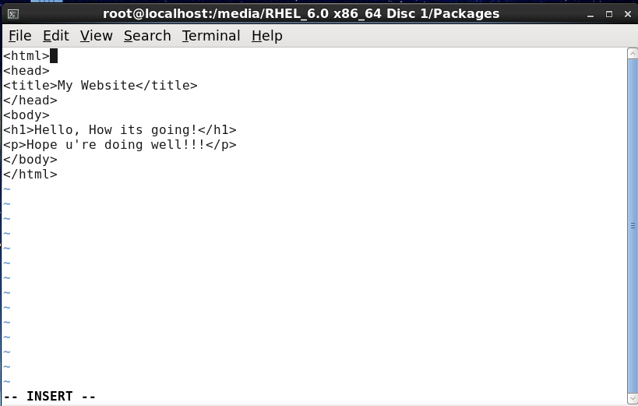

|  |
| --- |
| [root@localhost Packages]# ifconfig  eth1 Link encap:Ethernet HWaddr 00:0C:29:C6:00:43  inet addr:192.168.177.129 Bcast:192.168.177.255 Mask:255.255.255.0  inet6 addr: fe80::20c:29ff:fec6:43/64 Scope:Link  UP BROADCAST RUNNING MULTICAST MTU:1500 Metric:1  RX packets:412 errors:0 dropped:0 overruns:0 frame:0  TX packets:270 errors:0 dropped:0 overruns:0 carrier:0  collisions:0 txqueuelen:1000  RX bytes:38988 (38.0 KiB) TX bytes:30079 (29.3 KiB)  lo Link encap:Local Loopback  inet addr:127.0.0.1 Mask:255.0.0.0  inet6 addr: ::1/128 Scope:Host  UP LOOPBACK RUNNING MTU:16436 Metric:1  RX packets:22 errors:0 dropped:0 overruns:0 frame:0  TX packets:22 errors:0 dropped:0 overruns:0 carrier:0  collisions:0 txqueuelen:0  RX bytes:1788 (1.7 KiB) TX bytes:1788 (1.7 KiB)  [root@localhost Packages]# dig -x 192.168.177.129  ; <<>> DiG 9.7.0-P2-RedHat-9.7.0-5.P2.el6 <<>> -x 192.168.177.129  ;; global options: +cmd  ;; Got answer:  ;; ->>HEADER<<- opcode: QUERY, status: NXDOMAIN, id: 24585  ;; flags: qr rd ra; QUERY: 1, ANSWER: 0, AUTHORITY: 1, ADDITIONAL: 0  ;; QUESTION SECTION:  ;129.177.168.192.in-addr.arpa. IN PTR  ;; AUTHORITY SECTION:  168.192.in-addr.arpa. 5 IN SOA localhost. nobody.invalid. 1 3600 1200 604800 10800  ;; Query time: 70 msec  ;; SERVER: 192.168.177.2#53(192.168.177.2)  ;; WHEN: Mon Sep 19 22:51:12 2022  ;; MSG SIZE rcvd: 105  [root@localhost Packages]# vi /etc/httpd/conf/httpd.conf |

**At the end of the httpd.conf file make the following changes**

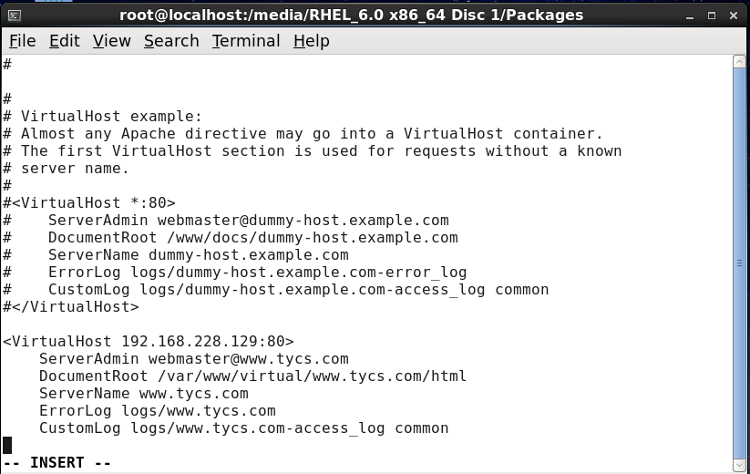

|  |
| --- |
| [root@localhost Packages]# service httpd restart  Stopping httpd: [ OK ]  Starting httpd: [ OK ]  [root@localhost Packages]# chkconfig httpd on  [root@localhost Packages]# chmod -R 777 /var/www/virtual/www.tycs.com/html |

**After this go to Mozilla Firefox browser and type** [**http://192.168.177.129**](http://192.168.177.129) **(your ipaddress)**

