HW-3
Team Members:
Praneeth Naidu(G01477360)
Ganesh Jasti(G01505410)
Venkata Abhiram Karuturi(G01505660)
Jithendra Sai Pappuri(G01506453)
1. Build Backend Docker Image:
Creating Dockerfile in HW3 folder
# Use Python lightweight image
FROM python:3.11-slim

# Disable .pyc and caching
ENV PYTHONDONTWRITEBYTECODE=1 \
PYTHONUNBUFFERED=1

# Create app directory
WORKDIR /app

# Copy requirements first for caching
COPY requirements.txt .
RUN pip install -r requirements.txt

# Copy FastAPI source code
COPY app ./app

# Expose FastAPI port
EXPOSE 8000

# Start FastAPI
CMD ["uvicorn", "app.main:app", "--host", "0.0.0.0", "--port", "8000"]

2. Build Frontend Docker Image:

FROM nginx:latest

RUN rm -rf /usr/share/nginx/html/*

COPY nginx.conf /etc/nginx/nginx.conf
COPY . /usr/share/nginx/html

EXPOSE 80

Log in to Docker Hub
docker login
Build the Docker image
docker build -t ganesh0912/hw3-backend:latest .
docker build -t ganesh0912/hw3-frontend:latest .
Push the image to Docker Hub
docker push ganesh0912/hw3-backend:latest
docker push ganesh0912/hw3-frontend:latest
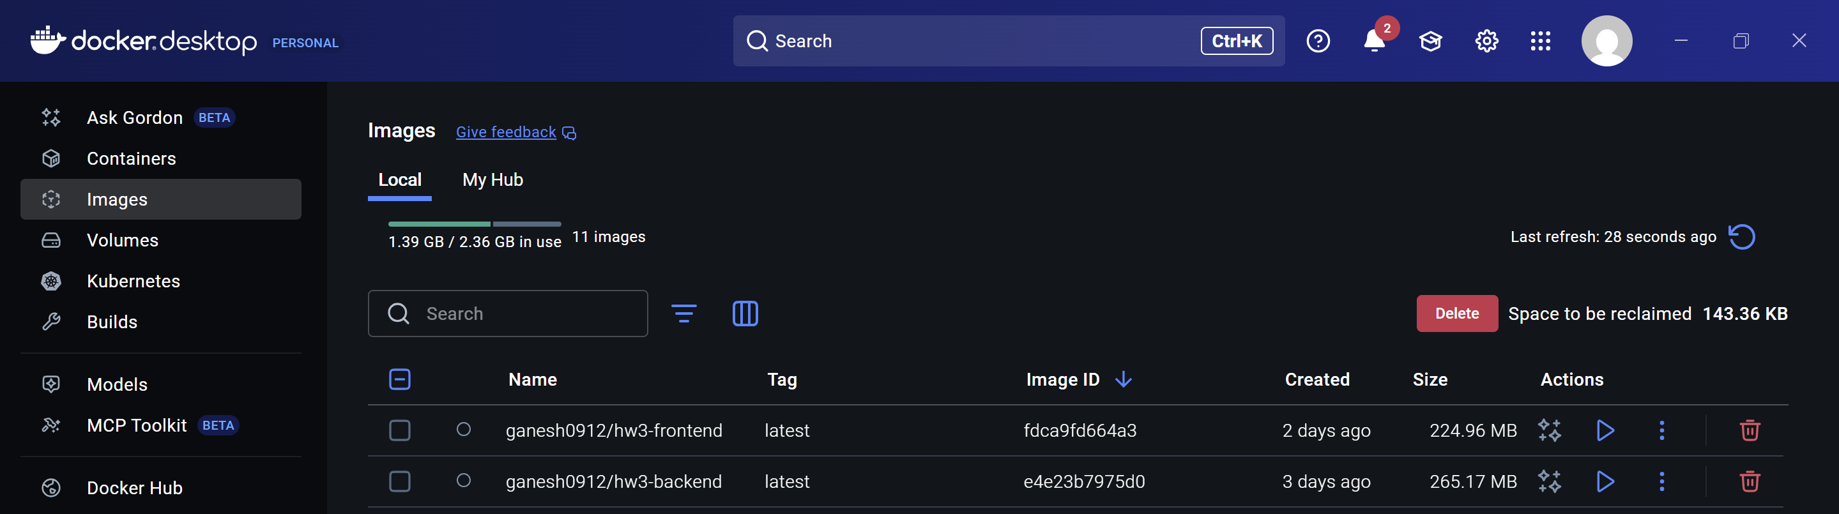
3. Kubernetes Setup on HW2 Cluster (Rancher EC2)
Create namespace hw3
kubectl create namespace hw3
Configure Deployment Files for Kubernetes
kubectl apply -f backend-deployment.yaml
kubectl apply -f backend-service.yaml
kubectl apply -f frontend-deployment.yaml
kubectl apply -f frontend-service.yaml
Sanity check for pods
kubectl get pods
kubectl get deployments
kubectl get svc
port no:
backend-service → 8000:31192/TCP
frontend-service → 80:30885/TCP
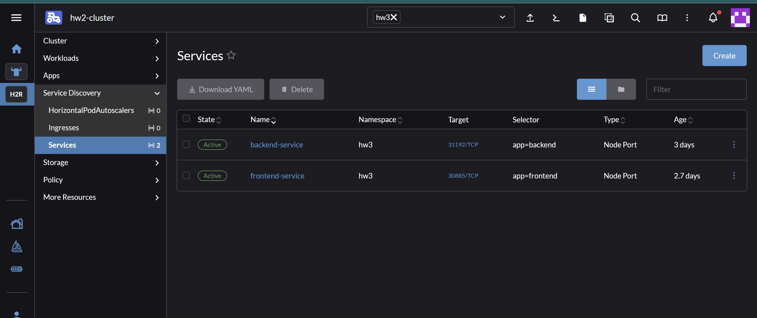

4. Updated API Call to Match Backend NodePort
During HW3 deployment, the frontend needed to communicate with the backend FastAPI service running on the Kubernetes cluster.
Since the backend was exposed using a NodePort (31192) on the HW2 RKE2 cluster, I updated the frontend code so that all API requests point to the correct backend URL.
const API_URL = "http://98.89.70.148:31192/surveys";
5. Access the App
http://98.89.70.148:30885
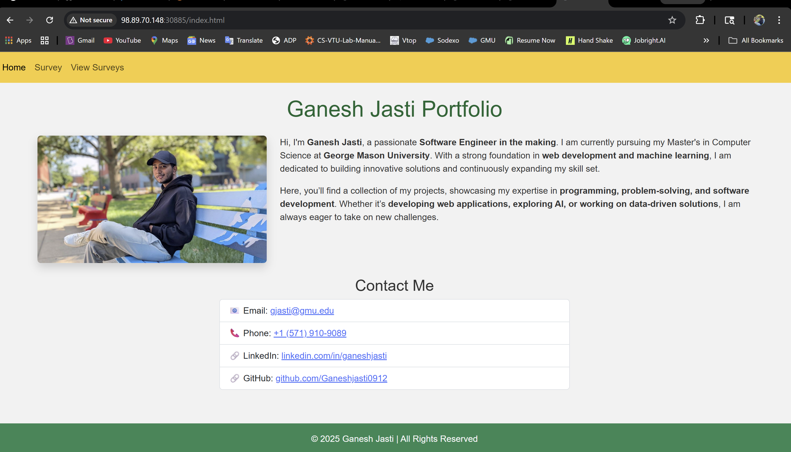
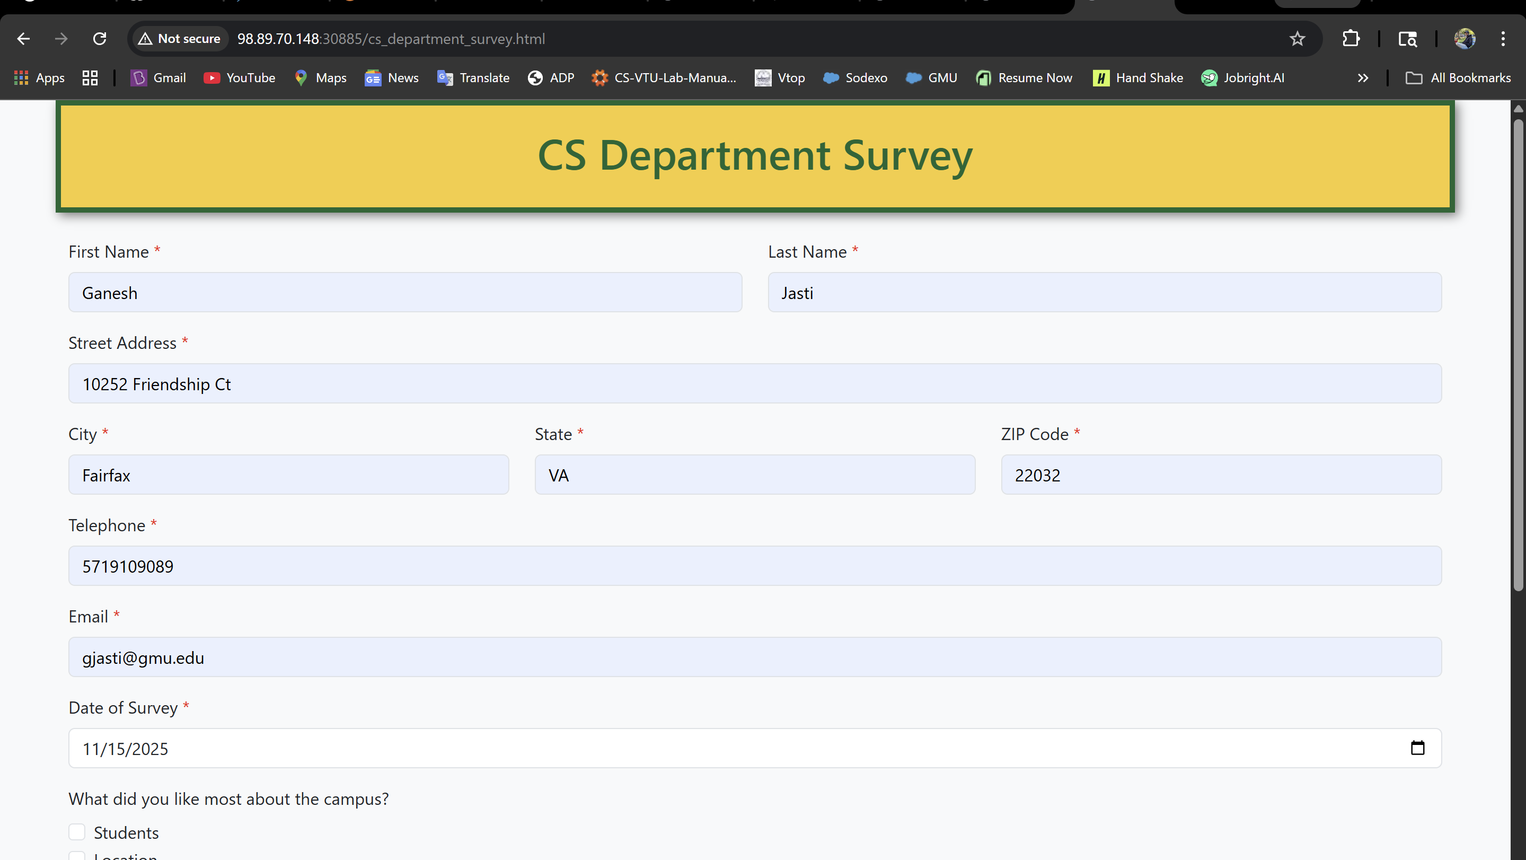
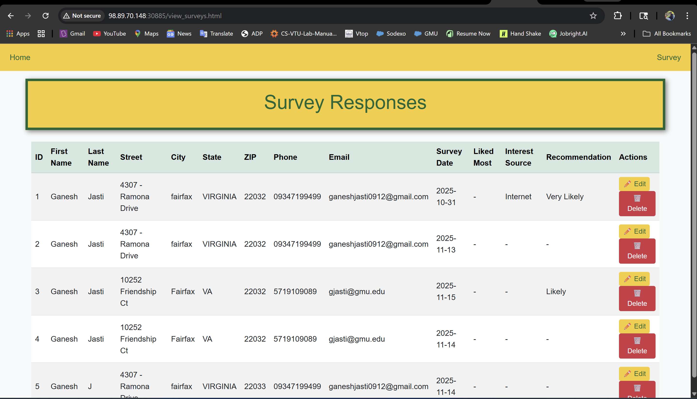

6. Jenkins CI/CD Pipeline (Using HW2 Jenkins EC2)
Now we automate everything with Jenkins using HW2 Jenkins EC2 instance.
Download KubeConfig from Rancher
- Go to Rancher UI: https://98.89.70.148
- Navigate to: Cluster Management → Clusters
- Click the three-dot menu next to your cluster → Download KubeConfig
- Save the file as config Copy KubeConfig to Jenkins Home
Copy KubeConfig to Jenkins Home
sudo su –
mkdir -p /var/lib/jenkins/.kube
cp /root/config /var/lib/jenkins/.kube/config
chown -R jenkins:jenkins /var/lib/jenkins/.kube
Switch to Jenkins User & Verify Access
sudo su - jenkins
export KUBECONFIG=/var/lib/jenkins/.kube/config
kubectl get nodes
Update Jenkins Pipeline to Use KubeConfig
environment {
BACKEND_IMAGE = "ganesh0912/hw3-backend"
FRONTEND_IMAGE = "ganesh0912/hw3-frontend"
KUBECONFIG = "/var/lib/jenkins/.kube/config"
}
7. Setup Jenkins CI/CD Pipeline
We now set up a Jenkins pipeline that:
1. Clones the GitHub repo
2. Builds the Docker image
3. Pushes to Docker Hub
4. Deploys to Kubernetes using kubectl

- Add Docker Hub Credentials
• Go to: Jenkins → Manage Jenkins → Credentials → (Global) → Add Credentials • Type: Username and Password
• ID: docker-hub-creds
• Username: ganeshjasti0912
• Password: *****
- Install Required Plugins
  - GitHub Integration
  - Docker Pipeline
  - Kubernetes CLI (kubectl) Plugin
- Configure GitHub Webhook
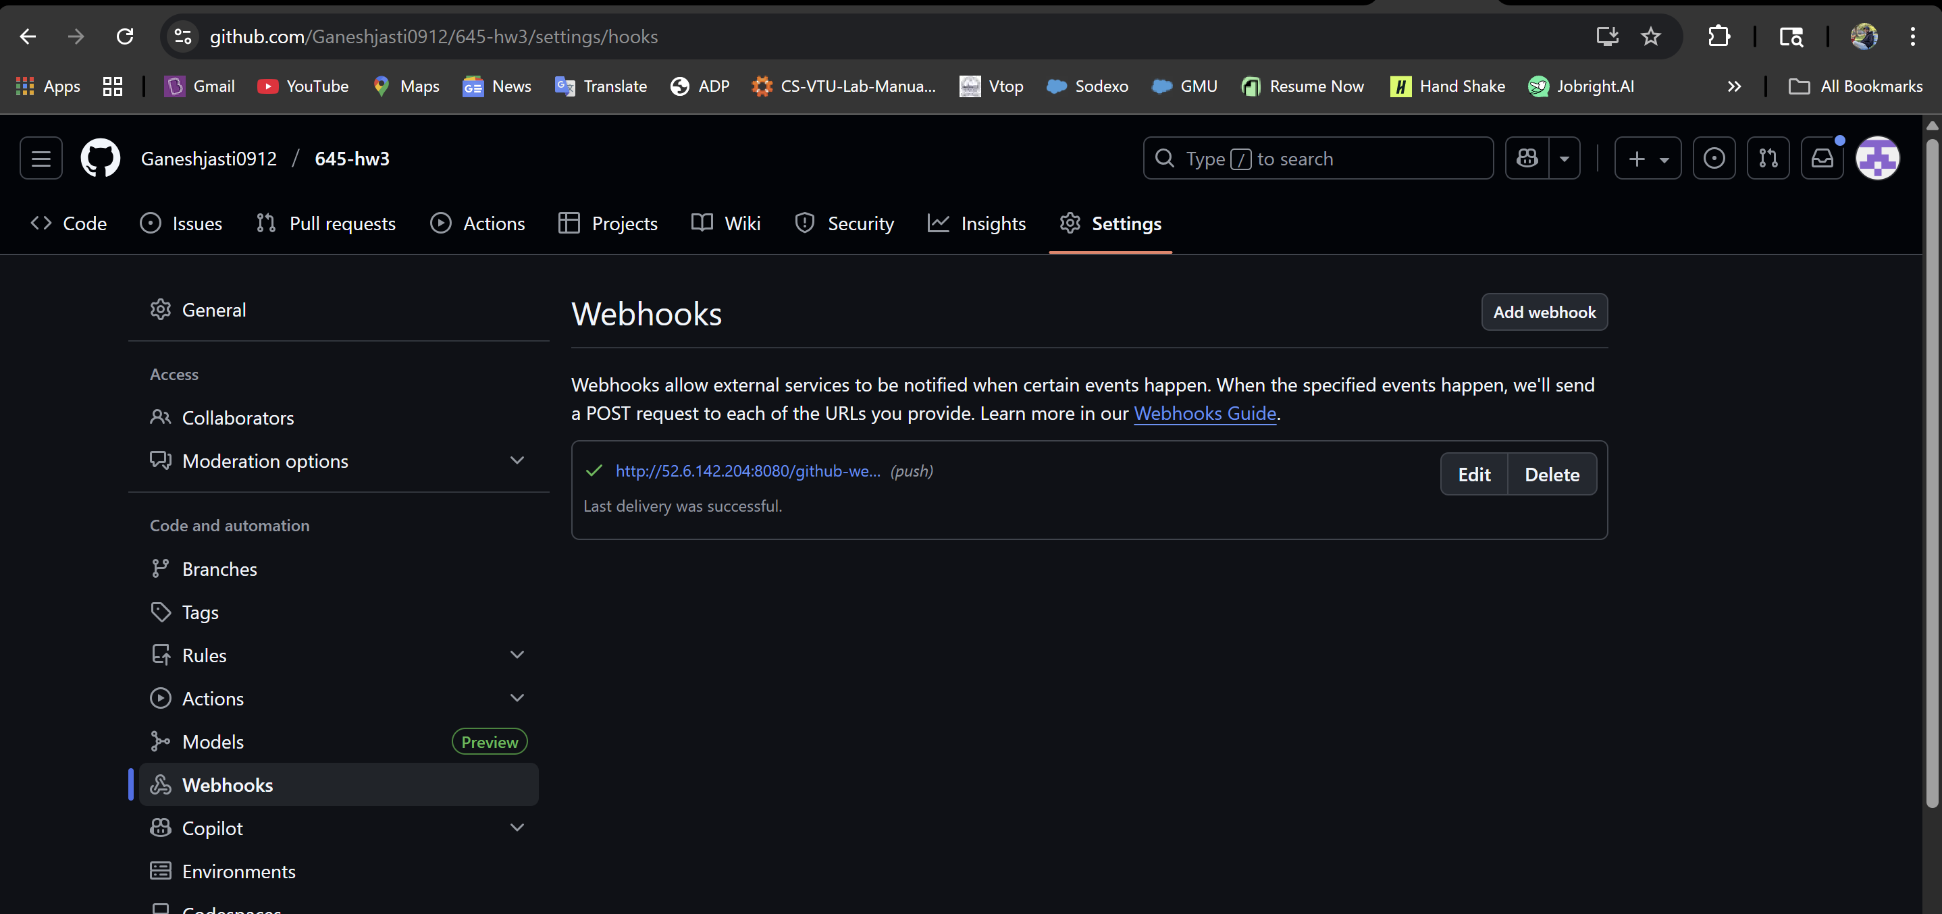
- Go to your GitHub repo → Settings → Webhooks → Add webhook
- Payload URL: http://52.6.142.204:8080
- Content type: application/json
- Event trigger: Just the push event
You must allow port 8080 in your EC2 Security Group.

8. Configure Jenkins Pipeline Job
- Go to Jenkins → New Item → Choose Pipeline
- Name: hw3-pipeline
- Select "Pipeline script from SCM"
- SCM: Git
- Repository URL: https://github.com/Ganeshjasti0912/645-hw3.git
- Branch: */main
- Script Path: Jenkinsfile
9. Test the Pipeline
Push a new change to your GitHub repo:
      - git add .
      - git commit -m "trigger build"
      - git push origin main
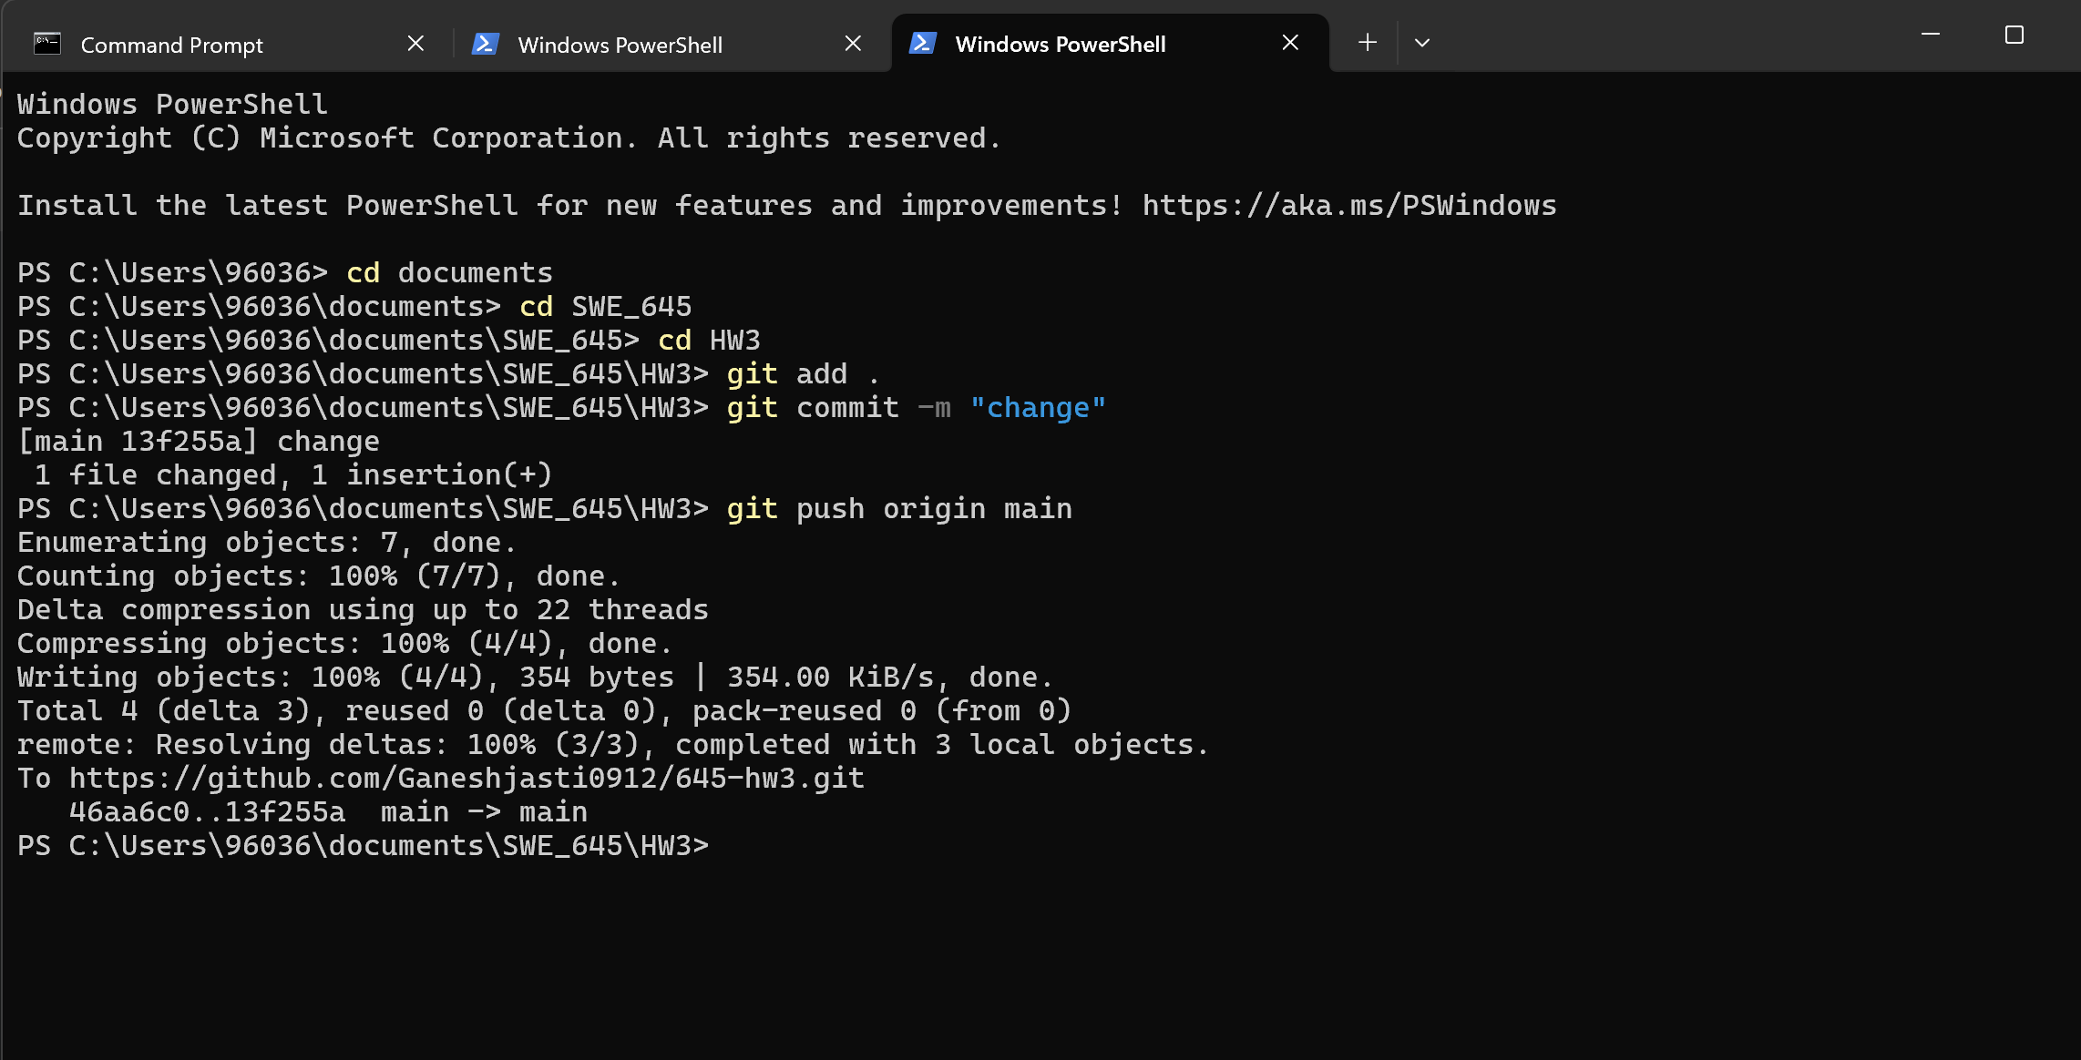
Jenkins will automatically trigger:
• Build Docker images
• Push to Docker Hub
• Deploy to Kubernetes via kubectl apply
