Optimizing User, Group, and Role Management with Access Control and Workflows
Requirement Analysis &amp; Planning
Description
This section defines the primary business goals of the project, emphasizing the need for clear role definitions, effective access control, and structured workflows. It aims to ensure accountability by making task ownership and progress transparent, improve collaboration through organized task management, enhance operational efficiency via automated task assignments and updates, and safeguard project data integrity through role-based restrictions and access controls.
Functional Scope
Description
User Management
o Create users Alice and Bob.
o Assign roles and responsibilities.
Group Management
o Create Project Team Group.
o Add Alice and Bob as members.
Role Definition
o Create Project Manager and Team Member roles.
o Assign roles to users.
Table Configuration
o Create Project Table and Task Table 2.
o Define columns for tasks and projects.
5. Application Access
o Configure modules for tables.
o Assign roles for controlled access.
6. Access Control Lists (ACLs)
o Restrict Bob’s edit rights to task fields (status, comments).
o Ensure Alice has full access.
7. Workflow Automation (Flow Designer)
o Automate task assignment, status updates, and approvals.
o Notify Alice when Bob completes tasks.

Stakeholder Mapping
Description
Project Manager (Alice)
o Assigns tasks, monitors progress, approves completions.
Team Member (Bob)
o Executes assigned tasks, updates progress.
ServiceNow Developers
o Configure users, groups, roles, tables, ACLs, and flows.
QA/Testers
o Validate workflows, ACLs, and role-based access.
Execution Roadmap
Description
Execution Roadmap Execution RoadMap divided into different phases
Phase 1: Requirement Analysis & Planning
Gather business requirements from stakeholders.
Document functional scope, use cases, and security expectations.
Define governance model and approval needs.
Finalize milestones and execution roadmap.
Phase 2: Core Platform Setup (Users, Groups, Roles)
Milestone 1 → Users: Create Alice and Bob in ServiceNow.
Milestone 2 → Groups: Create Project Team Group.
Milestone 3 → Roles: Create Project Manager and Team Member roles.
Deliverable: Base identity framework established in ServiceNow.
Phase 3: Data & Structural Configuration
Milestone 4 → Table: Create Project Table and Task Table 2 with required columns.
Deliverable: Platform structured to support access operations and auditing.
Phase 4: Access Assignment & Governance Enablement
Milestone 5 → Assign Users to Groups: Add Alice and Bob to Project Team Group.
Milestone 6 → Assign Roles to Users: Assign Project Manager role + table roles to Alice; Team Member role + task table role to Bob.
Milestone 7 → Assign Roles to Bob User (Scenario Validation).
Deliverable: Users mapped correctly, roles governed, controlled access ecosystem.
Phase 5: Application Security & Access Enforcement
Milestone 7 → Application Access: Configure application modules for Project Table and Task Table 2.
Milestone 8 → Access Control List (ACL): Create ACLs for Task Table fields (status, comments).
Deliverable: Strong security enforcement using least-privilege principles.
Phase 6: Automation & Workflow Optimization
Milestone 9 → Flow: Build Flow Designer flow for Task Table.
o Trigger: On record creation (status = In Progress, comments = Feedback, assigned to = Bob).
o Action 1: Update Status → Completed.
o Action 2: Ask for Approval → Approver = Alice.
Deliverable: Automation reduces manual effort and improves operational efficiency.
Phase 7: Testing & Validation
Functional testing of users, groups, roles.
ACL validation testing.
Workflow execution testing.
Security + performance validation.
Deliverable: Stable, secure, and correctly functioning system.
Phase 8: Project Closure & Conclusion
Summarize outcomes.
Highlight governance improvements.
Show automation and controlled security benefits.
Demonstrate real-time working use case.
Conclusion: The project successfully builds a secure, structured, automated User-Group-Role management system in ServiceNow with proper access control and workflows, ensuring strong governance, compliance, and efficiency.

Core Platform Setup (Users, Groups, Roles)
Description
This section outlines the data architecture setup for the project, detailing the creation of users, groups, and roles within ServiceNow. It includes defining key users—Alice as Project Manager and Bob as Team Member—establishing a project collaboration group, and configuring roles with appropriate access levels. The Project Manager role is granted full access to project and task records, while the Team Member role is restricted to viewing and updating assigned tasks, ensuring a structured and secure framework for task management and accountability.
Creation of Users
Navigate to: System Security > Users.
Click New to create a new user.
Fill in User Information: o Name: Alice o Role: Project Manager
Click Submit to create the user.
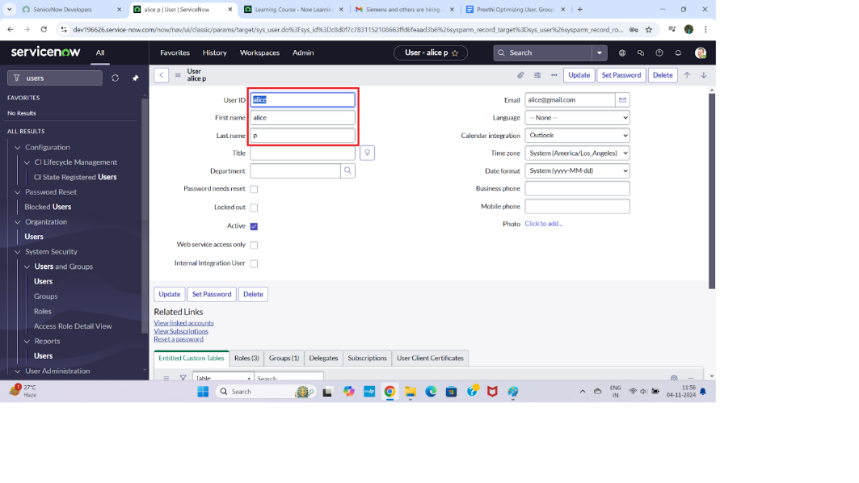
Create one more user:
Create another user with the following details Name: Bob Role : Team Member
Click on submit.
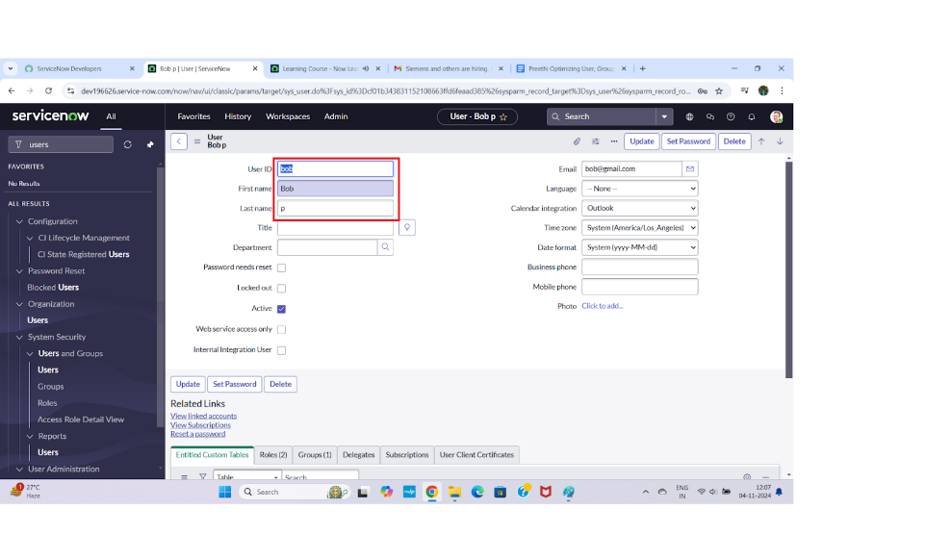
Creation of Groups
Description
Navigate to: System Security > Groups.
Click New to create a new group.
Fill in Group Information:
o Name: Project Team Group
o Description: Group for project collaboration
Click Submit to create the group.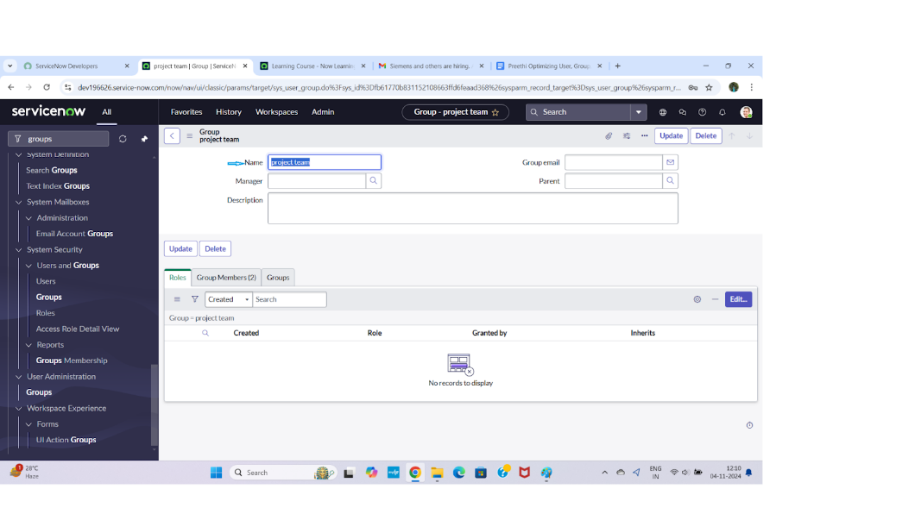
Creation of Roles
Description
Navigate to: System Security > Roles.
Click New to create a new role.
Fill in Role Information:
o Name: Project Manager Role
o Description: Full access to project and task tables
Click Submit.
Repeat steps to create Team Member Role with restricted access.
Save both roles.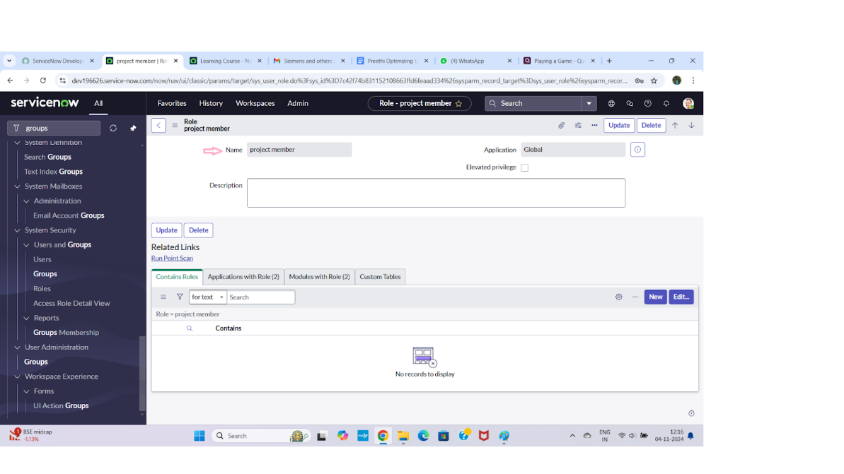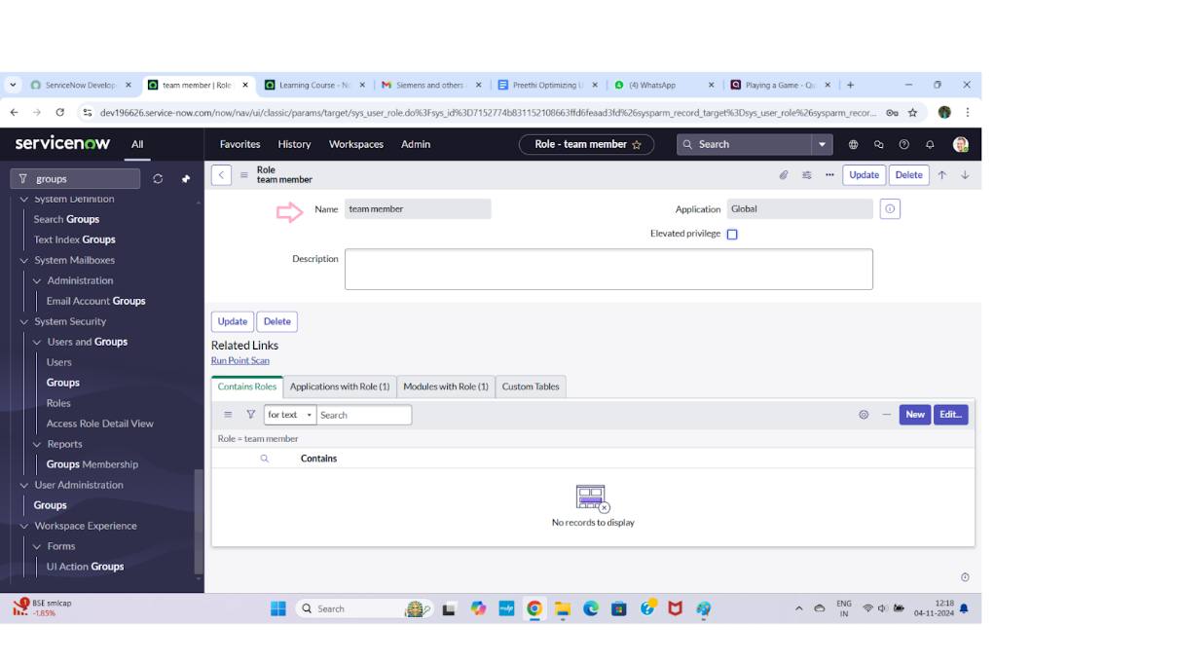
Create Project Table
Description
Open ServiceNow.
Click on All → search for Tables.
Select Tables under System Definition.
Click on New.
Fill in the following details:
o Label: Project Table
o Name: u_project_table
o Check the boxes Create Module & Create Mobile Module.
o Under New Menu Name: Project Table.
o Define table columns (e.g., Project Name, Owner, Deadline).
Click on Submit to create the table.
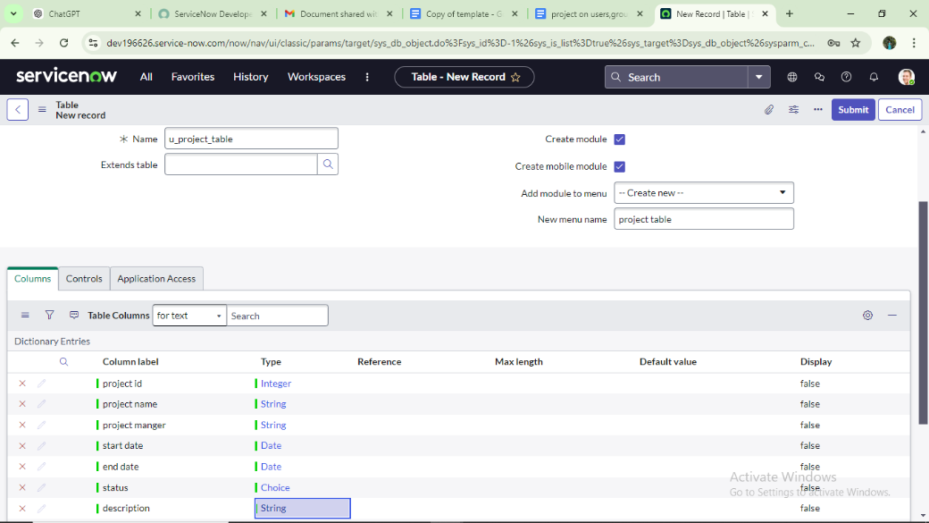

Create Task Table 2
Description
Open ServiceNow.
Click on All → search for Tables.
Select Tables under System Definition.
Click on New.
Fill in the following details:
o Label: Task Table 2
o Name: u_task_table2
o Add required columns (Task Name, Description, Status, Comments, Assigned To).
Click on Submit to create the table.
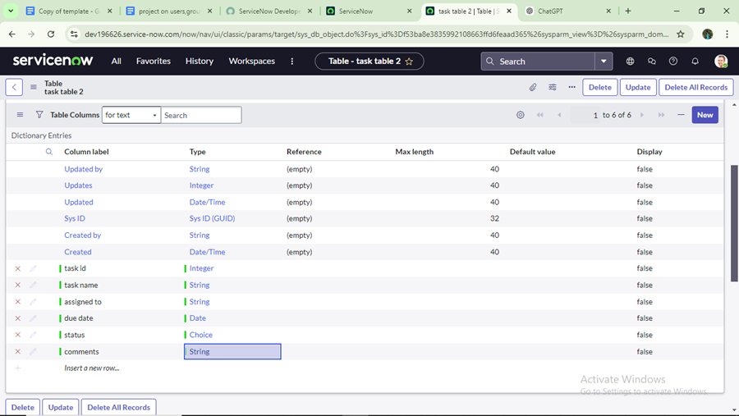
Access Assignment & Governance Enablement
Description
This phase focuses on enforcing governance by assigning appropriate roles to users and validating access controls. The Project Manager (Alice) is granted roles that provide full access to project and task tables, enabling complete management capabilities. The Team Member (Bob) is assigned restricted roles that allow access only to task-related data relevant to his responsibilities. User impersonation is used to verify that permissions are correctly applied, ensuring secure, role-based access and proper governance across the system.
Assign Roles to Alice (Project Manager)
Description
Open ServiceNow.
Click on All → search for Users.
Select Project Manager user (Alice).
Under Project Manager profile, click Edit.
Select Project Member role and save.
Click Edit again and add:
o u_project_table role
o u_task_table role
Click Save and update the form.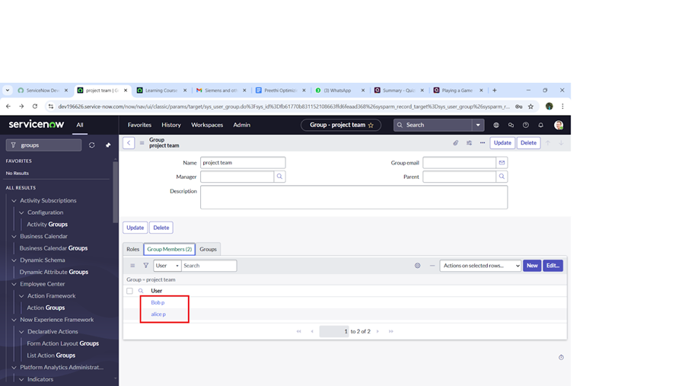
Assign Roles to Bob (Team Member)
Description
Open ServiceNow.
Click on All → search for Users.
Select Team Member user (Bob).
Under Team Member profile, click Edit.
Select Team Member role and assign table role.
Save the changes.
Click on the profile icon → Impersonate user Bob.
Verify that Bob can access Task Table 2 with restricted permissi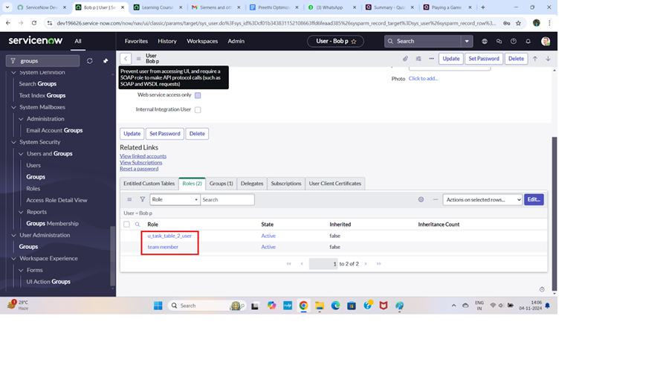

Application Security & Access Enforcement
Description
This phase ensures application-level security by controlling access to project and task modules based on user roles. Roles are assigned directly to the Project Table and Task Table applications to restrict visibility and usage within the Application Navigator. The Project Table application is limited to users with the Project Member role, while the Task Table application is accessible to both Project Manager and Team Member roles. This configuration enforces secure access to applications and prevents unauthorized users from viewing or interacting with project data.
Assign Table Access to Application
Description
When creating a table, ServiceNow automatically generates an application and module for that table.
Go to Application Navigator and search for Project Table application.
Click on Edit Module.
Assign Project Member role to the Project Table application.
Search for Task Table 2 application.
Click on Edit Application.
Assign both Project Member role and Team Member role to the Task Table 2 application.
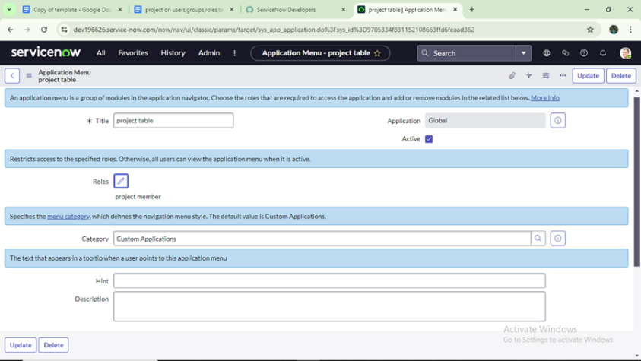
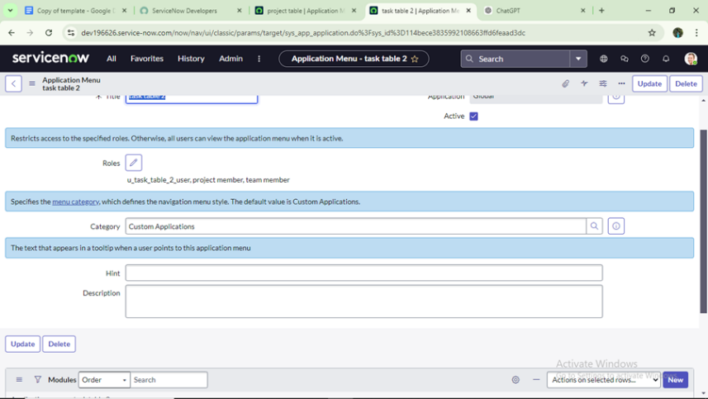

Create ACLs for Task Table 2
Description
Open ServiceNow.
Click on All → search for ACL.
Select Access Control (ACL) under System Security.
Click on Elevate Role.
Click on New to create a new ACL.
Fill in the following details:
o Table: Task Table 2
o Role: Team Member
Scroll down to Requires Role and insert the Team Member role.
Click Submit.
Similarly, create four ACLs for the following fields:
o Status
o Comments
o Assigned To
o Description (if required)
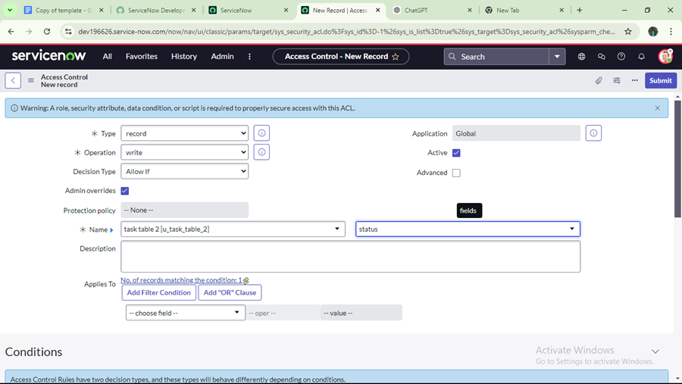
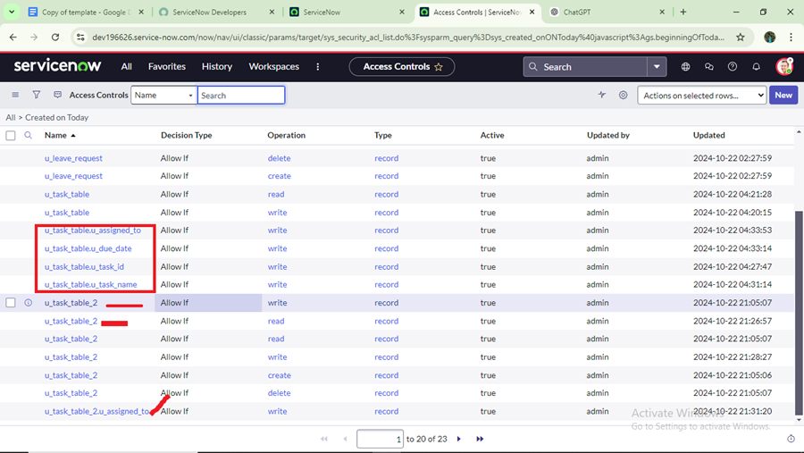
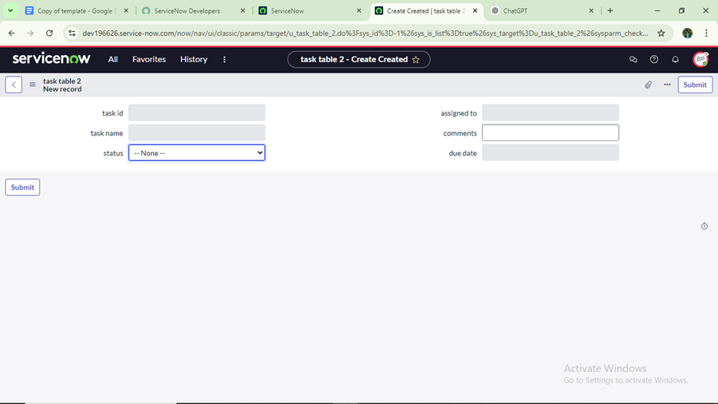
Automation & Workflow Optimization
Description
This phase focuses on automating task processing using Flow Designer. A flow is created on the Task Table that triggers when a task enters a specific state and meets defined conditions such as status, comments, and assignment. The flow automatically updates the task status and routes the record for approval to the Project Manager, ensuring consistent task completion handling, managerial oversight, and reduced manual intervention in task workflows.
Create a Flow to Assign Operations Ticket to Group
Description
Open ServiceNow.
Click on All → search for Flow Designer.
Select Flow Designer under Process Automation.
Click on New and select Flow.
Under Flow Properties, provide: o Flow Name: Task Table o Application: Global
Click Build Flow.
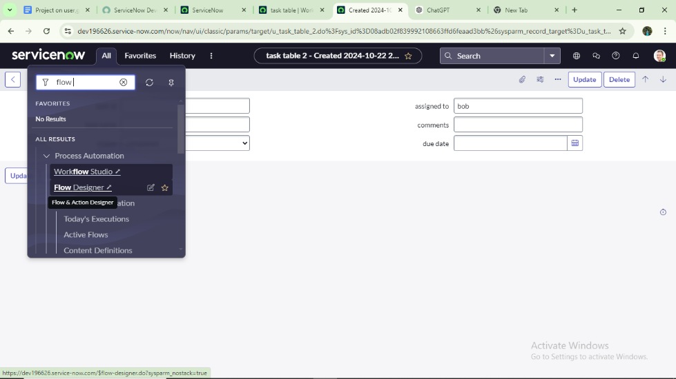
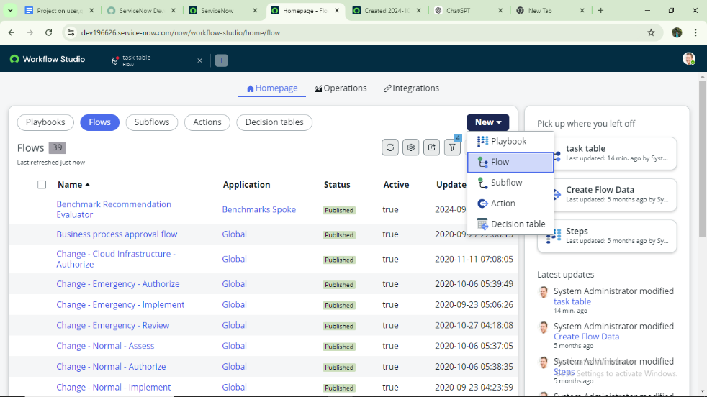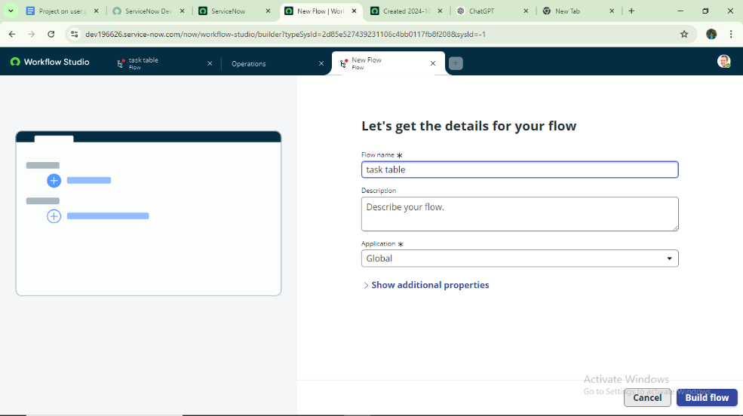
Next Step: Add Trigger
Click on Add a Trigger.
Search for Create Record and select it.
Table: Task Table.
Define conditions:
o Field: Status → Operator: is → Value: In Progress
o Field: Comments → Operator: is → Value: Feedback
o Field: Assigned To → Operator: is → Value: Bob
5. Click Done.
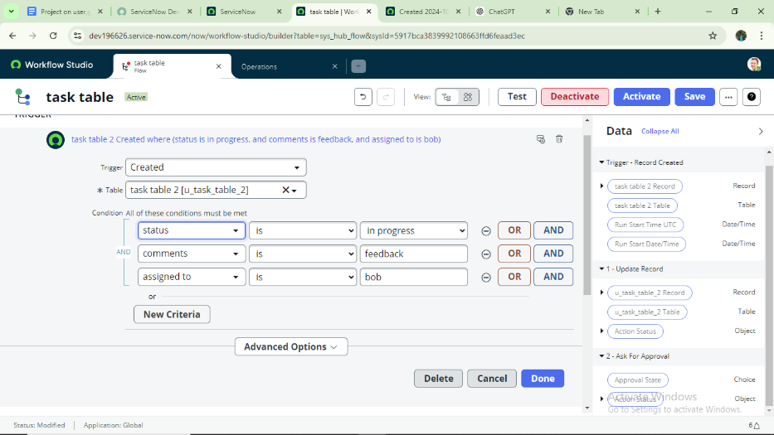
Next Step: Add Action (Update Record)
Click on Add an Action.
Search for Update Records.
In Record field, drag fields from the Data Navigation (Data pill) on the right side.
Table will be autoassigned.
Add field: Status → Value: Completed.
Click Done.
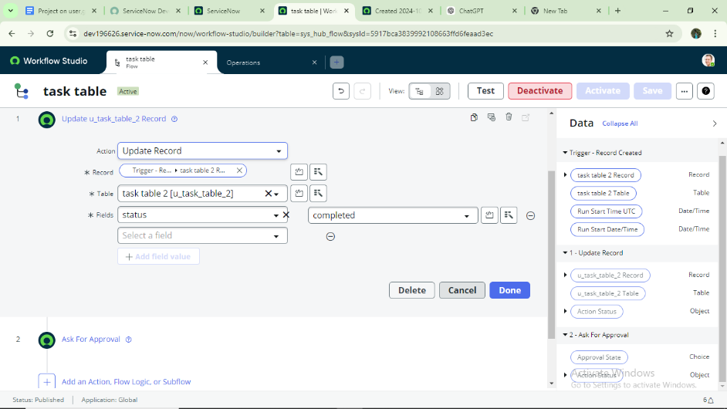
Next Step: Add Action (Ask for Approval)
Under Actions, click on Add an Action.
Search for Ask for Approval.
In Record field, drag fields from the Data Navigation (Data pill).
Table will be autoassigned.
Approval field: Status.
Approver: Alice (Project Manager).
Click Done.
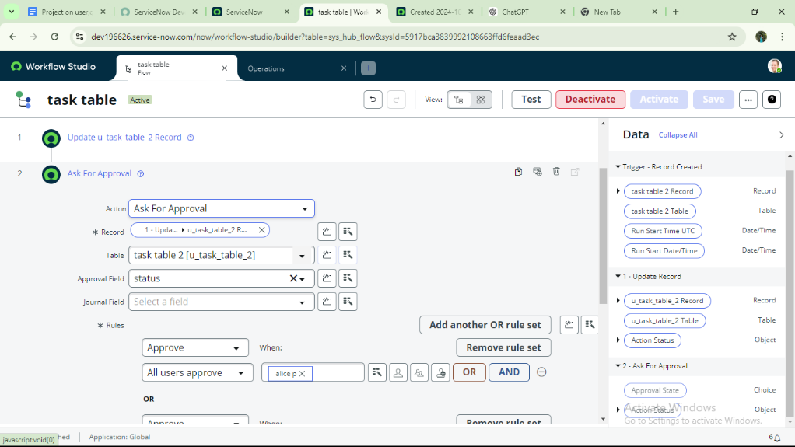
Testing & Validation
Description
This phase focuses on testing and validating the workflow execution to ensure it functions as designed. The task flow is verified by checking automatic status updates on the Task Table and confirming that approval requests are correctly generated. Approval routing is validated by ensuring the Project Manager receives and processes the request, confirming successful workflow execution and end-to-end functionality.
Workflow Execution Testing
Description
Go to Application Navigator and search for Task Table.
Verify that the Status field is updated to Completed after the workflow runs.
Go to Application Navigator and search for My Approval.
Click on My Approval under the Service Desk.
Confirm that Alice (Project Manager) received the approval request.
Rightclick on the Requested item.
Select Approved to complete the workflow validation.
