Assignment-14.3
Name:M.Ganesh Kumar
HTNO:2303A51358
Batch:20
Task 1: AI-Assisted Personal Portfolio Website
Prompt:
Generate a complete personal portfolio website using HTML, CSS, and JavaScript in a single file (or separate files if better).
Requirements:
1. HTML (Structure):
- Use semantic HTML5 tags (header, nav, section, main, footer)
- Sections required:
• Home (hero with name, title, intro, and button)
• About (short bio + skills list)
• Projects (at least 3 project cards with title, description, and link/button)
• Contact (form with name, email, message)
- Include a responsive navigation bar with links to each section
2. CSS (Design & Responsiveness):
- Use modern CSS (Flexbox and Grid)
- Create a clean, professional UI
- Add a color theme (soft gradient or modern palette)
- Make it fully responsive (mobile, tablet, desktop)
- Add spacing, shadows, and rounded corners
- Include hover effects on:
• Buttons
• Project cards (scale + shadow + smooth transition)
- Add a sticky navbar
- Use smooth scrolling behavior
3. JavaScript (Interactivity):
- Enable smooth scrolling for navbar links
- Highlight active section in navbar while scrolling
- Add a mobile menu toggle (hamburger menu)
- Add simple animation when sections appear on scroll (fade-in effect)

4. Additional Features:
- Clean and readable code with comments
- Use class-based styling
- Ensure accessibility (labels, alt text)
- Keep everything <beginner-friendly
Code:
<!DOCTYPE html>
<html lang="en">
<head>
<meta charset="UTF-8">
<meta name="viewport" content="width=device-width, initial-scale=1.0">
<title>Personal Portfolio | Creative Developer</title>
<link href="https://fonts.googleapis.com/css2?family=Inter:wght@300;400;600;700&display=swap" rel="stylesheet">
<style>
/* --- CSS VARIABLES --- */
:root {
--primary-color: #6366f1;
--secondary-color: #a855f7;
--bg-dark: #0f172a;
--bg-card: rgba(255, 255, 255, 0.05);
--text-light: #f8fafc;
--text-dim: #94a3b8;
--transition: all 0.3s ease;
}

/* --- RESET & BASE STYLES --- */
* {
margin: 0;
padding: 0;
box-sizing: border-box;
}

html {
scroll-behavior: smooth;
}

body {
font-family: 'Inter', sans-serif;
background-color: var(--bg-dark);
color: var(--text-light);
line-height: 1.6;
overflow-x: hidden;
}

ul { list-style: none; }
a { text-decoration: none; color: inherit; }

section {
padding: 100px 10%;
min-height: 100vh;
display: flex;
flex-direction: column;
justify-content: center;
opacity: 0; /* For Scroll Animation */
transform: translateY(30px);
transition: all 0.8s ease-out;
}

section.reveal {
opacity: 1;
transform: translateY(0);
}

/* --- NAVIGATION --- */
header {
position: fixed;
top: 0;
width: 100%;
padding: 20px 10%;
display: flex;
justify-content: space-between;
align-items: center;
z-index: 1000;
transition: var(--transition);
background: rgba(15, 23, 42, 0.8);
backdrop-filter: blur(10px);
}

.logo {
font-size: 1.5rem;
font-weight: 700;
background: linear-gradient(to right, var(--primary-color), var(--secondary-color));
-webkit-background-clip: text;
-webkit-text-fill-color: transparent;
}

.nav-links {
display: flex;
gap: 30px;
}

.nav-links a {
font-weight: 500;
transition: var(--transition);
}

.nav-links a:hover, .nav-links a.active {
color: var(--primary-color);
}

.hamburger {
display: none;
cursor: pointer;
flex-direction: column;
gap: 5px;
}

.hamburger span {
width: 25px;
height: 3px;
background: var(--text-light);
transition: var(--transition);
}

/* --- HERO SECTION --- */
#home {
text-align: center;
background: radial-gradient(circle at top right, #1e1b4b, transparent);
}

.hero-content h1 {
font-size: clamp(2.5rem, 8vw, 4.5rem);
margin-bottom: 1rem;
}

.hero-content span {
color: var(--primary-color);
}

.hero-content p {
font-size: 1.2rem;
color: var(--text-dim);
margin-bottom: 2rem;
}

.btn {
padding: 12px 30px;
background: var(--primary-color);
border-radius: 8px;
font-weight: 600;
transition: var(--transition);
display: inline-block;
border: none;
cursor: pointer;
color: white;
}

.btn:hover {
background: var(--secondary-color);
transform: translateY(-3px);
box-shadow: 0 10px 20px rgba(168, 85, 247, 0.3);
}

/* --- ABOUT & SKILLS --- */
.about-container {
display: grid;
grid-template-columns: 1fr 1fr;
gap: 50px;
align-items: center;
}

.skills-grid {
display: grid;
grid-template-columns: repeat(auto-fit, minmax(100px, 1fr));
gap: 15px;
margin-top: 20px;
}

.skill-item {
background: var(--bg-card);
padding: 10px;
text-align: center;
border-radius: 8px;
border: 1px solid rgba(255,255,255,0.1);
}

/* --- PROJECTS --- */
.project-grid {
display: grid;
grid-template-columns: repeat(auto-fit, minmax(300px, 1fr));
gap: 30px;
margin-top: 40px;
}

.project-card {
background: var(--bg-card);
border-radius: 15px;
overflow: hidden;
border: 1px solid rgba(255,255,255,0.1);
transition: var(--transition);
}

.project-info {
padding: 25px;
}

.project-info h3 { margin-bottom: 10px; }
.project-info p { color: var(--text-dim); font-size: 0.9rem; margin-bottom: 20px; }

.project-card:hover {
transform: translateY(-10px) scale(1.02);
box-shadow: 0 20px 40px rgba(0,0,0,0.4);
border-color: var(--primary-color);
}

/* --- CONTACT FORM --- */
.contact-form {
max-width: 600px;
margin: 40px auto 0;
width: 100%;
}

.form-group {
margin-bottom: 20px;
}

.form-group label {
display: block;
margin-bottom: 5px;
font-size: 0.9rem;
}

.form-group input, .form-group textarea {
width: 100%;
padding: 12px;
background: var(--bg-card);
border: 1px solid rgba(255,255,255,0.1);
border-radius: 8px;
color: white;
outline: none;
}

.form-group input:focus, .form-group textarea:focus {
border-color: var(--primary-color);
}

/* --- FOOTER --- */
footer {
text-align: center;
padding: 40px;
border-top: 1px solid rgba(255,255,255,0.1);
color: var(--text-dim);
}

/* --- RESPONSIVE MOBILE --- */
@media (max-width: 768px) {
.nav-links {
position: fixed;
top: 70px;
right: -100%;
flex-direction: column;
background: var(--bg-dark);
width: 100%;
text-align: center;
padding: 40px 0;
transition: 0.4s;
}

.nav-links.active { right: 0; }
.hamburger { display: flex; }
.about-container { grid-template-columns: 1fr; }
section { padding: 80px 5%; }
}
</style>
</head>
<body>

<header id="header">
<div class="logo">PORTFOLIO.</div>
<nav>
<ul class="nav-links" id="nav-menu">
<li><a href="#home" class="nav-item">Home</a></li>
<li><a href="#about" class="nav-item">About</a></li>
<li><a href="#projects" class="nav-item">Projects</a></li>
<li><a href="#contact" class="nav-item">Contact</a></li>
</ul>
</nav>
<div class="hamburger" id="hamburger">
<span></span>
<span></span>
<span></span>
</div>
</header>

<main>
<section id="home">
<div class="hero-content">
<h1>Hi, I'm <span>Alex Doe</span></h1>
<p>Full Stack Developer & UI/UX Enthusiast</p>
<a href="#projects" class="btn">View My Work</a>
</div>
</section>

<section id="about">
<div class="about-container">
<div class="about-text">
<h2>About Me</h2>
<p style="margin: 20px 0; color: var(--text-dim);">
I am a passionate developer with 3 years of experience building digital products.
I specialize in creating clean, user-friendly interfaces and writing efficient, scalable code.
</p>
<a href="#" class="btn">Download CV</a>
</div>
<div class="skills-section">
<h3>My Skills</h3>
<div class="skills-grid">
<div class="skill-item">HTML5</div>
<div class="skill-item">CSS3</div>
<div class="skill-item">JavaScript</div>
<div class="skill-item">React</div>
<div class="skill-item">Node.js</div>
<div class="skill-item">Git</div>
</div>
</div>
</div>
</section>

<section id="projects">
<h2 style="text-align: center;">Featured Projects</h2>
<div class="project-grid">
<div class="project-card">
<div class="project-info">
<h3>E-Commerce Platform</h3>
<p>A full-featured online store with payment integration and inventory management.</p>
<a href="#" class="btn">View Project</a>
</div>
</div>
<div class="project-card">
<div class="project-info">
<h3>Task Master App</h3>
<p>A productivity tool helping users manage daily goals using a drag-and-drop interface.</p>
<a href="#" class="btn">View Project</a>
</div>
</div>
<div class="project-card">
<div class="project-info">
<h3>Weather Dashboard</h3>
<p>Real-time weather tracking using OpenWeather API with dynamic background changes.</p>
<a href="#" class="btn">View Project</a>
</div>
</div>
</div>
</section>

<section id="contact">
<h2 style="text-align: center;">Get In Touch</h2>
<div class="contact-form">
<form id="portfolioContact">
<div class="form-group">
<label for="name">Name</label>
<input type="text" id="name" placeholder="Your Name" required>
</div>
<div class="form-group">
<label for="email">Email</label>
<input type="email" id="email" placeholder="Email Address" required>
</div>
<div class="form-group">
<label for="message">Message</label>
<textarea id="message" rows="5" placeholder="Your Message" required></textarea>
</div>
<button type="submit" class="btn" style="width: 100%;">Send Message</button>
</form>
</div>
</section>
</main>

<footer>
<p>&copy; 2026 Alex Doe. All rights reserved.</p>
</footer>

<script>
// --- MOBILE MENU TOGGLE ---
const hamburger = document.getElementById('hamburger');
const navMenu = document.getElementById('nav-menu');

hamburger.addEventListener('click', () => {
navMenu.classList.toggle('active');
});

// Close menu when clicking a link
document.querySelectorAll('.nav-item').forEach(link => {
link.addEventListener('click', () => {
navMenu.classList.remove('active');
});
});

// --- SCROLL REVEAL ANIMATION ---
const sections = document.querySelectorAll('section');
const observerOptions = {
threshold: 0.2
};

const observer = new IntersectionObserver((entries) => {
entries.forEach(entry => {
if (entry.isIntersecting) {
entry.target.classList.add('reveal');
}
});
}, observerOptions);

sections.forEach(section => {
observer.observe(section);
});

// --- ACTIVE LINK ON SCROLL ---
window.addEventListener('scroll', () => {
let current = '';
sections.forEach(section => {
const sectionTop = section.offsetTop;
const sectionHeight = section.clientHeight;
if (pageYOffset >= (sectionTop - sectionHeight / 3)) {
current = section.getAttribute('id');
}
});

document.querySelectorAll('.nav-item').forEach(li => {
li.classList.remove('active');
if (li.getAttribute('href').includes(current)) {
li.classList.add('active');
}
});
});

// --- FORM SUBMISSION PREVENTER ---
document.getElementById('portfolioContact').addEventListener('submit', (e) => {
e.preventDefault();
alert('Thanks for reaching out! (This is a demo)');
});
</script>
</body>
</html>
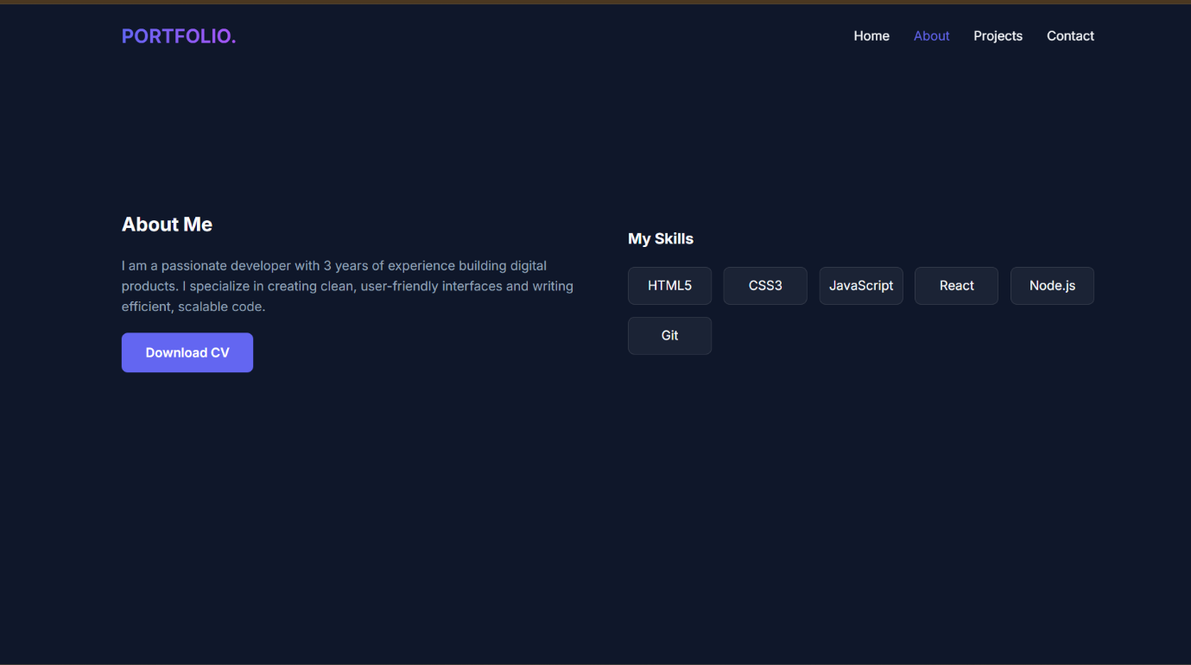
Explaination: This project is a personal portfolio website built using HTML, CSS, and JavaScript with sections like Home, About, Projects, and Contact.
It uses a responsive design with Flexbox, smooth navigation, and interactive project cards with hover effects.
The website has clean styling and includes a footer with the name Manu Sree (CSE Student).
Task:2
Prompt:
Create a simple and attractive restaurant landing page using HTML, CSS, and JavaScript. Requirements: Add a responsive navigation bar with links: Home, Menu, Gallery, Contact. Design a Menu section using CSS cards to display food items with name, image, and price. Implement a Gallery section with a JavaScript image slider (auto-slide + next/prev buttons). Add smooth animations and transitions (hover effects, fade-in, sliding effects). Ensure the page is responsive for mobile and desktop. Use clean, modern styling with good colors and spacing. give me effective page
Code:
<!DOCTYPE html>
<html lang="en">
<head>
<meta charset="UTF-8">
<meta name="viewport" content="width=device-width, initial-scale=1.0">
<title>Lumina Dine | Exquisite Flavors</title>
<link href="https://fonts.googleapis.com/css2?family=Playfair+Display:wght@700&family=Poppins:wght@300;400;600&display=swap" rel="stylesheet">
<style>
/* --- CSS VARIABLES & RESET --- */
:root {
--gold: #c5a059;
--dark: #0c0c0c;
--light-dark: #1a1a1a;
--white: #ffffff;
--grey: #a5a5a5;
--transition: all 0.4s cubic-bezier(0.165, 0.84, 0.44, 1);
}

* {
margin: 0;
padding: 0;
box-sizing: border-box;
}

html {
scroll-behavior: smooth;
}

body {
font-family: 'Poppins', sans-serif;
background-color: var(--dark);
color: var(--white);
line-height: 1.6;
overflow-x: hidden;
}

h1, h2, h3 {
font-family: 'Playfair Display', serif;
}

/* --- NAVIGATION --- */
header {
position: fixed;
top: 0;
width: 100%;
padding: 20px 5%;
display: flex;
justify-content: space-between;
align-items: center;
z-index: 1000;
background: rgba(12, 12, 12, 0.95);
border-bottom: 1px solid rgba(197, 160, 89, 0.2);
}

.logo {
font-size: 1.8rem;
color: var(--gold);
font-weight: 700;
text-transform: uppercase;
letter-spacing: 2px;
}

nav ul {
display: flex;
list-style: none;
gap: 30px;
}

nav a {
text-decoration: none;
color: var(--white);
font-weight: 400;
transition: var(--transition);
font-size: 0.9rem;
text-transform: uppercase;
}

nav a:hover {
color: var(--gold);
}

/* --- HERO SECTION --- */
#home {
height: 100vh;
background: linear-gradient(rgba(0,0,0,0.6), rgba(0,0,0,0.6)),
url('https://images.unsplash.com/photo-1514362545857-3bc16c4c7d1b?auto=format&fit=crop&q=80&w=1920') no-repeat center center/cover;
display: flex;
flex-direction: column;
justify-content: center;
align-items: center;
text-align: center;
padding: 0 20px;
}

.hero-content h1 {
font-size: clamp(3rem, 10vw, 5rem);
margin-bottom: 10px;
animation: fadeInDown 1s ease;
}

.hero-content p {
font-size: 1.2rem;
color: var(--gold);
letter-spacing: 4px;
text-transform: uppercase;
margin-bottom: 30px;
animation: fadeInUp 1s ease;
}

.btn {
padding: 12px 35px;
background: transparent;
border: 1px solid var(--gold);
color: var(--gold);
text-decoration: none;
transition: var(--transition);
text-transform: uppercase;
font-size: 0.8rem;
letter-spacing: 2px;
}

.btn:hover {
background: var(--gold);
color: var(--dark);
}

/* --- MENU SECTION --- */
section { padding: 100px 8%; }

.section-title {
text-align: center;
margin-bottom: 60px;
}

.section-title h2 {
font-size: 2.5rem;
color: var(--gold);
}

.menu-grid {
display: grid;
grid-template-columns: repeat(auto-fit, minmax(300px, 1fr));
gap: 30px;
}

.menu-card {
background: var(--light-dark);
border-radius: 5px;
overflow: hidden;
transition: var(--transition);
border: 1px solid #222;
}

.menu-card:hover {
transform: translateY(-10px);
border-color: var(--gold);
}

.menu-img {
height: 200px;
background-size: cover;
background-position: center;
}

.menu-info {
padding: 25px;
}

.menu-header {
display: flex;
justify-content: space-between;
align-items: center;
margin-bottom: 10px;
}

.menu-header h3 { color: var(--gold); }

.price {
color: var(--gold);
font-weight: 600;
}

.menu-info p {
color: var(--grey);
font-size: 0.9rem;
}

/* --- GALLERY SLIDER --- */
#gallery { background: var(--light-dark); }

.slider-container {
position: relative;
max-width: 1000px;
margin: 0 auto;
overflow: hidden;
border-radius: 10px;
}

.slider {
display: flex;
transition: transform 0.5s ease-in-out;
}

.slide {
min-width: 100%;
}

.slide img {
width: 100%;
height: 500px;
object-fit: cover;
}

.slider-btn {
position: absolute;
top: 50%;
transform: translateY(-50%);
background: rgba(0,0,0,0.5);
color: var(--gold);
border: none;
padding: 15px;
cursor: pointer;
font-size: 1.5rem;
z-index: 10;
}

.prev { left: 0; }
.next { right: 0; }

/* --- CONTACT --- */
.contact-container {
max-width: 700px;
margin: 0 auto;
}

.contact-form {
display: flex;
flex-direction: column;
gap: 20px;
}

.contact-form input, .contact-form textarea {
width: 100%;
padding: 15px;
background: var(--light-dark);
border: 1px solid #333;
color: white;
border-radius: 4px;
}

.contact-form input:focus, .contact-form textarea:focus {
outline: none;
border-color: var(--gold);
}

footer {
text-align: center;
padding: 40px;
background: #050505;
color: var(--grey);
font-size: 0.8rem;
}

/* --- ANIMATIONS --- */
@keyframes fadeInDown {
from { opacity: 0; transform: translateY(-30px); }
to { opacity: 1; transform: translateY(0); }
}

@keyframes fadeInUp {
from { opacity: 0; transform: translateY(30px); }
to { opacity: 1; transform: translateY(0); }
}

/* --- RESPONSIVE --- */
@media (max-width: 768px) {
nav { display: none; } /* Simplified for single cell: hides nav on mobile */
.slide img { height: 300px; }
section { padding: 60px 5%; }
}
</style>
</head>
<body>

<header>
<div class="logo">LUMINA</div>
<nav>
<ul>
<li><a href="#home">Home</a></li>
<li><a href="#menu">Menu</a></li>
<li><a href="#gallery">Gallery</a></li>
<li><a href="#contact">Contact</a></li>
</ul>
</nav>
</header>

<section id="home">
<div class="hero-content">
<p>Welcome to</p>
<h1>Lumina Dine</h1>
<a href="#menu" class="btn">Explore Menu</a>
</div>
</section>

<section id="menu">
<div class="section-title">
<h2>Seasonal Menu</h2>
</div>
<div class="menu-grid">
<div class="menu-card">
<div class="menu-img" style="background-image: url('https://images.unsplash.com/photo-1546069901-ba9599a7e63c?auto=format&fit=crop&q=80&w=600')"></div>
<div class="menu-info">
<div class="menu-header">
<h3>Truffle Risotto</h3>
<span class="price">$28</span>
</div>
<p>Creamy arborio rice infused with black truffle oil and wild mushrooms.</p>
</div>
</div>
<div class="menu-card">
<div class="menu-img" style="background-image: url('https://images.unsplash.com/photo-1565299624946-b28f40a0ae38?auto=format&fit=crop&q=80&w=600')"></div>
<div class="menu-info">
<div class="menu-header">
<h3>Wood-Fired Pizza</h3>
<span class="price">$22</span>
</div>
<p>Fresh buffalo mozzarella, heirloom tomatoes, and basil on a sourdough base.</p>
</div>
</div>
<div class="menu-card">
<div class="menu-img" style="background-image: url('https://images.unsplash.com/photo-1551024506-0bccd828d307?auto=format&fit=crop&q=80&w=600')"></div>
<div class="menu-info">
<div class="menu-header">
<h3>Glazed Duck</h3>
<span class="price">$34</span>
</div>
<p>Slow-roasted duck breast with honey-orange glaze and roasted roots.</p>
</div>
</div>
</div>
</section>

<section id="gallery">
<div class="section-title">
<h2>Our Ambience</h2>
</div>
<div class="slider-container">
<div class="slider" id="slider">
<div class="slide"><img src="https://images.unsplash.com/photo-1517248135467-4c7edcad34c4?auto=format&fit=crop&q=80&w=1000" alt="Restaurant Interior"></div>
<div class="slide"><img src="https://images.unsplash.com/photo-1550966841-3ee4ad058bbd?auto=format&fit=crop&q=80&w=1000" alt="Chef Cooking"></div>
<div class="slide"><img src="https://images.unsplash.com/photo-1559339352-11d035aa65de?auto=format&fit=crop&q=80&w=1000" alt="Cocktails"></div>
</div>
<button class="slider-btn prev" id="prevBtn">&#10094;</button>
<button class="slider-btn next" id="nextBtn">&#10095;</button>
</div>
</section>

<section id="contact">
<div class="section-title">
<h2>Reservations</h2>
</div>
<div class="contact-container">
<form class="contact-form" id="resForm">
<input type="text" placeholder="Full Name" required>
<input type="email" placeholder="Email Address" required>
<input type="date" required>
<textarea rows="5" placeholder="Special Requests"></textarea>
<button type="submit" class="btn">Book a Table</button>
</form>
</div>
</section>

<footer>
<p>&copy; 2026 Lumina Dine. Designed with Passion.</p>
</footer>

<script>
// --- IMAGE SLIDER LOGIC ---
const slider = document.getElementById('slider');
const slides = document.querySelectorAll('.slide');
const prevBtn = document.getElementById('prevBtn');
const nextBtn = document.getElementById('nextBtn');

let currentIndex = 0;
const totalSlides = slides.length;

function updateSlider() {
slider.style.transform = `translateX(-${currentIndex * 100}%)`;
}

function nextSlide() {
currentIndex = (currentIndex + 1) % totalSlides;
updateSlider();
}

function prevSlide() {
currentIndex = (currentIndex - 1 + totalSlides) % totalSlides;
updateSlider();
}

// Event Listeners
nextBtn.addEventListener('click', nextSlide);
prevBtn.addEventListener('click', prevSlide);

// Auto-slide
let slideInterval = setInterval(nextSlide, 5000);

// Stop auto-slide on hover
document.querySelector('.slider-container').addEventListener('mouseenter', () => {
clearInterval(slideInterval);
});

document.querySelector('.slider-container').addEventListener('mouseleave', () => {
slideInterval = setInterval(nextSlide, 5000);
});

// --- FORM SUBMISSION ---
document.getElementById('resForm').addEventListener('submit', function(e) {
e.preventDefault();
alert('Reservation request sent! We will contact you shortly.');
this.reset();
});

// --- OPTIONAL: NAVBAR BACKGROUND ON SCROLL ---
window.addEventListener('scroll', () => {
const header = document.querySelector('header');
if (window.scrollY > 50) {
header.style.padding = '10px 5%';
header.style.boxShadow = '0 5px 20px rgba(0,0,0,0.5)';
} else {
header.style.padding = '20px 5%';
header.style.boxShadow = 'none';
}
});
</script>
</body>
</html>
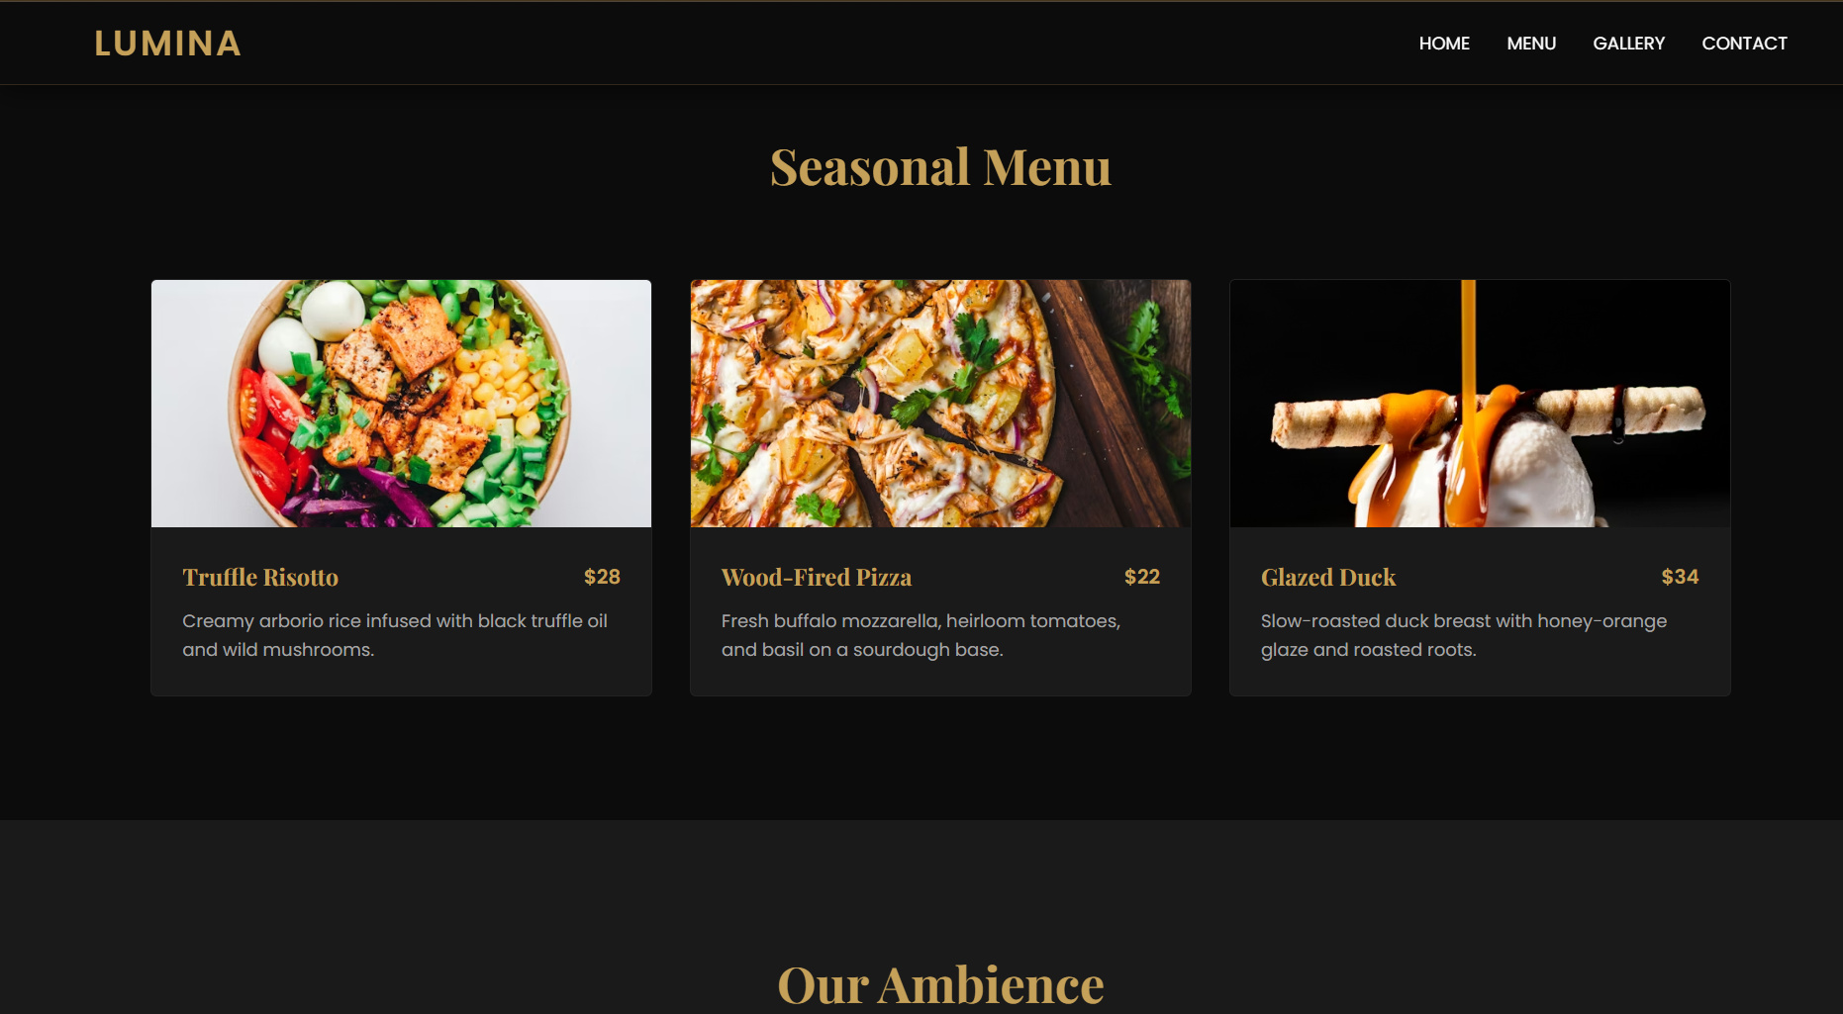
Task3:
Prompt: Create a responsive SR University fest registration form with Name, Email, Phone, Department, and Event fields.
Add CSS styling with a background image and clean layout for readability.
Include JavaScript for real-time validation (email format, phone length, required fields).
Code:
<!DOCTYPE html>
<html lang="en">
<head>
<meta charset="UTF-8">
<meta name="viewport" content="width=device-width, initial-scale=1.0">
<title>Event Registration | 2026</title>
<link href="https://fonts.googleapis.com/css2?family=Segoe+UI:wght@400;600&display=swap" rel="stylesheet">
<style>
/* --- RESET & BASE --- */
* {
margin: 0;
padding: 0;
box-sizing: border-box;
font-family: 'Segoe UI', Tahoma, Geneva, Verdana, sans-serif;
}

body {
background: linear-gradient(135deg, #667eea 0%, #764ba2 100%);
min-height: 100vh;
display: flex;
align-items: center;
justify-content: center;
padding: 20px;
}

/* --- FORM CONTAINER --- */
.registration-card {
background: #ffffff;
width: 100%;
max-width: 500px;
padding: 40px;
border-radius: 12px;
box-shadow: 0 15px 35px rgba(0,0,0,0.2);
}

h2 {
text-align: center;
color: #333;
margin-bottom: 25px;
font-size: 1.8rem;
}

/* --- FORM ELEMENTS --- */
.form-group {
margin-bottom: 20px;
position: relative;
}

label {
display: block;
margin-bottom: 8px;
color: #555;
font-weight: 600;
font-size: 0.9rem;
}

input, select {
width: 100%;
padding: 12px 15px;
border: 2px solid #e1e1e1;
border-radius: 8px;
font-size: 1rem;
transition: all 0.3s ease;
outline: none;
}

input:focus, select:focus {
border-color: #764ba2;
box-shadow: 0 0 8px rgba(118, 75, 162, 0.2);
}

/* --- VALIDATION STYLES --- */
.error-message {
color: #e74c3c;
font-size: 0.8rem;
margin-top: 5px;
height: 15px; /* Prevent layout shift */
display: block;
}

input.invalid {
border-color: #e74c3c;
}

/* --- BUTTON --- */
button {
width: 100%;
padding: 14px;
background: #764ba2;
color: white;
border: none;
border-radius: 8px;
font-size: 1.1rem;
font-weight: 600;
cursor: pointer;
transition: background 0.3s ease, transform 0.2s ease;
margin-top: 10px;
}

button:hover {
background: #5a3a8a;
}

button:active {
transform: scale(0.98);
}

/* --- SUCCESS MESSAGE --- */
#successCard {
display: none;
text-align: center;
}

.success-icon {
font-size: 50px;
color: #2ecc71;
margin-bottom: 15px;
}

/* --- RESPONSIVENESS --- */
@media (max-width: 480px) {
.registration-card {
padding: 25px;
}
}
</style>
</head>
<body>

<div class="registration-card" id="formContainer">
<form id="eventForm" novalidate>
<h2>Event Registration</h2>

<div class="form-group">
<label for="fullName">Full Name</label>
<input type="text" id="fullName" placeholder="Enter your name" required>
<span class="error-message" id="nameError"></span>
</div>

<div class="form-group">
<label for="email">Email Address</label>
<input type="email" id="email" placeholder="example@domain.com" required>
<span class="error-message" id="emailError"></span>
</div>

<div class="form-group">
<label for="phone">Phone Number (10 Digits)</label>
<input type="tel" id="phone" placeholder="9876543210" maxlength="10" required>
<span class="error-message" id="phoneError"></span>
</div>

<div class="form-group">
<label for="dept">Department</label>
<select id="dept" required>
<option value="" disabled selected>Select Department</option>
<option value="tech">Technology</option>
<option value="marketing">Marketing</option>
<option value="design">Design</option>
<option value="hr">Human Resources</option>
</select>
<span class="error-message" id="deptError"></span>
</div>

<div class="form-group">
<label for="event">Event Selection</label>
<select id="event" required>
<option value="" disabled selected>Select an Event</option>
<option value="workshop">Web Dev Workshop</option>
<option value="seminar">Future of AI Seminar</option>
<option value="networking">Networking Gala</option>
</select>
<span class="error-message" id="eventError"></span>
</div>

<button type="submit">Register Now</button>
</form>
</div>

<div class="registration-card" id="successCard">
<div class="success-icon">✔</div>
<h2>Registration Successful!</h2>
<p>Thank you for registering. Check your email for event details.</p>
<button onclick="location.reload()" style="margin-top: 20px; background: #2ecc71;">Go Back</button>
</div>

<script>
const form = document.getElementById('eventForm');
const formContainer = document.getElementById('formContainer');
const successCard = document.getElementById('successCard');

// Validation Rules
const validateEmail = (email) => {
return String(email)
.toLowerCase()
.match(/^[^\s@]+@[^\s@]+\.[^\s@]+$/);
};

const validatePhone = (phone) => {
return /^\d{10}$/.test(phone);
};

// Real-time Validation Helper
const showError = (input, message, errorId) => {
const errorSpan = document.getElementById(errorId);
if (message) {
input.classList.add('invalid');
errorSpan.innerText = message;
} else {
input.classList.remove('invalid');
errorSpan.innerText = '';
}
};

// Input Event Listeners for real-time feedback
form.fullName.addEventListener('input', (e) => {
showError(e.target, e.target.value.trim() === '' ? 'Name is required' : '', 'nameError');
});

form.email.addEventListener('input', (e) => {
const val = e.target.value;
let msg = '';
if (!val) msg = 'Email is required';
else if (!validateEmail(val)) msg = 'Enter a valid email address';
showError(e.target, msg, 'emailError');
});

form.phone.addEventListener('input', (e) => {
// Remove non-numeric characters
e.target.value = e.target.value.replace(/\D/g, '');
const val = e.target.value;
let msg = '';
if (!val) msg = 'Phone number is required';
else if (val.length !== 10) msg = 'Phone must be exactly 10 digits';
showError(e.target, msg, 'phoneError');
});

// Form Submission
form.addEventListener('submit', (e) => {
e.preventDefault();

let isValid = true;

// Final check for all fields
if (!form.fullName.value.trim()) {
showError(form.fullName, 'Name is required', 'nameError');
isValid = false;
}
if (!validateEmail(form.email.value)) {
showError(form.email, 'Valid email required', 'emailError');
isValid = false;
}
if (!validatePhone(form.phone.value)) {
showError(form.phone, '10-digit phone number required', 'phoneError');
isValid = false;
}
if (!form.dept.value) {
showError(form.dept, 'Please select a department', 'deptError');
isValid = false;
}
if (!form.event.value) {
showError(form.event, 'Please select an event', 'eventError');
isValid = false;
}

if (isValid) {
// Animate transition
formContainer.style.display = 'none';
successCard.style.display = 'block';
console.log("Form Data Captured:", {
name: form.fullName.value,
email: form.email.value,
phone: form.phone.value,
dept: form.dept.value,
event: form.event.value
});
}
});

// Reset error when select changes
form.dept.addEventListener('change', (e) => showError(e.target, '', 'deptError'));
form.event.addEventListener('change', (e) => showError(e.target, '', 'eventError'));
</script>
</body>
</html>
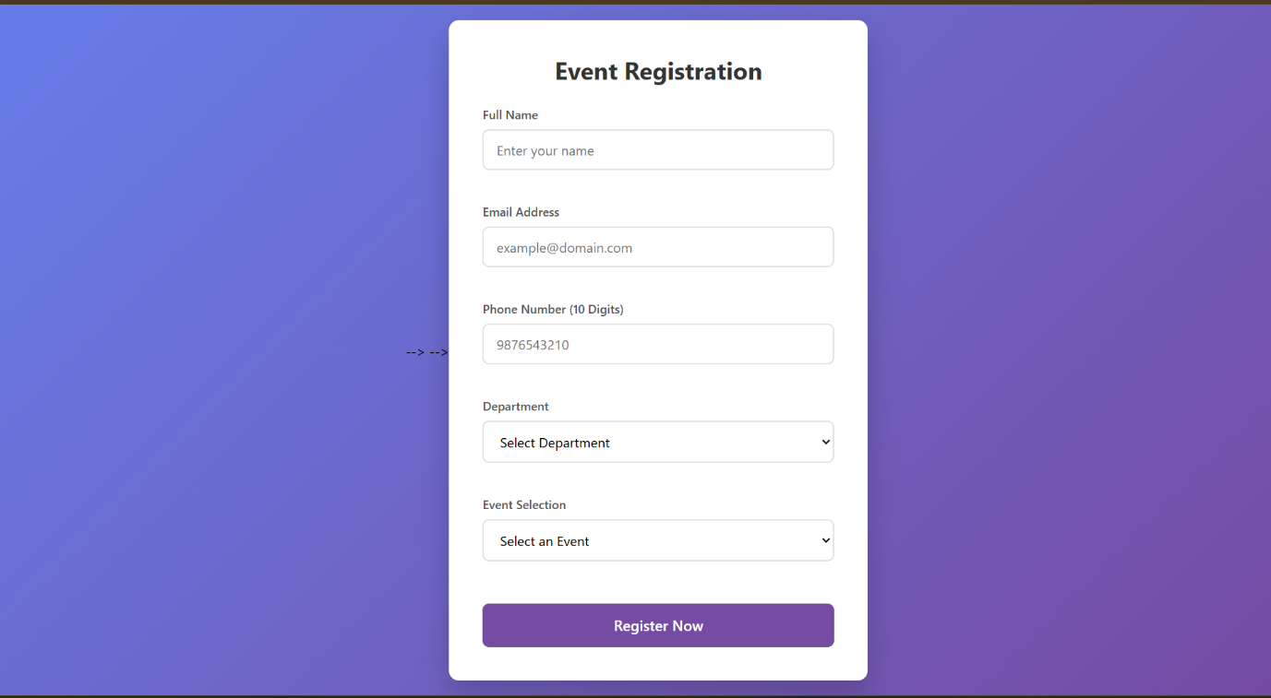

Explaination:
The HTML form collects user details like name, email, phone, department, and event in a simple layout.
CSS adds a background image and styles the form to make it clean, centered, and easy to read.
JavaScript validates inputs (email format, 10-digit phone, required fields) and prevents submission if data is invalid.
Task4:
Create an e-commerce product page with a grid layout using HTML and CSS.
Add JavaScript “Add to Cart” functionality with a cart counter at the top-right.
Include visual feedback when items are added and a background image.
Code:
<!DOCTYPE html>
<html>
<head>
<title>E-Commerce Product Page</title>

<style>
body {
font-family: Arial;
margin: 0;
background: url('https://images.unsplash.com/photo-1512436991641-6745cdb1723f') no-repeat center center fixed;
background-size: cover;
}

/* Cart Counter */
.cart {
position: fixed;
top: 15px;
right: 20px;
background: black;
color: white;
padding: 10px 15px;
border-radius: 20px;
font-size: 18px;
}

/* Product Grid */
.container {
display: grid;
grid-template-columns: repeat(auto-fit, minmax(200px, 1fr));
gap: 20px;
padding: 60px;
}

/* Product Card */
.card {
background: rgba(255,255,255,0.9);
padding: 20px;
text-align: center;
border-radius: 10px;
box-shadow: 0 0 10px gray;
}

button {
padding: 10px;
background: green;
color: white;
border: none;
cursor: pointer;
border-radius: 5px;
}

button:hover {
background: darkgreen;
}
</style>
</head>

<body>

<!-- Cart Counter -->
<div class="cart">🛒 <span id="count">0</span></div>

<!-- Product Catalog -->
<div class="container">

<div class="card">
<h3>Product 1</h3>
<p>₹500</p>
<button onclick="addToCart(this)">Add to Cart</button>
</div>

<div class="card">
<h3>Product 2</h3>
<p>₹700</p>
<button onclick="addToCart(this)">Add to Cart</button>
</div>

<div class="card">
<h3>Product 3</h3>
<p>₹900</p>
<button onclick="addToCart(this)">Add to Cart</button>
</div>

<div class="card">
<h3>Product 4</h3>
<p>₹1200</p>
<button onclick="addToCart(this)">Add to Cart</button>
</div>

</div>

<script>
let cartCount = 0;

function addToCart(btn) {
// Increase count
cartCount++;
document.getElementById("count").innerText = cartCount;

// Visual feedback
btn.innerText = "Added ✓";
btn.style.background = "gray";

// Reset after 1 second
setTimeout(() => {
btn.innerText = "Add to Cart";
btn.style.background = "green";
}, 1000);
}
</script>

</body>
</html>
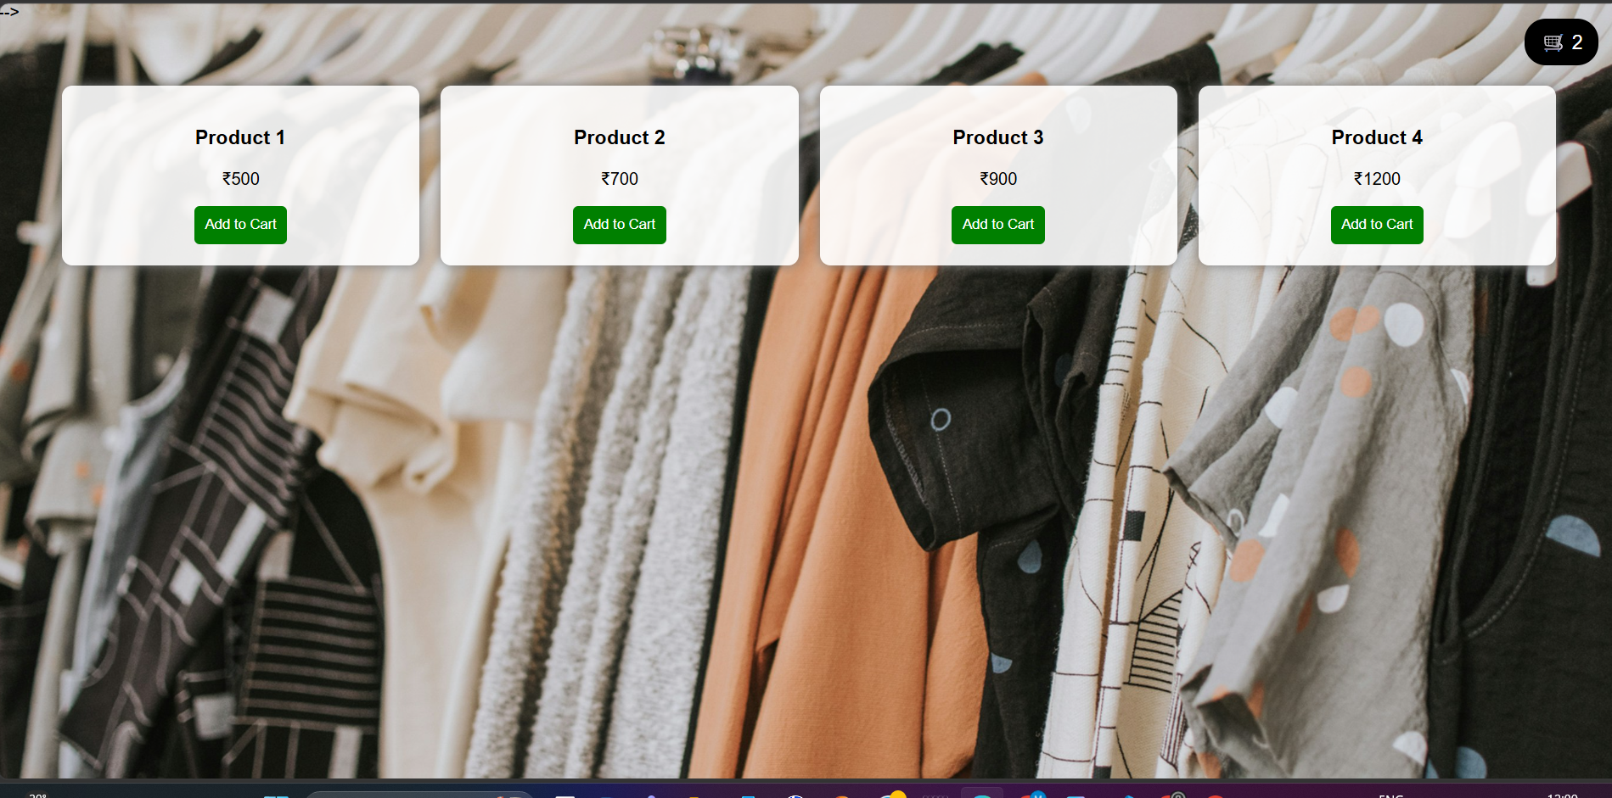

Explaination:
HTML creates a grid-based product catalog with cards and an “Add to Cart” button for each item.
CSS styles the layout, adds a background image, and positions the cart counter at the top-right corner.
JavaScript updates the cart count and gives visual feedback by temporarily changing the button when clicked.
Task5:
Prompt:
Create a responsive web page with header, navigation, main content, and footer using HTML and CSS.
Add responsive design using media queries for desktop, tablet, and mobile.
Include a background image without zoom and keep the layout clean and organized.
Code:
<!DOCTYPE html>
<html>
<head>
<title>Responsive Layout</title>

<style>
body {
margin: 0;
font-family: Arial;
background: url('https://images.unsplash.com/photo-1492724441997-5dc865305da7') no-repeat center center fixed;
background-size: 100% 100%; /* no zoom */
}

header {
background: black;
color: white;
padding: 15px;
text-align: center;
}

nav a {
color: white;
margin: 10px;
text-decoration: none;
}

.main {
display: flex;
padding: 20px;
}

.content {
flex: 3;
background: rgba(255,255,255,0.9);
padding: 20px;
margin-right: 10px;
}

.sidebar {
flex: 1;
background: rgba(200,200,200,0.9);
padding: 20px;
}

footer {
background: black;
color: white;
text-align: center;
padding: 10px;
}

/* Tablet */
@media (max-width: 768px) {
.main {
flex-direction: column;
}
}

/* Mobile */
@media (max-width: 480px) {
nav a {
display: block;
margin: 5px 0;
}
}
</style>
</head>

<body>

<header>
<h2>My Website</h2>
<nav>
<a href="#">Home</a>
<a href="#">About</a>
<a href="#">Contact</a>
</nav>
</header>

<div class="main">
<div class="content">
<h3>Main Content</h3>
<p>This is sample content for the webpage. It adjusts based on screen size.</p>
</div>

<div class="sidebar">
<h3>Sidebar</h3>
<p>Additional info or links</p>
</div>
</div>

<footer>
<p>© 2026 My Website | Contact: info@email.com</p>
</footer>

</body>
</html>
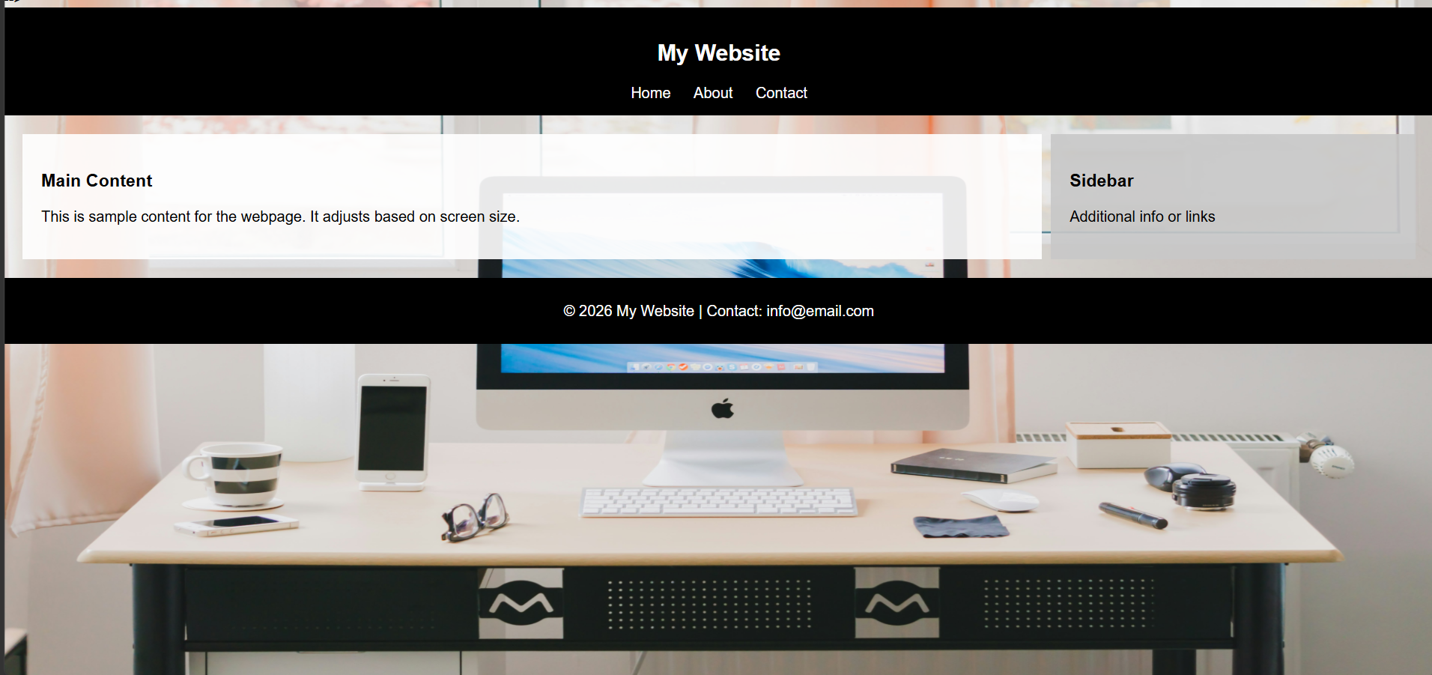
Explaination:
The HTML structure includes a header with navigation links, a main section (content + sidebar), and a footer for basic page layout.
CSS is used to style the layout, add a background image without zoom, and organize sections using Flexbox for a clean design.
Media queries make the page responsive, so it adjusts layout properly for desktop, tablet, and mobile screens.

