Assignment-15.5
Name:M.Ganesh Kumar
HTNO:2303A51358
Batch:20
Task1:
Prompt: Create a REST API using Express.js for student attendance.
Include GET, POST, PUT, DELETE endpoints.
Store data in an array.
Use JSON format for requests and responses.
Code: 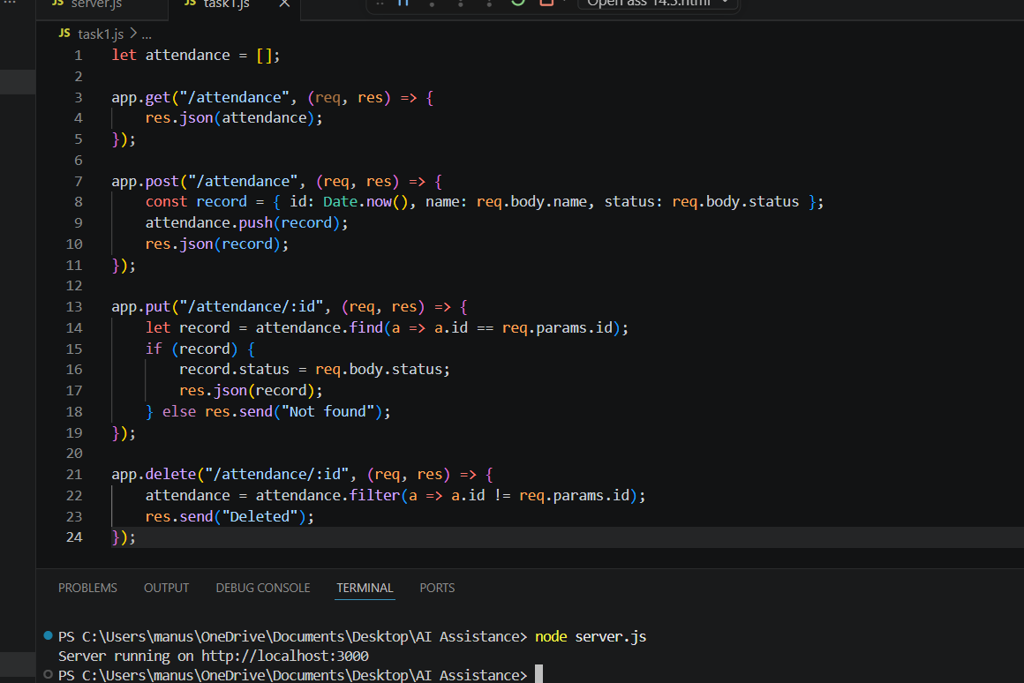
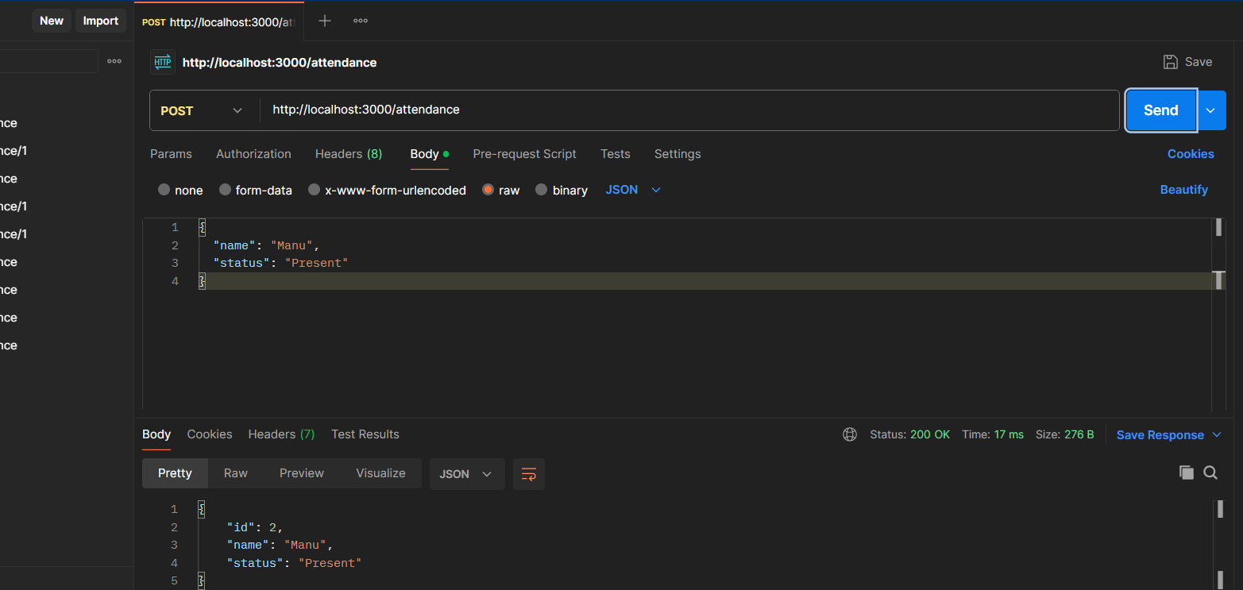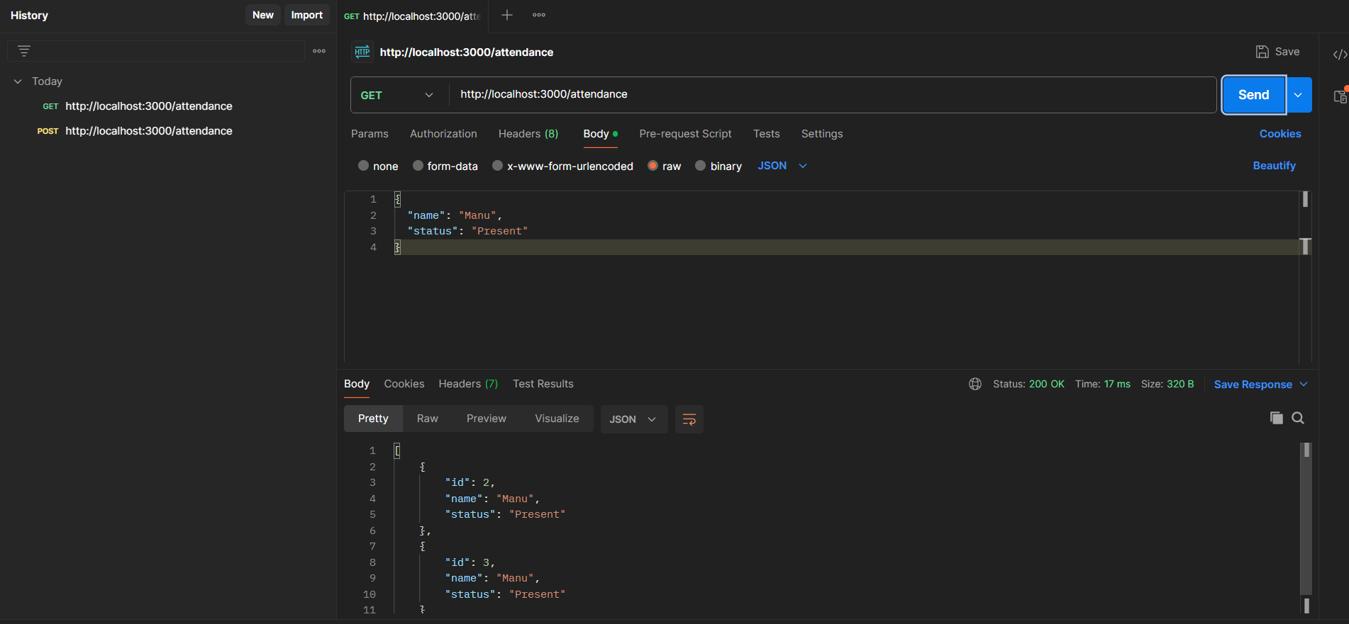
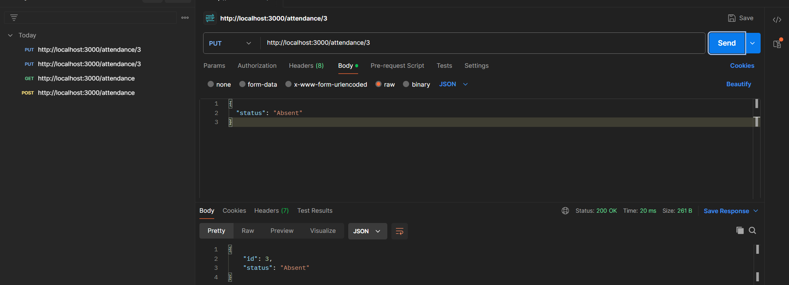

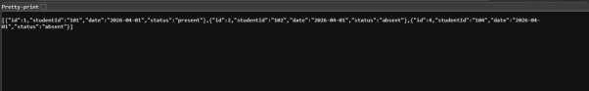
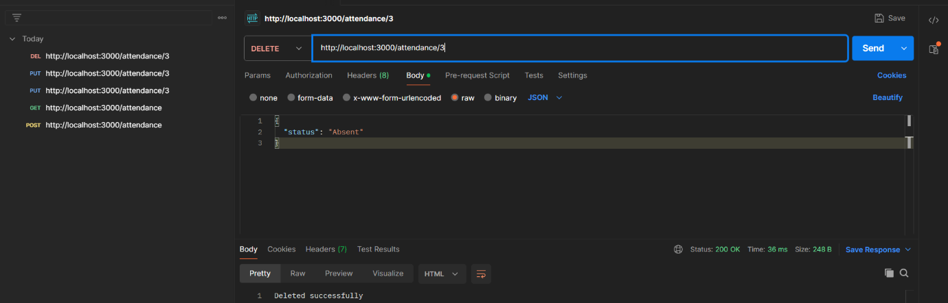
Observation:
The API performs CRUD operations on attendance records.
Data is stored in memory using an array.
Each request returns JSON response.
Endpoints work correctly for adding, updating, and deleting data.
Task2:
Prompt: The task is to develop a REST API for warehouse inventory management using Node.js and Express.
The API should provide endpoints to list all inventory items, add new items, update stock quantity, and delete items. The system should validate stock quantity and price values before updating the inventory. The API must handle JSON-based requests and responses for inventory operations.

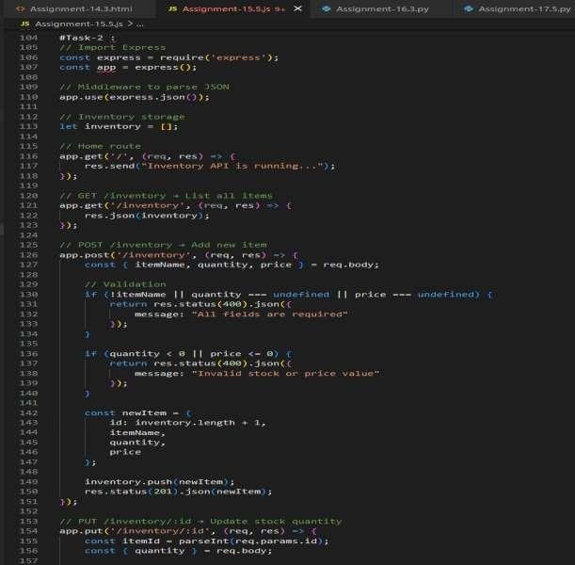 Output:
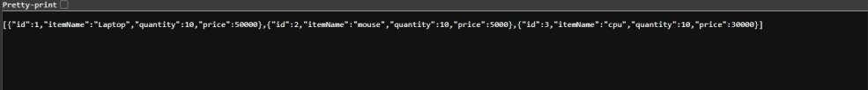
Observation:
This project demonstrates how REST APIs can be used to manage warehouse inventory and stock levels efficiently. It helps in understanding CRUD operations, data validation, and API development using Node.js and Express. The system ensures that invalid stock values are not entered through validation. This project is useful for learning backend development and inventory management systems.

Task 3:
Prompt: The task is to develop a RESTful API for hotel room booking using Node.js and Express. The API should allow users to view available rooms, book a room, view booking details by room ID, and
cancel bookings. The system should handle errors such as booking unavailable rooms or invalid room IDs. The API must use JSON-based request and response handling.
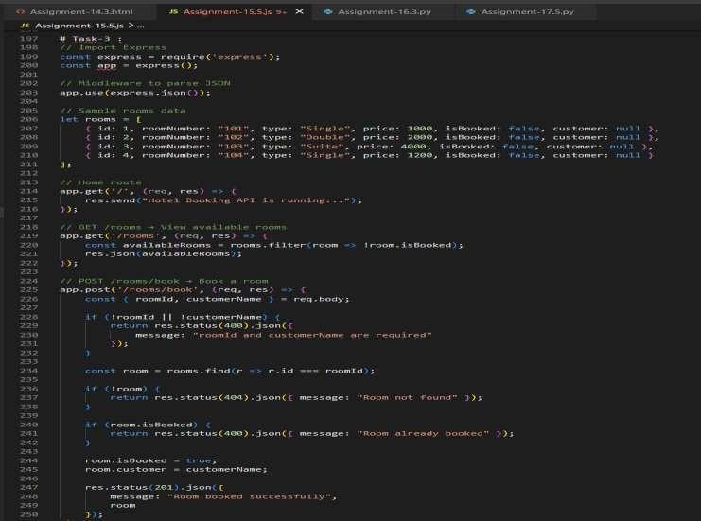
Output:
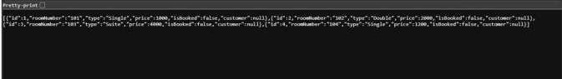
Observation:
This project demonstrates how RESTful APIs can be used to simulate hotel room booking operations. It helps in understanding API routing, booking logic, and error handling in backend development. The system ensures that rooms cannot be double booked and handles invalid booking requests. This project is useful for learning real-world booking system API development using Node.js and Express.

Task4:
Prompt: The task is to create a RESTful API for an online voting system using Node.js and Express. The API should allow users to view the list of candidates, cast a vote, and view voting results. The system must ensure that each user can vote only once using in-memory validation. The API should handle JSON-based requests and responses for voting operations.
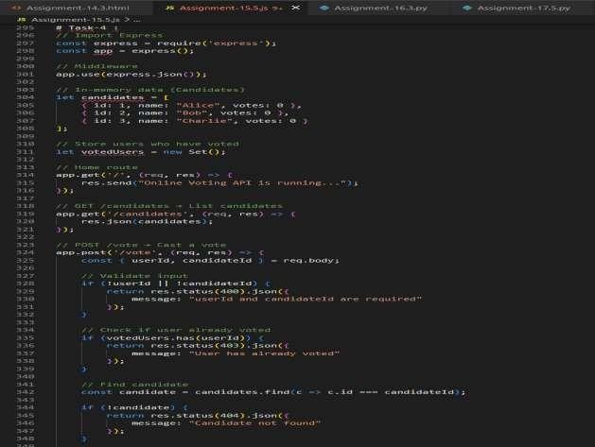
Output:
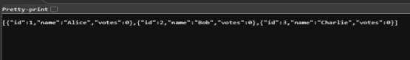

Observation:
This project demonstrates how RESTful APIs can be used to implement an online voting system with basic security validation. It helps in understanding API development, data validation, and preventing duplicate voting using in-memory storage. The system simulates a secure voting process and result calculation. This project is useful for learning backend API development and voting system logic.
Task5:
Prompt: The task is to develop a RESTful API to manage teacher records using Node.js and Express.
The API should allow users to list all teachers, add new teacher records, update teacher details, and
delete teacher records. The system must handle JSON-based requests and responses and include proper error handling for invalid teacher IDs or missing data. The API should support CRUD operations for teacher management.
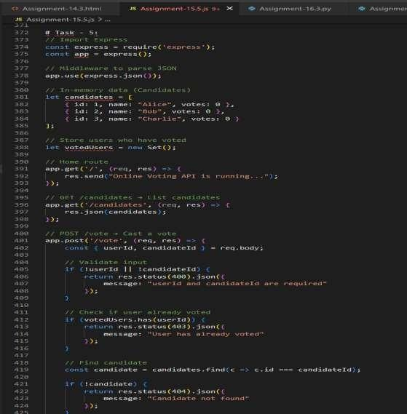

Output:
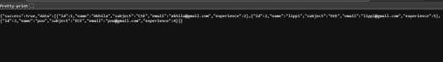
Observation:
This project demonstrates how RESTful APIs can be used to manage teacher information using CRUD operations. It helps in understanding API routing, JSON data handling, and error handling in backend development. The system allows efficient management of teacher records such as adding, updating, and deleting information. This project is useful for learning backend API development and data management systems.

