SIMATS ENGINEERING
ASSESSMENT TOOL 2

COURSE NAME: INTERNET PROGRAMMING
COURSE CODE: CSA43

COURSE OUTCOME COVERED

CO -2 : Apply CSS layout and styling techniques to create visually appealing and responsive web interfaces, and use JavaScript to enable interactive client-side behavior. (L3)
Assessment Tool : Design Task
Weightage: 20%

Name: A. Ganesh Kumar Reddy
Reg.No: 192372352

Question 1: Responsive Navigation Bar
Responsive navigation bars adapt to desktops, tablets, and mobiles using Flexbox and media queries.
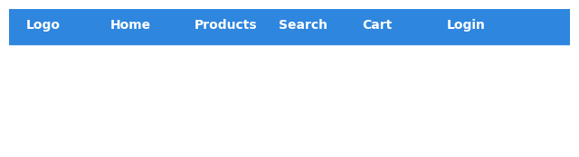
Explanation: This illustration supports the design concept described in the answer.

Question 2: Product Hover Effect
Hover effects use CSS transitions, transforms, shadows, and opacity for better interaction.
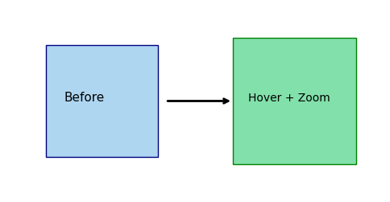
Explanation: This illustration supports the design concept described in the answer.

Question 3: CSS Grid Dashboard
CSS Grid is ideal for dashboard layouts with rows and columns.
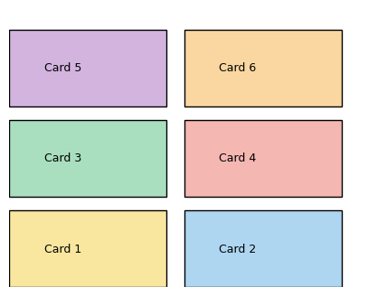
Explanation: This illustration supports the design concept described in the answer.

Question 4: Mobile-First Blog
A mobile-first layout begins with a single column and expands using media queries.
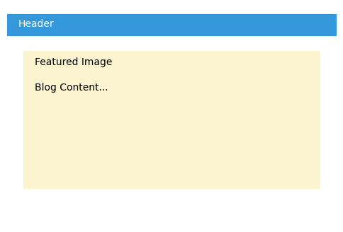
Explanation: This illustration supports the design concept described in the answer.

Question 5: Dynamic Menu
JavaScript click events toggle the hamburger menu for mobile devices.
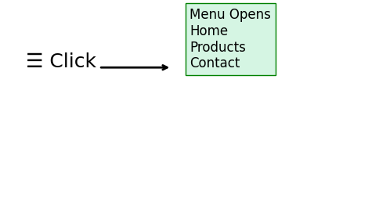
Explanation: This illustration supports the design concept described in the answer.

Conclusion
The assessment demonstrates responsive web design using CSS Flexbox, CSS Grid, animations, media queries, and JavaScript event handling.

