**Benchmark File Structure**



Source code for each benchmark is located in their specific folder

**CPU Benchmark Execution**

To execute Linpack CPU benchmark

* Change directory to CPU/linpack/
* ./runme_xeon64

Which performs the linpack benchmark with the input parameters as

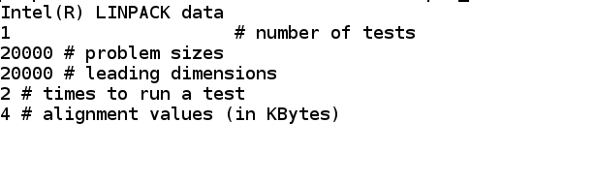

To execute our CPU benchmark manually by giving command line inputs

* Change directory to CPU/
* ./test <IOPS/FLOPS> <2><no_threads>
  + Example: ./test 1 2 8 for executing cpu benchmark for **IOPS with 8 threads**

*NOTE: second parameter 2 is a dummy here left for future enhancements*

To execute our pre- written script

* Change directory to CPU/
* ./release.sh

This will perform the following operations

