**Cart**

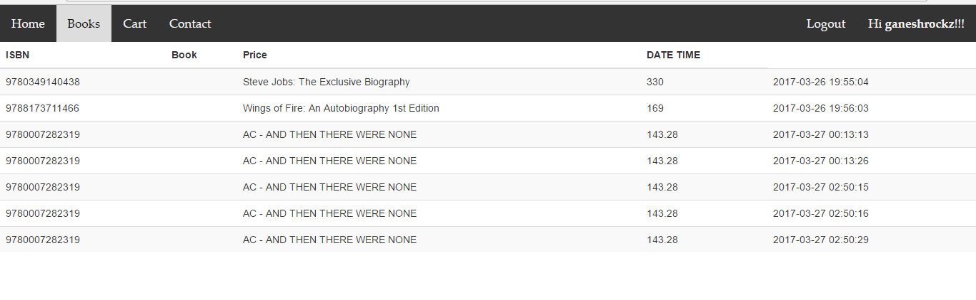

**Conformation Page**

