Procedures/Functions

The project uses various inbuilt mysql/php procedures for the manipulation of the data in database. One such procedure is used add dates to form a new date in the **shipment** relation.

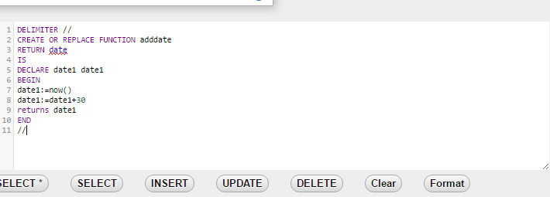

The adddate() function adds a particular scalar value to the present system date which is used to find the expected delivery date of the product in the shipment relation.

Also the php inbuilt procedure, **mysqli_fetch_rows($sql)** is used to find the number of rows returned by a particular query.