**OrderDetails**



**Review**

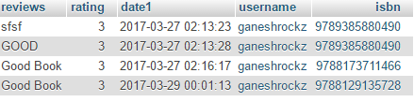

**Shipment**

