**PROJECT WORK REPORT**

**CERDIT CARD VALIDATOR(BY USING C++)**

Submitted in partial fulfillment of the Requirements for the award of

**DIPLOMA IN COMPUTER ENGINEERING**

**Name and Pin No : K. Mallikarjuna (21242-cm-016)**

**S. Mohammad (21242-cm-028)**

**Y. Shiva (21242-cm-032)**

**I. Maheedhar Reddy (21242-cm-012)**

**L . Manohar Reddy(21242-cm-017)**

**UNDER GUIDANCE OF:**

**DRAKSHAYANI**



**SUBMITTED TO:**

**DEPARTMENT OF COMPUTER ENGINEERING**

**SRI VENKATESA PERUMAL COLLEGE OF ENGINEERING & TECHNOLOGY**

**II Shift Polytechnic**

**An ISO 9001:2000 certified institute,Affiliated to SBTET ,Vijaywada,Approved by AICTE**

**Chinnarajakuppum,RVS Nagar,KN Road ,puttur-517583**

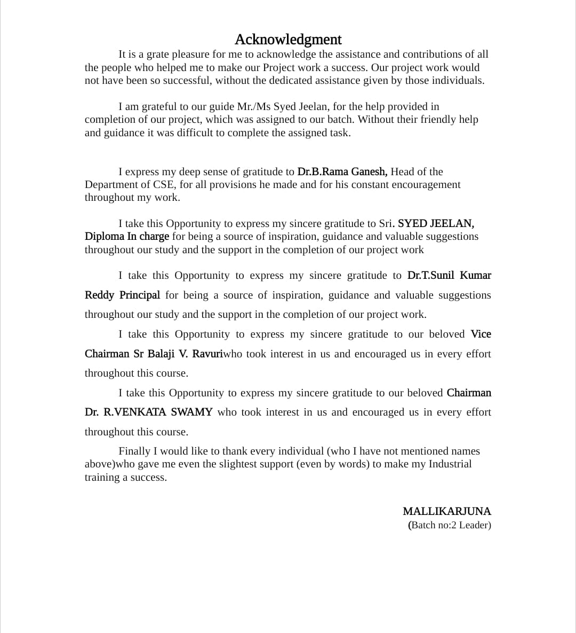

**CERTIFICATE**

This is to certify that the dissertation entitled "**CREDIT CARD VALIDATOR**", that is being submitted by BATCH NO:-2, as a Students of Diploma in Computer Engineering to the State Board of Technical Education & Training, vijaywada is a bonafide work carried out by him under my guidance and supervision during the year 2022-2023. The results embodied in this thesis have not been submitted to any other University or Institute for the award of any Diploma.

**Batch Members:- S.Mohammad(21242-cm-028)**

**Y.siva(21242-cm-032)**

**I. Maheedhar Reddy(21242-cm-012)**

**K. Mallikarjuna(21242-cm-016)**

**L. Manohar Reddy(21242-cm-017)**

**HEAD OF THE DEPARTMENT PRINCIPAL**

**(Dr.T.SUNIL KUMAR REDDY)**

**Abstract**

The Luhn algorithm is the first line of defense in many e-commerce sites and is used to validate a variety of identification numbers such as credit card numbers. Nevertheless, many card numbers exist and at such volumes, the algorithm cannot distinguish among these numbers. A variety of tests show that the Luhn algorithm suffers from weaknesses including the failure to determine the length and type of credit card number being analyzed. We intend to enhance the Luhn algorithm for the validation of credit card numbers. The enhancement is expected to be useful for many e commerce sites that use the algorithm.

Keyword- Security; Luhn algorithm; Credit Card Number Validation; Visa card Validation; JCB number Validation.

|  |  |
| --- | --- |
| S.NO | TABLE OF CONTENTS |
| 1 | INTRODUCTION |
| 2 | LUHN ALGORITHM |
| 3 | REAL TEST FOR LUHN ALGORITHM |
| 4 | FLOW CHART FOR LUHN ALGORITHM |
| 5 | SOURCE CODE |
| 6 | RESULT |
| 7 | CONCLUSION |
| 8 | REFERENCES |

CHAPTER 1: INTRODUCTION

Credit cards are the most frequenly med payment method, accounting about 95% of all line transactions; these are the primary means of payment for goods and services purchased online[1]. With increasing red card tee on the hormet comes dramatic increase in credit card fraud Tying emin are of the most comes that occur when temps type live it can be over the dedicated or on an e-commerce site. An example is when the key hit intrad of "T" A general credit, and mann Fig 1) uf an industry ID or major industry shifter (MIC dgir ID (digos, accent member (Vigent and checksum come dign) The Mlps the D I called the bouer kaftionumber (IN) or hack demification number (BIN), as defined in IEC 7913-1993 [31. MasterCandles 16 digits and its IN starts with 5, Visa card has 16 digits with an IN the stars with 4 and Japan Credit Bureau (JCB has digns and its Narts with 3-4-6)

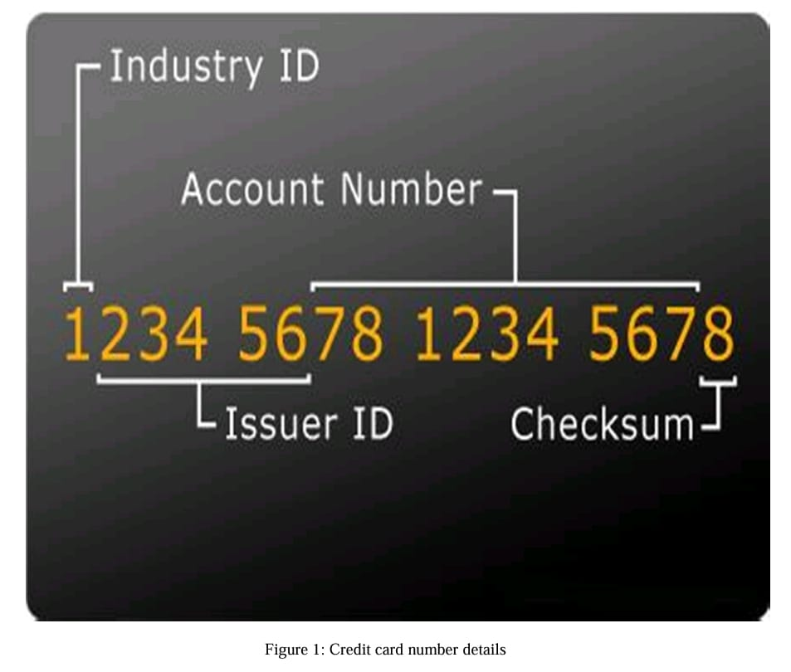

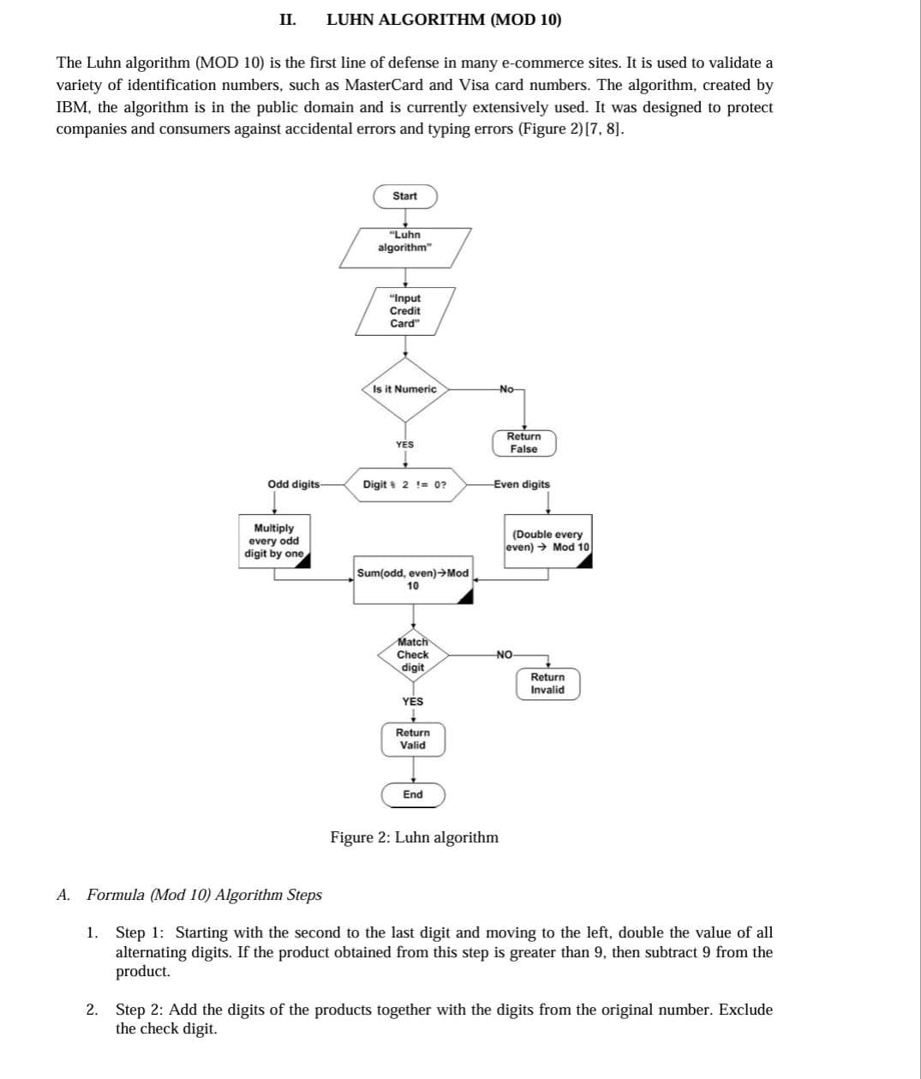

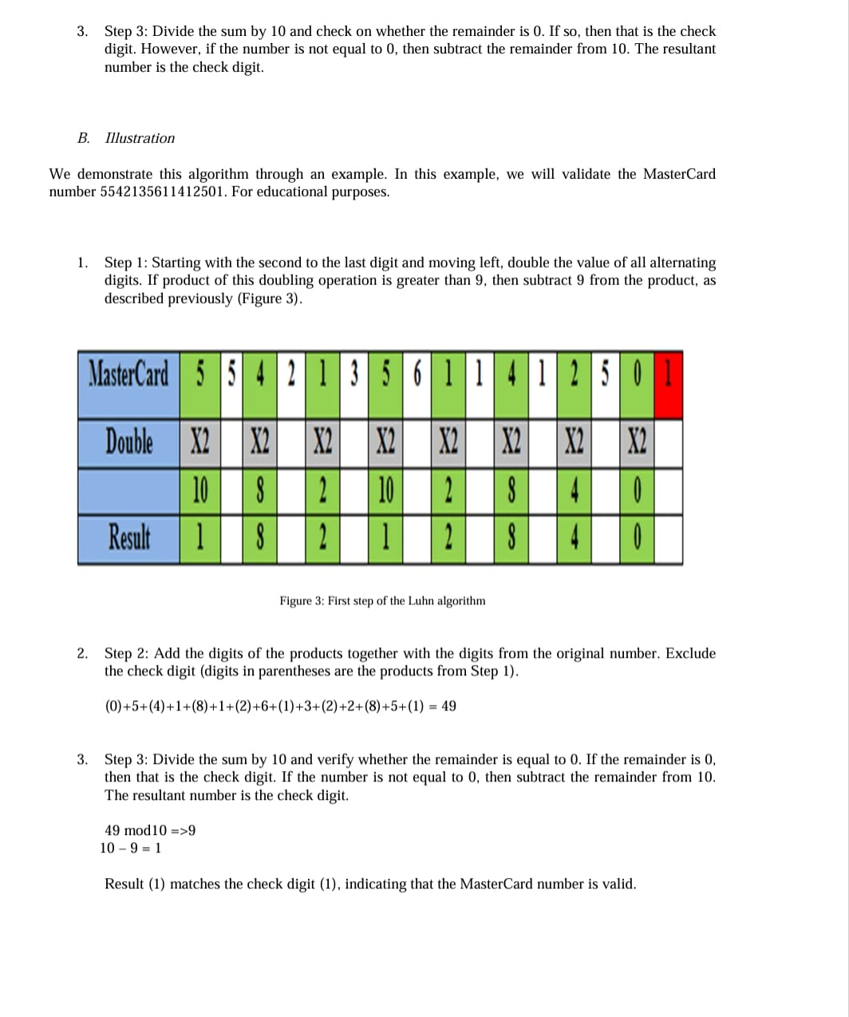

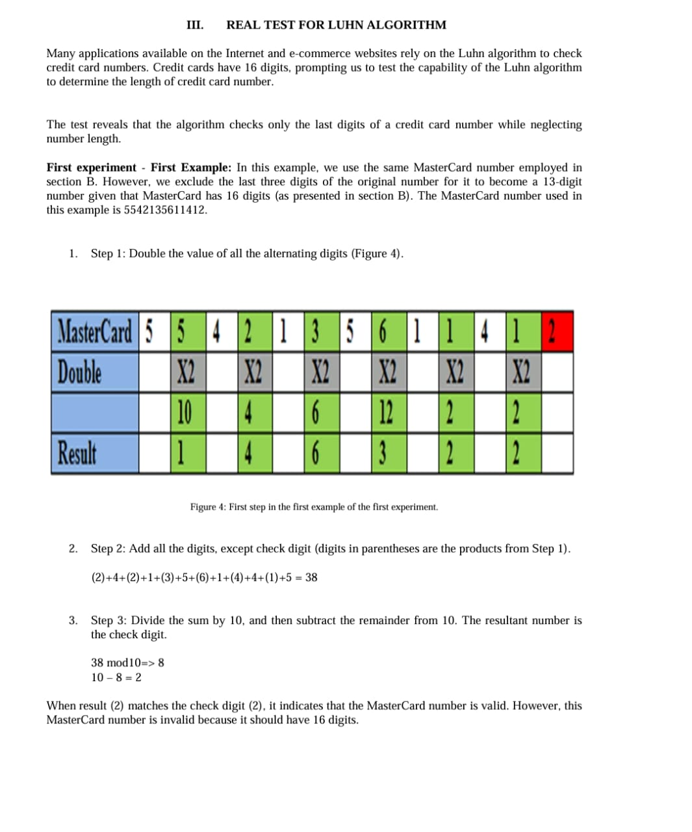

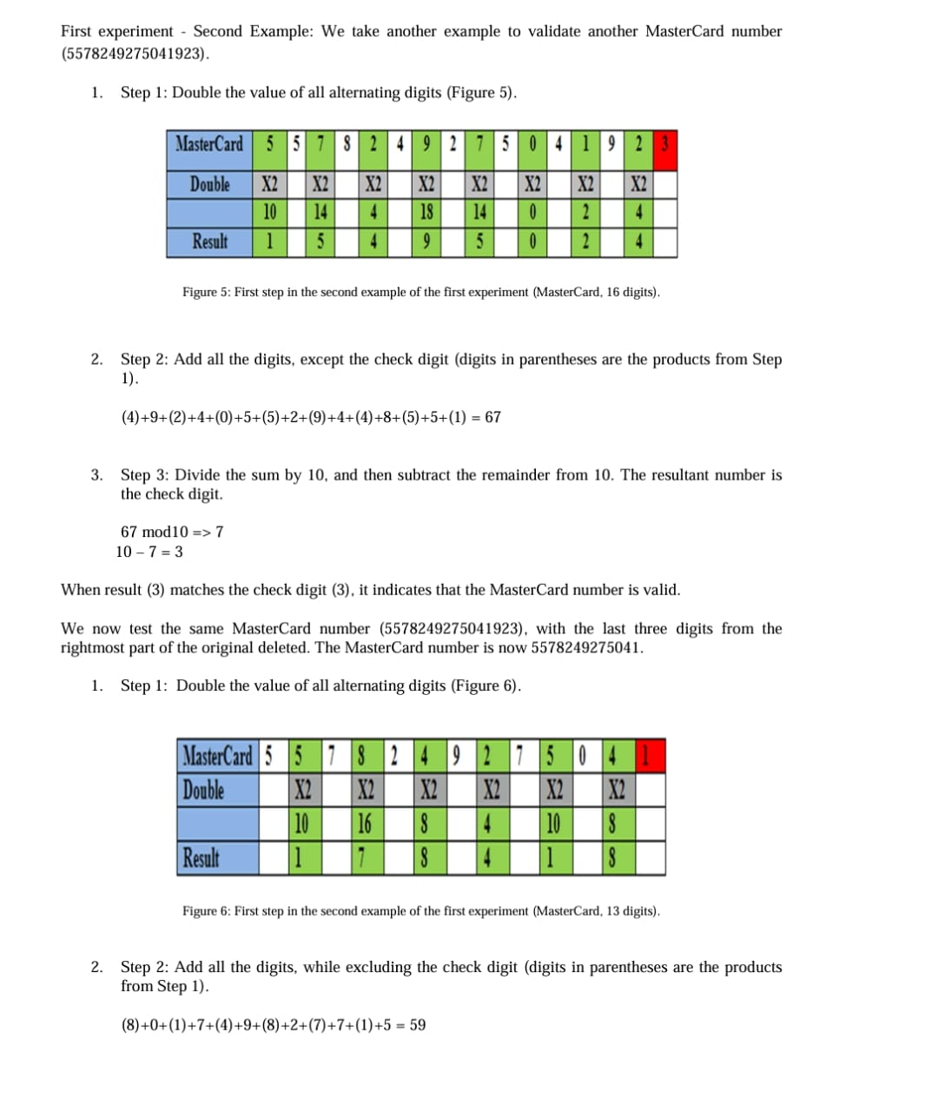

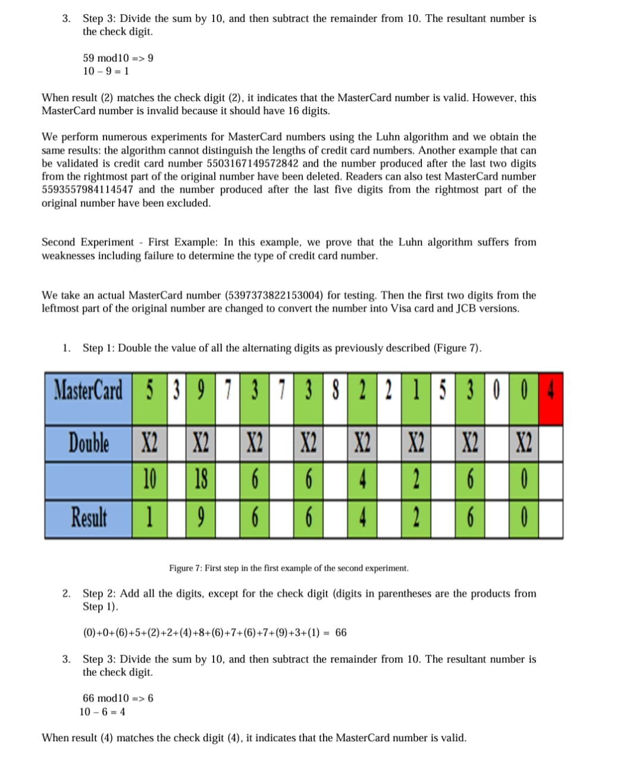

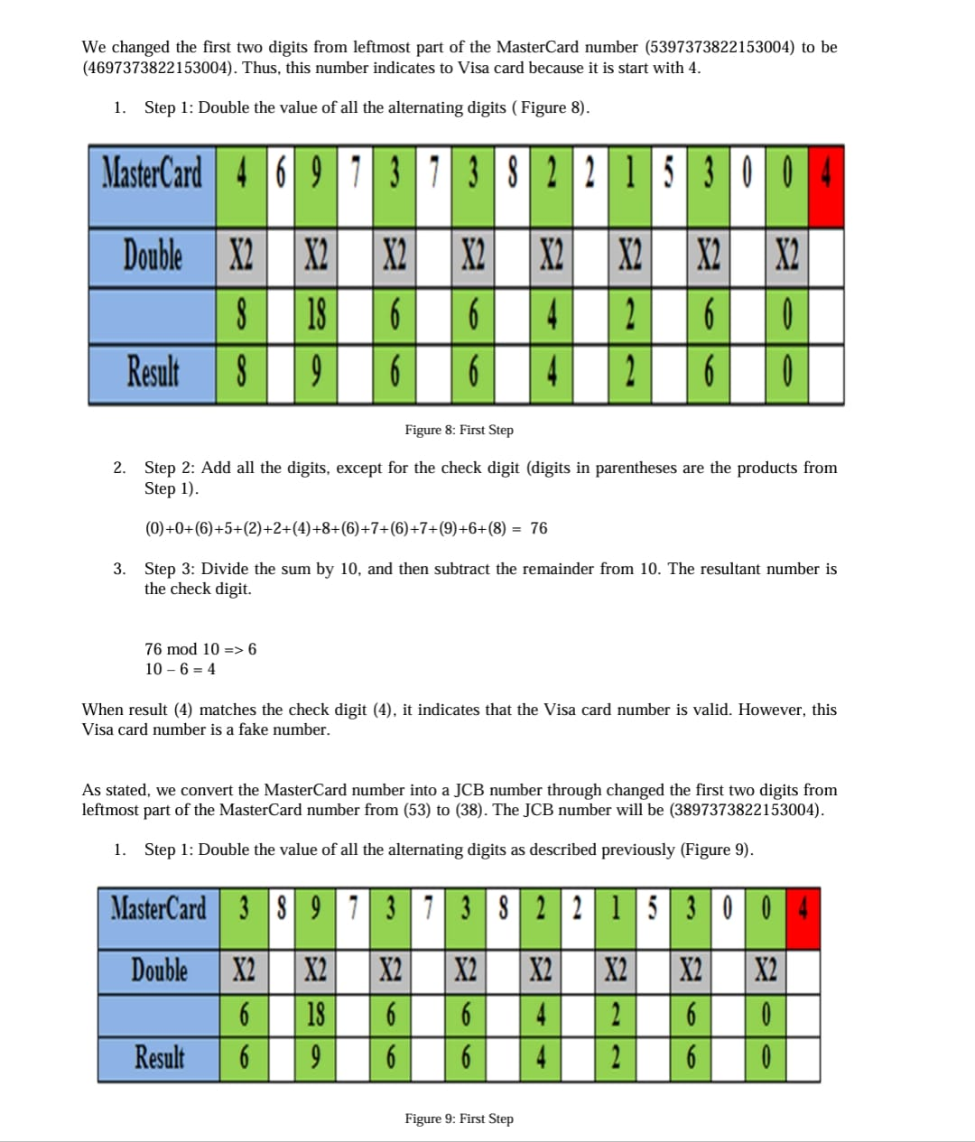

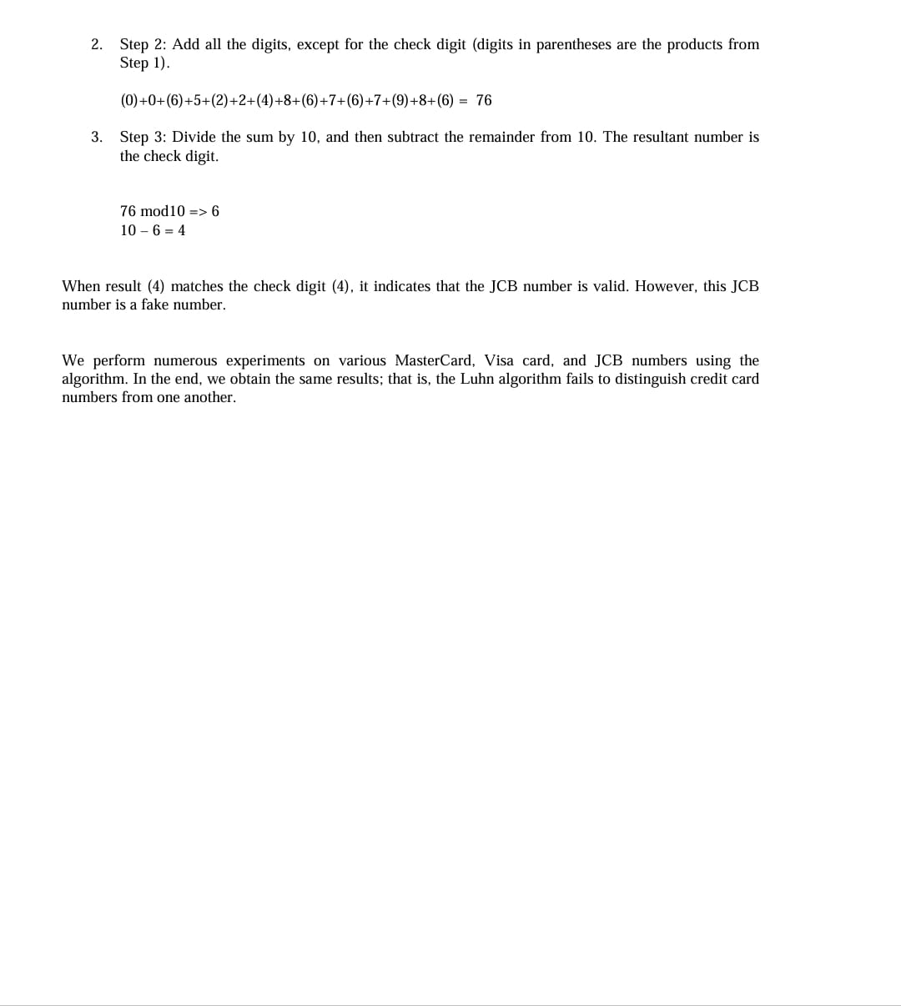

**SOURCE CODE**:

#include <stdio.h>

#include <iostream>

#include <string>

using namespace std;

bool isNumberString(const string& s) {

int len = s.length();

for (int i = 0; i < len; i++) {

if (s[i] < '0' || s[i] > '9')

return false;

}

return true;

}

int main() {

string ccNumber;

while (true) {

cout << "Please enter a CC number to validate: ";

cin >> ccNumber;

if (ccNumber == "exit")

break;

else if (!isNumberString(ccNumber)) {

cout << "Bad input! ";

continue;

}

int len = ccNumber.length();

int doubleEvenSum = 0;

for (int i = len - 2; i >= 0; i = i - 2) {

int dbl = ((ccNumber[i] - 48) * 2);

if (dbl > 9) {

dbl = (dbl / 10) + (dbl % 10);

}

doubleEvenSum += dbl;

}

for (int i = len - 1; i >= 0; i = i - 2) {

doubleEvenSum += (ccNumber[i] - 48);

}

cout << (doubleEvenSum % 10 == 0 ? "Valid!" : "Invalid!") << endl;

continue;

}

return 0;

}

**EXAMPLE CREDIT CARD:**

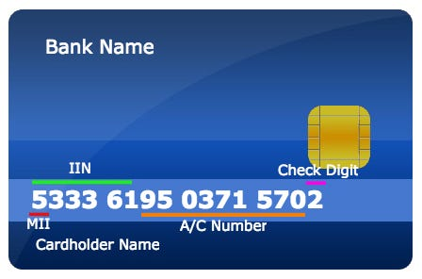

**RESULT:**

**Please enter a CC number to validate: 1234**

**Invalid!**

**Please enter a CC number to validate: 5333619503715702**

**Valid!**

**CHAPTER V. CONCLUSION**

The Luhn algorithm is widely used on the Internet to validate of credit card numbers, but this algorithm suffers from weaknesses, as confirmed by tests. We conducted two types of experiments for different credit card numbers. Some of these experiments and examples have been presented in this paper. We also included our improvements to the algorithm. In our future work, we will validate the performance of the Luhn algorithm in checking ID card numbers a more important factor, especially for websites that analyze ID card numbers to ensure non-repudiation of users or customers.

**REFERENCES**

[1] Paul Tucker, Innovations in retail payments, 2012, Committee on Payment and Settlement Systems. p. 96.

[2] Hetvi Modi, et al., Fraud Detection in Credit Card System Using Web Mining. International Journal of Innovative Research in Computer and Communication Engineering., 2013. 1(2): p. 175- 179.

[3:34 pm, 16/11/2023] mohammad: [3] David Addison. Anatomy of a credit card number and the utility of the BIN. 2011 [cited 2013. 24/June): Available from: http://www.dirigodev.com/blog/ecommerce/anatomy of a credit card number/

Asia News, et al., JCB WORLD REPORT, 2008 p. 8. HSBC Bank, JCB Gold Card Cardholder 2010. p. 20. 151

[6]

Professor Marshall, Introduction to How Credit Cards Work. 2006 22 Feb 2013 [cited 2013 25

June): Available from: http://money.howstuffworks.com/personal-finance/debt-

management/credit-card1.htm/printable. Chi Yuan Li and Zhi Qiang Yao, The Validation of Credit Card Number on the Wired and 171

Wireless Internet. Journal of Networks, 2011. 6: p. 432-437. Yao Zhiqiang, LI Chiyuan, and T. Huixian.. The Application of Credit Card Number Validation Algorithm on the Wired and Wireless Internet 2010, IEEEXplore: Ternopil, p. 1-4. 18