**Analyzing Customer Purchase Behavior for OLA**

Report submitted in partial fulfillment of the requirement for the degree of



B.Tech

In

Computer Science and Engineering

UNDER THE SUPERVISION OF

**Ms. JYOTI MISHRA**

**Maharana Institute Of Professional Studies , Kanpur**

**Dr. A.P.J Abdul Kalam Technical University, Lucknow Session :- 2024-25**

**DECLARATION**

This is to certify that Synopsis Report Entitled “**Analyzing Customer Purchase Behavior for OLA**” which is submitted in partial fulfillment of the requirement for the award of degree B.Tech. in Computer Science and Engineering to MPEC Kanpur, Dr. A.P.J. Abdul Kalam Technical University, Lucknow comprises only original work and studies carried out by students himself. The matter embodied in this synopsis has not been submitted for the award of any other degree.

**Date:**  **Students Name:**

Ganesh Tiwari (2203490100032)

Gaurav Gupta (2203490100033)

Om Dubey (2203490100057)

**Approved By:**

**Signature Signature**

Ms. JYOTI MISHRA Dr. Pankaj Singh Yadav

Project Guide Head of CSE

CSE Department Department

MIPS, Kanpur MIPS, Kanpur

# ABSTRACT



In today's competitive ride-sharing market, understanding customer purchase behaviour is crucial for companies like Ola to maintain and expand their market share. This study aims to Analyze the various factors influencing customer purchase decisions, preferences, and satisfaction levels with Ola's services. By examining key aspects such as service quality, pricing strategies, convenience, brand loyalty, and the impact of technological advancements, this research provides insights into the motivations and barriers affecting customer choices. Through a comprehensive review of existing literature, this study highlights trends and patterns in consumer behaviour, offering valuable recommendations for enhancing customer experience and fostering long-term loyalty in the dynamic ride-sharing industry.

**TABLE OF CONTENTS**

**TOPIC PAGE**

Chapter 1: Introduction 1

Chapter 2: Objective 2

Chapter 3: System Requirement 3

3.1 Software Requirements

3.2 Hardware Requirements

Chapter 4: Workflow 4

Chapter 5: Literature Review 5

Chapter 6: Technology Used 6

Chapter 7: Output 7

Chapter 8: Conclusion 10

Chapter 9: Future Scope 11

Chapter 10: Reference 12

Chapter 11: Appendix 13

**CHAPTER 1 : INTRODUCTION**

In the rapidly evolving ride-hailing industry, understanding customer purchase behavior is crucial for companies like Ola to maintain a competitive edge and foster customer loyalty. This analysis focuses on deciphering the complex patterns and trends in customer behavior, which are influenced by a multitude of factors including demographics, pricing strategies, service quality, and promotional activities.

The primary aim of this study is to delve into the behavioral aspects that drive customers to choose Ola over other competitors. By analyzing various data points such as frequency of rides, peak usage times, and response to promotional offers, we can uncover significant trends that inform strategic decision-making. This understanding enables Ola to tailor its services to meet the diverse needs of its customer base, enhance user satisfaction, and increase market share.

Technological advancements and the growing influence of digital platforms have transformed the way customers interact with ride-hailing services.Therefore, it is imperative to understand both online and offline behaviors to gain a comprehensive view of the customer journey. This study will employ a blend of quantitative data analysis and qualitative research methods to capture the full spectrum of customer experiences and preferences.

Furthermore, this analysis will highlight the impact of socio-economic factors, geographical variations, and emerging market trends on customer behavior. By leveraging these insights, Ola can innovate and adapt its offerings to better serve its customers, ensuring a seamless and rewarding experience.

In summary, this study aims to provide actionable insights into customer purchase behavior, enabling Ola to refine its strategies, enhance customer satisfaction, and achieve sustainable growth in a highly competitive market.

**CHAPTER 2 : OBJECTIVE**

The primary objective of this project is to conduct an exhaustive data analysis of Ola's operational metrics, with a focus on the following key aspects:

* **Overall Performance Analysis:** Examine the overall trends and patterns in Ola's operational data, including metrics such as total rides, revenue, and customer base.
* **Vehicle Type Analysis:** Investigate the performance of different vehicle types (e.g., Micro, Mini, Sedan, Prime) in terms of demand, revenue, and customer satisfaction.
* **Revenue Analysis:** Analyze Ola's revenue streams, including the impact of pricing strategies, promotional offers, and seasonal fluctuations.
* **Cancellation Analysis:** Examine the reasons behind ride cancellations, including the impact of driver availability, traffic conditions, and customer behavior.
* **Rating Analysis:** Investigate the factors influencing customer ratings, including driver behavior, ride quality, and customer support.
* **Geospatial** **Analysis:** Examine the spatial distribution of Ola's operations, including the identification of high-demand areas, traffic hotspots, and optimal driver allocation.
* **Time-Series Analysis:** Analyze the temporal patterns in Ola's operational data, including the impact of seasonal fluctuations, holidays, and special events.
* **Driver Performance Analysis**: Investigate the factors influencing driver performance, including metrics such as acceptance rate, cancellation rate, and customer satisfaction.
* **Customer Segmentation Analysis:** Examine the characteristics of Ola's customer base, including demographic profiles, ride behavior, and loyalty patterns.
* **By achieving these objectives:** this project aims to provide actionable insights and recommendations to enhance Ola's operational efficiency, improve customer satisfaction, and drive business growth."

**CHAPTER 3 : SYSTEM REQUIREMENTS**

**3.1-Hardware Requirements :-**

* Processor: - Intel Pentium 4 or Above
* Hard Disk: - 128GB or more
* RAM: - 4GB or more
* Printer: - Any
* Monitor: - SVGA Color Monitor (Touch Screen or Simple)
* Pointing Device: - Touch Pad or Keys

**3.2-Software Requirements :-**

* Operating System: - Microsoft Windows 10 or above.
* Language : SQL, Statical Mathematic, PowerBI, MS Excel, Probability.
  + - Application Software : MS PowerBI, MS Excel etc.

**CHAPTER 4: WORKFLOW**

**1.Data Cleaning (Excel)]GH**

* Removed duplicates and filled missing/null values.
* Standardized column formats for consistency.

**2.SQL Analysis**

* Addressed critical questions such as:
* Retrieve successful bookings and calculate total revenue.
* Analyze ride distances and ratings by vehicle type.
* Identify reasons for cancellations (customer vs. driver).
* Highlight top customers by bookings and revenue.
* Compare customer and driver ratings for completed rides.

**3.Power BI Dashboards**

Designed 10 interactive dashboards across five categories:

1. Overall Insights:

* Ride volume trends over time.
* Booking status distribution.

1. Vehicle Type:

* Top 5 vehicle types by ride distance.
* Average customer ratings by vehicle type.

1. Revenue: Revenue breakdown by payment method.

* Top customers by total booking value.

1. Cancellations:

* Reasons for cancellations by customers and drivers.

1. Ratings:

* Distribution of customer and driver ratings.

**CHAPTER 5: LITERATURE REVIEW**

The call taxi industry in India has experienced significant growth in recent years, driven by factors such as infrastructure development, growth of the middle class, increasing disposable incomes, and rising GDP (Rahman, 2014). The expansion of the BPO industry, with its odd working hours, has also contributed to the growth of this sector.

Studies have shown that the growth of the call taxi industry is more pronounced in metropolitan cities in India (Rahman, 2014). The market is highly competitive, with various operators such as Ola, Uber, Radio Cabs, Yellow Cabs, and Meru vying for market share.

To sustain in this competitive market, it is essential to understand the needs and preferences of users of rental cab services. Several studies have investigated the factors that influence the choice of rental cars. For instance, Peng et al. (2014) found that call taxi apps (CTAs) enhance perceived usefulness, ease of use, playfulness, and subjective norms.

Other studies have highlighted the importance of convenience, reliability, and affordability in the context of taxi services. Chen (2014) noted that CTAs facilitate the tracing of users and service providers, making the service more convenient. Luet al. (2015) found that self-service mobile technologies empower commuters by providing them with access to a wealth of information.

Research has also explored the impact of driver behavior on customer satisfaction. Horsu and Yeboah (2015) discovered that driver behavior has a negative correlation with customer satisfaction in Ghana. In contrast, continuous service, comfort, reliability, and affordability were found to have a positive impact on customer satisfaction.

**CHAPTER 6: TECHNOLOGY USED**

**SQL for Data Extraction & Preparation:** We begin by teaching you how to use SQL to query large datasets, clean and prepare data efficiently, and handle complex data structures. You'll learn practical techniques to solve real-life data challenges and gain confidence in working with relational databases.

**Excel for Data Analysis:** Once the data is extracted, we move to Excel for deeper analysis. From data sorting and pivot tables to advanced formulas, you’ll discover how to perform meaningful data interpretation and summarization. This phase highlights Excel's versatility in handling various analytical tasks.

**Power BI for Dashboard Creation:** Finally, we show you how to transform your insights into impactful visual stories using Power BI. You’ll learn to create an interactive and visually appealing dashboard that communicates key findings effectively, making complex data accessible to stakeholders.

Throughout this project, you'll acquire crucial data analytics skills and understand the workflow of a complete data project, from raw data to compelling visualization. This comprehensive guide ensures you walk away with a holistic understanding of the tools and techniques required for data analytics success.

This Project provides invaluable insights into data extraction, transformation, visualization, and reporting. Where the prediction and future outcome for business in Analyze using the SQL relational data and Data Visualization using the SQL(RDMS),MS Excel and MS PowerBI for Betterment of business and make task easy for analyzing the report and data of the companies.

**CHAPTER 7: OUTPUT**

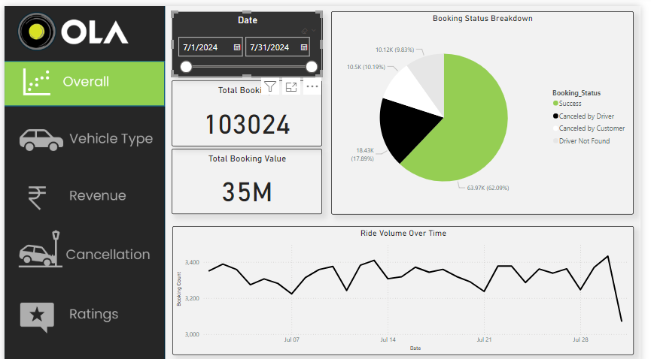

Fig-7.1:Screenshot 1

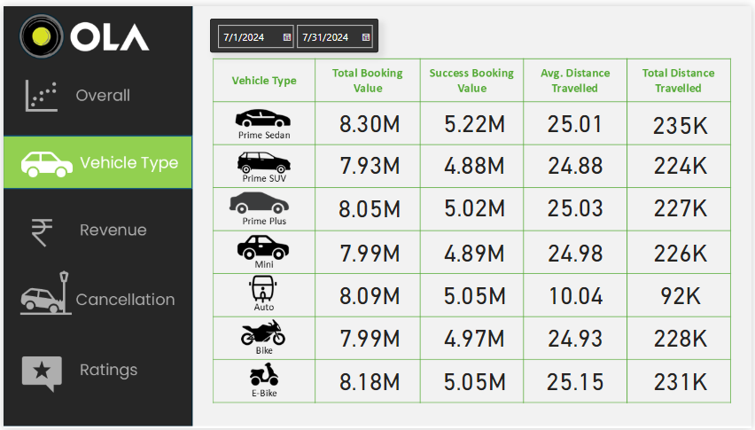

Fig-7.2:Screenshot 2

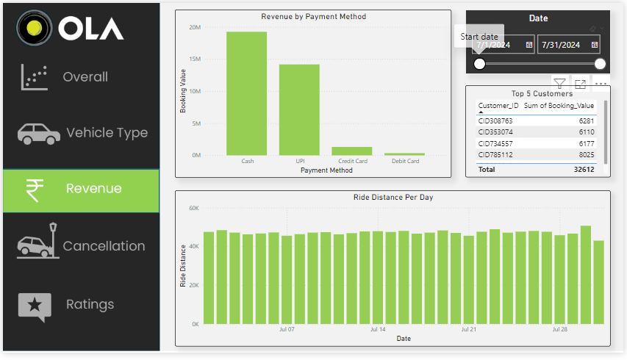

Fig-7.3:Screenshot 3

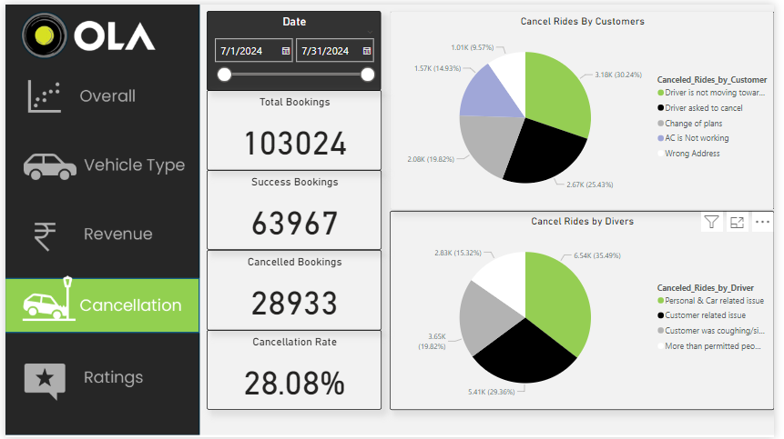

Fig-7.4:Screenshot 4

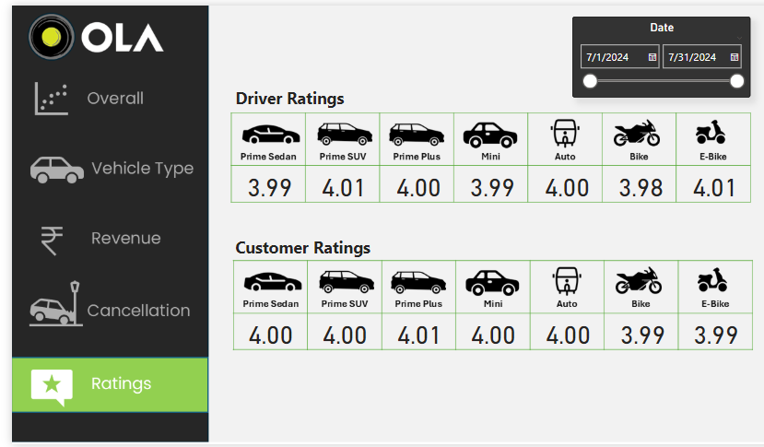

Fig-7.5:Screenshot 5

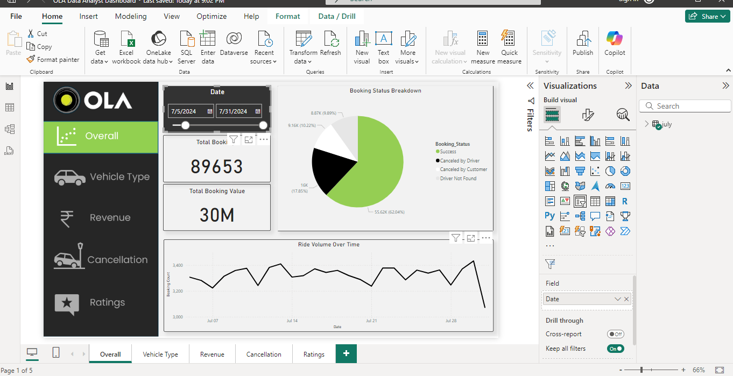

Fig-7.6:Screenshot 6

**CHAPTER 8: CONCLUSION**

The analysis of Ola's data has provided valuable insights into the company's operations, customer behavior, and market trends. The study has highlighted the importance of understanding customer preferences, optimizing pricing strategies, and improving service quality to enhance customer satisfaction and loyalty.The findings of this study have significant implications for Ola's business strategy and operations. By leveraging data analytics, Ola can optimize its services, improve customer satisfaction, and gain a competitive edge in the market.The study's results also suggest that there are opportunities for Ola to improve its services, particularly in terms of reducing cancellation rates, improving driver behavior, and enhancing the overall customer experience.Overall, this study demonstrates the power of data analytics in driving business growth, improving operational efficiency, and enhancing customer satisfaction. As Ola continues to grow and expand its services, data analytics will play an increasingly important role in informing its business strategy and operations.Ola should implement measures to improve service quality, reduce cancellation rates, and enhance the overall customer experience. And Ola should leverage data analytics to improve driver behavior, reduce accidents, and enhance road safety. Ola should explore opportunities to integrate its services with other modes of transportation, such as public transport, to provide a seamless and integrated mobility experience for customers.

**CHAPTER 9: FUTURE SCOPE**

The future implementation aims to leverage the insights gained from analyzing customer purchase behavior to optimize Ola's business strategies, enhance service offerings, and improve customer satisfaction. By continuously evolving and adapting to market trends, Ola can maintain its competitive edge and foster long-term customer loyalty.

The analysis of Ola's data has provided valuable insights into the company's operations, customer behavior, and market trends. However, there are several areas that can be explored further to gain a deeper understanding of the business and identify opportunities for growth.

**1. Integration with External Data Sources**

* Integrating Ola's data with external sources such as weather APIs, traffic updates, and social media feeds can provide a more comprehensive understanding of the factors that influence customer behavior and demand.

**2. Predictive Modeling**

* Developing predictive models that can forecast demand, supply, and revenue can help Ola optimize its operations, improve resource allocation, and make informed business decisions.

**3. Driver Behavior Analysis**

* Analyzing driver behavior and performance can help Ola identify areas for improvement, optimize driver incentives, and enhance the overall customer experience.

**4. Customer Segmentation**

* Conducting customer segmentation analysis can help Ola identify high-value customer segments, tailor its services to meet their needs, and develop targeted marketing campaigns.

**5. Data Visualization**

* Developing data visualization capabilities can help Ola communicate complex data insights to stakeholders, facilitate data-driven decision-making, and improve the overall efficiency of its business.

**CHAPTER 10: REFERENCE**

**BOOKS REFERRED:-**

* Allamdas Rohit H. (2020) ‘A Study of surge pricing by Uber & Ola legal in India’, ‘Airo International Research Journal, Vol XI. ISSN: 2320-3714.
* Chen, W. (2021). Technical Improvements on Mobile App Based Taxi Dispatching System. International Conference on Computer Science and Service System (pp. 281-284). Atlantis Press.
* Dr. Kavitha and R. Rajeswari (2021), Mobile wallets usage in taxi companies- problems & Challenges. International Journal of Informative & Futuristic Research. ISSN: 2347-1697. Vol 4. issues 3. pp: 5538-5544.
* Horsu, E. N., & Yeboah, S.T. (2022). Inflluence of service quality on customer satisfaction: A study of minicab taxi services in Cape Coast, Ghana. International Journal of Economics, Commerce and Management , 3 (5), 1451-1464.
* Kanjer Hanif and Nagda Sagar. (2022), An Empirical Research on the Penetration Levels for a Call-a-Cab Service in Mumbai. Reflections Journal of Management (RJOM). Volume 5.
* Sharma, K., & Das, S. (2023). Service Quality and Customer Satisfaction-With Special focus on the Online Cab Industry in India. International Journal of Business and Management, 12(7), 192.
* Paronda, A. G. A., Regidor, J. R. F., & Gaabucayan-Napalang, M. S. (2023). An Exploratory Study on Uber, GrabCar, and Conventional Taxis in Metro Manila.

**ONLINE RESOURCES:-**

* https://en.wikipedia.org/wiki/data-analysis-ola/
* [https://www.eeweb.com/tools/ola-data-analysis /](https://www.eeweb.com/tools/ola-data-analysis%20/)
* <https://stackoverflow.com/questions/24104968/data-analysis->for-ola
* [https://www.freecodecamp.org/news/what-is-the-data-analysis- tutorial/](https://www.freecodecamp.org/news/what-is-the-data-analysis-%20tutorial/)

**CHAPTER 11: APPENDIX**

## OLA Data Analyst Project

**ChatGPT Prompt to Create Data**

Please create a spreadsheet with 1 lac rows, for Bengaluru city. Give the following columns. The data will be for 1 month. use the following column –

1. Date
2. Time
3. Booking ID
4. Booking Status
5. Customer ID
6. Vehicle Type
   1. Auto
   2. Prime Plus
   3. Prime Sedan
   4. Mini
   5. Bike
   6. E-Bike
   7. Prime SUV
7. Pickup Location (Create dummy location points Take any 50 areas from Bangalore)
8. Drop Location (Take from dummy pickup locations)
9. Avg VTAT (Time taken to arrive at the vehicle)
10. Avg CTAT (Time taken to arrive the Customer)
11. Cancelled Rides by Customer
12. Reason for cancelling by Customer
    1. Driver is not moving towards pickup location
    2. Driver asked to cancel - AC is not working (Only for 4-wheelers)
    3. Change of plans
    4. Wrong Address
13. Cancelled Rides by Driver
    1. Personal & Car related issues
    2. Customer related issue
    3. The customer was coughing/sick
    4. More than permitted people in there
14. Incomplete Rides
15. Incomplete Rides Reason
    1. Customer Demand
    2. Vehicle Breakdown
    3. Other Issue
16. Booking Value
17. Ride Distance
18. Driver Ratings
19. Customer Rating Keep the overall booking status success for this data at 62%. If the booking status is successful, then only fare charge ratings, average VTAT, average CTAT, and other data will be there.

## Process in the Project

* Make sure orders cancelled by customers should not be more than 7% Make sure orders cancelled drivers should not be more than 18%
* Also, increase the number of orders on weekends and match days. Keep match day by using the following dates.
* keep incomplete rides less than 6%
* Keep order value high on weekends
* in Food Category keep around 67 Indian
* keep order ID with 10 digits starting with CNR and then digits keep orders under 500 value 70%
* keep orders above 500 value 28% keep remaining orders above 1000.

## Working of Project

**SQL Task:**

1. Retrieve all successful bookings:
2. Find the average ride distance for each vehicle type:
3. Get the total number of cancelled rides by customers:
4. List the top 5 customers who booked the highest number of rides:
5. Get the number of rides cancelled by drivers due to personal and car-related issues:
6. Find the maximum and minimum driver ratings for Prime Sedan bookings:
7. Retrieve all rides where payment was made using UPI:
8. Find the average customer rating per vehicle type:
9. Calculate the total booking value of rides completed successfully:
10. List all incomplete rides along with the reason:

# Power BI Task:

1. Ride Volume Over Time
2. Booking Status Breakdown
3. Top 5 Vehicle Types by Ride Distance
4. Average Customer Ratings by Vehicle Type
5. cancelled Rides Reasons
6. Revenue by Payment Method
7. Top 5 Customers by Total Booking Value
8. Ride Distance Distribution Per Day
9. Driver Ratings Distribution
10. Customer vs. Driver Ratings