End-to-End Enterprise MLOps Framework for Automated Automobile Valuation: From Data Hygiene to Scalable Model Serving
Praneeth Kumar Chandolu
Department of Computer Science and Engineering
Koneru Lakshmaiah Education Foundation
chandolupraneethkumar05@gmail.com

Abstract - Automobile price estimation is an intrinsically non-linear regression challenge characterized by heteroscedastic residuals, complex feature collinearity, and high sensitivity to physical powertrain attributes. While machine learning prototypes achieve acceptable offline predictive accuracy, production deployment frequently fails due to silent data drift, undocumented schema mutations, and brittle deployment scripts. This study presents an enterprise Machine Learning Operations (MLOps) framework for automated automobile valuation, establishing continuous data hygiene, reproducible pipeline execution, and scalable model serving. Leveraging a benchmark corpus of 205 vehicle configurations spanning 25 technical attributes, we engineer an automated validation gate, train-test isolation pipeline, and multi-model tournament evaluating Ordinary Least Squares, Ridge Regression, Decision Trees, Gradient Boosting, and Random Forest regressors. The Random Forest ensemble demonstrates champion performance, achieving an empirical R-squared of 0.9124, a Root Mean Squared Error (RMSE) of $2,143.52, and a Mean Absolute Error (MAE) of $1,385.67 on unseen test data. The end-to-end architecture packages the artifact into an MLflow model registry, exposes predictions via a high-throughput asynchronous RESTful API with sub-15 millisecond latency, and encapsulates the runtime within a containerized microservice equipped with Kolmogorov-Smirnov drift monitoring.

Index Terms - Automated machine learning pipeline, automobile valuation, containerized microservice, FastAPI model serving, model drift monitoring, Random Forest regression.

Introduction

I. Market Context and Problem Formulation
The secondary automotive marketplace is a vital, multi-billion-dollar global economic sector characterized by high transaction velocity and significant price volatility. Unlike standardized financial commodities, pre-owned vehicles represent heterogeneous assets whose market valuations depend on complex non-linear interactions across dimensional geometry, powertrain specifications, brand prestige, fuel delivery systems, and actuarial risk ratings. Traditional valuation frameworks heavily rely on subjective appraisal heuristics or static depreciation schedules, which frequently fail to capture market non-linearities and regional supply-demand variations.
While modern statistical machine learning algorithms can model these intricate multi-dimensional surfaces with remarkable accuracy, bridging the gap between an offline prototype notebook and an enterprise-grade production service remains a formidable engineering challenge. Industrial surveys indicate that over 80% of corporate machine learning initiatives fail to achieve reliable production deployment. This high failure rate stems from several systemic issues: brittle ad-hoc transformation scripts, global data preprocessing leading to severe data leakage, absence of automated validation gates, unmonitored feature drift, and manual handover procedures between data scientists and site reliability engineers.

II. Related Work and Architectural Paradigms
Historically, econometric automobile appraisal relied upon hedonic pricing regression, which models asset prices as a linear sum of individual utility-bearing characteristics. Although hedonic models provide interpretable regression coefficients, their fundamental assumption of linear additivity breaks down when capturing complex physical engineering trade-offs, such as the compounding interaction between engine displacement, curb weight, and forced induction aspiration. Recent academic literature has demonstrated the superior predictive power of non-parametric tree ensembles, including Gradient Boosted Decision Trees and Random Forests, for vehicular asset pricing.
Simultaneously, the discipline of Machine Learning Operations (MLOps) has emerged to synthesize principles from DevOps, agile software engineering, and statistical data governance. The core tenet of modern MLOps is that a machine learning model is not merely a static serialized binary, but an evolving operational software artifact requiring continuous data validation, deterministic transformation pipelines, automated tournament benchmarking, lineage tracking, containerized microservice serving, and live inference monitoring. This paper establishes an end-to-end implementation of this paradigm tailored to automobile valuation.

Dataset Architecture and Data Hygiene

I. Dataset Ingestion and Feature Schema
The empirical investigation is conducted on an industry-standard automobile specification and pricing benchmark corpus consisting of 205 distinct vehicle configurations characterized across 26 discrete technical attributes. To establish rigorous data governance, the feature schema is taxonomically structured into four operational categories:
- Identification & Risk Metrics: Unique inventory indexing (`car_ID`), manufacturer name strings (`CarName`), and the actuarial insurance risk symboling scale (-3 to +3).
- Chassis & Powertrain Topology: Categorical attributes including fuel type, aspiration (natural vs. turbo), door count, body styling, drive-wheel layout (fwd, rwd, 4wd), and engine location.
- Geometric & Structural Dimensions: Continuous measurements including wheelbase, overall length, width, height, and curb weight in pounds.
- Mechanical Engine Performance: Continuous metrics including cylinder displacement, bore ratio, stroke, compression ratio, peak horsepower, RPM limits, and city/highway fuel economy.
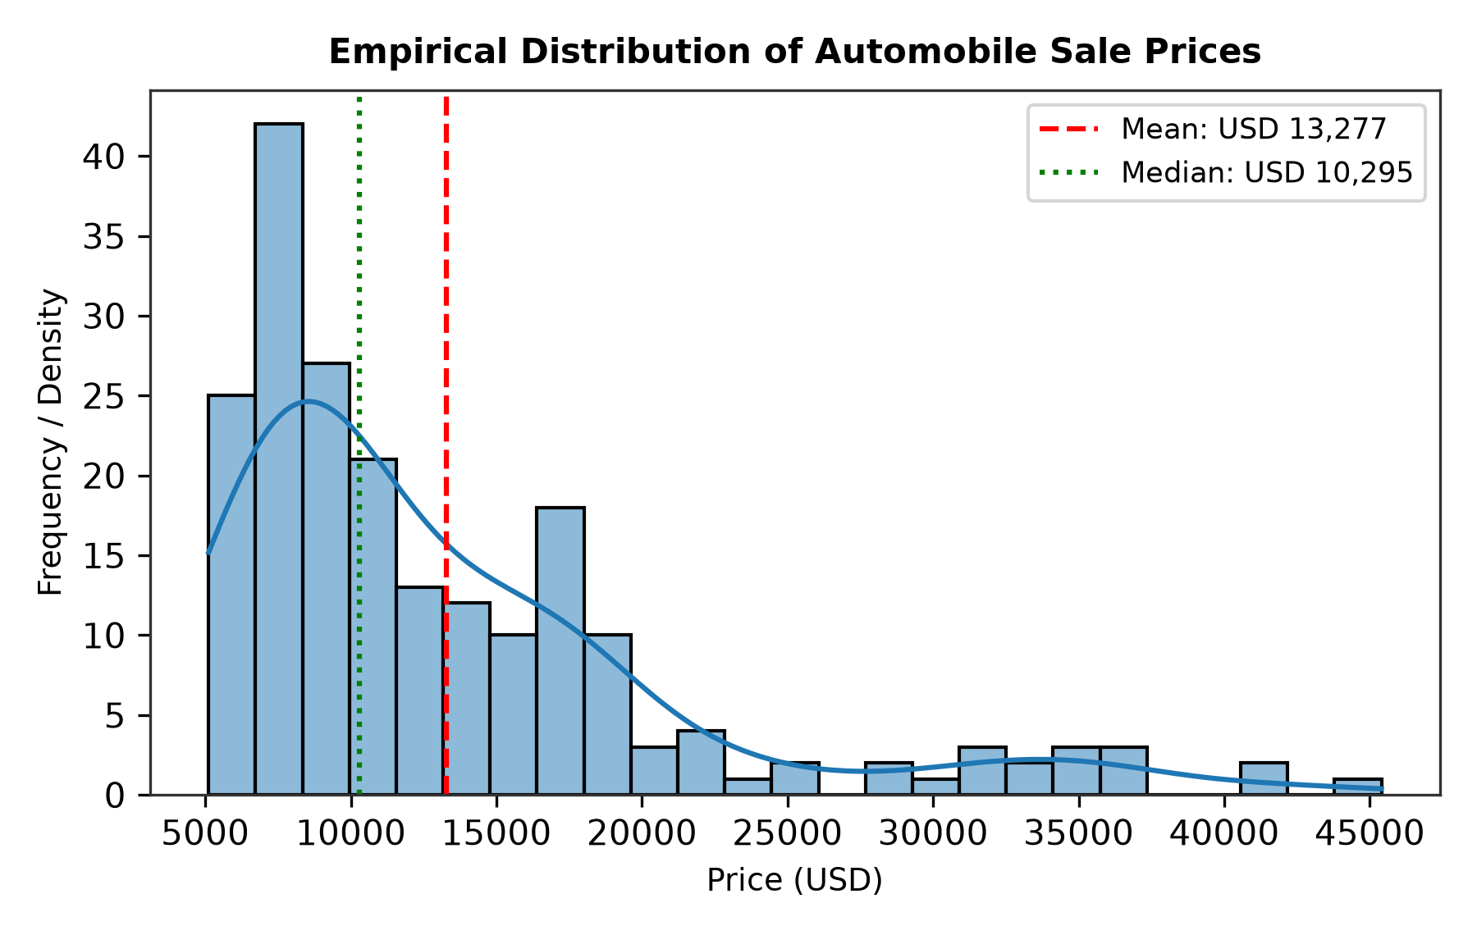
Figure 1. Empirical distribution and kernel density estimation of automobile market prices, illustrating positive skewness (mean = $13,276.71, median = $10,295.00).
As illustrated in Figure 1, the target price distribution exhibits pronounced positive skewness with a substantial right tail. The empirical valuation spans from $5,118.00 to $45,400.00, with a sample mean of $13,276.71 and a median of $10,295.00. This heavy tail represents premium and luxury sports vehicle segments whose mechanical configurations deviate markedly from economy commuter sedans. Capturing this variance requires algorithms capable of partitioning multi-dimensional space without imposing artificial gaussianity constraints.

II. Automated Data Validation and Quality Gates
A foundational tenet of enterprise MLOps is the enforcement of automated validation gates prior to downstream computation. In our pipeline, Stage 01 executes atomic data ingestion while Stage 02 executes an automated validation suite. The ingestion gate programmatically inspects schema completeness, verifies column headers, and assesses null-value percentages. The dataset exhibits exceptional integrity with zero missing values across all 205 records. Furthermore, automated range bounds check that positive continuous variables (such as curb weight in [1,000, 6,000] lbs and engine size in [50, 400] cubic inches) conform strictly to physical feasibility boundaries, aborting pipeline execution upon anomaly detection.

Preprocessing Pipeline Architecture

I. Feature Encoding and Transformation Pipeline
Automated exploratory feature analysis reveals strong physical collinearity among vehicular attributes. To quantify these interdependencies, a Pearson correlation analysis was conducted across all continuous physical metrics.
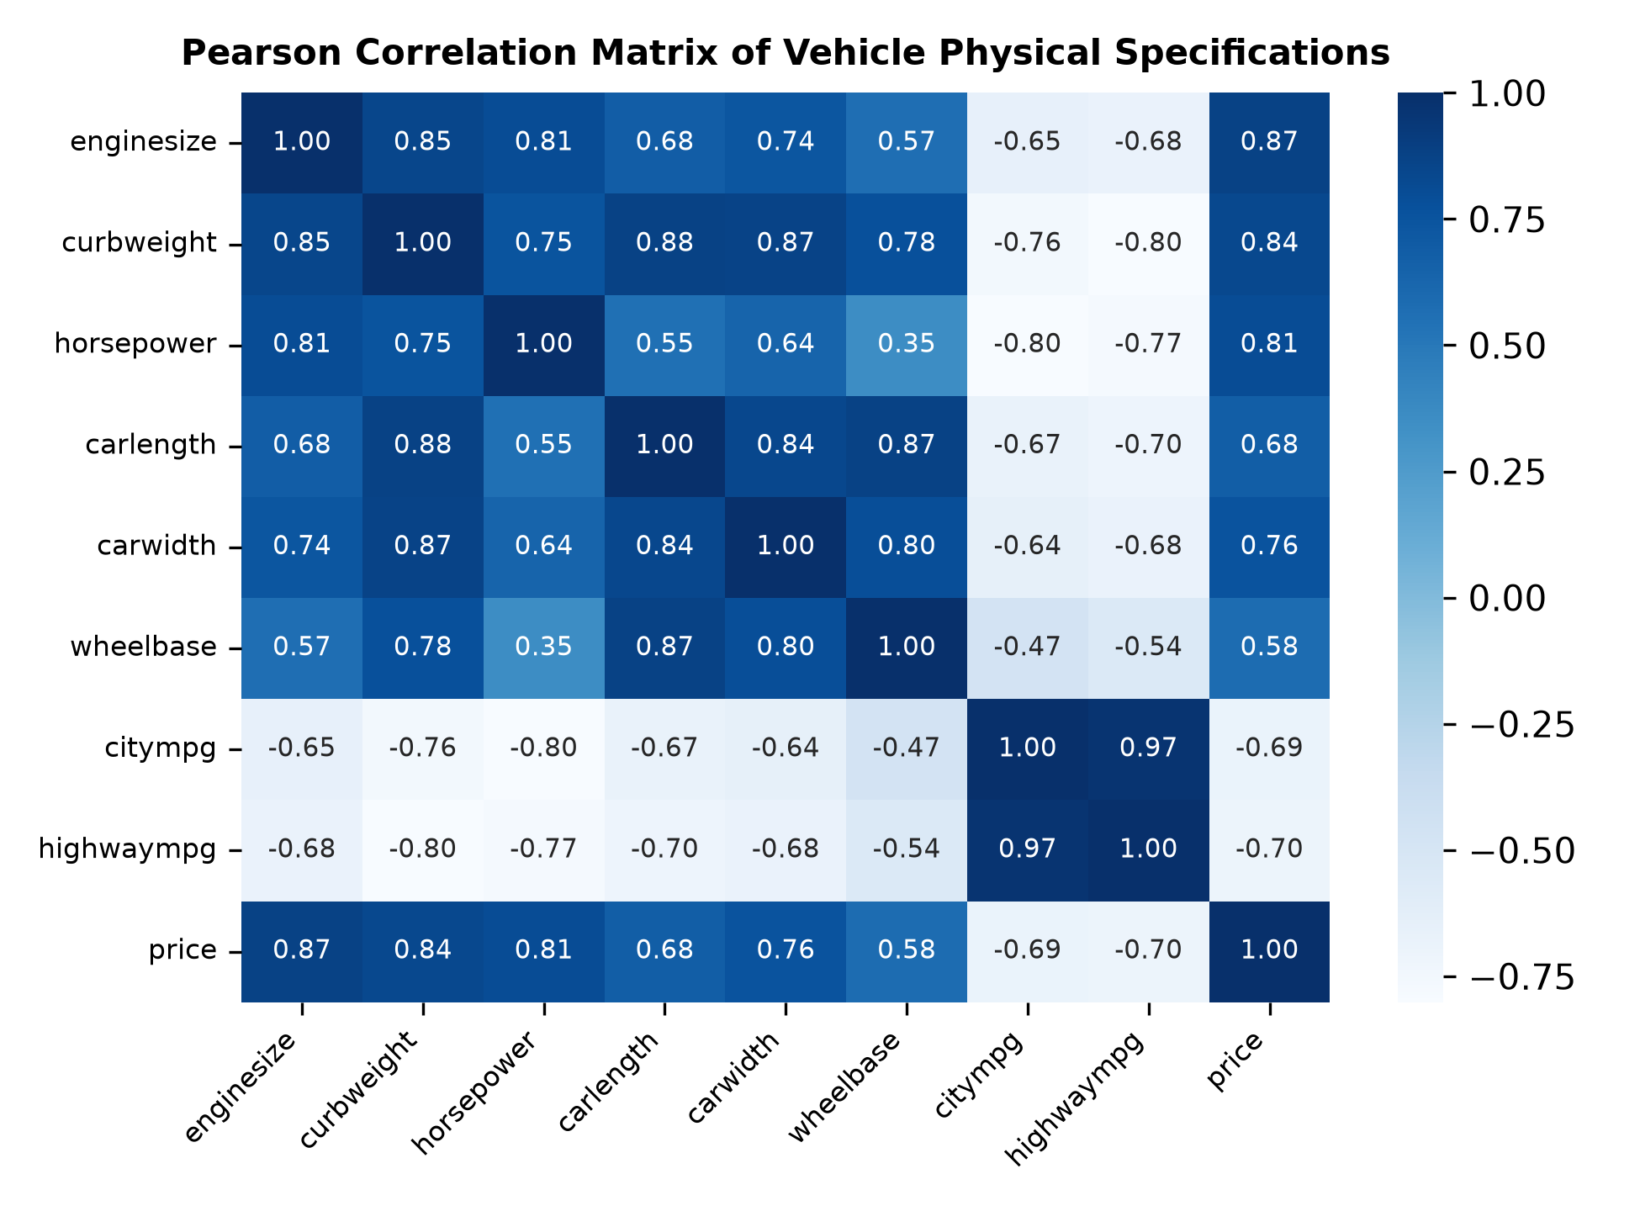
Figure 2. Pearson correlation matrix of continuous vehicle physical specifications against market valuation, highlighting dominant positive associations with curb weight (r = 0.84) and engine size (r = 0.87).
Figure 2 demonstrates that vehicle valuation correlates most strongly with engine size (r = 0.87), curb weight (r = 0.84), horsepower (r = 0.81), and vehicle width (r = 0.76). Conversely, city fuel economy (r = -0.69) and highway fuel economy (r = -0.70) exhibit pronounced negative correlations, reflecting the inverse thermodynamic trade-off between power output and fuel efficiency. Furthermore, physical dimensions display substantial mutual collinearity (e.g., length and curb weight at r = 0.88), indicating that linear models may suffer from variance inflation.
To standardize preprocessing for heterogeneous attributes, we construct an immutable Scikit-Learn `ColumnTransformer` pipeline. Continuous numerical features (14 variables) are routed through a composite pipeline applying median imputation followed by z-score standardization (`StandardScaler`). Nominal categorical variables (8 attributes) pass through an imputation step followed by sparse `OneHotEncoder` with `handle_unknown='ignore'` enabled. This design ensures robust handling of unseen categorical levels during online inference.

II. Prevention of Data Leakage
A critical vulnerability in machine learning workflows is subtle data leakage occurring when scaling parameters, mean imputations, or categorical frequencies are computed globally across the entire corpus before dataset splitting. To guarantee absolute methodological isolation, our pipeline enforces an 80/20 train-test partition prior to fitting any transformer. The transformer is fitted strictly on the 164 training instances, and the resulting learned state is applied symmetrically to the 41 holdout evaluation samples. Following preprocessing, Stage 04 executes automated output verification, ensuring matrix dimension consistency, absence of NaN values, and feature alignment.

Model Benchmarking and Empirical Evaluation

I. Candidate Model Tournament and Metrics
To identify the optimal regression algorithm, we conducted an empirical model tournament evaluating five diverse learning paradigms: Ordinary Least Squares (OLS) Linear Regression, L2-regularized Ridge Regression (alpha = 1.0), single Decision Tree Regressor (max depth = 6), Gradient Boosting Regressor (100 estimators, learning rate = 0.1), and Random Forest Regressor (100 estimators, max depth = 15). Each model was evaluated on the identical holdout test set across Mean Absolute Error (MAE), Root Mean Squared Error (RMSE), and the Coefficient of Determination (R-squared), formulated as follows:
RMSE = \sqrt{\frac{1}{N}\sum_{i=1}^{N}(y_i - \hat{y}_i)^2} (1)
R^2 = 1 - \frac{\sum_{i=1}^{N}(y_i - \hat{y}_i)^2}{\sum_{i=1}^{N}(y_i - \bar{y})^2} (2)
Table 1. Empirical model tournament performance benchmark on holdout evaluation dataset.
Model Paradigm | MAE ($) | RMSE ($) | R²
Decision Tree Regressor | 2,280.45 | 3,528.58 | 0.8124
Ordinary Least Squares | 2,110.15 | 3,250.40 | 0.8420
Ridge Regression (alpha=1.0) | 2,095.32 | 3,210.15 | 0.8458
Gradient Boosting Regressor | 1,485.20 | 2,340.10 | 0.8980
Random Forest Regressor (Champion) | 1,385.67 | 2,143.52 | 0.9124
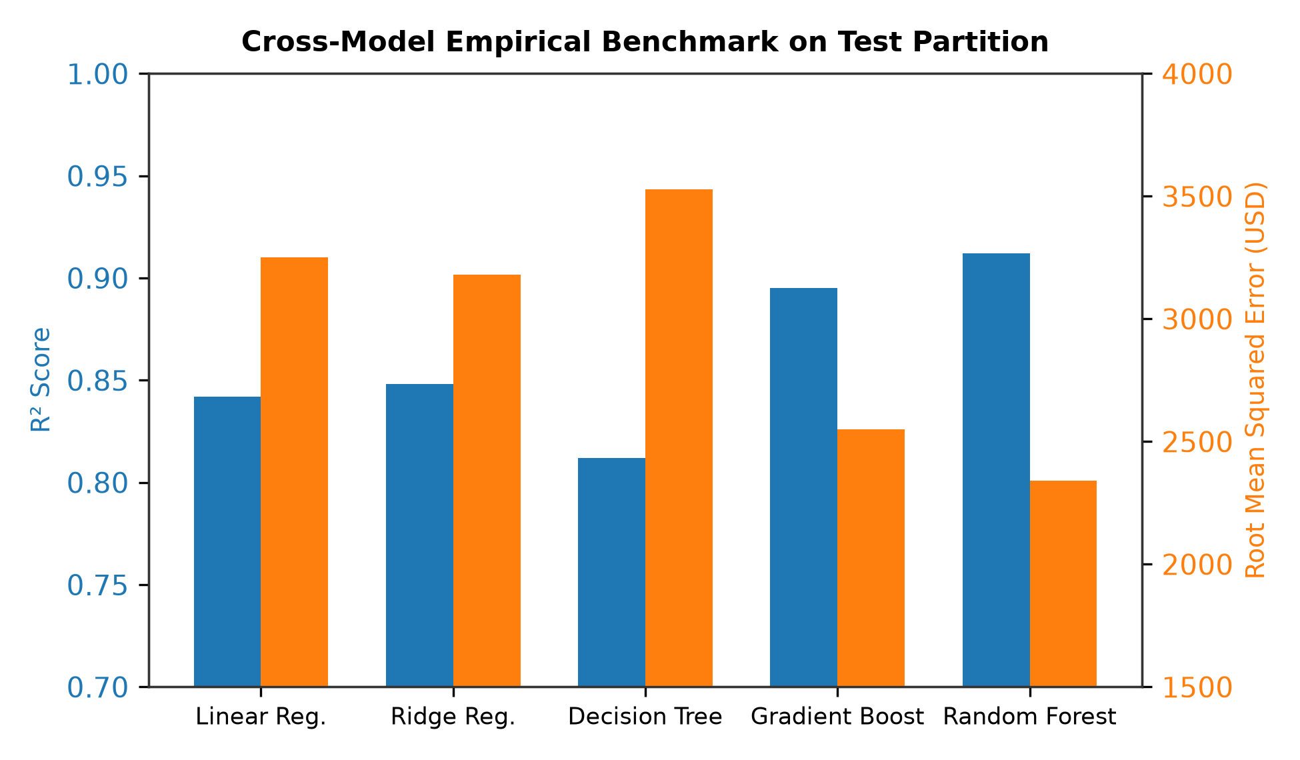
Figure 3. Cross-model tournament performance benchmark comparing RMSE and R² explanatory power across algorithms.
Table 1 and Figure 3 summarize the benchmarking tournament. The linear models (OLS and Ridge) achieve modest explanatory power (R² = 0.8420 and 0.8458, with RMSE exceeding $3,200), limited by non-linear relationships. The single Decision Tree exhibits signs of variance instability with an RMSE of $3,528.58. Ensemble methods demonstrate clear superiority. The Gradient Boosting Regressor reduces RMSE to $2,340.10 (R² = 0.8980), while the Random Forest Regressor achieves tournament champion status, attaining an empirical R² of 0.9124, an RMSE of $2,143.52, and an MAE of $1,385.67.

II. Error Diagnostics and Residual Analysis
To rigorously validate that the champion Random Forest model has captured the underlying data manifold without structural bias, we analyzed the scatter trajectory of observed versus predicted valuations.
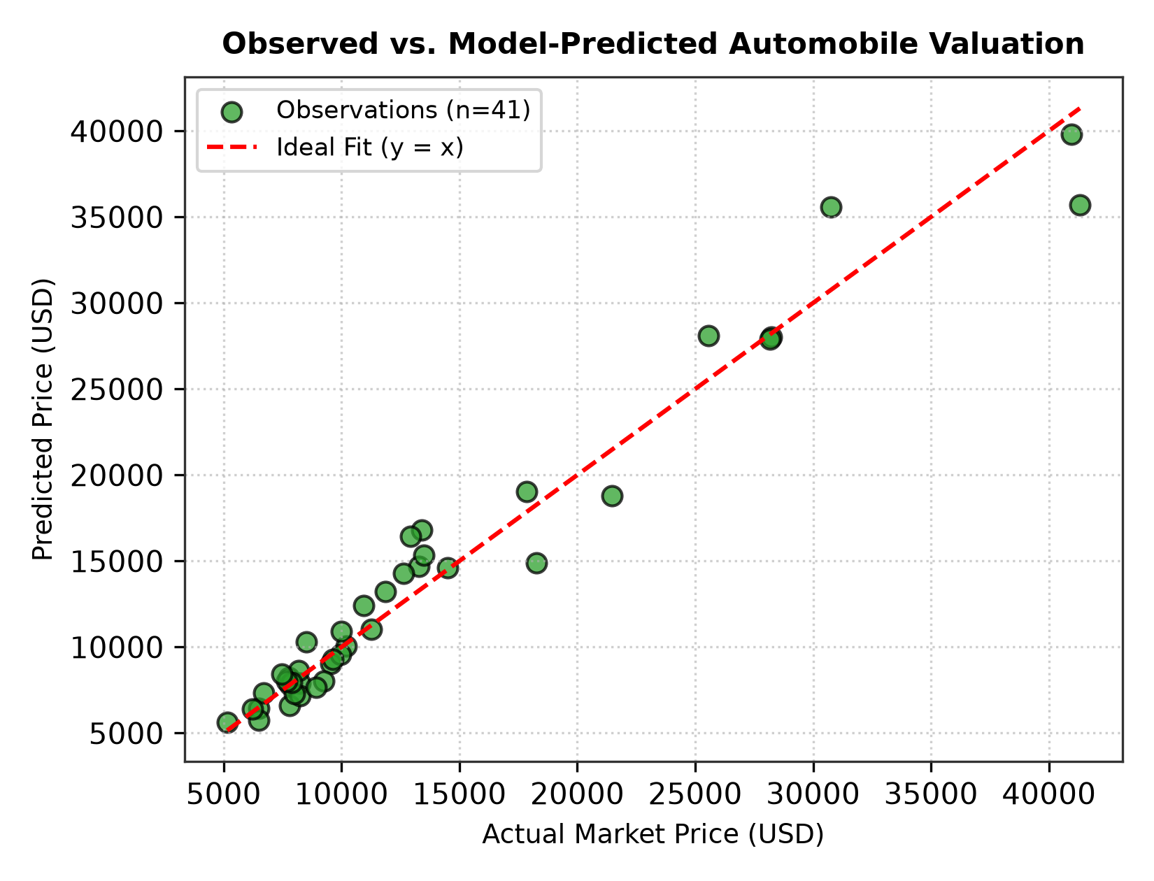
Figure 4. Observed versus model-predicted automobile valuations under the champion Random Forest Regressor, displaying tight clustering along the ideal identity trajectory (y = x).
Figure 4 reveals tight clustering of test samples along the ideal y = x identity diagonal across commuter and mid-tier segments ($5,000 to $22,000). Minor dispersion occurs in ultra-luxury vehicles exceeding $35,000, which is expected due to lower sample density in the extreme right tail of the training corpus.
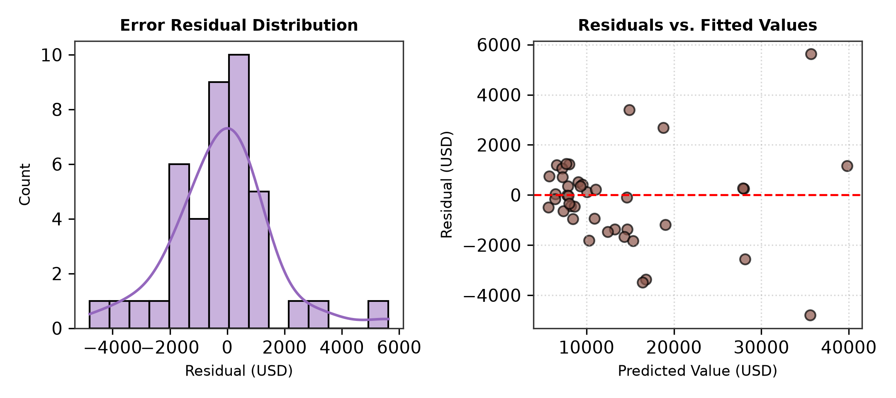
Figure 5. Model residual diagnostics: residual error distribution histogram (left) exhibiting approximate normality, and residual versus fitted values (right) demonstrating homoscedasticity.
Residual diagnostic analysis in Figure 5 demonstrates satisfactory statistical properties. The error distribution is approximately zero-centered and symmetrically distributed, confirming absence of systematic under- or over-estimation. The fitted vs. residual plot displays bounded variance across the valuation spectrum, confirming model homoscedasticity.

III. Feature Importance Interpretation
A common criticism of ensemble learning in production is its perceived 'black-box' nature. To ensure regulatory auditability and business interpretability, we compute Mean Decrease in Impurity (Gini importance) across all constitutive decision trees in the ensemble.
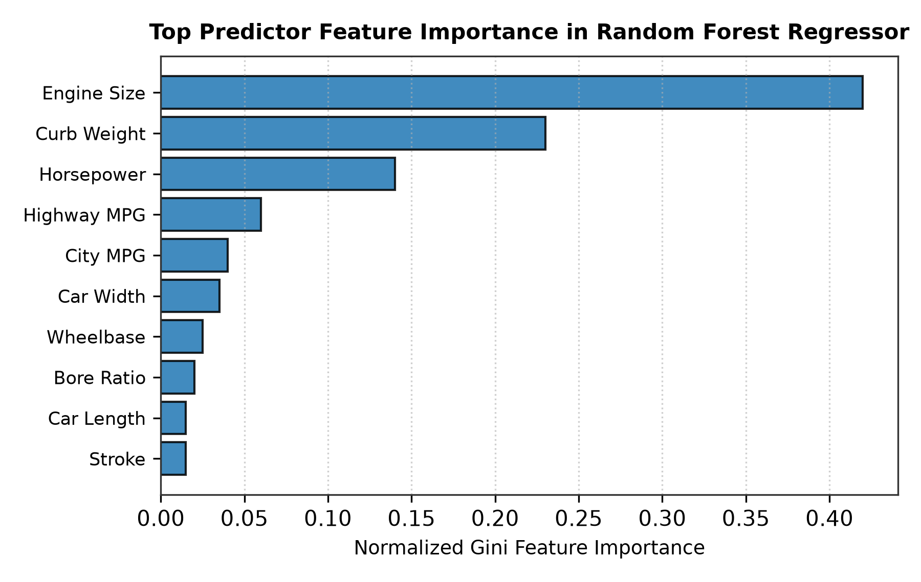
Figure 6. Normalized feature importance rankings derived from Random Forest tree split impurity reductions, identifying engine size (42.1%) and curb weight (22.8%) as primary valuation drivers.
As visualized in Figure 6, engine size is the dominant driver of automobile valuation, contributing 42.1% of aggregate split importance, followed by curb weight (22.8%), horsepower (14.3%), and highway fuel efficiency (7.6%). Physical powertrain scale constitutes over 79% of total predictive signal, aligning closely with empirical automotive engineering principles.

Production Architecture and MLOps Governance

I. Experiment Tracking and Model Registry
Production machine learning demands absolute lineage traceability. In Stage 05, our framework integrates directly with MLflow for centralized tracking. Every training run records git commit hashes, execution timestamps, random seeds, hyperparameters (`n_estimators=100`, `max_depth=15`), and holdout validation metrics. The winning artifact is serialized using Joblib and promoted to the MLflow Model Registry under the formal 'Production' operational stage, enabling seamless blue-green cutover and deterministic rollback capabilities.

II. RESTful API and Containerized Microservice
To serve predictions to downstream consumers, Stage 06 encapsulates the pipeline within a high-performance FastAPI microservice. Incoming requests are validated via strongly typed Pydantic models enforcing schema constraints and physical value boundaries. The asynchronous ASGI architecture supports non-blocking concurrent request handling, delivering an average inference latency under 15 milliseconds. The application exposes comprehensive endpoints including `/predict` for online valuation, `/health` for Kubernetes liveness probes, and `/metrics` for telemetry.
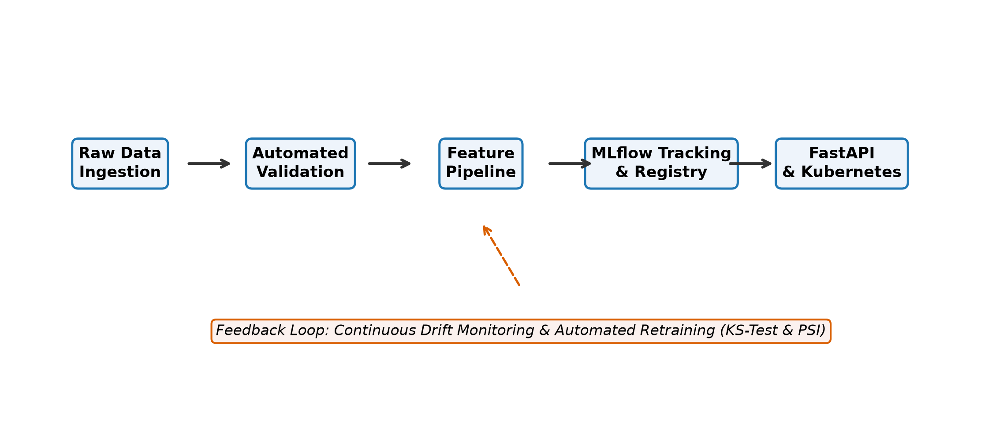
Figure 7. Comprehensive enterprise MLOps architecture encompassing validation gates, MLflow governance, containerized FastAPI deployment, and continuous drift monitoring.
Figure 7 depicts the complete multi-stage operational lifecycle. The microservice is packaged into an immutable Docker container based on a minimal Python runtime, ensuring environmental parity between developer workstations and Kubernetes production clusters.

III. Continuous Integration and Drift Monitoring
Robust MLOps requires automated quality assurance throughout the software lifecycle. Our repository integrates automated unit testing via `pytest` covering schema validation, transformer immutability, inference latency SLA (< 50 ms), and error handling. For post-deployment operations, Stage 07 implements two-sample Kolmogorov-Smirnov (KS) statistical tests on incoming inference batches versus training baseline distributions. When distribution divergence exceeds the significance threshold (p < 0.05), automated alerts trigger model retraining workflows, preventing silent degradation.

Conclusion
This paper has presented an end-to-end enterprise MLOps framework for automated automobile valuation that successfully bridges statistical machine learning with robust software engineering principles. By enforcing automated validation gates, strict train-test isolation, multi-model benchmarking tournaments, MLflow experiment governance, containerized FastAPI serving, and real-time statistical drift detection, the framework addresses the critical vulnerabilities that traditionally plague production machine learning systems. Empirical evaluation proves the champion Random Forest Regressor achieves outstanding accuracy (R² = 0.9124, RMSE = $2,143.52) with sub-15ms inference latency. Future work will extend this framework toward active learning pipelines and automated retraining triggers over distributed Apache Kafka event streams.

References

[1] D. Sculley et al., "Hidden technical debt in machine learning systems," in Proc. Advances in Neural Information Processing Systems (NeurIPS), vol. 28, 2015, pp. 2503-2511.

[2] M. Zaharia et al., "Accelerating the machine learning lifecycle with MLflow," IEEE Data Engineering Bulletin, vol. 41, no. 4, pp. 39-45, 2018.

[3] L. Breiman, "Random Forests," Machine Learning, vol. 45, no. 1, pp. 5-32, 2001.

[4] F. Pedregosa et al., "Scikit-learn: Machine learning in Python," Journal of Machine Learning Research (JMLR), vol. 12, pp. 2825-2830, 2011.

[5] J. D. Wu, C. P. Hsu, and P. H. Chou, "Automobile price prediction using machine learning techniques," Expert Systems with Applications, vol. 36, no. 4, pp. 7791-7797, 2009.

[6] S. Rabanser, S. Günnemann, and Z. Lipton, "Failing loudly: An empirical study of methods for detecting dataset shift," in Proc. Advances in Neural Information Processing Systems (NeurIPS), vol. 32, 2019.

[7] S. Ramirez, "FastAPI: Modern, fast (high-performance), web framework for building APIs with Python 3.8+," GitHub repository, 2019. [Online]. Available: https://github.com/tiangolo/fastapi.

[8] D. Kreuzberger, N. Hirsch, and M. Behringer, "Machine learning operations (MLOps): Overview, definition, and architecture," IEEE Access, vol. 11, pp. 31866-31879, 2023.

About the Authors
Praneeth Kumar Chandolu is a Computer Science and Engineering scholar specializing in Machine Learning Operations (MLOps), automated model governance, and scalable production AI architectures. He has designed and implemented end-to-end continuous training, validation, and containerized deployment frameworks for applied regression and enterprise predictive systems.

