2.5 HOURS

## RENMIN UNIVERSITY OF CHINA

# Advanced Micro- and Macro-Economics

Semester 2, Academic Year 2013-2014

16 June, 2014

Electronic calculators and dictionaries may be used, provided that they cannot store text or allow you to access to the internet.

P.T.O.

**Please choose ONE to answer from Questions 1-3.**

1. A utility function is quasi-linear (in the first commodity) if it has the form



for a function .

(a) Use the Lagrange approach to write down the first order conditions for a solution  of the consumer’s problem. [20 marks]

(b) Use the first order conditions to argue that for  the demand function  does, in fact, not depend on income . [30 marks]

2. Consider the utility function



where the vector or parameters  satisfies  and .

(a) Use the Lagrange approach to solve for the Marshallian demand function. [15 marks]

(b) Determine the indirect utility function and verity Roy’s identity. [10 marks]

(c) Determine the expenditure function (without solving the expenditure minimisation problem) and use Shepard’s lemma to obtain the Hicksian demand function. [20 marks]

(d) Check whether your answer to (c) satisfies the relation . [5 marks]{注意希克斯需求将效用替换为间接效用函数，即可得马歇尔需求函数}

注：马歇尔需求函数的参数为价格和收入；希克斯需求函数的参数为价格和效用。

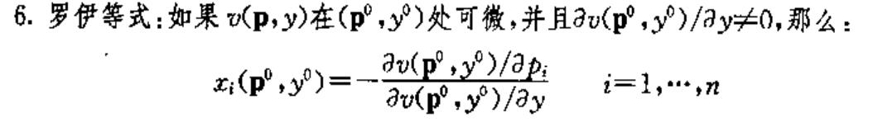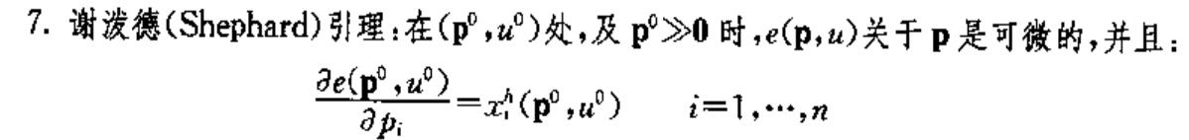

3. Consider a two-period utility function of the form:



where  enters into the second period utility function, too. The utility of consumption in the second period depends not simply on , but also on . The higher is first-period consumption, the higher  must be to provide a given level of utility. Economists use utility functions of this form to capture *habit formation*. When you consume more, you get used to it, and it creates a strong distaste for consuming less in future periods.

(a) Set up the standard two-period intertemporal consumption optimisation problem, and derive the Euler equation for this utility function. Assume no assets or bonds. The first- and second-period incomes are denoted by  and , respectively. [20 marks]

(b) Assume that . What does the Euler equation say about the ratio of  to ? [10 marks]

(c) Assume that . What is the ratio of  to  if the utility function is a standard one, ? [10 marks]

(d) Based on your answers to (b) and (c), compare the magnitude of the ratios of  to  in the case of habit formation and in the standard case? Explain your answer given the economic intuition. [10 marks]

**Please answer the Question 4.**

4. Consider a closed economy in which the production function is given by, where *Y* = output, *K* = capital, *L* = land, *A* = labour effectiveness, population (also known as labour or employment), , and . Aggregate savings in the economy is given by *S = sY*, where *s* = savings rate and . Capital depreciates at the rate  where . Population grows at the rate  and labour effectiveness grows at the rate  where the dot denotes the changes between  and . Assume strict exogeneity in parameters. Denote per capita values as  and . (a) Show that  can be written as a function of ; and derive the expression of . [10 marks]

(b) Derive the steady-state income per capita and capital per capita. Draw diagrams to demonstrate whether they are stable and provide reasons. [10 marks]

(c) What is the impact of increasing savings rate on the steady-state values in (b)? [5 marks]

(d) In the balanced growth, calculate the growth rates of income per capita  and capital per capita . [10 marks]

(e) Further assume that this economy is a developing country where agriculture dominates. Based on your answers to (c) and (d), discuss whether technological progress (i.e., ) can guarantee long-term increases in income per capita and capital per capita. [5 marks] When population grows, how would the growth rates of  and  change in the balanced growth? [5 marks] Based on what you have answered to (e), discuss the role of agriculture for this developing country. [5 marks]