**Assessment:2**

**1. In logistic regression, what is the logistic function (sigmoid function) and how is it used to**

**compute probabilities?**

Logistic regression is a powerful statistical technique widely used in machine learning and statistics for binary classification problems. One of its key components is the sigmoid function, which plays a crucial role in mapping inputs to probabilities. This article will delve into the sigmoid function's definition, characteristics, and its fundamental role in logistic regression.

**What is the Sigmoid Function?**

The sigmoid function, also known as the logistic function, is a mathematical curve that has an S-shaped or sigmoidal curve. It is defined as follows:

S(x)=1/1+ex

In this equation:

* *f*(*x*) represents the output of the sigmoid function.
* *x* is the input, which can take any real value.
* *e* is the base of the natural logarithm, approximately equal to 2.71828.

The sigmoid function takes any real number as input and outputs a value between 0 and 1. It approaches 0 as the input becomes negative and 1 as the input becomes positive. When the input is 0, the sigmoid function returns 0.5.

**Characteristics of the Sigmoid Function**

1. **S-Shaped Curve**: The most prominent characteristic of the sigmoid function is its S-shaped curve, which makes it suitable for modeling the probability of binary outcomes.
2. **Bounded Output**: The sigmoid function always produces values between 0 and 1, which is ideal for representing probabilities.
3. **Symmetry**: The sigmoid function is symmetric around its midpoint at *x*=0.5.
4. **Differentiability**: The sigmoid function is differentiable, allowing for the calculation of gradients necessary for optimization algorithms like gradient descent.

### Role of Sigmoid Function in Logistic Regression

Logistic regression is used for binary classification, where the goal is to predict one of two possible outcomes, typically represented as 0 and 1. The sigmoid function is at the core of logistic regression, serving as the link function that maps the linear combination of input features to a probability.

The logistic regression model is represented as:

P(y=1)=1/1+e-0Tx[2]

In this equation:

* *P*(*y*=1) is the probability of the output being 1.
* *θ* represents the model's parameters (weights).
* *x* is the input feature.

The sigmoid function transforms the linear combination *θTx* into a probability. If *θTx* is large and positive, the probability approaches 1, indicating a high confidence in class 1. Conversely, if *θTx* is large and negative, the probability approaches 0, indicating a high confidence in class 0.

**2. When constructing a decision tree, what criterion is commonly used to split nodes, and**

**how is it calculated?**

**Construction of Decision Tree:** A tree can be “learned” by splitting the source set into subsets based on Attribute Selection Measures. Attribute selection measure (ASM) is a criterion used in decision tree algorithms to evaluate the usefulness of different attributes for splitting a dataset. The goal of ASM is to identify the attribute that will create the most homogeneous subsets of data after the split, thereby maximizing the information gain. This process is repeated on each derived subset in a recursive manner called recursive partitioning. The recursion is completed when the subset at a node all has the same value of the target variable, or when splitting no longer adds value to the predictions. The construction of a decision tree classifier does not require any domain knowledge or parameter setting and therefore is appropriate for exploratory knowledge discovery. Decision trees can handle high-dimensional data

#### Entropy:

Entropy is the measure of the degree of randomness or uncertainty in the dataset. In the case of classifications, It measures the randomness based on the distribution of class labels in the dataset.

The entropy for a subset of the original dataset having K number of classes for the ith node can be defined as:

Where,

* S is the dataset sample.
* k is the particular class from K classes
* p(k) is the proportion of the data points that belong to class k to the total number of data

points in dataset sample S.

* Here p(i,k) should not be equal to zero.

**Important points related to Entropy:**

1. The entropy is 0 when the dataset is completely homogeneous, meaning that each instance belongs to the same class. It is the lowest entropy indicating no uncertainty in the dataset sample.
2. when the dataset is equally divided between multiple classes, the entropy is at its maximum value. Therefore, entropy is highest when the distribution of class labels is even, indicating maximum uncertainty in the dataset sample.
3. Entropy is used to evaluate the quality of a split. The goal of entropy is to select the attribute that minimizes the entropy of the resulting subsets, by splitting the dataset into more homogeneous subsets with respect to the class labels.
4. The highest information gain attribute is chosen as the splitting criterion (i.e., the reduction in entropy after splitting on that attribute), and the process is repeated recursively to build the decision tree.

#### Gini Impurity or index:

Gini Impurity is a score that evaluates how accurate a split is among the classified groups. The Gini Impurity evaluates a score in the range between 0 and 1, where 0 is when all observations belong to one class, and 1 is a random distribution of the elements within classes. In this case, we want to have a Gini index score as low as possible. Gini Index is the evaluation metric we shall use to evaluate our Decision Tree Model.

* pi is the proportion of elements in the set that belongs to the ith category.

#### Information Gain:

Information gain measures the reduction in entropy or variance that results from splitting a dataset based on a specific property. It is used in decision tree algorithms to determine the usefulness of a feature by partitioning the dataset into more homogeneous subsets with respect to the class labels or target variable. The higher the information gain, the more valuable the feature is in predicting the target variable.

The information gain of an attribute A, with respect to a dataset S, is calculated as follows:

Information gain (H,A)=H-sumation of |Hv|/|H| Hv

where

* A is the specific attribute or class label
* |H| is the entropy of dataset sample S
* |HV| is the number of instances in the subset S that have the value v for attribute A

Information gain measures the reduction in entropy or variance achieved by partitioning the dataset on attribute A. The attribute that maximizes information gain is chosen as the splitting criterion for building the decision tree.

Information gain is used in both classification and regression decision trees. In classification, entropy is used as a measure of impurity, while in regression, variance is used as a measure of impurity. The information gain calculation remains the same in both cases, except that entropy or variance is used instead of entropy in the formula

The decision tree operates by analyzing the data set to predict its classification. It commences from the tree’s root node, where the algorithm views the value of the root attribute compared to the attribute of the record in the actual data set. Based on the comparison, it proceeds to follow the branch and move to the next node.

The algorithm repeats this action for every subsequent node by comparing its attribute values with those of the sub-nodes and continuing the process further. It repeats until it reaches the leaf node of the tree. The complete mechanism can be better explained through the algorithm given below.

* Step-1: Begin the tree with the root node, says S, which contains the complete dataset.
* Step-2: Find the best attribute in the dataset using Attribute Selection Measure (ASM).
* Step-3: Divide the S into subsets that contains possible values for the best attributes.
* Step-4: Generate the decision tree node, which contains the best attribute.
* Step-5: Recursively make new decision trees using the subsets of the dataset created in step -3. Continue this process until a stage is reached where you cannot further classify the nodes and called the final node as a leaf nodeClassification and Regression Tree algorithm.

**3. Explain the concept of entropy and information gain in the context of decision tree**

**construction.**

# **Entropy :**

**Entropy** is a measure of disorder or impurity in the given dataset.

In the decision tree, messy data are split based on values of the feature vector associated with each data point. With each split, the data becomes more homogenous which will decrease the entropy. However, some data in some nodes will not be homogenous, where the entropy value will not be small. The higher the entropy, the harder it is to draw any conclusion. When the tree finally reaches the terminal or leaf node maximum purity is added.

For a dataset that has C classes and the probability of randomly choosing data from class, i is Pi. Then entropy E(S) can be mathematically represented as

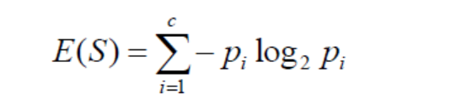

If we have a dataset of 10 observations belonging to two classes YES and NO. If 6 observations belong to the class, YES, and 4 observations belong to class NO, then entropy can be written as below.

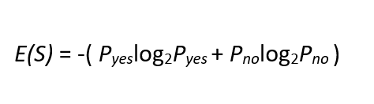

Pyes is the probability of choosing Yes and Pno is the probability of choosing a No. Here Pyes is 6/10 and Pno is 4/10.

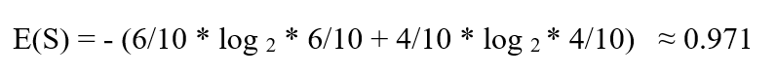

If all the 10 observations belong to 1 class then entropy will be equal to zero. Which implies the node is a pure node.



If both classes YES and NO have an equal number of observations, then entropy will be equal to 1.

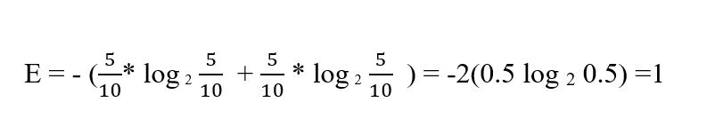

# **Information Gain**

**The Information Gain** measures the expected reduction in entropy. Entropy measures impurity in the data and information gain measures reduction in impurity in the data. The feature which has minimum impurity will be considered as the root node.

Information gain is used to decide which feature to split on at each step in building the tree. The creation of sub-nodes increases the homogeneity, that is decreases the entropy of these nodes. The more the child node is homogeneous, the more the variance will be decreased after each split. Thus Information Gain is the variance reduction and can calculate by how much the variance decreases after each split.

Information gain of a parent node can be calculated as the entropy of the parent node subtracted entropy of the weighted average of the child node.

As per the above example, the dataset has 10 observations belonging to two classes YES and NO. Where 6 observations belong to the class, YES, and 4 observations belong to class NO.

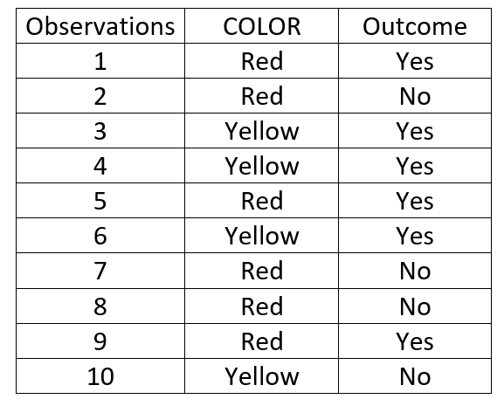

Red color has 3 Yes outcome and 3 No outcome whereas yellow has 3 Yes outcome and 1 No outcome.

E(S), we have already calculated and it is approximately equal to 0.971

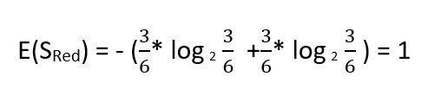

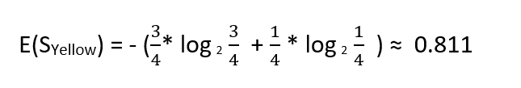

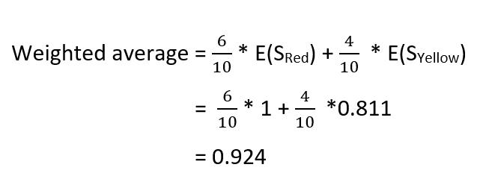

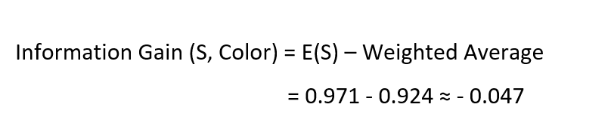

For a dataset having many features, the information gain of each feature is calculated. The feature having maximum information gain will be the most important feature which will be the root node for the decision tree.

**4. How does the random forest algorithm utilize bagging and feature randomization toimprove classification accuracy?**

The random forest algorithm improves classification accuracy by utilizing bagging (bootstrap aggregating) and feature randomization. Here's how it works:

1. **Bagging (Bootstrap Aggregating):**
   * Bagging involves creating multiple subsets of the original dataset by sampling with replacement (bootstrap samples). Each subset is used to train a separate decision tree model.
   * By sampling with replacement, some instances may be repeated in each subset, while others may be left out. This variability helps in reducing overfitting by exposing the model to different subsets of data.
   * After training each individual decision tree on a bootstrap sample, predictions are made by averaging (for regression) or voting (for classification) over all the trees.
2. **Feature Randomization:**
   * In addition to building each tree on a different bootstrap sample, random forest introduces further randomness by considering only a subset of features for splitting at each node.
   * Instead of using all features to split a node, a random subset of features is selected. This subset size can be tuned and is typically smaller than the total number of features.
   * This process ensures that each tree in the forest is trained on different subsets of features, reducing the correlation between trees and leading to a diverse set of decision trees.
   * By considering a subset of features at each split, the model is less likely to be biased towards the features that may dominate the dataset, and it becomes more robust to noise and irrelevant features.

Overall, by combining bagging and feature randomization, random forest reduces overfitting, improves generalization, and increases classification accuracy by creating an ensemble of diverse decision trees that collectively make more accurate predictions.

Top of Form

**5. What distance metric is typically used in k-nearest neighbors (KNN) classification, and**

**how does it impact the algorithm's performance?**

The most commonly used distance metric in k-nearest neighbors (KNN) classification is the Euclidean distance. However, other distance metrics such as Manhattan distance (also known as city block distance or L1 norm) and Minkowski distance (generalization of both Euclidean and Manhattan distances) can also be used depending on the specific application.

The choice of distance metric can have a significant impact on the performance of the KNN algorithm:

1. **Euclidean Distance:**
   * Euclidean distance is the most intuitive distance metric and is widely used in KNN.
   * It calculates the straight-line distance between two points in Euclidean space.
   * Euclidean distance works well when the features are continuous and have similar scales. It assumes that all dimensions are equally important.
   * However, it can be sensitive to outliers and may not perform well if the features have different scales or if the dataset contains noisy data.
2. **Manhattan Distance:**
   * Manhattan distance calculates the distance between two points by summing the absolute differences between their coordinates along each dimension.
   * It is less sensitive to outliers compared to Euclidean distance, making it a better choice for datasets with noisy or skewed distributions.
   * Manhattan distance is suitable for datasets with categorical or ordinal features.
3. **Minkowski Distance:**
   * Minkowski distance is a generalization of both Euclidean and Manhattan distances, where the parameter "p" determines the type of distance metric:
     + When p=1, it becomes Manhattan distance.
     + When p=2, it becomes Euclidean distance.
   * By varying the value of "p," Minkowski distance can adapt to different types of datasets and distributions.
   * It provides a more flexible distance metric that can be tailored to the specific characteristics of the data.

Choosing the appropriate distance metric is crucial for the performance of the KNN algorithm. It often requires experimentation and consideration of the dataset's characteristics, such as the distribution of features, the presence of outliers, and the scaling of features. Additionally, feature scaling techniques such as normalization or standardization may be applied to improve the algorithm's performance, especially when using distance-based methods like KNN.

Top of Form

**6. Describe the Naïve-Bayes assumption of feature independence and its implications for**

**Classification?**

The Naïve Bayes classifier is based on the assumption of feature independence, which states that the features (or variables) used to describe instances are independent of each other given the class label. In other words, each feature contributes to the probability of an instance belonging to a particular class independently of the other features.

This assumption simplifies the computation of the conditional probability of a class given a set of features using Bayes' theorem. Instead of calculating the joint probability of all features given the class label, it calculates the product of the probabilities of each individual feature given the class label:

*P*(*C*∣*x*1​,*x*2​,...,*xn*​)=*P*(*x*1​)⋅*P*(*x*2​)⋅...⋅*P*(*xn*​)*P*(*C*)⋅*P*(*x*1​∣*C*)⋅*P*(*x*2​∣*C*)⋅...⋅*P*(*xn*​∣*C*)​

Where*P*(*C*∣*x*1​,*x*2​,...,*xn*​) is the probability of class *C* given the features *x*1​,*x*2​,...,*xn*​.

* *P*(*C*) is the prior probability of class *C*.
* *P*(*xi*​∣*C*) is the probability of feature *xi*​ given class *C*.
* *P*(*x*1​),*P*(*x*2​),...,*P*(*xn*​) are the probabilities of the individual features.

Implications of the Naïve Bayes assumption of feature independence for classification:

1. **Simplicity:** The assumption simplifies the model by reducing the number of parameters that need to be estimated. Instead of estimating the joint distribution of all features, only the individual conditional probabilities need to be estimated.
2. **Efficiency:** Computationally, Naïve Bayes classifiers are very efficient, especially for high-dimensional datasets, because the independence assumption allows for the calculation of conditional probabilities independently for each feature.
3. **Limited Representation:** While the assumption of feature independence is often unrealistic in real-world datasets, Naïve Bayes classifiers can still perform well, especially when the features are approximately independent or when the dependence between features does not significantly affect the classification task.
4. **Robustness:** Naïve Bayes classifiers are robust to irrelevant features since they assume independence. Irrelevant features will not affect the classification decision as long as they are conditionally independent of the class given other features.

Overall, while the assumption of feature independence may not hold true in all cases, Naïve Bayes classifiers can still be effective in practice, particularly for text classification, spam filtering, and other tasks where the simplicity and efficiency of the model outweigh the limitations of the assumption.

Top of Form

**7. In SVMs, what is the role of the kernel function, and what are some commonly used kernel**

**functions?**

In Support Vector Machines (SVMs), the kernel function plays a crucial role in transforming the input features into a higher-dimensional space where the data points become more linearly separable. The kernel function calculates the inner products between the data points in this transformed space without explicitly computing the transformation itself. This enables SVMs to find complex decision boundaries in the original feature space by working in a higher-dimensional space where the data may be more separable.

The role of the kernel function in SVMs can be summarized as follows:

1. **Mapping to Higher Dimensional Space:** The kernel function implicitly maps the input data points from the original feature space to a higher-dimensional feature space where the data may be more separable.
2. **Computing Inner Products:** In the higher-dimensional space, the kernel function calculates the inner products between pairs of data points, which are used to define the decision boundary (hyperplane) separating different classes.
3. **Kernel Trick:** The kernel trick allows SVMs to operate efficiently in the higher-dimensional space without explicitly computing the transformation, thereby avoiding the computational burden associated with high-dimensional transformations.

Some commonly used kernel functions in SVMs include:

1. **Linear Kernel (Linear SVM):**
   * *K*(*xi*​,*xj*​)=*xiT*​*xj*​
   * The linear kernel computes the inner product of the original feature vectors, which corresponds to a linear decision boundary in the original feature space.
2. **Polynomial Kernel:**
   * *K*(*xi*​,*xj*​)=(*xiT*​*xj*​+*c*)*d*
   * The polynomial kernel maps the data points to a higher-dimensional space using polynomial functions, allowing SVMs to capture non-linear decision boundaries.
3. **Gaussian Radial Basis Function (RBF) Kernel:**
   * *K*(*xi*​,*xj*​)=exp(−*γ*∥*xi*​−*xj*​∥2)
   * The RBF kernel maps the data points to an infinite-dimensional space using Gaussian radial basis functions. It is effective for capturing complex, non-linear decision boundaries and is one of the most commonly used kernels in SVMs.
4. **Sigmoid Kernel:**
   * *K*(*xi*​,*xj*​)=tanh(*αxiT*​*xj*​+*c*)
   * The sigmoid kernel is based on hyperbolic tangent functions and is suitable for problems where the decision boundary is expected to be non-linear.

The choice of kernel function in SVMs depends on the characteristics of the data and the complexity of the decision boundary required for the classification task. Experimentation and cross-validation are often used to select the most appropriate kernel function and its hyperparameters for a given problem.

**8. Discuss the bias-variance trade off in the context of model complexity and overfitting.**

The bias is known as the difference between the prediction of the values by the [Machine Learning](https://www.geeksforgeeks.org/machine-learning/) model and the correct value. Being high in biasing gives a large error in training as well as testing data.

The model with high variance has a very complex fit to the training data and thus is not able to fit accurately on the data which it hasn’t seen before. As a result, such models perform very well on training data but have high error rates on test data. When a model is high on variance, it is then said to as **Overfitting of Data**.

**Bias Variance Tradeoff**

If the algorithm is too simple (hypothesis with linear equation) then it may be on high bias and low variance condition and thus is error-prone.

We try to optimize the value of the total error for the model by using the Bias-Variance Tradeoff.

Total Error = Bias^2 + Variance + Irreducible Error

**9. How does TensorFlow facilitate the creation and training of neural networks?**

TensorFlow also provides a number of tools for constructing and training neural networks. One of the most popular tools is the utility tf.keras which allows users to quickly build and train deep learning models without having to write code from scratch

TensorFlow is one of the most popular frameworks for deep learning, and it continues to evolve as more powerful algorithms are developed.

**10. Explain the concept of cross-validation and its importance in evaluating model**

**performance**.

**Cross validation is a technique used in machine learning to evaluate the performance of a model on unseen data**. It involves dividing the available data into multiple folds or subsets, using one of these folds as a validation set, and training the model on the remaining folds.

**11.What techniques can be employed to handle overfitting in machine learning models?**

Techniques to Reduce **Overfitting Increase training data. Reduce model complexity. Early stopping during the training phase (have an eye over the loss over the training period as soon as loss begins to increase stop training). Ridge Regularization and Lasso Regularization. Use dropout for neural networks to tackle overfitting.**

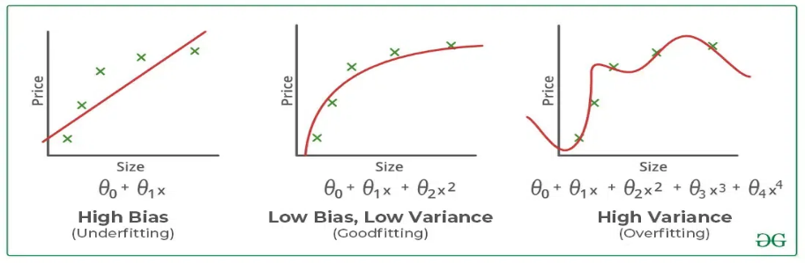

**12.What is the purpose of regularization in machine learning and how does it work?**

## Regularization in Machine Learning

Regularization is a technique used to reduce errors by fitting the function appropriately on the given training set and avoiding overfitting. The commonly used [regularization techniques](https://www.geeksforgeeks.org/lasso-vs-ridge-vs-elastic-net-ml/) are :

1. Lasso Regularization – L1 Regularization
2. Ridge Regularization – L2 Regularization
3. Elastic Net Regularization – L1 and L2 Regularization

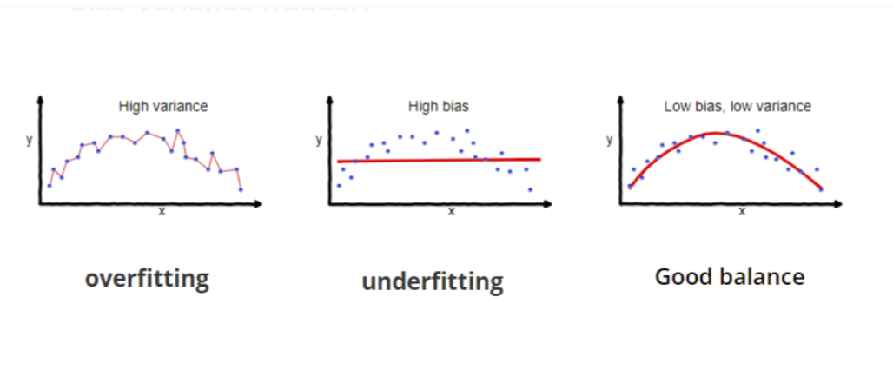

Lasso Regression

A regression model which uses the L1 Regularization technique is called LASSO(Least Absolute Shrinkage and Selection Operator) regression

**Lasso Regression** adds the *“absolute value of magnitude”* of the coefficient as a penalty term to the loss function(L). Lasso regression also helps us achieve feature selection by penalizing the weights to approximately equal to zero if that feature does not serve any purpose in the model.

### Ridge Regression

A regression model that uses the **L2 regularization** technique is called **Ridge regression**. **Ridge regression** adds the “*squared magnitude*” of the coefficient as a penalty term to the loss function(L).

### Elastic Net Regression

This model is a combination of L1 as well as L2 regularization. That implies that we add the absolute norm of the weights as well as the squared measure of the weights. With the help of an extra [hyperparameter](https://www.geeksforgeeks.org/hyperparameter-tuning/) that controls the ratio of the L1 and L2 regularization.

13.Describe the role of hyper-parameters in machine learning models and how they are tuned for optimal performance?

Hyperparameter tuning is the process of selecting the optimal values for a [machine learning](https://www.geeksforgeeks.org/machine-learning/) model’s hyperparameters. Hyperparameters are settings that control the learning process of the model, such as the learning rate, the number of neurons in a neural network, or the kernel size in a support vector machine. The goal of hyperparameter tuning is to find the values that lead to the best performance on a given task.

### Different Ways of Hyperparameters Tuning

Hyperparameters are configuration variables that control the learning process of a machine learning model. They are distinct from model parameters, which are the weights and biases that are learned from the data

#### Hyperparameters in Support Vector Machine

#### Hyperparameters in Neural Networks

#### Hyperparameters in XG Boost

### Hyperparameter Tuning techniques

1. [GridSearchCV](https://scikit-learn.org/stable/modules/generated/sklearn.model_selection.GridSearchCV.html)
2. [RandomizedSearchCV](https://scikit-learn.org/stable/modules/generated/sklearn.model_selection.RandomizedSearchCV.html)
3. [Bayesian Optimization](https://www.geeksforgeeks.org/catboost-bayesian-optimization/)

**14. What are precision and recall, and how do they differ from accuracy in classification**

**evaluation?**

Precision and recall are two important metrics used to evaluate the performance of classification models, particularly in tasks with imbalanced class distributions. They measure different aspects of a classifier's performance compared to accuracy.

1. **Precision:**
   * Precision is the proportion of correctly predicted positive instances (true positives) among all instances that were predicted as positive (true positives + false positives): Precision=True PositivesTrue Positives+False PositivesPrecision=True Positives+False PositivesTrue Positives​
   * Precision represents the model's ability to correctly identify positive instances without misclassifying negative instances as positives. It quantifies the classifier's accuracy on positive predictions.
2. **Recall (Sensitivity or True Positive Rate):**
   * Recall, also known as sensitivity or true positive rate (TPR), is the proportion of correctly predicted positive instances (true positives) among all actual positive instances: Recall=True PositivesTrue Positives+False NegativesRecall=True Positives+False NegativesTrue Positives​
   * Recall measures the model's ability to capture all positive instances in the dataset. It quantifies the classifier's ability to avoid false negatives.
3. **Accuracy:**
   * Accuracy is the proportion of correctly classified instances (both true positives and true negatives) among all instances in the dataset: Accuracy=True Positives+True NegativesTotal Number of InstancesAccuracy=Total Number of InstancesTrue Positives+True Negatives​
   * Accuracy measures the overall correctness of the classifier's predictions, regardless of class imbalance. It gives equal weight to true positives, true negatives, false positives, and false negatives.

**Differences:**

* Precision focuses on the accuracy of positive predictions, whereas recall focuses on the coverage of positive instances.
* Precision is sensitive to false positives, while recall is sensitive to false negatives.
* Accuracy considers both true positives and true negatives and does not explicitly account for class imbalance.
* Precision and recall are more informative metrics when dealing with imbalanced datasets, where accuracy alone might be misleading.

In summary, precision and recall provide complementary insights into the performance of classification models, particularly in scenarios where class distributions are imbalanced. They help assess a classifier's ability to make correct positive predictions and capture all positive instances, respectively, providing a more nuanced evaluation compared to accuracy alone.

Top of Form

**15. Explain the ROC curve and how it is used to visualize the performance of binary classifiers.**

The Receiver Operating Characteristic (ROC) curve is a graphical representation used to evaluate the performance of binary classifiers across different threshold settings. It illustrates the trade-off between the true positive rate (TPR) and the false positive rate (FPR) as the discrimination threshold varies.

Here's how the ROC curve is constructed and interpreted:

1. **True Positive Rate (TPR) and False Positive Rate (FPR):**
   * TPR, also known as sensitivity or recall, is the ratio of correctly predicted positive instances to all actual positive instances: TPR=True Positives/True Positives+False Negatives
   * FPR is the ratio of incorrectly predicted positive instances to all actual negative instances: FPR=False PositivesFalse/ Positives+True Negatives ​
2. **Threshold Variation:**
   * In a binary classifier, predictions are typically made based on a probability threshold. Observations with predicted probabilities above the threshold are classified as positive, while those below are classified as negative.
   * By varying this threshold, the classifier's sensitivity and specificity change, leading to different TPR and FPR values.
3. **ROC Curve Construction:**
   * The ROC curve is created by plotting the TPR against the FPR for various threshold settings.
   * Each point on the ROC curve represents a different threshold value, ranging from 0 to 1.
   * The diagonal line (the line of no-discrimination) represents the performance of a random classifier.
4. **Interpretation:**
   * A classifier with perfect discrimination would have a ROC curve that passes through the point (0, 1), i.e., TPR = 1 and FPR = 0.
   * The area under the ROC curve (AUC) quantifies the classifier's performance. A higher AUC indicates better overall performance, with a maximum value of 1 for a perfect classifier and a minimum value of 0.5 for a random classifier.
   * The ROC curve allows you to visually assess how well the classifier separates the two classes and to choose an appropriate threshold based on the desired balance between TPR and FPR.
5. **Application:**
   * The ROC curve is widely used in machine learning, particularly in tasks where the cost of false positives and false negatives varies.
   * It provides insights into the classifier's performance across different operating points and helps in selecting the threshold that optimizes the desired trade-off between true positives and false positives.

In summary, the ROC curve is a valuable tool for evaluating and comparing the performance of binary classifiers, providing a comprehensive visualization of their discrimination ability across different threshold settings.