**Microsoft Stock Price Prediction: Time Series Analysis For Stock Market Trends**

**Introduction:**

The financial markets have always been subject to volatility, influenced by a multitude of factors ranging from economic indicators to geopolitical events. In this context, the ability to anticipate and forecast stock price movements assumes paramount importance for investors, traders, and financial institutions. Microsoft Corporation, a stalwart in the technology sector, commands significant attention from stakeholders due to its market dominance, innovative prowess, and global reach.

Time series analysis, a branch of statistics and data science, focuses on analyzing data points collected or recorded at successive time intervals. It offers a structured framework for understanding patterns, trends, and dependencies inherent in sequential data, making it particularly well-suited for modeling stock market trends. By extrapolating historical stock price data, time series analysis enables the development of predictive models capable of forecasting future price movements.

This project endeavors to conduct a comprehensive analysis of Microsoft's stock price dynamics using time series techniques. Through rigorous data collection, preprocessing, exploratory data analysis, and model development, the project aims to unravel the underlying patterns within Microsoft's stock price data. By harnessing the predictive capabilities of advanced time series models, such as ARIMA (Auto Regressive Integrated Moving Average) and SARIMA (Seasonal ARIMA), the project seeks to generate forecasts that can aid investors in making informed decisions.

Ultimately, this endeavor aspires to contribute valuable insights into the intricacies of Microsoft's stock market behavior, offering stakeholders a data-driven perspective on potential future price movements. Through the amalgamation of statistical methodologies, computational techniques, and domain knowledge, this project endeavors to shed light on the enigmatic world of stock market forecasting, with Microsoft's stock price serving as the focal point of analysis.

**Abstract:**

The stock market, with its dynamic nature and constant fluctuations, poses a challenging yet intriguing arena for investors and analysts alike. Predicting stock prices accurately is crucial for making informed investment decisions, and time series analysis serves as a powerful tool in this endeavor. This project aims to leverage time series analysis techniques to forecast the stock prices of Microsoft Corporation (NASDAQ: MSFT), one of the world's leading technology companies. By employing a systematic approach encompassing data collection, preprocessing, exploratory data analysis, model selection, evaluation, and forecasting, this project seeks to provide insights into Microsoft's stock price trends and potential future movements.

**Libraries and Packages Used:**

Pmdarima = =1.8.4

Cython = = 0.29.23

Scipy = = 1.5.4

Setuptools = = 49.6.0.post20210108

Statsmodels = = 0.12.2

urllib3 = =1.26.4

pandas = =1.2.3

joblib = =1.0.1

scikit-learn = =0.24.1

numpy = = 1.19.5

python-dateutil = =2.8.1

pytz = =2021.1

six = =1.15.0

threadpoolctl= =2.1.0

patsy = =0.5.1

**Technology Used**

Jupyter Notebook: Interactive computing environment for running Python code and documenting the analysis process.

Jupyter Notebook is a popular open-source web application that allows you to create and share documents containing live code, equations, visualizations, and narrative text. Some of the key features of Jupyter Notebook include:

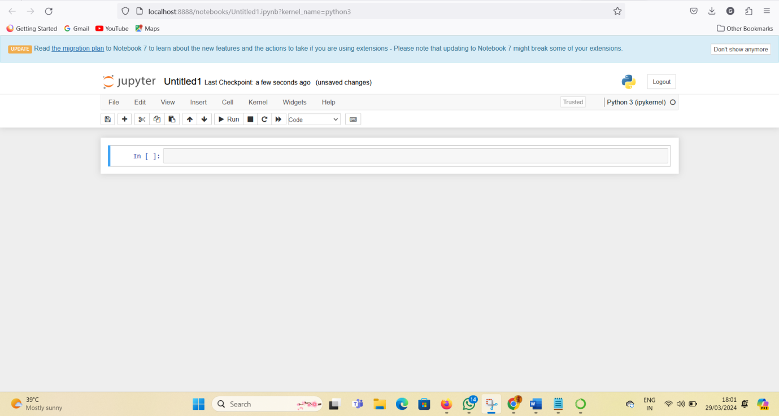

**Features:**

* Interactive Computing: Jupyter Notebook provides an interactive computing environment where you can write and execute code in small, manageable chunks called cells. This allows for rapid prototyping, experimentation, and iterative development.
* Support for Multiple Languages: While initially designed for Python, Jupyter Notebook supports over 40 programming languages, including R, Julia, and Scala. This makes it a versatile tool for data analysis, scientific computing, machine learning, and more
* Rich Output Formats: Jupyter Notebook allows you to generate various types of output, including text, images, HTML, LaTeX equations, and interactive visualizations. This enables you to create comprehensive and visually appealing documents that combine code, results, and explanations.
* Markdown Support: Jupyter Notebook supports Markdown, a lightweight markup language, for formatting text, creating headings, lists, tables, and inserting hyperlinks and images. Markdown cells can be used to provide context, explanations, and documentation alongside code cells.
* Code Execution: Code cells in Jupyter Notebook can be executed individually or all at once. The output of code execution, including errors and print statements, is displayed directly below the corresponding code cell, facilitating debugging and troubleshooting
* Kernel Architecture: Jupyter Notebook uses a client-server architecture, where the Jupyter server communicates with computational engines called kernels. Each kernel is responsible for executing code in a specific programming language.This architecture enables language agnosticism and supports the integration of multiple kernels within a single notebook.
* Notebook Sharing and Collaboration: Jupyter Notebook allows you to share your notebooks with others by exporting them to various formats, including HTML, PDF, and slides. You can also share notebooks online via platforms like GitHub, GitLab, and JupyterHub. Additionally, collaborative editing and commenting features are available through services like JupyterLab and Google Colab.
* Extensions and Plugins: Jupyter Notebook supports a rich ecosystem of extensions and plugins that enhance its functionality.These extensions provide additional features such as code snippets, keyboard shortcuts, spell-checking, and integration with version control systems.

**Flow Chart of the project:**

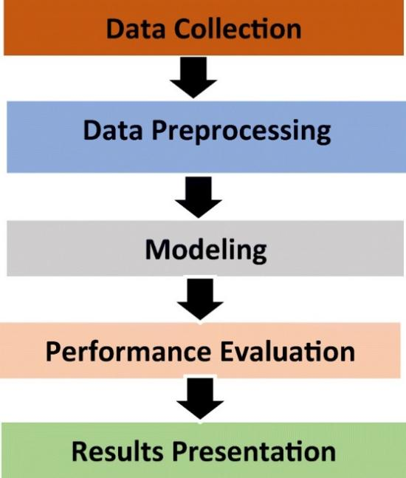

Fig: phases of stock price prediction

* Data Collection: Obtain historical stock price data for Microsoft from financial data platforms.
* Data Preprocessing: Handle missing values, convert data into a time series format, and ensure data integrity.
* Exploratory Data Analysis (EDA): Visualize the data to understand trends, seasonality, and other patterns.
* Time Series Analysis: Decompose the time series, check for stationarity, and apply transformations if necessary.
* Model Selection: Choose appropriate time series models (e.g., ARIMA, SARIMA) based on the data characteristics.
* Model Training: Split the data into training and testing sets, and train the selected models on the training data.
* Model Evaluation: Evaluate the performance of the models using metrics like Mean Absolute Error (MAE) and Root Mean Squared Error (RMSE).
* Forecasting: Use the trained models to forecast future stock prices for Microsoft.
* Fine-tuning and Optimization: Fine-tune the models and validate their performance using cross-validation techniques.
* Deployment: Deploy the final model for real-time forecasting and monitoring.

**Conclusion or Expected Output:**

The expected output of the project is a set of forecasts for Microsoft's stock prices, based on historical data and time series analysis techniques. These forecasts provide stakeholders with valuable insights into potential future trends in Microsoft's stock price movements. By accurately predicting stock prices, the project aims to assist investors, traders, and financial analysts in making informed decisions regarding their investment strategies related to Microsoft Corporation.

**SUBMITTED BY:**

|  |  |
| --- | --- |
| BURRAREDDY PRANAVI | 20L21A0558 |
| LINGALA GANGADHARANI | 20L21A0574 |