https://www.hivemq.com/demos/websocket-client/
https://www.hivemq.com/demos/websocket-client/
https://wokwi.com/projects/469806555829955585

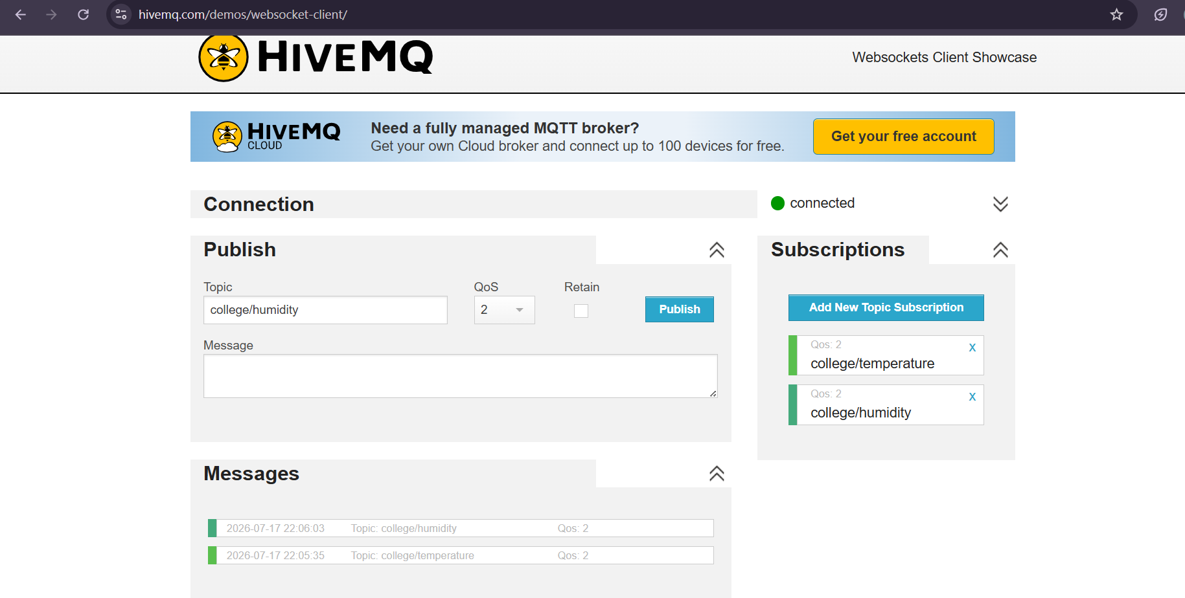
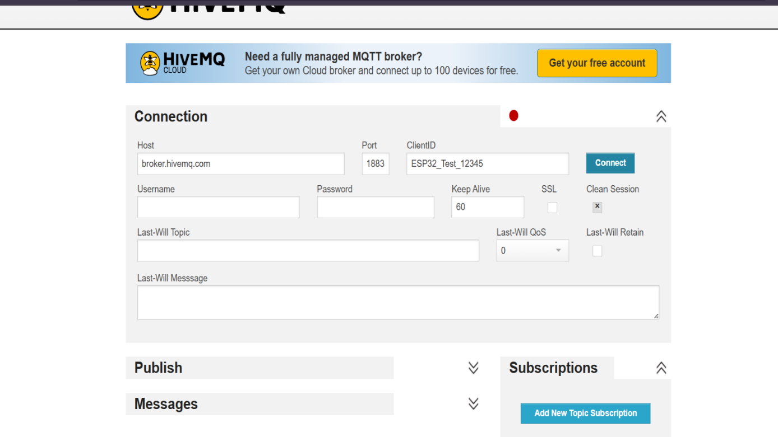
D:\MQTTFirebaseBridge\
package.json
node_modules\smartcity-7c0cc-firebase-adminsdk-fbsvc-113b36623a

