1) **Find all the information about each products?**

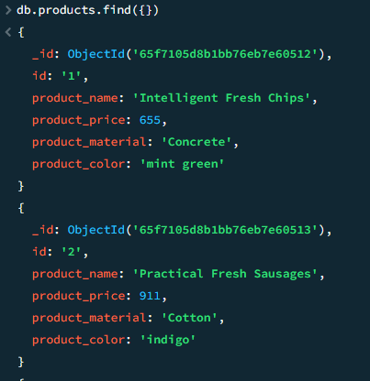

2) **Find the product price which are between 400 to 800?**

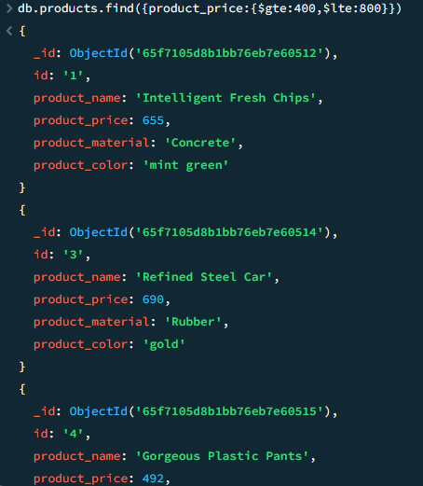

3) **Find the product price which are not between 400 to 600?**

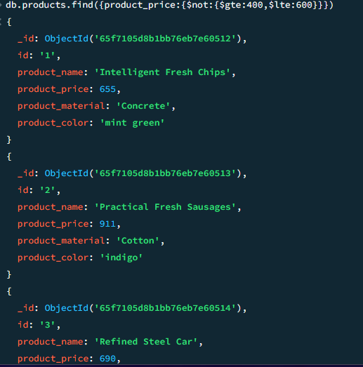

4) **List the four product which are grater than 500 in price ?**

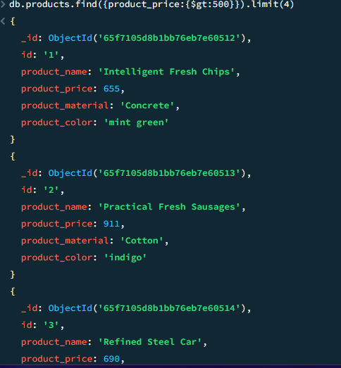

5) **Find the product name and product material of each products?**

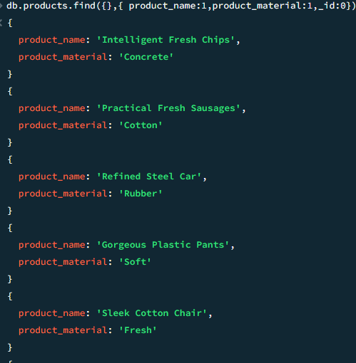

6) **Find the product with a row id of 10?**

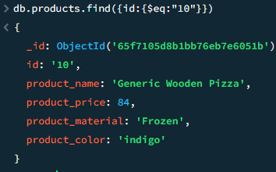

7) **Find only the product name and product material ?**

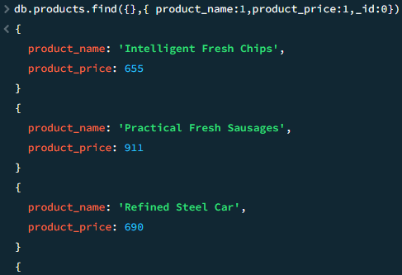

8) **Find all products which contain the value of soft in product material ?**

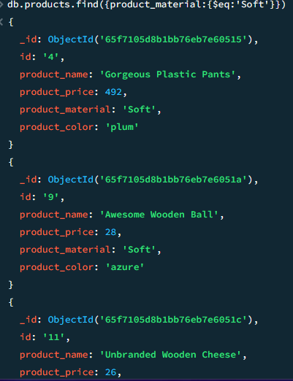

9) **Find products which contain product color indigo and product price 492.00 ?**

