Admin Analytics for Mansakha (SIH26094)
What Exists, What It’s Missing, and What We Should Build Next

Problem Statement | SIH26094 — AI-Powered Dynamic Mental Health Monitoring and Distress Prediction System for Victims of Atrocities
Owning Ministry | Ministry of Social Justice & Empowerment (MoSJE)
Scope of this document | What District/State/National Admin and Ministry analytics should become — including a hard look at Reports, Policy Tracking, and Emergency Broadcast: keep, fix, or drop
Status | Planning / pre-implementation — no code written yet

Part A — Context, in Brief
This section is deliberately short — it exists only to ground Part B, which is where the real content of this document lives. Full sourcing for every claim here is in the earlier project note (SIH26094_Admin_Analytics_Case_Study, first pass); it is not repeated at length below.

A.1 The problem, in one paragraph
Victims under the SC/ST (Prevention of Atrocities) Act go through a long legal journey — investigation, trial, rehabilitation, compensation — during which they face intimidation, delays, and hardship. Every existing government tool (NHAA/SAMBAL, Tele-MANAS, the Witness Protection Scheme) tracks the case or offers general counselling, but nothing continuously watches how the person is coping mentally, and nothing links a legal-case event (a hearing, a bail decision, a delay) to a spike in distress. That is the specific gap this problem statement exists to close, and it is why district/state/national dashboards are named as a required deliverable, not an optional extra — they are how detection turns into real action.

A.2 What real-world systems teach us, in three lines
- COVID-19 dashboards show what happens without deliberate design: local, state, and national views collapse into "the same chart, zoomed differently" instead of answering different questions — exactly the trap Mansakha is currently in.
- Child Protective Services systems — the closest real analog, since they also manage individual at-risk people through a supervisory hierarchy — are explicit that a caseworker, a supervisor, and a state office need fundamentally different views, not the same one at a different zoom level.
- Public-health surveillance doctrine frames this as three tiers — operational, tactical, strategic — each ending in a different kind of action: reassigning a single case vs. shifting a funding formula.

A.3 Where Mansakha stands today (condensed)
District, State, and National Admin currently run near-identical logic — the same risk counts, the same score-trend chart, the same counsellor-efficacy number — differing only in which jurisdiction subtree is selected. One AI-generated qualitative summary exists per jurisdiction, reused the same way at every tier. No table anywhere records legal-case milestones (hearings, bail changes, chargesheet delays) as a timeline — only the case’s current stage is stored, which means the single most-requested capability in the problem statement literature (correlating case events with distress) cannot be built at all yet, at any tier.

Part B — What We Should Add, and How It Actually Works
This is the real content of this document. Each addition below is written the same way: the problem it solves, what actually happens end to end in plain language, a diagram of that flow, and which office(s) it is for. A dedicated section (B.6) then answers directly: do we need Reports, Policy Tracking, and Emergency Broadcast at all — and if so, what specifically is broken in each one today.

B.1 — Connect case events to distress trends (the flagship addition)
This is the single capability named directly in the project’s own research as the one thing no existing system — not Tele-MANAS, not NHAA/SAMBAL, not any global crisis-AI tool — currently does: notice that a victim’s distress spiked right around a hearing, a bail decision, or a chargesheet delay, instead of treating every spike as unexplained.
How it works, in plain terms:
- Whenever something happens on a case — a hearing takes place, bail status changes, a chargesheet is filed or delayed — whoever is handling that update (a counsellor or a district admin) records it against that case, the same way case notes are recorded today.
- The victim’s regular check-ins keep producing a distress reading over time, exactly as they do now — nothing changes about how that data is collected.
- The system automatically lines the two timelines up next to each other for every case, so a spike in distress that happens right after a case event is visibly different from a spike that comes out of nowhere.
- When a spike clusters tightly around an event — for example, distress rising sharply within a few days of a bail decision — that is surfaced as its own flag, not buried inside a generic trend line.
- A District Admin sees this overlay directly on a case; over many cases, the same signal rolls up into a pattern a State or National office can see too (see B.2).
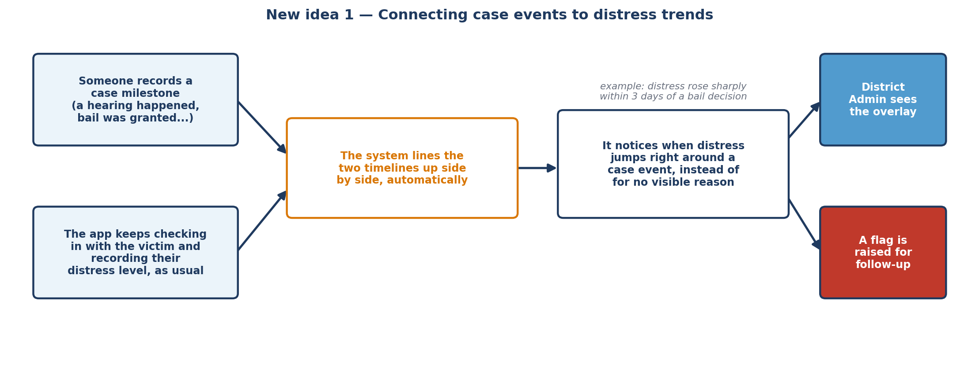
How a case event and a distress trend get connected automatically

Gap today: nothing in the system today records case events as their own timeline at all — only a case’s current stage (e.g. "Trial") is stored, with no history of what happened or when.

B.2 — Give every office its own view, not the same one at a smaller size
Today, opening the dashboard as a District Admin, a State Admin, or a National Admin shows the same layout with the same numbers, just filtered to a smaller area. That means none of them is actually answering the question that office is responsible for — it is the same report, zoomed.
What each office should get instead, and why that specific thing:
- District Admin — the operational level. They are the one office that can act within days: reassign a counsellor, follow up on a specific case. So they should see the case-event overlay from B.1, which counsellors are overloaded, and how quickly alerts are actually being acted on — not just how many alerts exist.
- State Admin — the comparative level. Their job is deciding where to send help. So instead of one district’s numbers, they should see every district in their state lined up side by side, compared fairly (by rate, not raw headcount, so a bigger district doesn’t automatically look worse) — and, crucially, whether a policy tried in one district actually worked better than doing nothing (see B.4).
- National Admin — the pattern level. Individual cases are too granular here, and single-state comparisons are too narrow. This office should see which case types are trending worse nationally, and where the system is quietly under-serving a region (fewer counsellors, slower response) — patterns only visible at national scale.
- Ministry — the accountability level. This office needs to answer "is the scheme working" and defend that answer with evidence — not operate any single case. Their view should be the effectiveness of interventions overall, whether statutory protections are being renewed on time, and a plain-language summary suitable for a funding or policy conversation.
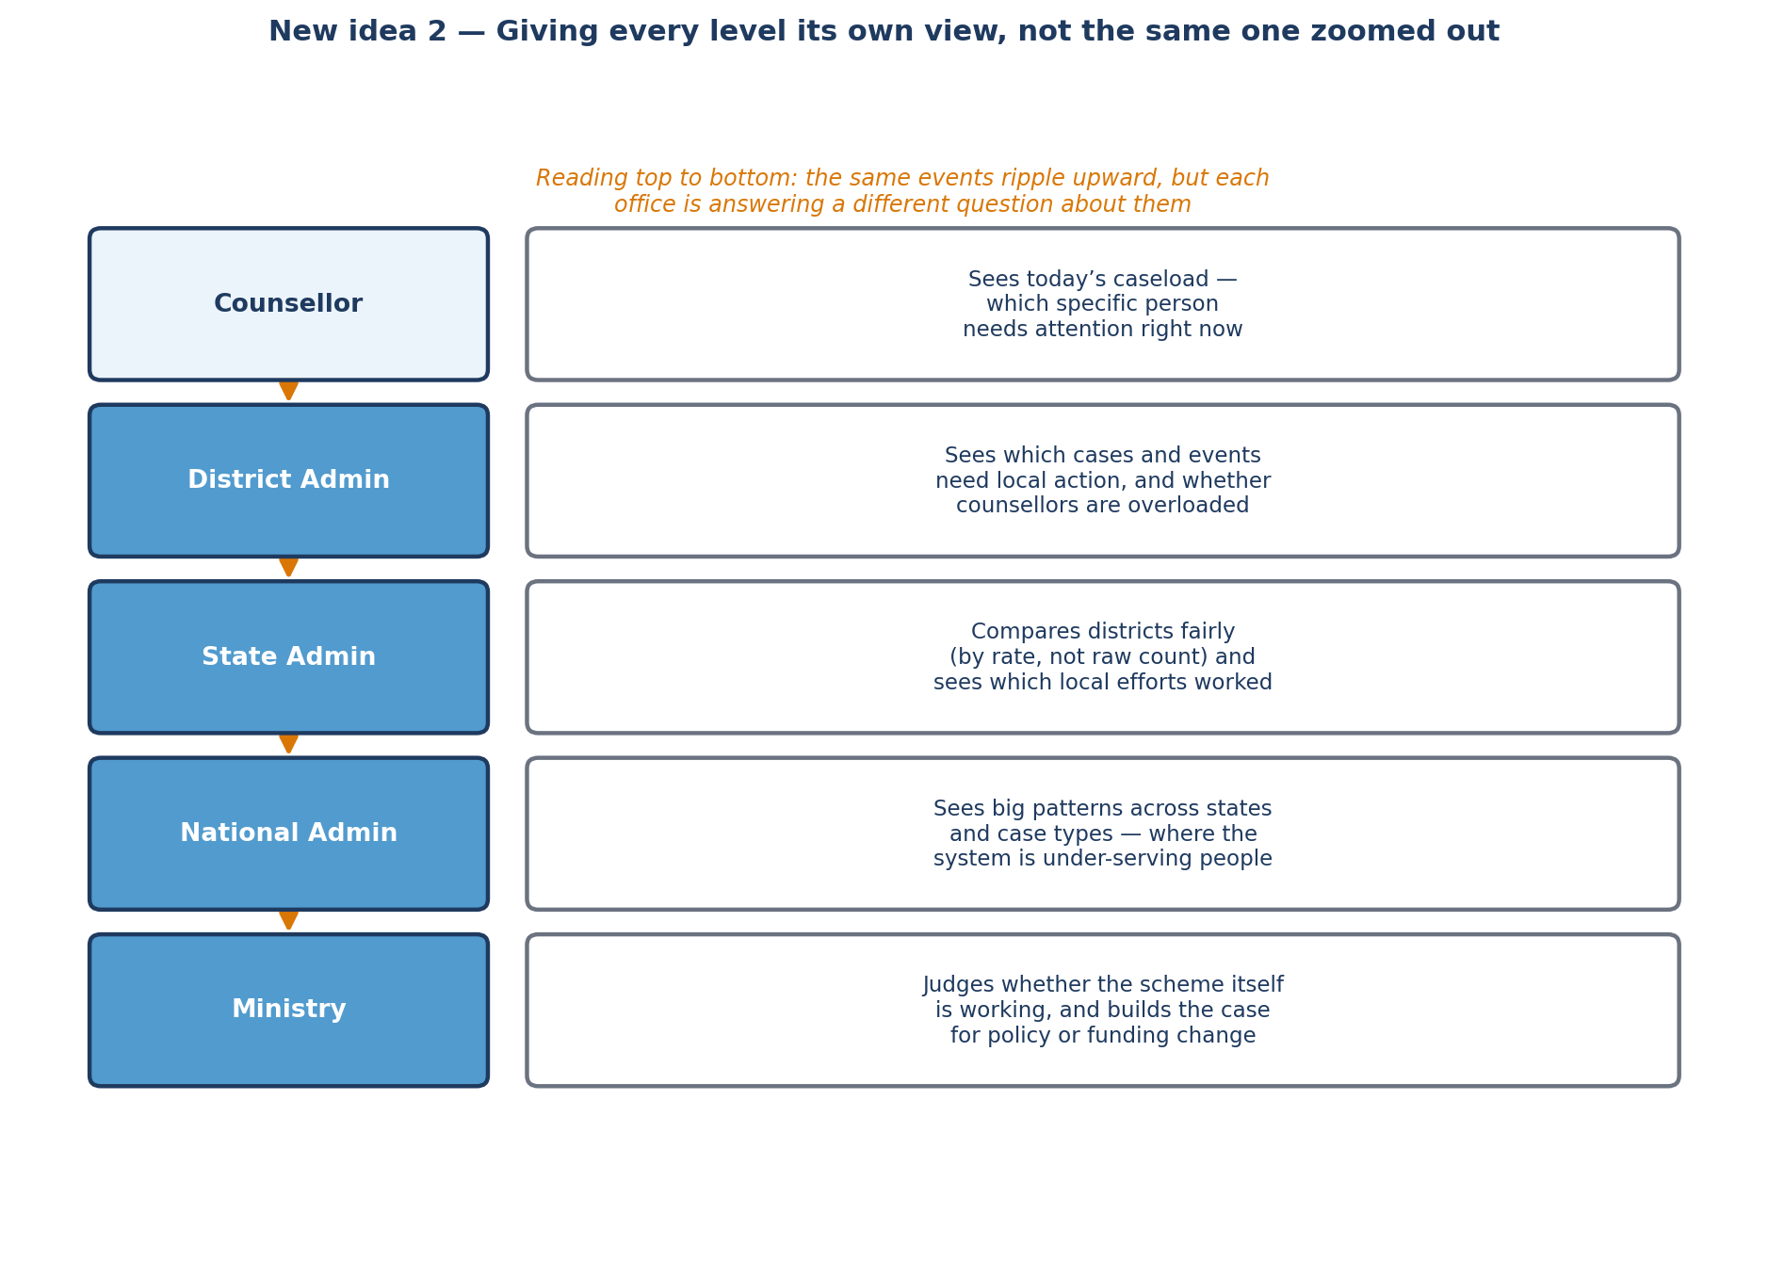
The same underlying events, a different question asked at every level

B.3 — Fix Reports: let the right office send them, and make them readable
This is discussed in more depth in B.6 below, but the shape of the fix is: give District and State Admin a real button to package up and send their own numbers upward (today only Ministry can generate a report, and only for itself), and replace the receiving screen’s raw data dump with an actual readable summary.
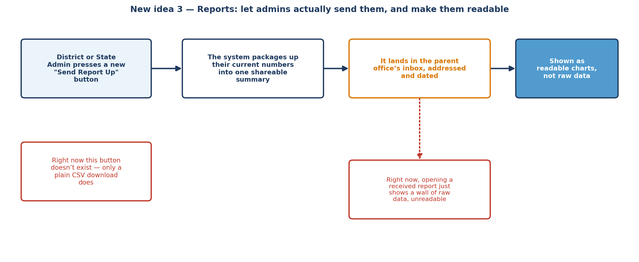
From "only Ministry can do this" to a real two-way, readable exchange

B.4 — Turn Policy Tracking from a marker into a measurement
Also covered in depth in B.6. In short: right now noting that a policy launched just places a marker on a chart. The fix is to have the system actually compare distress levels before and after that date, so a State Admin can tell whether a policy tried in one district measurably helped — not just that it happened.
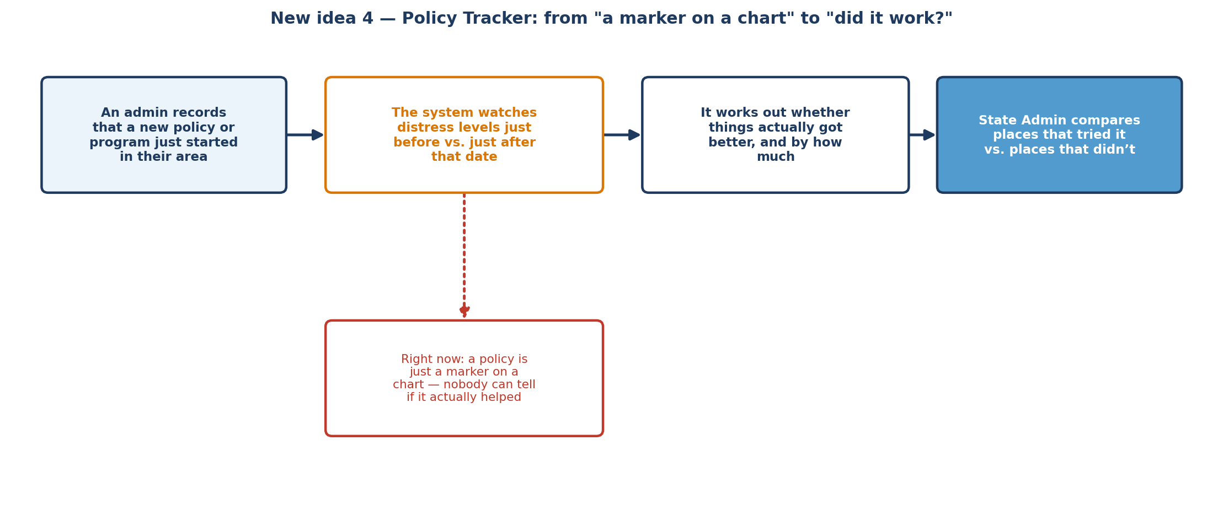
From "a policy launched here" to "and here is what changed because of it"

B.5 — Finish Emergency Broadcast, and let danger patterns trigger it automatically
Also covered in depth in B.6. In short: District, State, and National Admin can already send an emergency broadcast on the backend, but only Ministry actually has a screen to do it from. The fix is to give each office its own simple version of that screen, and — as a further step — let the AI trigger a broadcast automatically when it notices a dangerous pattern across several victims tied to the same case, instead of waiting for a person to notice first.
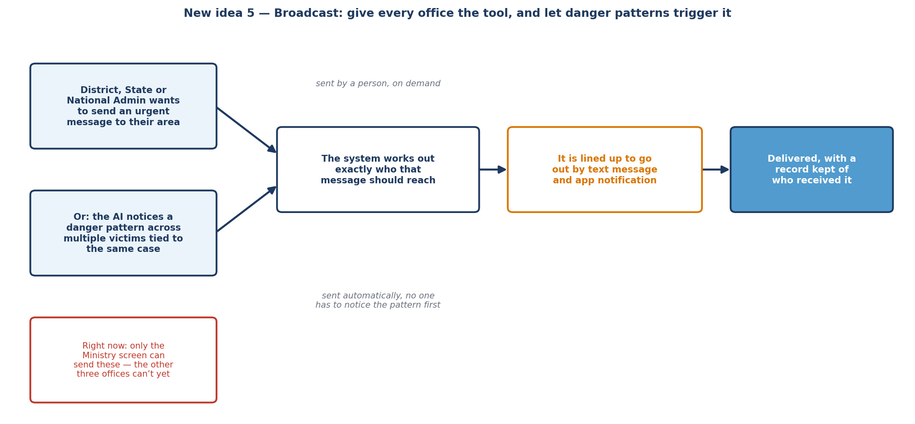
From one office having the tool, to every relevant office having it — and the AI able to use it too

B.6 — Do We Need Reports, Policy Tracking, and Broadcast? A Direct Answer
This section exists to answer one direct question: are these three existing features actually needed, and if so, what exactly is wrong with them today. The short answer for all three is keep — but two of them are only half-built, and the reasoning differs for each, so each is treated on its own below.

B.6.1 Reports — keep, and it needs real work
This one is not optional — the project’s own feature list explicitly requires District and State Admin to "generate and share reports... upwards with the Super Admin," and requires Ministry to "receive and analyze" what comes in. So the feature is correctly in scope. The problem is that only half of it was built.
- What actually works today: the backend for generating a report, saving it, and routing it to a parent office is solid — it supports drafts, submission, and a "reviewed" state, and can carry a written note alongside the numbers.
- What is missing: a District or State Admin has no button anywhere in their own screens that uses any of this. The only "report" action they can see is a plain CSV download, which is not the same feature at all. Right now, the only person who can actually generate and send one of these reports is Ministry itself, generating one for whatever jurisdiction it chooses — which is the opposite of what the spec describes (the base-level office is supposed to push a report upward, not have the top office pull one down).
- The other problem: when a report does arrive, opening it just shows a wall of raw underlying data, not something a person can actually read at a glance. "View and analyze," as the spec puts it, is not really happening — there is nothing to analyze, only to scroll through.
How to fix it:
- Give District and State Admin their own "Send Report Up" action, sitting right where they already look at their own numbers — so sending a report is a natural next step after reviewing the dashboard, not a separate hidden feature.
- Replace the raw-data view on the receiving side with the same kind of charts the sending office already sees — a trend line, a severity breakdown, a short written note — so "reviewing" a report is actually possible.
- Once B.1 and B.2 exist, let a report optionally carry the new tier-specific view (the case-event overlay for a district report, the comparison view for a state report) instead of only the generic numbers it carries today.

B.6.2 Policy Tracking — keep, but it is currently too shallow to be useful
This one is not named as its own separate feature in the spec, but it is a reasonable and deliberate way of building the "longitudinal data for evidence-based policymaking" the spec explicitly asks National Admin to have. The problem is that it currently stops at "a policy exists and happened on this date" — it does not go the extra step of actually saying whether it worked.
- What actually works today: an admin can log that a policy or program launched, with a title, a description, and a date, and it appears as a marker on the existing trend chart.
- What is missing: nothing compares distress levels before and after that date, and nothing compares one district that tried a policy against a similar one that didn’t. As it stands, the feature can tell you that something happened, but never whether it helped — which is the entire reason a policymaker would want this in the first place.
How to fix it, without adding a new table:
- For each logged policy, automatically work out the average distress level in the weeks just before its launch date and the weeks just after, for the district it applies to.
- Show that before-and-after change directly next to the policy, instead of leaving it as an unexplained marker on a chart.
- At the State Admin level, let two or more districts that logged a similar policy be compared side by side, and let a district that never adopted it serve as a natural baseline for comparison.

B.6.3 Emergency Broadcast — keep, but finish it and connect it to something real
This is the one of the three that was never in the original feature list at all — it was added later as a useful extra, not requested by the base problem statement. That does not make it wrong to keep; mass-notifying everyone in an area during a real emergency is a legitimate, safety-relevant capability. But it is currently the most unevenly built of the three, and today it does not connect to anything else the system already knows.
- What actually works today: the underlying mechanism — working out who should receive a message and queuing it for delivery by text and app notification — is built correctly, and was built three times over (once for District, once for State, once for National Admin, each scoped to their own area).
- What is missing: a screen to actually use it exists only for Ministry. District, State, and National Admin each have the machinery working behind the scenes but no button anywhere to trigger it themselves. And separately, nothing about it is connected to the AI’s own risk detection — it only ever fires when a person remembers to open the screen and write a message by hand.
How to fix it — two options, not mutually exclusive:
- Finish what is already three-quarters built: give District, State, and National Admin their own small version of the same screen Ministry already has, scoped to their own area. This is the cheaper of the two, since the hard part (working out who receives it, and delivering it) already exists for all three.
- Connect it to a real trigger, not just a person’s judgment: the project’s own backlog already describes a related idea — when the AI notices a coordinated distress spike across several victims tied to the same case (a strong sign of intimidation, not coincidence), that is exactly the situation broadcast-style urgent notification exists for. Wiring the two together turns broadcast from "a tool someone has to remember to use" into a safety net that activates itself.
If neither of these is done, Broadcast is the one candidate genuinely worth reconsidering — not because the idea is bad, but because half-finished, disconnected safety tooling is worse than not having it, since it creates a false impression that every office can already do this. The recommendation here is to finish it, not remove it: the hard engineering work is already done three times over, and completing the remaining screen is small compared to what has already been built.

Part C — Suggested Order
- 1. Case-event timeline (B.1). Foundational — nearly every other addition in this document either depends on it or becomes much more valuable once it exists.
- 2. Reports self-service + readable view (B.6.1). Backend mostly exists; this is closing a gap, not building something new.
- 3. District-tier view (B.2). Builds directly on B.1 and delivers value to the office with the most day-to-day cases.
- 4. Policy impact measurement (B.6.2). A calculation on top of data that already exists — no new data collection required.
- 5. State and National comparative views (B.2). Naturally follow once B.1–B.4 exist, since they are largely aggregations of the same underlying data.
- 6. Broadcast completion (B.6.3). Independent of the rest — can be done at any point, but is lower priority than the analytics work above since it does not depend on, or unlock, anything else here.

This document is a design and planning note only — no schema changes, endpoints, or UI have been implemented yet.

