New Roles & Government-Integration Plan
End-to-End Implementation Plan for Investigating Officer, Independent Oversight, and the Legal Aid / Medical Help / Witness Protection Referrals — walked through with Pravin’s real two-case account

Problem Statement | SIH26094 — AI-Powered Dynamic Mental Health Monitoring and Distress Prediction System for Victims of Atrocities
Scope of this document | Detailed build plan for two new roles and three government-integration referrals, with flow diagrams and a concrete worked example
Companion document | SIH26094_Admin_Analytics_Case_Study.docx covers the admin analytics feature separately — this document is scoped only to the roles/integrations below
Status | Planning / pre-implementation — no code written yet

0. Required, Integrate, or Recommended — Reading the PS Honestly First
Before any of the roles below, it matters which parts of this plan the problem statement actually requires, which parts are things the government already provides that Mansakha must integrate with rather than rebuild, and which parts are this document’s own design proposal for satisfying a real requirement.

0.1 Required for sure — verbatim from the PS
- Regular check-ins, NLP + sentiment + emotion + voice-stress AI, a Dynamic Distress Score as a trend, automatic threshold alerts, and district/state/national dashboards — all already built.
- “Actionable recommendations: counselling, medical help, witness protection, relocation, financial aid, legal aid” — the PS names all six explicitly (Literature Survey §2). The Decision Panel already offers all six as choices, but several currently just save a text note nobody acts on. Closing those loops (Section 5 below) is not a bonus feature — it is finishing a requirement that is already half-built, and witness protection belongs on this list exactly like legal aid does, no differently.
- “Case-timeline-aware prediction” — correlating hearing dates, bail status and chargesheet delays with the distress score, explicitly named as “the genuinely new piece no existing system currently does” (Literature Survey §5).

0.2 What government already provides — integrate, do not rebuild
Existing facility | What it already does | How this plan uses it
Tele-MANAS (14416), Ministry of Health | 24/7 counselling + psychiatric consultation + AI triage | The PS explicitly says to reuse Tele-MANAS’s counsellor network instead of building a separate call centre — “Need medical help” hands off here (Section 5)
NHAA/SAMBAL (14566), MoSJE’s own portal | Tracks FIR/chargesheet/compensation; NGOs already check status there | Reuse the same case ID — Mansakha’s docket number maps to NHAA’s own case reference; this is also why no separate NGO-facing screen belongs inside Mansakha
Witness Protection Scheme, 2018 | Provides escort, relocation, identity change via a district Competent Authority (District & Sessions Judge, DM, SP) — but with no digital renewal tracking; orders lapse silently after 3 months | “Need witness protection”, escort, and relocation all route to this same real Competent Authority as a referral (Section 5) — Mansakha never assesses threat itself

0.3 This document’s own recommendation — honestly labeled
The two new roles below are this plan’s proposed mechanism for satisfying the requirements above — the Feature Catalog does not name them by title. Investigating Officer is strongly grounded in the Act’s own chargesheet process. Independent Oversight is the weaker-grounded of the two — nothing in the PS or its own backlog document asks for it. It is a reasonable accountability argument built from real constitutional structure (Section 6), but it is the one piece here that could be dropped without contradicting anything the PS actually requires.
An earlier draft of this plan also proposed a District Magistrate role that would let the AI auto-detect a “coordinated distress spike” and auto-draft a Section 15A protection request for a DM to approve. That was removed: a distress score measures psychological state, not physical threat, and having the AI trigger a legal protection action off a mental-health signal risks a real category error — the AI could be confidently wrong in both directions (flagging a synchronized reaction to a hard hearing as intimidation, or missing real intimidation from someone who masks their fear). Witness protection stays fully in scope as a PS requirement; it just does not need a new AI mechanism or a new approval role to satisfy that requirement — a human-triggered referral, exactly like legal aid, does the job correctly.

1. System Map — Where Everything Sits
Two new roles, three things that are deliberately not roles, and one existing shared identity that none of this touches.
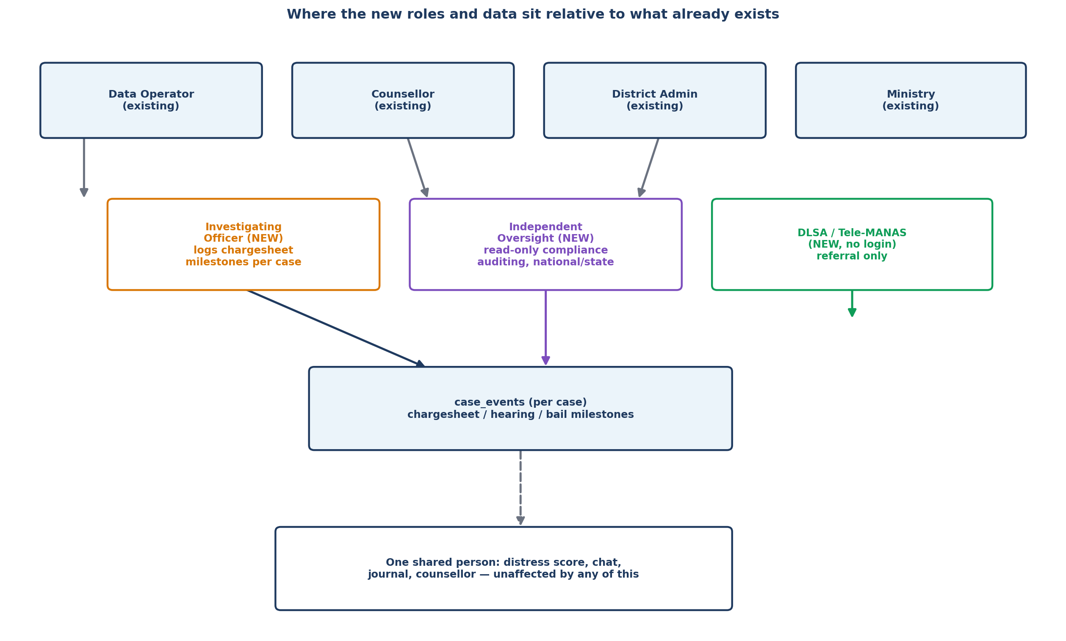
The new roles and referrals relative to what already exists in Mansakha

2. The Design Principle This Whole Plan Depends On
Every addition here has to answer one question correctly: does it belong to the person, or to the specific case? Distress score, chat, journal, and the assigned counsellor belong to the person. Case events and every referral in this document belong to the specific case — exactly like case notes and case stage already do. Pravin’s real account proves why this matters, not just illustrates it.
 | Docket 1 | Docket 2
Jurisdiction | Porbandar, Gujarat | Ballia, Uttar Pradesh
Case type / stage | Murder / Grievous Hurt / Arson — Trial | Rape — Rehabilitation

Two different states, two different accused, two completely unrelated proceedings — sharing only one person’s mental-health identity and one counsellor (Sunita Sharma). A chargesheet-delay event from the Gujarat murder case has no business appearing on the Uttar Pradesh rape case’s timeline, and a witness-protection referral for one has nothing to do with the other.
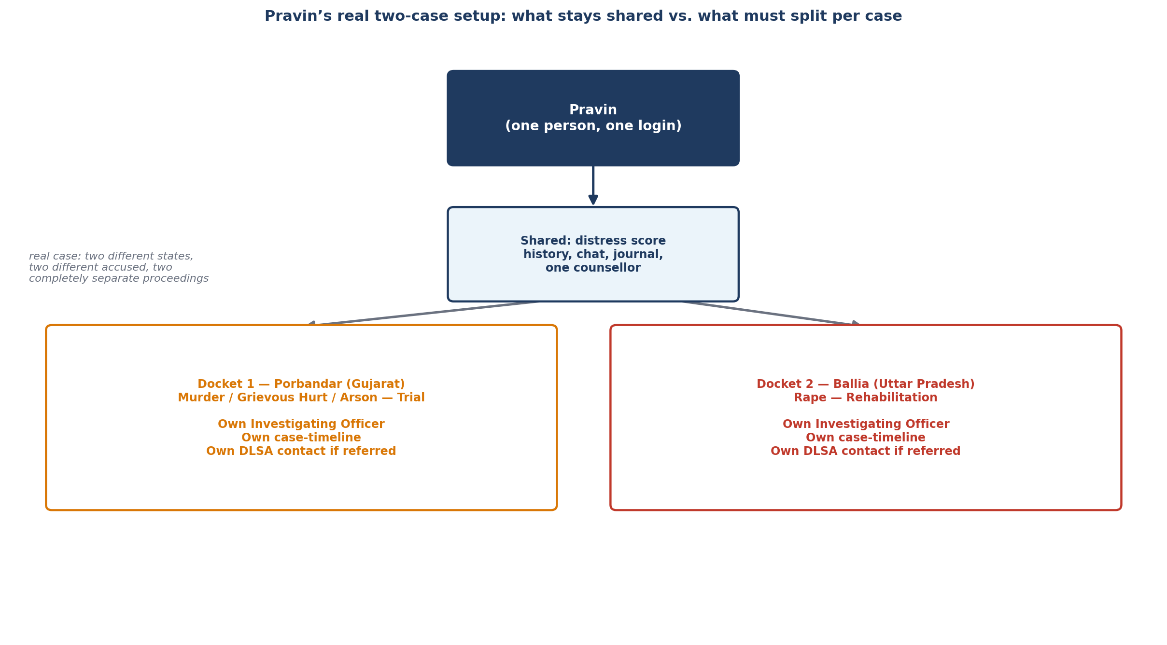
What stays shared vs. what must split per case, using Pravin’s real account

3. The Two New Roles — Definition and Account Model
Role | Real-world office | Job inside Mansakha | One account, or many?
Investigating Officer | The specific IO assigned to a case’s investigation (the Act requires at least DSP rank) | Logs chargesheet-stage milestones only, for cases they are personally assigned to | Many — one account per real individual, scoped to their assigned cases, not a whole district
Independent Oversight | National Commission for Scheduled Castes, and State Commissions for SC/ST where they exist | Read-only compliance auditing — response-time SLAs and outcome patterns | Many, at two scopes — a national account type and a state-bounded account type, always read-only

Investigating Officer replaces an earlier, broader draft of this role that also included the Special Public Prosecutor. The IO is only in the loop during the investigation phase, before a chargesheet is filed — exactly the phase no court record (real or simulated) will ever have, because the case hasn’t reached court yet. Trial-stage events (hearings, bail) are what the court-data lookup in Section 7 is for.

4. Investigating Officer — Full Flow
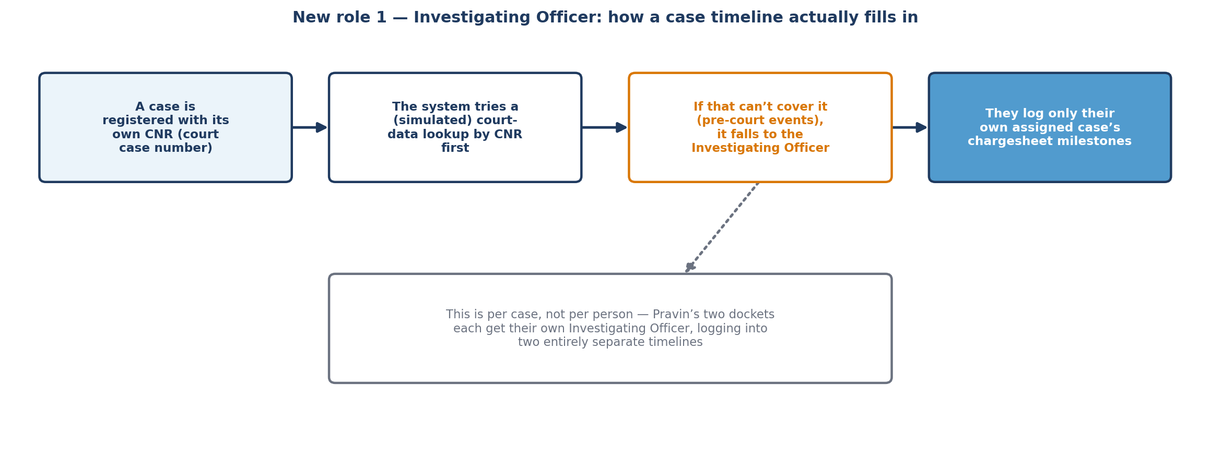
How a case timeline actually fills in, per case

Step by step:
- A case is registered (by Data Operator, as already happens today) with one new field: its CNR, the court case number, captured the same way docket number and case type already are.
- For any case-timeline question, the system first tries a court-data lookup by that CNR (Section 7) — no human needed for that path.
- Investigation-stage milestones (chargesheet filed, chargesheet delayed) will never appear in that lookup, because they happen before the case reaches court. Those fall to the assigned Investigating Officer.
- The IO sees only their own assigned cases — docket number and case type, nothing else identifying — and one action: log an event from a fixed list, pick a date, optional short note.
- That event is stored against that specific case and feeds directly into the case-timeline correlation view District Admin sees (the analytics feature covered in the companion document).
Deliberately excluded from this role: any visibility into distress scores, chat, journal, or counsellor notes — the same population this system exists to protect can, in some cases, face intimidation with local police influence, so this role’s access stays narrow and one-directional by design.

5. Closing Three Existing Loops — No New Login, No AI Detection, for Any of Them
The Decision Panel already offers "Need medical counselling / escort / legal aid / relocation," and witness protection is named directly in the PS as a required recommendation. All three below are triggered entirely by a counsellor’s own judgment — the AI never initiates any of these on its own.
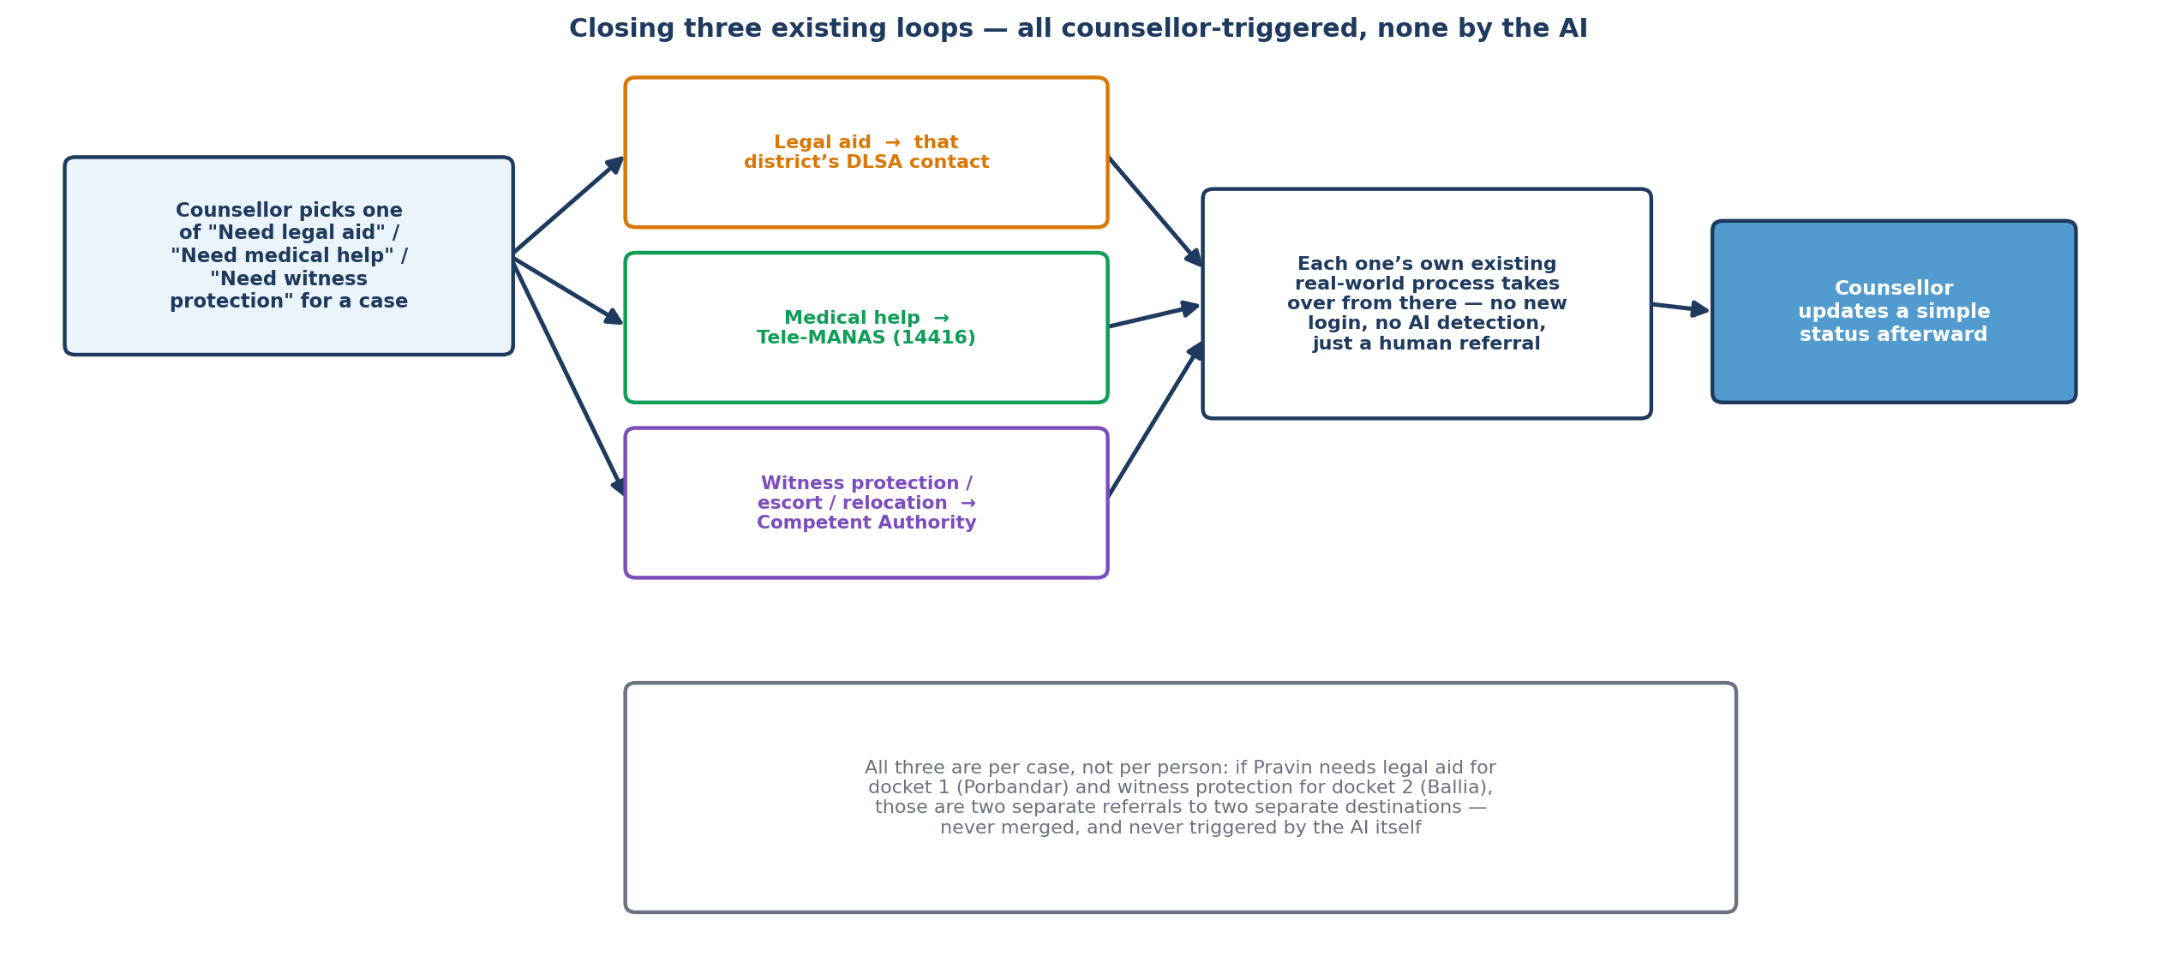
Three referrals, three real destinations, no new accounts and no AI trigger

Decision | Real destination | Why no login or AI detection is needed
Need legal aid | That district’s DLSA (District Legal Services Authority) contact | DLSA intake is still largely manual and local — a notification reaches someone through a channel they already check
Need medical help | Tele-MANAS (14416) | The PS explicitly names reusing Tele-MANAS’s own counsellor network — a national helpline, not a per-district contact to maintain
Need witness protection / escort / relocation | That district’s Competent Authority under the Witness Protection Scheme (District & Sessions Judge, DM, SP) | Only people trained to assess real physical risk should decide this — the counsellor refers based on their own judgment of the situation, and the Competent Authority runs the actual threat assessment. Mansakha never claims to detect a threat itself

All three are per case, exactly like the Investigating Officer role — a referral logged against Pravin’s docket 1 goes to Porbandar’s contact; the same decision logged against docket 2 goes to Ballia’s.

6. Independent Oversight — Features and Functioning
No flow diagram for this one — there is no multi-step process, only a read-only view. Access is bounded by data type, not geography: compliance data only, never individual case content.
- A national compliance dashboard: response-time SLAs (alert to counsellor action), referral follow-through rates, and outcome patterns by state and district.
- Drill-down into any state or district’s compliance numbers — never into an individual victim’s case, chat, or journal.
- The same audit log Ministry already sees, but read by a genuinely separate party rather than through Ministry’s own screen.
- No edit or action capability anywhere — this role investigates and reports, matching the Commission’s real constitutional mandate.

7. The Court-Data Lookup — Simulated for Now, Real Later
Not a role — a backend data step, keyed by CNR, feeding the same case-timeline data structure the Investigating Officer writes to.
NJDG does not offer an open public API for third-party systems today — what exists is a public website meant for a person searching in a browser. Real system-to-system access would mean going through the eCourts eCommittee/NIC’s formal data-sharing process, which isn’t realistic for this build right now.
- Build this simulated, the same way NHAA’s “Fetch Case Details” is already simulated in this project.
- Architect the lookup as a single, swappable function, so a real integration can replace it later.
- Treat the Investigating Officer role as the actual near-term mechanism, not a rare fallback.

8. End-to-End Walkthrough — Pravin’s Two Real Cases
Docket 1: Murder/Grievous Hurt/Arson, Porbandar, Gujarat, currently at Trial. Docket 2: Rape, Ballia, Uttar Pradesh, currently at Rehabilitation — a later stage, meaning its investigation and trial already happened. Both are linked to the same person and the same counsellor, Sunita Sharma.

8.1 Setting up the timelines
- At registration, Data Operator captures a CNR for each docket separately — two unrelated court records, two unrelated lookups.
- Docket 1 is at Trial, so the (simulated) court-data lookup by its CNR returns a live sequence of hearing dates.
- Docket 2 is already at Rehabilitation — its Investigating Officer would have logged the chargesheet-filed event back when the case was still at that earlier stage.
- Both timelines render on Sunita’s existing Case Detail screen for Pravin, one per docket, through the same Switch Case dropdown already built for multi-case support.

8.2 Two referrals, two different districts, on the same day
During a session on docket 2 (Ballia), Sunita logs “Need medical help.” Because this routes to Tele-MANAS — a national line — it doesn’t matter which docket triggered it. Separately, reviewing docket 1 (Porbandar), she logs “Need legal aid” for an appeal-related matter, which goes specifically to Porbandar’s DLSA contact — not Ballia’s, even though it’s the same counsellor, the same person, the same day.

8.3 A witness protection referral, on her own judgment
Some weeks later, during a routine session on docket 1, Sunita has reason to believe — from what Pravin actually tells her, not from any score or AI flag — that he may be facing pressure related to the Porbandar case. She logs “Need witness protection” against docket 1. This is entirely her own professional judgment, made the same way she’d decide “need legal aid” — the system never suggested it. The referral goes to Porbandar’s Competent Authority, who run the actual threat assessment; Mansakha’s role ends at making sure that referral reaches the right district, addressed correctly, without delay.

8.4 What the Commission sees, months later
Independent Oversight, reviewing national compliance data, sees Pravin’s account contribute two entries to national case-volume counts (case-volume reporting counts by case, not by person — a deliberate, existing decision) — but his actual distress-outcome trend counts once, not twice, in any efficacy-style metric, because that fix was already built during the multi-case work earlier this session. The witness-protection referral shows up in Porbandar’s referral-response-time metric; Ballia contributes nothing to it, because no referral was ever logged there.

9. What Actually Needs to Be Built
New data | Scope | Notes
case_events table | Per case (like case_notes) | Stores chargesheet/hearing/bail milestones, whether from the IO or the simulated court-data lookup
CNR field | Per case | Added to the existing case registration form (Data Operator)
Contact registries | Per district (DLSA, Competent Authority) / national (Tele-MANAS number) | Maintained in Ministry’s existing System Configuration area — same pattern already used for case types and intervention types
Investigating Officer page | New, minimal | Case list scoped to assignment + one “log an event” form
Independent Oversight page | New, read-only | National/state compliance dashboard + audit log viewer
Referral notification | Reuses existing dispatch pipeline | One SMS/email per referral, to the relevant contact registry entry — no new delivery infrastructure

10. Suggested Build Order
- 1. case_events + CNR field + simulated court-data lookup. Foundational — the Investigating Officer role and the case-timeline analytics both depend on this existing first.
- 2. Investigating Officer role. The real near-term mechanism, per Section 7’s honest assessment of NJDG access.
- 3. The three referrals (legal aid, medical, witness protection). Cheapest additions here — one notification each, reusing the existing dispatch pipeline, no new accounts, no AI logic.
- 4. Independent Oversight. Last — it only has something to show once the above are producing real compliance data to audit.

This document is a design and planning note only — no schema changes, endpoints, or UI have been implemented yet.

