COSTING:

The two major components in ASIC costs are:

* ASIC development costs
* ASIC unit cost

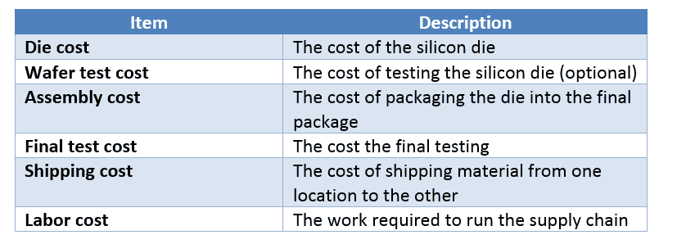

Ref link : <https://anysilicon.com/calculate-asic-unit-cost/> - for more info on each above mentioned

Example :

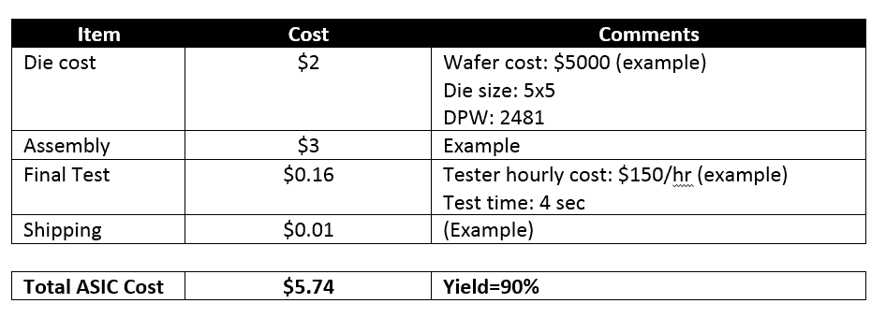

**ASIC Development cost calculator:** <https://www.sigenics.com/page/asic-cost-calculator>

**ASIC Cost:**

You should take the ASIC avenue only if you cannot meet your goals using standard off-the-shelf chips. ASIC development cost can be high and will require you to make an upfront payment for the engineering and production tooling cost (in addition to the unit cost).

ASIC design cost varies from vendor to vendor but consists usually of the following items:

* **ASIC development cost** – this item will cover the engineering hours required to design your ASIC. Hint: ASIC design companies that have done similar ASICs in the past will most likely be cheaper as the can utilize their past experience.
* **ASIC development software** – ASIC engineers are using software tools to design and simulate the ASIC before they go to production. These tools are called EDA tools. This cost will probably be included in the ASIC development cost (above).
* **IP cores** – these are ASIC blocks or sub-blocks that have been already designed by IP core companies and can be acquired per project. The cost of the IP block is lower than designing the IP block from scratch, so it’s a clever idea to use them.
* **Prototype cost** – this item will cover the cost of the 50-100 first porotypes that can be used for product testing and validation.
* **ASIC production tooling** – these are the tools that will be used in production to manufacture your ASIC. Usually consisting of: maskset, package tools and a test solution.
* **ASIC qualification** – in this phase, you’ll need to perform several reliability test to ensure your ASIC manufacturing process is robust and generates quality products.

How much does it cost to design and fabricate an integrated circuit?

🡪 <https://www.quora.com/How-much-does-it-cost-to-design-and-fabricate-an-integrated-circuit>

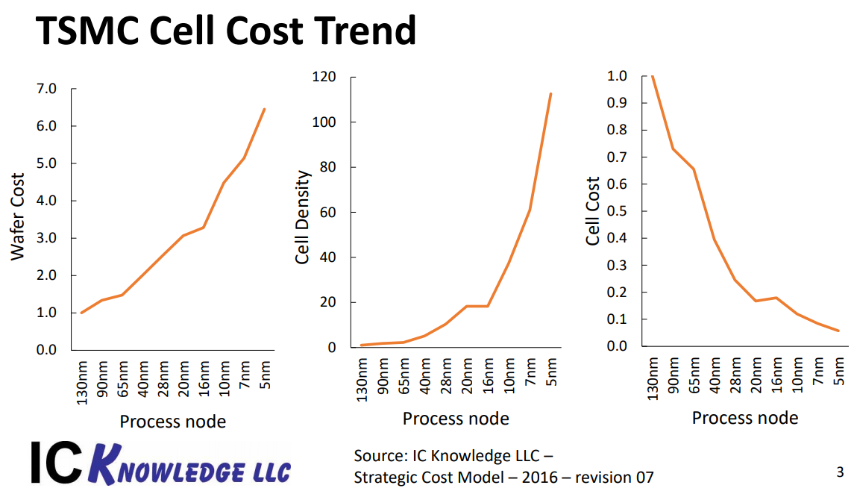

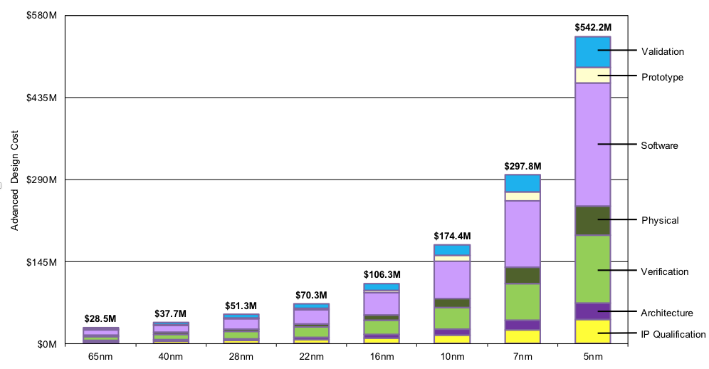

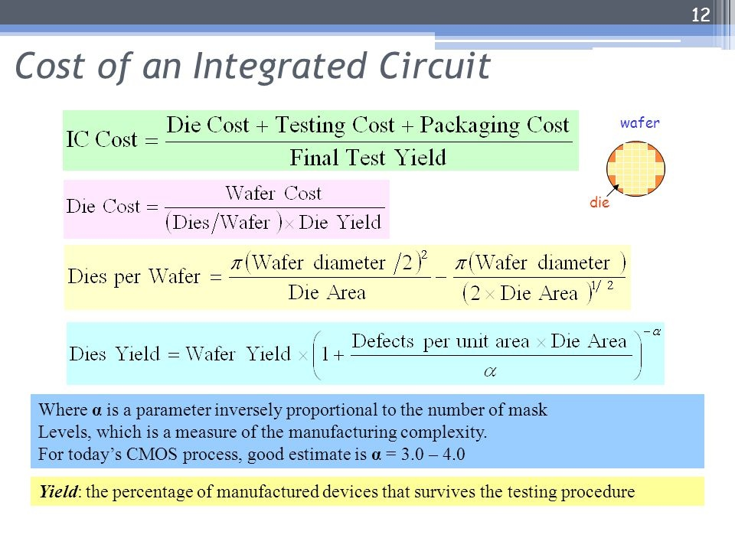

Hi! I was wondering how is the semiconductor wafer price is actually constructed? are there any impact on volume or other options?

March 05, 2019 at 2:22 pm [#8276](https://anysilicon.com/forums/topic/wafer-price/#post-8276)

**LP**

I guess the main reason for your question is because you understand that wafer cost can vary based on different parameters, I will try to list them here:

– Firstly, the main price factor is related to the **wafer technology node**. Meant, that 65nm wafers will cost more than 180nm wafers.  
– Then you need to consider **the total number of mask layers**. Meant, how many metal layers do you use in your design and whether you need additional layers for various options you might need: eFlash, MIM cap, HVT, LVT, etc all these features add more complexity to your wafer configuration and hence increase the price.  
– Process maturity – of course **the new processes will cost more money**. A decade ago, I used 65nm process, the mask set price was 700K US$. This the price is half.  
-Process **defect density**, when you buy wafers from any fab, you buy the good and bad wafers. Therefore, you have a big interest that the fab has high yield on the target process (ask them).

Hidden costs:

🡪<https://www.quora.com/What-hidden-costs-are-there-for-Hardware-Start-ups>

* Hidden cost most people don't think about is **regulatory approval** and **safety certification testing**.

Average cost of regulatory and safety testing is between $5,000 and $50,000 depending on the complexity of the product, the testing required, and how many tries it takes to pass. Those numbers do not include the cost of your engineering staff's time putting together the documentation nor the costs of creating a new revision of the product to correct any deficiencies uncovered by the testing.

*To figure what the hidden costs are, you'll need to know how the typical development cycle for a hardware/electronics product looks like.   
  
**Start: Idea**  
  
***Step 1) Market Research & Analysis***

* Verify that there's an actual market for your good idea.  (Environment scanning, market analysis, TAM ... etc)
* Understand the people who will buy your product (Consumer behavior analysis, customer needs & wants analysis)
* Understand your competitors &  what's currently on the market to fulfill the above, and how yours can  do better (competitor analysis)
* Product  specs (this is where you determine what exactly you want to do that can  fulfill the consumer's needs & wants better than anything that's  currently available)
* Cost & Break-even analysis (How much is  it going to cost to do all this.  Can you afford the initial burns?  Are  the margins enough?)

***Step 2) Idea => Initial design or proof-of-concept***

* Before you involve a manufacturer, do your initial Industrial Design (3D CAD  files).  What do you want the end product to look like?
* Decide on your CMF (color/material/finish) requirements.  Look & Feel comes into play here.
* Put together an initial prototype or proof-of-concept.  After all, it's  your responsibility to make sure your idea works.  Initially, the  PCBA/electronics may be bulky and awkward with possibly different boards  connecting to each other and ugly wires sticking out.  You may need  partial or total redesign to shrink it into a size that can fit into  your industrial design / final enclosures.  This may mean modifying your  schematics, BOM (Bill of Materials), and ultimately your layout (gerber  file).  If you lack the engineering resources, it's fine to approach  the manufacturer with just a proof-of-concept to communicate your idea.   If you're talking about a *mature* product (ie, laptops, cell  phones) that the manufacturer has tons of experience with, you may not  even need to have a proof-of-concept (just specs & industrial design  is fine).

*At this point, you'd be more or less ready to let a qualified ODM/manufacturer get involved, who will:*   
  
***Step 3) RFQ process***

* Perform feasibility evaluation on industrial design => give DFM recommendations where necessary.
* Perform BOM checks => give component switch recommendations where  necessary (ie, EOL check, same performance but lower cost, better  lead-times, better terms ... etc).  Be aware that pricing and terms get  more attractive with volume.
* After back & forth discussion on  spec clarification/confirmation and feasibility evaluation, the  manufacturer will give you a quotation including fixed costs like  tooling, NRE (non-recurring engineering costs), certification fees, and  unit costs.  The manufacturer will also tell you the payment terms and  breakdown schedule.
* You will choose a manufacturer from the batch you approached (ie, award the project), and progress the  project further with this manufacturer.

***Step 4) Design***

* Yup, although you've already done the industrial design, some mechanical  engineering work is still needed to design the inner structures in a way  for the entire device to be strong, robust, and manufacturable.
* The manufacturer will then create a  mockup/prototype of its own to verify the mechanical engineering. After  all, tooling is expensive and you'd want to get it right on the first  try.
* In parallel, EE modifications and long lead-time parts will be purchased at this point.

***Step 5) EVT (Engineering Verification Test)***

* After the mechanical design is verified via mockup/prototypes, the tooling/molding can start.  This could take around 6 weeks.
* On the electrical side, the manufacturer would be preparing the  materials for the production run of the first samples, including the  PCB.
* These first samples would be used mainly for functional testing and basic performance testing.
* Not everything would be perfect here.  Engineers would debug the bugs and modify the design for the next samples run.

***Step 6) DVT (Design Verification Test)***

* At  this point, the basic functions should all work, and focus would be put  on tweaking the design to optimize performance.  More intensive testing  would be performed at this stage, including environmental, reliability,  compatibility, and other quality tests.  This is to ensure that the  product could work for a long time, at a variety of environment.
* It's also at this stage where samples  would be sent out to pass regulatory tests to receive the necessary  certifications (ie, FCC, CE, CCC ...etc) where you want the devices to  be sold.
* At the end of this stage, all design bugs should be cleared and the design should be fixed.

***Step 7) PVT (Pilot Verification Test)***

* This stage  focuses on optimizing the production process => how to "multiply from  one to many" the most efficiently, utilizing the best use of time and  human resources, with the least failure rate.  Quality assurance,  industrial engineers, production engineers and others all work hard  together to make this happen.
* A small-volume pilot run of a few  hundred units would take place to test and optimize this process.  At  this point, you, the customer would usually be present at the  manufacturer to audit everything and make sure everything is going  according to the customer's standards and tastes.
* At the end of this stage, the customer would give the green light for mass production.

***Step 8) MP (Mass Production) and shipment***

* Mass production, shipment, and may good things happen.
* Be sure to receive the necessary certificates before shipment to that particular country.

From experience, the entire process takes six months to 15 months to complete, and this duration depends on the complexity of the product and the contract manufacturer that you work with.

More information:

<https://electronics.stackexchange.com/questions/7042/how-much-does-it-cost-to-have-a-custom-asic-made>

<https://www.fierceelectronics.com/sponsored/era-affordability-for-custom-system-chips-socs>