**PL/SQL**

Q1: Write a PL/SQL program to find the factorial of a given number

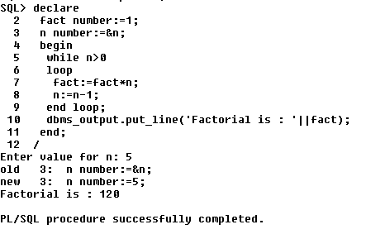

Q2: Write a PL/SQL program to check whether the given no is prime or not

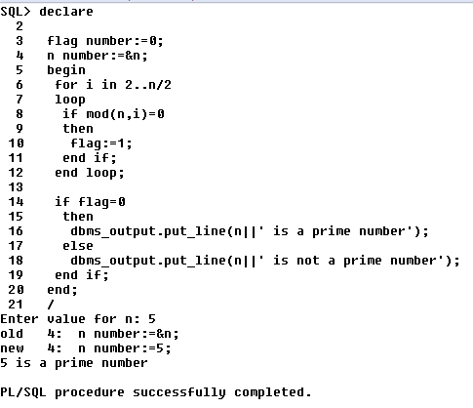

**Functions**

Q1: Write a PL/SQL program to Check whether a number is Armstrong or

not using functions

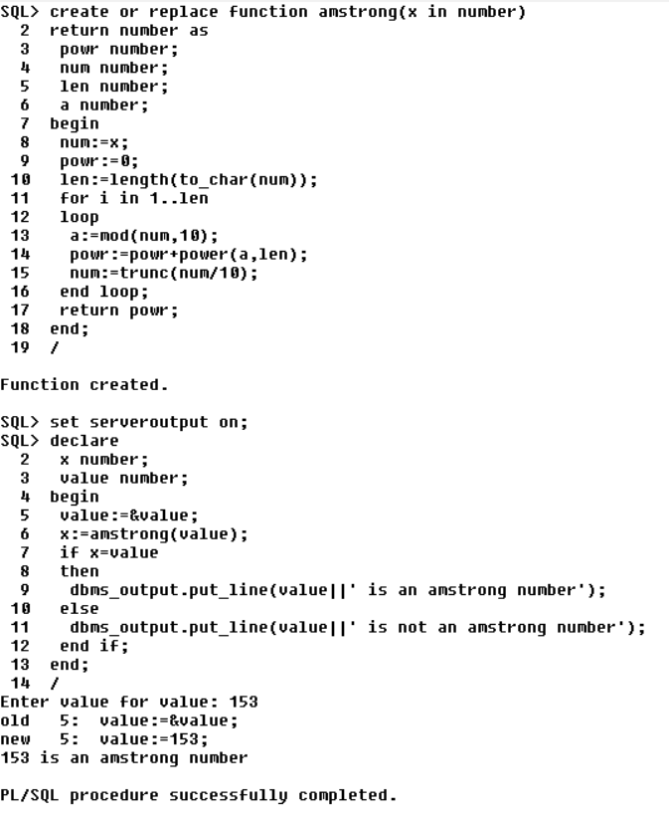

Q2.Create table that contains itemid,item_name &amp; price of several items sold in a grocery shop, Using functions retrieve the item name &amp; price from table when itemid is given as input.

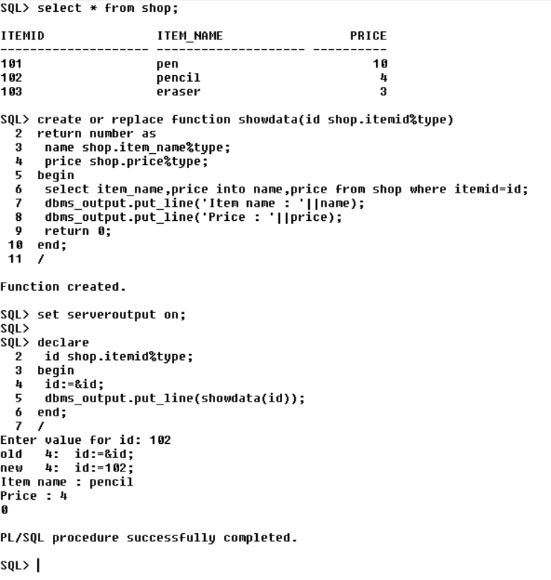

Q3.Write a PL/SQL function called POW that takes two numbers as argument and return the value of the first number raised to the power of the second.

