**CO1 PROGRAMS**

**CO1_2 : Display future leap years from current year to a final year entered by user.**

**INPUT :**

s=int(input("Enter start year:"))

e=int(input("Enter end year:"))

if(s<e):

print("Leap years are:",end=" ")

for i in range(s,e):

if (i%4==0) or (i % 100 !=0) and (i%4==0):

print(i,end=" ")

**OUTPUT :**

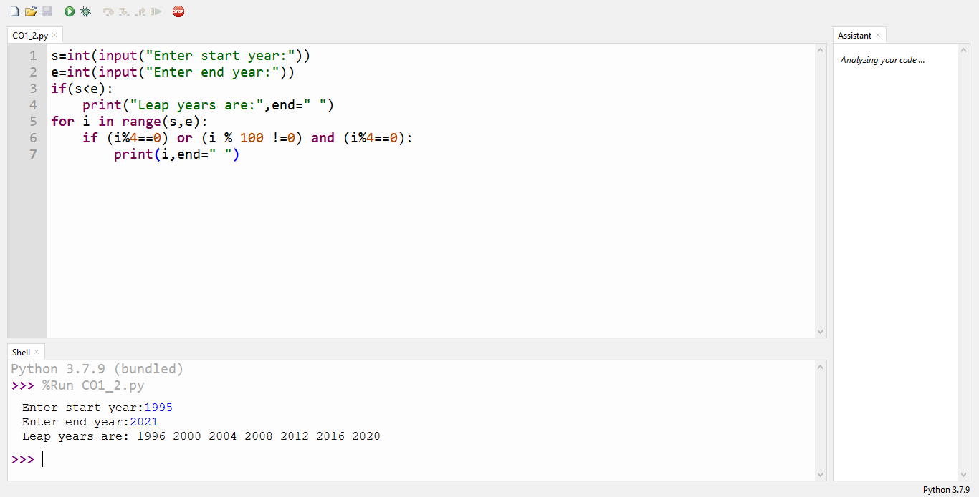

…………………………………………………………………………………………………………

**CO1_3.1 : Generate positive list of numbers from a given list of integers**

**INPUT :**

list1 =[1,-1,2,-2,3,-3]

positive=[num for num in list1 if num>=0]

print(positive)

**OUTPUT :**

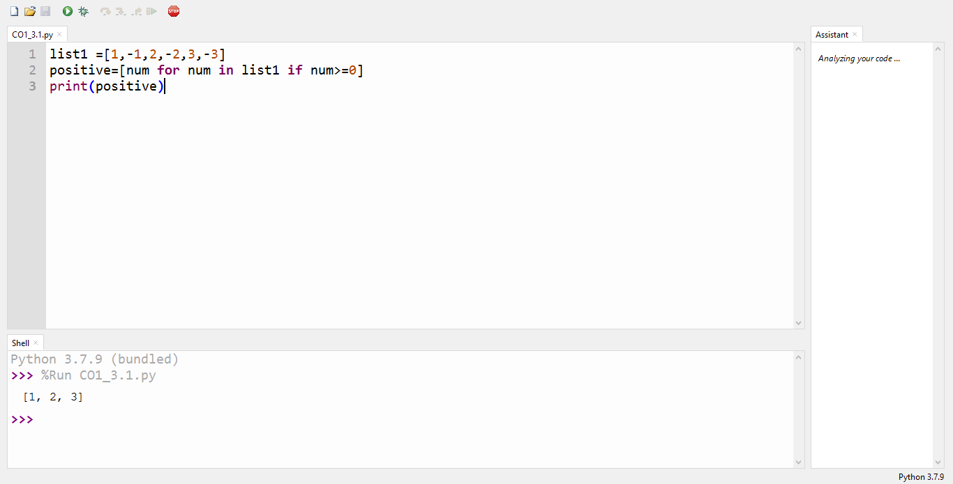

…………………………………………………………………………………………………………

**CO1_3.2 :** **Square of N number**

**INPUT :**

n=int(input("enter limit:"))

squarelist= [ i**2 for i in range(1,n+1)]

print("Square of N numbers : ", squarelist)

**OUTPUT :**

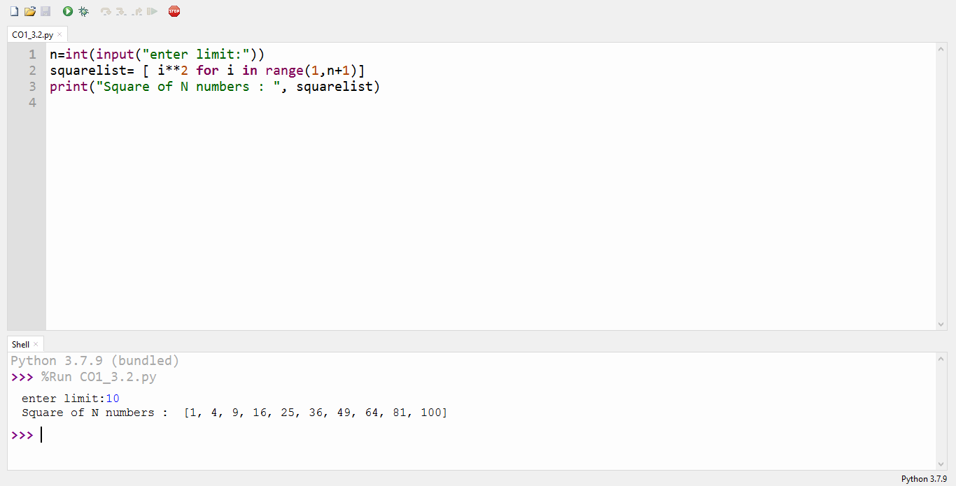

……………………………………………………………………………………………………………

**CO1_3.3 : Form a list of vowels selected from a given word**

**INPUT :**

word =str(input("Enter the word :"))

print("The original string is : "+word)

print("The vowel are : ",end="")

for i in word:

if i in 'aeiouAEIOU':

print([i],end=" ")

**OUTPUT :**

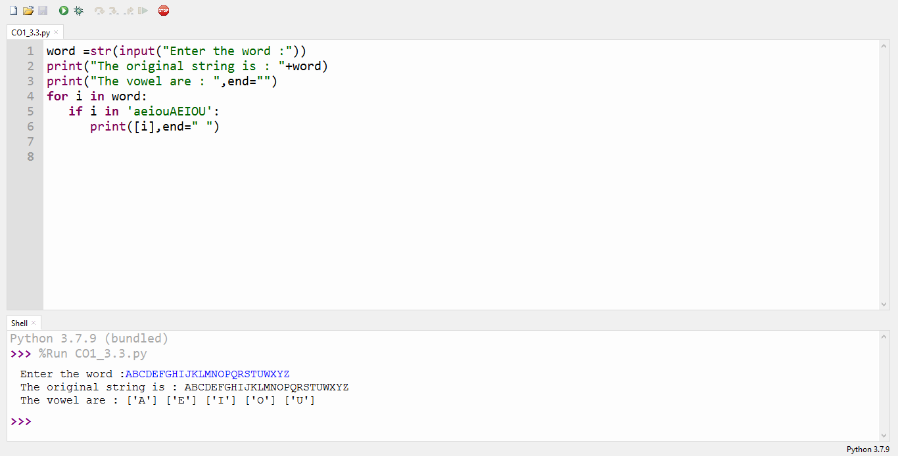

……………………………………………………………………………………………………………

**CO1_3.4 : List ordinal value of each element of a word**

**INPUT :**

w=input("Enter a word:")

print("Ordinal values corresponding to each element is:")

for i in w:

print(i,end=":")

print(ord(i),end=" ")

**OUTPUT :**

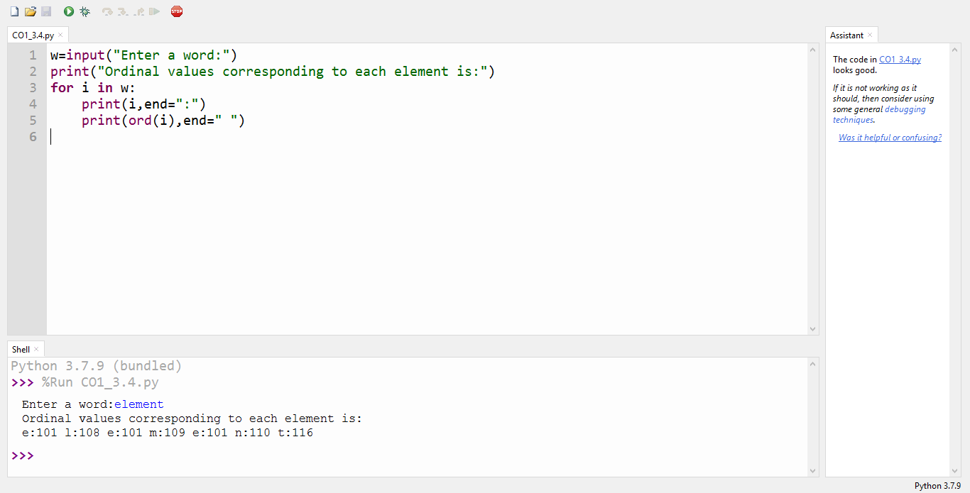

……………………………………………………………………………………………………………

**CO1_4 : Count the occurrences of each word in a line of text.**

**INPUT :**

str1=input("Enter a string : ")

wordlist=str1.split()

count=[]

for w in wordlist: count.append(wordlist.count(w))

print("count of the occurrence:" + str(list(zip(wordlist, count))))

**OUTPUT :**

Enter a string : Ohh I see Can you see

count of the occurrence:[('Ohh', 1), ('I', 1), ('see', 2), ('Can', 1), ('you', 1), ('see', 2)]

……………………………………………………………………………………………………………

**CO1_5 : Prompt the user for a list of integers. For all values greater than 100, store ‘over’ instead**

**INPUT :**

n=[]

s=int(input("Enter a limit:"))

print("Enter {s} values")

for i in range(0,s): n.append(int(input()))

print("\nThe list after assigning:\n")

for i in range(0,len(n)):

if n[i]>=100:print("over")

else:print(n[i])

**OUTPUT :**

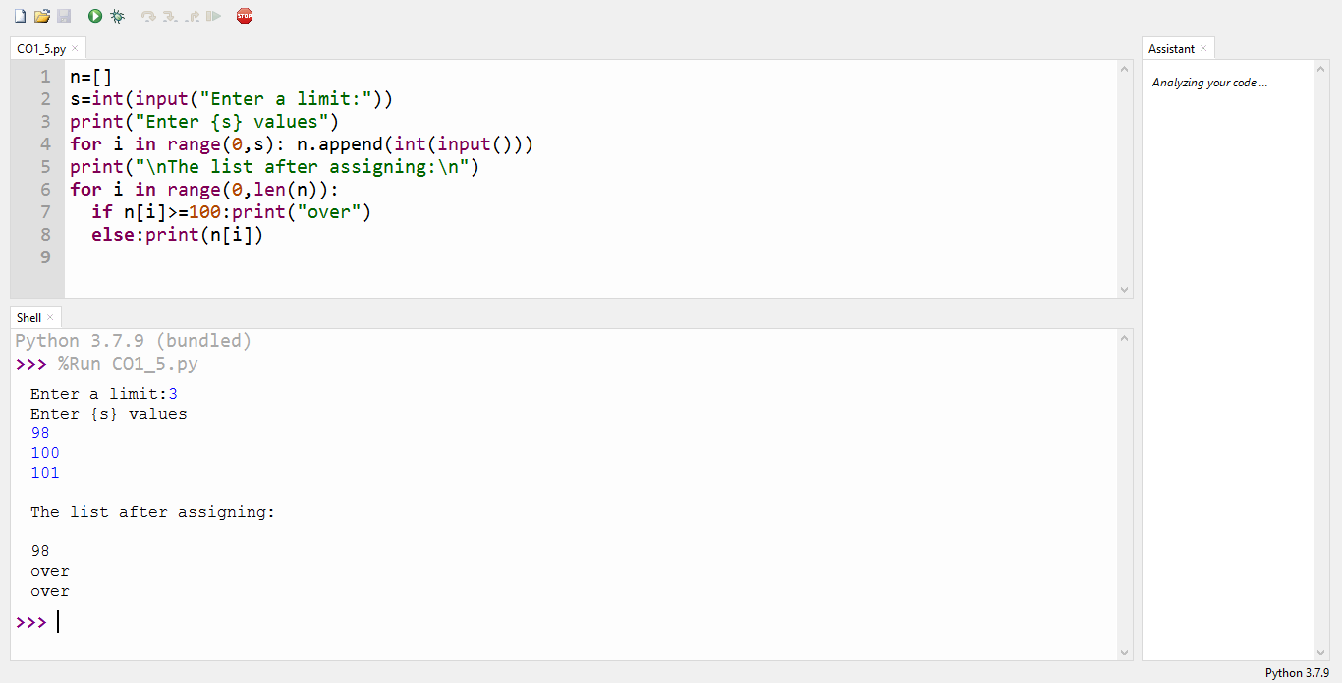

……………………………………………………………………………………………………………

**CO1_6 : Store a list of first names. Count the occurrences of ‘a’ within the list**

**INPUT :**

list=["a","b","a"]

occ=list.count("a")

print("count of occurences of a:",occ)

**OUTPUT :**

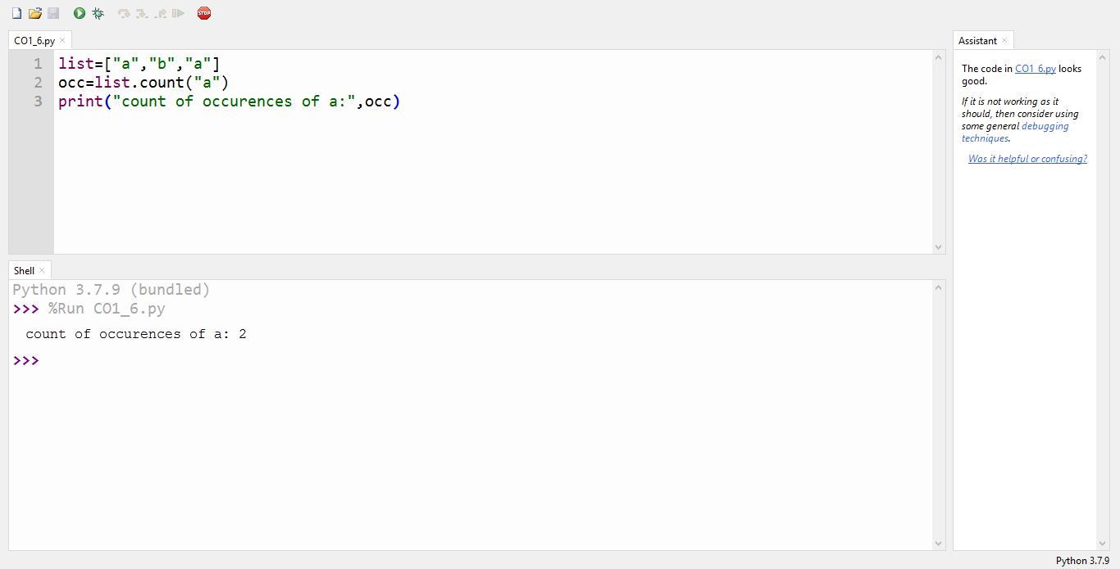

……………………………………………………………………………………………………………

**CO1_7 : Enter 2 lists of integers. Check**

**(a) Whether list are of same length**

**(b) whether list sums to same value**

**(c) whether any value occur in both**

**INPUT :**

lst=[1,3,5,7,9,11,34]

lst1=[5,13,45,7,20,65,1]

s=int(0)

c=int(0)

if len(lst)==len(lst1):

print("Lists are of same length")

else:

print("Lists have different length")

for i in range(0,len(lst) and len(lst1)):

s=s+lst[i]

c=c+lst1[i]

if(s==c):

print("equal sum")

else:

print("not same sum")

print("Elements that matched are:")

l=[]

for i in range(0,len(lst)):

for j in range(0,len(lst1)):

if lst[i]==lst1[j]:

l.append(lst[i] and lst1[j])

else:

continue

print(l)

**OUTPUT :**

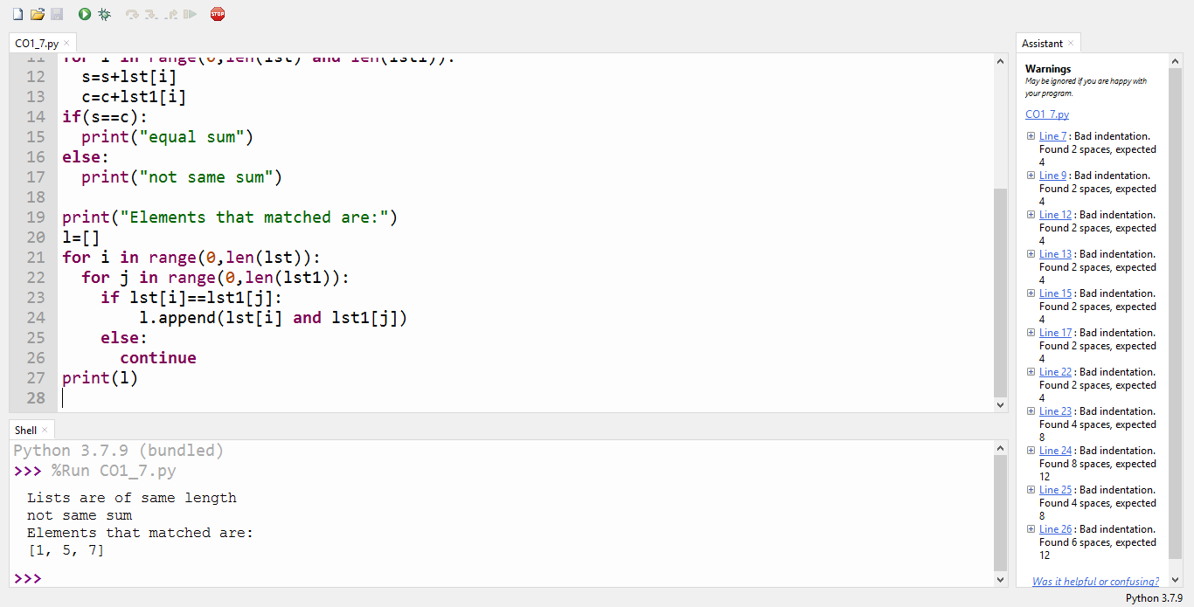

……………………………………………………………………………………………………………

**CO1_8 : Get a string from an input string where all occurrences of first character replaced with ‘$’, except first character.**

**INPUT :**

str1="malayalam"

char=str1[0]

str1=str1.replace(char,'$')

str1=char+str1[1:]

print(str1)

**OUTPUT :**

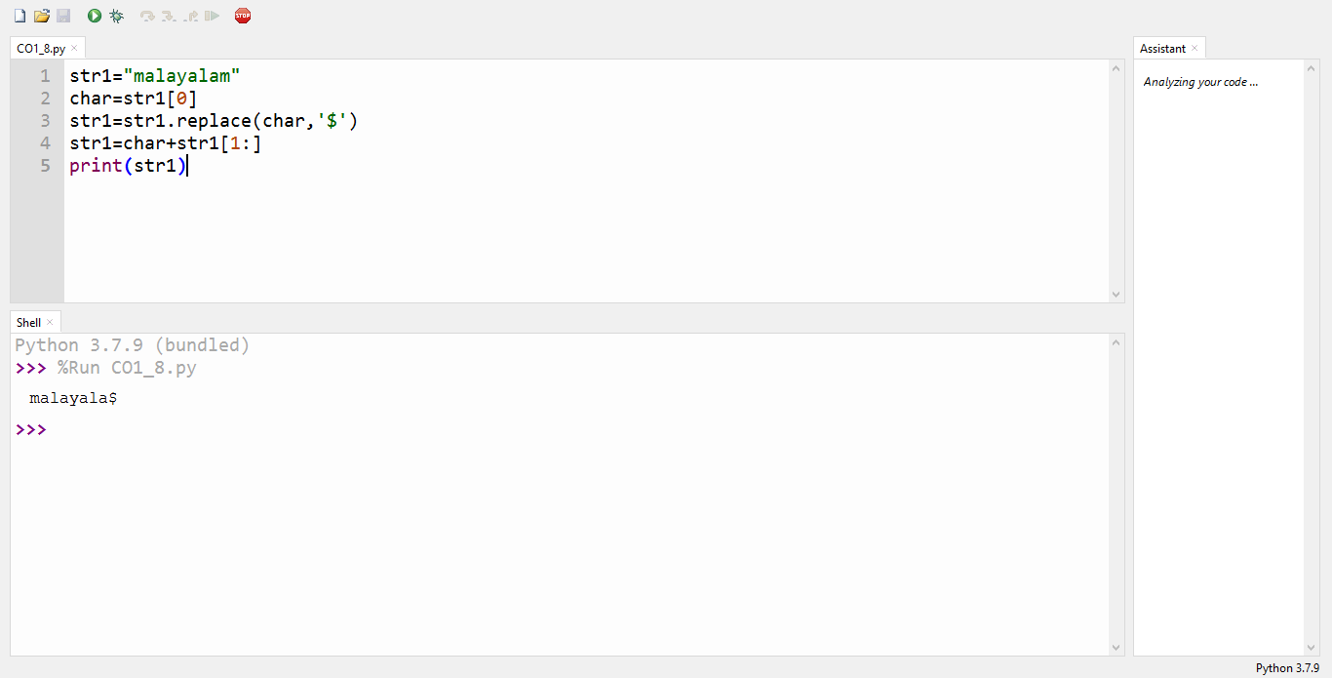

……………………………………………………………………………………………………………

**CO1_9 : Create a string from given string where first and last characters exchanged.**

**INPUT :**

str=input("Enter a string:")

new_str=str[-1:]+str[1:-1]+str[:1]

print("New string:",new_str)

**OUTPUT :**

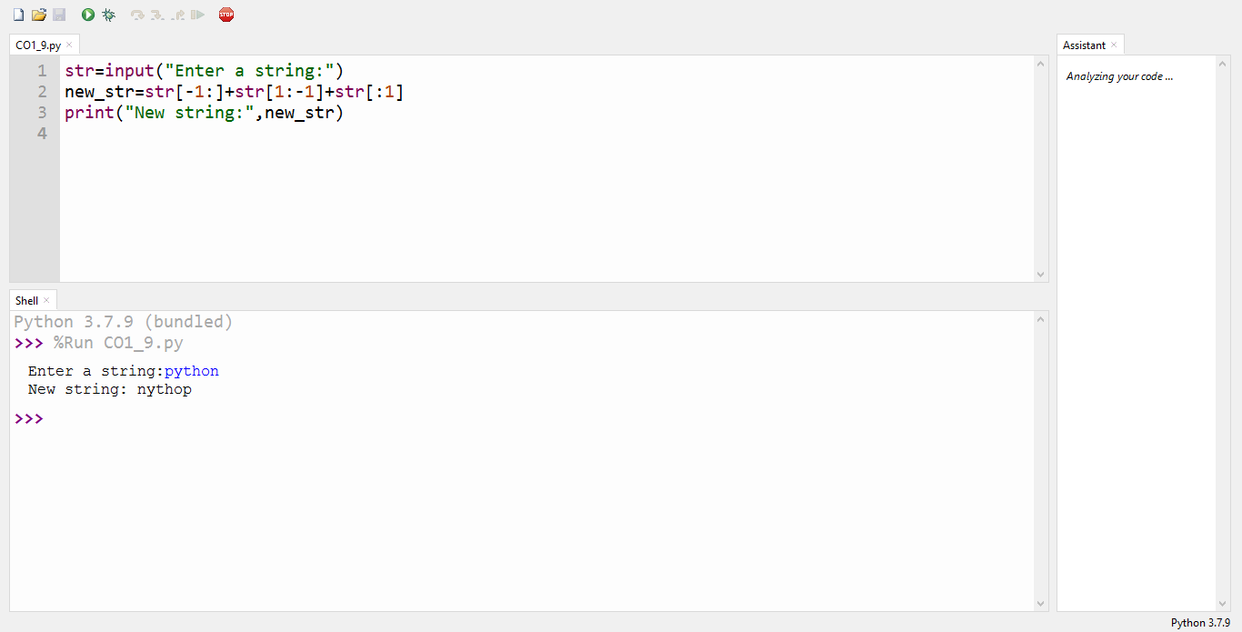

……………………………………………………………………………………………………………

**CO1_10 : Accept the radius from user and find area of circle.**

**INPUT :**

pi=3.14

r=float(input("Input the radius of the circle:"))

result=3.14*r**2

print("The area of the circle with radius is:",result)

**OUTPUT :**

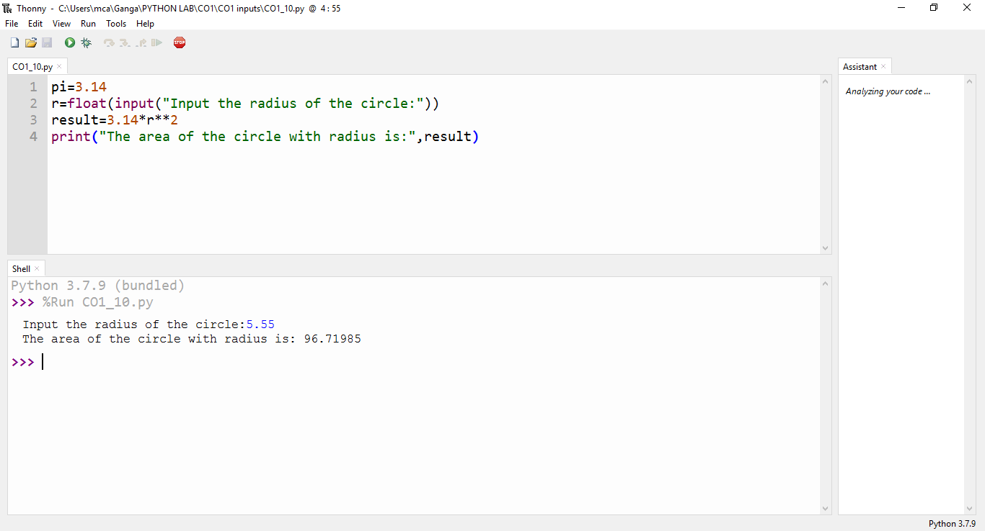

……………………………………………………………………………………………………………

**CO1_11 : Find biggest of 3 numbers entered**

**INPUT :**

x=int(input("Enter 1st number : "))

y=int(input("Enter 2nd number : "))

z=int(input("Enter 3rd number : "))

if(x>y)and(x>z):largest=x

elif(y>x)and(y>z):largest=y

else:largest=z

print("The largest number is",largest)

**OUTPUT :**

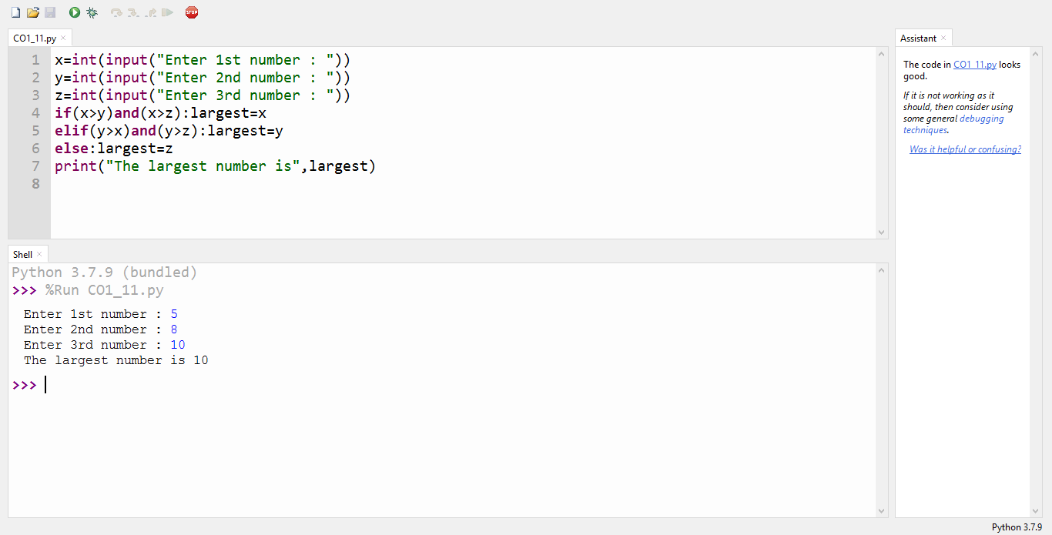

……………………………………………………………………………………………………………

**CO1_12 : Accept a file name from user and print extension of that**

**INPUT :**

file=input("Enter filename:")

f=file.split(".")

print("Extension of the file is:"+f[-1])

**OUTPUT :**

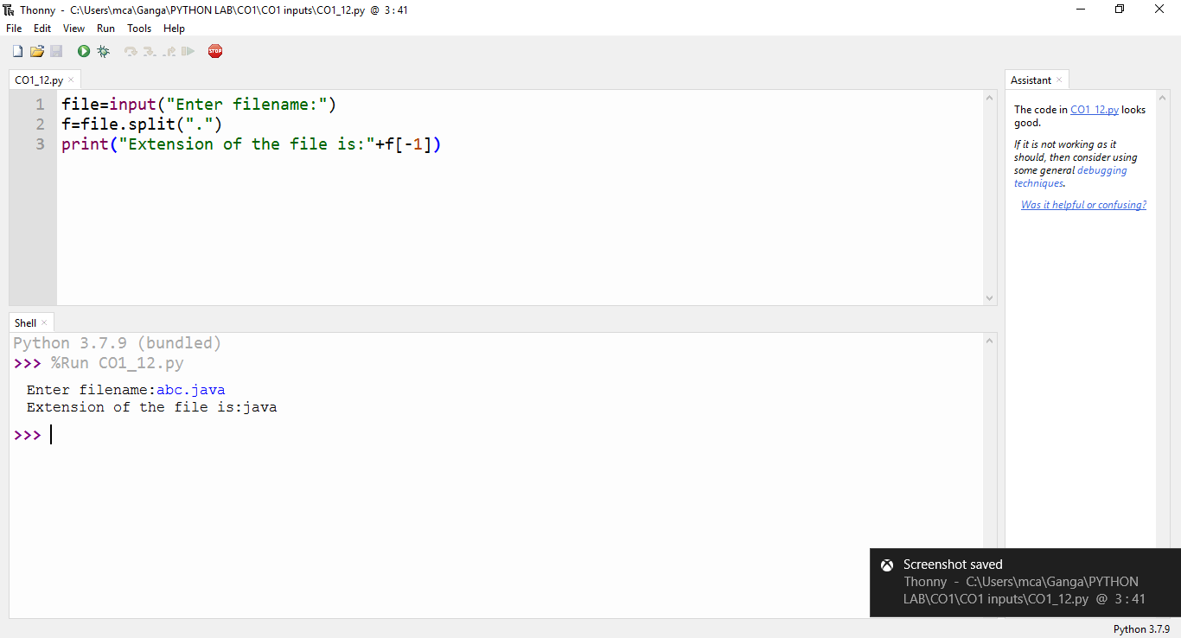

……………………………………………………………………………………………………………

**CO1_13 : Create a list of colors from comma-separated color names entered by user.Display first and last colors.**

**INPUT :**

a=[]

for i in range(3):

b=input("Enter the color : ")

a.append(b)

print(a)

print("First color :",a[0])

print("Second color :",a[2])

**OUTPUT :**

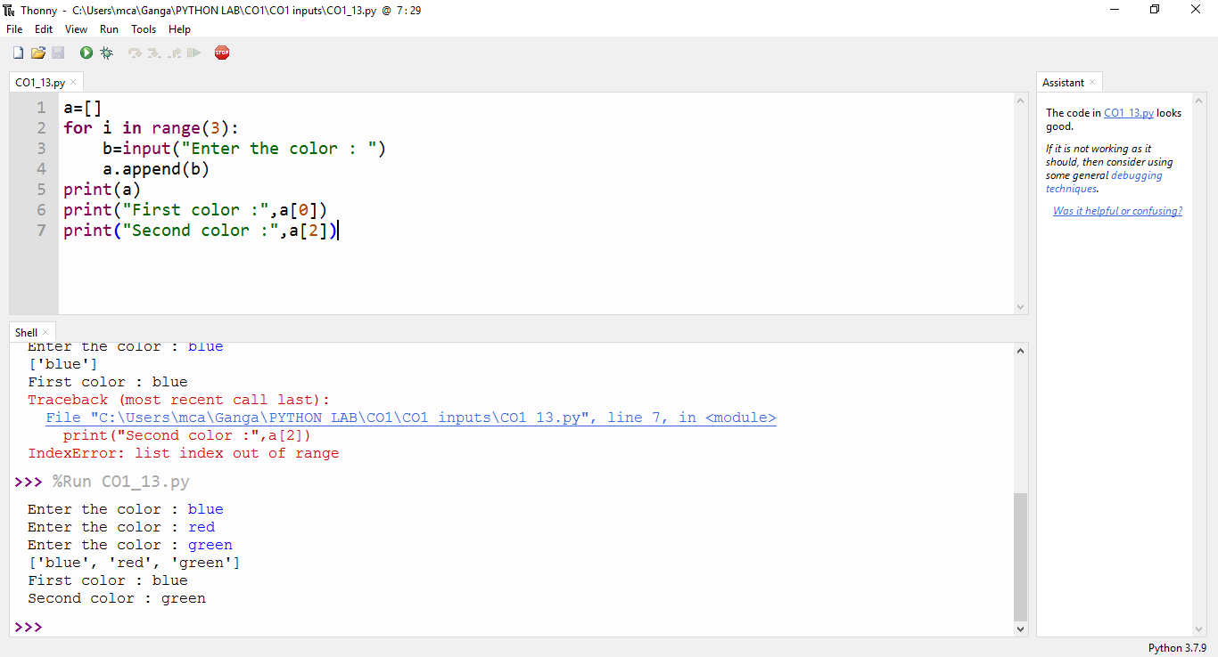

……………………………………………………………………………………………………………

**CO1_14 : Accept an integer n and compute n+nn+nnn**

**INPUT :**

n=int(input("Enter a number:"))

x=int("%s"%n)

y=int("%s%s"%(n,n))

z=int("%s%s%s"%(n,n,n))

print("n+nn+nnn:",x+y+z)

**OUTPUT :**

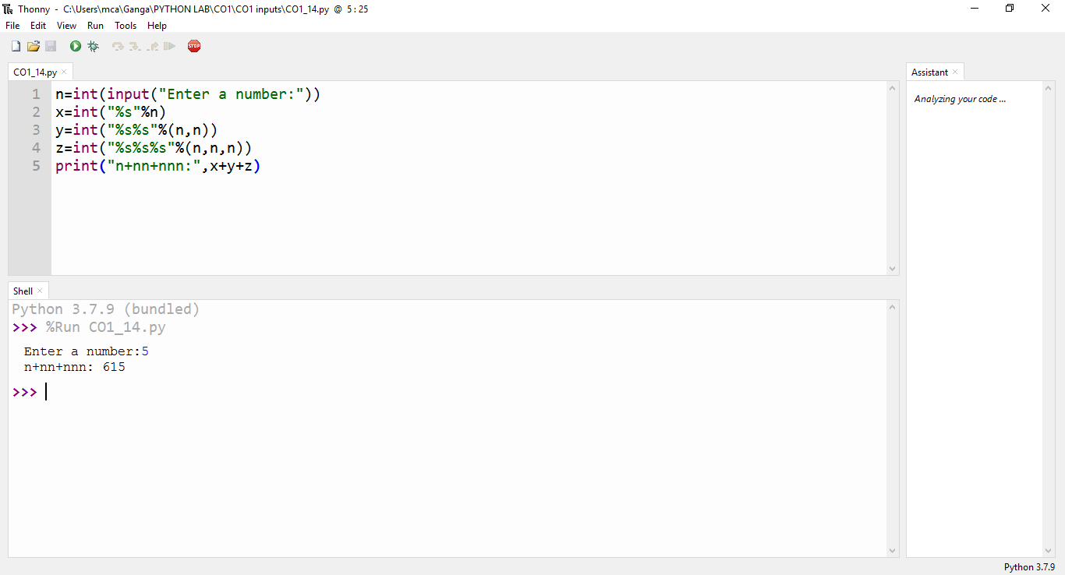

……………………………………………………………………………………………………………

**CO1_15 : Print out all colors from color-list1 not contained in color-list2.**

**INPUT :**

list1={"White","pink","Red","Blue"}

list2={"Red","Green","pink"}

print(list1.difference(list2))

**OUTPUT :**

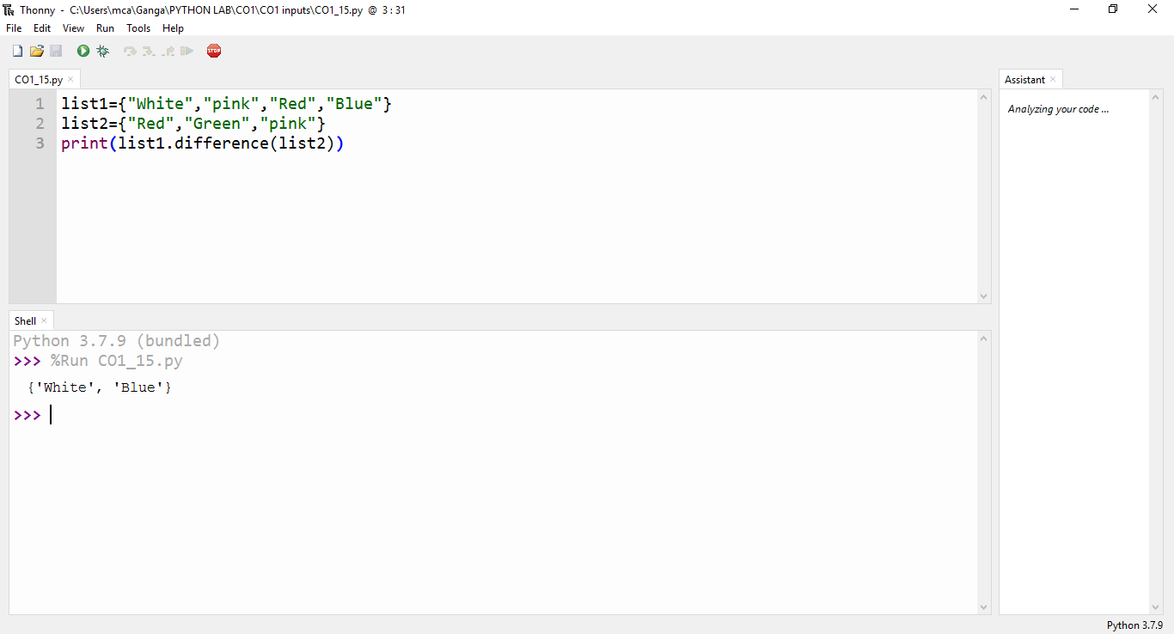

……………………………………………………………………………………………………………

**CO1_16 : Create a single string separated with space from two strings by swapping the character at position 1.**

**INPUT :**

a="python"

b="java"

p1=a[0]

p2=b[0]

c=b[0]+a[1:]+" "+a[0]+b[1:]

print(c)

**OUTPUT :**

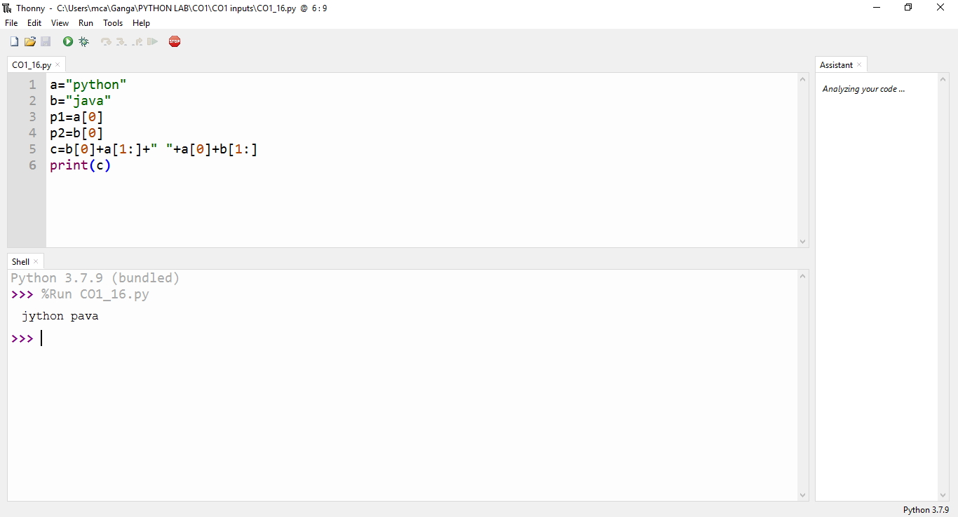

……………………………………………………………………………………………………………

**CO1_17 : Sort dictionary in ascending and descending order**

**INPUT :**

import operator

d={1:2,3:4,4:3,2:1,0:0}

print('Original dictionary : ',d)

sorted_d=sorted(d.items(),key=operator.itemgetter(1))

print('Dictionary in ascending order by value ',sorted_d)

sorted_d=dict( sorted(d.items(),key=operator.itemgetter(1),reverse=True))

print('Dictionary in descending order by value : ',sorted_d)

**OUTPUT :**

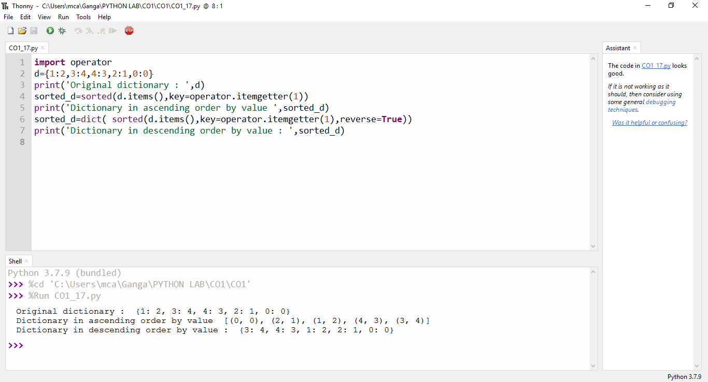

……………………………………………………………………………………………………………

**CO1_18 : Merge two dictionaries**

**INPUT :**

d1 ={ 'a': 100, 'b': 200}

d2 ={'x' : 300, 'y': 200}

print ("Dict ionary 1=:", d1)

print ("Dictionary 2-: ", d2)

d =d1. copy ()

d.update (d2)

print ("Merged Dictionary: ", d)

**OUTPUT :**

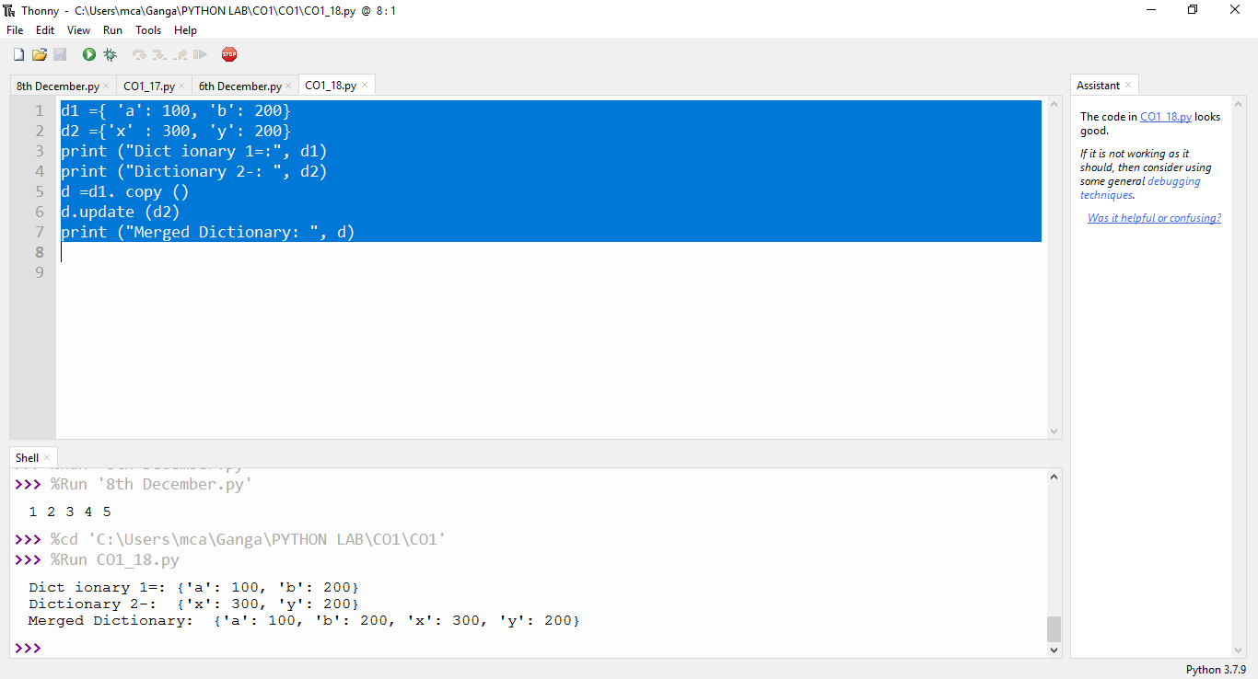

……………………………………………………………………………………………………………

**CO1_19 : Find gcd of 2 numbers.**

**INPUT :**

x=int(input("Enter 1st number: "))

y=int(input("Enter 2nd number: "))

i=1

while(i<=x and i<=y):

if(x%i==0 and y%i==0):

gcd=i

i=i+1

print("GCD :",gcd)

**OUTPUT :**

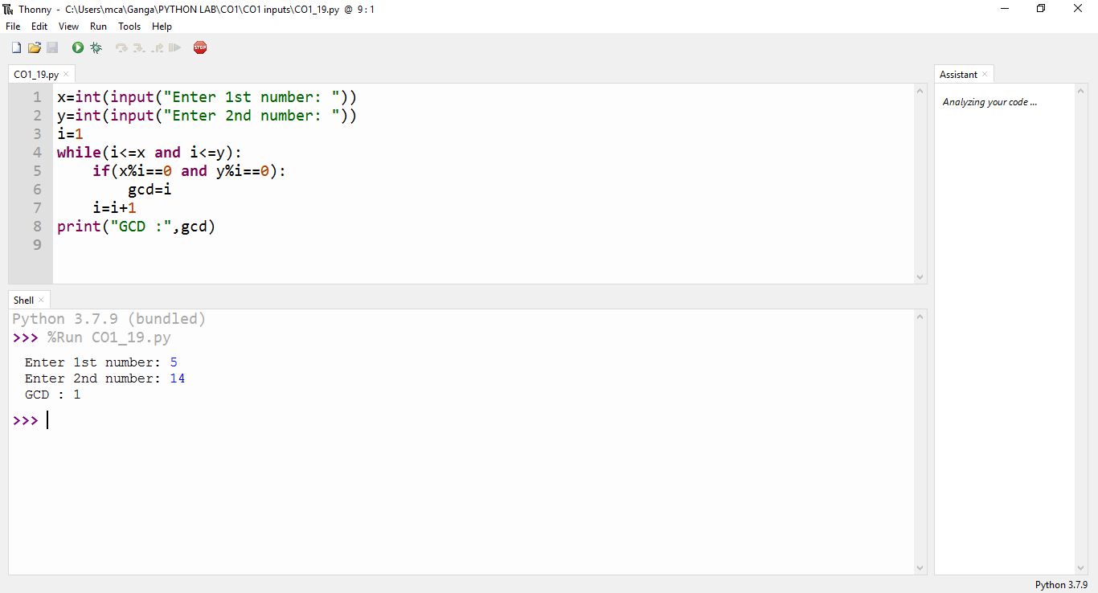

……………………………………………………………………………………………………………

**CO1_20 : From a list of integers, create a list removing even numbers.**

**INPUT :**

num = [1,2,3,4,5,6,7,8,9,10]

print( "Original list:",num)

num = [x for x in num if x%2!=0]

print("List after removing even numbers:",num)

**OUTPUT :**

