**CO2 PROGRAMS**

**CO2_1 : Program to find the factorial of a number**

**INPUT :**

n=int(input('Enter a number : '))

f=1

for i in range(1,n+1):

f=f*i

print ('Factorial of',n, '=',f)

**OUTPUT :**

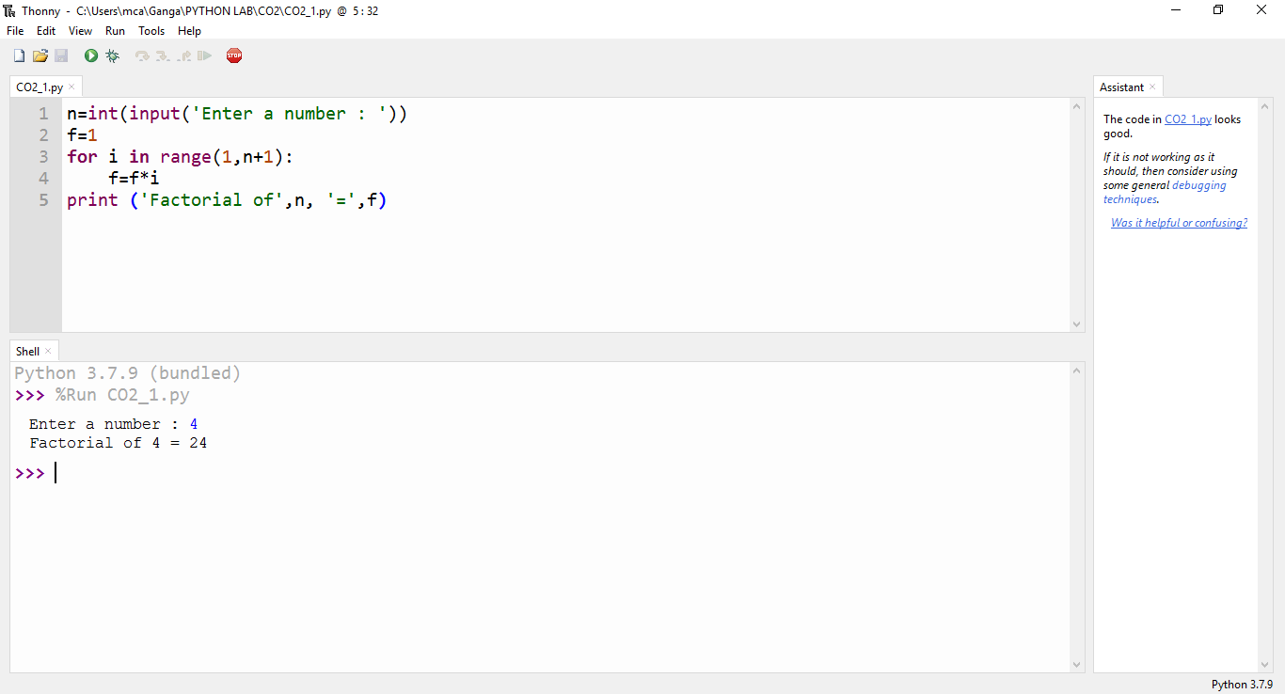

…………………………………………………………………………………………………………………………………………………………….

**CO2_2 : Generate Fibonacci series of N terms**

**INPUT :**

n=int(input("Enter the limit : "))

a=0

b=1

sum=0

count=1

print("Fibonacci Series :",end= " ")

while(count <= n):

print(sum,end=" ")

count += 1

a=b

b=sum

sum=a+b

**OUTPUT :**

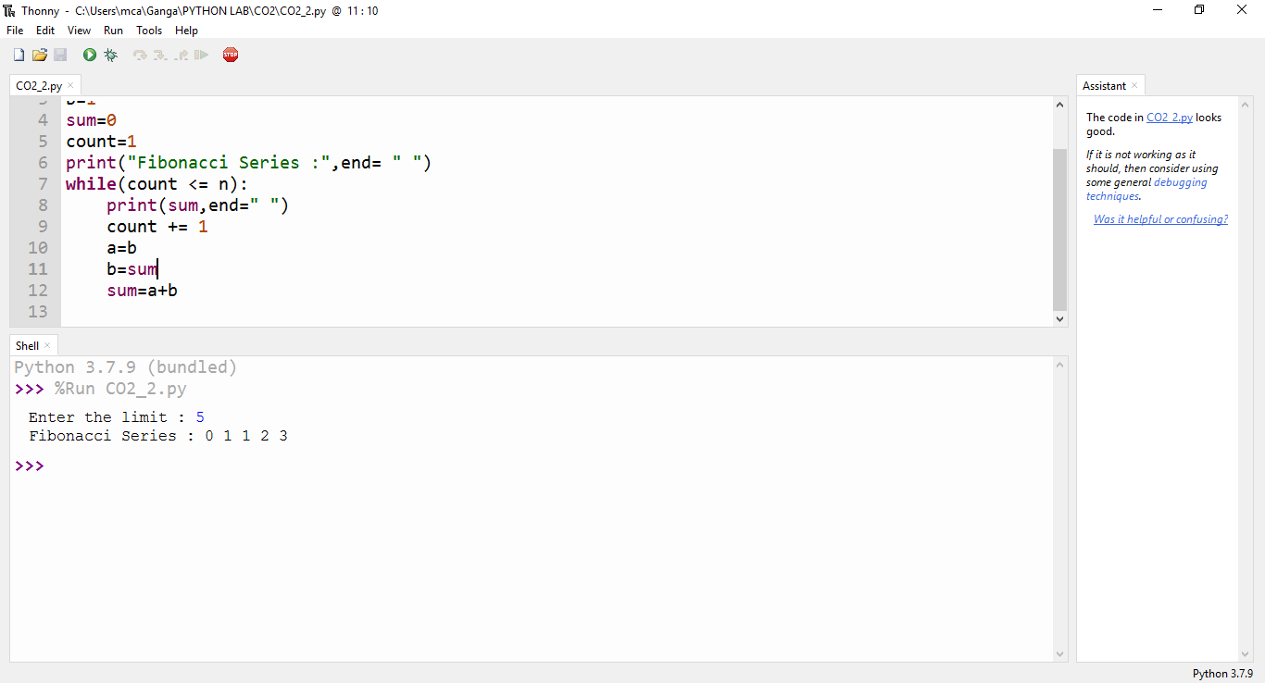

…………………………………………………………………………………………………………………………………………………………….

**CO2_3 : Find the sum of all items in a list**

**INPUT :**

list1=[10, 15, 20, 25, 30]

total=sum(list1)

print("Sum of list : ",total)

**OUTPUT :**

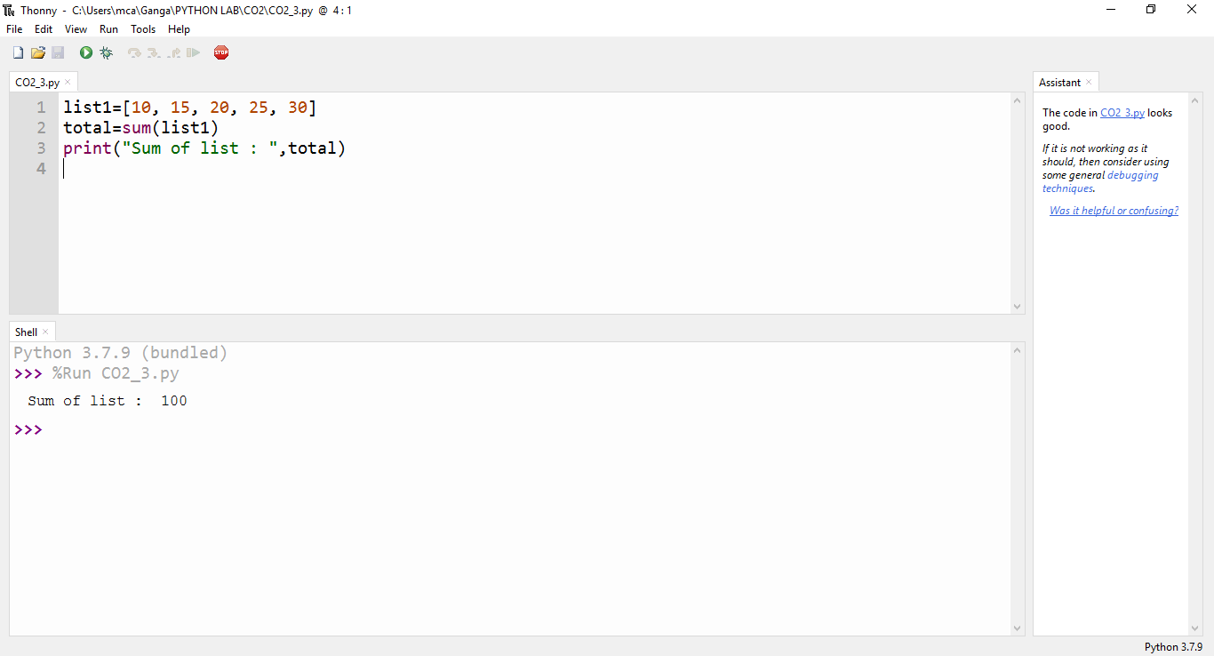

…………………………………………………………………………………………………………………………………………………………….

**CO2_4 : Generate a list of four digit numbers in a given range with all their digits even and the number is a perfect square.**

**INPUT :**

from math import sqrt as s

for i in range(1000,10000):

if s(i)==int(s(i)) and i%2==0:

print(i,end=" ")

**OUTPUT :**

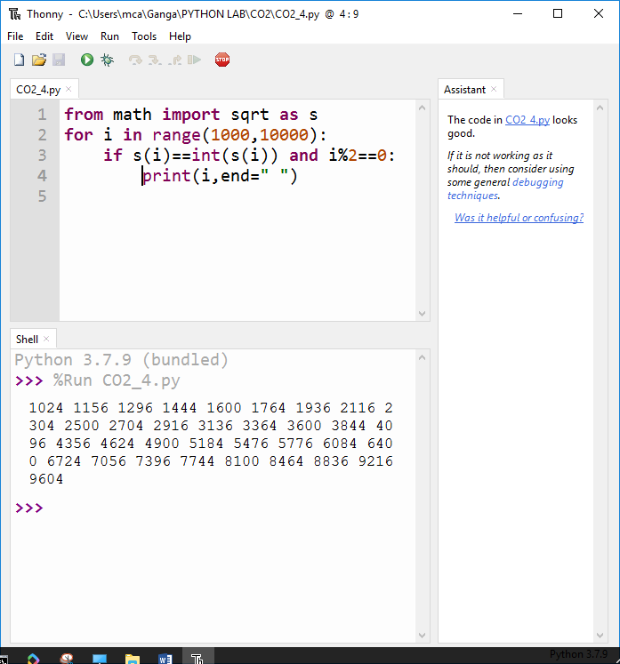

…………………………………………………………………………………………………………………………………………………………….

**CO2_5 : Display the given pyramid with step number accepted from user.**

**INPUT :**

rows = int(input("Enter the number of rows: "))

for i in range(1, rows+1):

for j in range(1,i+1):

print(i * j, end=' ')

print()

**OUTPUT :**

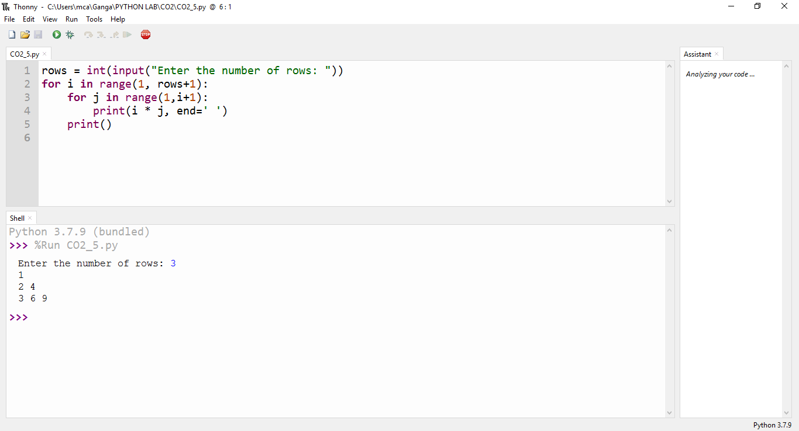

…………………………………………………………………………………………………………………………………………………………….

**CO2_7 :** **Add ‘ing’ at the end of a given string. If it already ends with ‘ing’, then add ‘ly’**

**INPUT :**

str=input("enter a string:")

print("inputed string is:",str)

if(str.endswith("ing")):

str=str+'ly'

else:

str=str+'ing'

print("the formated string is:",str)

**OUTPUT :**

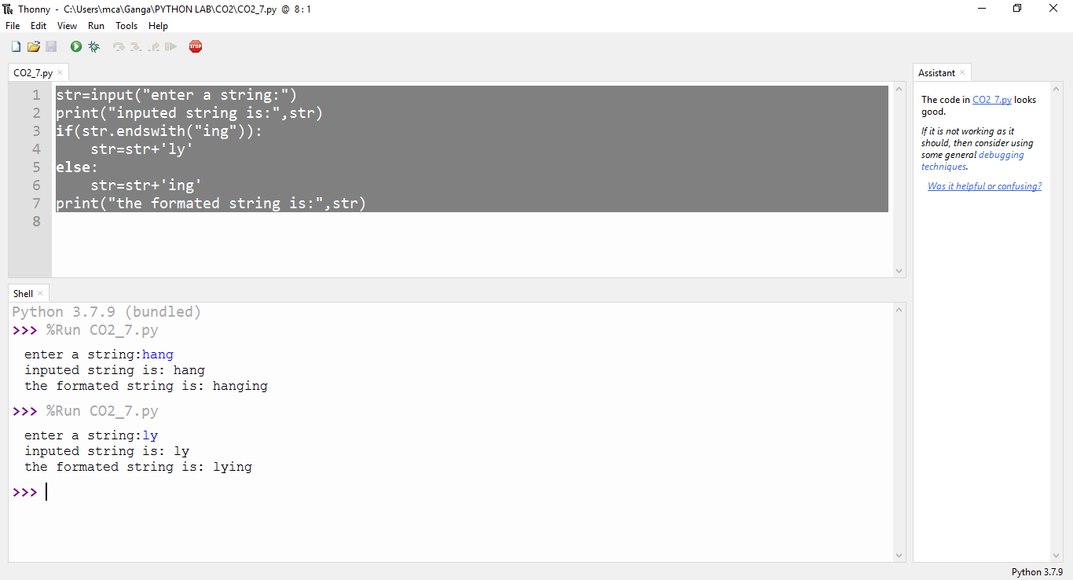

…………………………………………………………………………………………………………………………………………………………….

**CO2_8 : Accept a list of words and return length of longest word.**

**INPUT :**

a=[]

n= int(input("Enter the number of elements in list:"))

for x in range(0,n):

element=input("Enter element "+ str(x+1) )

a.append(element)

max1=len(a[0])

temp=a[0]

for i in a:

if(len(i)>max1):

max1=len(i)

temp=i

print("Longest Word:",temp)

print("Length of longest word :",max1)

**OUTPUT :**

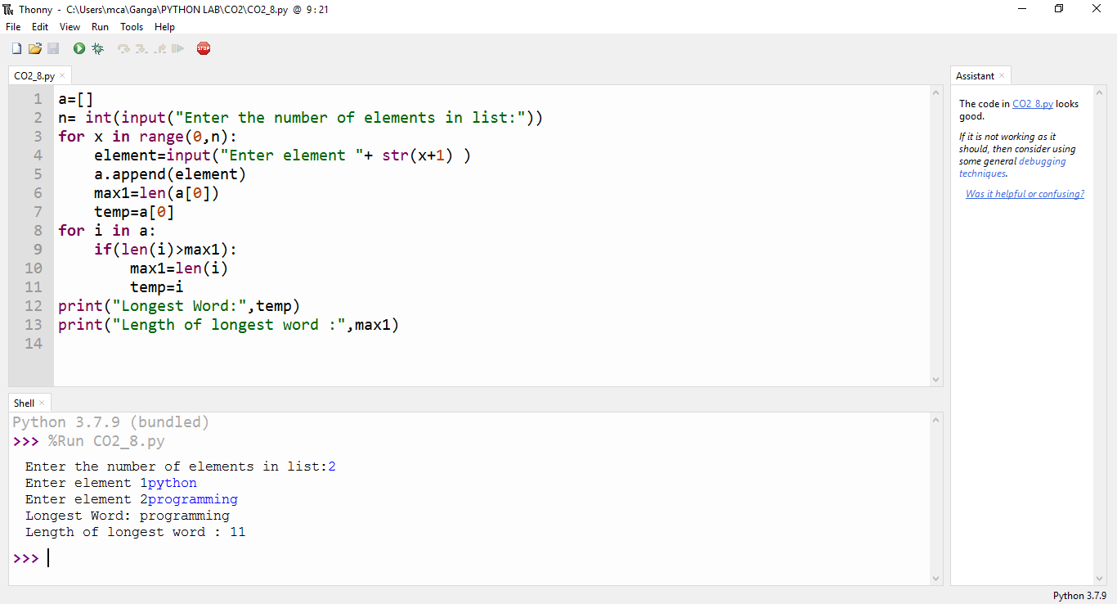

…………………………………………………………………………………………………………………………………………………………….

**CO2_9 : Construct following pattern using nested loop**

# *

**\* \***

**\* * \***

**\* * * \***

**\* * \***

**\* \***

**\***

**INPUT :**

n= int(input("Enter the limit:"))

for i in range(n):

for j in range(i):

print ('* ', end="")

print('')

for i in range(n,0,-1):

for j in range(i): print('* ', end="")

print('')

**OUTPUT :**

