Task:1. Database Design

1. Create the database named "TechShop"

=>CREATE DATABASE TechShop;

Use Techshop;

2. Define the schema for the Customers, Products, Orders, OrderDetails and Inventory tables based on the provided schema.

=>Customers Table

CREATE TABLE Customers(

CustomerId integer(5),

FirstName varchar(20),

LastName Varchar(20),

Email varchar(20) UNIQUE ,

Phone bigint(15) UNIQUE,

Address Varchar(20),

constraint customers_customerId_pk primary key(customerId)

);

=>Products Table

CREATE TABLE Products(

ProductId integer(8),

ProductName varchar(20),

Description Varchar(50),

Price Decimal(20) ,

constraint products_ProductId_pk primary key(productId)

);

=>Orders Table

CREATE TABLE Orders(

OrderID integer(8),

CustomerId integer(5) ,

OrderDate Date,

TotalAmount Decimal(20),

constraint orders_orderId_pk primary key(orderId),

constraint orders_customerId_fk foreign key(customerId) references customers(customerId)

);

=>OrderDetails Table

CREATE TABLE OrderDetails(

OrderDetailID integer(10),

constraint ordersDetails_OrderDetailID_pk primary key(OrderDetailID),

OrderId integer(8),

constraint ordersDetails_orderId_fk foreign key(orderId) REFERENCES Orders(OrderID),

ProductID integer(8),

constraint ordersDetails_productId_fk foreign key(productId) REFERENCES Products(ProductId),

Quantity Integer(50)

);

=>Inventory Table

CREATE TABLE Inventory(

InventoryID integer(10),

constraint Inventory_InventoryID_pk Primary Key(InventoryID),

ProductID integer(8),

constraint Inventory_productId_fk foreign key(productId) REFERENCES Products(ProductID),

QuantityInStock integer(100),

LastStockUpdate Date

);

5. Insert at least 10 sample records into each of the following tables.

a. Customer :

insert into customers values(101,'Arav','Josh','arav@gmailcom',9876543212,'Bangalore');

insert into customers values(102,'Harsh','Singh','harsh@gmailcom',9865433276,'Hyderbad');

insert into customers values(103,'Siya','Gupta','siya@gmailcom',9766578654,'Mumbai');

insert into customers values(104,'Siri','Kumar','siri@gmailcom',9776589076,'Pune');

insert into customers values(105,'Sam','sharma','sam@gmailcom',9765432178,'Bangalore');

insert into customers values(106,'Dhruv','Patel','dhruv@gmailcom',7786543289,'chennai');

insert into customers values(107,'Manya','Agarwal','manya@gmailcom',7869540091,'lucknow');

insert into customers values(108,'Manoj','Jain','manoj@gmailcom',6789543005,'Goa');

insert into customers values(109,'Gagana','Joshi','gagana@gmailcom',8765455900,'Mysore');

insert into customers values(110,'Amulya','Bhatt','amulya@gmailcom',7865443109,'Indore');

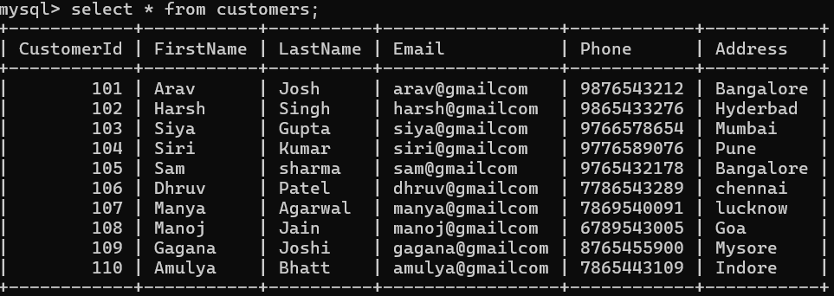

b.Products :

insert into products values(1,'Phone','samsung',100000);

insert into products values(2,'Laptop','Lenovo',500000);

insert into products values(3,'TV','Sony',300000);

insert into products values(4,'Computer','Bosh',200000);

insert into products values(5,'Speaker','Echo',20000);

insert into products values(6,'Washing Machine','LG',70000);

insert into products values(7,'Refrigerator','IFB',90000);

insert into products values(8,'Bulb','panasonic',900);

insert into products values(9,'Camera','canon',80000);

insert into products values(10,'Tablet','apple',77000);

c.Orders :

insert into orders values(201,102,'2001-10-23',40000);

insert into orders values(202,108,'2008-11-03',7000);

insert into orders values(203,101,'1998-01-13',90000);

insert into orders values(204,103,'1995-12-05',88000);

insert into orders values(205,110,'2000-07-08',67000);

insert into orders values(206,109,'2008-05-18',68090);

insert into orders values(207,105,'2018-09-28',98050);

insert into orders values(208,104,'2009-06-16',8790);

insert into orders values(209,106,'2015-04-18',7899);

insert into orders values(210,107,'2019-08-10',77777);

c.Ordersdetails :

insert into orderdetails values(1001,202,4,2);

insert into orderdetails values(1002,205,3,3);

insert into orderdetails values(1003,201,1,5);

insert into orderdetails values(1004,210,10,2);

insert into orderdetails values(1005,209,9,1);

insert into orderdetails values(1006,203,2,4);

insert into orderdetails values(1007,204,5,5);

insert into orderdetails values(1008,206,7,1);

insert into orderdetails values(1009,207,6,2);

insert into orderdetails values(1010,208,8,6);

d.Inventory :

insert into inventory values (2001,3,10, ‘2024-01-18’);

insert into inventory values (2002,2,15 , ‘2023-12-28’);

insert into inventory values (2003,1,18 , ‘2023-11-12’);

insert into inventory values (2004,10,12 , ‘2024-03-10’);

insert into inventory values (2005,9,11, ‘2023-12-12’);

insert into inventory values (2006,4,10 , ‘2022-10-20’);

insert into inventory values (2007,5,16 , ‘2022-07-29’);

insert into inventory values (2008,6,8 , ‘2022-04-27’);

insert into inventory values (2009,7,17 , ‘2023-08-22’);

insert into inventory values (2010,8,13 , ‘2024-02-04’);

Tasks 2: Select, Where, Between, AND, LIKE:

1. Write an SQL query to retrieve the names and emails of all customers.

->select FirstName, Lastname, Email from customers;

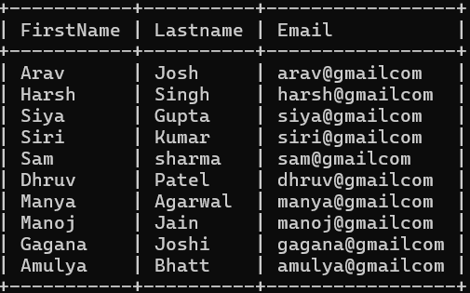

1. Write an SQL query to list all orders with their order dates and corresponding customer names.

-> select o.orderId ,o.OrderDate ,c.FirstName,c.LastName from orders o ,customers c where o.customerid=c.customerid;

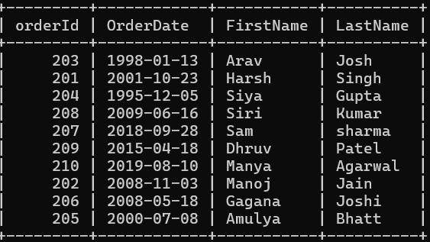

1. Write an SQL query to insert a new customer record into the "Customers" table. Include customer information such as name, email, and address.

-> INSERT INTO Customers (customerid,FirstName, LastName, Email, Address)VALUES (111,'Ananya', 'Bhatt', 'ananya@gmai

l.com', 'Los Angeles');



1. Write an SQL query to update the prices of all electronic gadgets in the "Products" table by increasing them by 10%.

->UPDATE Products

-> SET Price = Price * 1.10;

select * from products;

1. Write an SQL query to delete a specific order and its associated order details from the "Orders" and "OrderDetails" tables. Allow users to input the order ID as a parameter.

-> DELETE FROM OrderDetails WHERE OrderId = 201;

-> DELETE FROM Orders WHERE OrderID = 201;

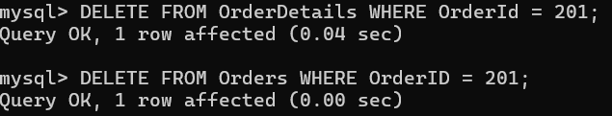

1. Write an SQL query to insert a new order into the "Orders" table. Include the customer ID, order date, and any other necessary information.

->INSERT INTO Orders values(211,109,'2023-10-25',29000);



1. Write an SQL query to update the contact information (e.g., email and address) of a specific customer in the "Customers" table. Allow users to input the customer ID and new contact information.

-> update customers set email='agarwal@gmail.com' ,address='mysore' where customerid=107;



1. Write an SQL query to recalculate and update the total cost of each order in the "Orders" table based on the prices and quantities in the "OrderDetails" table.

UPDATE Orders

-> SET TotalAmount = (

-> SELECT SUM(od.Quantity * p.Price)

-> FROM OrderDetails od

-> JOIN Products p ON od.ProductID = p.ProductId

-> WHERE od.OrderId = Orders.OrderID

-> );

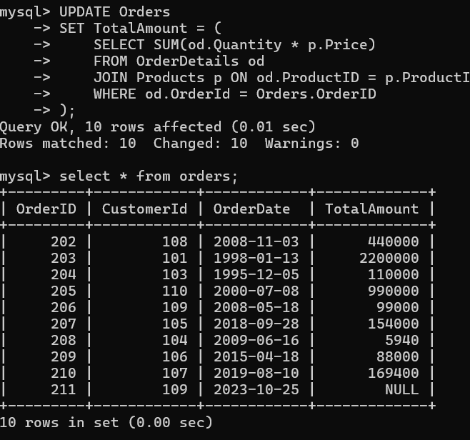

1. Write an SQL query to delete all orders and their associated order details for a specific customer from the "Orders" and "OrderDetails" tables. Allow users to input the customer ID as a parameter.

->DELETE FROM OrderDetails WHERE OrderId IN( SELECT OrderId FROM Orders WHERE CustomerId = 101);

->DELETE FROM Orders WHERE CustomerId=101;

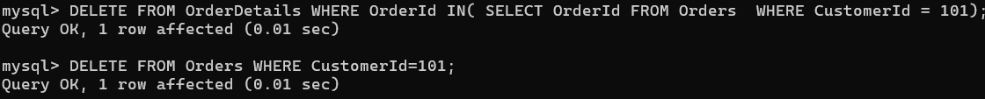

1. Write an SQL query to insert a new electronic gadget product into the "Products" table, including product name, category, price, and any other relevant details.

-> INSERT INTO Products VALUES (11,'Smartwatch', 'boat', 25000);



1. Write an SQL query to update the status of a specific order in the "Orders" table (e.g., from "Pending" to "Shipped"). Allow users to input the order ID and the new status.

-> ALTER TABLE Orders ADD status VARCHAR(20);

-> UPDATE Orders SET status = 'pending' WHERE OrderID =209;

-> UPDATE Orders SET status = 'shipped' WHERE OrderID =209;

1. Write an SQL query to calculate and update the number of orders placed by each customer in the "Customers" table based on the data in the "Orders" table.

-> ALTER TABLE Customers

-> ADD OrderCount INT DEFAULT 0;

->UPDATE Customers AS c

-> SET OrderCount = (

-> SELECT COUNT(DISTINCT od.OrderId)

-> FROM OrderDetails AS od

-> JOIN Orders AS o ON od.OrderId = o.OrderId

-> WHERE o.CustomerId = c.CustomerId

-> );

Task 3. Aggregate functions, Having, Order By, GroupBy and Joins:

1. Write an SQL query to retrieve a list of all orders along with customer information (e.g., customer name) for each order.

-> select o.orderId ,o.orderDate , o.totalamount ,c.FirstName ,c.LastName,c.email from orders o inner join customers c on o.customerId=c.customerId;

1. Write an SQL query to find the total revenue generated by each electronic gadget product. Include the product name and the total revenue.

-> SELECT p.productName, SUM(od.quantity * p.Price) AS total_revenue

-> FROM products AS p

-> INNER JOIN orderdetails AS od ON p.productId = od.productId

-> GROUP BY p.productId, p.productName

-> ORDER BY total_revenue DESC;

1. Write an SQL query to list all customers who have made at least one purchase. Include their names and contact information.

-> SELECT c.FirstName, c.LastName, c.Phone FROM Customers c INNER JOIN Orders o ON c.CustomerId = o.CustomerId;

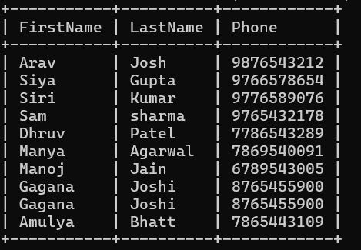

1. Write an SQL query to find the most popular electronic gadget, which is the one with the highest total quantity ordered. Include the product name and the total quantity ordered.

-> select p.productname, od.quantity from products as p inner join orderdetails as od where p.productid=od.productid order by od.quantity desc limit 1;

1. Write an SQL query to retrieve a list of electronic gadgets along with their corresponding categories.

-> alter table products add(categories varchar(20));

update products set categories='communication' where productId=1;

update products set categories='microcomputers' where productId=2;

update products set categories='telecommunication' where productId=3;

update products set categories='microcomputer' where productId=4;

update products set categories='speech' where productId=5;

update products set categories='consumer' where productId=6;

update products set categories='consumer' where productId=7;

update products set categories='homeappliance' where productId=8;

update products set categories='images' where productId=9;

-> select productname ,categories from products;

1. Write an SQL query to calculate the average order value for each customer. Include the customer's name and their average order value.

-> select c.firstname, c.lastname, avg(o.totalamount) from customers c inner join orders o on c.customerId=o.customerId group by c.firstname, c.lastname;

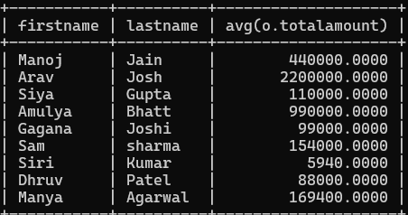

1. Write an SQL query to find the order with the highest total revenue. Include the order ID, customer information, and the total revenue.

-> SELECT o.OrderID, c.FirstName, c.LastName, SUM(od.Quantity * p.Price) as totalrevenue FROM Orders AS o INNER JOIN Customers AS c ON o.CustomerId = c.CustomerId INNER JOIN OrderDetails AS od ON o.OrderID = od.OrderId INNER JOIN Products AS p ON od.ProductID = p.Pro

ductId GROUP BY o.OrderID, c.FirstName, c.LastName ORDER BY totalrevenue desc limit 1;

1. Write an SQL query to list electronic gadgets and the number of times each product has been ordered.

-> select p.productname ,od.quantity from products as p inner join orderdetails as od on p.productid=od.productid ;

1. Write an SQL query to find customers who have purchased a specific electronic gadget product. Allow users to input the product name as a parameter.

-> SELECT c.FirstName, c.LastName, c.Email

-> FROM Customers AS c JOIN Orders AS o ON c.CustomerId = o.CustomerId

-> JOIN OrderDetails AS od ON o.OrderID = od.OrderID

-> JOIN Products AS p ON od.ProductID = p.ProductID

-> WHERE p.ProductName = 'camera';

1. Write an SQL query to calculate the total revenue generated by all orders placed within a specific time period. Allow users to input the start and end dates as parameter.

-> SELECT SUM(o.TotalAmount) AS TotalRevenue

-> FROM Orders AS o

-> WHERE o.OrderDate BETWEEN '2019-08-10' AND '2022-08-29';

Task 4. Subquery and its type:

1.Write an SQL query to find out which customers have not placed any orders.

->SELECT c.CustomerId, c.FirstName, c.LastName

-> FROM Customers AS c

-> WHERE c.CustomerId NOT IN (SELECT o.CustomerId FROM Orders AS o);

2. Write an SQL query to find the total number of products available for sale.

->select sum(QuantityInStock) from inventory;

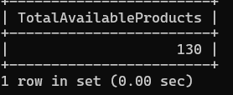

3. Write an SQL query to calculate the total revenue generated by TechShop.

-> select sum(totalamount) as revenue from orders;

4. Write an SQL query to calculate the average quantity ordered for products in a specific category. Allow users to input the category name as a parameter.

-> SELECT p.ProductName, AVG(od.Quantity)

-> FROM OrderDetails AS od

-> INNER JOIN Products AS p ON od.ProductID = p.ProductId

-> GROUP BY p.ProductName;

5. Write an SQL query to calculate the total revenue generated by a specific customer. Allow users to input the customer ID as a parameter.

->SELECT o.CustomerId, SUM(od.Quantity * p.Price) as revenue

-> FROM Orders AS o INNER JOIN OrderDetails AS od ON o.OrderID = od.OrderId

-> INNER JOIN Products AS p ON od.ProductID = p.ProductId

-> GROUP BY o.CustomerId;

6. Write an SQL query to find the customers who have placed the most orders. List their names and the number of orders they've placed.

-> SELECT c.firstName,c.lastName,COUNT(o.orderId) AS order_count

-> FROM customers AS c INNER JOIN orders AS o ON c.customerId = o.customerId

-> GROUP BY c.customerId, c.firstName, c.lastName

-> ORDER BY order_count DESC;

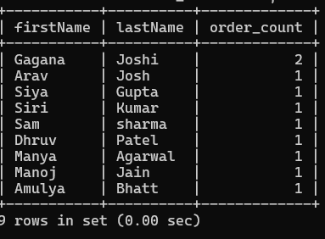

7. Write an SQL query to find the most popular product category, which is the one with the highest total quantity ordered across all orders.

->SELECT c.firstName,c.lastName,p.productName,SUM(od.quantity) AS total_quantity_ordered

-> FROM customers AS c INNER JOIN orders AS o ON c.customerId = o.customerId

-> INNER JOIN orderdetails AS od ON o.orderId = od.orderId

-> INNER JOIN products AS p ON od.productId = p.productId

-> GROUP BY c.customerId, c.firstName, c.lastName, p.productName

-> ORDER BY total_quantity_ordered DESC limit 1;

8. Write an SQL query to find the customer who has spent the most money (highest total revenue) on electronic gadgets. List their name and total spending.

->SELECT c.firstName, c.lastName, SUM(od.quantity * p.price) AS total_spending

-> FROM customers AS c

-> INNER JOIN orders AS o ON c.customerId = o.customerId

-> INNER JOIN orderdetails AS od ON o.orderId = od.orderId

-> INNER JOIN products AS p ON od.productId = p.productId

-> GROUP BY c.customerId

-> ORDER BY total_spending DESC

-> LIMIT 1;

9. Write an SQL query to calculate the average order value (total revenue divided by the number of orders) for all customers.

->SELECT AVG(order_value) AS average_order_value FROM (

-> SELECT o.customerId,SUM(od.quantity * p.price) AS order_value

-> FROM orders AS o INNER JOIN orderdetails AS od ON o.orderId = od.orderId

-> INNER JOIN products AS p ON od.productId = p.productId

-> GROUP BY o.orderId)as order_summary;

10. Write an SQL query to find the total number of orders placed by each customer and list their names along with the order count.

->SELECT c.firstName, COUNT(o.orderId) AS total_orders

-> FROM customers AS c

-> LEFT JOIN orders AS o ON c.customerId = o.customerId

-> GROUP BY c.firstName;

