**Steps to create Flask Application**

1. Create a New Folder – MyFlask in Visual Studio Code and run the following commands either in Terminal or Command Prompt by going to the same directory where folder is created.

Commands below

a. python --version

(Check Python Version, it should be Python 3 or above)

b. Create a Virtual Environment with the commands below -

pip install virtualenv env

.\env\Scripts\activate.bat

You should see the following in the Explorer section with env showing up–

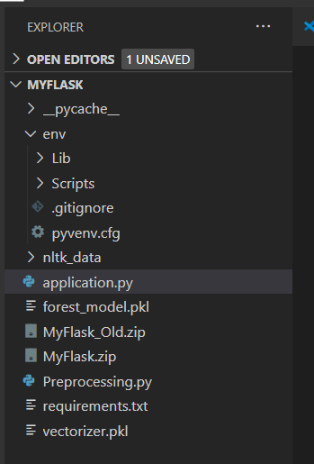

3. Unzip the files provided and copy the python files and pickle files to the folder and open the files application.py & preprocessing.py provided and run the files using the command in Command Prompt –

python Preprocessing.py

python application.py

4. You should be able to run the HelloWorld and Sentiment Analysis on your local host-

Ex - <http://127.0.0.1:5000>

Once the code runs on local host, we need to deploy the zip files provided on the AWS Beanstalk service. So, create an application, then upload the zip folder and deploy the application. AWS would provide an end point that can be used to make similar predictions as below –

[airlinetweetsentiment-env.eb-nse.us-west.elasticbeanstalk.com/sentiment?tweet=This airline is worse](http://airlinetweetsentiment-env.eba-fnnhnse5.us-west-2.elasticbeanstalk.com/sentiment?tweet=This%20airline%20is%20worse)