VertexArc
Developer Network
PDF Question & Answer Application
Project Documentation
Developer Evaluation Task — June 2026
Document-based Retrieval-Augmented Generation (RAG) Q&A

Table of Contents

1. Abstract
VertexArc PDF Q&A is a document-based question-and-answer web application. A user uploads a PDF document and asks natural-language questions about its contents; the system returns answers grounded strictly in the uploaded document using a Retrieval-Augmented Generation (RAG) pipeline. On upload, the application automatically produces a concise summary of the document. Each uploaded document maintains an independent chat session, the interface displays the most recent questions and answers, and the full conversation can be exported as a text or PDF file. The application is built with Streamlit for both the user interface and the application logic, and uses the OpenAI API for text embeddings and answer generation.

2. Problem Statement
Professionals frequently need specific information locked inside long PDF documents — contracts, reports, manuals, research papers — and reading the entire document to find one answer is slow and error-prone. General-purpose chatbots are not a safe substitute because they answer from broad training data and may hallucinate facts that are not present in the user's document. The challenge is to let users query their own documents conversationally while guaranteeing that every answer is derived only from the supplied source, with a clear signal when the answer is not present.

3. Objectives
- Allow users to upload a PDF and ask questions about it through an intuitive chat interface.
- Generate answers using only the uploaded document as context (no outside knowledge).
- Maintain an independent session and knowledge index per uploaded document.
- Automatically summarise each document on upload and show recent conversation history.
- Gracefully handle questions whose answers are not contained in the document.
- Let users export their conversation, and ensure the interface works on desktop and mobile.

4. Proposed Solution
The application implements a classic RAG pipeline. When a PDF is uploaded, its text is extracted page by page and split into overlapping character chunks that preserve their source page numbers. Each chunk is converted into a vector embedding and stored in an in-memory index tied to that document's session. When the user asks a question, the question is embedded and compared against the chunk vectors using cosine similarity; the top-matching chunks are retrieved and passed to a chat model with strict instructions to answer only from that context. If the best similarity score is below a confidence floor, or the model indicates the answer is absent, the application returns a clear “not found in this document” message instead of guessing. Answers cite the source page numbers they were drawn from.

5. Functional Requirements
The application satisfies all nine functional requirements defined in the assessment:
# | Requirement | How it is met
1 | PDF upload | Sidebar uploader accepting .pdf files (up to 50 MB).
2 | Q&A interface | Chat input box with message bubbles for questions and answers.
3 | Context-based answers | Answers generated only from retrieved document chunks.
4 | Session-based handling | Each document hash creates its own independent session and index.
5 | Conversation history | The last five question-answer pairs are displayed in the session.
6 | Document summary | A short summary is generated automatically on upload.
7 | Unsupported questions | A clear message is shown when the answer is not in the document.
8 | Export | Conversation can be downloaded as a .txt or .pdf file.
9 | Responsive UI | Streamlit layout with responsive CSS for desktop and mobile.

6. System Architecture
The system is a single Streamlit application that orchestrates four core modules: PDF processing, the RAG engine, exporters, and configuration. The diagram below shows the ingestion path (top) and the query path (bottom).
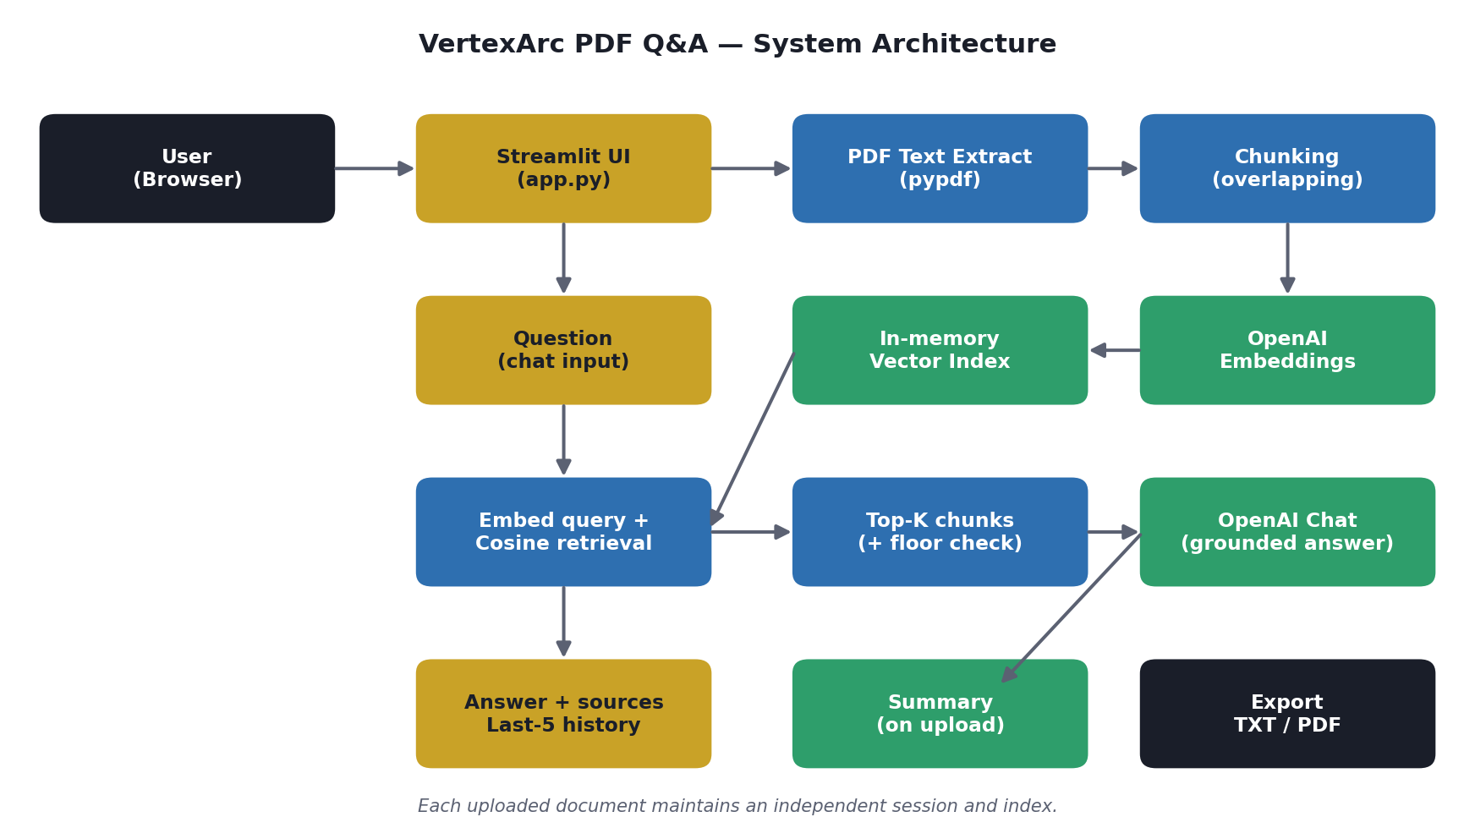

Component responsibilities
- app.py — Streamlit UI: upload, chat, summary display, history, export, and session state.
- pdf_utils.py — extracts text per page and splits it into overlapping, page-tagged chunks.
- rag_engine.py — builds the embedding index, retrieves top-K chunks, generates grounded answers and the document summary.
- exporters.py — renders the conversation to plain text or a formatted PDF.
- config.py — central settings and the OpenAI client, reading credentials from environment variables locally or Streamlit secrets in the cloud.

7. Data Model
The application is intentionally stateless across users and does not require an external database. All working data lives in the Streamlit session for the duration of a user's visit. This keeps deployment simple and avoids storing potentially sensitive document contents on a server. The in-session data structures are:
Entity | Fields | Lifetime / storage
Document session | doc_id (MD5 hash), doc_name, page text | Streamlit session_state
Vector index | chunk text, page number, embedding vector | In-memory (NumPy array) per session
Chat history | question, answer, source pages | Streamlit session_state (list)
Summary | generated summary text | Streamlit session_state
Rationale: a document-scoped, in-memory index gives fast similarity search without the operational overhead of a managed vector database, which is appropriate for an interactive single-document assistant. The architecture can be extended to a persistent vector store (e.g., FAISS on disk, Pinecone, or pgvector) if multi-session persistence or very large corpora are required — see Future Enhancements.

8. Technology Stack
Layer | Technology | Why
UI & backend | Streamlit | Single framework for UI and Python logic; fast to build and deploy.
PDF parsing | pypdf | Lightweight, pure-Python text extraction.
Embeddings | OpenAI text-embedding-3-small | High-quality, low-cost semantic vectors.
Answering | OpenAI gpt-4o-mini | Strong instruction-following at low cost.
Vector math | NumPy | Fast in-memory cosine similarity.
Export | fpdf2 | Generates PDF exports without external services.
Hosting | Streamlit Community Cloud | Free public hosting directly from GitHub.

9. Workflow Explanation
- The user opens the app and uploads a PDF from the sidebar.
- The PDF is hashed; a new hash starts a fresh, independent session. Text is extracted and chunked.
- Each chunk is embedded via the OpenAI embeddings API and stored in an in-memory index.
- A short document summary is generated and displayed.
- The user types a question. It is embedded and matched against the index by cosine similarity.
- The top-K chunks are sent to the chat model with instructions to answer only from that context.
- If confidence is too low or no answer exists, a “not found” message is returned; otherwise the answer is shown with its source pages.
- The Q&A pair is appended to history; the last five pairs are displayed. The user can export the conversation as TXT or PDF at any time.

10. Folder Structure
vertexarc-pdf-qa/
app.py Streamlit UI (upload, chat, summary, history, export)
config.py Settings + OpenAI client (.env or st.secrets)
pdf_utils.py PDF text extraction + chunking
rag_engine.py Embeddings, retrieval, answering, summarization
exporters.py Conversation export to TXT / PDF
requirements.txt Python dependencies
README.md Setup and deployment guide
.env.example Local environment template
.gitignore
.streamlit/
config.toml Theme + upload size
secrets.toml.example Cloud secrets template

11. Setup Instructions

Run locally
- Clone the repository and create a virtual environment (Python 3.10+).
- Install dependencies: pip install -r requirements.txt
- Copy .env.example to .env and add your OPENAI_API_KEY.
- Launch with: streamlit run app.py — the app opens at http://localhost:8501.

Deploy to Streamlit Community Cloud
- Push the repository to GitHub.
- On share.streamlit.io, create a new app pointing to app.py.
- Add OPENAI_API_KEY (and optional model names) under Advanced settings → Secrets.
- Deploy to obtain a public https://<app>.streamlit.app URL.

12. Screenshots
Insert the following screenshots captured from the running application before final submission: (1) home screen, (2) PDF upload, (3) chat interface with a question and answer, (4) the auto-generated document summary, and (5) the export functionality. Placeholder slots are provided below.
[ Screenshot: Home screen ]
[ Screenshot: PDF upload ]
[ Screenshot: Chat interface ]
[ Screenshot: Document summary ]
[ Screenshot: Export functionality ]

13. Challenges Faced
- Grounding answers strictly in the document and preventing hallucination — solved with a strict system prompt, a similarity floor, and an explicit “no answer” sentinel.
- Keeping sessions independent per document — solved by keying the index and history on a hash of the file bytes.
- Choosing chunk size and overlap that balance retrieval precision with context completeness.
- Producing clean PDF exports across fpdf versions, including correct text wrapping and byte output.

14. Future Enhancements
- OCR support for scanned / image-only PDFs.
- Persistent vector store (FAISS, pgvector, or Pinecone) for multi-session history and large corpora.
- Multi-document querying and citation highlighting within the original PDF.
- User accounts and saved conversations.
- Streaming answers and configurable model selection from the UI.

15. References
- Streamlit documentation — https://docs.streamlit.io
- OpenAI API reference — https://platform.openai.com/docs
- pypdf documentation — https://pypdf.readthedocs.io
- fpdf2 documentation — https://py-pdf.github.io/fpdf2
- Lewis et al., “Retrieval-Augmented Generation for Knowledge-Intensive NLP Tasks” (2020).

16. Conclusion
VertexArc PDF Q&A delivers a complete, deployable solution to the problem of querying PDF documents conversationally while guaranteeing that answers stay faithful to the source. It satisfies all functional requirements, uses a pragmatic stateless architecture that is simple to host, and is structured for straightforward extension. The project demonstrates effective, responsible use of AI-assisted development to deliver a professional end-to-end product within the deadline.

