**Lists:**

***<ol>, <ul>, <li>***

**Navigation:**

<nav>

  <a href = “page.html”> Home </a>

  <a href = “about.html”> About </a>

</nav>

**Forms:**

* ***Input types,***
  + ***Text***
  + ***Radio***
  + ***Checkbox etc …***
* ***<form method = “get” action = “processing server url”> </form>***

<form>

  <input type = "radio" id = "e1" name = "email_id" value = "email">

  <label for = "radio1">Transfer</label><br>

</form>

* **for** attribute **=>** hitting the label selects the form field. (i.e; improves hit area)
* **name** attribute is used to reference the data after submitting the form.
  + Only form elements with a **name** attribute will have their values passed to the database when submitting a form.
* The **value** attribute defines the value that is submitted when the input is selected.
* For the case of text inputs, you can use the value attribute to define a **default value** that will be submitted unless a different value is provided by the user.
* <input type = "radio" id = "e1" name = "email_id" value = "email">

**Dropdown menu:**

    <form>

      <label for="dropdown">

      Choose an option:</label>

      <select id="dropdown">

        <option value="r">Red</option>

        <option value="g" selected>Green</option>

      </select>

      <input type="submit">

    </form>

* **<select>** is used to create a dropdown menu.
* **<option>** is used to create options in the dropdown menu.
* **Id** attributein select can be associated with **<label>**

**Multimedia:**

**Video:**

* When different **<source>** options are included, the browser will choose the first one it supports.

    <video>

        <source src="videofile.mp4" type="video/mp4">

        <source src="videofile.webm" type="video/webm">

    </video>

* You can add text between the **<video>** tags. The text will only be displayed in browsers that don’t support the video element.

    <video>

        <source src="videofile.mp4" type="video/mp4">

        <source src="videofile.webm" type="video/webm">

        Video is not supported

    </video>

* You can display play/pause, volume and other video controls with the **controls**attribute.

    <video controls>

<!-- code -->

    </video>

**Audio:**

* Here, instead of **<video>** we use **<audio>**

<audio>

    <source src="audiofile.mp3" type="audio/mpeg">

    <source src="audiofile.ogg" type="audio/ogg">

    Audio not supported.

</audio>

* We can use the following attributes along with both **<audio> & <video>.**
  + **No sound - muted**
  + **Automatically play - autoplay**
  + **Play repeateadly - loop**
  + **Media controls - controls**

**Layout:**

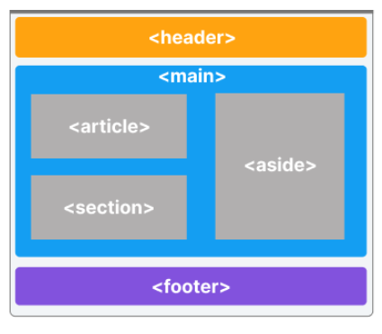

* All above tags are **semantic tags.**
* Webpage can be divided into 3 parts.
  + Header **(<header>)**
    - contains introductory information.
    - contains search bar, navigation links, brand logos.
  + Main **(<main>)**
    - Includes main content of webpage.
    - Article **(<article>)**
      * Contains independent, self-contained piece of content.
      * Used for content like news, articles, blog posts, or product reviews.
    - Section **(<section>)**
      * Helps to break down the content into parts.
    - Aside **(<aside>)**
      * Is used to add secondary, additional related content.
  + Footer **(<footer>)**
    - Contains authorship, copyright & contact information.

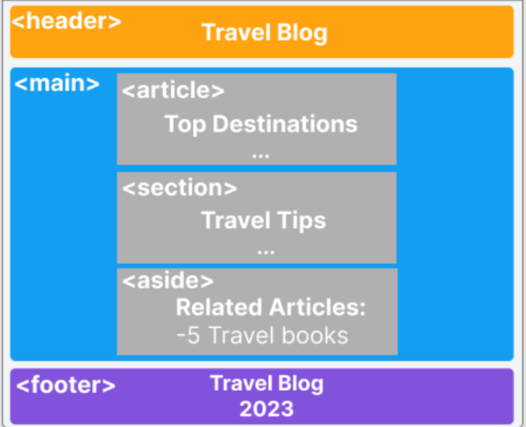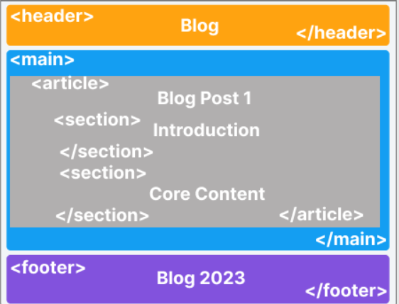

**Content Division:**

* Grouping different elements can make customization, maintainance easier & loads page faster.

**Tables:**

    <table>

      <tr>

        <th>Name</th><th>Age</th>

      </tr>

      <tr>

        <td>Amy</td><td>38</td>

      </tr>

    </table>

* **<tr>** **- rows**
* **<th> -** **heading**
* **<td> - data**
* Merging rows & columns,
  + **Column merge - colspan**
  + **Row merge - rowspan**

      <tr>

        <td style="border:solid"

        colspan="2">Sum: 900</td>

      </tr>

**Notes:**

* Single web page navigation,
  + To jump to a specific part of the webpage,
    - **<h1 id = “contact-us”> contact us </h1>**
  + Once the element is marked with id, we can target it with anchor tag <a>.
    - **<a href = “#contact-us”> jump to contact us section </a>**
    - **#** means that we are targeting a section of same document
* **<label>** tag is used to add input description.
* **<hr>** adds horizontal line in the page.
* **<br>** adds a new line.
* **<pre>** defines preformatted text.
* Two types of elements,
  + **Inline - takes up as much width necessary.**
    - **Ex: <i>, <b>, <u> etc.**
  + **Block - takes up full width & starts on a new line.** 
    - **Ex: <p>, <h1> etc.**

**Attributes:**

* **Title** attribute is used to display text when we hover on the element.
* **<html lang = ”en-US”>** used to specify English is the language of site and US is the country.
* **Placeholder in forms.**

**Hyper Links:**

* **target: _self, _blank, _parent, _top**

**Notes:**

* div is block level element, span is inline element.
* Block elements can’t be inserted inside inline elements.
* **<a href = ”../file.hmtl”> click me </a>**