TECHNICAL IMPLEMENTATION DOCUMENT
HR Analytics:
Employee Performance & Attrition

Prepared By
D S S Gangadhara Prathap
Internship Organization
Accenture
Submission Date
08-07-2026

1. Introduction
This document presents the technical implementation approach for the HR Analytics case study (Use Case 08 – Employee Performance & Attrition). The organisation described in the case study seeks to build an HR analytics capability to understand employee attrition patterns, the relationship between performance ratings and exits, and the cost of attrition. Employee master data, performance review records, and exit event records are currently maintained in separate systems, and this implementation aims to consolidate them into a dimensional data model suitable for analytical reporting in Oracle Analytics Cloud (OAC).
The sections that follow describe the source data, the logical data model, the database implementation, the handling of Slowly Changing Dimension (SCD) Type 2 for the Employee Dimension, the SQL views developed to answer the specified business questions, and the resulting OAC dashboard.
2. Business Context
A large organisation wants to build an HR analytics capability to understand employee attrition patterns, the relationship between performance ratings and exits, and the cost of attrition. The organisation holds employee master data, performance review records, and exit event records in separate systems, and requires these to be brought together to support analysis of attrition trends, performance-linked exit behaviour, and the financial impact of employee turnover.
3. Objectives
Based on the case study, the objectives of this implementation are to:
- Design a logical data model with two separate fact tables — Performance Review and Attrition Event — sharing common dimensions (Employee, Department, Calendar).
- Implement Slowly Changing Dimension (SCD) Type 2 for the Employee Dimension to correctly track designation changes over time.
- Develop SQL views to answer the four specified business questions relating to attrition rate, performance ratings by exit type, replacement cost, and post-promotion attrition.
- Populate the model with sample data comprising at least 5 departments, 20 employees, and 10 attrition events.
- Build an OAC dashboard including an attrition heat map by department and a performance vs. exit correlation chart.
2. Source Data Description

The HR Analytics data warehouse uses three-dimension tables and two fact tables. The dimension tables store descriptive information, while the fact tables store performance and attrition records. These tables are linked using primary and foreign keys to support analytical reporting and business insights.

2.1 Employee Dimension
Stores employee details such as personal information, department, designation, hiring date, exit date, and active status. SCD Type 2 is implemented to maintain the history of designation changes after promotions.

Table 2.1: DIM_EMPLOYEE
Column Name | Data Type | Constraint
EMP_SK | NUMBER | Primary Key, NOT NULL
EMP_ID | NUMBER | NOT NULL
NAME | VARCHAR2(100) | NOT NULL
GENDER | VARCHAR2(10) | NOT NULL
AGE | NUMBER | NOT NULL
DEPARTMENT_ID | VARCHAR2(20) | Foreign Key, NOT NULL
DESIGNATION | VARCHAR2(100) | NOT NULL
HIRE_DATE | DATE | NOT NULL
EXIT_DATE | DATE | NULL
EFFECTIVE_START_DATE | DATE | NOT NULL
EFFECTIVE_END_DATE | DATE | NOT NULL
CURRENT_FLAG | CHAR(1) | NOT NULL
IS_ACTIVE | CHAR(1) | NOT NULL

2.2 Department Dimension
The DIM_DEPARTMENT table stores department-related information used in the HR Analytics data warehouse. It contains department details, cost centre, location, and business unit information, supporting department-wise attrition analysis, performance reporting, and replacement cost analysis.
Column Name | Data Type | Constraint
DEPT_SK | NUMBER | Primary Key, NOT NULL
DEPARTMENT_ID | VARCHAR2(20) | UNIQUE, NOT NULL
DEPARTMENT_NAME | VARCHAR2(100) | NOT NULL
COST_CENTER | VARCHAR2(20) | NOT NULL
LOCATION | VARCHAR2(100) | NOT NULL
BUSINESS_UNIT | VARCHAR2(50) | NOT NULL

2.3 Calendar Dimension
The DIM_CALENDER table stores date-related information used for time-based analysis. It provides day, month, quarter, and year details, allowing performance reviews and attrition events to be analysed across different time periods in the HR Analytics data warehouse.
Column Name | Data Type | Constraint
DAY_SK | NUMBER | Primary Key, NOT NULL
FULL_DATE | DATE | UNIQUE, NOT NULL
MONTH | NUMBER(2) | NOT NULL
QUARTER | NUMBER(2) | NOT NULL
YEAR | NUMBER(4) | NOT NULL

2.4 Performance Review Fact
The FACT_PERFORMANCE table stores employee performance review records. It includes performance ratings, KPI achievement, promotion status, and references to the Employee, Department, and Calendar dimensions, enabling performance analysis and promotion-related reporting in the HR Analytics data warehouse.
Column Name | Data Type | Constraint
PERFORMANCE_ID | NUMBER | Primary Key, NOT NULL
EMP_SK | NUMBER | Foreign Key, NOT NULL
DEPT_SK | NUMBER | Foreign Key, NOT NULL
DAY_SK | NUMBER | Foreign Key, NOT NULL
RATING_SCORE | NUMBER(1,0) | NOT NULL
KPI_ACHIEVEMENT_PERCENTAGE | NUMBER(5,2) | NOT NULL
PROMOTION_FLAG | CHAR(1) | NOT NULL

2.5 Attrition Event Fact
The FACT_ATTRITION table stores employee exit records. It captures the reason for attrition, notice period served, estimated replacement cost, and regrettable attrition status. The table is linked to the employee, department, and calendar dimensions to support attrition and workforce analysis.
Column Name | Data Type | Constraint
ATTRITION_ID | NUMBER | Primary Key, NOT NULL
EMP_SK | NUMBER | Foreign Key, NOT NULL
DAY_SK | NUMBER | Foreign Key, NOT NULL
DEPT_SK | NUMBER | Foreign Key, NOT NULL
EXIT_REASON_CATEGORY | VARCHAR2(30) | NOT NULL
NOTICE_PERIOD_SERVED | NUMBER | NOT NULL
ESTIMATED_REPLACEMENT_COST | NUMBER(12,2) | NOT NULL
REGRETTABLE_ATTRITION_FLAG | CHAR(1) | NOT NULL

3. Logical Data Model
The logical data model follows a star schema in which two fact tables — Performance Review Fact and Attrition Event Fact — share a common set of dimensions: Employee, Department, and Calendar. This allows performance and attrition data to be analysed independently or jointly, using the shared dimensions as common analytical axes.

3.1 Fact-to-Dimension Relationships
- Performance Review Fact links to the Employee Dimension using EMP_SK.
- Performance Review Fact links to the Calendar Dimension via the review date.
- Attrition Event Fact links to the Employee Dimension via the employee reference.
- Attrition Event Fact links to the Calendar Dimension via the exit date.
- Both the Employee Dimension and, through it, Department Dimension are shared conformed dimensions between the two fact tables, enabling attrition and performance to be analysed by department, cost centre, location, and business unit.

3.2 Entity-Relationship Diagram

Since the implementation contains two fact tables, separate Entity-Relationship (ER) diagrams are provided for FACT_PERFORMANCE and FACT_ATTRITION to clearly illustrate their relationships with the shared dimension tables.

Entity-Relationship diagram for Fact_Performance table
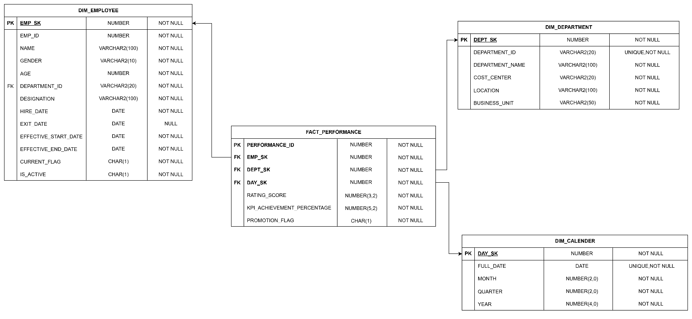

Entity-Relationship diagram for Fact_Attrition table
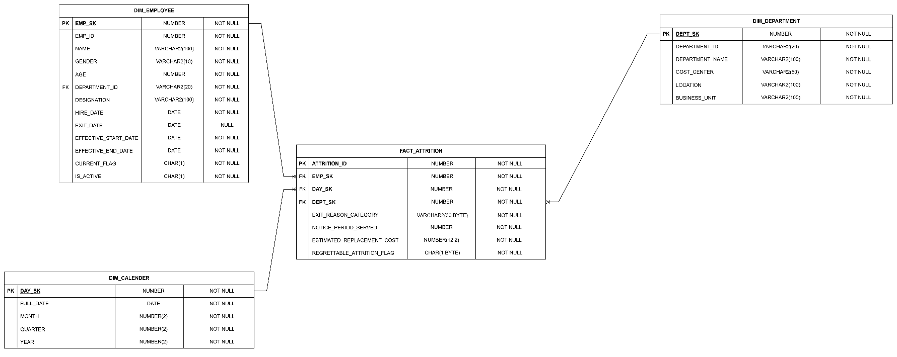

4. Database Implementation
This section outlines the purpose and structure of each table in the model. SQL DDL scripts are not generated here; placeholders are provided for insertion of the final implementation.

4.1 DIM_EMPLOYEE
Purpose
Stores employee master data, including attributes that change over time (such as designation) under SCD Type 2 tracking, as described in Section 5.
Description
Contains emp_id, name, gender, age, department_id (FK to DIM_DEPARTMENT), designation, hire date, exit date, and is_active flag, along with SCD Type 2 tracking attributes (surrogate key, effective dates, current-record flag).
CREATE TABLE DIM_EMPLOYEE (
EMP_SK NUMBER PRIMARY KEY,
EMP_ID NUMBER NOT NULL,
NAME VARCHAR2(100) NOT NULL,
GENDER VARCHAR2(10) NOT NULL,
AGE NUMBER NOT NULL,
DEPARTMENT_ID VARCHAR2(20) NOT NULL,
DESIGNATION VARCHAR2(100) NOT NULL,
HIRE_DATE DATE NOT NULL,
EXIT_DATE DATE,
EFFECTIVE_START_DATE DATE NOT NULL,
EFFECTIVE_END_DATE DATE NOT NULL,
CURRENT_FLAG CHAR(1) NOT NULL,
IS_ACTIVE CHAR(1) NOT NULL
);
Output:
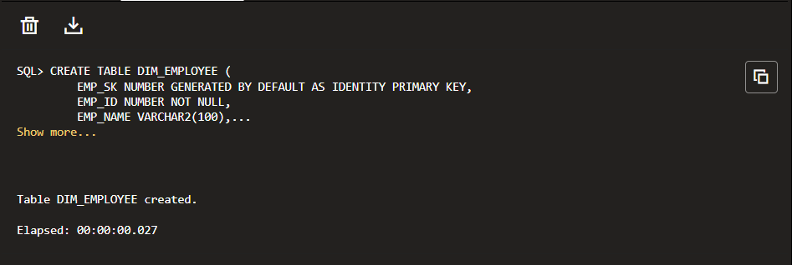
To Check the Table:
SELECT * FROM DIM_EMPLOYEE

4.2 DIM_DEPARTMENT
Purpose
Stores department master data used to analyse attrition and performance by department, cost centre, location, and business unit.
Description
Contains dept_id, department name, cost centre, location, and business unit.
Source code:
CREATE TABLE DIM_DEPARTMENT (
DEPT_SK NUMBER PRIMARY KEY,
DEPARTMENT_ID VARCHAR2(20) UNIQUE NOT NULL,
DEPARTMENT_NAME VARCHAR2(100) NOT NULL,
COST_CENTER VARCHAR2(20) NOT NULL,
LOCATION VARCHAR2(100) NOT NULL,
BUSINESS_UNIT VARCHAR2(50) NOT NULL
);
Output:
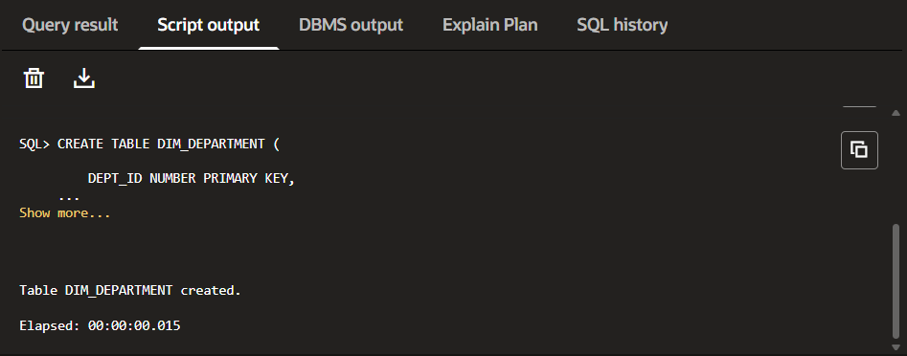
To Check the Table:
SELECT * FROM DIM_DEPARTMENT

4.3 DIM_CALENDER
Purpose
Provides a standard time dimension for date-based analysis across both fact tables.
Description
Contains DAY_SK, FULL_DATE, MONTH, QUARTER, and YEAR.
Source code:
CREATE TABLE DIM_CALENDER (
DAY_SK NUMBER PRIMARY KEY,
FULL_DATE DATE UNIQUE NOT NULL,
MONTH NUMBER(2,0) NOT NULL,
QUARTER NUMBER(2,0) NOT NULL,
YEAR NUMBER(4,0) NOT NULL
);
Output:
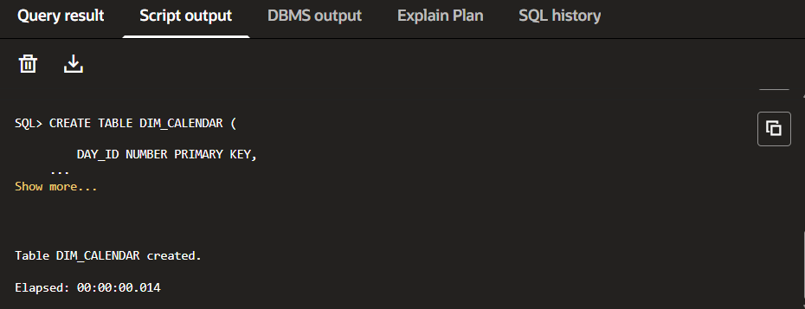
To Check the Table:
SELECT * FROM DIM_CALENDER

4.4 FACT_PERFORMANCE
Purpose
Stores one row per annual performance review per employee, supporting analysis of performance ratings and their relationship to promotions and subsequent attrition.
Description
Contains a reference to the employee (correct SCD Type 2 version), review date, rating score, KPI achievement percentage, and promotion flag
Source Code:
CREATE TABLE FACT_PERFORMANCE (
PERFORMANCE_ID NUMBER PRIMARY KEY,
EMP_SK NUMBER NOT NULL,
DEPT_SK NUMBER NOT NULL,
DAY_SK NUMBER NOT NULL,
RATING_SCORE NUMBER(1,0) NOT NULL,
KPI_ACHIEVEMENT_PERCENTAGE NUMBER(5,2) NOT NULL,
PROMOTION_FLAG CHAR(1) NOT NULL,

CONSTRAINT FK_FP_EMP
FOREIGN KEY (EMP_SK)
REFERENCES DIM_EMPLOYEE (EMP_SK),

CONSTRAINT FK_FP_DEPT
FOREIGN KEY (DEPT_SK)
REFERENCES DIM_DEPARTMENT (DEPT_SK),

CONSTRAINT FK_FP_DAY
FOREIGN KEY (DAY_SK)
REFERENCES DIM_CALENDER (DAY_SK)
);
Output:
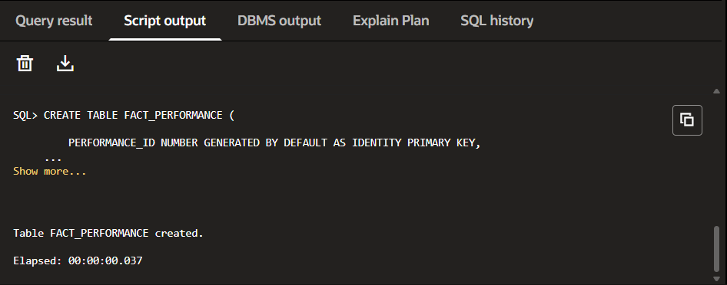

To Check the Table:
SELECT * FROM FACT_PERFORMANCE

4.5 FACT_ATTRITION
Purpose
Stores one row per exit event, supporting analysis of attrition rate, exit reason, replacement cost, and regrettable attrition.
Description
Contains a reference to the employee (correct SCD Type 2 version, per Section 9), exit date, exit reason category, notice period served, estimated replacement cost, and regrettable attrition flag.
Source Code:
CREATE TABLE FACT_ATTRITION (
ATTRITION_ID NUMBER PRIMARY KEY,
EMP_SK NUMBER NOT NULL,
DAY_SK NUMBER NOT NULL,
DEPT_SK NUMBER NOT NULL,
EXIT_REASON_CATEGORY VARCHAR2(30) NOT NULL,
NOTICE_PERIOD_SERVED NUMBER NOT NULL,
ESTIMATED_REPLACEMENT_COST NUMBER(12,2) NOT NULL,
REGRETTABLE_ATTRITION_FLAG CHAR(1) NOT NULL,

CONSTRAINT FK_FA_EMP
FOREIGN KEY (EMP_SK)
REFERENCES DIM_EMPLOYEE (EMP_SK),

CONSTRAINT FK_FA_DEPT
FOREIGN KEY (DEPT_SK)
REFERENCES DIM_DEPARTMENT (DEPT_SK),

CONSTRAINT FK_FA_DAY
FOREIGN KEY (DAY_SK)
REFERENCES DIM_CALENDER (DAY_SK)
);
Output:
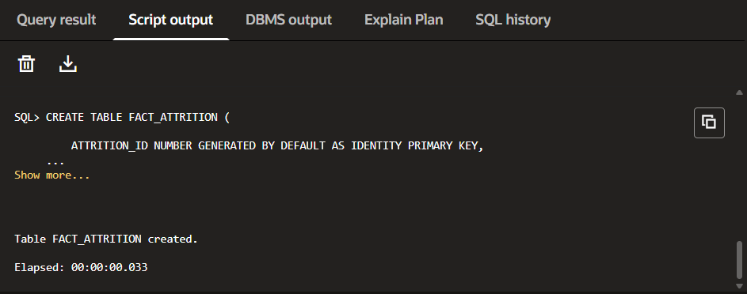
To Check the Table:
SELECT * FROM FACT_ATTRITION

5. SCD Type 2 Implementation

5.1 Why SCD Type 2 Is Required

Employee designations change when promotions occur. Using SCD Type 2 allows the system to keep previous designation records instead of overwriting them. This preserves historical employee information and ensures reports always reflect the designation that was valid when a performance review or attrition event occurred.

5.2 How Designation Changes Are Handled

When an employee is promoted, a new record is added to DIM_EMPLOYEE with a new surrogate key and updated designation. The previous record is closed by setting the effective end date and changing the current flag. The new record becomes the active version while preserving the employee's historical information.

5.3 Why Surrogate Keys Are Used
Because a single employee (identified by the natural key emp_id) can have multiple rows in DIM_EMPLOYEE over time under SCD Type 2, a surrogate key is introduced to uniquely identify each individual version of an employee record. The natural key (emp_id) identifies the employee across all their historical versions, while the surrogate key identifies one specific version of that employee's record as it existed during a specific period of time.

5.4 Ensuring Fact Tables Link to the Correct Employee Version
This addresses the SCD challenge raised in the case study: since SCD Type 2 produces multiple rows per employee in DIM_EMPLOYEE, the Performance Review Fact and Attrition Event Fact tables must always link to the version of the employee record that was current at the time of the event, not simply to the employee's natural key.
- Each fact table stores the surrogate key of DIM_EMPLOYEE, not the natural key (emp_id), as its foreign key to the Employee Dimension.
- When a fact row is loaded (a performance review or an exit event), the surrogate key is resolved by looking up the DIM_EMPLOYEE row for that emp_id whose effective date range contains the event date (i.e., the version that was current on the review date or exit date).
- This ensures that, for example, a performance review recorded before a promotion links to the pre-promotion designation, while a review recorded after the promotion links to the post-promotion designation — even though both reviews are for the same employee (same emp_id).
- Because the surrogate key is fixed at load time to the version that was current on the event date, historical facts remain correctly attributed to the employee's designation as it was at that point in time, regardless of any later promotions.

6. Data Population
Dummy data was created for demonstration purposes, in line with the case study requirement for sample data covering at least 5 departments, 20 employees, and 10 attrition events. This sample data is used to populate DIM_DEPARTMENT, DIM_EMPLOYEE (including SCD Type 2 versions for promoted employees), DIM_CALENDER, FACT_PERFORMANCE, and FACT_ATTRITION for the purpose of validating the data model and the SQL views described in Section 7.
6.1 DIM_DEPARTMENT
The DIM_DEPARTMENT table was populated with sample records representing different departments within the organization. Each department includes its corresponding cost center, location, and business unit. This dimension serves as the master reference for departmental analysis across both fact tables. 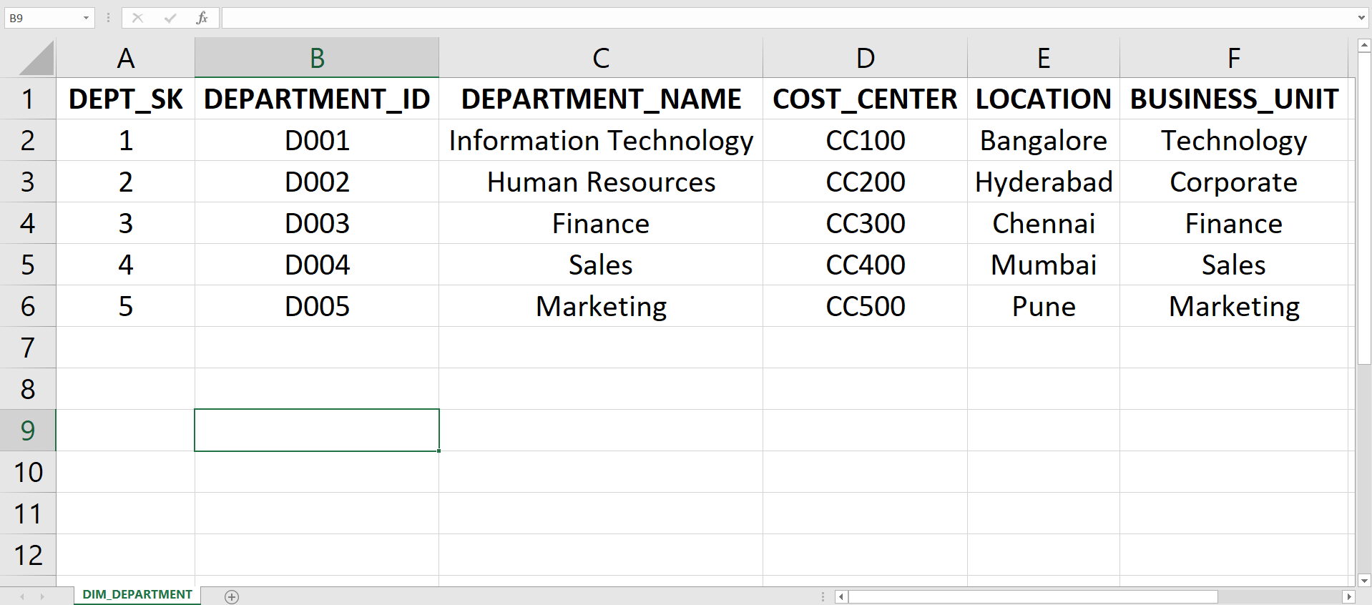
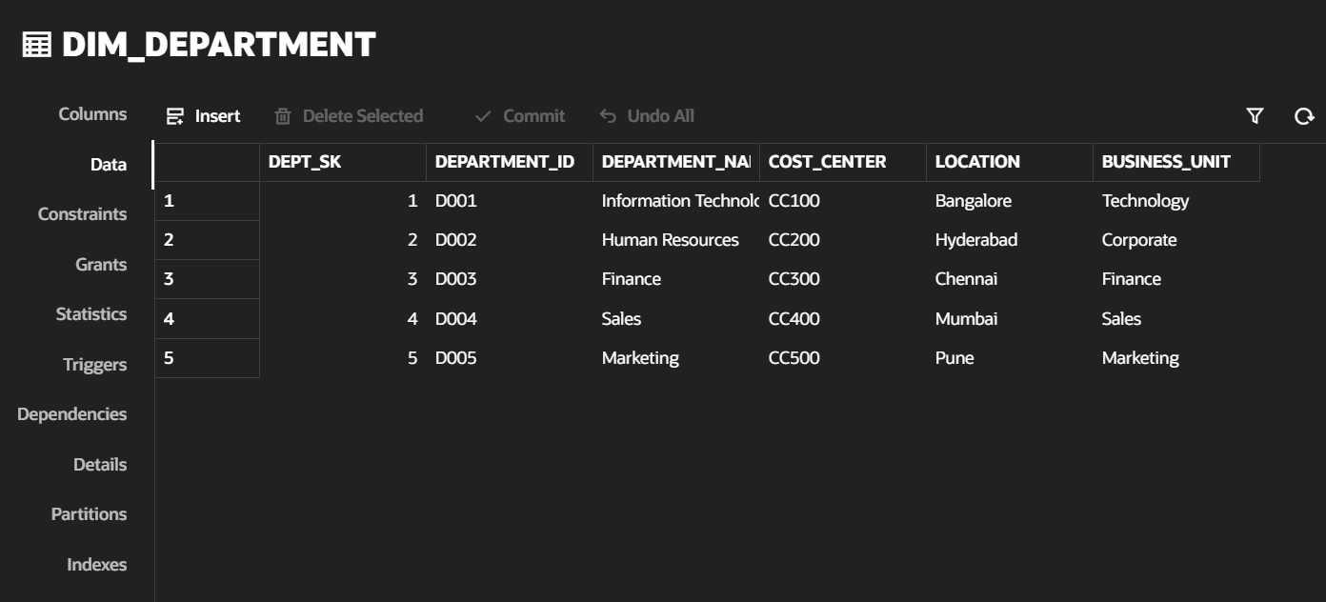
Fig 6.1.1 : Input DIM_DEPARTMENT demo data
Fig 6.1.2: DIM_DEPARTMENT demo data after the insertion
6.2 DIM_EMPLOYEE
The DIM_EMPLOYEE table was populated with employee master data, including demographic details, department assignments, and designations. To demonstrate SCD Type 2, multiple records were created for promoted employees while preserving their historical designation changes using effective dates and the current flag.
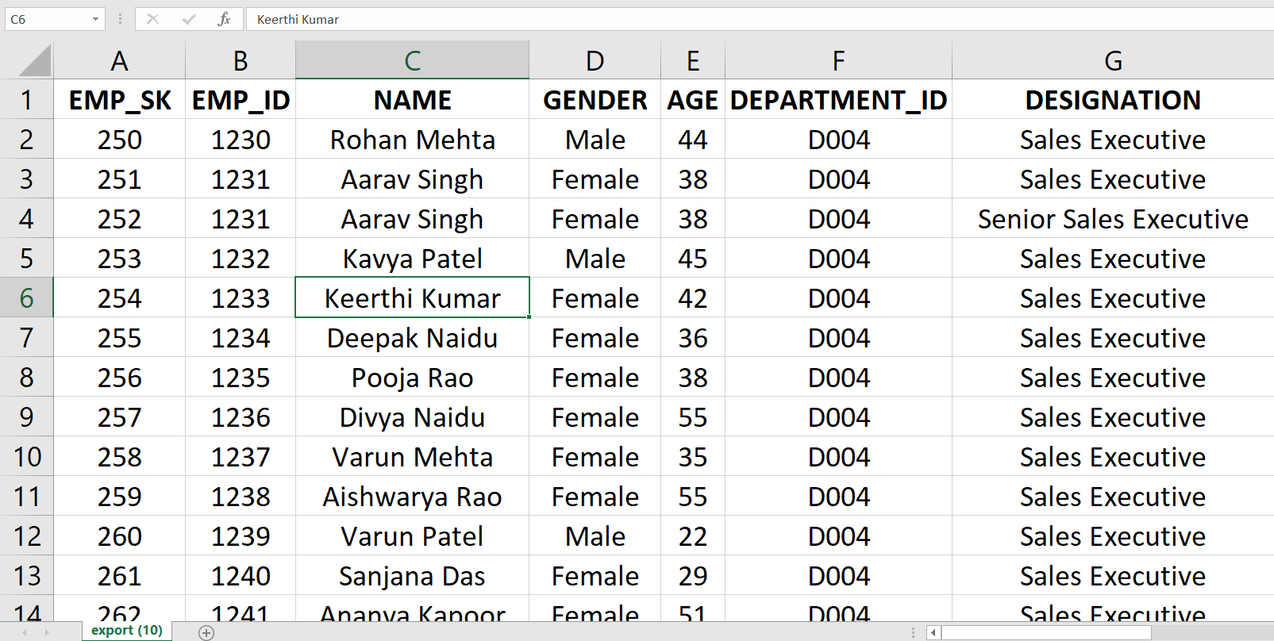
Fig 6.2.1: Input DIM_EMPLOYEE demo data
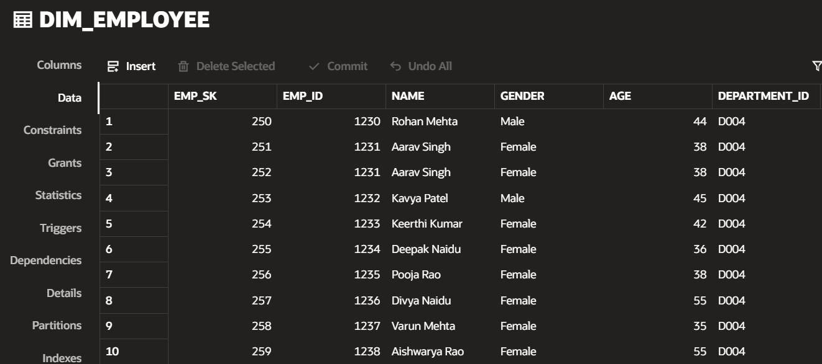
Fig 6.2.2: DIM_EMPLOYEE demo data after the insertion

6.3 DIM_CALENDER
The DIM_CALENDER table was populated with date records covering the required analysis period. It provides calendar attributes such as full date, month, quarter, and year, enabling time-based reporting and trend analysis for both performance reviews and attrition events.
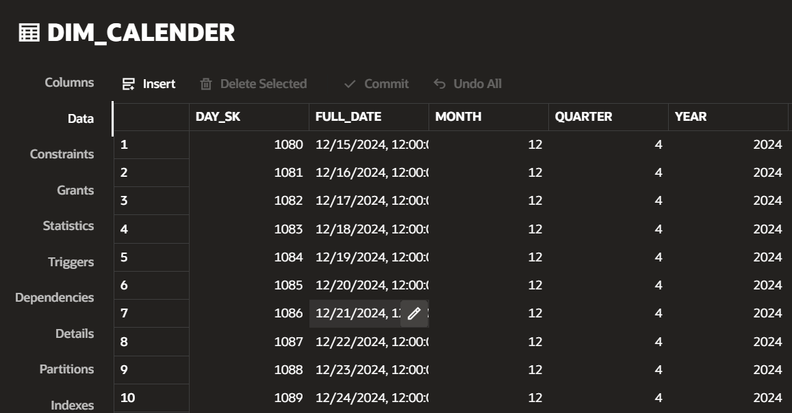
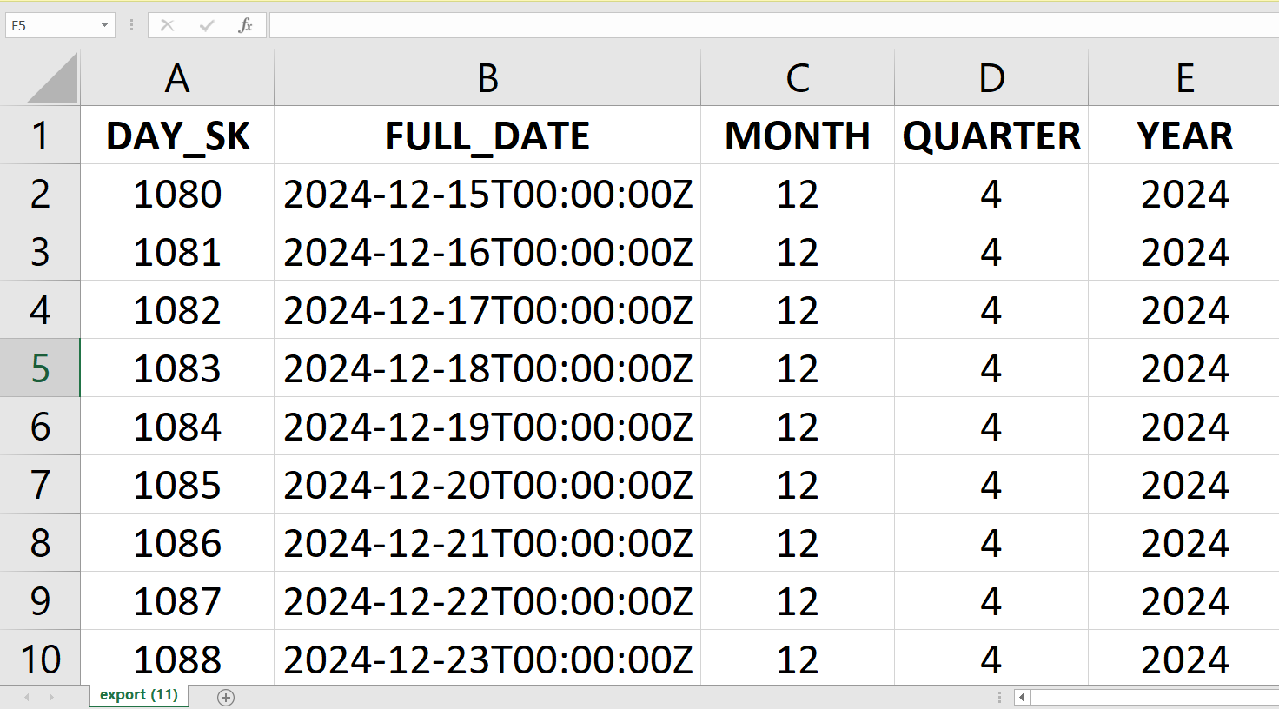
Fig 6.3.1: Input DIM_CALENDER demo data
Fig 6.3.2: DIM_CALENDER demo data after the insertion

6.4 FACT_PERFORMANCE
The FACT_PERFORMANCE table was populated with annual employee performance review records. Each record captures the employee, review date, performance rating, KPI achievement percentage, and promotion status. This data is used to analyse employee performance trends and promotion outcomes.
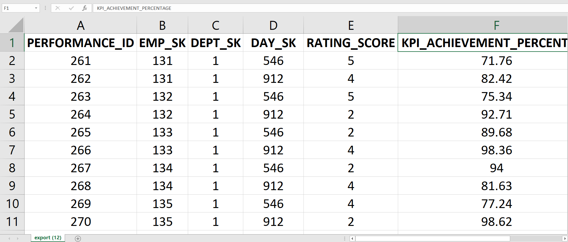
Fig 6.4.1: Input FACT_PERFORMANCE demo data
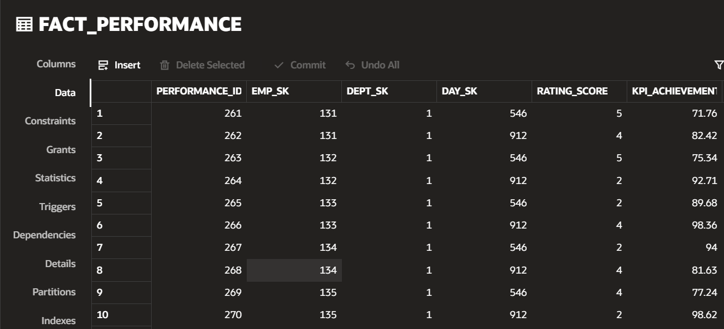
Fig 6.4.2: FACT_PERFORMANCE demo data after the insertion

6.5 FACT_ATTRITION
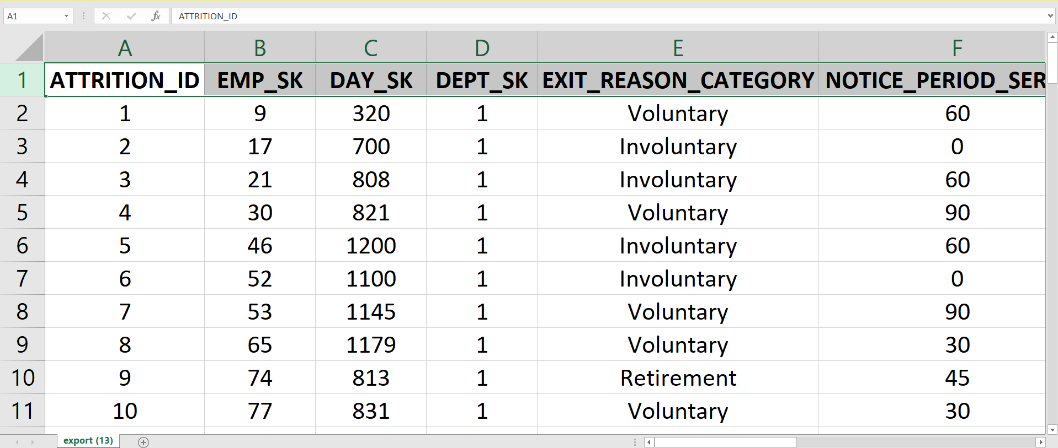
The FACT_ATTRITION table was populated with employee exit records, including exit date, exit reason, notice period served, estimated replacement cost, and regrettable attrition status. This data supports the analysis of attrition patterns, financial impact, and employee retention.
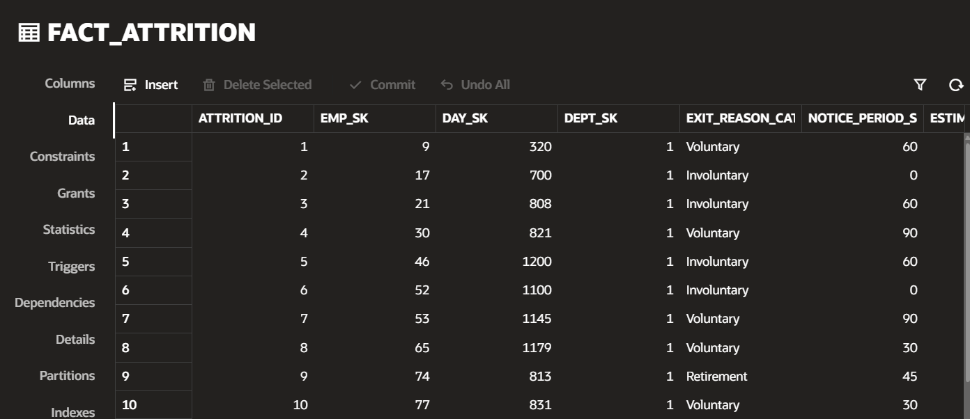
Fig 6.5.1: Input FACT_ATTRITION demo data
Fig 6.5.2: FACT_ATTRITION demo data after the insertion

7. SQL Views and Business Questions
This section addresses each of the four business questions specified in the case study.

7.1 Business Question 1
Business Question
Which department has the highest attrition rate in the last 2 years?
Objective
Identify the department with the highest attrition rate over the most recent two-year period, to help the organisation focus retention efforts.
Explanation of Logic

The view joins FACT_ATTRITION with DIM_DEPARTMENT and DIM_CALENDER to retrieve department information and filter attrition records from the last two years. It counts the total number of employee attrition events for each department using the COUNT() function and groups the results by department name. The output provides the total attrition for each department, which can be sorted to identify the department with the highest attrition.

View Creation Code:
CREATE OR REPLACE VIEW VW_ATTRITION_BY_DEPARTMENT AS
SELECT
d.DEPARTMENT_NAME,
COUNT(fa.ATTRITION_ID) AS TOTAL_ATTRITIONS
FROM FACT_ATTRITION fa
JOIN DIM_DEPARTMENT d
ON fa.DEPT_SK = d.DEPT_SK
JOIN DIM_CALENDER c
ON fa.DAY_SK = c.DAY_SK
WHERE c.FULL_DATE >= ADD_MONTHS(SYSDATE, -24)
GROUP BY d.DEPARTMENT_NAME;

View Checking Code:
SELECT *
FROM VW_ATTRITION_BY_DEPARTMENT
ORDER BY TOTAL_ATTRITIONS DESC;

Output:
Department Name | Total Attrition
Sales | 22
Finance | 13
Information Technology | 12
Human Resources | 8
Marketing | 6

Dashboard:

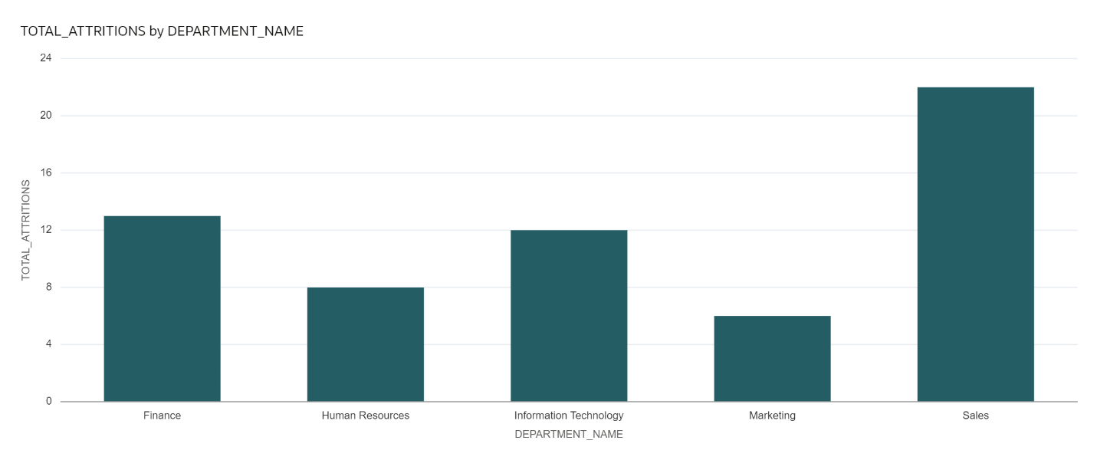
Analysis:
The Sales department recorded the highest number of employee attrition events (22) during the last two years, followed by Finance (13) and Information Technology (12). Human Resources and Marketing reported lower attrition counts. These results help HR identify departments with higher employee turnover and support better workforce planning and retention strategies.

7.2 Business Question 2
Business Question
What is the average performance rating of employees who left voluntarily vs. those who were involuntarily exited?
Objective
Compare average performance rating between voluntary and involuntary exits to understand whether exit type correlates with prior performance.
Explanation of Logic
The view joins FACT_ATTRITION and FACT_PERFORMANCE using the common EMP_SK key. It filters the records to include only employees who left through Voluntary or Involuntary attrition. The AVG() function is used to calculate the average performance rating for each exit category, and the results are grouped by the exit reason. The ROUND() function formats the average rating to two decimal places for easier interpretation..

View Creation Code:
CREATE OR REPLACE VIEW VW_PERFORMANCE_EXIT_ANALYSIS AS
SELECT
fa.EXIT_REASON_CATEGORY,
ROUND(AVG(fp.RATING_SCORE),2) AS AVERAGE_RATING
FROM FACT_ATTRITION fa
JOIN FACT_PERFORMANCE fp
ON fa.EMP_SK = fp.EMP_SK
WHERE fa.EXIT_REASON_CATEGORY IN ('Voluntary','Involuntary')
GROUP BY fa.EXIT_REASON_CATEGORY;

View Checking Code:
SELECT *
FROM VW_PERFORMANCE_EXIT_ANALYSIS;

Output:
Exit Reason Category | Average Rating
Involuntary | 3.43
Voluntary | 3.71

Dashboard:

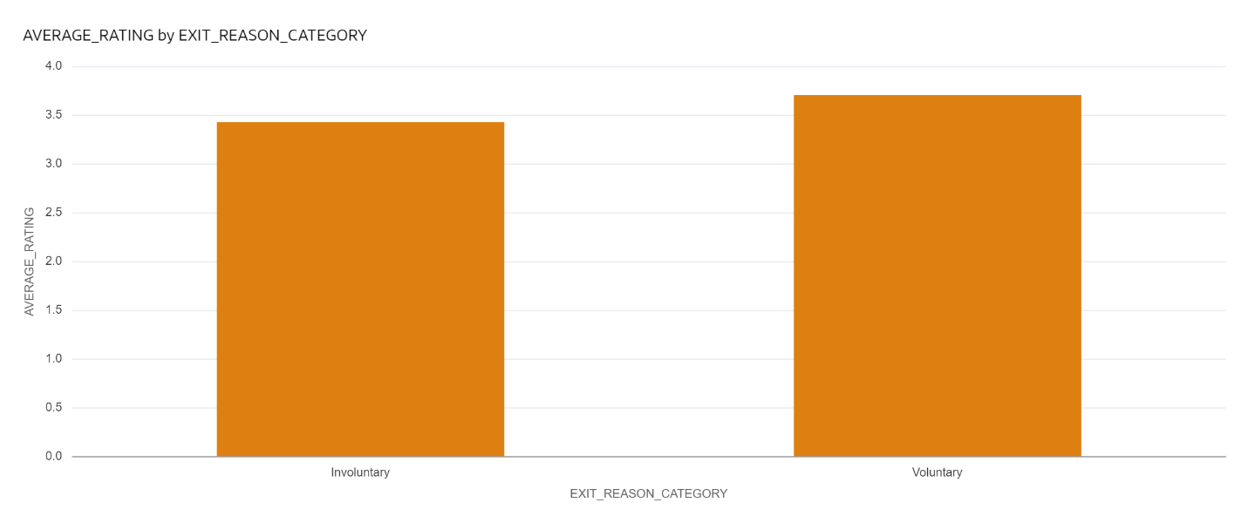

Analysis:
The results show that employees who left voluntarily had a slightly higher average performance rating (3.71) than those who were involuntarily exited (3.43). This comparison helps HR understand the relationship between employee performance and different types of employee exits.

7.3 Business Question 3
Business Question
What is the total estimated replacement cost by business unit for the last financial year?
Objective
Quantify the financial impact of attrition by business unit for the last financial year.
Explanation of Logic

The view joins FACT_ATTRITION, DIM_DEPARTMENT, and DIM_CALENDER using the department and calendar keys. It filters attrition records for the last financial year and calculates the total estimated replacement cost for each business unit using the SUM() function. The results are grouped by business unit to provide the overall replacement cost incurred due to employee attrition.

View Creation Code:
CREATE OR REPLACE VIEW VW_REPLACEMENT_COST AS
SELECT
d.BUSINESS_UNIT,
SUM(fa.ESTIMATED_REPLACEMENT_COST) AS TOTAL_REPLACEMENT_COST
FROM FACT_ATTRITION fa
JOIN DIM_DEPARTMENT d
ON fa.DEPT_SK = d.DEPT_SK
JOIN DIM_CALENDER c
ON fa.DAY_SK = c.DAY_SK
WHERE c.YEAR = EXTRACT(YEAR FROM ADD_MONTHS(SYSDATE,-12))
GROUP BY d.BUSINESS_UNIT;

View Checking Code:
SELECT *
FROM VW_REPLACEMENT_COST
ORDER BY TOTAL_REPLACEMENT_COST DESC;

Output:
Business Unit | Total Replacement Cost
Sales | 5,384,061
Finance | 2,761,309
Corporate | 2,611,238
Technology | 2,143,609
Marketing | 451,872

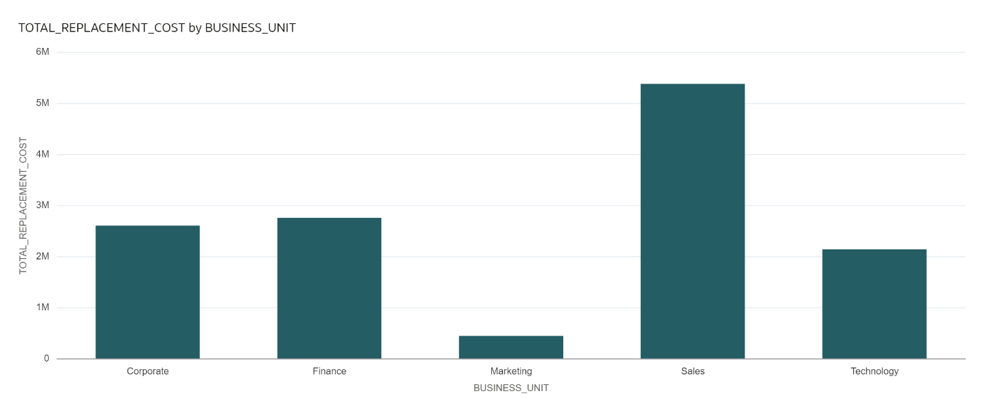
Dashboard:

Analysis:
The Sales business unit recorded the highest estimated replacement cost (5,384,061), followed by Finance and Corporate. Marketing had the lowest replacement cost. These results help the organisation understand the financial impact of employee attrition across different business units and support workforce planning and budgeting decisions.

7.4 Business Question 4
Business Question
For employees who were promoted (promotion_flag = Y), what is their subsequent attrition rate within 12 months of promotion?
Objective
Determine whether promotion is associated with higher or lower subsequent attrition, within a 12-month window following promotion.
Explanation of Logic
The view joins FACT_PERFORMANCE with DIM_CALENDER to identify employees who received a promotion between 2022 and 2024. It then performs a LEFT JOIN with FACT_ATTRITION using EMP_SK and checks whether the employee left the organisation within 365 days of the promotion date. The number of promoted employees who left within this period is divided by the total number of promoted employees for each year to calculate the attrition rate. The NULLIF() function prevents division by zero, while the ROUND() function formats the result to two decimal places. The final output is grouped and displayed by promotion year.

View Creation Code:
CREATE OR REPLACE VIEW VW_PROMOTION_ATTRITION_TREND AS
SELECT
c.YEAR AS PROMOTION_YEAR,
ROUND(
COUNT(DISTINCT fa.EMP_SK) * 100.0 /
NULLIF(COUNT(DISTINCT fp.EMP_SK),0),
2
) AS ATTRITION_RATE_PERCENT
FROM FACT_PERFORMANCE fp
JOIN DIM_CALENDER c
ON fp.DAY_SK = c.DAY_SK
LEFT JOIN FACT_ATTRITION fa
ON fp.EMP_SK = fa.EMP_SK
AND fa.DAY_SK BETWEEN fp.DAY_SK
AND fp.DAY_SK + 365
WHERE fp.PROMOTION_FLAG = 'Y'
AND c.YEAR BETWEEN 2022 AND 2024
GROUP BY c.YEAR
ORDER BY c.YEAR;

View Checking Code:
SELECT *
FROM VW_PROMOTION_ATTRITION_TREND;

Output:
Promotion Year | Attrition Rate (%)
2022 | 6.67
2023 | 17.65
2024 | 10.00

Dashboard:
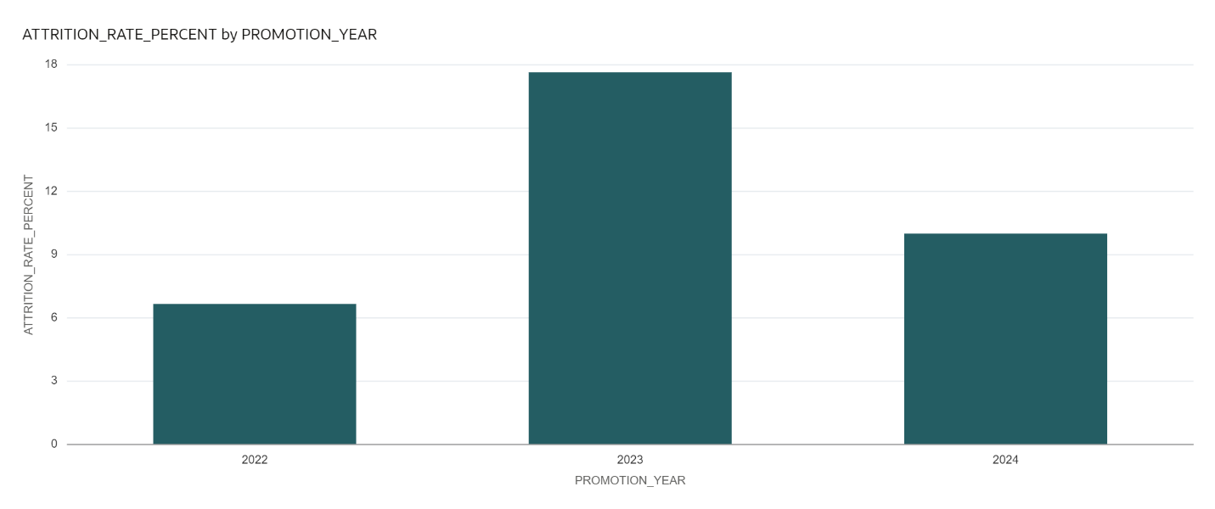

Analysis:
The results show that the highest promotion-related attrition rate occurred in 2023 (17.65%), followed by 2024 (10.00%) and 2022 (6.67%). This analysis helps HR evaluate whether promoted employees continue to stay with the organisation after receiving a promotion and supports the assessment of promotion and employee retention strategies.

8. Dashboard
The SQL views developed in Section 7 are used as data sources in Oracle Analytics Cloud (OAC) to build the dashboard required by the case study, consisting of an attrition heat map by department and a performance vs. exit correlation chart.

8.1 Attrition Heat Map by Department
Built from the Business Question 1 view, showing attrition rate intensity across departments.

View Code:
SELECT
d.DEPARTMENT_NAME,
ROUND(
COUNT(DISTINCT fa.EMP_SK)*100.0/
COUNT(DISTINCT fp.EMP_SK),2
) AS ATTRITION_RATE
FROM FACT_PERFORMANCE fp
JOIN DIM_DEPARTMENT d
ON fp.DEPT_SK=d.DEPT_SK

LEFT JOIN FACT_ATTRITION fa
ON fp.EMP_SK=fa.EMP_SK

GROUP BY d.DEPARTMENT_NAME;

Output:
Department Name | Attrition Rate (%)
Information Technology | 13.13
Human Resources | 21.54
Finance | 30.00
Sales | 16.92
Marketing | 19.57

Dashboard:

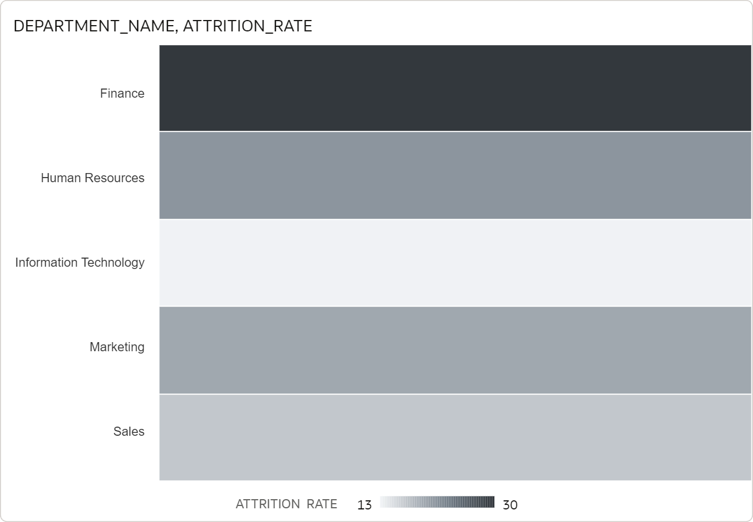

Analysis:
The results show that the Finance department has the highest attrition rate at 30.00%, indicating that nearly one-third of its employees left the organisation during the analysis period. Human Resources (21.54%) and Marketing (19.57%) also recorded relatively high attrition rates, while Sales (16.92%) and Information Technology (13.13%) had lower rates. These insights help the HR team identify departments with higher employee turnover and support the development of targeted retention strategies.

8.2 Performance vs. Exit Correlation Chart
Built from the Business Question 2 view, showing the relationship between performance rating and exit type (Excited vs Stayed).

View Creation Code:
WITH LATEST_PERFORMANCE AS
(
SELECT fp.*
FROM FACT_PERFORMANCE fp
JOIN
(
SELECT
EMP_SK,
MAX(DAY_SK) MAX_DAY
FROM FACT_PERFORMANCE
GROUP BY EMP_SK
) x
ON fp.EMP_SK=x.EMP_SK
AND fp.DAY_SK=x.MAX_DAY
)

SELECT
lp.RATING_SCORE,

CASE
WHEN fa.EMP_SK IS NULL
THEN 'Stayed'
ELSE 'Exited'
END EMPLOYEE_STATUS,

COUNT(*) EMPLOYEE_COUNT

FROM LATEST_PERFORMANCE lp

LEFT JOIN FACT_ATTRITION fa
ON lp.EMP_SK=fa.EMP_SK

GROUP BY
lp.RATING_SCORE,
CASE
WHEN fa.EMP_SK IS NULL
THEN 'Stayed'
ELSE 'Exited'
END

ORDER BY
lp.RATING_SCORE;

Output:
Rating Score | Employee Status | Employee Count
2 | Exited | 26
2 | Stayed | 112
3 | Exited | 19
3 | Stayed | 92
4 | Exited | 19
4 | Stayed | 112
5 | Exited | 29
5 | Stayed | 91

Dashboard:

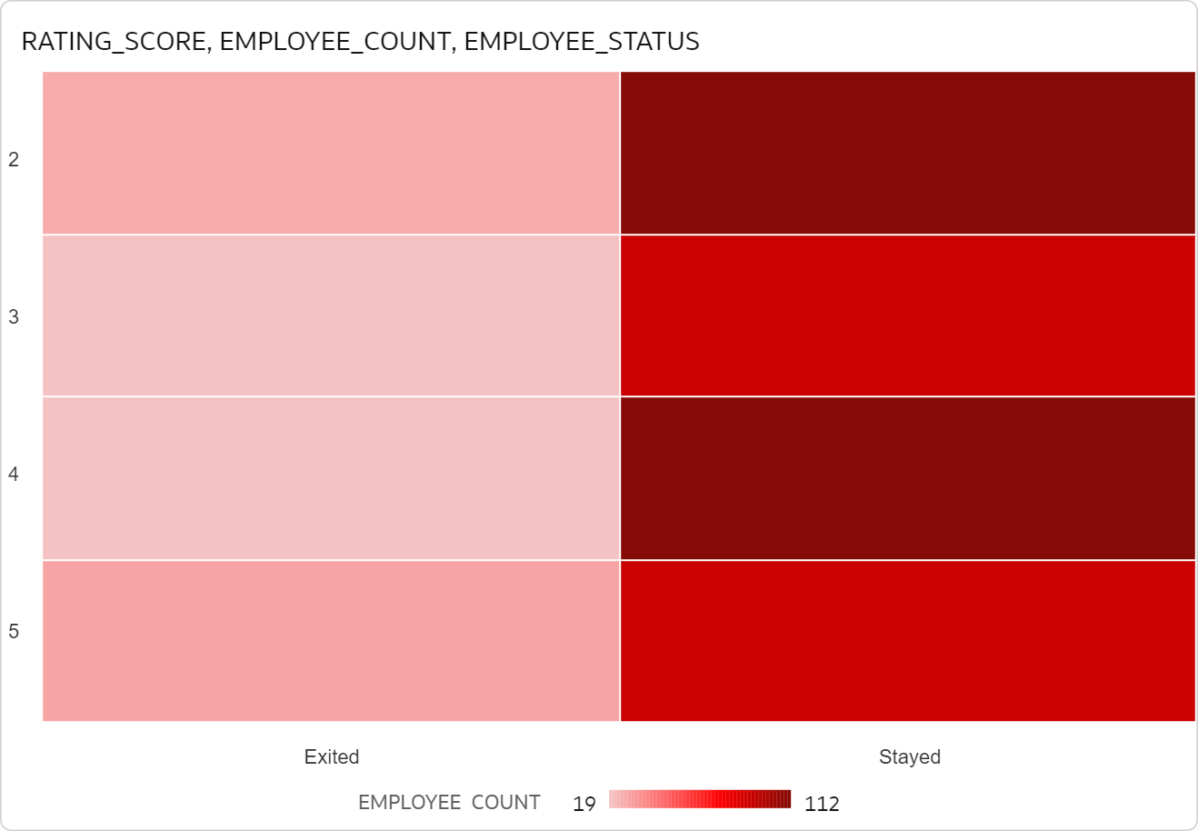

Analysis:
The table compares employee performance ratings with their employment status. Across all rating levels, the number of employees who stayed is higher than those who exited, indicating that employee retention is generally stronger than attrition. Employees with a rating of 5 recorded the highest number of exits (29), suggesting that even high-performing employees may leave the organisation. This analysis helps HR understand the relationship between employee performance and retention and supports decisions related to employee engagement and retention strategies.
9. Challenges Faced
The primary implementation challenge identified in the case study relates to SCD Type 2 handling for the Employee Dimension: since designation changes create multiple rows per employee, care is required to ensure that the Performance Review Fact and Attrition Event Fact tables always link to the correct historical version of the employee record (the version current at the time of the event), rather than the employee's current designation. This was addressed through surrogate key resolution based on effective date ranges, as described in Section 9.
10. Future Scope
Within the scope of this HR Analytics case study, the following logical extensions could be considered:
- Extending the attrition rate analysis (Business Question 1) beyond a fixed 2-year window to a rolling or configurable time period.
- Extending the replacement cost analysis (Business Question 3) across multiple financial years to observe year-on-year trends.
- Extending the post-promotion attrition analysis (Business Question 4) to test different follow-up windows beyond 12 months.
- Adding further OAC dashboard views that build on the existing Performance Review and Attrition Event facts and their shared dimensions, in line with the same case study scope.
11. Conclusion
This implementation establishes a dimensional data model for HR Analytics, with two fact tables — Performance Review and Attrition Event — sharing conformed Employee, Department, and Calendar dimensions. SCD Type 2 handling on the Employee Dimension ensures that designation changes are tracked accurately over time, and that fact records remain correctly linked to the employee version applicable at the time of each event. SQL views were developed to address the four business questions specified in the case study, covering departmental attrition rate, performance rating by exit type, replacement cost by business unit, and post-promotion attrition, forming the basis of the OAC dashboard delivered as part of this case study.

