1.Insert Document

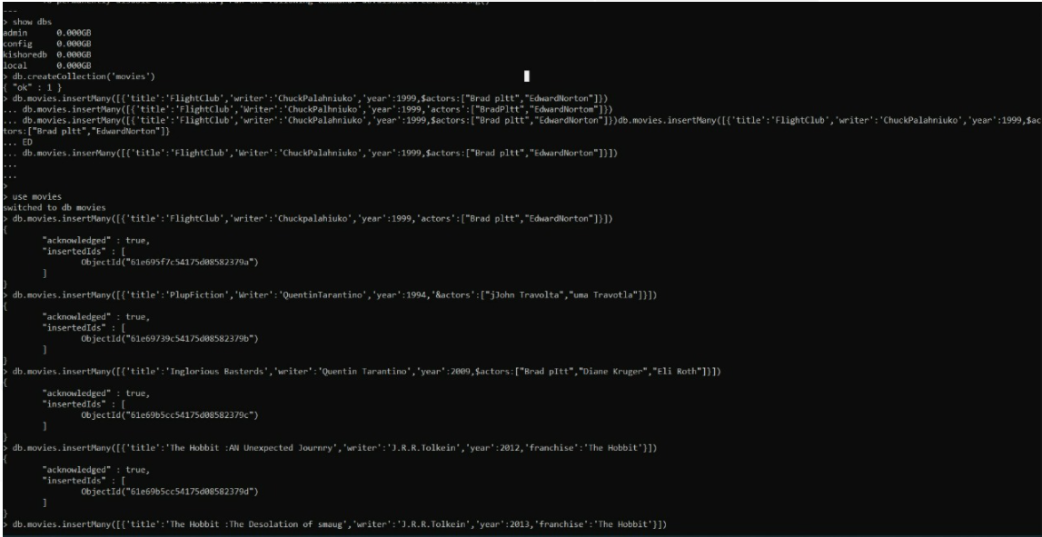

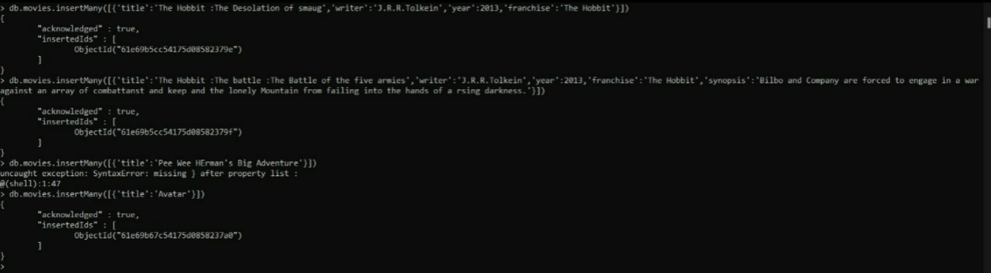

Use Movies collection

2.Query/Find Document

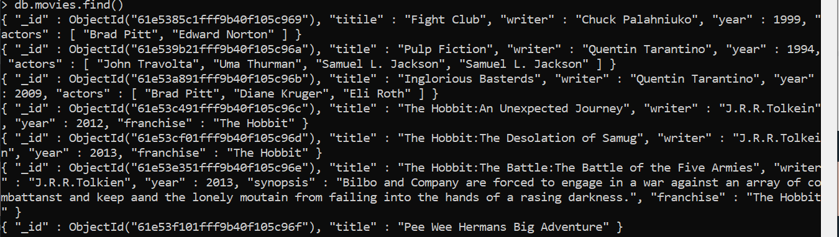





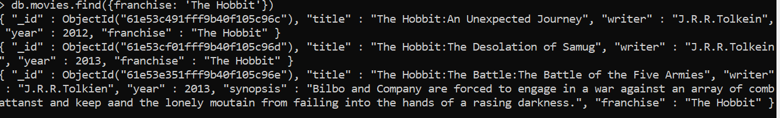



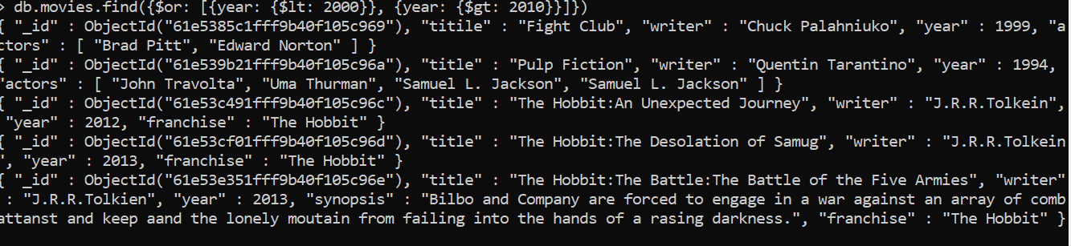

3.Query/Update Documents

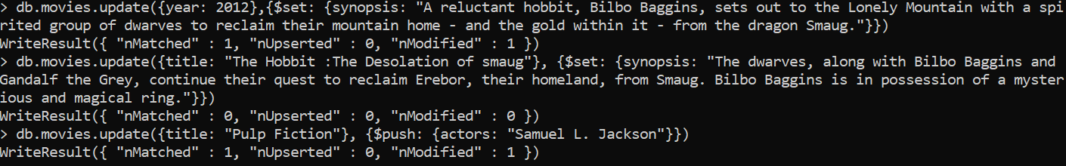

4.Query/Text Documents

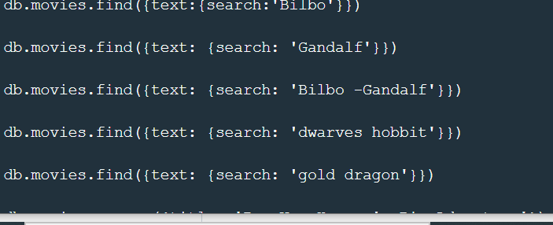

5.Query/Delete Documents





**Relationships**

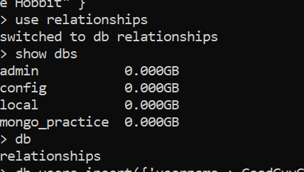

Insert Users:





Insert Posts:

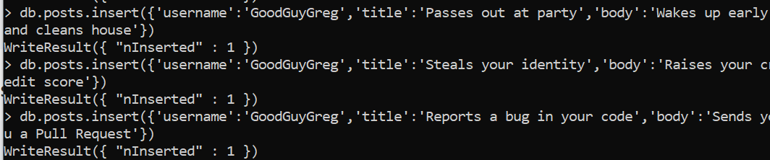

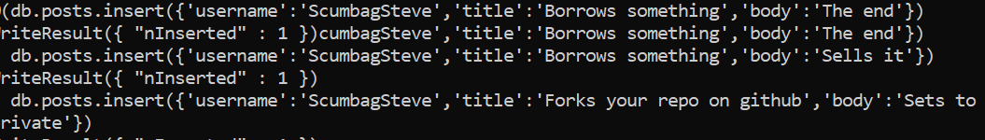

Insert Comments:

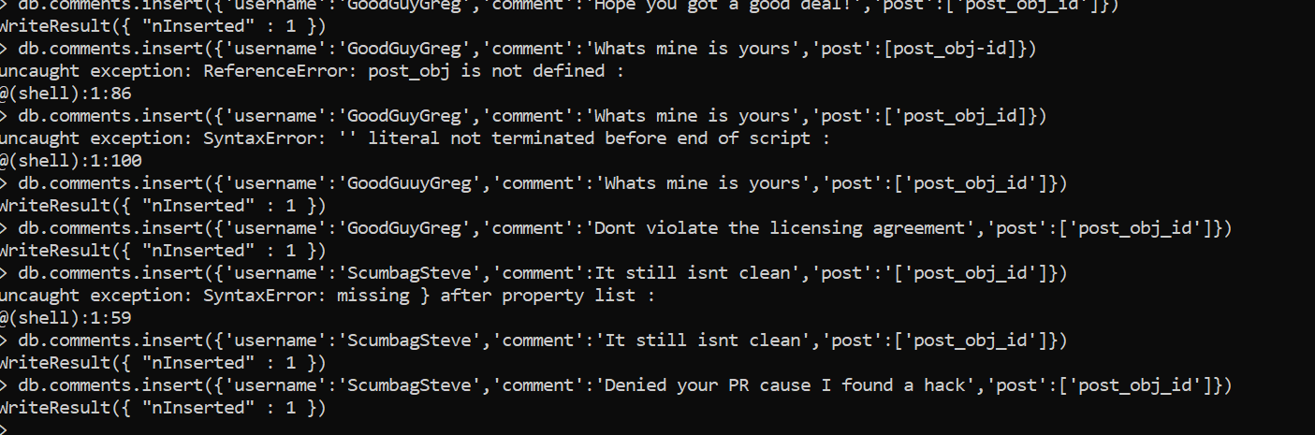

Find users



Find posts

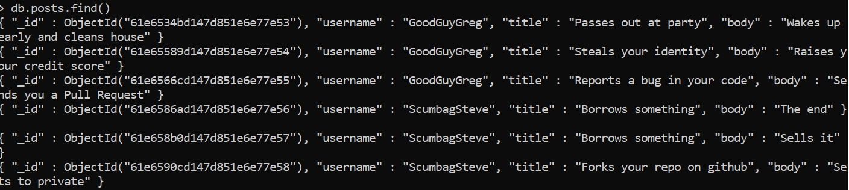

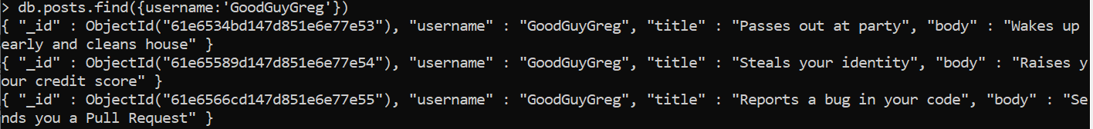

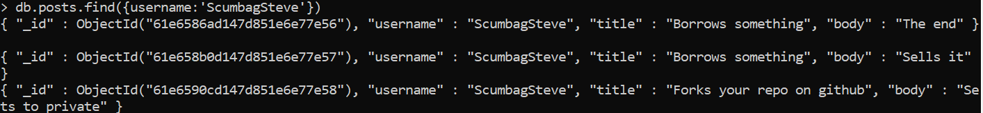

Find comments

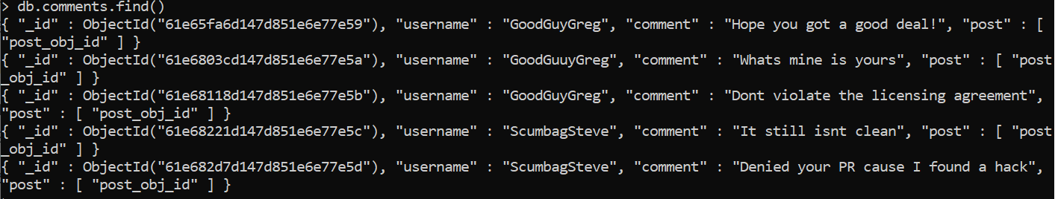





**MongoDB-Aggregate Exercises**

Atlanta Population

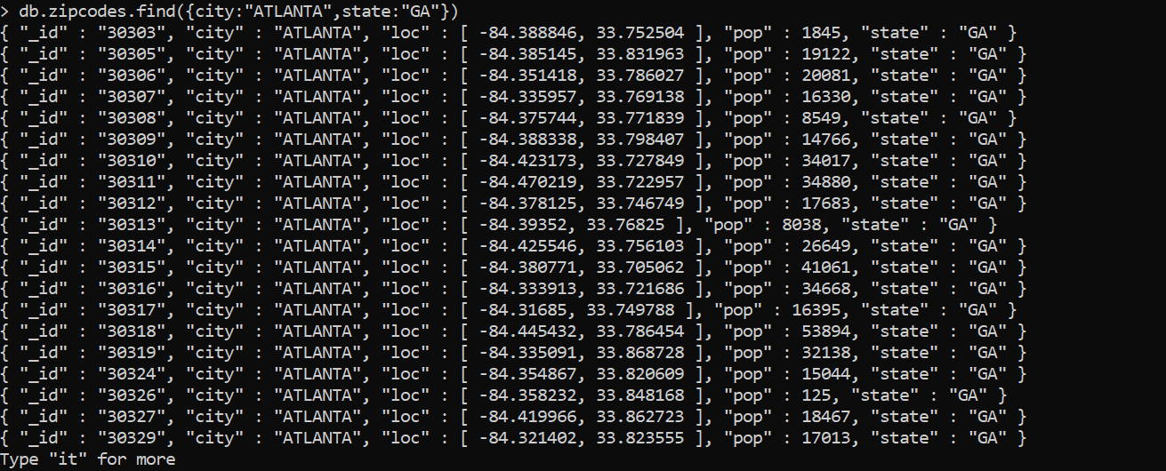

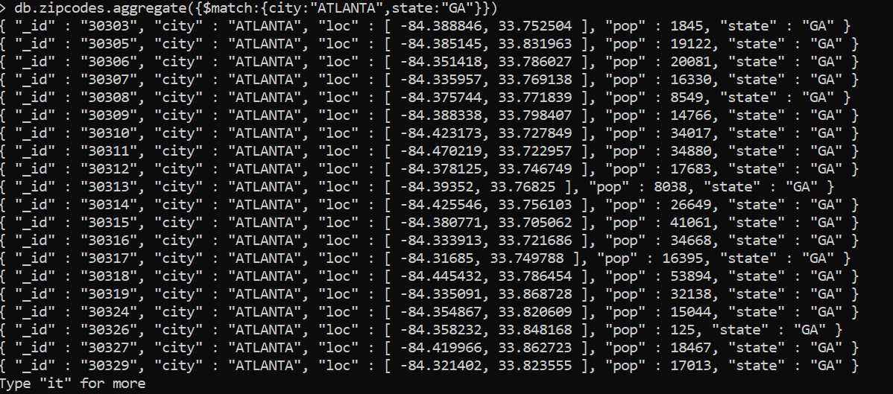

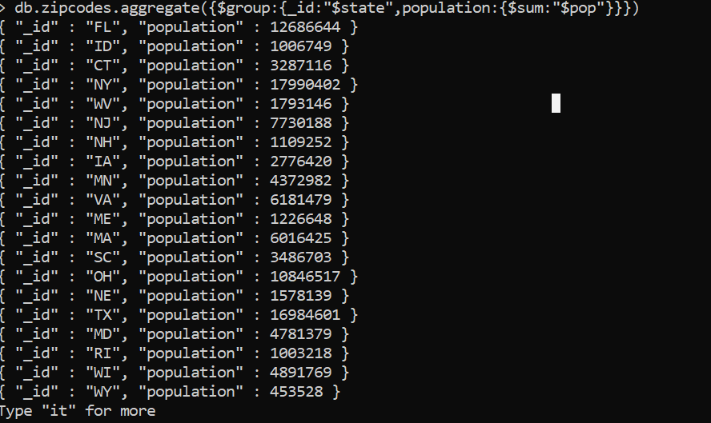

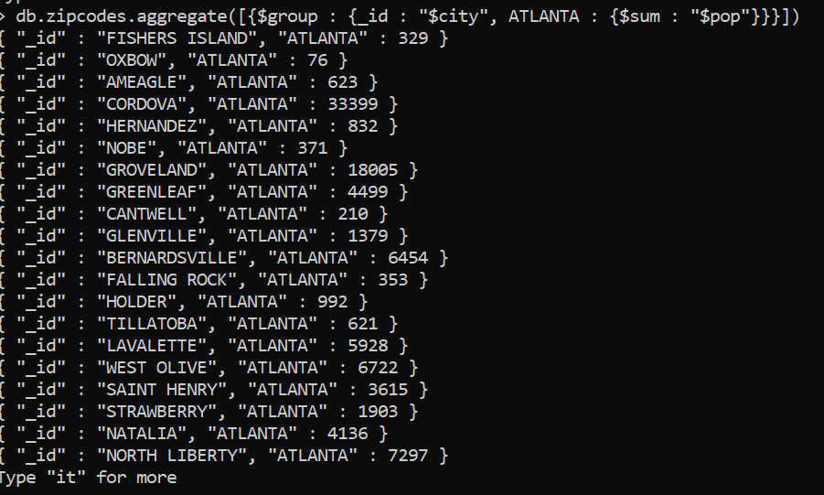

Population By State &city

