PROJECT REPORT
AI-Assisted Web Application Project
Semester 3 – CSE (AI/ML)
Project Title
[ENTER PROJECT TITLE]
Submitted by
Student Name: Busetty Gangadhara
Enrollment No.: 92540118011
Division: 3EN4

Contents
1. Introduction 3
2. Target User 3
3. Tools Used 3
4. Prompt Engineering Process 3
5. Application Design and Development 3
6. Final Application 3
7. Conclusion 3

Introduction
Outpatient departments (OPDs) in local clinics and hospitals frequently suffer from overcrowded waiting rooms, unpredictable waiting times, and manual paper-based token management. Patients—especially senior citizens, parents with young children, and urgent-care visitors—often spend hours waiting without knowing which token number is currently being served or how long their turn will take.
To solve this real-world healthcare problem, QuickCare — Smart Clinic Appointment & Live Queue Token System was developed as a responsive, single-page web application prototype. Using structured Prompt Engineering and generative AI tools, the application was planned, designed, generated, tested, and refined. QuickCare enables patients to book department-specific doctor appointments, automatically generates a unique digital queue token (e.g., #T-108), calculates priority-adjusted waiting times, and provides a live interactive department token board.

2. Target User
1. Outpatient Visitors & Patients: Citizens seeking consultations across General Medicine, Cardiology, Orthopedics, Pediatrics, Dermatology, and ENT without standing in physical queues.
2. Senior Citizens & Emergency/Triage Patients: Vulnerable patients who benefit from automated priority queue fast-tracking.
3. Clinic Receptionists & OPD Coordinators: Front-desk staff who manage token progression, verify digital token slips, and update consultation statuses (Waiting, In Consultation, Completed, Cancelled).
4. Consulting Doctors: Specialists whose live availability, room numbers, and active queue counts are displayed transparently.

3. Tools Used

Technologies, Languages & Libraries:

HTML5: Semantic page structure, forms, tables, and modal dialogs.

Tailwind CSS (via CDN): Responsive healthcare visual styling (teal/emerald/sky palette), mobile-first grid layouts, and status badges.

Vanilla JavaScript (ES6+): Dynamic doctor filtering by department, priority-based wait-time calculation algorithm, live queue progression simulator, search/filter logic, and localStorage data persistence.

FontAwesome 6 & Google Fonts (Inter): Medical iconography and high-legibility clinical typography.

AI Tools & Their Roles:

Google Gemini (AI Assistant):

1. Idea & Problem Analysis: Identifying key pain points in Indian outpatient clinic queues.

Requirements Engineering: Structuring functional modules and priority triage rules.

UI/UX Layout Planning: Designing a clean dashboard with KPI cards, a live estimator, and a printable digital token slip.

Code Generation: Generating modular, self-contained HTML/Tailwind/JS code.

Testing & Prompt Iteration: Adding 10-digit Indian phone validation, localStorage persistence, and a "Simulate Next Token" button for live evaluation.

4. Prompt Engineering Process
Include prompts : Write purpose of prompt and put screenshot of prompt

Stage 1: Idea / Problem Analysis

Purpose of Prompt: To analyze the outpatient clinic crowding problem and identify an effective digital prototype scope.

Initial Prompt: "Give me a project idea for a hospital appointment website." 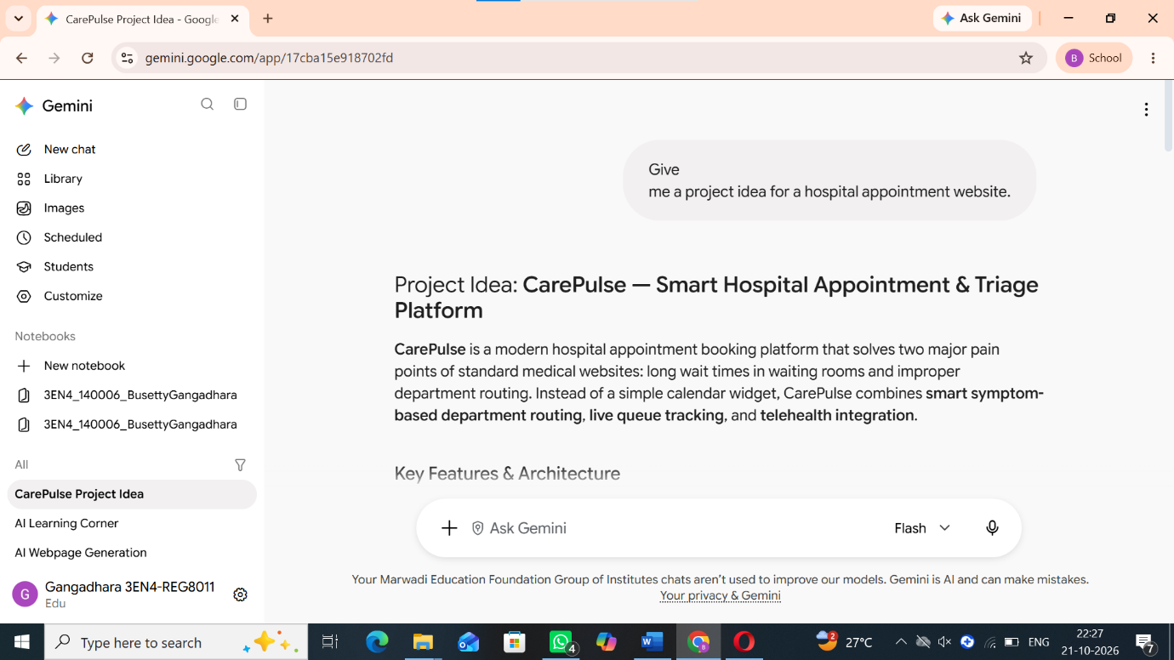

Improved Prompt Used:

"Act as a Healthcare Systems Analyst. Analyze the problem of overcrowded outpatient departments (OPDs) in urban Indian clinics. Define the core problem statement, primary objectives, target users, and how a live digital queue token tracker can reduce patient wait time anxiety." 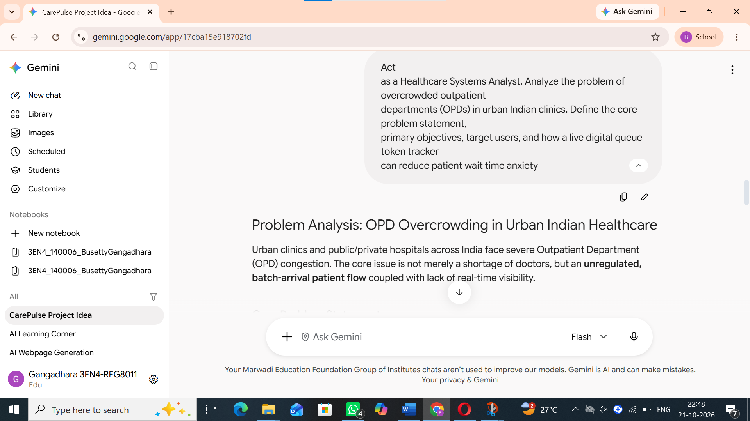

Stage 2: Requirements & Features Definition

Purpose of Prompt: To convert the problem statement into structured functional requirements and queue calculation rules.

Improved Prompt Used:

"Define the functional requirements for 'QuickCare — Smart Clinic Appointment & Live Queue Token System'. Include 6 outpatient departments (General Medicine, Cardiology, Orthopedics, Pediatrics, Dermatology, ENT), dynamic doctor filtering with consultation fees in ₹, priority categories (Regular, Senior Citizen, Emergency), and an automated wait-time formula." 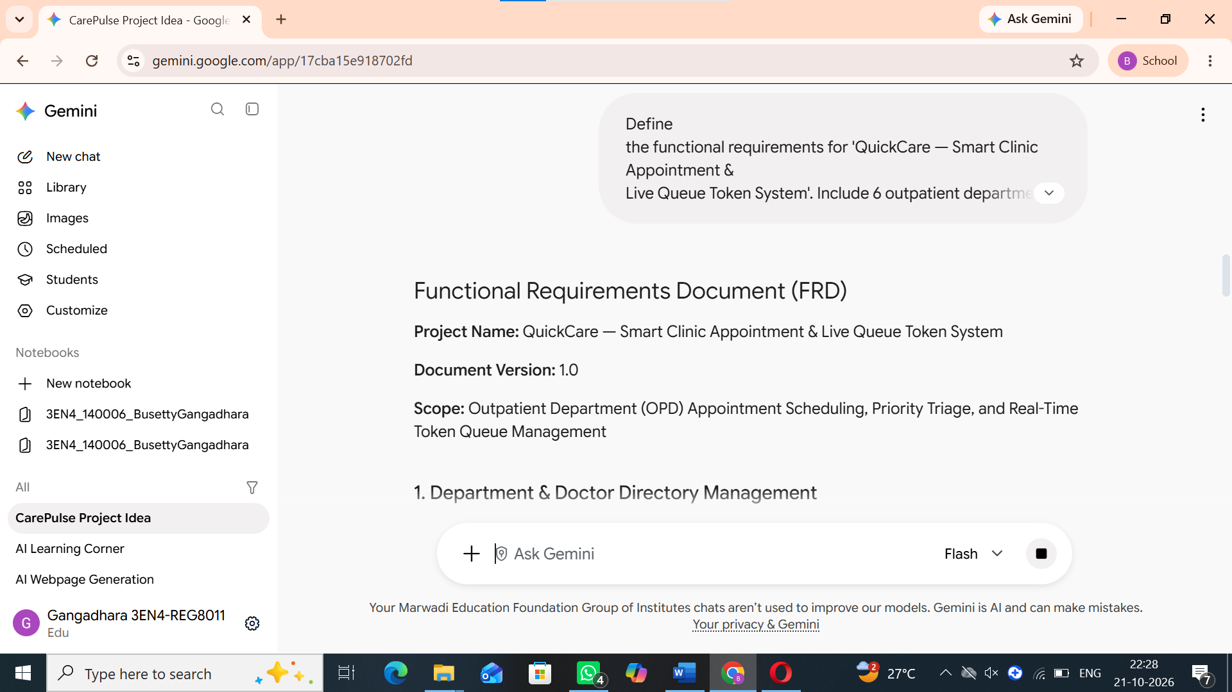

Stage 3: UI / Layout Design

Purpose of Prompt: To plan a responsive, clinical interface that is intuitive for patients and receptionists.

Improved Prompt Used:

"Design a single-page UI layout for QuickCare Clinic using Tailwind CSS with a calming medical teal and sky-blue palette. Plan 5 sections: (1) Sticky Header & 4 KPI Summary Cards, (2) Live Department Queue Status Board, (3) Split-screen Appointment Booking Form with a real-time Token Estimator card, (4) Searchable Appointments & Token Tracker Table, and (5) Doctor Availability Directory." 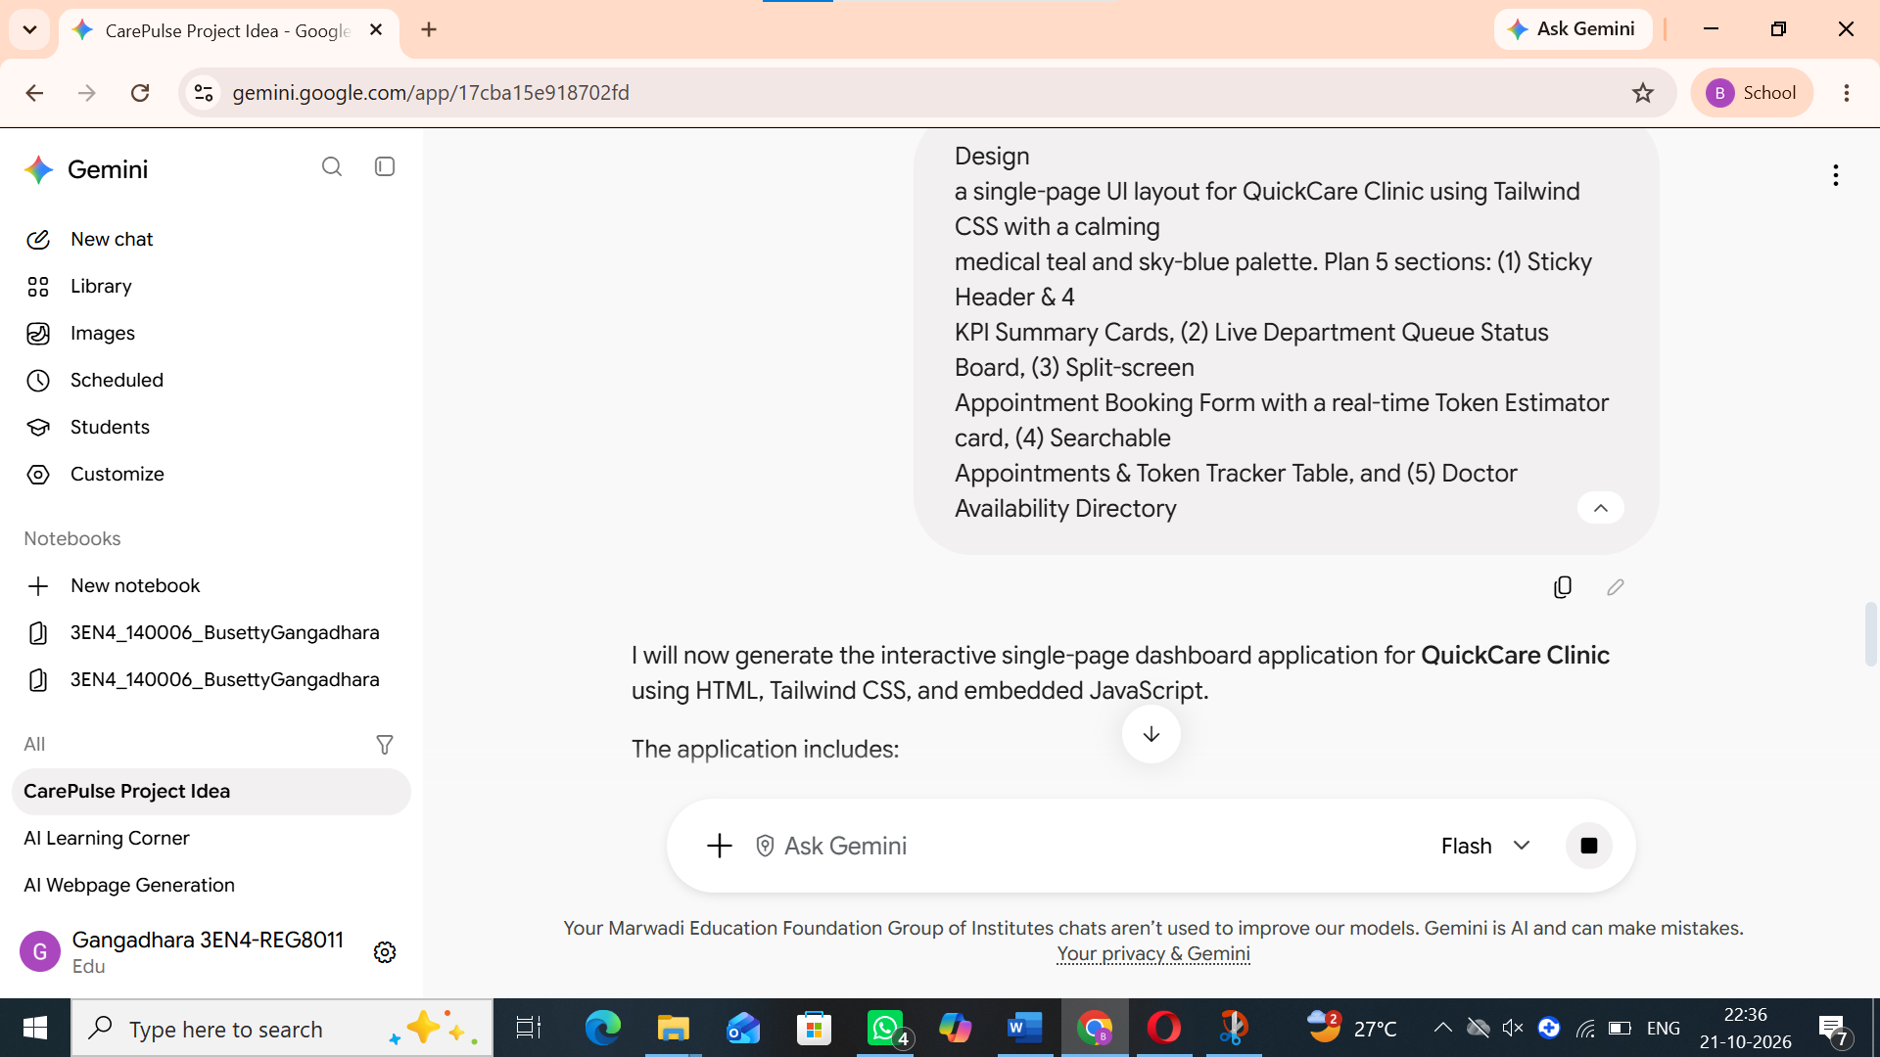

Stage 4: Code Generation

Purpose of Prompt: To generate the complete working prototype in a single runnable HTML file with pre-loaded sample data.

Improved Prompt Used:

"Build a complete, responsive, single-page web application in one index.html file for 'QuickCare — Smart Clinic Appointment & Live Queue Token System' using HTML5, Tailwind CSS CDN, FontAwesome icons, and Vanilla JS. Pre-load 4 realistic Indian patient appointments in localStorage so the dashboard looks rich immediately, and generate a printable Digital Token Slip modal upon form submission." 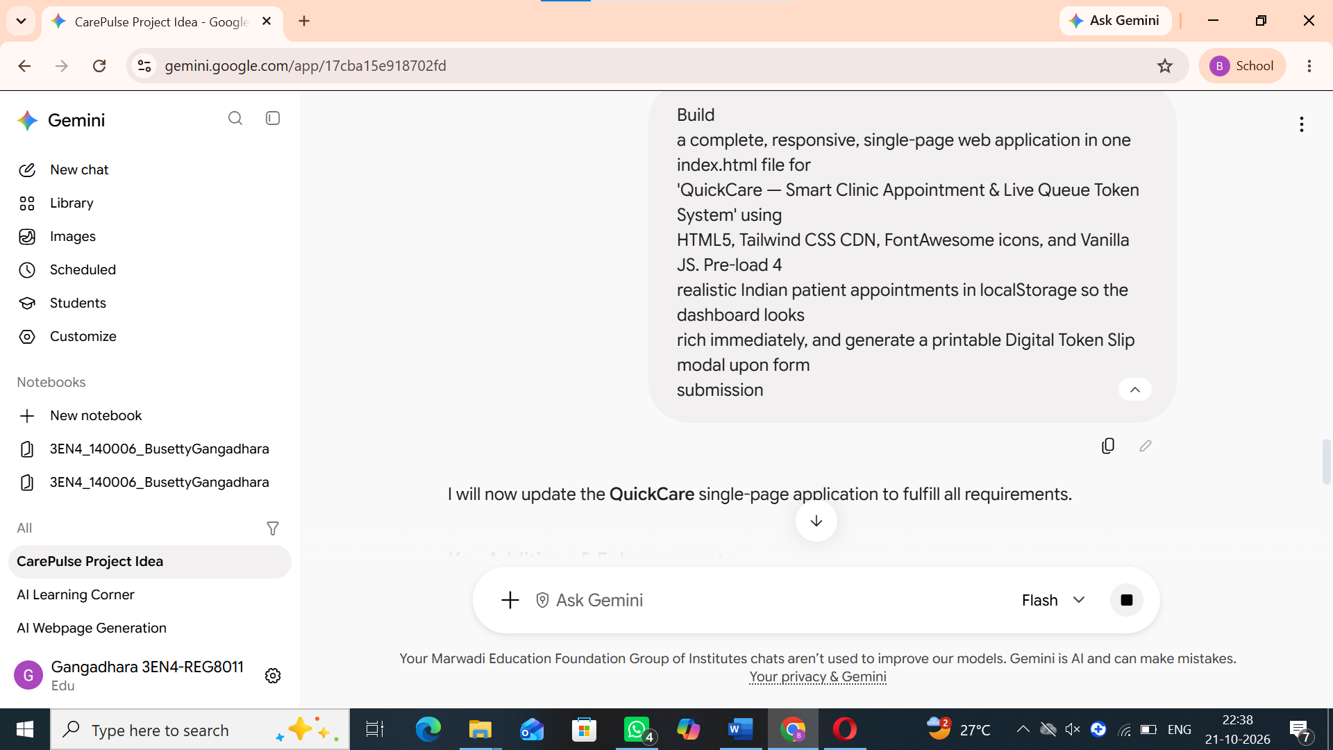

Stage 5: Testing

Purpose of Prompt: To generate test cases for form validation, search filters, and priority wait-time calculation.

Improved Prompt Used:

"Create a functional test checklist for QuickCare Clinic covering: (1) empty form submission, (2) invalid 10-digit Indian phone numbers, (3) age boundary validation (1–120), (4) dynamic doctor dropdown updates when changing departments, and (5) verifying that Emergency priority reduces estimated wait time to ~5 minutes." 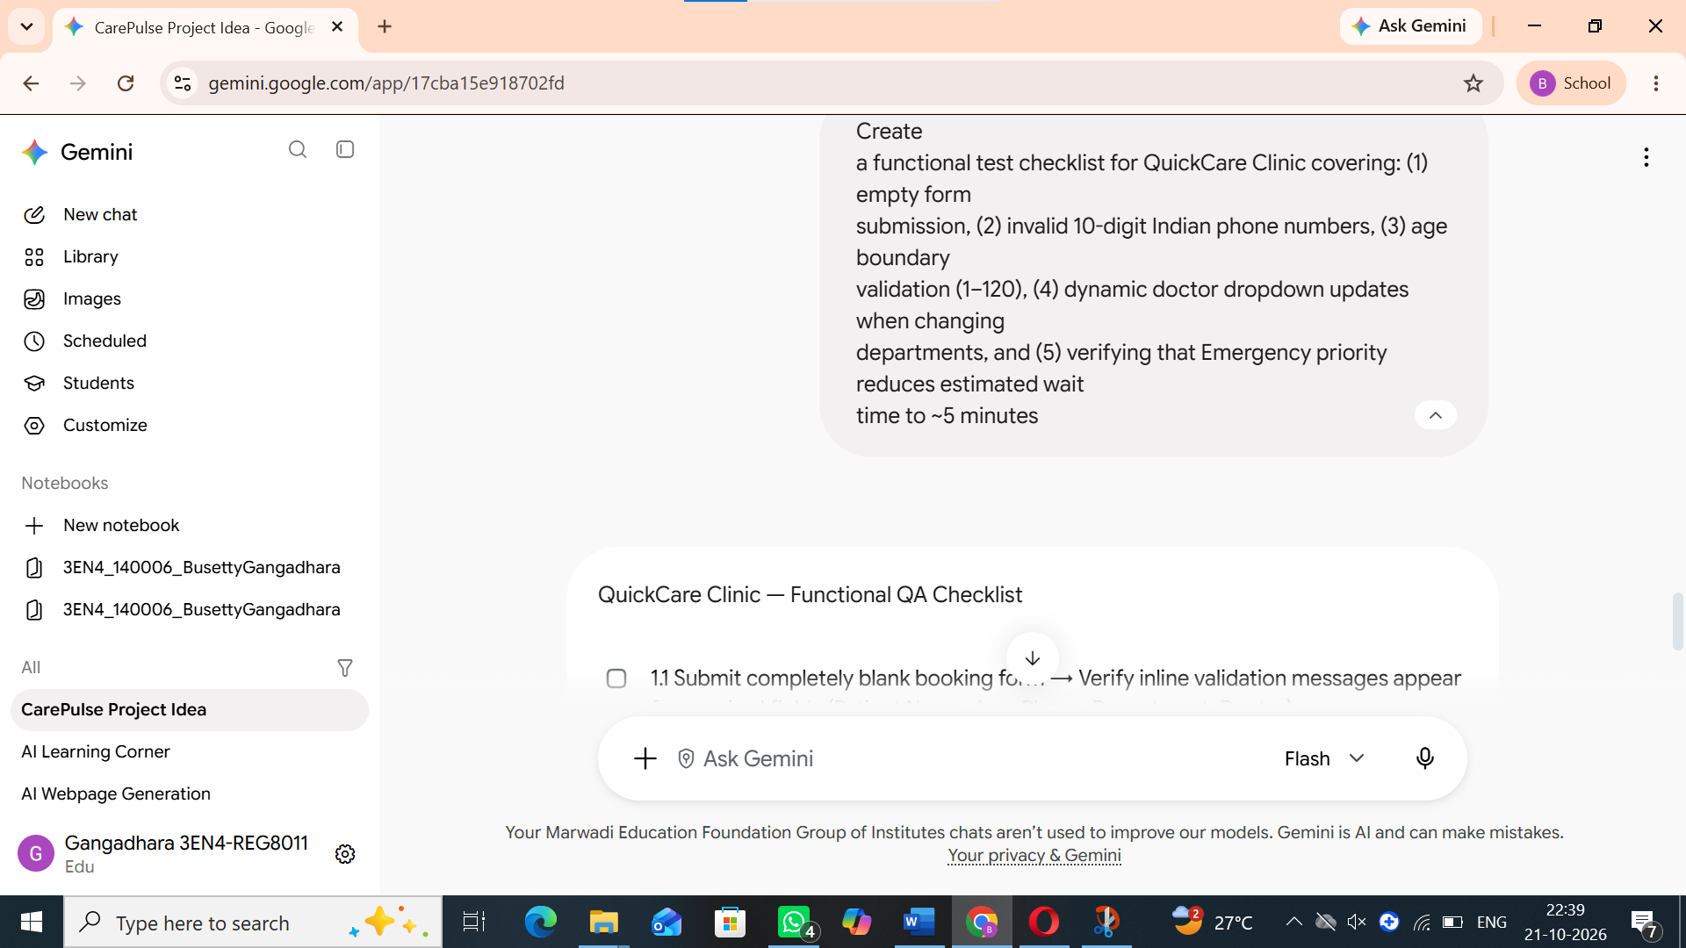

Stage 6: Debugging and Improvement

Purpose of Prompt: To add an interactive queue progression simulator so the faculty evaluator can test live token changes in real time.

Improved Prompt Used:

"Improve the QuickCare prototype by adding an interactive 'Simulate Next Token' button in the Live Queue section. Clicking it should mark the current 'In Consultation' token as 'Completed', promote the next 'Waiting' patient to 'In Consultation', recalculate wait times for remaining patients, and show a toast notification. Also add a 'Reset Demo' button to restore the default 4 sample records." 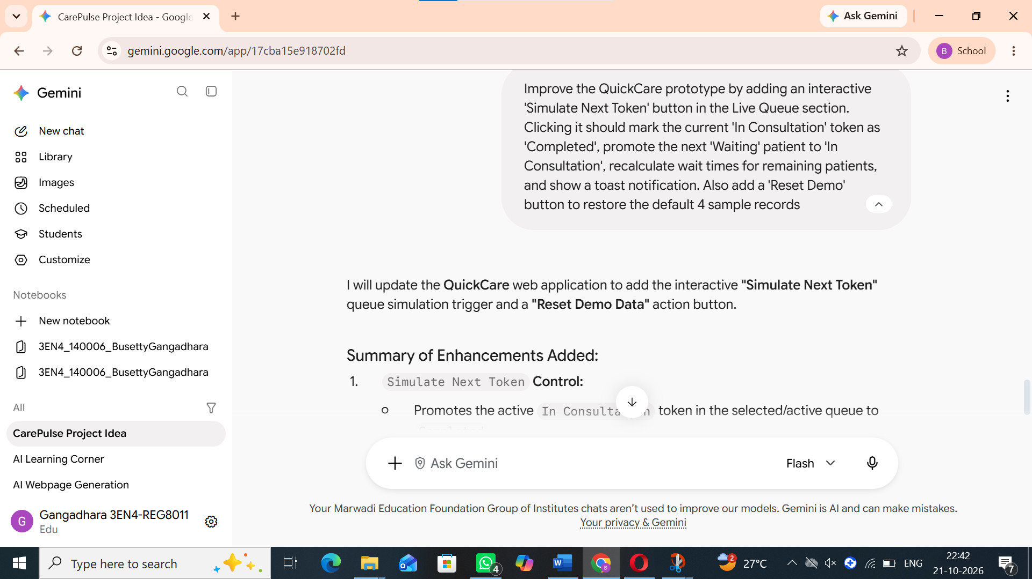

5. Application Design and Development
Describe the page structure, navigation, major UI components and application flow.
- Insert screenshots/diagrams below.
- Insert system/page structure diagram
- Insert UI screenshots with captions

6. Final Application

Working Features Summary:

Instant Digital Token Generation (#T-108, #T-109, etc.) with localStorage persistence.

Priority-aware waiting time algorithm (~5 mins for Emergency, 40% faster for Senior Citizens).

Interactive "Simulate Next Token" and "Reset Demo" controls for seamless classroom demonstration.

Printable Digital Token Slip Modal with patient details, room number, and consultation fee.

7. Conclusion
Summarize the project, the role of AI, the final result and possible future improvements.

