**Weather:**

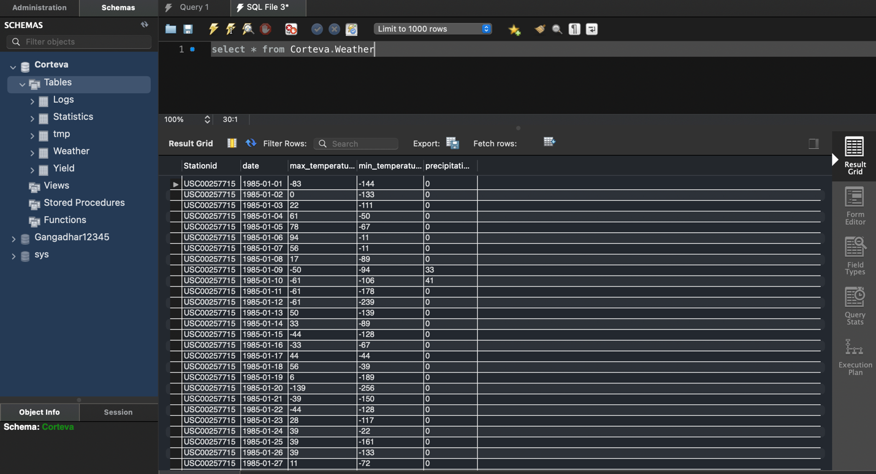

**Yield:**

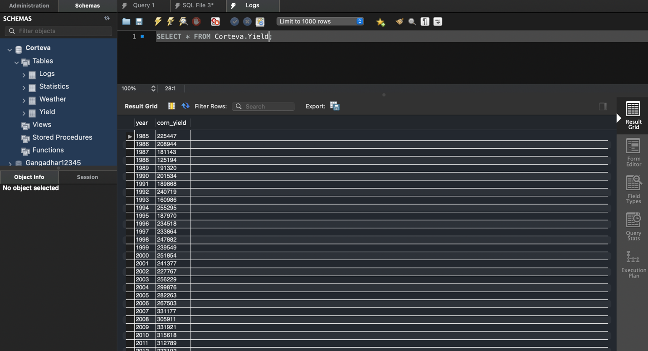

**Statistics:**

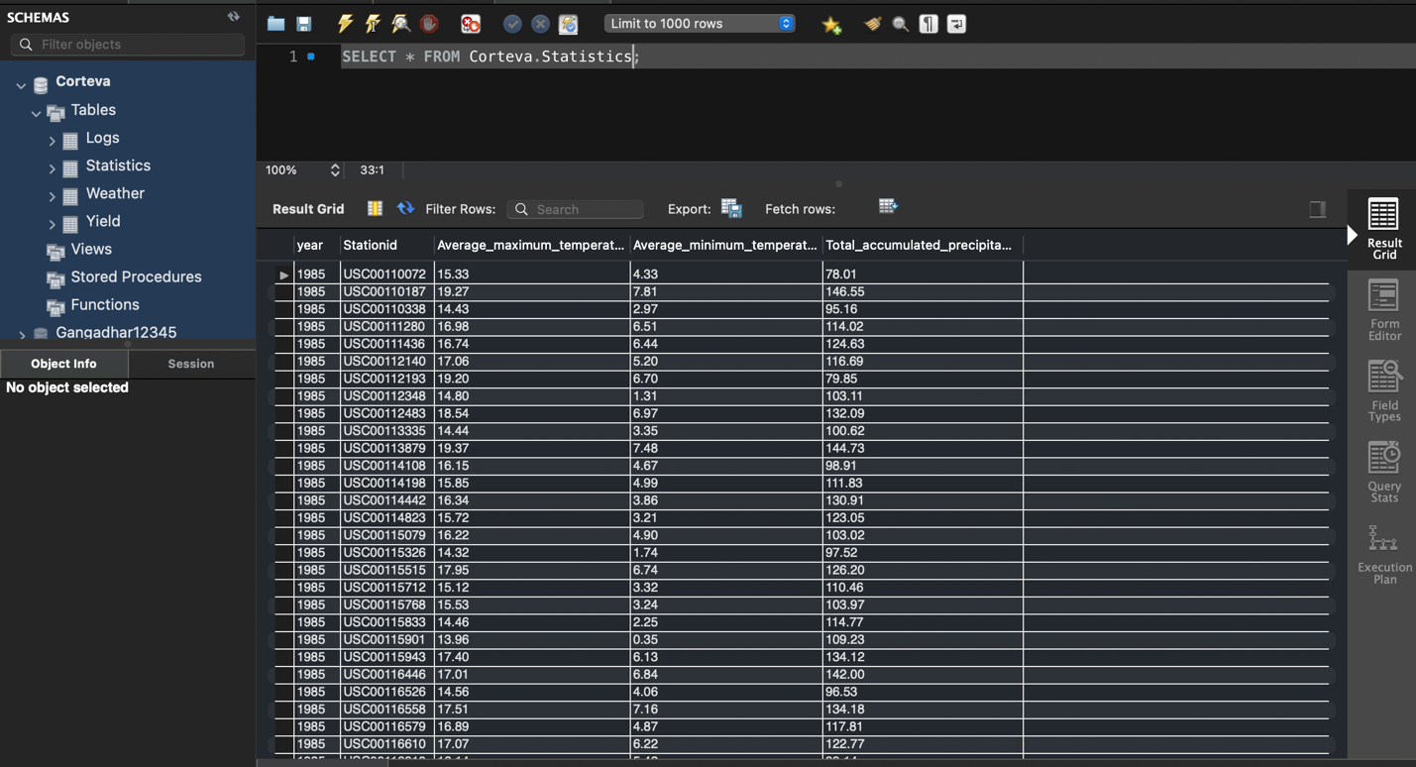

**Logs:**

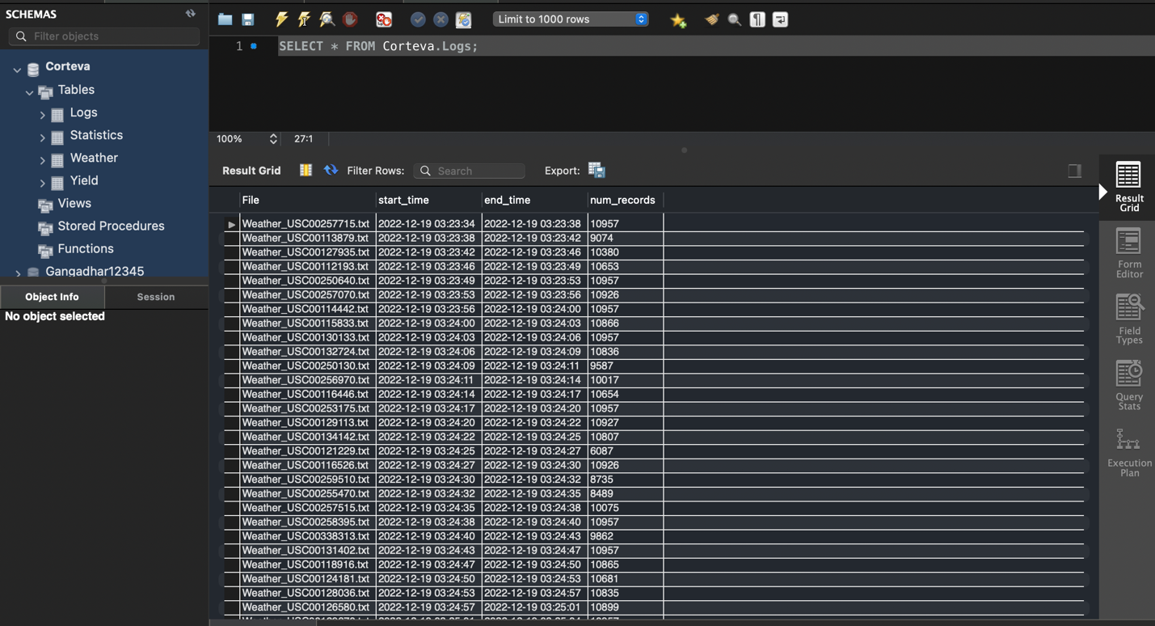

1. **/api/weather**

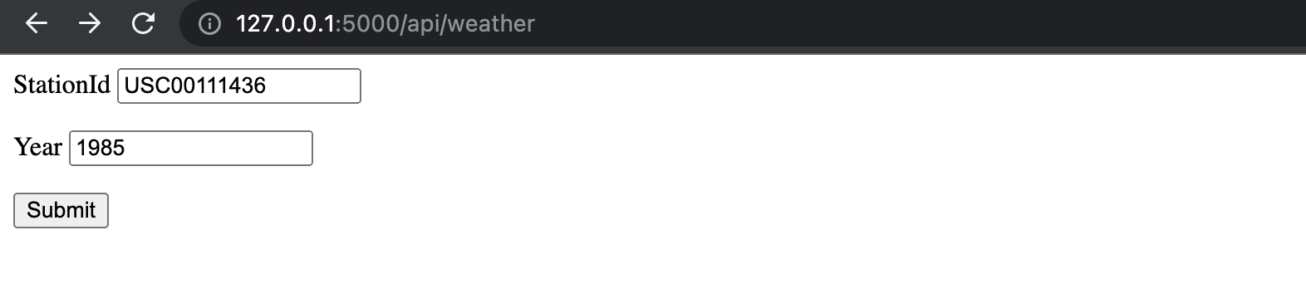

Results:

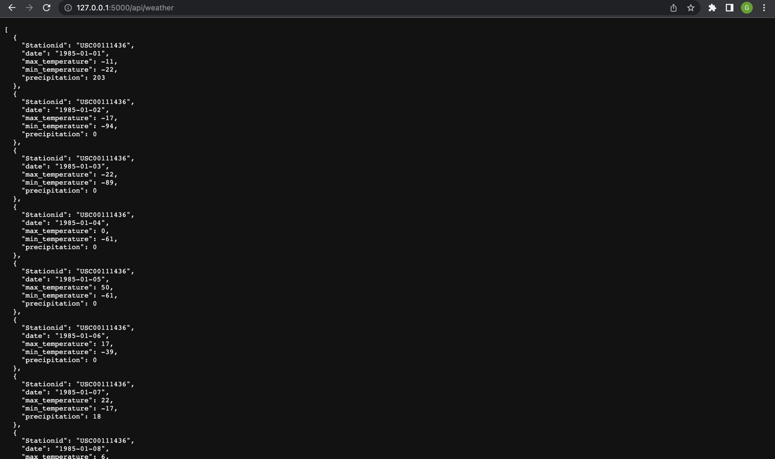

Both Input values required:

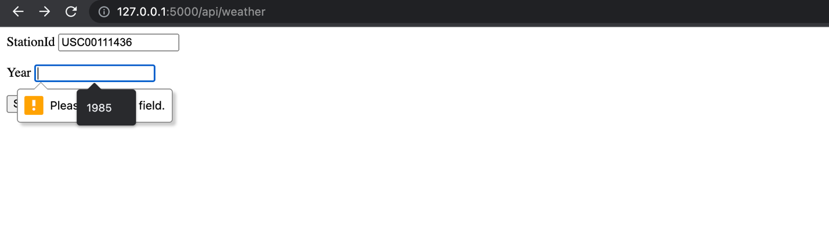

1. **/api/yield**

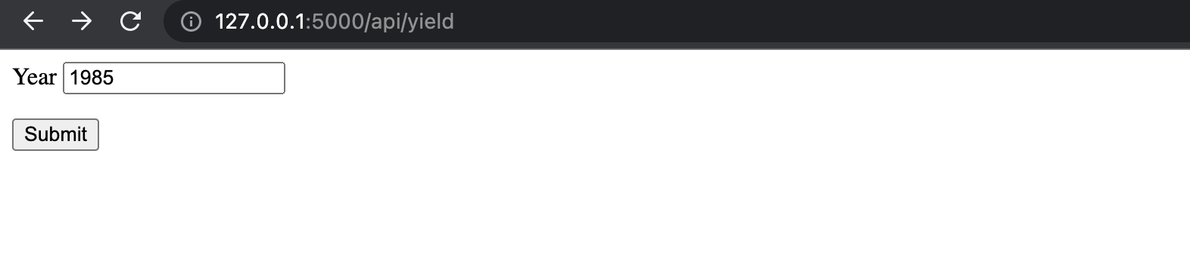

Results:

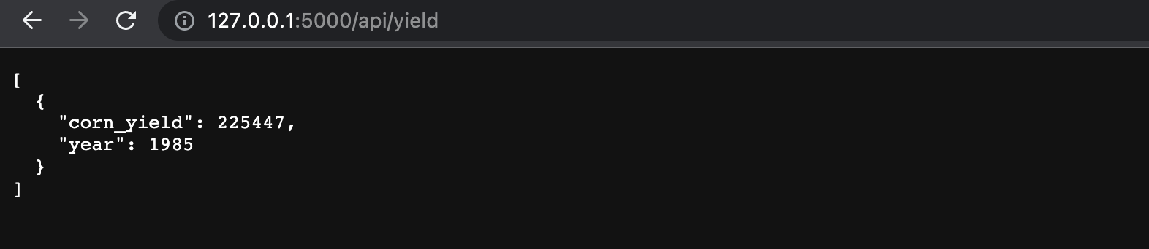

1. **/api/weather/stats**

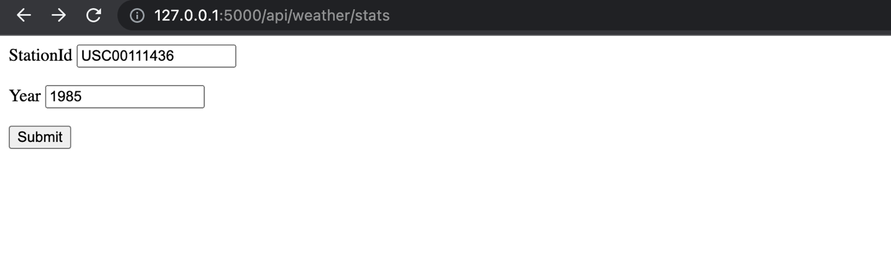

Results:

