**Phase 2 Org Setup & Configuration**

**1 Org Creation :** Visit developer.salesforce.com/signup; create Developer Edition org. Install CPQ package from AppExchange.

**2 Enable Features:** Setup > Quick Find > "Revenue Cloud" > Install (if not preinstalled). Enable Einstein for Revenue (Setup > Einstein > Enable). Assign "CPQ Admin" & "Einstein for Revenue" permissions to profile.

**3 Product CatLog Setup :** Go to **Setup → Products → New**.

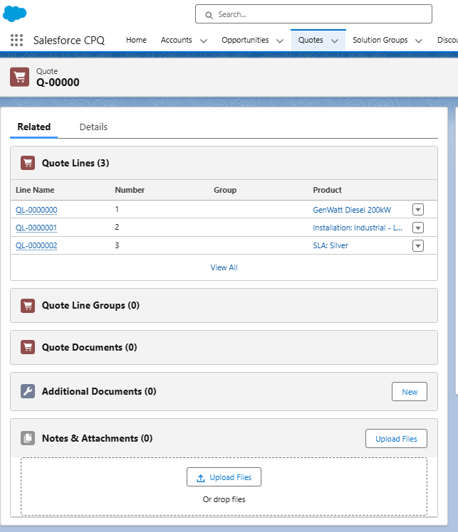

**4 Users & Profiles :** Go to **Setup → Users → New** → Create users.

• **CPQ Rep** , **CPQ Manager**

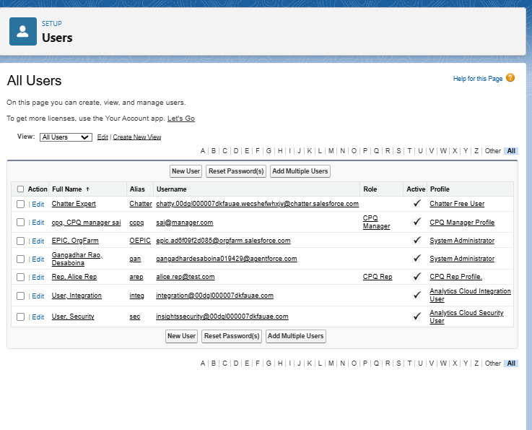

**5 OWD (Org-Wide Defaults) & Sharing Rules :**

Setup → **Security → Sharing Settings** → Set **Quote = Private**.

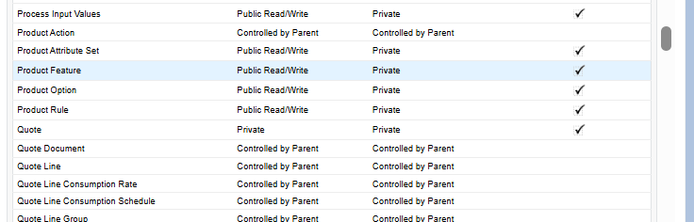

**6 Roles & Permissions :** Setup → **Roles → New** → Create hierarchy: Manager → Rep.

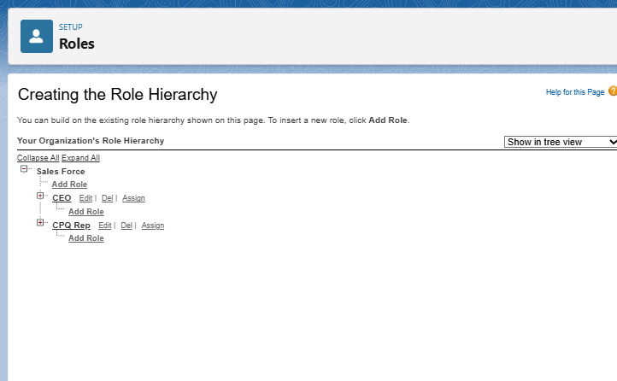

**7 Testing :** Log in as a **Rep user** → create a **Quote** → ensure pricing rules and permissions are applied correctly

