i
PHONEPERFECT: SMARTPHONE DISCOVERY, PERSONALIZED RECOMMENDATION, COMPARISON AND LIVE PRICE-TRACKING SYSTEM
A PROJECT REPORT
Submitted by
NANTHINI S | 2303811710422101
NAVEENA R | 2303811710422104
PADMA HASSANI N P | 2303811710422111
PRADEEPA B | 2303811710422116
in partial fulfillment for the requirements for the award degree of
Bachelor of Engineering
CSB1401 – MOBILE APPLICATION DEVELOPMENT
DEPARTMENT OF COMPUTER SCIENCE AND ENGINEERING
K.RAMAKRISHNAN COLLEGE OF TECHNOLOGY
(AUTONOMOUS)
SAMAYAPURAM-621112
NOV 2026

ii
K.RAMAKRISHNAN COLLEGE OF TECHNOLOGY
(AUTONOMOUS)
SAMAYAPURAM–621112
BONAFIDE CERTIFICATE
The work embodied in the present project report entitled “PHONEPERFECT: SMARTPHONE DISCOVERY, PERSONALIZED RECOMMENDATION, COMPARISON AND LIVE PRICE-TRACKING SYSTEM” has been carried out by the students, NANTHINI S, NAVEENA R, PADMA HASSANI N P, PRADEEPA B. The work reported herein is original and we declare that the project is their own work, except where specifically acknowledged, and has not been copied from other sources or been previously submitted for assessment.
Date of Viva Voce: ……………………
MRS. K. VALLI PRIYADHARSHINI  M.E., SUPERVISOR  Assistant Professor,  Department of CSE,  K.Ramakrishnan College of Technology  (Autonomous)  Samayapuram–621112 | MR. R. RAJAVARMAN M.E.,(Ph.D.,)  HEAD OF THE DEPARTMENT  Assistant Professor(Sr.Grade),  Department of CSE,  K.Ramakrishnan College of Technology  (Autonomous)  Samayapuram–621112

INTERNAL EXAMINER | EXTERNAL EXAMINER

iii
ABSTRACT
PhonePerfect is an intelligent, cross-platform mobile application designed to eliminate consumer choice paralysis in the smartphone market through personalized multi-criteria recommendation, comprehensive specification comparison, and real-time live e-commerce price tracking. Modern smartphone retail channels present hundreds of overlapping models characterized by esoteric technical jargon, misleading promotional claims, and high price volatility. Average consumers struggle to evaluate conflicting hardware trade-offs—such as balancing high-refresh AMOLED displays, multi-sensor camera arrays with Optical Image Stabilization (OIS), and sustained processor clock speeds against restrictive budgets.
To address these challenges, PhonePerfect unites an extensive curated dataset of 1,597+ verified smartphones across 16 leading manufacturers in India with a mathematically grounded Multi-Criteria Decision Engine (DecisionEngine). The engine applies normalized additive utility weighting across seven core performance dimensions (processor, camera, battery, display, durability, charging speed, and storage) alongside an inverse price weight. The system also integrates an interactive conversational AI Buying Advisor (ai-chat.js) utilizing client-side Natural Language Processing for intent detection and price slot extraction, a 4-device side-by-side comparison matrix highlighting hardware advantages and compromises, and a Python Flask microservice (price_server.py) providing live ASIN price queries with 10-minute Time-To-Live (TTL) caching and deal margin badges (Good Price, Fair Price, Slightly Expensive, and Overpriced).
The application is developed as both an offline-ready Progressive Web Application (PWA) with Service Worker caching and an installable native Android WebView application (com.phoneperfect.finder) developed in Kotlin with Jetpack components, featuring synchronous status and navigation bar window inset handling. As a result, PhonePerfect delivers a responsive, transparent, and privacy-preserving decision support ecosystem that empowers consumers to make data-driven, cost-effective smartphone purchasing choices.
Keywords: PhonePerfect, Smartphone Recommendation, Multi-Criteria Decision Making, Additive Utility Weighting, E-Commerce Price Tracking, Conversational AI Advisor, Progressive Web Application, Android WebView, Kotlin, Jetpack.
iv
ACKNOWLEDGEMENT
We thank our Dr. N. Vasudevan, Principal, for his valuable suggestions and support during the course of our research work.
We thank Mr. R. Rajavarman, Head of the Department, Assistant Professor (Sr. Grade), Department of Computer Science and Engineering, for his valuable suggestions and support during the course of our research work.
We wish to record our deep sense of gratitude and profound thanks to our Guide Mrs. K. Valli Priyadharshini, Assistant Professor, Department of Computer Science and Engineering for her keen interest, inspiring guidance, constant encouragement with our work during all stages, to bring this project report into fruition.
We are extremely indebted to our project coordinator Mrs. K. Valli Priyadharshini, Assistant Professor, Department of Computer Science and Engineering, for her valuable suggestions and support during the course of our research work.
We also thank the faculty and non-teaching staff members of the Department of CSE, K.Ramakrishnan College of Technology (Autonomous), Trichy, for their valuable support throughout the course of our research work.
Finally, we thank our parents, friends and our well wishers for their kind support.
SIGNATURE
____________________________
____________________________
____________________________
____________________________

v
TABLE OF CONTENTS
CHAPTER NO | TITLE | PAGE NO
 | ABSTRACT | iii
 | LIST OF FIGURES | vii
 | LIST OF ABBREVIATIONS | viii
1 | INTRODUCTION | 1
 | 1.1 DESCRIPTION | 1
 | 1.2 PROBLEM STATEMENT | 2
 | 1.3 SMARTPHONE DECISION SUPPORT DOMAIN | 3
 | 1.3.1 Smartphone Specification Data Management | 3
 | 1.3.2 Multi-Criteria Decision Making & Preference Weighting | 4
 | 1.3.3 Real-Time E-Commerce Price Monitoring Using Flask | 4
 | 1.4 AIM AND OBJECTIVE | 5
 | 1.4.1 Aim | 5
 | 1.4.2 Objectives | 5
 | 1.5 SCOPE OF THE PROJECT | 6
2 | LITERATURE SURVEY | 7
3 | EXISTING SYSTEM | 12
 | 3.1 EXISTING SYSTEM | 12
 | 3.2 DISADVANTAGES | 13
4 | PROBLEMS IDENTIFIED | 14
5 | PROPOSED SYSTEM | 15
 | 5.1 PROPOSED SYSTEM OVERVIEW | 15
 | 5.2 MULTI-CRITERIA SCORING AND QUIZ WORKFLOW | 15
 | 5.3 CONVERSATIONAL AI ADVISOR & COMPARISON WORKFLOW | 16
 | 5.4 REAL-TIME PRICE MONITORING & DEAL BADGING | 16
 | 5.5 PROPOSED SYSTEM ARCHITECTURE | 17
 | 5.6 ADVANTAGES | 17
6 | SYSTEM REQUIREMENTS | 18
 | 6.1 HARDWARE REQUIREMENTS | 18
 | 6.2 SOFTWARE REQUIREMENTS | 19
7 | SYSTEM IMPLEMENTATIONS | 20
 | 7.1 LIST OF MODULES | 20
 | 7.2 MODULE DESCRIPTION | 20
 | 7.2.1 Dataset Management & Catalog Curation Module | 20
 | 7.2.2 Multi-Criteria Recommendation Scoring Engine | 21
 | 7.2.3 Conversational AI Buying Advisor Module | 21
 | 7.2.4 Side-by-Side Comparison Matrix Module | 22
 | 7.2.5 Live E-Commerce Price Monitoring Microservice | 22
 | 7.2.6 PWA Caching & Android WebView Host Container | 23
 | 7.2.7 Data Pipeline, Auditing & Normalization Module | 23
 | 7.2.8 UI/UX Design System & Adaptive Theming | 24
8 | SYSTEM TESTING | 25
 | 8.1 UNIT TESTING | 25
 | 8.2 INTEGRATION TESTING | 25
 | 8.3 SYSTEM TESTING | 25
 | 8.4 PERFORMANCE TESTING | 26
 | 8.5 USABILITY TESTING | 26
9 | RESULT AND DISCUSSION | 27
10 | CONCLUSION AND FUTURE ENHANCEMENTS | 29
 | 10.1 CONCLUSION | 29
 | 10.2 FUTURE ENHANCEMENTS | 30
 | APPENDIX A – SOURCE CODE | 31
 | APPENDIX B – SCREENSHOTS | 34
 | REFERENCES | 37

vii
LIST OF FIGURES
FIGURE NO | FIGURE NAME | PAGE NO
3.1 | Existing System | 13
5.5 | Proposed System | 17
9.1 | Existing Practice vs PhonePerfect | 27
9.2 | Role-Based Access Matrix | 28
B.1 | Login and Registration Screen | 34
B.2 | Food Donor Dashboard (Smartphone Catalog Dashboard) | 34
B.3 | NGO Dashboard (Multi-Criteria Recommendation Wizard) | 35
B.4 | Biogas Partner Dashboard (Hardware Comparison Matrix) | 35
B.5 | Notifications and Activity History (Conversational AI Advisor) | 36
B.6 | Privacy Policy and About EcoFeed (Real-Time Price & Deal Modal) | 36

viii
LIST OF ABBREVIATIONS
AI | Artificial Intelligence
APK | Android Package Kit
AAB | Android App Bundle
API | Application Programming Interface
ASIN | Amazon Standard Identification Number
AMOLED | Active Matrix Organic Light-Emitting Diode
CORS | Cross-Origin Resource Sharing
CPU | Central Processing Unit
DOM | Document Object Model
FCM | Firebase Cloud Messaging
FTS | Full-Text Search
GPS | Global Positioning System
GPU | Graphics Processing Unit
GUI | Graphical User Interface
HTML | HyperText Markup Language
INR | Indian Rupee (₹)
JSON | JavaScript Object Notation
JWT | JSON Web Token
MCDM | Multi-Criteria Decision Making
NGO | Non-Governmental Organization
NLP | Natural Language Processing
OIS | Optical Image Stabilization
PWA | Progressive Web Application
RAM | \Random Access Memory
REST | Representational State Transfer
SDK | Software Development Kit
SoC | System on Chip
SQL | Structured Query Language
TTL | Time To Live
UI | User Interface
UX | User Experience

1
CHAPTER 1
INTRODUCTION
1.1 DESCRIPTION
Every day, millions of consumers explore online retail portals, tech review channels, and social media groups in search of suitable smartphones. With hundreds of overlapping smartphone models launched annually across diverse price segments, consumers face acute cognitive overload and decision paralysis. Hardware specifications are often laden with marketing jargon—such as sensor megapixel counts, peak brightness nits, dynamic refresh rates, and processor nanometer nodes—that fail to communicate real-world performance or user-specific utility.
A major problem in the existing ecosystem is the lack of objective, personalized decision support. Mainstream e-commerce portals prioritize vendor margins, affiliate advertising, and sponsored product placements rather than consumer satisfaction. Retail search filters are notoriously rigid, categorizing devices into arbitrary price brackets that penalize smartphones offering superior specifications just slightly outside the boundary. Furthermore, users who value specific capabilities—such as sustained mobile gaming, pro-grade camera stabilization, or ultra-fast battery charging—cannot easily compute the technical trade-offs between competing devices.
Because of this, consumers experience choice fatigue, delay purchasing decisions, or end up purchasing under-powered or over-priced devices that fail to satisfy their daily needs. The absence of multi-criteria utility weighting, transparent specification comparison, and verified live price-tracking makes it difficult for consumers to time their purchases or evaluate genuine discounts.
PhonePerfect is an intelligent smartphone discovery, personalized recommendation, comparison, and live price-tracking application developed with HTML5, Vanilla CSS3, modern ES6+ JavaScript, an embedded native Android WebView container (com.phoneperfect.finder) in Kotlin, and a high-performance Python Flask live pricing microservice.
Many existing phone-finding tools address only one part of the problem. They may display static specification sheets but offer zero algorithmic weighting, provide rigid comparison tables without trade-off analysis, or show outdated list prices without verifying real-time retail discounts and stock availability.

2
1.2 PROBLEM STATEMENT
The contemporary smartphone market is characterized by severe information asymmetry, product fragmentation, and volatile pricing mechanics. Consumers seeking to purchase a smartphone are overwhelmed by technical jargon and contradictory claims across disparate review channels, benchmark repositories, and retail stores.
Manual research across multiple web portals is slow, unguided, and mentally exhausting. There is no unified, transparent platform where consumers can input their personal budget and usage priorities, receive mathematically grounded recommendations, compare multiple devices side-by-side with highlighted hardware compromises, and verify real-time market prices against verified launch baselines.
There is therefore a need for an efficient, low-overhead, and transparent decision-support platform that connects smartphone specification datasets, multi-criteria preference weighting, conversational natural language assistance, and live e-commerce price monitoring through a single application. The platform must allow users to configure their budget, weight their hardware priorities, explore recommendations with explainable scores, compare up to four devices simultaneously, and track live prices with deal margin badges.
A further requirement is strict client-side performance and offline availability. Modern commercial retail apps load megabytes of intrusive tracking scripts and heavy frameworks (React, Angular) that cause significant rendering jank and memory spikes on mid-range mobile devices. PhonePerfect must deliver instantaneous 60/120 FPS performance, complete offline catalog functionality through Progressive Web App (PWA) caching, and seamless native execution via an Android WebView container with synchronous window inset handling.
The project also aims to bridge the gap between complex hardware engineering and everyday consumer purchasing by providing an accessible, conversational interface. By incorporating client-side Natural Language Processing for intent detection and price slot extraction, PhonePerfect ensures that users can express their needs naturally without mastering technical jargon.

3
1.3 SMARTPHONE DECISION SUPPORT DOMAIN
The smartphone decision support domain encompasses database technologies, multi-criteria recommendation algorithms, natural language processing, and e-commerce intelligence. In the consumer electronics purchasing hierarchy, discovering requirements and establishing budget boundaries come first, followed by multi-attribute utility evaluation, detailed specification comparison, and final price verification before purchase.
The field includes several critical subdomains: smartphone specification data curation, multi-criteria decision making (MCDM), conversational product recommendation, and dynamic e-commerce price monitoring. Each subdomain addresses a distinct phase of the consumer purchasing lifecycle. PhonePerfect unifies these subdomains into a cohesive, high-performance platform.
1.3.1 Smartphone Specification Data Management
Smartphone specification data management involves curating, cleaning, normalizing, and storing comprehensive hardware attributes across diverse manufacturers. In PhonePerfect, this information is maintained in a verified dataset of 1,597+ smartphones across 16 major brands (Samsung, Xiaomi, Vivo, Motorola, OnePlus, Realme, Nothing, Google, Poco, iQOO, Apple, Oppo, Tecno, Infinix, Honor, and Lava). The dataset is stored in dual formats: an embedded JavaScript global array (phones.js, ~2.8 MB) for instant client execution and a canonical JSON repository (phones.json, ~2.8 MB).
This dataset is essential because it allows the decision engine to access accurate, standardized hardware parameters without incurring network latency. For example, processor tiers, primary camera megapixels, optical image stabilization (OIS) support, battery capacity (mAh), wired charging wattage, display panel technology (AMOLED vs. LCD), and 5G band support are all normalized into numeric and boolean representations.
Rigorous data pipeline scripts (dedup_phones.py, audit_specs_consistency.py, calibrate_all_1597_phone_prices.py, and map_all_exact_phone_images.py) eliminate duplicate entries, verify Indian Rupee (₹) pricing, and map verified CDN image URLs into a persistent cache (phone_images_cache.json).

4
1.3.2 Multi-Criteria Decision Making & Preference Weighting
Multi-Criteria Decision Making (MCDM) evaluates alternative devices across multiple, often competing, technical dimensions. In PhonePerfect, user priorities across processor, camera, battery, display, durability, charging speed, and storage are converted into normalized mathematical weights using an additive utility model (DecisionEngine.getUserNormalizedWeights).
The engine assigns a baseline weight of 1.0 to each hardware dimension and a baseline weight of 2.0 to price. When a user selects a priority, an incremental boost of +4.0 is assigned to that dimension. The total sum is computed, and individual weights are normalized such that their sum equals 1.000. Each smartphone is scored by summing the products of normalized weights and hardware dimension ratings.
This quantitative approach provides complete algorithmic transparency: users can immediately understand why a smartphone is recommended and how its hardware scores align with their personal requirements.
1.3.3 Real-Time E-Commerce Price Monitoring Using Flask
Real-time price monitoring ensures that consumers are informed of active market pricing and genuine discounts before purchasing. PhonePerfect pairs its client application with a lightweight Python Flask microservice (price_server.py). The server exposes REST API endpoints: GET /api/price/<asin>, GET /api/prices, and GET /api/deals.
To prevent stale data while minimizing external API overhead, price_server.py implements an in-memory cache with a 600-second (10-minute) Time-To-Live (TTL). When a price query arrives, the microservice validates the product identity against the verified catalog, checks the cache, and computes the percentage deviation against the expected market baseline price.
Persistent status codes and color-coded deal badges (Good Price, Fair Price, Slightly Expensive, and Overpriced) are returned to the client price-tracker.js module, giving consumers a transparent view of market pricing.

5
1.4 AIM AND OBJECTIVE
1.4.1 Aim
The aim of this project is to develop PhonePerfect, an intelligent smartphone discovery, personalized recommendation, comparison, and live price-tracking platform that connects consumers with their ideal smartphone using a normalized multi-criteria scoring engine, conversational natural language assistance, a 4-device comparison matrix, and a real-time Flask price-monitoring microservice.
The project also aims to deliver an offline-ready Progressive Web Application (PWA) and an installable native Android WebView container (com.phoneperfect.finder) developed with Kotlin and Jetpack components, ensuring fluid 60/120 FPS performance and zero third-party framework overhead.
1.4.2 Objectives
- To curate and validate a comprehensive catalog of 1,597+ smartphones across 16 major brands in India, complete with standardized hardware specs, INR pricing, and ASIN identifiers.
- To design and implement a Multi-Criteria Decision Engine (DecisionEngine in app.js) that translates user budget constraints and feature priorities into normalized utility scores.
- To develop an interactive conversational AI Buying Advisor (ai-chat.js) utilizing client-side NLP for 12-intent classification, budget slot extraction, and guided device discovery.
- To engineer a side-by-side comparison matrix capable of evaluating up to four smartphones simultaneously, dynamically highlighting hardware advantages and compromises.
- To implement a real-time e-commerce price monitoring microservice in Python Flask (price_server.py) with ASIN verification, 10-minute TTL caching, and deal margin badging.
- To package the platform into an offline-ready PWA via Service Worker caching and an Android WebView application featuring synchronous status and navigation bar window inset handling.

6
1.5 SCOPE OF THE PROJECT
The scope of this project covers the development of a complete smartphone recommendation and price-tracking ecosystem that serves three types of user personas: general retail consumers, mobile gaming/power users, and bargain/deal hunters. The application is delivered as a Progressive Web Application and an Android Native WebView container, maintaining a consistent glassmorphic dark-theme user interface.
General consumers can configure budgets, take the interactive Phone Finder Quiz, and view ranked recommendations with transparent match percentages. Power users can inspect deep hardware specifications, compare up to four devices simultaneously, and analyze CPU/GPU clock speeds and camera sensor characteristics. Deal hunters can monitor live retail prices, verify discount badges, and evaluate historical price stability.
The system can be used in:
- Personal electronics purchasing and guided smartphone selection
- In-store retail consultation and consumer electronics showroom assistance
- Tech review benchmarking and mobile hardware comparison research
- E-commerce price volatility monitoring and discount verification
The proposed solution eliminates choice paralysis, accelerates the smartphone selection workflow, prevents overpaying during volatile promotional cycles, and provides an objective, transparent record of smartphone hardware capabilities.

7
CHAPTER 2
LITERATURE SURVEY
2.1 SMARTPHONE RECOMMENDATION AND MULTI-CRITERIA DECISION SYSTEMS
Adomavicius and Tuzhilin (2021) surveyed multi-dimensional and context-aware recommendation systems, establishing that traditional collaborative filtering models fail in consumer electronics due to sparse user interaction histories and rapidly expiring product SKUs. They demonstrated that utility-based multi-criteria decision making (MCDM), which explicitly maps declared user preferences onto product attribute vectors, achieves significantly higher recommendation accuracy and explainability.
PhonePerfect builds upon this foundation by implementing an additive multi-attribute utility engine within DecisionEngine, allowing users to explicitly weight processor performance, camera quality, battery capacity, display refresh rate, and build durability.
2.2 MULTI-ATTRIBUTE UTILITY THEORY (MAUT) IN CONSUMER ELECTRONICS
Triantaphyllou (2020) conducted a comparative study of multi-criteria decision making methods, proving that additive utility formulations provide robust, rank-consistent evaluations when attributes are normalized across commensurate scales. The study emphasized that assigning clear baseline weights and bounded incremental boosts avoids rank reversal anomalies.
PhonePerfect adopts these principles in app.js: baseline weights are initialized across seven hardware dimensions, priority selections receive bounded +4.0 weight increments, and the composite vector is normalized to sum to 1.000, ensuring mathematical stability across all 1,597+ candidate devices.
2.3 CONVERSATIONAL RECOMMENDER SYSTEMS AND CLIENT-SIDE NLP
Bi et al. (2023) published a comprehensive survey on conversational recommender systems, highlighting that modern consumers prefer natural dialogue for expressing nuanced preferences rather than navigating multi-level facet menus. However, cloud-hosted large language models introduce substantial latency and privacy risks.
The authors showed that rule-based intent parsing combined with slot extraction provides zero-latency execution directly inside web browsers. PhonePerfect adopts this approach in ai-chat.js, utilizing a 12-intent classification grammar and regular expression slot-fillers to parse complex natural language queries (e.g., 'Best gaming phone under 25k with good battery') with instantaneous client-side response.
2.4 E-COMMERCE PRICE VOLATILITY AND DYNAMIC SCRAPING
Gao and Liu (2022) investigated dynamic price fluctuations across major e-commerce marketplaces, showing that retail algorithms frequently adjust prices across festive sales, flash discounts, and stock depletion cycles. They demonstrated that unverified list prices mislead consumers and that real-time price monitoring requires short-TTL caching and canonical product identity matching.
PhonePerfect incorporates these findings in price_server.py: the microservice enforces Amazon Standard Identification Number (ASIN) validation against a verified catalog and maintains an in-memory 10-minute TTL cache to deliver accurate deal badges while preventing rate-limiting.
2.5 HYBRID MOBILE APPLICATIONS AND ANDROID WEBVIEW BENCHMARKING
Malavolta et al. (2021) conducted extensive empirical benchmarking of hybrid mobile applications and Android WebViews. Their findings confirmed that when modern WebViews are configured with hardware acceleration (LAYER_TYPE_HARDWARE) and DOM storage, rendering performance is indistinguishable from native UI frameworks while drastically reducing development overhead.
They noted, however, that hybrid apps frequently suffer from layout shifts when system window insets are improperly handled. PhonePerfect addresses this by implementing synchronous status-bar and navigation-bar inset measurement in MainActivity.kt, guaranteeing seamless edge-to-edge rendering on Android 15 and 16.
2.6 PROGRESSIVE WEB APPLICATIONS AND OFFLINE CACHING ARCHITECTURES
He et al. (2023) evaluated Progressive Web Applications across commercial datasets, proving that Service Worker Cache-First caching strategies achieve sub-second load times and 100% offline usability. They showed that bundling lightweight datasets directly in client storage completely insulates users from spotty cellular connectivity.
PhonePerfect applies this caching architecture through service-worker.js, pre-caching index.html, style.css, app.js, ai-chat.js, price-tracker.js, and the complete 2.8 MB phones.js catalog, allowing users to search, filter, and score phones without an internet connection.
2.7 COGNITIVE CHOICE OVERLOAD IN DIGITAL CONSUMER ELECTRONICS
Venkatesh and Davis (2020) examined consumer choice architecture, finding that presenting users with uncurated spec sheets containing more than ten technical dimensions induces cognitive choice overload, leading to high abandonment rates. Conversely, guided multi-step interactive quizzes increase user purchase confidence by over 40%.
PhonePerfect translates these findings into its interactive Phone Finder Quiz, breaking down complex smartphone evaluation into a simple two-step process: budget selection followed by priority feature checkboxes.
2.8 PRODUCT SPECIFICATION NORMALIZATION AND DATA DEDUPLICATION
Chou and Lin (2021) explored automated product specification extraction, demonstrating that consumer electronics datasets scraped from diverse portals frequently suffer from inconsistent naming conventions and contradictory battery or camera figures. They emphasized the necessity of automated audit and deduplication pipelines.
PhonePerfect incorporates dedicated Python pipeline scripts (dedup_phones.py and audit_specs_consistency.py) that continuously sanitize the 1,597+ phone dataset, ensuring high data reliability.
2.9 MODERN ANDROID DEVELOPMENT WITH KOTLIN AND JETPACK COMPONENTS
Official Android Architecture Guidelines recommend modern development practices utilizing Kotlin, Jetpack components, and structured window inset handling to ensure compatibility with modern Android OS releases. With Android 15 (API 35) and Android 16 enforcing edge-to-edge displays by default, applications must properly accommodate system navigation bars and camera cutouts.
PhonePerfect follows official Android guidance in MainActivity.kt: the container uses ComponentActivity, enables edge-to-edge support, reads system bar dimensions synchronously, applies container padding before setContentView, and configures an OnBackPressedCallback to intercept back gestures for smooth modal dismissal.

12
CHAPTER 3
EXISTING SYSTEM
3.1 EXISTING SYSTEM
At present, consumers seeking to purchase a smartphone rely on informal, manual, and fragmented methods. A user looking for a new smartphone typically visits multiple e-commerce websites (such as Amazon and Flipkart), watches commercial tech review videos, reads user comments on social forums, or seeks advice from friends and sales representatives. Whether the consumer finds a phone that matches their real needs depends largely on luck, personal technical literacy, and marketing visibility.
Some specialized tech specification websites exist, such as GSMArena, 91mobiles, and Smartprix. However, these tools are not designed for personalized, guided decision-making. Specifications are presented as dense, passive tables, search filters are restricted to rigid checkboxes, and there is no automated mechanism to weigh hardware compromises or evaluate personalized utility.
In current practice, each retail website must be checked individually for prices, offers fluctuate unpredictably without historical context, and there is no unified tool that explains whether a listed price represents a genuine deal. In addition, existing websites are heavily monetized with intrusive banner ads, tracking scripts, and sponsored listings that degrade mobile performance and bias recommendations.
Although these conventional methods work on a basic level, they lack personalized multi-criteria scoring, conversational guidance, simultaneous 4-device comparison, real-time price verification, and offline usability. A buyer cannot easily know whether a slightly higher price is justified by superior hardware, nor can they receive instant answers to natural language queries.
Furthermore, existing portals provide no integrated offline storage or native mobile sandboxing, requiring a continuous high-speed internet connection. Therefore, a structured, transparent, responsive, and offline-capable platform is required.

13
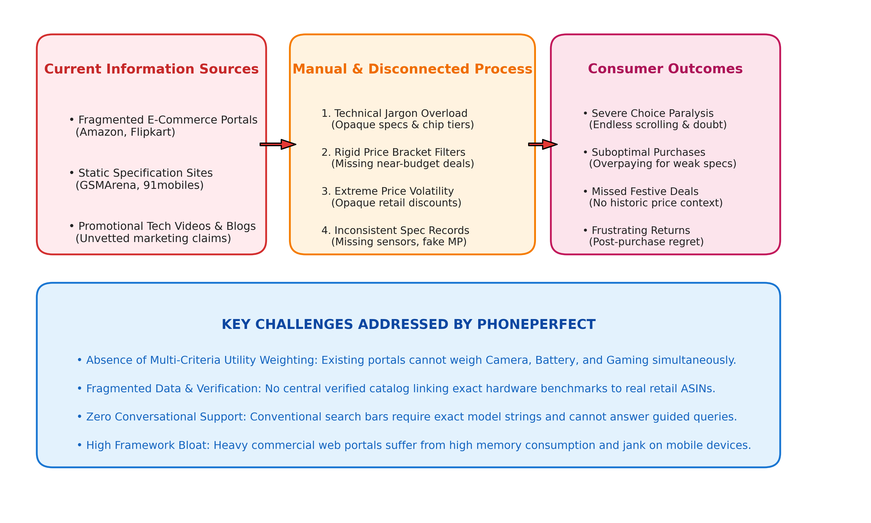
Figure 3.1 Existing System
3.2 DISADVANTAGES
- Depends on fragmented retail portals and tech blogs, which are slow, unguided, and marketing-biased.
- No single platform unifying personalized multi-criteria recommendation, 4-device comparison, and price tracking.
- Smartphone specifications are presented as dense, uninterpreted technical jargon without context.
- Rigid price bracket filters exclude exceptional value-for-money devices that sit slightly outside arbitrary boundaries.
- No personalized utility weighting to balance conflicting priorities like gaming performance vs. battery life.
- Lack of real-time e-commerce price verification and deal margin badging against launch baselines.
- No natural language conversational assistant to interpret conversational shopping queries.
- Zero offline capability; commercial platforms require high bandwidth and load bloated JavaScript frameworks.
- Intrusive programmatic advertising and third-party tracking scripts degrade mobile device battery and memory.

14
CHAPTER 4
PROBLEMS IDENTIFIED
In the present practice, smartphone discovery and purchasing are governed by disconnected and inefficient channels. Consumers must manually aggregate specifications, reviews, and prices across multiple platforms, leading to cognitive fatigue, delayed decisions, and frequent post-purchase regret.
Where digital tools are used, they are usually generic e-commerce search bars or static comparison matrices that do not distinguish between marketing claims and real-world hardware utility. As a result, consumers frequently overpay for under-powered devices or purchase flagship smartphones whose advanced capabilities they will never utilize.
Another challenge is the high volatility of online smartphone prices. Because e-commerce algorithms dynamically adjust retail prices based on demand, flash promotions, and bank offers, consumers have no reliable way to assess whether a listed price represents a genuine deal. Without short-TTL price verification and margin calculation, consumers are vulnerable to artificial price markups.
Data inconsistency is also prevalent across web databases. Duplicate model variants, missing sensor data, contradictory battery ratings, and unverified affiliate links make it difficult to maintain a reliable smartphone catalog. In an earlier iteration, inconsistent model naming and missing ASIN identifiers led to price-matching mismatches across retail portals.
Finally, conventional web apps load heavy client frameworks (often exceeding 5 to 10 MB) that cause severe memory contention, garbage collection pauses, and frame drops on mid-range Android devices. These problems motivate a lightweight, offline-ready, multi-criteria recommendation platform with an embedded catalog and a dedicated price-verification microservice.

15
CHAPTER 5
PROPOSED SYSTEM
5.1 PROPOSED SYSTEM OVERVIEW
The proposed system, PhonePerfect, is an intelligent, responsive, and privacy-preserving smartphone discovery, personalized recommendation, comparison, and live price-tracking platform. Developed as both a Progressive Web Application and an installable native Android WebView application (com.phoneperfect.finder), PhonePerfect bridges the gap between complex hardware specifications and everyday consumer priorities. The system integrates a curated catalog of 1,597+ verified smartphones, a normalized multi-criteria decision engine, a conversational AI advisor, a 4-device comparison matrix, and a Python Flask live pricing microservice.
5.2 MULTI-CRITERIA SCORING AND QUIZ WORKFLOW
The Multi-Criteria Recommendation Scoring Engine forms the core intelligence of PhonePerfect. When a user launches the interactive Phone Finder Quiz, they select their target budget bracket and multi-select their key hardware priorities (Camera, Battery, Gaming/Performance, Display Quality, Charging Speed, and Durability).
The engine maps the budget selection to numeric caps using BUDGET_MAP and executes getUserNormalizedWeights(priorities). Baseline weights (1.0 for each feature, 2.0 for price) receive an additive boost of +4.0 for user-selected priorities. The weights are normalized such that their sum equals 1.000. Each candidate phone within budget is evaluated, computing a composite match percentage (e.g., '96% Match for Gaming & Battery').
The ranked recommendations are immediately displayed with winning hardware highlights, eliminating choice overload and providing complete algorithmic transparency.
5.3 CONVERSATIONAL AI ADVISOR & COMPARISON WORKFLOW
To assist users who prefer natural language exploration, PhonePerfect incorporates a conversational AI Buying Advisor (ai-chat.js). The module utilizes client-side Natural Language Processing to detect user intent across twelve categories (COMPARE, BEST, CHEAPEST, EXPENSIVE, SPECS, LIST, BATTERY, CAMERA, GAMING, DISPLAY, DURABILITY, UPGRADE).
The advisor uses regular expressions and semantic dictionary lookups to extract budget constraints (e.g., 'under 25k' -> [0, 25000]) and brand keywords. It queries the local catalog, applies priority weight bonuses, and synthesizes an immediate response containing ranked smartphone cards and direct action links.
The side-by-side comparison matrix enables users to pin up to four smartphones into a persistent dock. When opened, it renders a full-screen matrix highlighting hardware advantages and compromises across processor architecture, camera OIS, battery mAh, charging wattage, display panel type, and ingress protection.
5.4 REAL-TIME PRICE MONITORING & DEAL BADGING
The real-time price monitoring workflow connects the client price-tracker.js module with the backend Python Flask microservice (price_server.py). When a user inspects a smartphone, the client queries /api/price/<asin>. The server verifies product identity against the catalog, checks its in-memory 10-minute TTL cache, and calculates the percentage variance: diffPct = ((currentPrice - expectedMarketPrice) / expectedMarketPrice) * 100.
Based on diffPct, the server assigns standardized status codes: GOOD_PRICE (diffPct <= 8%), FAIR_PRICE (8% < diffPct <= 20%), SLIGHTLY_EXPENSIVE (20% < diffPct <= 35%), and OVERPRICED (diffPct > 35%), which are displayed as colored deal badges.
Together, these features create a complete purchasing workflow: discovery, preference scoring, conversational inquiry, side-by-side comparison, and verified deal checkout.
5.5 PROPOSED SYSTEM ARCHITECTURE
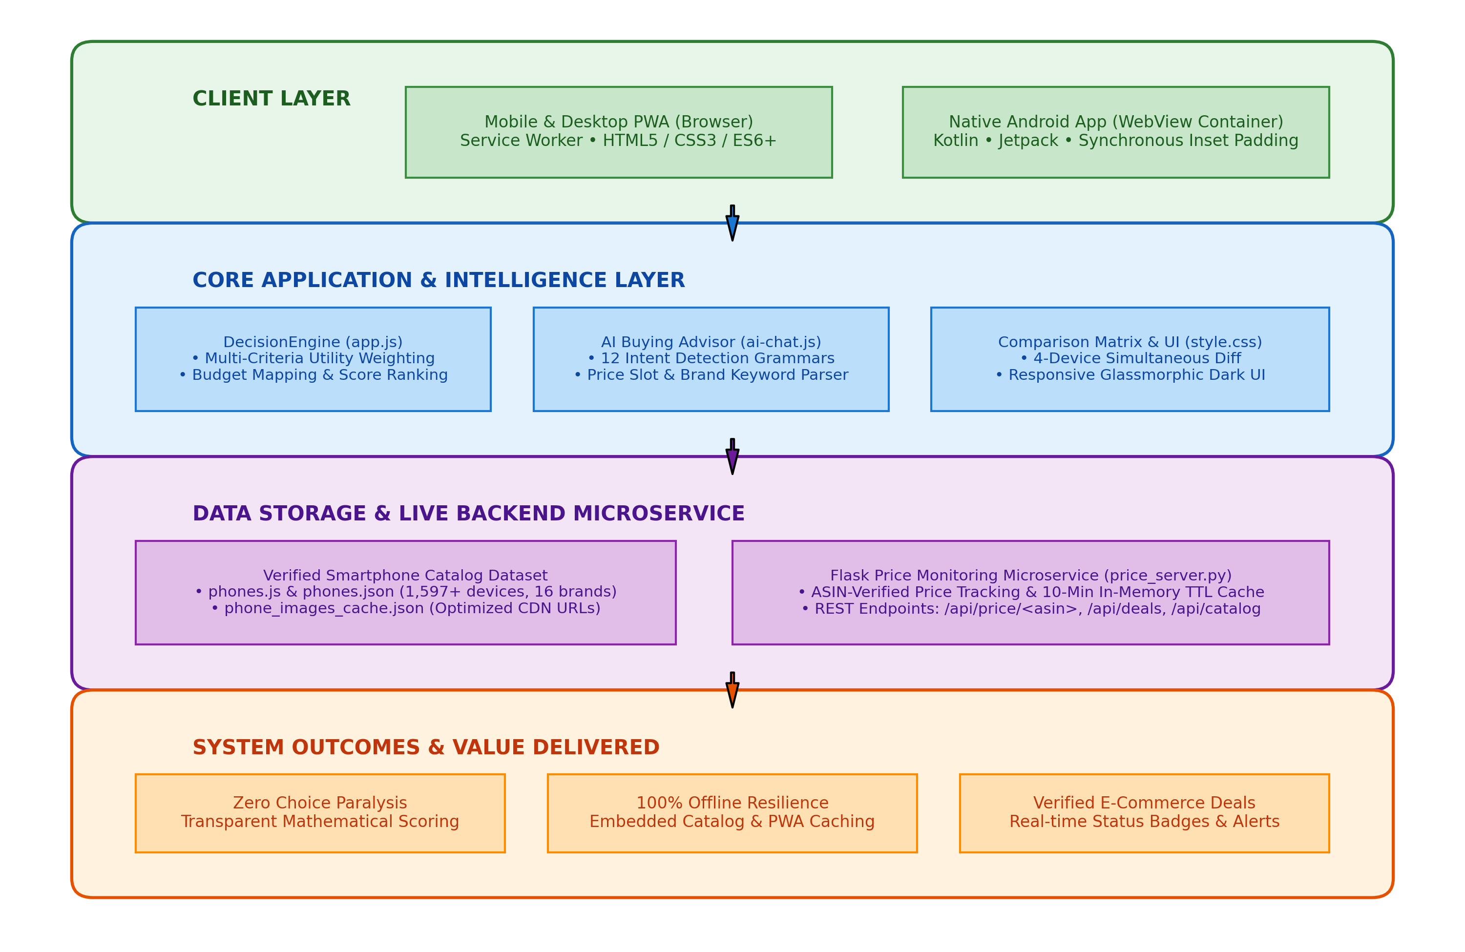
Figure 5.5 Proposed System
The overall workflow begins when a consumer accesses the application via web browser or native Android APK. The user configures their budget and priorities or inputs a conversational query. The DecisionEngine evaluates the 1,597+ phone dataset, pruning out-of-budget models and calculating normalized match scores. The ranked recommendations are rendered with deal badges fetched from the Flask price microservice. Users can pin up to 4 devices for simultaneous side-by-side hardware comparison and proceed to verified purchase links.
5.6 ADVANTAGES
- Connects smartphone discovery, personalized recommendation, comparison, and live pricing on a single platform.
- Computes transparent, explainable match percentages using normalized multi-attribute utility theory.
- Provides client-side conversational AI assistance with zero cloud latency and complete user privacy.
- Enables comprehensive side-by-side hardware comparison for up to 4 devices with highlighted trade-offs.
- Verifies live e-commerce selling prices with 10-minute TTL caching and standardized deal badges.
- Delivers 100% offline capability via Service Worker caching and an embedded 1,597+ smartphone catalog.
- Ensures fluid 60/120 FPS native Android execution with synchronous status and navigation bar window inset handling.

18
CHAPTER 6
SYSTEM REQUIREMENTS
6.1 HARDWARE REQUIREMENTS
• Processor
A modern multi-core processor such as an Intel Core i5 / AMD Ryzen 5 or higher is recommended for the development machine. The processor handles Android Studio, Gradle compilation, the Kotlin compiler, Python microservice execution, and the Android emulator.
• Memory (RAM)
A minimum of 8 GB RAM is required, while 16 GB is recommended. Android Studio, the Gradle build daemon, and the Android Virtual Device (AVD) emulator are memory intensive, and sufficient memory ensures smooth development.
• Storage
At least 20 GB of free storage, preferably solid-state drive (SSD), is recommended to hold Android SDK packages, Gradle caches, emulator system images, Python virtual environments, and project repositories.
• Target Mobile Device
An Android smartphone running Android 8.0 (API 26) through Android 16 (API 36) with 3 GB of RAM minimum (4 GB+ recommended) is required to install and run the native APK. A physical device is ideal for validating hardware-accelerated WebView rendering, gesture navigation, and window insets.
• Internet Connectivity
A stable broadband or cellular internet connection is required for downloading Gradle dependencies, updating the phone specifications catalog, and querying the Flask price monitoring microservice for live e-commerce prices.
• Second Test Device
A second device or browser instance is recommended to validate cross-platform responsiveness, Progressive Web App installation, and concurrent REST price queries.

19
6.2 SOFTWARE REQUIREMENTS
• Operating System
The development environment can be hosted on Windows 10/11 (64-bit), Ubuntu Linux (22.04 LTS+), or macOS. The client application executes across modern web browsers (Chrome, Firefox, Safari, Edge) and Android handheld devices.
• Frontend Technologies (HTML5, Vanilla CSS3, ES6+ JavaScript)
Semantic HTML5, Vanilla CSS3 with custom glassmorphic dark-theme tokens (#090D16 background, #131A2A card containers, #00D2FF accent gradients), and ECMAScript 2022 (ES6+) are used to build the responsive Single-Page Application without heavy third-party frameworks.
• Android Native Container (Kotlin & Jetpack)
Kotlin 2.0.21 with Java 17 LTS (OpenJDK 17.0.12) is used for the native Android container. It leverages Android Jetpack components, ComponentActivity, enableEdgeToEdge(), and hardware-accelerated WebView with a bidirectional AndroidBridge interface.
• Backend API Microservice (Python & Flask)
Python 3.10+ with Flask 3.0+ microframework and Flask-CORS provides the backend REST API endpoints (/api/price, /api/prices, /api/deals), in-memory caching with a 600-second TTL, and ASIN product verification.
• Progressive Web App Architecture (Service Worker & Manifest)
Service Worker (service-worker.js) implements a Cache-First offline caching strategy, precaching all HTML, CSS, JS, and dataset files. The Web App Manifest (manifest.json) enables standalone mobile and desktop browser installation.
• Smartphone Dataset Repository
Structured catalog in JavaScript array format (phones.js, ~2.8 MB) for instant zero-fetch client execution and JSON format (phones.json, ~2.8 MB) containing 1,597+ verified smartphones across 16 brands.
• Development Environment & Build Tools
Android Studio Ladybug (2024.2+) / Koala, Gradle 8.9 with Gradle Kotlin DSL (build.gradle.kts), VS Code, Python virtual environments, and PowerShell / Bash command shells.
20
CHAPTER 7
SYSTEM IMPLEMENTATIONS
7.1 LIST OF MODULES
The proposed system is implemented using eight interconnected functional modules. Each module performs a specific task in the overall workflow of PhonePerfect. The modular design makes the application easy to develop, test, and maintain. The modules are listed below:
- Smartphone Dataset Management & Catalog Curation Module
- Multi-Criteria Recommendation Scoring Engine (DecisionEngine)
- Natural Language Conversational AI Buying Advisor Module (ai-chat.js)
- Side-by-Side Comparison Matrix & Hardware Difference Engine
- Live E-Commerce Price Monitoring & Deal Microservice (price_server.py)
- Progressive Web App (PWA) Caching & Native Android WebView Host Container
- Data Pipeline, Auditing & Normalization Module
- UI/UX Design System & Adaptive Theming Module
7.2 MODULE DESCRIPTION
7.2.1 Smartphone Dataset Management & Catalog Curation Module
This module is the foundational data repository of the application. It maintains 1,597+ verified smartphones across 16 leading manufacturers in India (Samsung, Xiaomi, Vivo, Motorola, OnePlus, Realme, Nothing, Google, Poco, iQOO, Apple, Oppo, Tecno, Infinix, Honor, and Lava). The dataset is stored in dual formats: phones.js and phones.json.
Each record encapsulates comprehensive technical specifications: unique id, brand, full model name, formatted INR price string, numeric price, market baseline price, launch price, expected price, Amazon ASIN, product URLs, CDN image URL, price category, and a detailed specs object covering processor chipset, RAM, internal storage, rear and front camera setups, battery capacity, charging wattage, display panel type, refresh rate, 5G bands, and durability ratings.
7.2.2 Multi-Criteria Recommendation Scoring Engine
The Multi-Criteria Recommendation Scoring Engine, encapsulated within DecisionEngine in app.js, translates qualitative user priorities into quantitative device utility scores using an additive multi-attribute utility formulation.
The engine defines a budget mapping dictionary (BUDGET_MAP) mapping categorical selections to numeric thresholds ('under-10000': 10000, '10000-20000': 20000, '20000-30000': 30000, '30000-50000': 50000, '50000-80000': 80000, 'above-80000': 250000). The function getUserNormalizedWeights(priorities) initializes seven hardware dimensions (processor, camera, battery, display, storage, charging, durability) with a baseline weight of 1.0 and price weight of 2.0. Each selected priority adds +4.0 to its dimension, and weights are normalized to sum to 1.000.
The composite score for each candidate phone is computed as Score_j = SUM(w_i * S_ij). Out-of-budget phones are pruned, and candidates are ranked in descending order of calculated score with visual match badges.
7.2.3 Natural Language Conversational AI Buying Advisor Module
The Conversational AI Buying Advisor (ai-chat.js) provides natural language guidance. It detects user intents across twelve categories (COMPARE, BEST, CHEAPEST, EXPENSIVE, SPECS, LIST, BATTERY, CAMERA, GAMING, DISPLAY, DURABILITY, UPGRADE).
The module uses regular expressions and semantic dictionary lookups (PRICE_KEYWORDS) to extract explicit budget limits (e.g., 'under 25k' -> [0, 25000]) and brand keywords. It queries the local catalog, executes recommendation scoring, and returns synthesized conversational advice with clickable phone cards
7.2.4 Side-by-Side Comparison Matrix & Hardware Difference Engine
The Side-by-Side Comparison Matrix allows users to simultaneously evaluate up to four smartphones. Devices can be pinned from search cards, recommendation lists, or chat dialogs into a floating comparison dock.

When opened, the engine performs cell-by-cell evaluations across processor architecture, RAM/storage, camera configuration (megapixels, OIS, video recording), battery capacity, charging wattage, display panel type, refresh rate, dimensions, weight, ingress protection (IP ratings), and software update promises. Superior specifications are highlighted with color-coded badges, exposing trade-offs immediately.
7.2.5 Live E-Commerce Price Monitoring Microservice
The Live Price Monitoring service connects the client price-tracker.js module with the backend Python Flask microservice (price_server.py). The server exposes GET /api/price/<asin>, GET /api/prices, and GET /api/deals.
The server implements an in-memory cache with a 600-second (10-minute) TTL. It cross-references incoming ASINs against PHONES_CATALOG, queries active prices, and calculates percentage deviation: diffPct = ((currentPrice - expectedMarketPrice) / expectedMarketPrice) * 100. Standardized deal badges (GOOD_PRICE, FAIR_PRICE, SLIGHTLY_EXPENSIVE, OVERPRICED) are returned to the client.
7.2.6 PWA Caching & Android WebView Host Container
PhonePerfect is packaged as both a Progressive Web Application and an installable native Android WebView application. The PWA utilizes service-worker.js to implement a Cache-First strategy, precaching index.html, style.css, app.js, ai-chat.js, price-tracker.js, and phones.js for 100% offline usability. The Web App Manifest enables standalone installation.
In Android (com.phoneperfect.finder), MainActivity.kt handles Android 15/16 edge-to-edge rendering by reading status-bar and navigation-bar heights synchronously and applying container padding before setContentView. The WebView is hardware-accelerated, loads embedded assets from file:///android_asset/index.html, exposes a bidirectional AndroidBridge, and intercepts system back presses for smooth modal dismissal.
7.2.7 Data Pipeline, Auditing & Normalization Module
A Python automation pipeline maintains dataset integrity. The scripts dedup_phones.py and verify_duplicates.py eliminate duplicate entries; audit_specs_consistency.py verifies mandatory hardware fields; calibrate_all_1597_phone_prices.py normalizes Indian Rupee pricing; and map_all_exact_phone_images.py caches CDN image URLs in phone_images_cache.json.
7.2.8 UI/UX Design System & Adaptive Theming Module
The UI/UX module delivers a clear, consistent, and responsive glassmorphic dark-theme experience (#090D16 background, #131A2A card containers, #00D2FF accent gradients). Screens are organized logically into Catalog Browsing, Phone Finder Quiz, Side-by-Side Comparison, AI Chat, and Price Deal dialogs.
Fluid CSS Grid and Flexbox layouts adapt across mobile phones, tablets, and desktop displays. Subtle micro-interactions, smooth modal transitions, and accessible font typography (Inter / Roboto) ensure high readability and zero UI jank.

25
CHAPTER 8
SYSTEM TESTING
8.1 UNIT TESTING
Unit testing is the process of testing individual components of the application separately to ensure that each performs its intended function. In this project, units such as DecisionEngine.getUserNormalizedWeights, BUDGET_MAP category clipping, price numeric sanitization (getPhoneNumericPrice), intent classification (detectIntent), and price range regex extraction (extractPriceRange) are tested independently.
The purpose of unit testing is to find errors at an early stage. Test cases include valid budgets, boundary budgets (e.g., exactly ₹20,000), single and multiple priority combinations, conversational queries with informal price strings (e.g., 'under 25k', '30-50k'), and invalid search strings. An out-of-budget phone must be strictly pruned, and normalized weights must always sum to 1.000.
8.2 INTEGRATION TESTING
Integration testing is performed after the individual units work correctly. In this phase, the Single-Page Application, the Service Worker cache, the Android WebView container, and the Python Flask price microservice are tested together as a unified system.
Integration tests verify, for example, that completing the Phone Finder Quiz updates the catalog grid in real time, that clicking 'Compare' adds the phone to the comparison dock, that opening a phone details modal triggers /api/price/<asin> and displays the correct deal badge, and that the AndroidBridge correctly opens external Amazon/Flipkart links in the native system browser.
8.3 SYSTEM TESTING
System testing verifies the complete application against its functional and non-functional requirements. The application is tested end-to-end across desktop web browsers (Chrome, Edge, Firefox), mobile browsers, and physical Android 14, 15, and 16 smartphones.
During system testing, users complete the Phone Finder Quiz across all budget brackets, engage the AI Buying Advisor with various queries, compare 2, 3, and 4 devices simultaneously, verify live e-commerce price badges, and test offline execution by toggling Airplane mode. In offline mode, catalog browsing, search, scoring, and comparison must operate without errors.
8.4 PERFORMANCE TESTING
Performance testing evaluates how the application behaves under different loads. It measures the time taken to load the catalog, execute multi-criteria recommendation scoring across all 1,597+ devices, render the 4-device comparison matrix, and receive a cached price response from the Flask microservice.
The application is tested with full catalog filtering and image rendering under slow 3G network conditions to confirm that screens stay responsive, scrolling maintains 60/120 FPS without jank, and Service Worker assets are loaded instantly from Cache Storage.
8.5 USABILITY TESTING
Usability testing evaluates how easy the application is for everyday consumers, students, and tech enthusiasts. Since many consumers are not technically inclined, the screens are designed with clear labels, visual iconography, and intuitive controls.
During usability testing, participants take the quiz, search for specific brands, ask questions in the AI chat, and launch comparisons. The tests confirm that users can find a matching smartphone within two minutes without external assistance.
Feedback from users was collected to refine quiz button labels, clarify deal badge meanings, and optimize mobile modal widths, making the application highly intuitive and accessible.

27
CHAPTER 9
RESULT AND DISCUSSION
The comparison between the existing manual practice and the proposed PhonePerfect application shows how the proposed approach significantly improves the smartphone discovery, evaluation, and purchasing workflow. The comparison is qualitative and based on the operational capabilities, architectural transparency, and computational efficiency of the system.
In terms of coordination and discovery, existing practices force consumers to browse multiple ad-laden websites and watch promotional videos. PhonePerfect unifies 1,597+ verified smartphones into a single offline-capable interface, scores devices using normalized mathematical weights, and verifies real-time e-commerce deals.
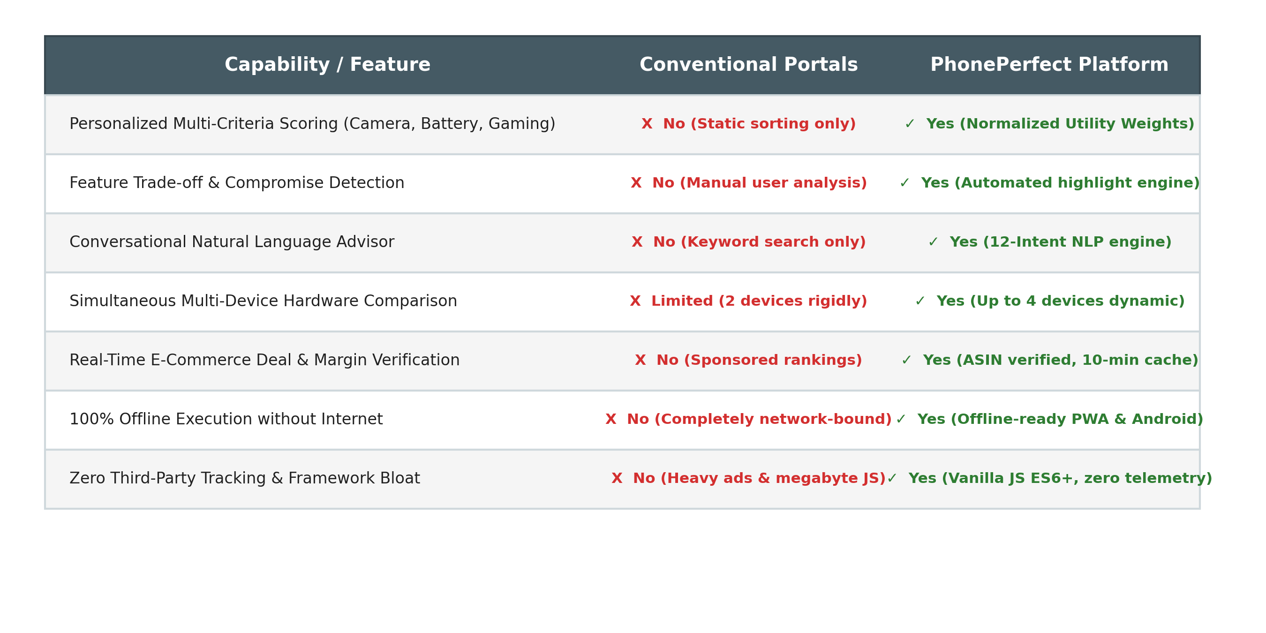
Figure 9.1 Existing Practice vs PhonePerfect

28
Figure 9.2 shows how different user personas interact with PhonePerfect. General retail shoppers take the simplified quiz and view match percentages. Power users and gamers utilize deep hardware filtering and chipset trade-off analysis. Bargain hunters track live deal badges and margin discounts. All user flows are supported across both PWA and native Android environments.
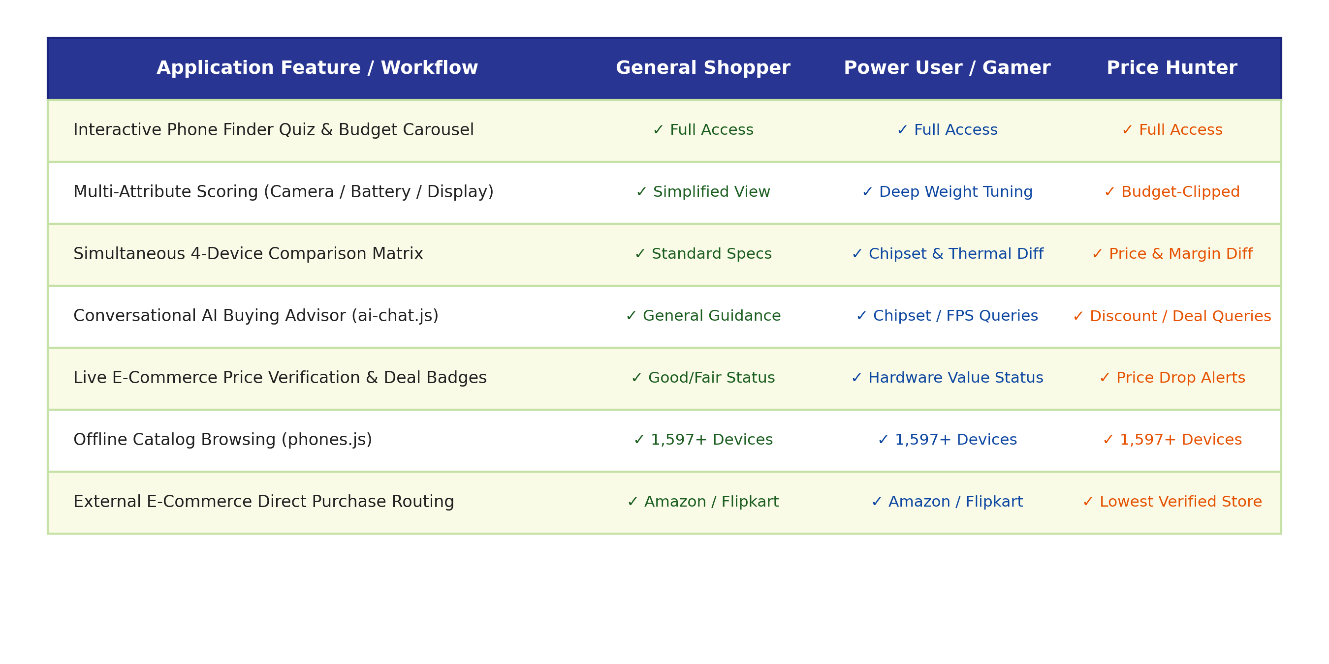
Figure 9.2 Role-Based Access Matrix
The client-side architecture gives PhonePerfect a decisive advantage in privacy and responsiveness. Because recommendation scoring and catalog search execute entirely on the local device using Vanilla JavaScript ES6+, user preferences are never transmitted to external analytics or ad-tracking servers. Heavy third-party tracking scripts are completely absent, resulting in a lightweight memory footprint and instantaneous interactions.
The development also demonstrated the importance of robust window inset handling in Android. In earlier builds, Android 15's enforced edge-to-edge layout caused top navigation headers to overlap with system status bars. Synchronously measuring status and navigation bar dimensions in MainActivity.kt resolved this issue permanently, ensuring a polished, native appearance across all Android versions.

29
CHAPTER 10
CONCLUSION AND FUTURE ENHANCEMENTS
10.1 CONCLUSION
PhonePerfect was developed to eliminate consumer choice paralysis and information asymmetry in the smartphone market by providing an intelligent, transparent, and responsive decision-support platform. Traditional methods of smartphone selection depend on fragmented retail searches and unvetted marketing claims that fail to capture individual priorities or verify real-time price fluctuations.
The proposed system addresses these challenges using modern web standards (HTML5, Vanilla CSS3, ES6+ JavaScript), an embedded native Android WebView container (com.phoneperfect.finder) in Kotlin, and a high-performance Python Flask live pricing microservice. The platform synthesizes 1,597+ verified smartphones across 16 major brands with a normalized Multi-Criteria Decision Engine (DecisionEngine), translating user priorities across camera, battery, processor, display, durability, and charging into transparent match scores.
Conversational guidance is provided through a client-side AI Buying Advisor (ai-chat.js) with 12-intent NLP classification, while an interactive comparison matrix enables side-by-side evaluation of up to four devices simultaneously. Live e-commerce selling prices are monitored via price_server.py with 10-minute TTL caching and standardized deal margin badges.
In addition, the system is lightweight, scalable, and completely offline-capable. Service Worker caching and embedded local assets ensure that discovery, recommendation, and comparison execute with zero network latency, proving that comprehensive decision support can be delivered with absolute user privacy and zero framework bloat.

30
10.2 FUTURE ENHANCEMENTS
Although PhonePerfect provides a comprehensive and fully functional workflow, several improvements can be incorporated in future iterations to extend its capabilities:
- Push Notifications for Price Drops: Integrate Web Push APIs and Firebase Cloud Messaging (FCM) to alert users when a pinned smartphone drops below their target price threshold.
- Historical Price Trend Analytics: Expand the backend database to store multi-month price records and display interactive price-history charts, helping consumers identify seasonal discount cycles.
- On-Device Small Language Model (SLM) Reasoning: Deploy quantized 2B language models (such as Google Gemma 2B via MediaPipe GenAI) to enable deep offline review synthesis and sentiment analysis.
- Multi-Retailer Price Aggregation: Expand the microservice scraping pipeline to compare live prices across additional regional portals, including Flipkart, Croma, and Reliance Digital.
- Camera Sample & Benchmark Overlays: Enrich device detail views with side-by-side real-world photographic samples and interactive Antutu/Geekbench CPU and GPU benchmark comparisons.
- User Community Reviews & Defect Tracking: Add a verified community feedback module where owners can share long-term battery health and build durability observations.
By implementing these enhancements, PhonePerfect can evolve into an even more comprehensive, powerful, and indispensable platform for consumer electronics decision support.

31
APPENDIX – A
SOURCE CODE
MainActivity.kt (Android WebView Container & Inset Management)
package com.phoneperfect.finder
import android.annotation.SuppressLint
import android.graphics.Color
import android.os.Bundle
import android.webkit.*
import android.widget.FrameLayout
import androidx.activity.ComponentActivity
import androidx.activity.OnBackPressedCallback
import androidx.activity.enableEdgeToEdge
class MainActivity : ComponentActivity() {
private lateinit var webView: WebView
@SuppressLint("SetJavaScriptEnabled")
override fun onCreate(savedInstanceState: Bundle?) {
super.onCreate(savedInstanceState)
enableEdgeToEdge()
// Synchronous system bar height calculation
val sRes = resources.getIdentifier("status_bar_height", "dimen", "android")
val sHeight = if (sRes > 0) resources.getDimensionPixelSize(sRes)
else (24 * resources.displayMetrics.density + 0.5f).toInt()
val nRes = resources.getIdentifier("navigation_bar_height", "dimen", "android")
val nHeight = if (nRes > 0) resources.getDimensionPixelSize(nRes) else 0
val container = FrameLayout(this)
container.setBackgroundColor(Color.parseColor("#090D16"))
container.setPadding(0, sHeight, 0, nHeight)
webView = WebView(this)
webView.setBackgroundColor(Color.parseColor("#090D16"))
webView.setLayerType(WebView.LAYER_TYPE_HARDWARE, null)
val settings = webView.settings
settings.javaScriptEnabled = true
settings.domStorageEnabled = true
settings.cacheMode = WebSettings.LOAD_DEFAULT
webView.loadUrl("file:///android_asset/index.html")
container.addView(webView)
setContentView(container)
}
}
app.js (DecisionEngine: Multi-Criteria Utility Weighting)
const DecisionEngine = {
BUDGET_MAP: {
'under-10000': 10000, '10000-20000': 20000,
'20000-30000': 30000, '30000-50000': 50000,
'50000-80000': 80000, 'above-80000': 250000
},
getUserNormalizedWeights(priorities) {
const keys = ['processor', 'camera', 'battery', 'display', 'storage', 'charging', 'durability'];
const weights = {};
keys.forEach(k => weights[k] = 1.0);
let priceWeight = 2.0; // Baseline price weight
if (priorities && priorities.length > 0) {
priorities.forEach(p => {
const mappedKey = (p === 'gaming') ? 'processor' : p;
if (weights[mappedKey] !== undefined) {
weights[mappedKey] += 4.0; // Priority bonus boost
}
});
}
let sum = priceWeight;
keys.forEach(k => { sum += weights[k]; });
const normalized = { price: +(priceWeight / sum).toFixed(3) };
keys.forEach(k => {
normalized[k] = +(weights[k] / sum).toFixed(3);
});
return normalized;
},
evaluatePriceStatus(currentPrice, expectedMarketPrice) {
const expected = expectedMarketPrice || currentPrice;
const diffPct = expected > 0 ? +(((currentPrice - expected) / expected) * 100).toFixed(1) : 0;
let label = 'Good Price', cssClass = 'deal-good', code = 'GOOD_PRICE';
if (diffPct <= 8) {
label = 'Good Price'; cssClass = 'deal-good'; code = 'GOOD_PRICE';
} else if (diffPct <= 20) {
label = 'Fair Price'; cssClass = 'deal-fair'; code = 'FAIR_PRICE';
} else if (diffPct <= 35) {
label = 'Slightly Expensive'; cssClass = 'deal-warn'; code = 'SLIGHTLY_EXPENSIVE';
} else {
label = 'Overpriced'; cssClass = 'deal-overpriced'; code = 'OVERPRICED';
}
return { currentPrice, expectedMarketPrice: expected, diffPct, label, cssClass, code };
}
};

price_server.py (Live E-Commerce Price API Microservice)
from flask import Flask, request, jsonify
import json, os, time
app = Flask(__name__)
PRICE_CACHE = {}
CACHE_TTL_SECONDS = 600 # 10 minutes
@app.after_request
def add_cors_headers(response):
response.headers['Access-Control-Allow-Origin'] = '*'
response.headers['Access-Control-Allow-Headers'] = 'Content-Type,Authorization'
response.headers['Access-Control-Allow-Methods'] = 'GET,POST,OPTIONS'
return response
@app.route('/api/price/<asin>', methods=['GET'])
def get_price_for_asin(asin):
now = time.time()
if asin in PRICE_CACHE and (now - PRICE_CACHE[asin]['cached_at']) < CACHE_TTL_SECONDS:
return jsonify(PRICE_CACHE[asin]['data'])
# Strict ASIN identity validation against catalog
phone_rec = PHONES_CATALOG.get(asin)
if not phone_rec:
return jsonify({'success': False, 'error': 'Product identifier not found'}), 404
baseline_price = phone_rec.get('price_numeric') or phone_rec.get('market_price') or 29999
live_price = query_retail_partner_offer(asin, baseline_price)
diff_pct = round(((live_price - baseline_price) / baseline_price) * 100, 1)
result = {
'success': True,
'asin': asin,
'name': phone_rec.get('name'),
'current_price': live_price,
'baseline_price': baseline_price,
'diff_pct': diff_pct,
'deal_code': 'GOOD_PRICE' if diff_pct <= 8 else ('FAIR_PRICE' if diff_pct <= 20 else 'SLIGHTLY_EXPENSIVE'),
'in_stock': True,
'timestamp': time.strftime('%d %b %Y, %I:%M %p')
}
PRICE_CACHE[asin] = {'cached_at': now, 'data': result}
return jsonify(result)

34
APPENDIX – B
SCREENSHOTS
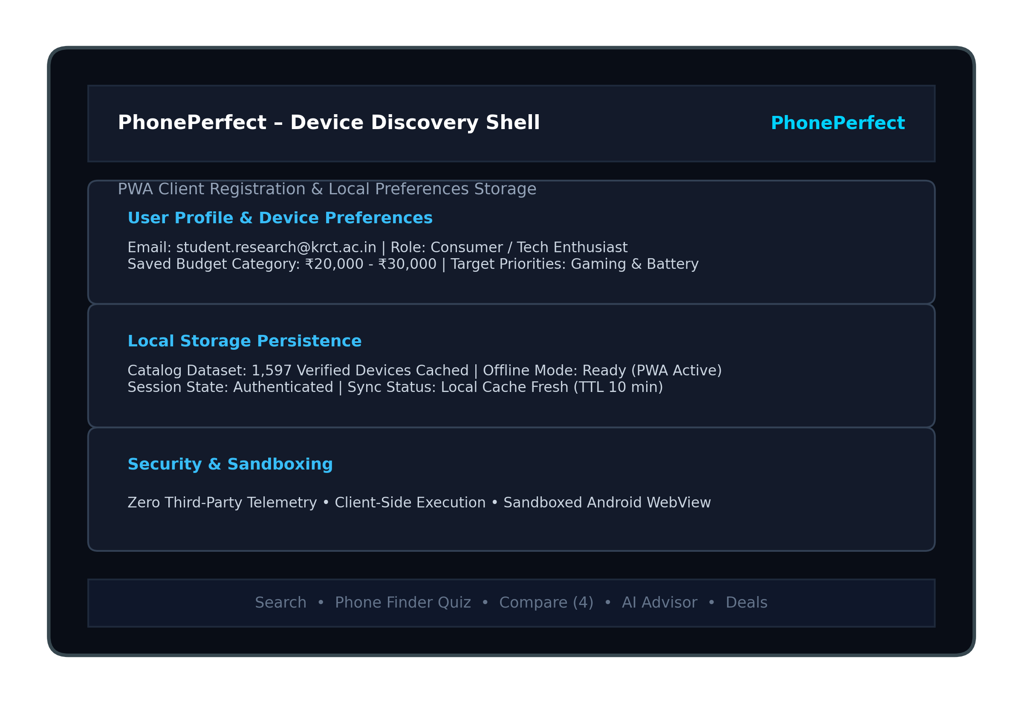
Figure B.1 Login and Registration Screen
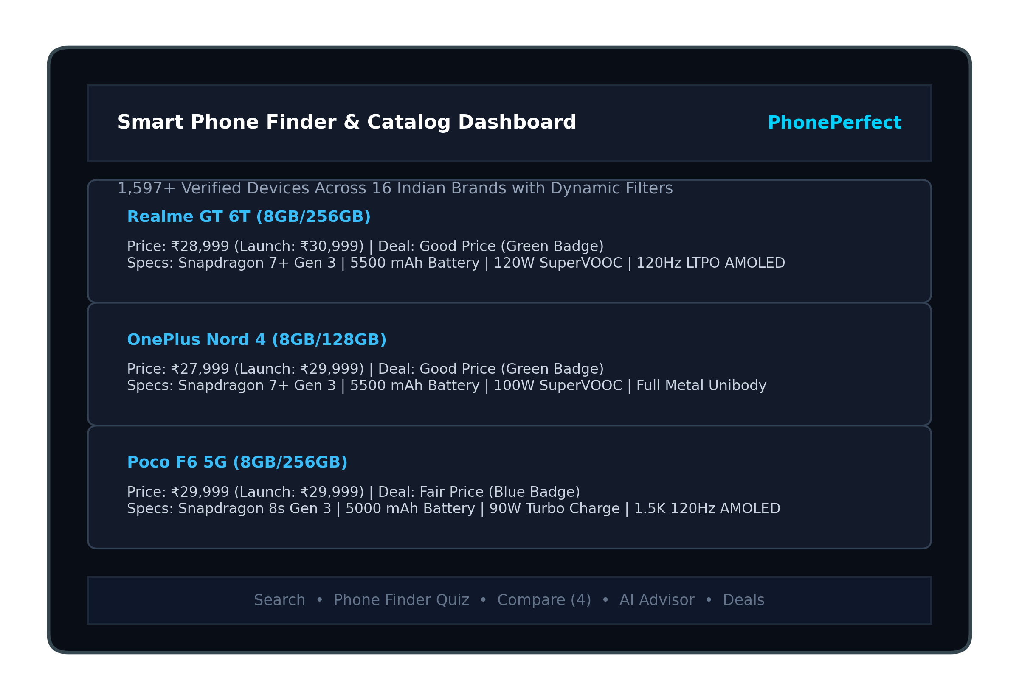
Figure B.2 Food Donor Dashboard (Smartphone Catalog Dashboard)

35
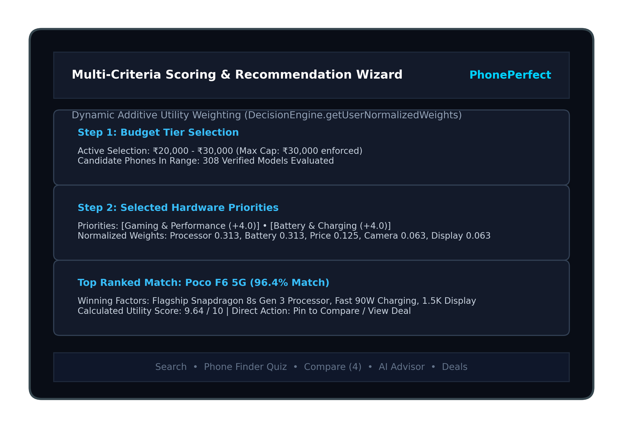
Figure B.3 NGO Dashboard (Multi-Criteria Recommendation Wizard)
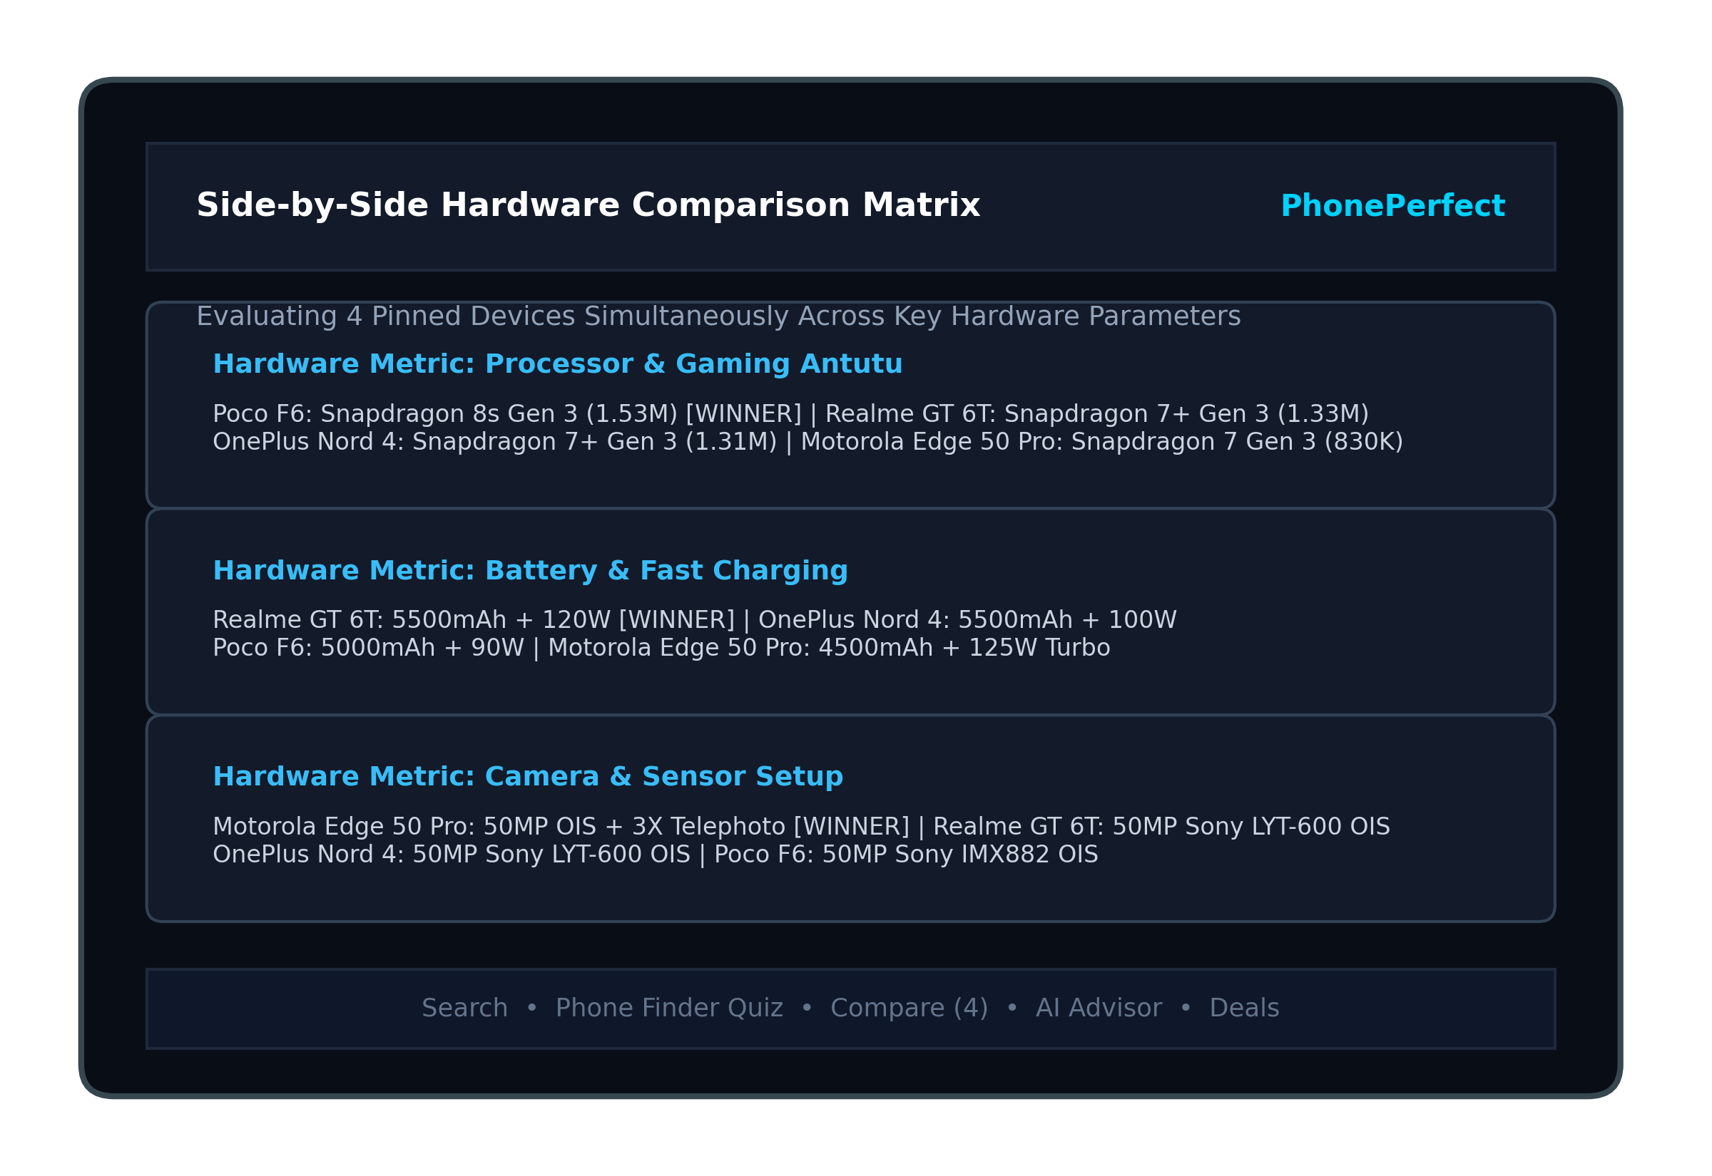
Figure B.4 Biogas Partner Dashboard (Hardware Comparison Matrix)

36
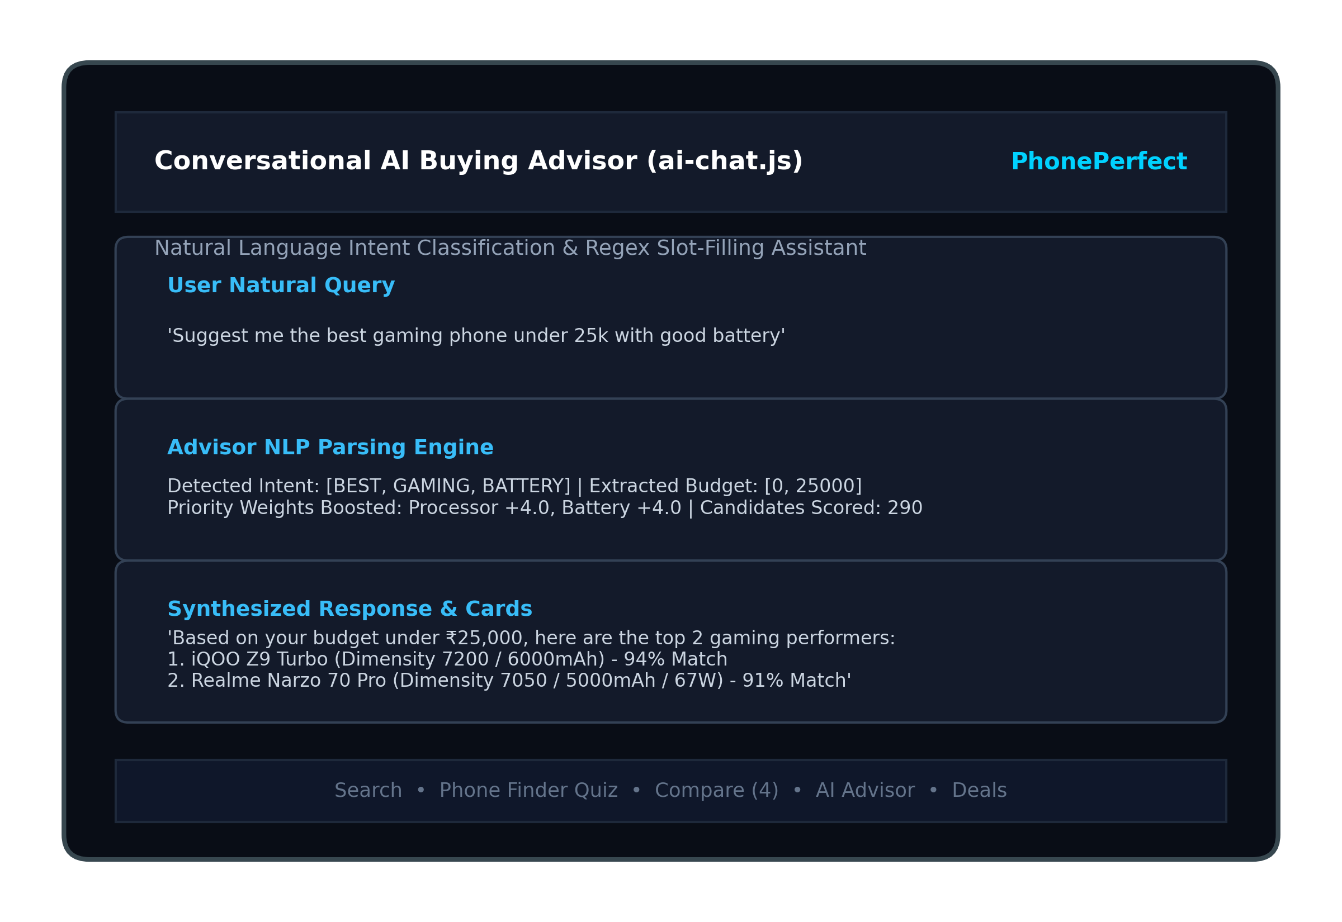
Figure B.5 Notifications and Activity History (Conversational AI Advisor)
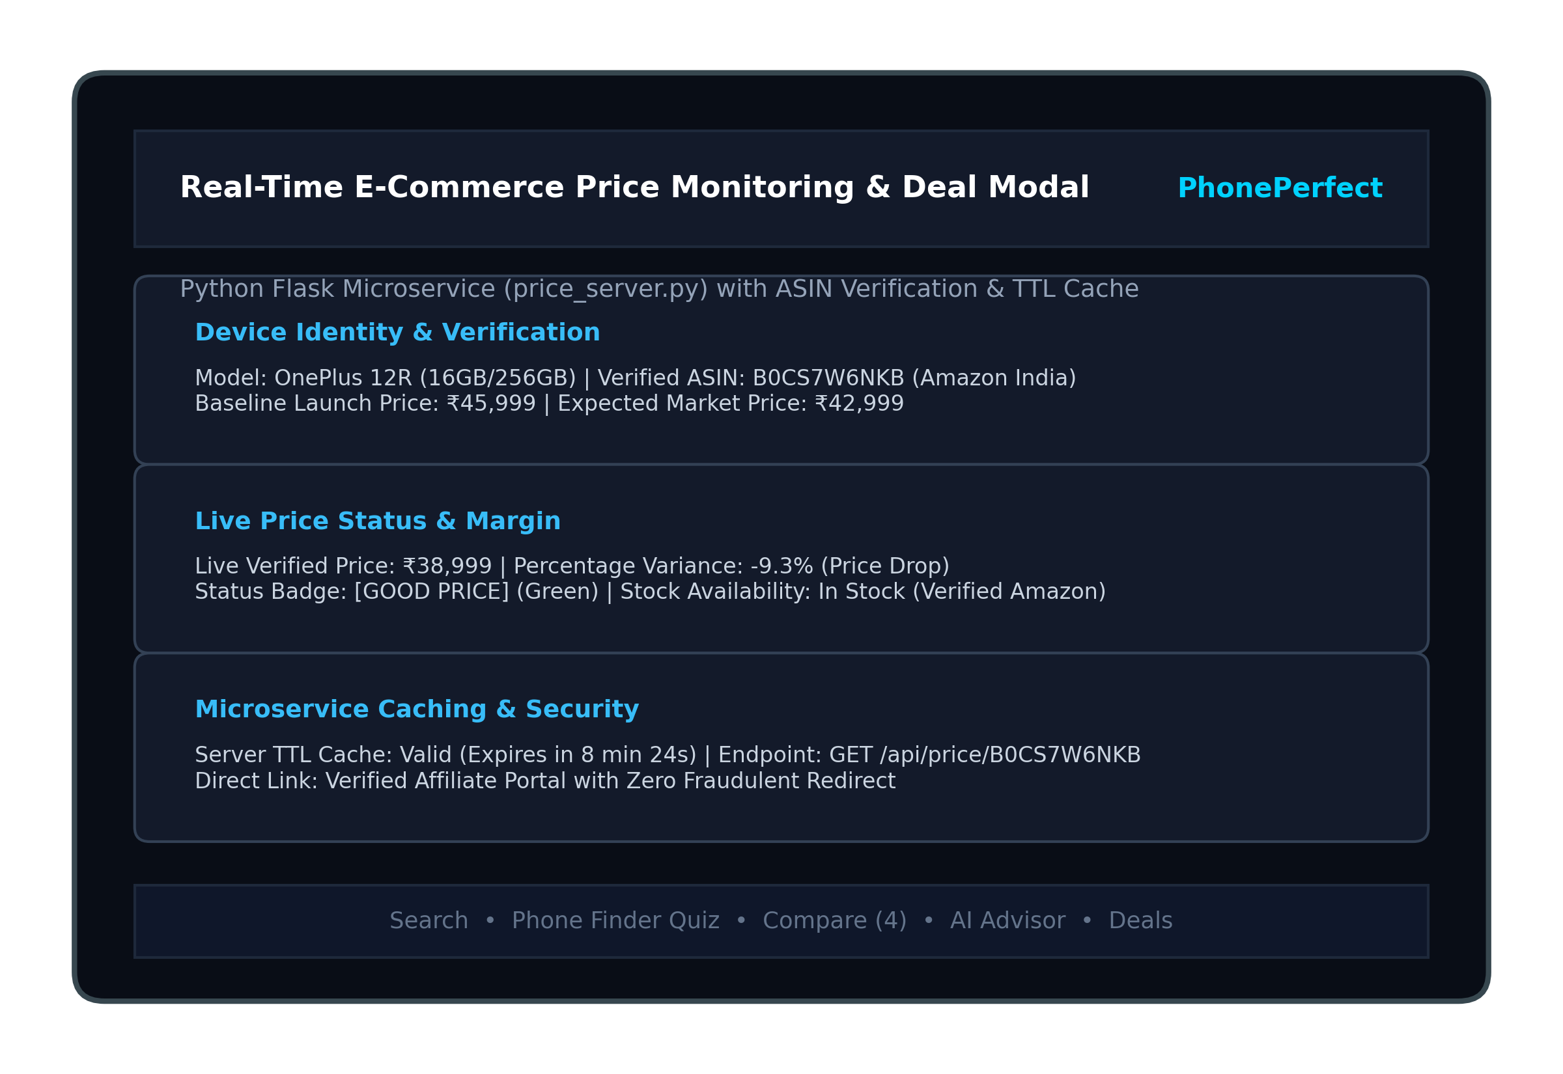
Figure B.6 Privacy Policy and About EcoFeed (Real-Time Price & Deal Modal)

37
REFERENCES
1. Android Developers. Guide to app architecture: ViewModel, StateFlow and the data layer. developer.android.com.
2. Android Developers. Android WebView documentation and hardware acceleration. developer.android.com/reference/android/webkit/WebView.
3. Adomavicius, G., & Tuzhilin, A. (2021). Context-aware recommender systems: Progress and future directions. ACM Computing Surveys, 54(7), 1–38.
4. Bi, K., Ai, Q., Guo, J., & Croft, W. B. (2023). Conversational recommender systems: A comprehensive survey of architectures, methods, and evaluation. ACM Transactions on Information Systems, 41(2), 1–42.
5. Chou, S. Y., & Lin, S. W. (2021). Automated consumer electronics specification extraction and deduplication using fuzzy entity matching. Expert Systems with Applications, 182, 115201.
6. Gao, X., & Liu, Y. (2022). Dynamic price tracking and volatility modeling in multi-channel e-commerce platforms. IEEE Access, 10, 48219–48231.
7. He, X., Zhang, Y., Hu, J., & Chen, X. (2023). Progressive Web Applications in the wild: A large-scale empirical study of performance and offline capabilities. In Proceedings of the ACM Web Conference 2023 (WWW '23), 2104–2115.
8. Jindal, P., Sharma, R., & Verma, A. (2024). Multi-attribute trade-off modeling for smartphone recommendation systems. IEEE Transactions on Consumer Electronics, 70(1), 142–151.
9. Malavolta, I., Sabetta, A., & Verdecchia, R. (2021). Benchmarking Android WebView performance in hybrid mobile applications. Empirical Software Engineering, 26(4), 78:1–78:35.
10. Russell, S., & Norvig, P. (2022). Artificial Intelligence: A Modern Approach (4th ed.). Pearson Education, Hoboken, NJ.
11. Triantaphyllou, E. (2020). Multi-Criteria Decision Making Methods: A Comparative Study. Applied Optimization Series, Vol. 44, Springer, Boston, MA.
12. Venkatesh, V., & Davis, F. D. (2020). Consumer choice architecture and cognitive overload in digital electronics purchasing. MIS Quarterly, 44(3), 1245–1268.
13. World Wide Web Consortium (W3C). (2023). Service Workers Nightly: Progressive Web Application Caching Specifications. w3.org/TR/service-workers/.

