CS731 SOFTWARE TESTING PROJECT REPORT

MUTATION TESTING ON SOURCE CODE OF STANDARD ALGORITHMS

SUBMITTED BY:
MT2024048 GANGASAGAR HL MT2024081 KULDEEP CHAMOLI

Git: https://github.com/Gangasagarhl/Mutation-Testing

PROJECT AIM
The aim of the project is to use Mutation Testing to test a real-world software project with the help of open-source tools.

CODE TESTED
Algorithms form an important aspect of any program and are used everywhere to achieve specific tasks. For example, the TCP/IP protocol is used to reliably transfer data between computers over the Internet. They are also used in complex systems such as rocket launches. Given the importance of algorithms, it becomes important to ensure that they are correct and work exactly as intended, while producing outputs that are correct. Hence, we chose to perform mutation testing on algorithms. We used the popular GitHub repository TheAlgorithms to test the code. To be more specific, we used the algorithms implemented in Java (GitHub repository link) to perform the testing.
A complete list of algorithms that are implemented in Java language (in the above GitHub repository) can be found here. The long list of the algorithms implemented show the sheer amount of code that is present in this repository.

LINES OF CODE EXCLUDING DOCUMENTATION
Total Lines: ∼ 1592 lines
- Greedy Algorithms : 599 lines
- Backtracking: 671 lines
- Sorting: 322 lines

TESTING STRATEGY AND TOOLS USED
Mutation testing is a form of testing where small modifications are made to the source code (and each modification is called a mutant). The aim of mutation testing is to “kill” these mutants – that is to show that making small changes to the code can alter the execution of the program and hence the result that it produces. There are 2 ways to “kill” a mutant:
- Kill a mutant weakly: Here, the memory state of the program after the execution of the mutated statement is different from the memory state of the program when the statement was not mutated and executed. Notice that in this case, the output of the program on a test case can remain the same, irrespective of whether a program statement was mutated or not.
- Kill a mutant strongly: Here, the output of the program on a test case, when a statement was mutated and not mutated, must change. Notice that when we kill

a mutant strongly, the error propagates through the program and we notice this by seeing different outputs in the presence and absence of the mutant.
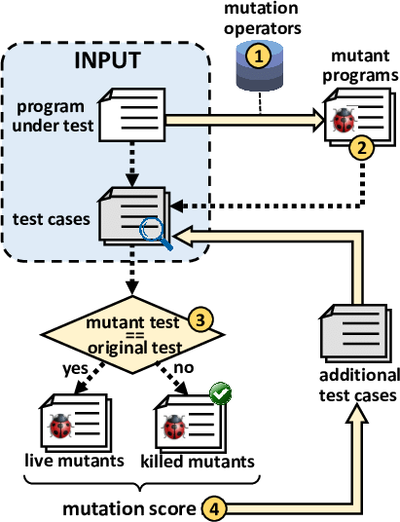
We chose mutation testing as our testing strategy, with the aim to kill the mutants

strongly.
The tools that we used for mutation testing are as follows:
- IntelliJ IDEA: IntelliJ IDEA is a powerful IDE for Java development, offering seamless support for plugins to enhance its functionality. It supports built-in features for debugging, version control, and code completion while allowing developers to install or create plugins for additional capabilities.
- PIT Mutation Testing Tool: An easy-to-use mutation testing tool, that works for Java. We used the PITclipse plugin for Eclipse to integrate this tool into the Eclipse IDE.

LEVELS OF MUTATION TESTING
- Unit Mutation: Unit mutation focuses on individual components like functions or methods. It delves into the internal workings of these units, making changes such as altering operators or tweaking logic. This testing method assesses how well the test suite can detect modifications within these isolated components, ensuring each piece of the software puzzle functions correctly on its own.
- Integration Mutation: Integration mutation (sometimes called interface mutation) works by creating mutants on the connections between components. Most of the mutations are around method calls, and both the calling (caller) and the called (callee) method are considered. We will work on both of these as a part of our Mutation Testing project.

MUTATIONS USED:
PIT, by default, provides a set of mutation operators. These operators are listed below:
  - CONDITIONALS_BOUNDARY
  - EMPTY_RETURNS
  - FALSE_RETURNS
  - INCREMENTS
  - INVERT_NEGS
  - MATH
  - NEGATE_CONDITIONALS
  - NULL_RETURNS
  - PRIMITIVE_RETURNS
  - TRUE_RETURNS
  - VOID_METHOD_CALLS

We added the below configuration to the org.pitest (pitest-maven) plugin in the pom.xml file to have all the mutators in our code.
<configuration>
<mutators>
<mutator>ALL</mutator>
</mutators>
</configuration>

ACTIVE MUTATORS:
Mutation Operators Generated in PIT:
  - CONDITIONALS BOUNDARY (Relational Operator Replacement - UNIT TESTING)
  - CONSTRUCTOR CALLS (Default Constructor Deletion - INTEGRATION TESTING)
  - EMPTY_RETURNS (Integration Return Expression Modification (IREM) - INTEGRATION TESTING )
  - EXPERIMENTAL_ARGUMENT_PROPAGATION (Integration Method Call Deletion (IMCD) - INTEGRATION TESTING )
  - EXPERIMENTAL_BIG_DECIMAL
  - EXPERIMENTAL_BIG_INTEGER
  - EXPERIMENTAL_MEMBER_VARIABLE (Integration Parameter Variable Replacement (IVPR) - INTEGRATION TESTING)
  - EXPERIMENTAL_NAKED_RECEIVER
  - EXPERIMENTAL_REMOVE_SWITCH_MUTATOR_[0-99]
  - EXPERIMENTAL_SWITCH
  - FALSE_RETURNS (Integration Return Expression Modification (IREM) - INTEGRATION TESTING)
  - INCREMENTS (Unary Operator Replacement - UNIT TESTING)
  - INLINE_CONSTS Integration Parameter Variable Replacement (IVPR) - INTEGRATION TESTING)
  - INVERT_NEGS (Integration Unary Operator Insertion (IUOI) - INTEGRATION TESTING)
  - MATH (Arithmetic Operator Replacement - UNIT TESTING)

  - NEGATE_CONDITIONALS (Relational Operator Replacement - UNIT TESTING)
  - NON_VOID_METHOD_CALLS (Integration Method Call Deletion (IMCD) - INTEGRATION TESTING)
  - NULL_RETURNS Integration Return Expression Modification (IREM).
  - PRIMITIVE_RETURNS (Integration Return Expression Modification - INTEGRATION TESTING)
  - REMOVE_CONDITIONALS_EQUAL_ELSE (Relational Operator Replacement - UNIT TESTING)
  - REMOVE_CONDITIONALS_EQUAL_IF (Relational Operator Replacement - UNIT TESTING)
  - REMOVE_CONDITIONALS_ORDER_ELSE (Relational Operator Replacement - UNIT TESTING)
  - REMOVE_CONDITIONALS_ORDER_IF (Relational Operator Replacement - UNIT TESTING)
  - REMOVE_INCREMENTS (Unary Operator Deletion - UNIT TESTING)
  - TRUE_RETURNS (Integration Return Expression Modification - INTEGRATION TESTING)
  - VOID_METHOD_CALLS (Integration Method Call Deletion (IMCD) - INTEGRATION TESTING)
It was mentioned in the problem statement that the mutated program needs to be strongly killed by the designed test cases. At least three different mutation operators should be used at the unit level and three different mutation operators at the integration level should be used.
The following are the five interface mutation operators that are used in our code at the integration level.
- Integration Parameter Variable Replacement (IVPR): In this mutation operator, each parameter in a method call is replaced with every other variable of a compatible type within the scope of the method call. This ensures that syntactically illegal replacements, such as those involving incompatible types, are avoided.
- Integration Unary Operator Insertion (IUOI): This mutation operator modifies each expression in a method call by inserting all possible unary operators both before and after the expression.
- Integration Parameter Exchange (IPEX): This operator swaps each parameter in a method call with every other parameter of a compatible type within the same method call.

- Integration Method Call Deletion (IMCD): This operator removes method calls. If the method returns a value used in an expression, the method call is replaced with a suitable constant or default value.
- Integration Return Expression Modification (IREM): Each expression in a return statement is modified by applying Unary Operator Insertion (UOI) and Arithmetic Operator Replacement (AOR).

PROGRAM-LEVEL MUTATION OPERATORS FOR UNIT LEVEL TESTING
Mutation testing involves creating mutants of the program by modifying specific program elements and testing if the original tests can "kill" these mutants (i.e., cause the tests to fail). The following mutation operators modify various types of operators in the code (e.g., arithmetic, relational, logical, etc.).

Absolute Value Insertion:
  - Description: Each arithmetic expression or sub-expression is modified by applying one of three functions:
    - Abs(): Returns the absolute value of the expression.
    - negAbs(): Returns the negative of the absolute value.
    - failOnZero(): Checks if the expression is zero. If it is, the mutant is killed (the test fails). If the expression is not zero, execution continues, and the expression is returned.
  - Example: For the expression x = 3 * a, the following mutants are generated:
    - x = 3 * abs(a)
    - x = 3 * negAbs(a)
    - x = 3 * failOnZero(a)

Arithmetic Operator Replacement:
  - Description: Each occurrence of an arithmetic operator (e.g., +, -, *, /, **, %) is replaced by each of the other operators. Additionally, special mutation operators such as leftOp, rightOp, and mod are applied.
    - leftOp: Returns the left operand (ignores the right).
    - rightOp: Returns the right operand (ignores the left).
    - mod: Computes the remainder when the left operand is divided by the right.

  - Example: For the expression x = a + b, the following mutants are generated:
    - x = a - b
    - x = a * b
    - x = a / b
    - x = a ** b
    - x = a
    - x = b
    - x = a % b

Relational Operator Replacement:
  - Description: Each occurrence of a relational operator (e.g., <, >, <=, >=, =, ≠) is replaced by other relational operators and two special operators: falseOp and trueOp.
    - falseOp: Always returns false.
    - trueOp: Always returns true.
  - Example: For the expression if (m > n), the following mutants are generated:
    - if (m >= n)
    - if (m < n)
    - if (m <= n)
    - if (m == n)
    - if (m = n)
    - if (false)
    - if (true)

Conditional Operator Replacement:
  - Description: Each logical operator (e.g., &&, ||, &, |, !) is replaced by other operators, and special operators like falseOp, trueOp, leftOp, and rightOp are applied.
    - leftOp: Returns the left operand (ignores the right).
    - rightOp: Returns the right operand (ignores the left).
  - Example: For the expression if (a && b), the following mutants are generated:

    - if (a || b)
    - if (a & b)
    - if (a | b)
    - if (a b) (invalid logical operator)
    - if (false)
    - if (true)
    - if (a)
    - if (b)

Shift Operator Replacement:
  - Description: Each shift operator (<<, >>, >>>) is replaced by each other shift operator. Additionally, a special mutation operator leftOp is applied, which returns the left operand unshifted.
Example: For the expression x = m << a, the following mutants are generated:
    - x = m >> a
    - x = m >>> a
    - x = m (the left operand unshifted)

Logical Operator Replacement:
  - Description: Each bitwise logical operator (e.g., &, |, ^) is replaced by each of the other operators, and special operators leftOp and rightOp are applied.
    - leftOp: Returns the left operand (ignores the right).
    - rightOp: Returns the right operand (ignores the left).
  - Example: For the expression x = m & n, the following mutants are generated:
    - x = m | n
    - x = m ^ n
    - x = m
    - x = n

Assignment Operator Replacement:
  - Description: Each assignment operator (e.g., +=, -=, *=, =, %=, &=, |=, <<=,
>>=, >>>=) is replaced by each other assignment operator.
Example: For the expression x += 3, the following mutants are generated:

    - x -= 3
    - x *= 3
    - x = 3
    - x %= 3
    - x &= 3
    - x |= 3
    - x = 3
    - x <<= 3
    - x >>= 3
    - x >>>= 3

Unary Operator Insertion:
  - Description: Each unary operator (e.g., +, -, !, ~) is inserted before each expression of the correct type.
Example: For the expression x = 3 * a, the following mutants are generated:
    - x = 3 * +a
    - x = 3 * -a
    - x = +3 * a
    - x = -3 * a

Unary Operator Deletion:
  - Description: Each unary operator (e.g., +, -, !, ~) is deleted from the expression.
Example: For the expression if (a > -b), the following mutants are generated:
    - if (a > b) (after deleting the unary - before b)

Scalar Variable Replacement:
  - Description: Each variable reference is replaced by every other variable of the appropriate type that is declared in the current scope.
Example: For the expression x = a * b, the following mutants are generated:
    - x = a * a
    - x = a * x
    - x = b * a

    - x = b * b
    - x = x * b
    - x = a * b (itself, no mutation)

TABULATED TESTING RESULTS

Algorithm Domain | Algorithm Name | Mutations Killed | %  Mutations Killed | Lines of Code  in Algorithm (approx.)  **
Greedy Algorithms | Activity Selection | 39/44 | 89 | 51
Greedy Algorithms | Bandwidth Allocation | 33/35 | 94 | 45
Greedy Algorithms | Binary Addition | 92/95 | 97 | 55
Greedy Algorithms | Coin Change | 48/50 | 96 | 30
Greedy Algorithms | Digit Separation | 24/24 | 100 | 38
Greedy Algorithms | Egyptian Fraction | 12/12 | 100 | 39
Greedy Algorithms | Fractional Knapsack | 29/31 | 94 | 33
Greedy Algorithms | Gale Shapley | 45/52 | 87 | 44
Greedy Algorithms | Job Sequencing | 61/66 | 92 | 63
Greedy Algorithms | KCenters | 38/46 | 83 | 38
Greedy Algorithms | MergeIntervals | 38/39 | 97 | 30
Greedy Algorithms | Minimizing Lateness | 28/32 | 88 | 42
Greedy Algorithms | Minimum Waiting Time | 16/19 | 84 | 34
Greedy Algorithms | Optimal File Merging | 29/31 | 94 | 36

 | Stock Profit Calculator | 15/15 | 100 | 21
Backtracking | All Paths From Source To Target | 37/42 | 88 | 61
Backtracking | Combination | 42/46 | 91 | 45
Backtracking | Flood Fill | 35/35 | 100 | 25
Backtracking | Hamiltonian Cycle | 58/67 | 87 | 49
Backtracking | Maze Recursion | 41/46 | 89 | 37
Backtracking | M-Coloring | 55/62 | 89 | 37
Backtracking | N-Queens | 60/62 | 87 | 54
Backtracking | Parentheses generator | 31/31 | 100 | 31
Backtracking | Partitions of a set | 60/74 | 81 | 56
Backtracking | Permutations | 17/19 | 89 | 33
Backtracking | Word Break | 27/28 | 96 | 37
Backtracking | Power Sum | 39/49 | 80 | 43
Backtracking | Subsequence Finder | 28/30 | 93 | 36
Backtracking | Word Pattern Matcher | 76/83 | 92 | 51
Backtracking | Word Search | 96/106 | 91 | 55
Sorting | Bubble Sort | 40/44 | 91 | 28
Sorting | Bucket Sort | 64/66 | 97 | 40
Sorting | Counting Sort | 58/60 | 97 | 37
Sorting | Heap Sort | 41/47 | 87 | 34
Sorting | Insertion Sort | 34/38 | 89 | 28

 | Merge Sort | 66/69 | 96 | 50
 | Priority Queues | 35/40 | 88 | 33
 | Quick Sort | 28/31 | 90 | 28
 | Radix Sort | 46/48 | 96 | 25
 | Shell Sort | 20/23 | 87 | 19

We are able to achieve at least 90% mutation kills in almost all of the functions.

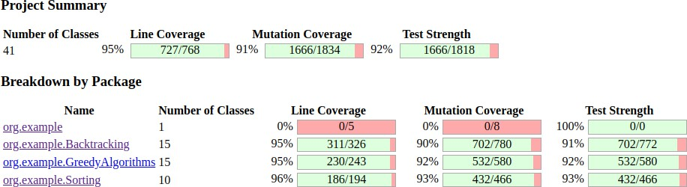
TESTING SUMMARIES:

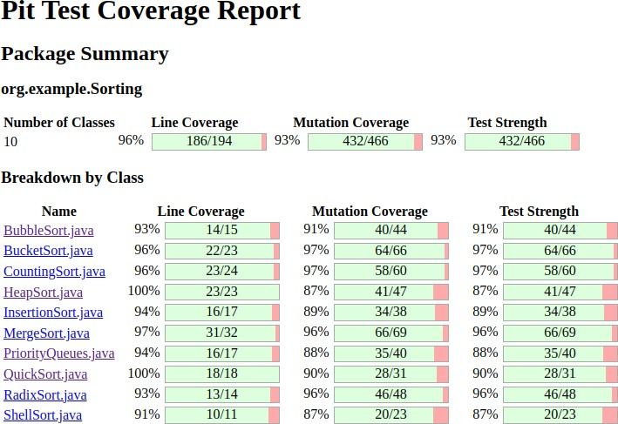
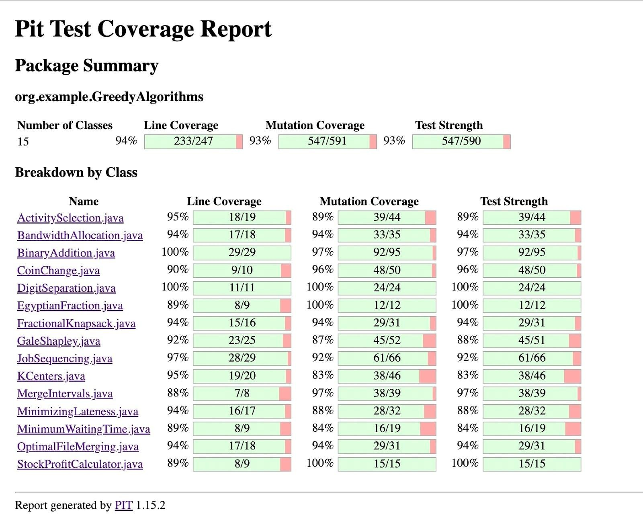

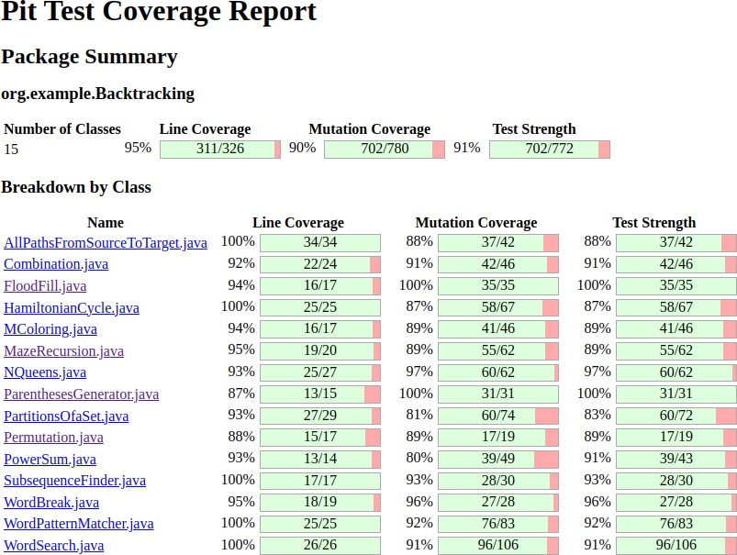

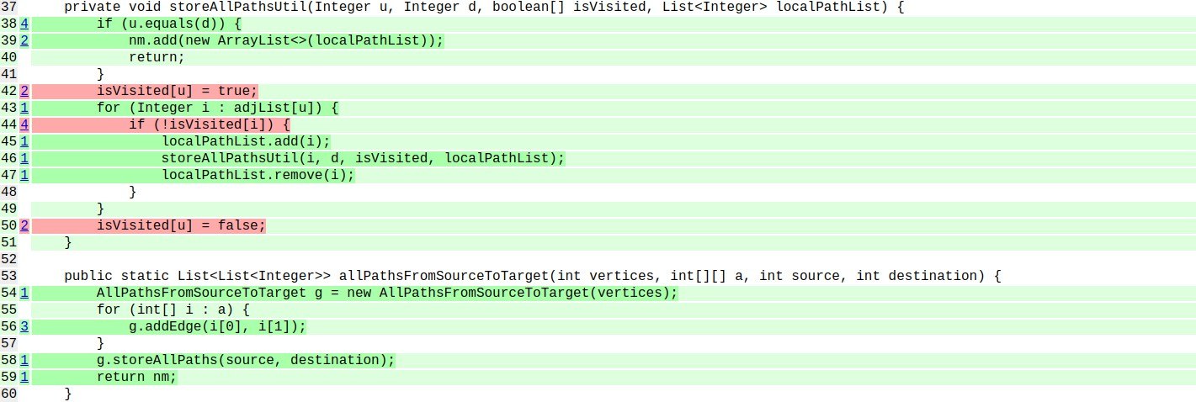
Code Structure in HTML Report in PIT (Java)

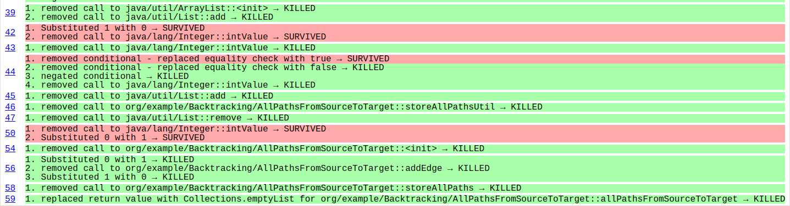
Mutation Operators in our Code in PIT (Java)

REFERENCES
- Mutation Testing Theory: https://www.geeksforgeeks.org/software-testing-mutation-testing/ https://www.guru99.com/mutation-testing.html
- Mutation Testing Tutorial: https://youtu.be/wZeZMtqVmck https://www.youtube.com/watch?v=fiVma2syvoo&t=720s
- JUnit Assert: https://junit.org/junit5/docs/5.0.1/api/org/junit/jupiter/api/Assertions.html
- PITest: https://medium.com/geekculture/mutation-testing-for-maven-project-using-pitest- f9b8fef03a05

