**LED-TURN OFF-ON**

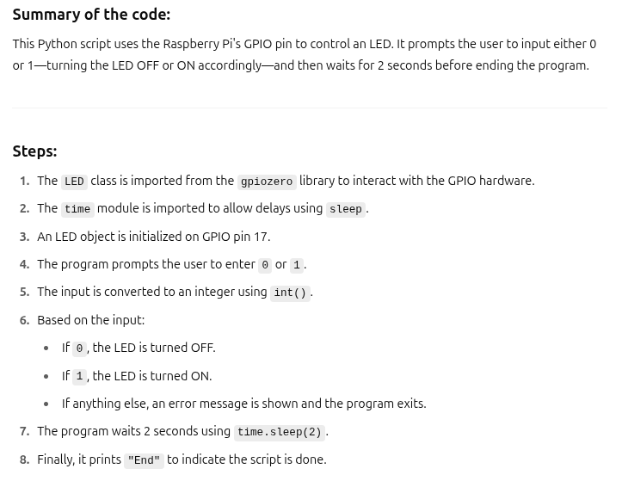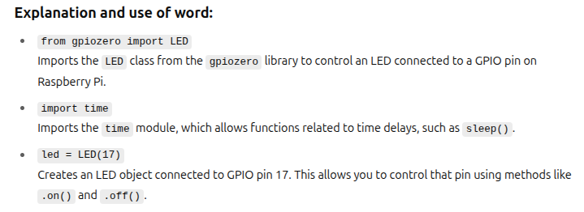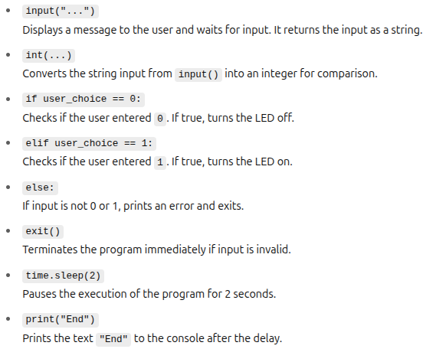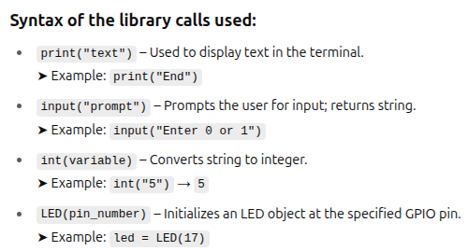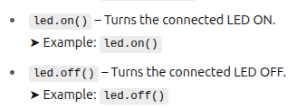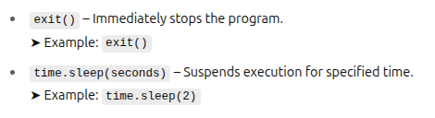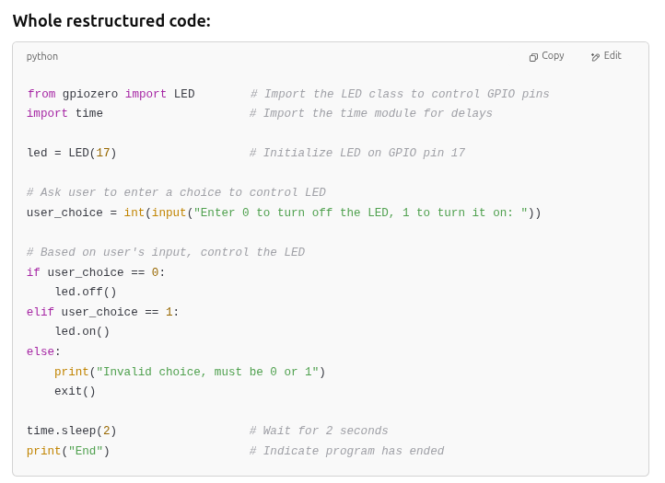

**SIGNAL-BUTTON**

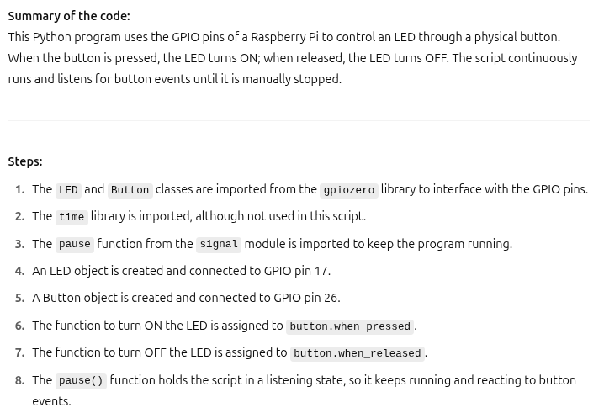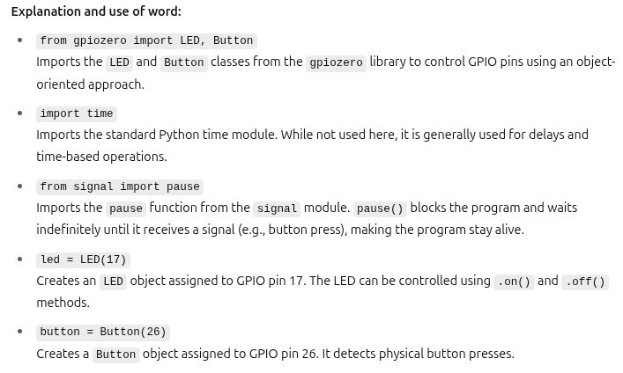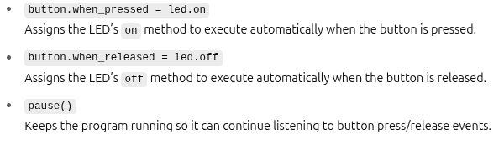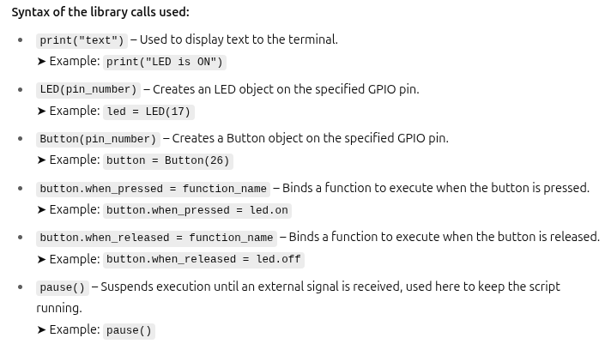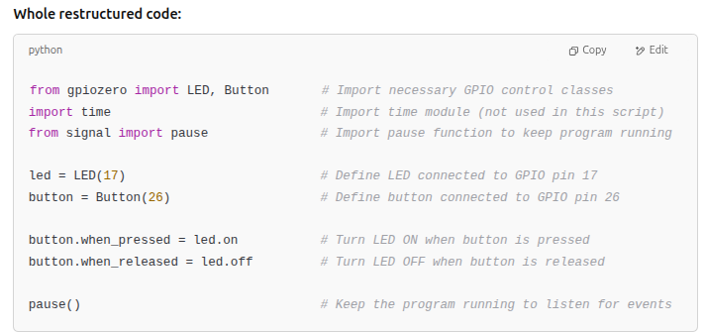

**MULTIPLE LED’S**

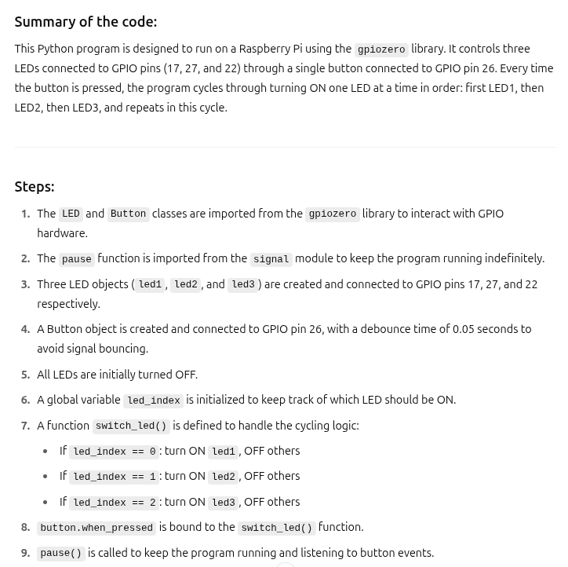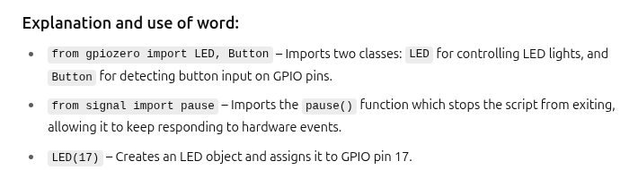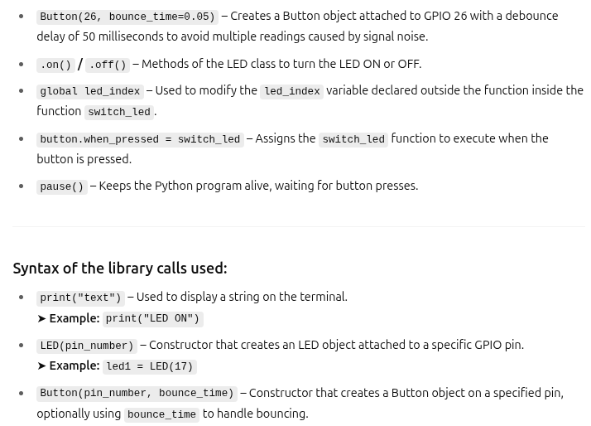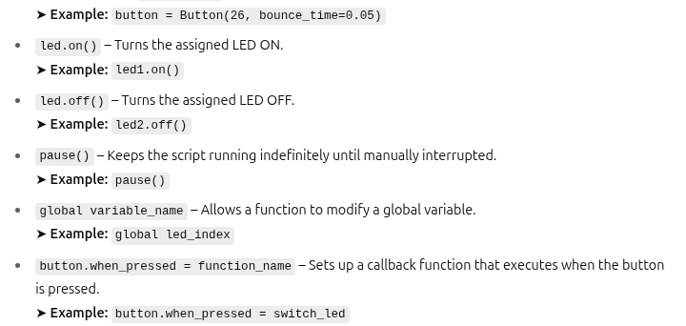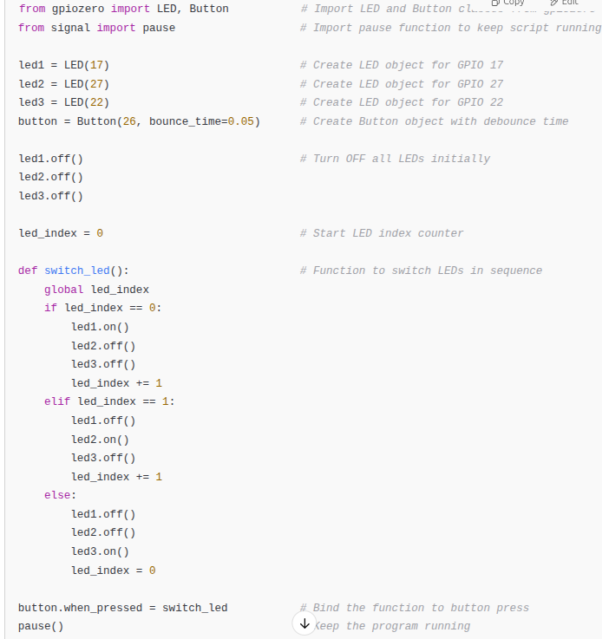

**PROGRAM -4**

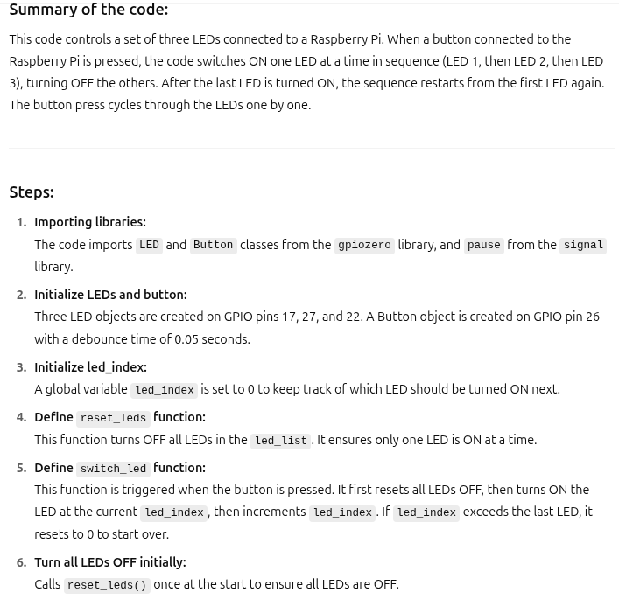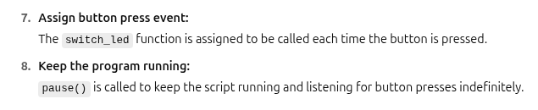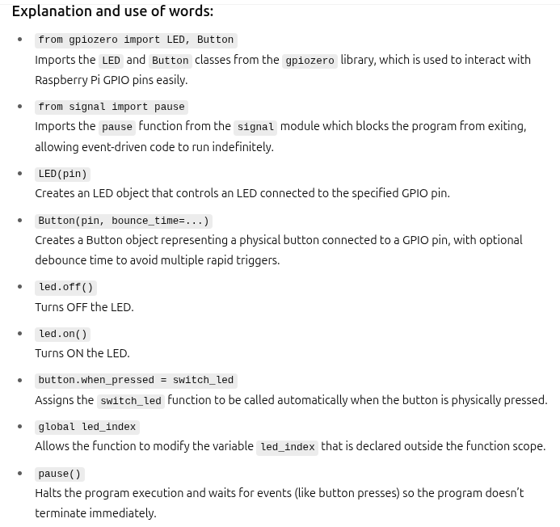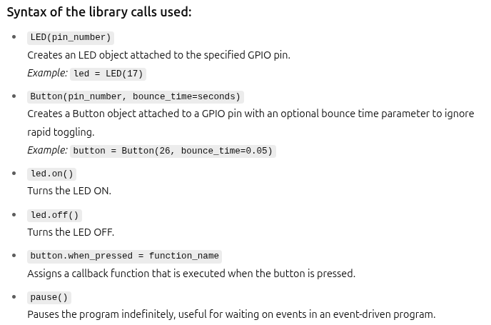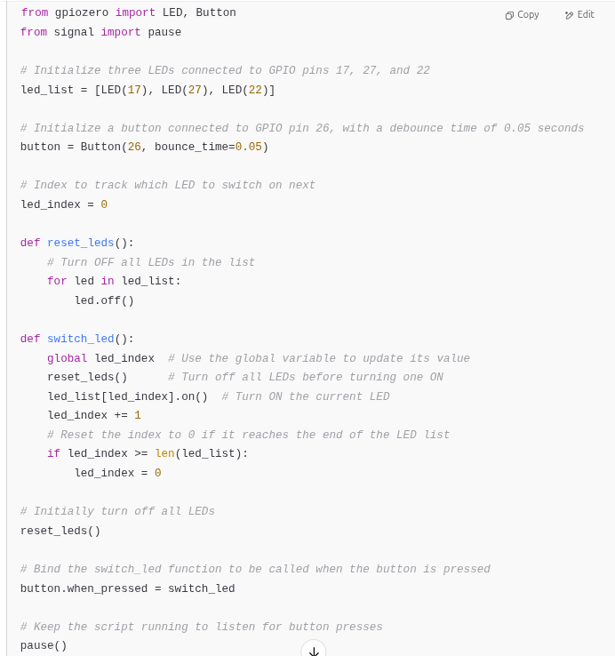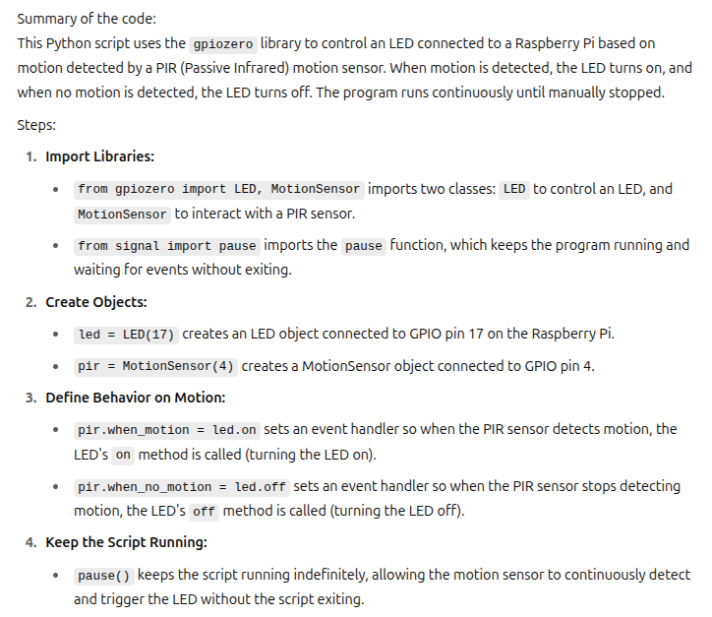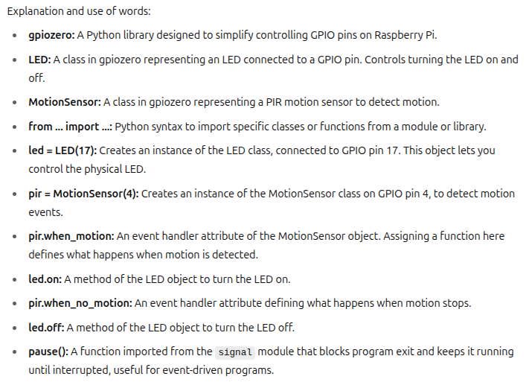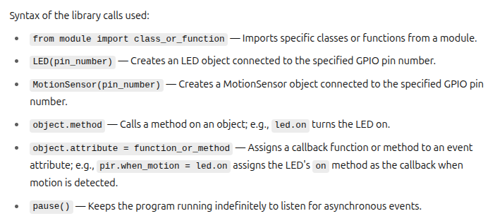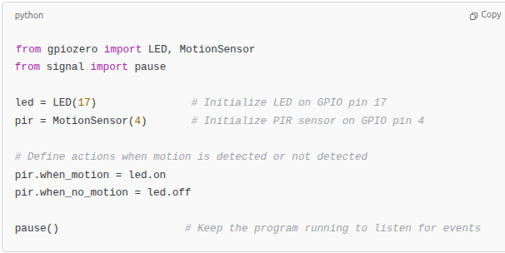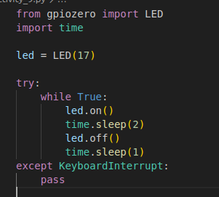

**PYTHON - CAMERA**

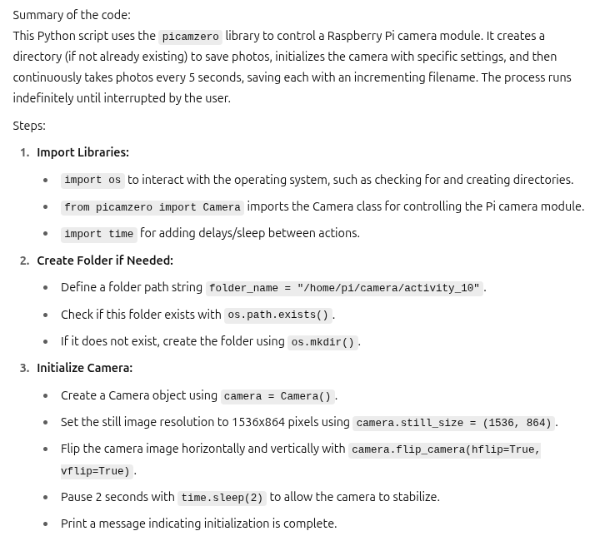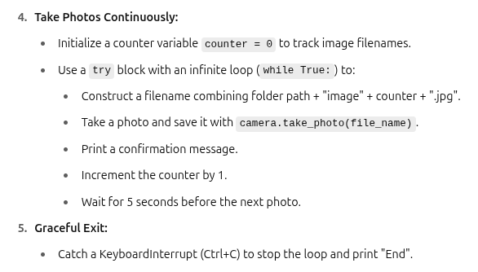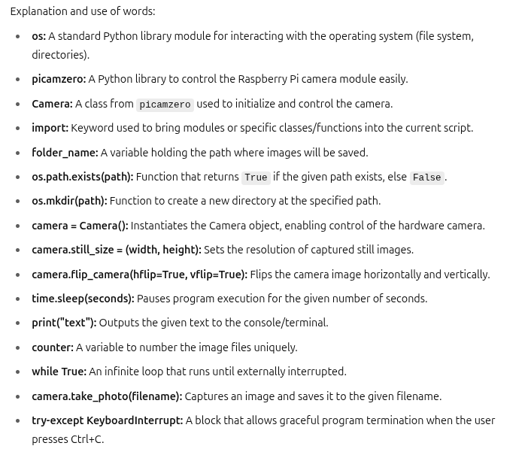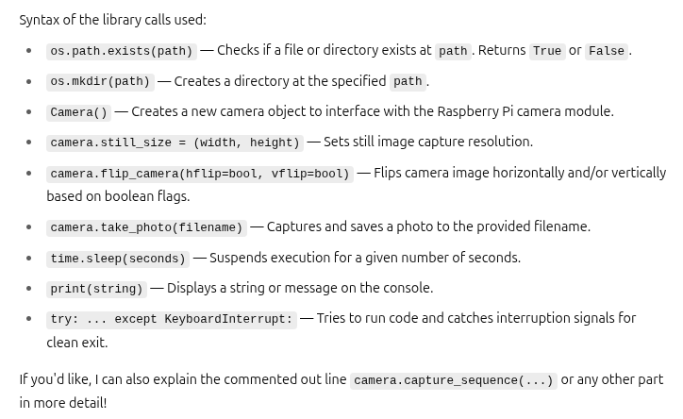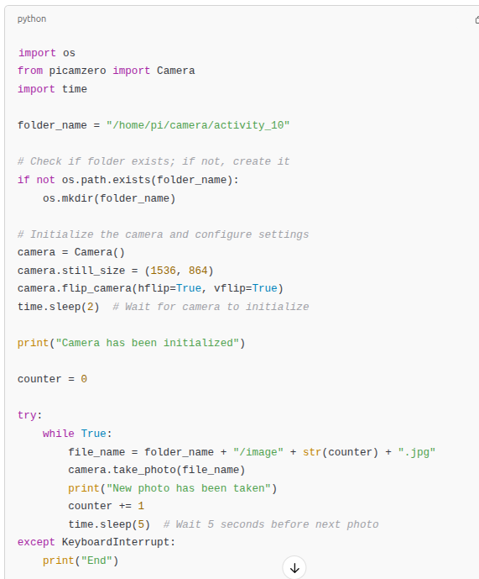

**FLASK**

**Summary of the code**:

This Python script uses the Flask web framework to create a web server that interacts with GPIO components (a button and three LEDs) on a Raspberry Pi. The user can access the server through a browser to check the button state or control the LEDs by sending specific HTTP requests.

**Steps**:

1) Import required libraries: `Flask` for web application creation, `Button` and `LED` from `gpiozero` for GPIO hardware control.

2) Initialize a `Button` object on GPIO pin 26 with a debounce time of 0.05 seconds to prevent false triggers.

3) Initialize three `LED` objects connected to GPIO pins 17, 27, and 22 and store them in a list.

4) Turn off all LEDs initially using a `for` loop.

5) Create a Flask web application instance.

6) Define a route at `/` which returns a welcome message when accessed.

7) Define a route `/push-button` that checks if the physical button is pressed and returns the result.

8) Define a route `/led/<int:led_number>/state/<int:state>` to turn ON or OFF a specific LED based on the values passed in the URL.

9) Start the Flask application, making it accessible from any IP on the network.

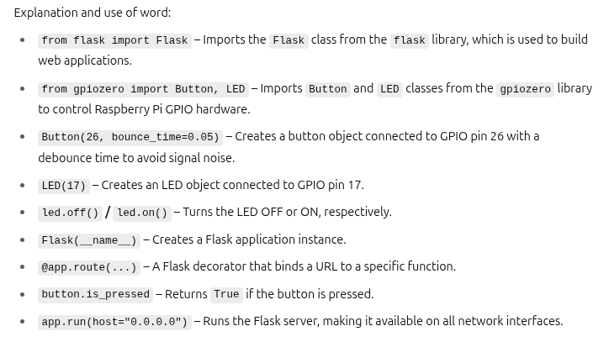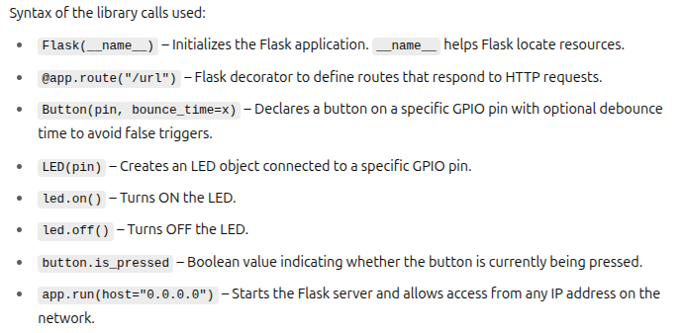

**RASPBERRY PI –Project Setup**

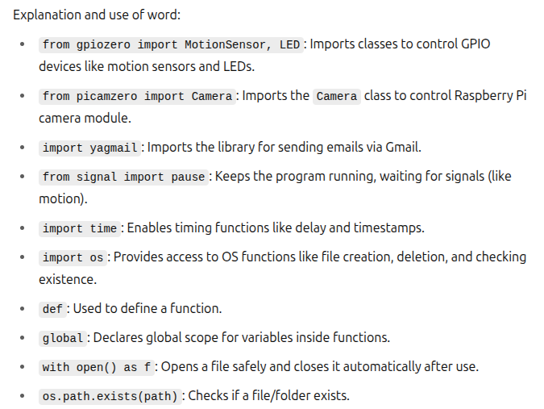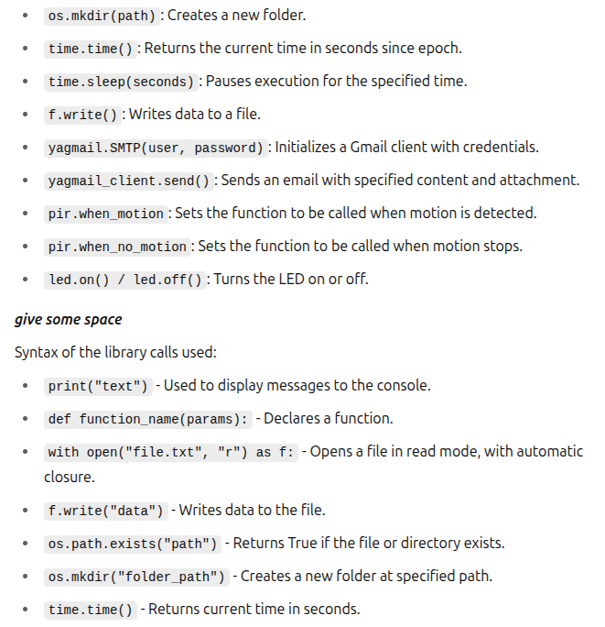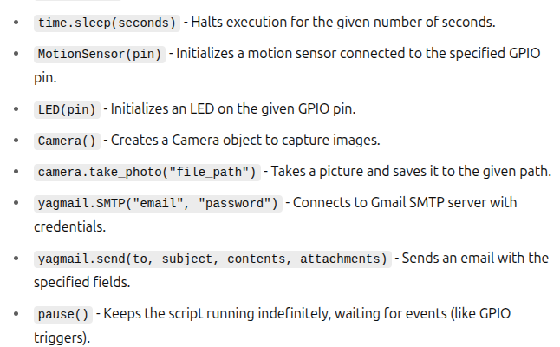

**Summary of the code:**

This Python script runs on a Raspberry Pi and automates the process of detecting motion using a PIR (Passive Infrared) sensor. When motion is detected and it lasts longer than a threshold time, the Raspberry Pi camera takes a picture. This picture is saved in a folder, logged into a file, and then sent via email to a predefined recipient. The system uses LEDs for visual feedback and ensures that photos are not taken too frequently.

**Steps**:

1) Import required libraries to handle GPIO (motion sensor, LED), camera control, email sending, time control, and file operations.

2) Define utility functions:

- `take_photo()` to capture an image using the camera.

- `update_photo_log_file()` to log photo file paths.

- `send_photo_by_email()` to email the captured image.

3) Initialize global variables for motion tracking, timing, paths, and thresholds.

4) Setup email credentials securely from a hidden password file.

5) Setup and configure the camera resolution and orientation.

6) Ensure the destination folder and log file are ready (create/delete as needed).

7) Initialize GPIO components: PIR motion sensor and LED.

8) Define callbacks:

- `motion_detected()` to record the start time and turn the LED on.

- `motion_finished()` to check motion duration, take a photo if valid, and send it via email.

9) Bind the callbacks to the PIR sensor events.

10) Run the program continuously with `pause()` to keep it active.

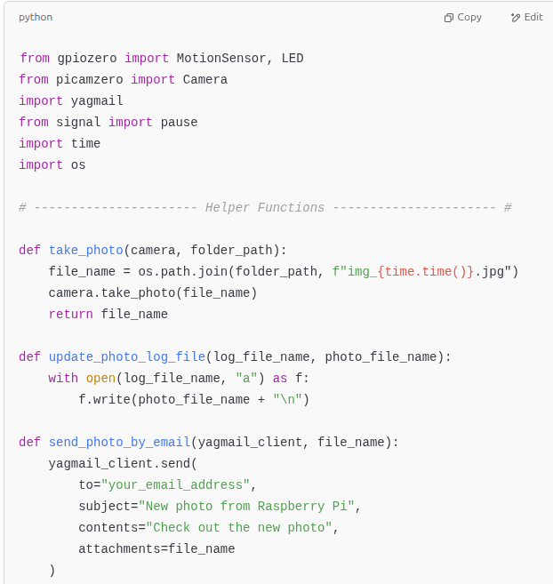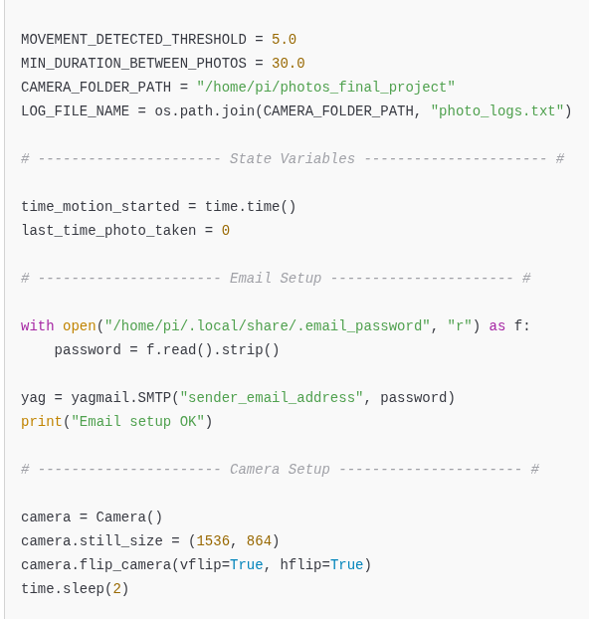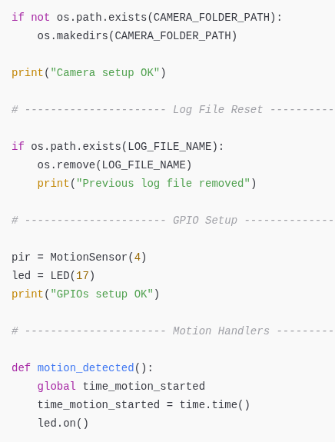

def motion_finished():

global last_time_photo_taken

led.off()

motion_duration = time.time() - time_motion_started

if motion_duration > MOVEMENT_DETECTED_THRESHOLD:

if time.time() - last_time_photo_taken > MIN_DURATION_BETWEEN_PHOTOS:

last_time_photo_taken = time.time()

print("Taking a photo and sending it by email")

photo_file_name = take_photo(camera, CAMERA_FOLDER_PATH)

update_photo_log_file(LOG_FILE_NAME, photo_file_name)

send_photo_by_email(yag, photo_file_name)

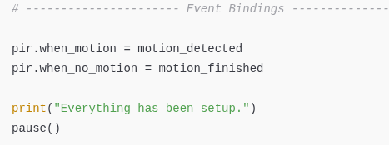

**FINAL CODE**

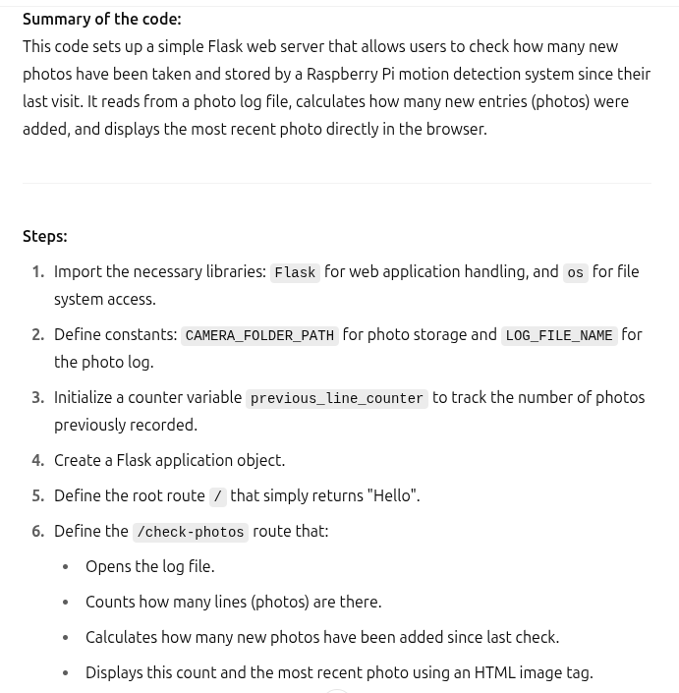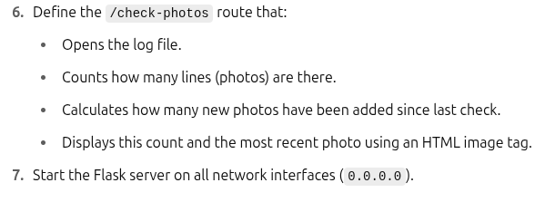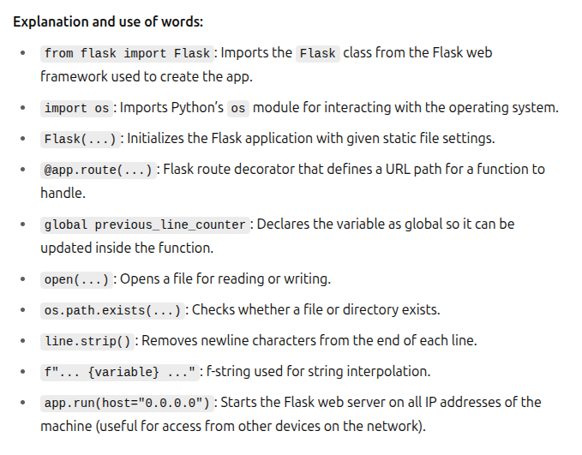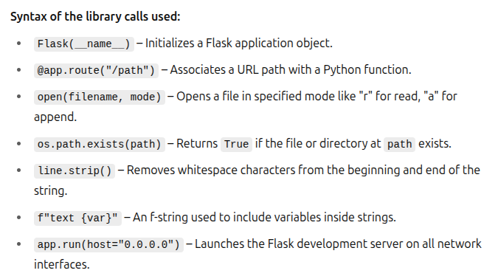

from flask import Flask

import os

# ---------------- Constants ----------------

CAMERA_FOLDER_PATH = "/home/pi/photos_final_project"

LOG_FILE_NAME = os.path.join(CAMERA_FOLDER_PATH, "photo_logs.txt")

previous_line_counter = 0

# ---------------- Flask App Initialization ----------------

app = Flask(__name__, static_url_path=CAMERA_FOLDER_PATH, static_folder=CAMERA_FOLDER_PATH)

# ---------------- Routes ----------------

@app.route("/")

def index():

return "Hello"

@app.route("/check-photos")

def check_photos():

global previous_line_counter

line_counter = 0

if os.path.exists(LOG_FILE_NAME):

last_photo_file_name = ""

with open(LOG_FILE_NAME, "r") as f:

for line in f:

line_counter += 1

last_photo_file_name = line.strip()

difference = line_counter - previous_line_counter

previous_line_counter = line_counter

message = f"{difference} new photos since you last checked <br/>"

message += f"Last photo: {last_photo_file_name} <br/>"

message += f"<img src=\"{last_photo_file_name}\">"

return message

else:

return "No photo available"

# ---------------- Run Server ----------------

app.run(host="0.0.0.0")