**Problem 1**: Produced when something eror occurred while writing to SD, so you need to start to make the partition of the sd card again, so follow the steps.

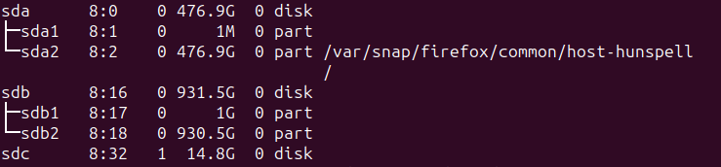

The last entry shows that, the sd card inserted and, but it is not partitioned.

So you need to follow some commands to make it partitioned.

In the coming process, since you do not know anything in much detail, keep pressign enter to it, then it keeps changing everytime.

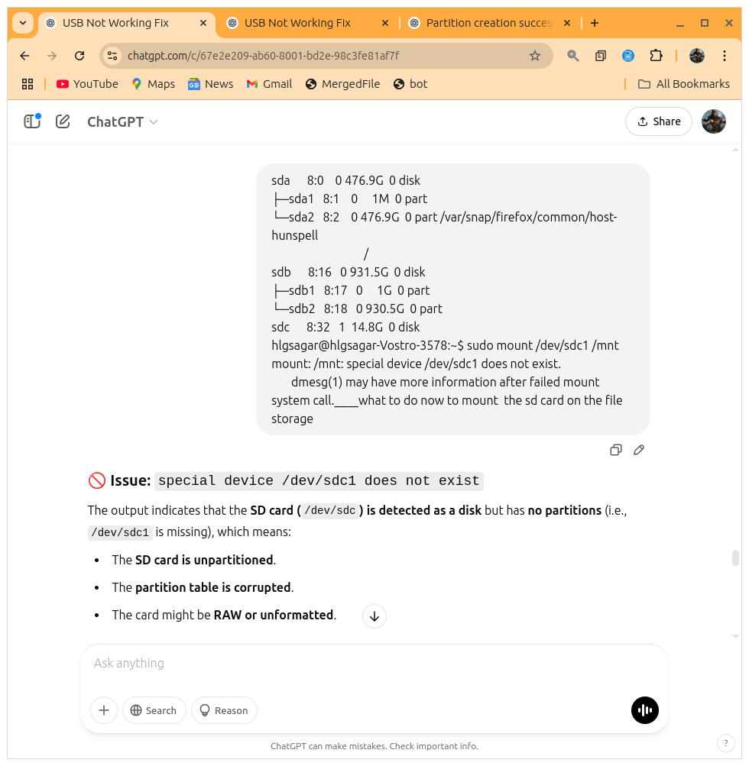

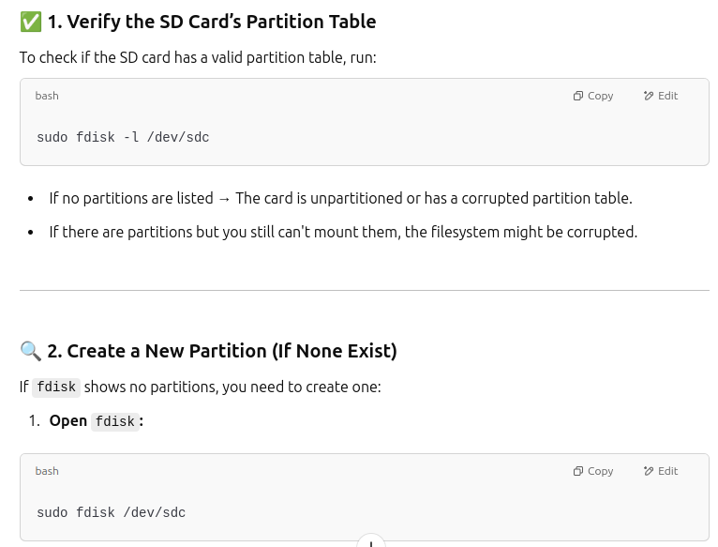

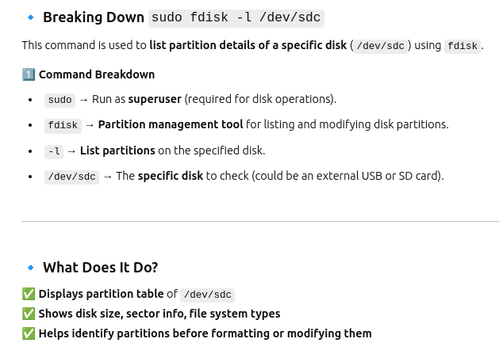

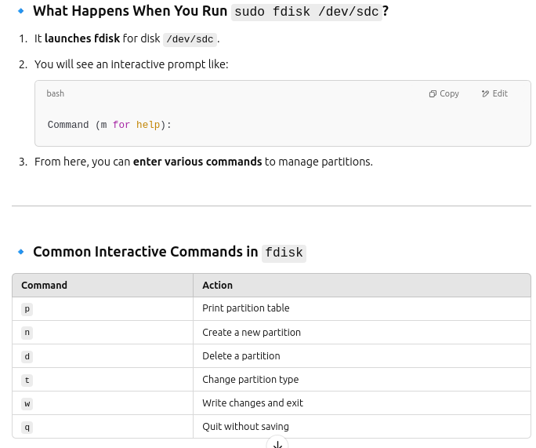

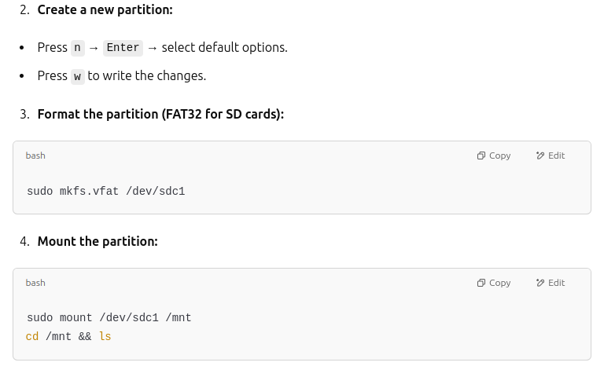

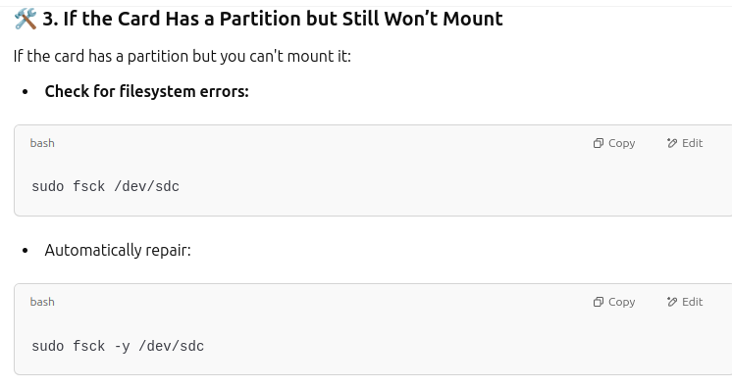

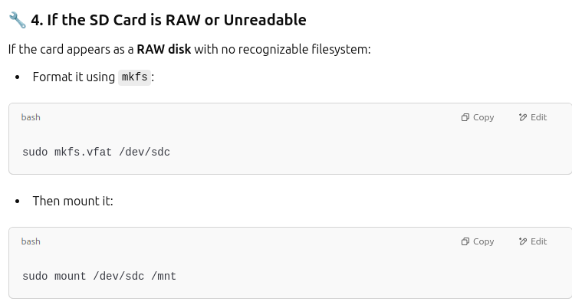

After mounting you will see this after plugging and puttin it again.

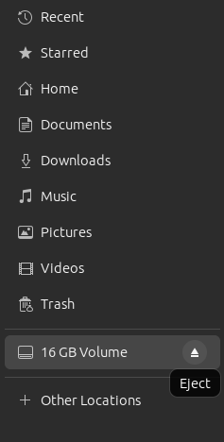

the command of lsblk, showed this

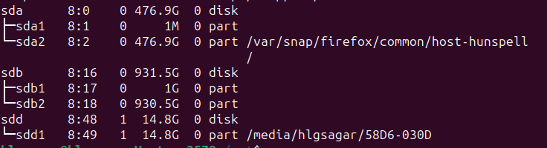

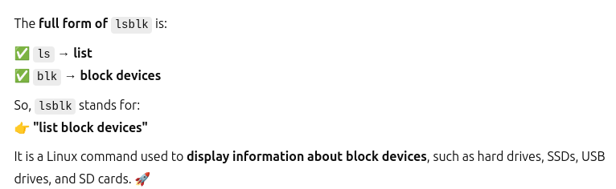

**Problem 2**: Writing issue to the SD card.

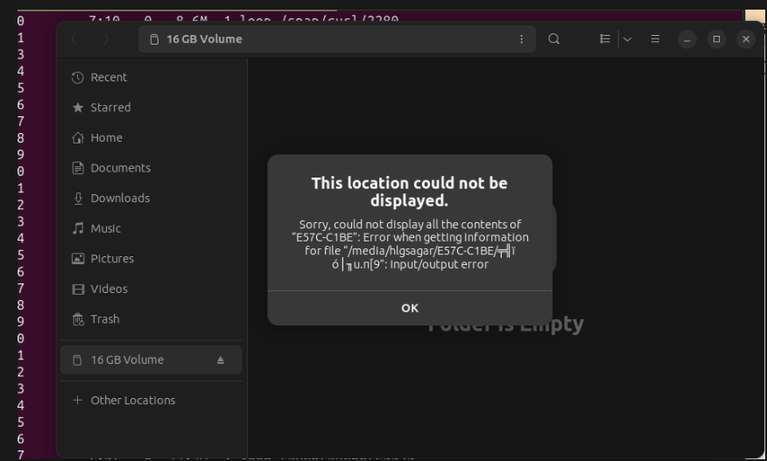

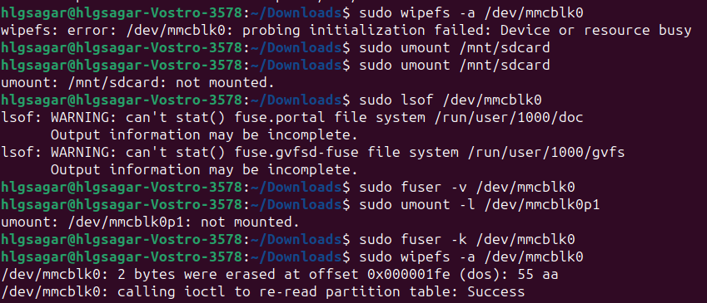

output of lsblk

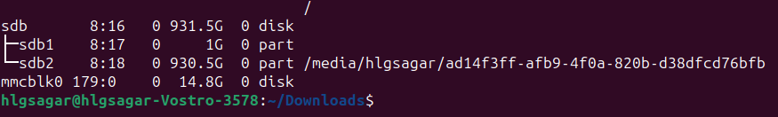

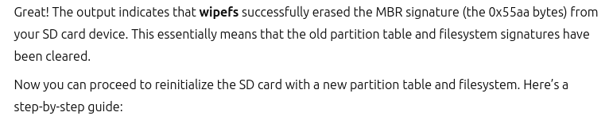

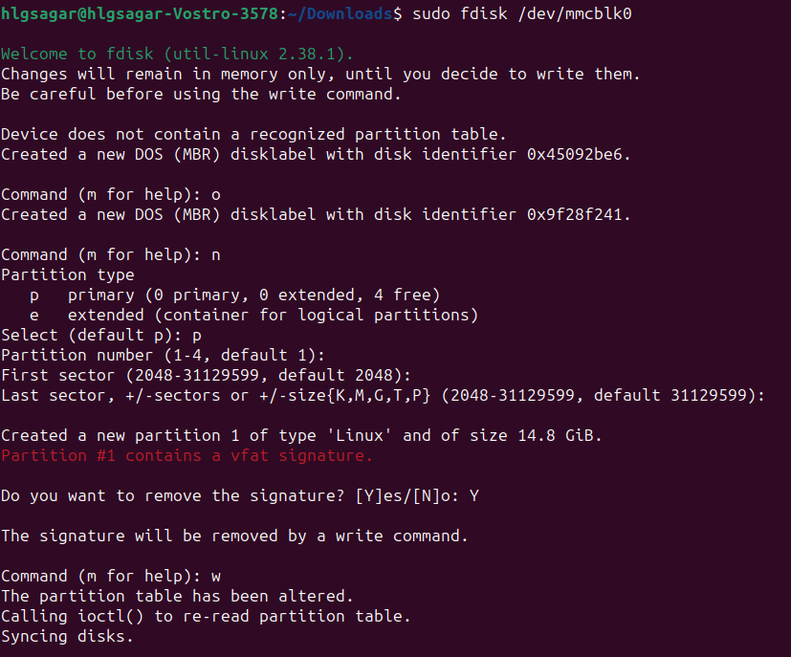



successful

lsblk, after that.



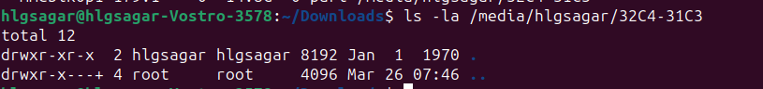

The output indicates that your SD card is successfully mounted and is currently empty. This is expected for a freshly formatted drive. Here are the next steps you can take to verify that everything works and start using it:

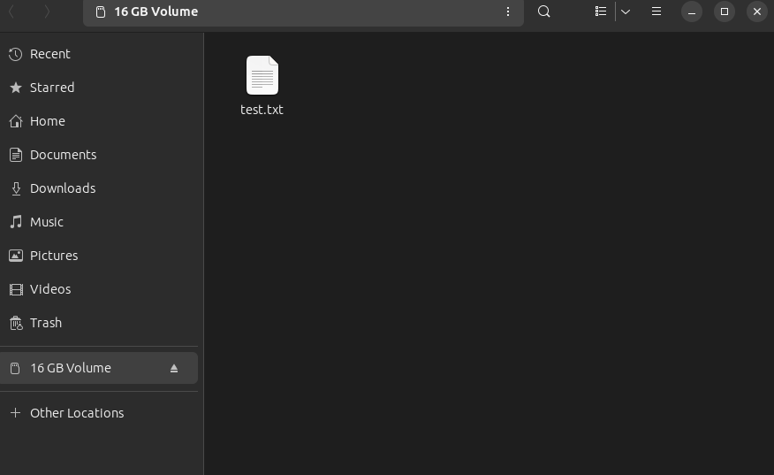

Now it working properly, start using the rpi manager, boot the os to it.

Problem 3

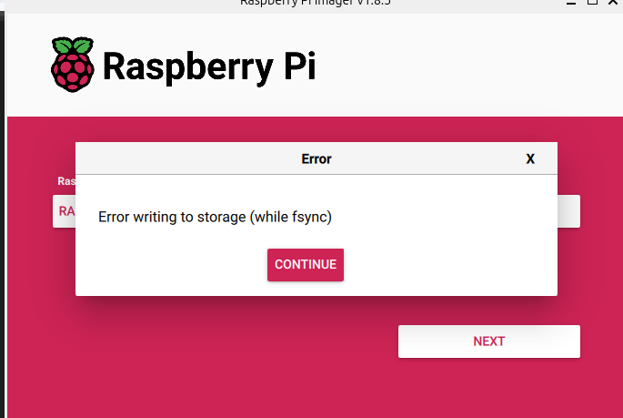

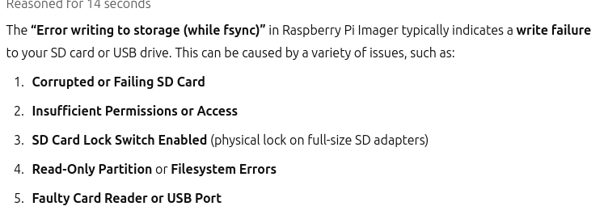

1. Checking for the SD card failure:

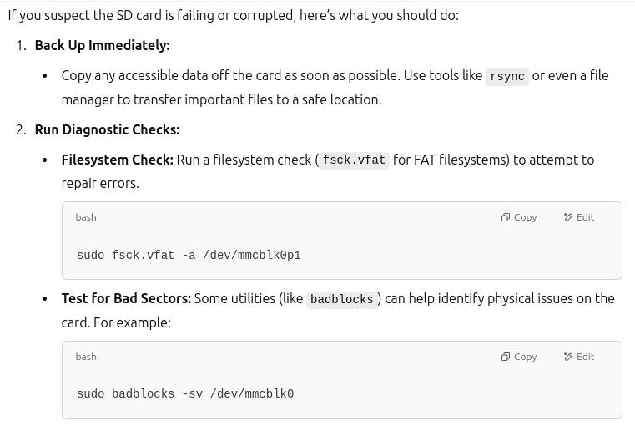

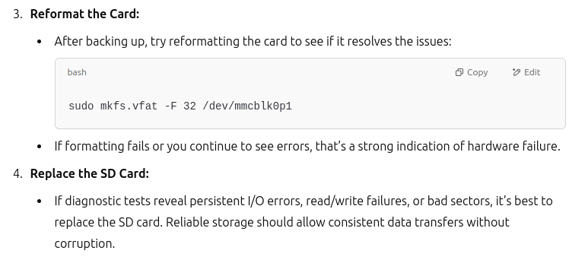

FORMATING THE SD CARD FORECFULLY

