**Fibbinocci Number**

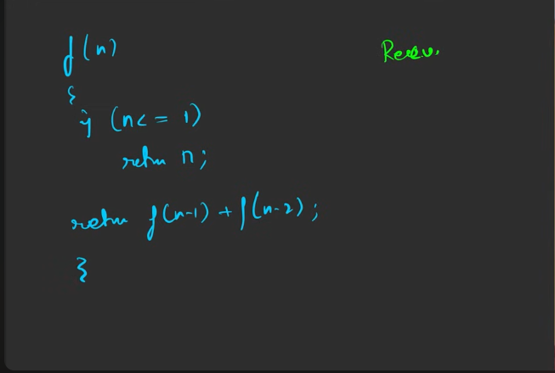

Overlapping sub problems:   
The computation of certain kind of the functions is already done, doing it again will lead to time waste. So we can store the result of thse kind of results and later we are giung to use it.

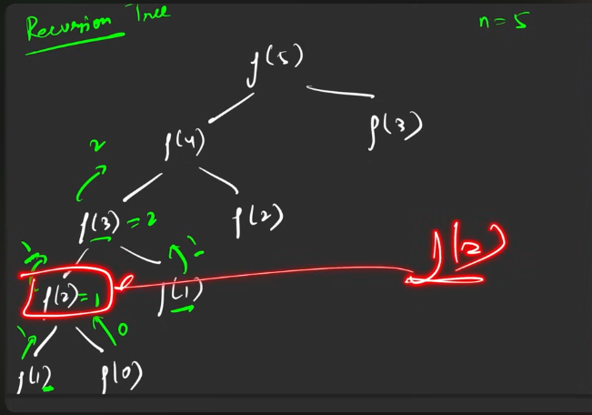

This is where the memoization kicks in. e are going to store the result of this.

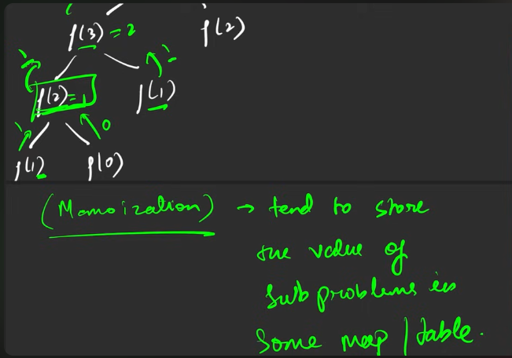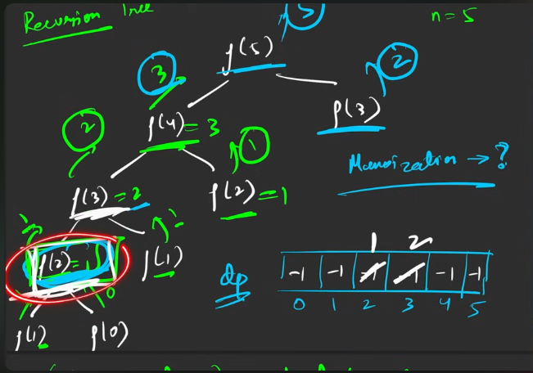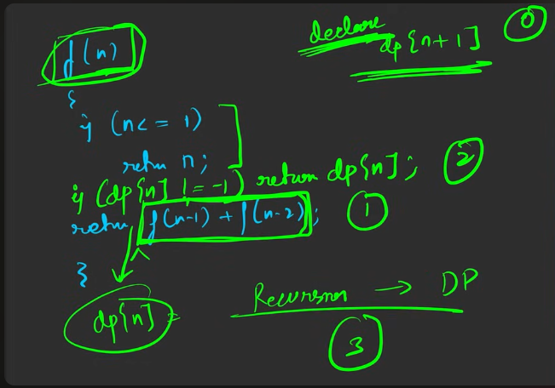

**Steps to convert from reccursion to DP**:

1. Declare the array based on the number of elements to store the intermediate results.
2. The result generated from the reccurssion to be stored in the particulare place, based o the above declaration.
3. Before calling for the reccursion after the base case, check whether the contnt is available in the array declared or not, if availble then return the answer there itself , else return the reccurssion call.

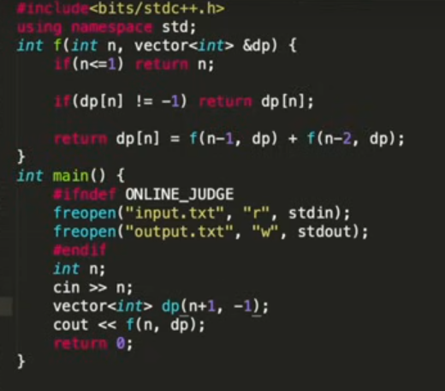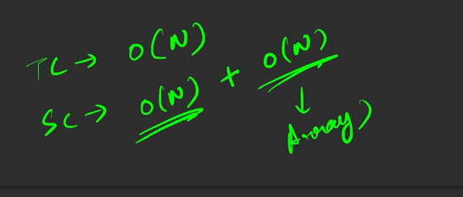

How to convert from reccursion into tabulation method?

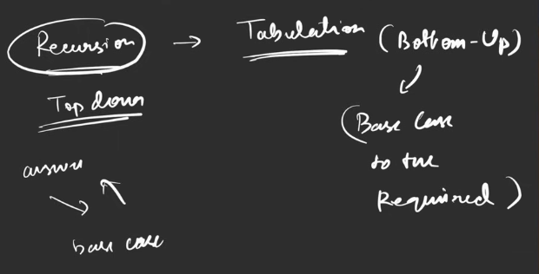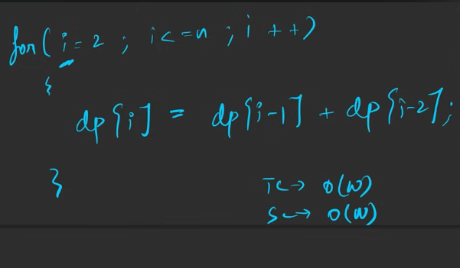

To convert from the reccurssion to tabulation:

1. The base cases has to be precomputed ,like the above assignment.
2. The one which comes after the precomputation should be kept in the loop, based on the loop, the answer will be computed:
   1. Convert the reccursiin to storage .
   2. The range that should be followed depends based on the followed base case.

The above way is better we are remove the reccurssion.

