Assign Cookies
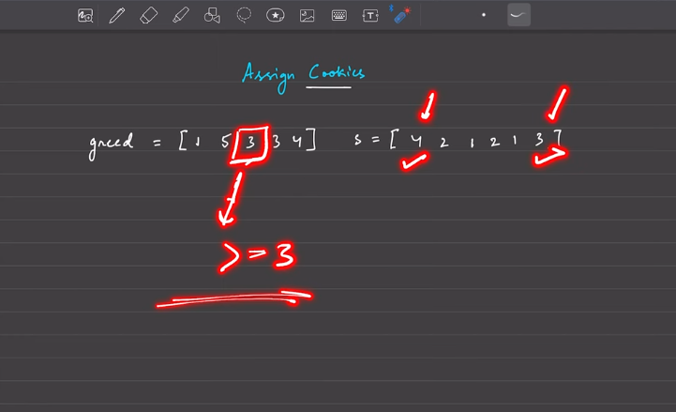
Greed says, child greed can be satisfied only when the assigning of the cookies is more than the greed.
- Brute forece: O(N^2) search again and again.
- Optimal:
- Sort the 2 array and keep counting when the greed is satisfied, by keeping the 2 pointers
Return maximum number of cookie to be allotted.

GREEDY: Either the smallest or the largest will be taken at each step, this i what the greedyness is.

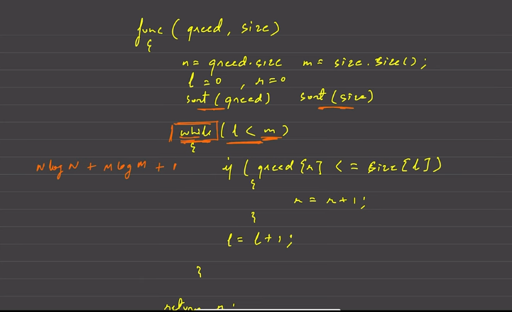

Lemonade Change

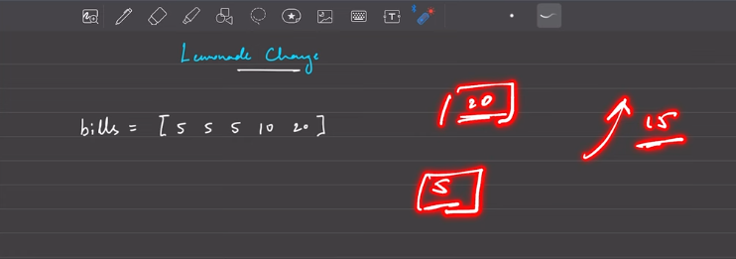
The lemonade is costed only 5 denominations, but the person can come with different denominations. One must be able to return the remaining money,check if it is possible or not
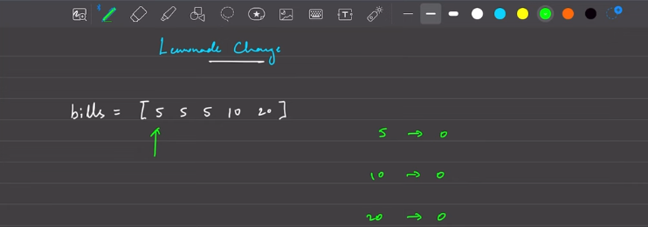
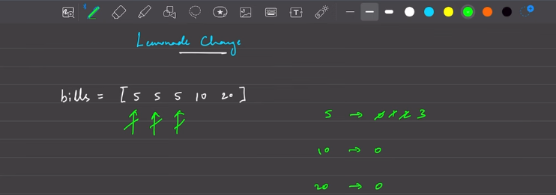
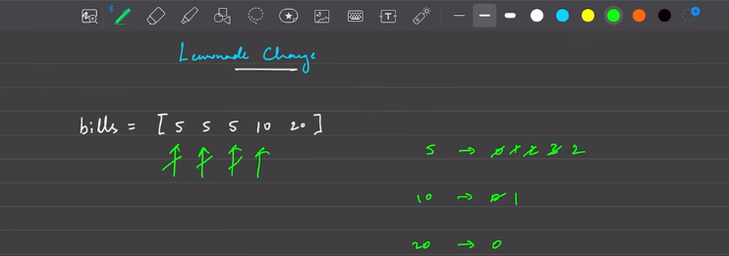
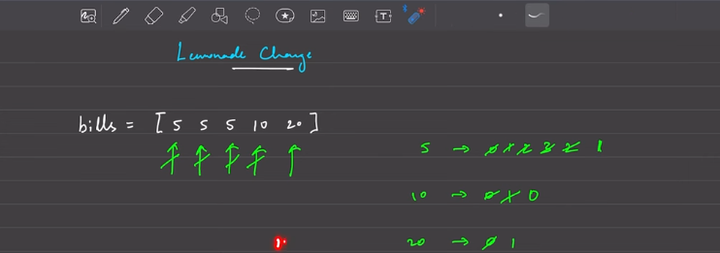
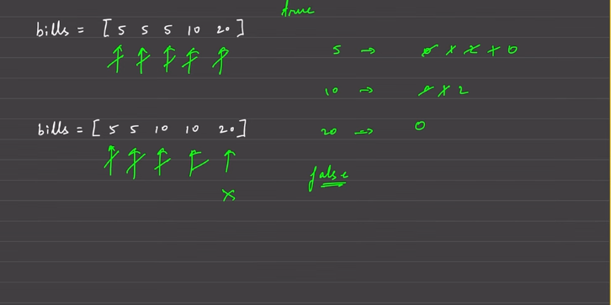
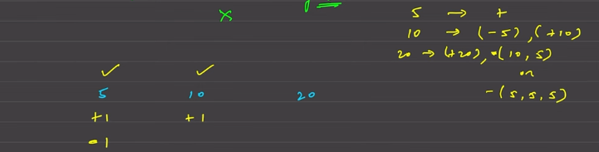
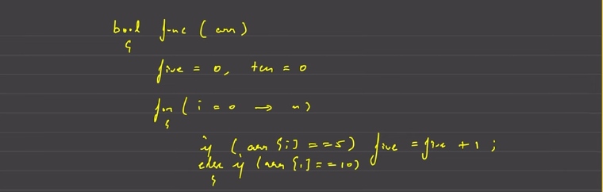
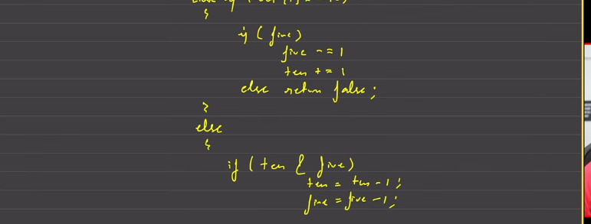



Shortest Job First (or SJF) CPU Scheduling

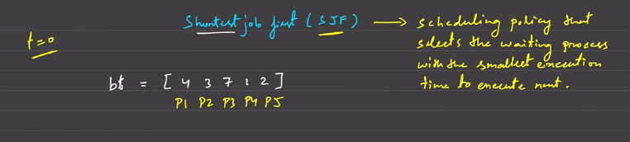
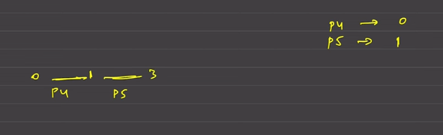
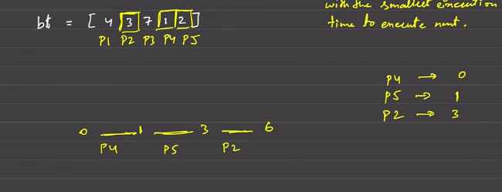
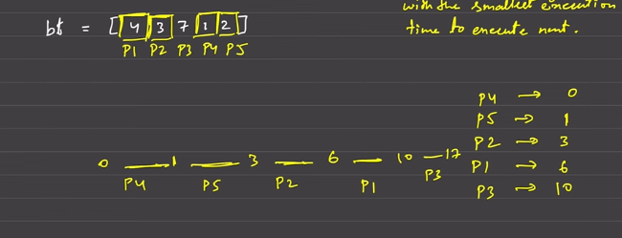
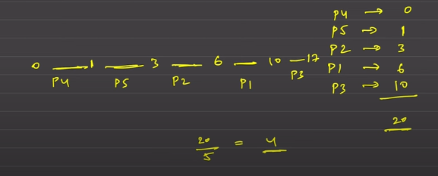
The nearest smallest integer to be returned, which must be average.

smallest execution at first
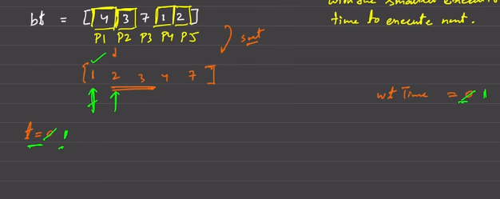
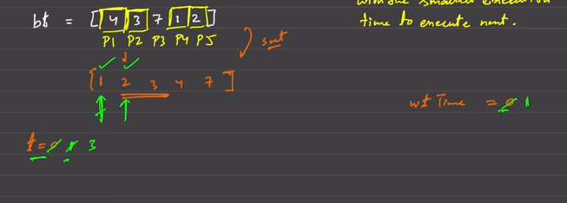
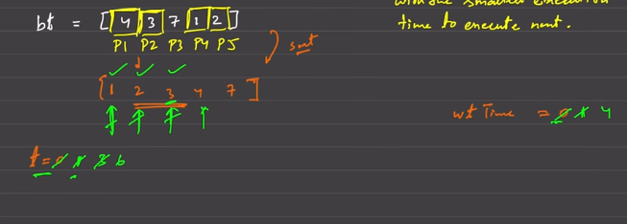
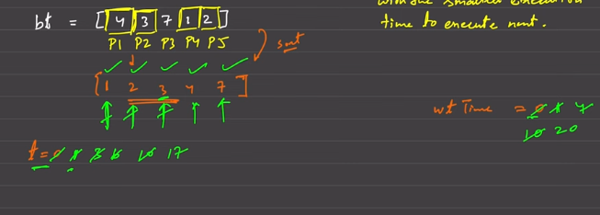
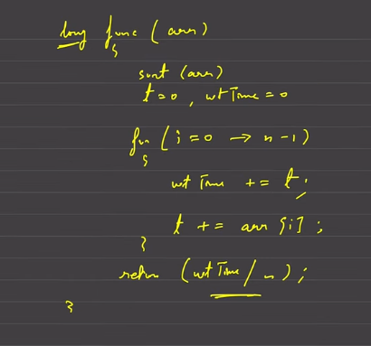 s

JUMP GAME

