Coin Change | Medium | Solution
5 | Fraction to Recurring Decimal | Medium | Solution
3 | Degree of an Array | Easy | Solution
3 | Minimum Moves to Equal Array Elements | Easy | Solution
3 | Distinct Subsequences | Hard | Solution
2 | Keyboard Row

1028. Recover a Tree From Preorder Traversal
| 1130. Minimum Cost Tree From Leaf Values.md
Traveling is Fun
[✅] Mathworks | Reverse LinkedList

# Ascend | Online Assessment | Traveling is Fun

Julia is planning a vacation and has a list of cities she wants to visit. She doesn't have a map of the area, but she does have some data that will help here determine whether there is a road connection all the cities she wants to visit. The data comes in the form of two arrays. Each of the first array's elements is an origin city. Each of the second array's is a destination. There is also an integer value threshold. She can tell that any two cities are connected if the values at origin and destination share a common divisor greater than the threshold. Citites are indexed starting at *0*.

Each of the pairs, *originCities[0]* and *destinationCities[0]* for example, represents a route she wants to take. For each pair, determine whether there is a route between cities. The route does not have to be direct. See the explanation to Sample Case 1 relating to originCity equals *2* or *4* for examples.

For instance, consider an array *originCities = [1,2,3]* and *destinationCities = [4,5,6]*. The threshold value is *2*. There are 6 total cities. To draw the map, first determine the divisors of all cities:

| Origin Cities | Divisors | Destination Cities | Divisors |
| ------------- | -------- | ------------------ | -------- |
| 1 | 1 | 4 | 1,2,4 |
| 2 | 1,2 | 5 | 1,5 |
| 3 | 1,3 | 6 | 1,2,3,6 |

The threshold is *2*, so we can eliminate cities *1* and *2*. Their deivisors are not greater than the threshold. This leaves city *3* to check in the origins list. It has a divisor in common with city *6*, and is greater than the threshold so there is a road between them. This is the only pair connected cities. Now that we have created a map, we can check her routes.

She wants to go from *originCity[0] = 1* to *desitinationCity[0] = 4* but there is no road. There is no road for her second route either, form city *2* to *5*. There is only a road that matches her third route at index 2, from city *3* to *6*. A true/fals array of her results would be *paths = [0,0,1]*.

### Function description

Complete the function *connected Cities* in the editor below. The function must return a true/fals array where each *paths[i]* contains *1* if the route between *originCities[i]* and *destinationCities[i]* exists, or *0* if it does not.

connectedCities has the following parameter(s):
*n*: integer, the number of cities
*g*: integer, the threshold value
*originCities[originCities[0], ... originCities[q-1]]*: an array of integers
*desitinationCities[desitnationCities[0], ... desitinationCities[q-1]]*: an array of integers

### Constraints

- 2 <= n <= 2 *10^5
- 0 <= g <= n
- 1 <= q <= min(n*(n-1)/2, 10^5)
- 1 <= originCities[i], destinationCities[i] <= n, where 0 <= i < q
- originCities[i] != destinationCities[i], where 0 <= i < q

### Input Format for Custom Testing

Input from stdin will be processed as follows and passed to the function.

The first line contains an integer *n*, the total number of cities.
The second line contains an integer *g*, the threshold value.
The next line contains an integer *q* the size of the array *originCities*.
The next *q* lines each contain an element *originCities[i]* where 0 <= i < q.
The next line contains an integer *q*, the size of the array *destinationCities*.
The next *q* lines each contain an element *destinationCities[i]* where 0 <= i < q.

### Sample Case 0

#### Sample Input 0

```
6
0
4
1
4
3
6
4
3
6
2
5
```

#### Sample Output 0

```
1
1
1
1
```

#### Explanation 0

There are *n = 6* cities and *g = 0*. We know that two cities *x* and *y* are connected if and only if the greatest common divisor, *gcd(x,y)>0*. A map is drawn below.

![image](https://assets.leetcode.com/users/mathiasarens/image_1544235393.png)

The city graph. Each city is directly connected to other cities, so a path always exists for each *(x,y)* pair.

Julia wants to know whether any path exists from:

- City *1* to city *3*
- City *4* to city *6*
- City *3* to city *2*
- City *6* to city *5*

Let the return array be *paths*, then:

- *paths[0] = 1* because a path exists from city *1* to city *3*.
- *paths[1] = 1* because a path exists from city *4* to city *6*.
- *paths[2] = 1* because a path exists from city *3* to city *2*.
- *paths[3] = 1* because a path exists from city *6* to city *5*.

Return *paths = [1,1,1,1]* as the answer.

### Sample Case 1

#### Sample Input 1

```
6
1
4
1
2
4
6
4
3
3
3
4
```

#### Sample Output 1

```
0
1
1
1
```

#### Explanation 1

There are *n = 6* cities and *g = 1*. We know that two cities *x* and *y* are connected if and only if the greatest common divisor, *gcd(x,y)>1*. A map is drawn below.

![image](https://assets.leetcode.com/users/mathiasarens/image_1544235400.png)

The city graph.

Julia wants to know whether any path exists from:

- City *1* to city *3*
- City *2* to city *3*
- City *4* to city *3*
- City *6* to city *4*

Let the return array be *paths*, then:

- *paths[0] = 0* because it's impossible to reach any city from city *1*.
- *paths[1] = 1* because a path exists from city *2* to city *3*.
- *paths[2] = 1* because a path exists from city *4* to city *3*.
- *paths[3] = 1* because a path exists from city *6* to city *4*.

Return *paths = [0,1,1,1]* as the answer.

## Code

```python
def connectedCities(n, g, originCities, destinationCities):
if g == 0:
return [1] * len(originCities)
if g >= n:
return [0] * len(originCities)
components = {i: i for i in range(g + 1, n + 1)}
for candidate in range(g + 1, n + 1):
current = [t * candidate for t in range(1, n // candidate + 1)]
current_components = [components[e] for e in current]
minone = min(current_components)
for curr in current:
components[curr] = minone
res = []
for k in range(len(originCities)):
origin, destination = originCities[k], destinationCities[k]
if origin > g and destination > g and components[origin] == components[destination]:
res.append(1)
else:
res.append(0)
return res

n = 6
g = 1
originCities = [1,2,4,6]
destinationCities = [3,3,3,4]
print(connectedCities(n, g, originCities, destinationCities))
```

1 | ID | URL | Title | Difficulty | Acceptance % | Frequency %
2 | 526 | https://leetcode.com/problems/beautiful-arrangement | Beautiful Arrangement | Medium | 64.6% | 50.0%
3 | 2861 | https://leetcode.com/problems/maximum-number-of-alloys | Maximum Number of Alloys | Medium | 39.0% | 100.0%
4 | 2514 | https://leetcode.com/problems/count-anagrams | Count Anagrams | Hard | 35.3% | 87.5%
5 | 566 | https://leetcode.com/problems/reshape-the-matrix | Reshape the Matrix | Easy | 64.0% | 87.5%
6 | 2038 | https://leetcode.com/problems/remove-colored-pieces-if-both-neighbors-are-the-same-color | Remove Colored Pieces if Both Neighbors are the Same Color | Medium | 62.9% | 87.5%
7 | 1048 | https://leetcode.com/problems/longest-string-chain | Longest String Chain | Medium | 62.1% | 62.5%
8 | 1163 | https://leetcode.com/problems/last-substring-in-lexicographical-order | Last Substring in Lexicographical Order | Hard | 34.6% | 87.5%
9 | 1130 | https://leetcode.com/problems/minimum-cost-tree-from-leaf-values | Minimum Cost Tree From Leaf Values | Medium | 67.7% | 87.5%
10 | 3049 | https://leetcode.com/problems/earliest-second-to-mark-indices-ii | Earliest Second to Mark Indices II | Hard | 20.0% | 87.5%
11 | 3048 | https://leetcode.com/problems/earliest-second-to-mark-indices-i | Earliest Second to Mark Indices I | Medium | 34.8% | 87.5%
12 | 3035 | https://leetcode.com/problems/maximum-palindromes-after-operations | Maximum Palindromes After Operations | Medium | 43.2% | 87.5%
13 | 834 | https://leetcode.com/problems/sum-of-distances-in-tree | Sum of Distances in Tree | Hard | 65.4% | 50.0%
14 | 410 | https://leetcode.com/problems/split-array-largest-sum | Split Array Largest Sum | Hard | 58.3% | 62.5%
15 | 2851 | https://leetcode.com/problems/string-transformation | String Transformation | Hard | 25.5% | 87.5%
16 | 2444 | https://leetcode.com/problems/count-subarrays-with-fixed-bounds | Count Subarrays With Fixed Bounds | Hard | 69.4% | 100.0%
17 | 500 | https://leetcode.com/problems/keyboard-row | Keyboard Row | Easy | 72.6% | 87.5%
18 | 2462 | https://leetcode.com/problems/total-cost-to-hire-k-workers | Total Cost to Hire K Workers | Medium | 43.2% | 87.5%
19 | 1328 | https://leetcode.com/problems/break-a-palindrome | Break a Palindrome | Medium | 51.6% | 50.0%
20 | 25 | https://leetcode.com/problems/reverse-nodes-in-k-group | Reverse Nodes in k-Group | Hard | 63.3% | 50.0%
21 | 2582 | https://leetcode.com/problems/pass-the-pillow | Pass the Pillow | Easy | 56.6% | 87.5%
22 | 2858 | https://leetcode.com/problems/minimum-edge-reversals-so-every-node-is-reachable | Minimum Edge Reversals So Every Node Is Reachable | Hard | 55.4% | 75.0%
23 | 2964 | https://leetcode.com/problems/number-of-divisible-triplet-sums | Number of Divisible Triplet Sums | Medium | 67.8% | 62.5%
24 | 2016 | https://leetcode.com/problems/maximum-difference-between-increasing-elements | Maximum Difference Between Increasing Elements | Easy | 66.2% | 50.0%
25 | 1290 | https://leetcode.com/problems/convert-binary-number-in-a-linked-list-to-integer | Convert Binary Number in a Linked List to Integer | Easy | 81.2% | 50.0%
26 | 424 | https://leetcode.com/problems/longest-repeating-character-replacement | Longest Repeating Character Replacement | Medium | 57.4% | 50.0%
27 | 115 | https://leetcode.com/problems/distinct-subsequences | Distinct Subsequences | Hard | 50.3% | 50.0%
28 | 968 | https://leetcode.com/problems/binary-tree-cameras | Binary Tree Cameras | Hard | 47.3% | 87.5%
29 | 1648 | https://leetcode.com/problems/sell-diminishing-valued-colored-balls | Sell Diminishing-Valued Colored Balls | Medium | 30.0% | 87.5%
30 | 638 | https://leetcode.com/problems/shopping-offers | Shopping Offers | Medium | 51.9% | 87.5%
31 | 621 | https://leetcode.com/problems/task-scheduler | Task Scheduler | Medium | 61.7% | 50.0%
32 | 108 | https://leetcode.com/problems/convert-sorted-array-to-binary-search-tree | Convert Sorted Array to Binary Search Tree | Easy | 74.2% | 50.0%

2582 | https://leetcode.com/problems/pass-the-pillow | Pass the Pillow | Easy | 56.6% | 62.5%
3 | 2444 | https://leetcode.com/problems/count-subarrays-with-fixed-bounds | Count Subarrays With Fixed Bounds | Hard | 69.4% | 62.5%
4 | 2858 | https://leetcode.com/problems/minimum-edge-reversals-so-every-node-is-reachable | Minimum Edge Reversals So Every Node Is Reachable | Hard | 55.4% | 62.5%
5 | 968 | https://leetcode.com/problems/binary-tree-cameras | Binary Tree Cameras | Hard | 47.3% | 100.0%
6 | 1648 | https://leetcode.com/problems/sell-diminishing-valued-colored-balls | Sell Diminishing-Valued Colored Balls | Medium | 30.0% | 100.0%
7 | 638 | https://leetcode.com/problems/shopping-offers | Shopping Offers

968 | https://leetcode.com/problems/binary-tree-cameras | Binary Tree Cameras | Hard | 47.3% | 100.0%
3 | 1648 | https://leetcode.com/problems/sell-diminishing-valued-colored-balls | Sell Diminishing-Valued Colored Balls | Medium | 30.0% | 100.0%
4 | 638 | https://leetcode.com/problems/shopping-offers

- Kth reverse
Node* kReverse(Node* head, int k){

Node* temp = head;
Node* prevLast = NULL;

while(temp != NULL){

Node* kThNode = getKthNode(temp, k);
if(kThNode == NULL){
if(prevLast){
prevLast -> next = temp;
}
break;
}
Node* nextNode = kThNode -> next;
kThNode -> next = NULL;
reverseLinkedList(temp);

if(temp == head){
head = kThNode;
}else{
prevLast -> next = kThNode;
}
prevLast = temp;
temp = nextNode;
}

return head;
}

- Given sorted array, make BST out of it

class Solution {
public:
TreeNode* sortedArrayToBST(vector<int>& nums) {
return convert(nums,0, nums.size()-1);
}

TreeNode* convert(vector<int> &nums, int l, int r){
if(l>r) return NULL;
int m= (l+(r-l)/2);
TreeNode* n = new TreeNode(nums[m]);
n->left = convert(nums, l, m-1);
n->right = convert(nums,m+1, r);

return n;

}

};

COOL GRAPH

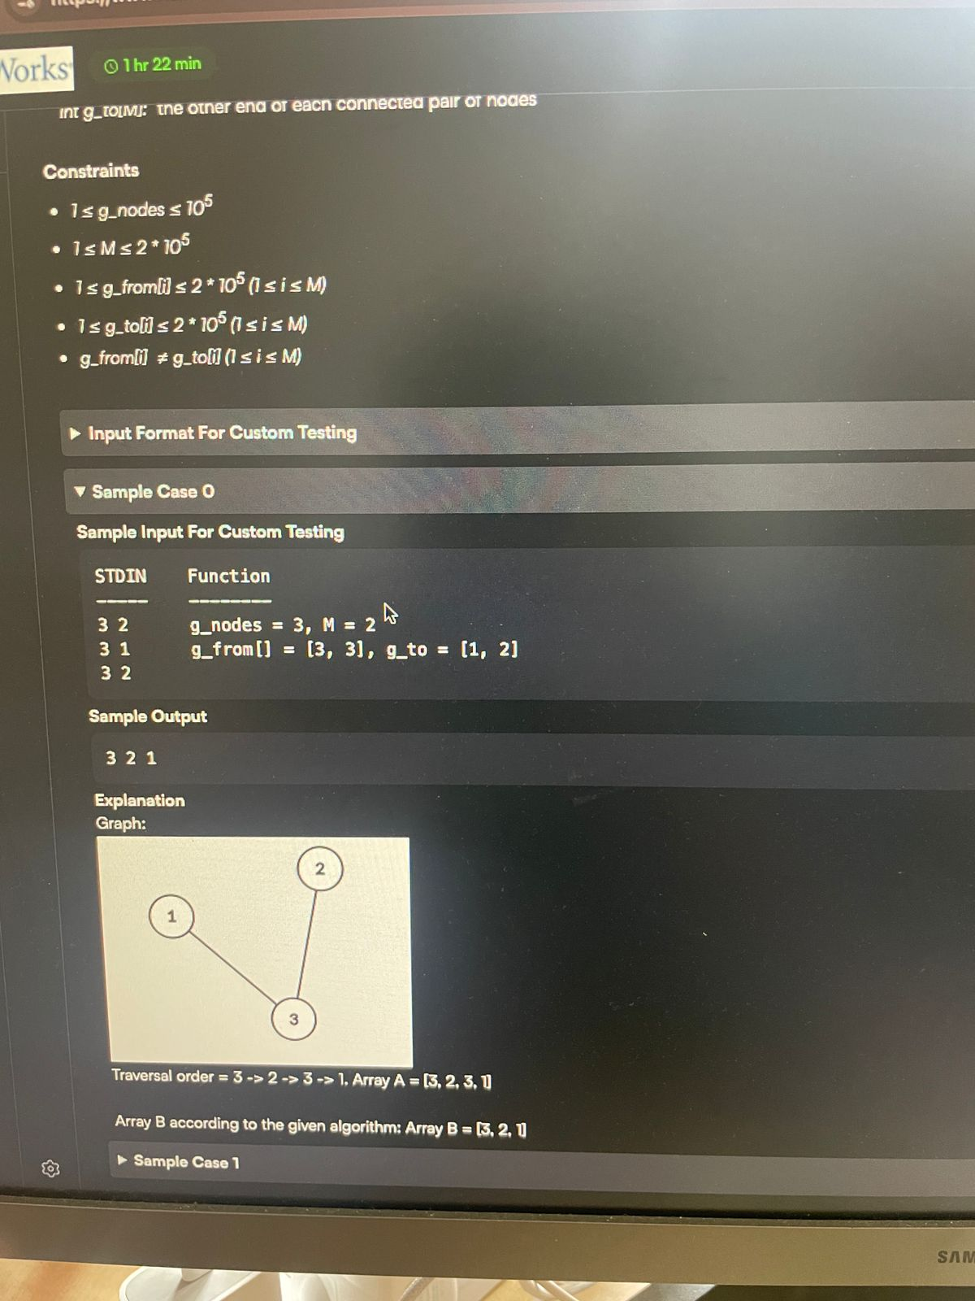

Goal:
- Traverse all nodes to produce a traversal order A.
- From A, construct a new list B:
- B starts empty.
- For each element in A:
- If it’s not already in B, add it.
- Return B.
- The challenge is to pick a traversal order A such that resulting B is lexicographically largest.

Type 1

#include <bits/stdc++.h>
using namespace std;

// Separate DFS function
void dfs(int node, vector<vector<int>>& adj, vector<bool>& visited, vector<int>& A) {
visited[node] = true;
A.push_back(node);
for (int neighbor : adj[node]) {
if (!visited[neighbor]) {
dfs(neighbor, adj, visited, A);
}
}
}

vector<int> coolGraph(int g_nodes, vector<int> g_from, vector<int> g_to) {
vector<vector<int>> adj(g_nodes + 1);

// Build adjacency list
for (int i = 0; i < g_from.size(); i++) {
adj[g_from[i]].push_back(g_to[i]);
adj[g_to[i]].push_back(g_from[i]); // undirected graph
}

// Sort neighbors in descending order for lexicographical maximum
for (int i = 1; i <= g_nodes; i++) {
sort(adj[i].rbegin(), adj[i].rend());
}

vector<bool> visited(g_nodes + 1, false);
vector<int> A;

// Start DFS from highest-numbered node
for (int i = g_nodes; i >= 1; i--) {
if (!visited[i]) {
dfs(i, adj, visited, A);
}
}

// Remove duplicates from A to get B
vector<int> B;
unordered_set<int> seen;
for (int node : A) {ode* tempode* temp
if (!seen.count(node)) {
B.push_back(node);
seen.insert(node);
}
}

return B;
}

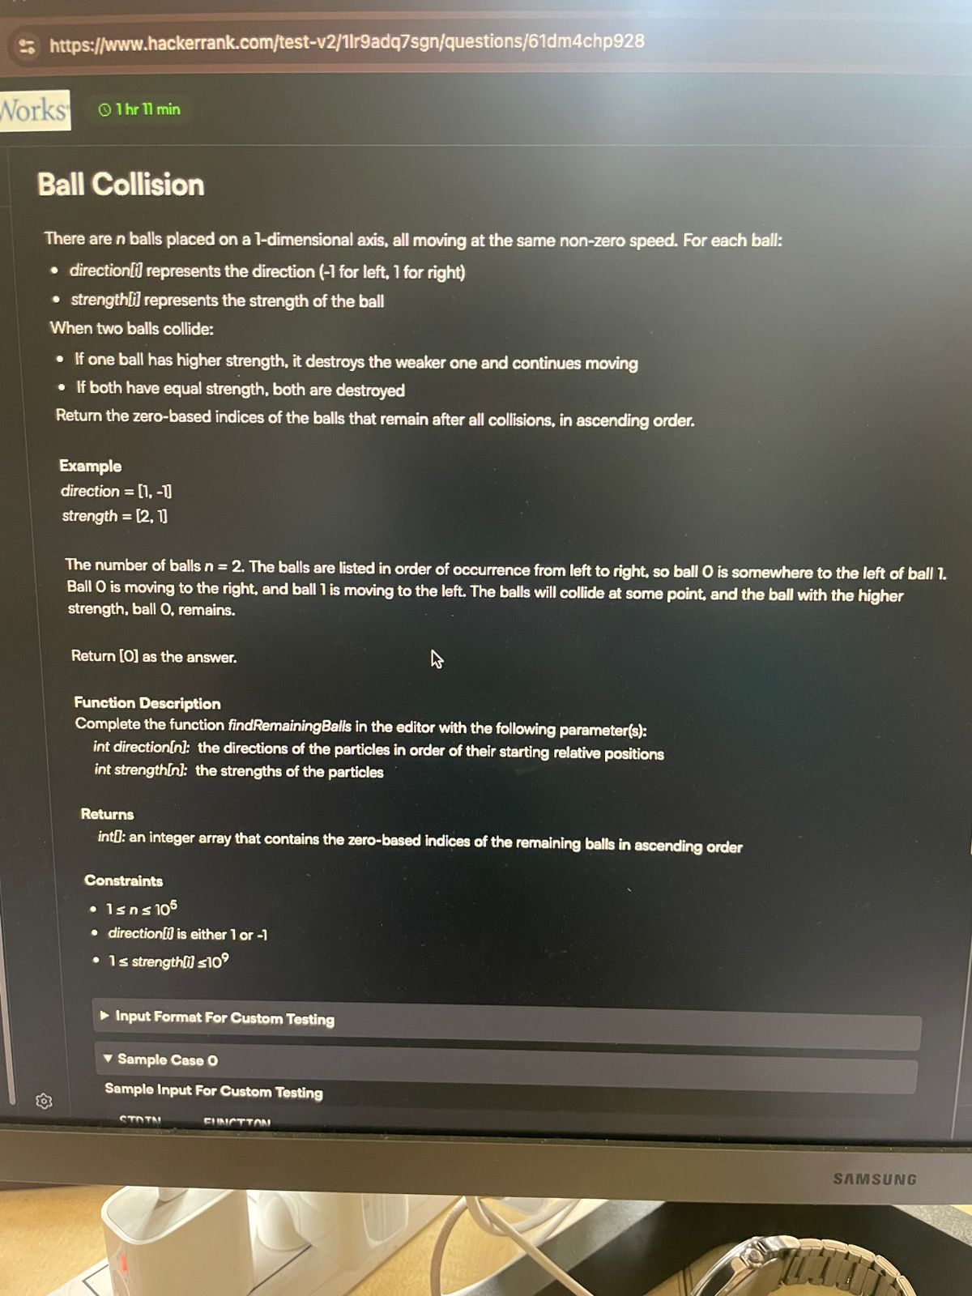
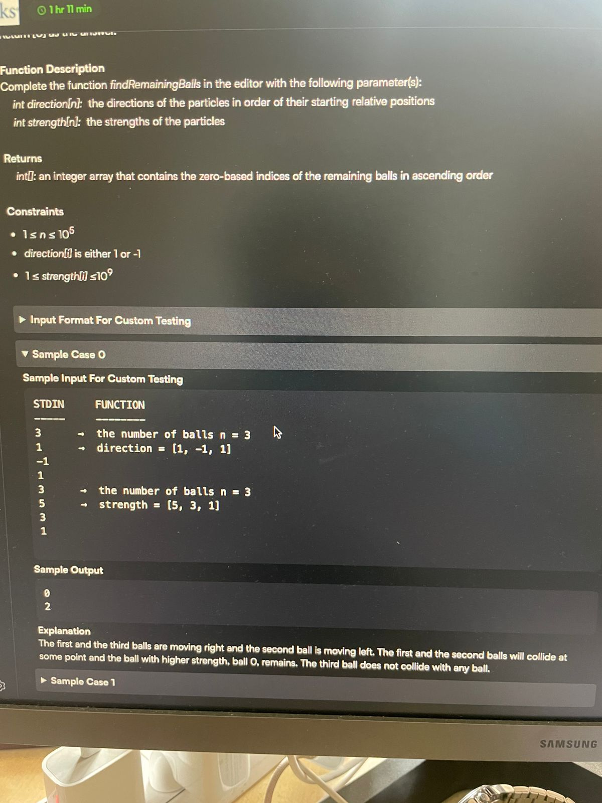

Type 1

#include #include #include #include
using namespace std;
vector findRemainingBalls(vector& direction, vector& strength) { int n = direction.size(); stack rightMoving; // store indices of balls moving to the right set destroyed;
for (int i = 0; i < n; ++i) {
if (direction[i] == 1) {
rightMoving.push(i);
} else {
while (!rightMoving.empty()) {
int top = rightMoving.top();
if (strength[top] < strength[i]) {
destroyed.insert(top);
rightMoving.pop();
} else if (strength[top] == strength[i]) {
destroyed.insert(top);
destroyed.insert(i);
rightMoving.pop();
break;
} else {
destroyed.insert(i);
break;
}
}
// If stack is empty and no break happened, the left-mover i survives
}
}
// Collect surviving balls vector result;
for (int i = 0; i < n; ++i) {
if (destroyed.find(i) == destroyed.end()) {
result.push_back(i);
}
}
return result;
}
int main() { vector direction = {1, -1, 1}; vector strength = {5, 3, 1};
vector survivors = findRemainingBalls(direction, strength);
for (int idx : survivors) {
cout << idx << " ";
}
cout << endl;
return 0;
}

Type 2

#include #include
using namespace std;
vector findRemainingBalls(int n, vector& direction, vector& strength) { stack activeBalls; // Store indices of active balls
for (int i = 0; i < n; i++) {
while (!activeBalls.empty()) {
int lastIdx = activeBalls.top();
// Check if current ball and last ball collide (opposite directions)
if (direction[i] + direction[lastIdx] == 0) {
// Compare strengths
if (strength[i] > strength[lastIdx]) {
activeBalls.pop(); // Remove weaker ball
} else if (strength[i] < strength[lastIdx]) {
break; // Current ball is destroyed, stop
} else {
activeBalls.pop(); // Both destroyed
break;
}
} else {
break; // No collision, move to next
}
}
if (activeBalls.empty() || direction[i] + direction[activeBalls.top()] != 0) {
activeBalls.push(i); // Add current ball if no collision or stack is empty
}
}
vector result;
while (!activeBalls.empty()) {
result.push_back(activeBalls.top());
activeBalls.pop();
}
// Reverse to get ascending order
for (int i = 0; i < result.size() / 2; i++) {
swap(result[i], result[result.size() - 1 - i]);
}
return result;
}

BOOK allocation striver

class Solution {
public:

int fun(vector<int> &nums, int m, int mn){

int all = 0, stu=0;
for(int i=0;i<mn;i++){
if(all + nums[i]<= m )
all += nums[i];

else{
stu++;
all = nums[i];
}
}
return stu;
}
int findPages(vector<int> &nums, int m) {

int mn = nums.size();
if(mn < m) return -1;

int l = *max_element(nums.begin(), nums.end());
int h = accumulate(nums.begin(), nums.end(), 0);

while(l<=h){
int mi = l+(h-l)/2;
int s = fun(nums, mi, mn);

if(s<m){
h= mi-1;

}
else{
l = mi+1;
}

}
return l;

}
};

Intern task

#include <bits/stdc++.h>
using namespace std;

int getMaximumRewardPoints(int k, vector<int>& reward_1, vector<int>& reward_2) {
int n = reward_1.size();

// Create a vector of pairs: (difference, index)
// difference = reward_1[i] - reward_2[i]
vector<pair<int, int>> diff_index;

for (int i = 0; i < n; i++) {
diff_index.push_back({reward_1[i] - reward_2[i], i});
}

// Sort by difference in descending order
// Intern 1 should take tasks where they have maximum advantage
sort(diff_index.begin(), diff_index.end(), greater<pair<int, int>>());

int total_reward = 0;

// Intern 1 takes first k tasks (highest differences)
for (int i = 0; i < k; i++) {
int task_index = diff_index[i].second;
total_reward += reward_1[task_index];
}

// Intern 2 takes remaining (n-k) tasks
for (int i = k; i < n; i++) {
int task_index = diff_index[i].second;
total_reward += reward_2[task_index];
}

return total_reward;
}

int main() {
int k;
cin >> k;

int n;
cin >> n;

vector<int> reward_1(n), reward_2(n);

for (int i = 0; i < n; i++) {
cin >> reward_1[i];
}

for (int i = 0; i < n; i++) {
cin >> reward_2[i];
}

int result = getMaximumRewardPoints(k, reward_1, reward_2);
cout << result << endl;

return 0;
}

/*
Example walkthrough:
Input: k=3, n=4, reward_1=[1,2,3,2], reward_2=[1,2,3,2]

Step 1: Calculate differences
diff[0] = 1-1 = 0, index 0
diff[1] = 2-2 = 0, index 1
diff[2] = 3-3 = 0, index 2
diff[3] = 2-2 = 0, index 3

Step 2: Sort by difference (all equal, so order remains same)
[(0,0), (0,1), (0,2), (0,3)]

Step 3: Intern 1 takes first 3 tasks (indices 0,1,2)
Reward from intern 1: reward_1[0] + reward_1[1] + reward_1[2] = 1+2+3 = 6

Step 4: Intern 2 takes remaining task (index 3)
Reward from intern 2: reward_2[3] = 2

Total: 6 + 2 = 8

Time Complexity: O(n log n) due to sorting
Space Complexity: O(n) for the difference array
*/

Subsequence sort

#include <iostream>
#include <vector>
#include <string>
using namespace std;

vector<string> checkStrings(string binary, vector<string> arr) {
// Count 0s and 1s in binary string
int count0 = 0, count1 = 0;
for (char c : binary) {
if (c == '0') count0++;
else count1++;
}

vector<string> result;

for (string s : arr) {
// Count required 0s, 1s, and question marks
int need0 = 0, need1 = 0, questions = 0;

for (char c : s) {
if (c == '0') need0++;
else if (c == '1') need1++;
else questions++; // c == '?'
}

// Check if we can satisfy the requirements
// We need at least need0 zeros and need1 ones
// The remaining question marks can be filled with leftover 0s and 1s
if (need0 <= count0 && need1 <= count1) {
int remaining0 = count0 - need0;
int remaining1 = count1 - need1;

// Check if we have enough characters to fill question marks
if (remaining0 + remaining1 >= questions) {
result.push_back("YES");
} else {
result.push_back("NO");
}
} else {
result.push_back("NO");
}
}

return result;
}

int main() {
// Test with the given example
string binary = "101011";
vector<string> arr = {"???111", "001101"};

vector<string> result = checkStrings(binary, arr);

for (string res : result) {
cout << res << endl;
}

// Additional test cases
cout << "\nTesting additional cases:" << endl;

// Test case 2
binary = "110100";
arr = {"?110?1", "111???", "000000"};
result = checkStrings(binary, arr);

for (string res : result) {
cout << res << endl;
}

return 0;
}

// Function to be submitted (without main)
/*
vector<string> checkStrings(string binary, vector<string> arr) {
int count0 = 0, count1 = 0;
for (char c : binary) {
if (c == '0') count0++;
else count1++;
}

vector<string> result;

for (string s : arr) {
int need0 = 0, need1 = 0, questions = 0;

for (char c : s) {
if (c == '0') need0++;
else if (c == '1') need1++;
else questions++;
}

if (need0 <= count0 && need1 <= count1) {
int remaining0 = count0 - need0;
int remaining1 = count1 - need1;

if (remaining0 + remaining1 >= questions) {
result.push_back("YES");
} else {
result.push_back("NO");
}
} else {
result.push_back("NO");
}
}

return result;
}
*/

2nd version

#include <iostream>
#include <vector>
#include <string>
using namespace std;

vector<string> checkStrings(string binary, vector<string> arr) {
// Count 0s and 1s in binary string
int count0 = 0, count1 = 0;
for (char c : binary) {
if (c == '0') count0++;
else count1++;
}

vector<string> result;

for (string s : arr) {
// Count required 0s, 1s, and question marks
int need0 = 0, need1 = 0, questions = 0;

for (char c : s) {
if (c == '0') need0++;
else if (c == '1') need1++;
else questions++; // c == '?'
}

// Since |arr[i]| = |binary|, we must use all characters
// Check if we can satisfy the requirements exactly
if (need0 <= count0 && need1 <= count1) {
int remaining0 = count0 - need0;
int remaining1 = count1 - need1;

// The question marks must be filled with exactly the remaining characters
if (remaining0 + remaining1 == questions) {
result.push_back("YES");
} else {
result.push_back("NO");
}
} else {
result.push_back("NO");
}
}

return result;
}

int main() {
// Test with the given example
string binary = "101011";
vector<string> arr = {"???111", "001101"};

vector<string> result = checkStrings(binary, arr);

for (string res : result) {
cout << res << endl;
}

// Additional test cases
cout << "\nTesting additional cases:" << endl;

// Test case 2
binary = "110100";
arr = {"?110?1", "111???", "000000"};
result = checkStrings(binary, arr);

for (string res : result) {
cout << res << endl;
}

return 0;
}

// Function to be submitted (without main)
/*
vector<string> checkStrings(string binary, vector<string> arr) {
int count0 = 0, count1 = 0;
for (char c : binary) {
if (c == '0') count0++;
else count1++;
}

vector<string> result;

for (string s : arr) {
int need0 = 0, need1 = 0, questions = 0;

for (char c : s) {
if (c == '0') need0++;
else if (c == '1') need1++;
else questions++;
}

if (need0 <= count0 && need1 <= count1) {
int remaining0 = count0 - need0;
int remaining1 = count1 - need1;

if (remaining0 + remaining1 >= questions) {
result.push_back("YES");
} else {
result.push_back("NO");
}
} else {
result.push_back("NO");
}
}

return result;
}
*/

vector<string> checkStrings(string binary, vector<string> arr) {
int count0 = 0, count1 = 0;
for (char c : binary) {
if (c == '0') count0++;
else count1++;
}

vector<string> result;

for (string s : arr) {
int need0 = 0, need1 = 0, questions = 0;

for (char c : s) {
if (c == '0') need0++;
else if (c == '1') need1++;
else questions++;
}

if (need0 <= count0 && need1 <= count1) {
int remaining0 = count0 - need0;
int remaining1 = count1 - need1;

if (remaining0 + remaining1 == questions) {
result.push_back("YES");
} else {
result.push_back("NO");
}
} else {
result.push_back("NO");
}
}

return result;
}

