We can answer any questions of 2d dp using this
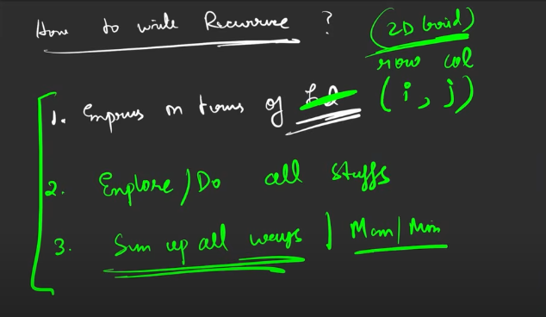

Grid unique paths from start (0,0) till (n-1, n-1)

I follow to traverse from the end ; hence
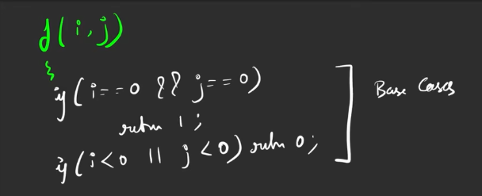
If I’m going to reach (0,0) then i’m going to return 1, since I have reached the end .
If I’m going anywhere out of the range, then no need to count it, then it will return 0
The index exploration is done, it is time to explore all the things menioned in the problem:

- I can move in right or down direction, but we are moving from bottom, hene it is opposite, left or upward.
- Up, left:
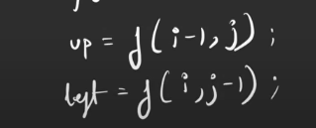
- Finally return the value


