Serialize and De-serialize Binary Tree |

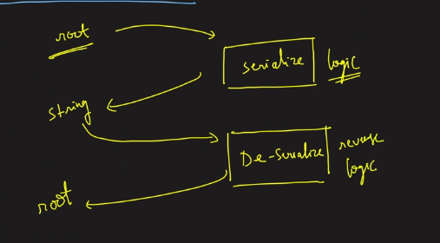
Given the root of the tree, need to return the string which has the tree’s node in it in some order
That is serialise
Deserilise will take the same string and give the tree by returning teh same as head
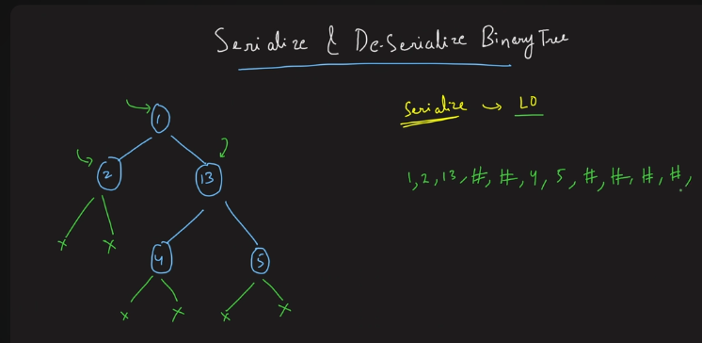
Make use of the queue DS.
Make the level order traversal of the nodes , for each and every node will be having the 2 child nodes with them, that is left and right, if not append # over there and move on.
Finally return the string which has teh nodes as well as the # character in it .
The above is to serialise the given tree.
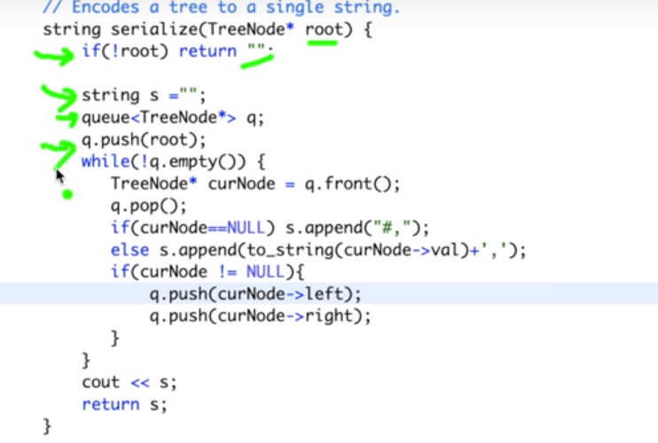
This is used to push everything into the queue, if that is queu then we will be pushing it.

Deserialise:
Take the string, whenever you see the alphanum(chatracter), then we will be making the node for the character. Hence after making the node, keep that value in queue.
Then pop the node to a variable, that pointers left should be the new node created if the character present at that moment, if the alphanum is not present then make the corresponding pointer to be null.
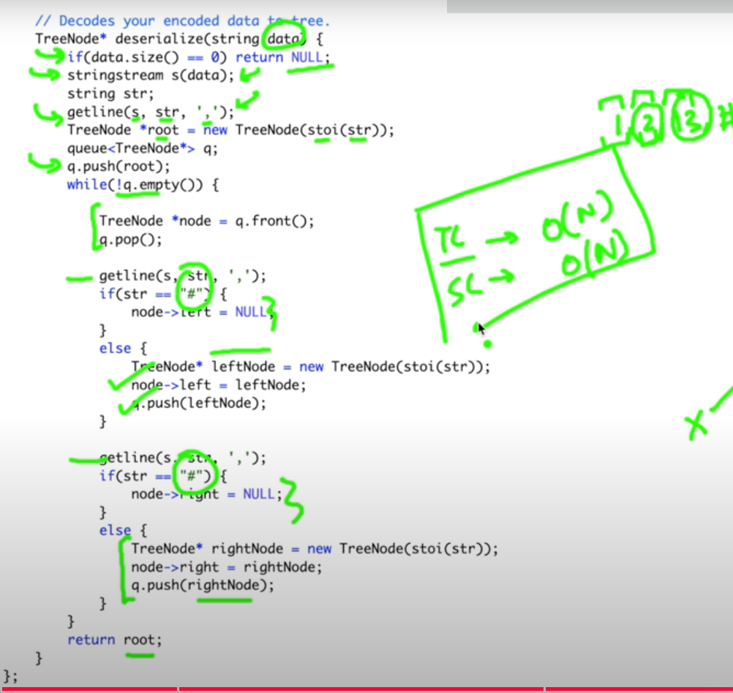

Morris order Traversal

‘

