Minimum Spannig Tree
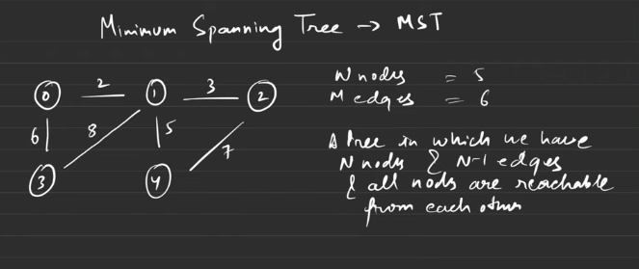
Below are the spannig trees
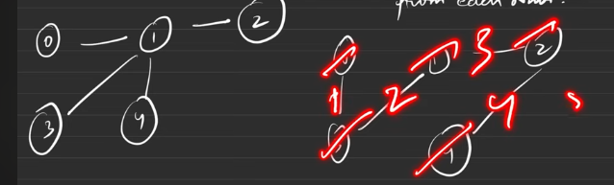
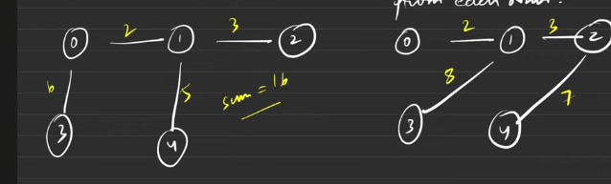
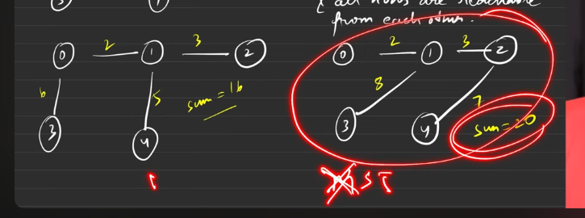
Ex:
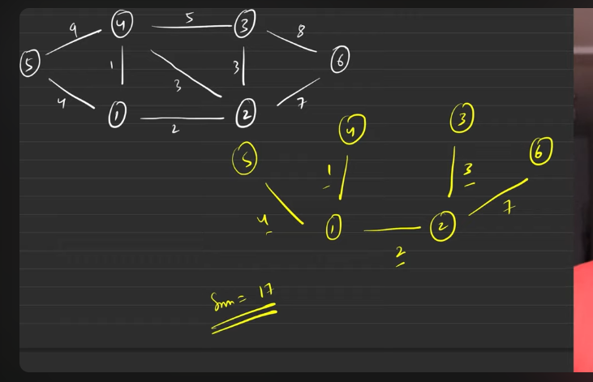

PRIMS ALGO
Make the inital configuarations as the priority queue insertion with {wt, node , parent}- this to be pushed with the 0 as the inital node.
Keep the visited array to know which are all the nodes are already visited.
- Pop the node PQ, and check for all the adjacent nodes, if the node is not visited then do not entered the visited node into PQ.
- With the distance from the current node to the target node, { entry of PQ }.
- Keep teh sum tracked and edge to be pushed to vector.

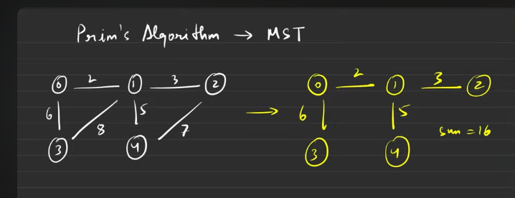
Prims algorithms helps us to find the MST
Init config:
- Priority queue
- Visited array
- A vector which holds the mst
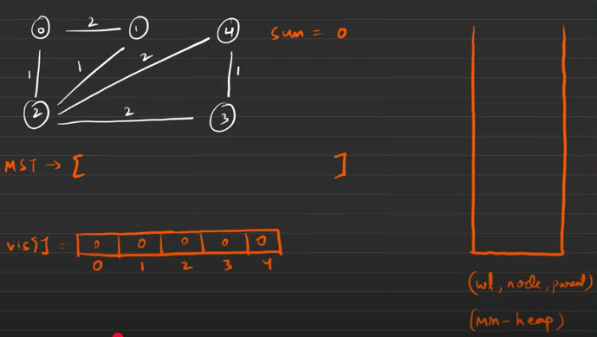
The inital configuarations to be made is this, we need to push those things initial configuarions into the min heap. If parent is -1 then it is the start node.
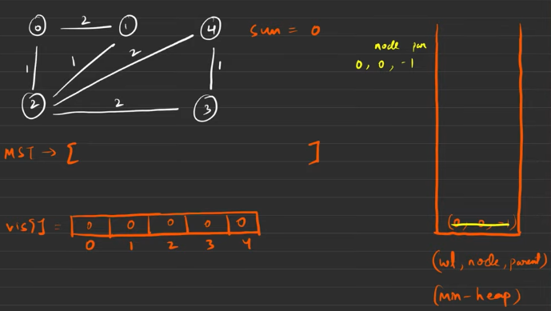
Whatever it is related to the popped noed from the min heap, that will be pushed into min heap. Mark the popped as 1 in visited for the node.
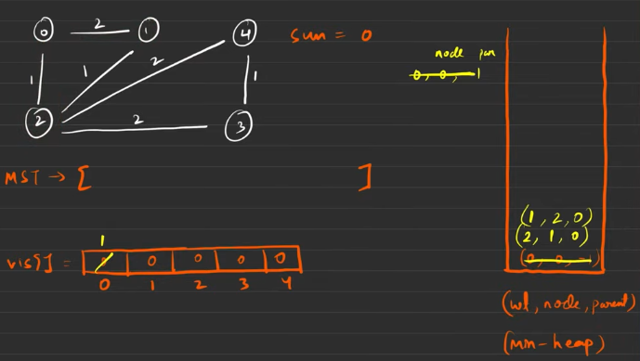
Now pop and make the visited[index] =1 then add the edge to MST.
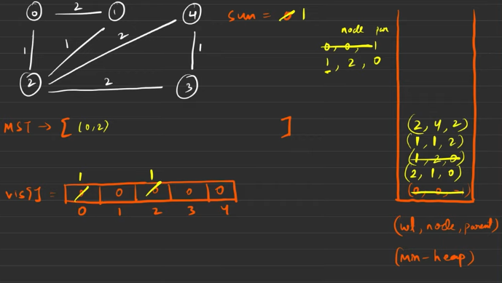
When the neighbour is visited then it is not advised to not yo keep the data into the priority queue.
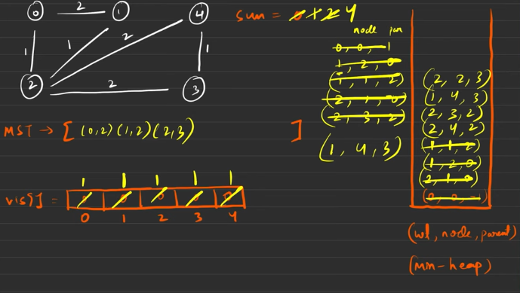

In question if they are asking for the MST keep the parent too. If the MST s not asked then it is better to go with {wt, node}.
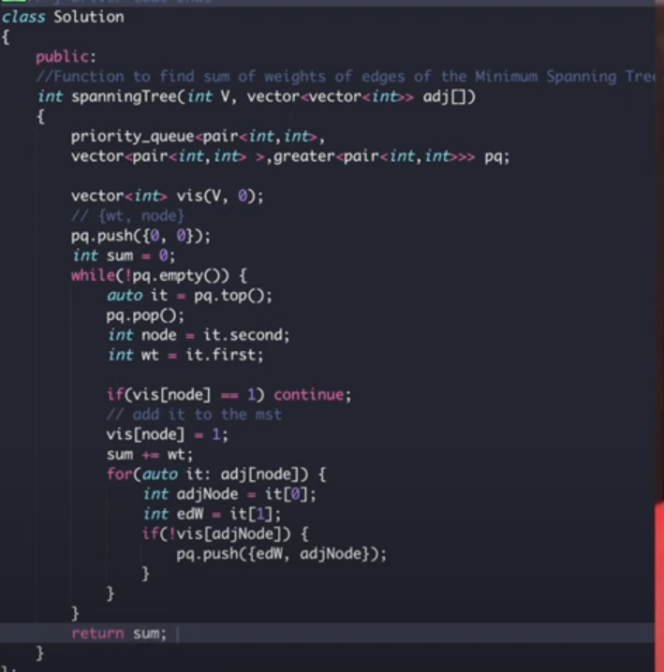
In this:

The above edge was ignored (0->1,2)because of the greedy nature of PQ
Intuition is greedy.
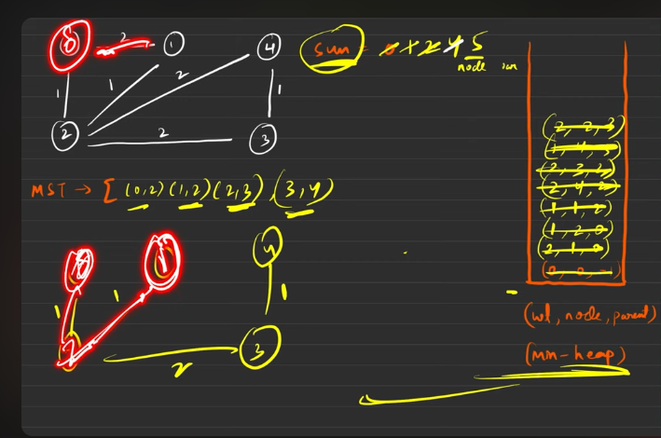
Time complexity:
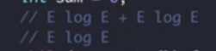

Disjoint Set

To say that a particular node is a part of the tree or not, we had to do DFS or BFS and we were getting that to know in O(N) time complexity.
But to know whether a node belongs to the tree or not in Disjoint, then it is possible to know it in O(constant ) time.

Usually this is used in Dynamci graph, the graph which is used to change the configuarations everytime.

It gives 2 functions:
- FindingParent()
- FindUnion() by rank or by size

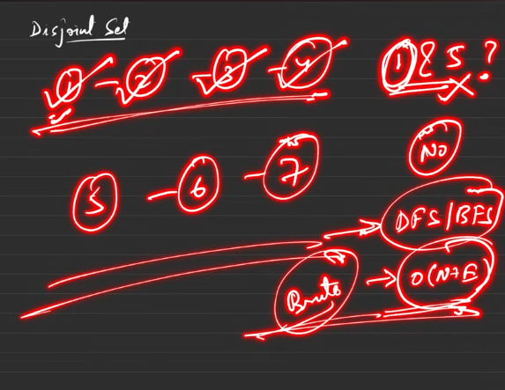

Dynamic graphs or how does the graphs configuaration is changing everytime?

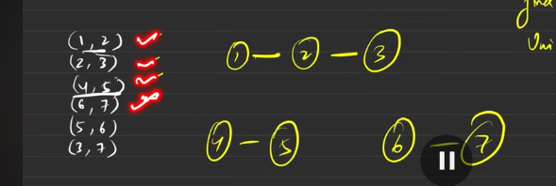
Initally only the nodes are present,
When half of the edeges are connected then and some one asks aout the whether these things are connected ro not?
Still the graphs are changing themsleves by making the edges between the nodes everytime, till not completley filled and suddenly someone asks the question regarding th configuarations then this is called as the Dynamic graphs. But this is how the graph is formed

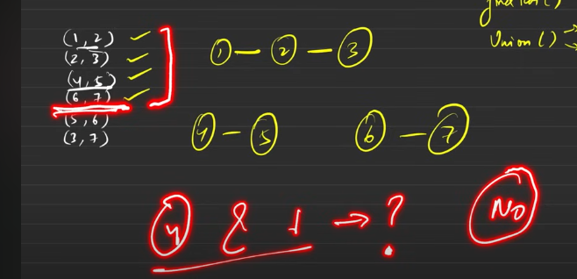
4 and 1 is not in teh csame component? No
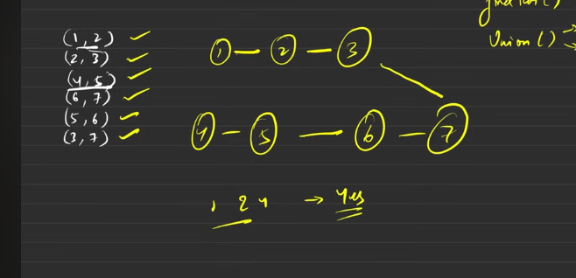does 1 and 4 belongs to the same component? Yes this is called the dynamic configuarations
It hhas 2 functions:
- findParent()
Union can be done in 2 ways:
- Rank
- Size

Initialaisations;
Rank – we declare the size of rank with the size of the nodes in it.
It says how many number of child nodes are present under it, currently it is 0 , hence all 0s.
Parent array: All elemnts are parent of itself.
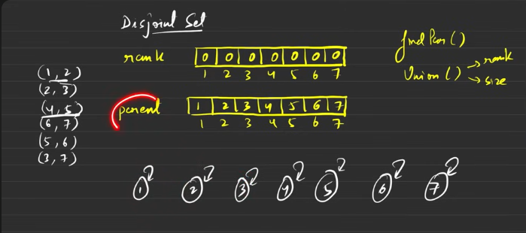

Psuedocode:
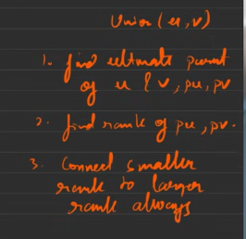
- Find the ultimate parent
- Find the rank of ultimate parent node(top guy)
- Connect the smaller rank to the larger rank, if same rank we can connect anyone with anyone
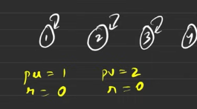
Currernly we can connect anyone with anyone

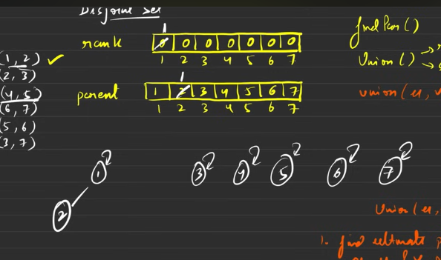
The rank of the node 1 is changed to 1 and parent of 2 is 1 right now.
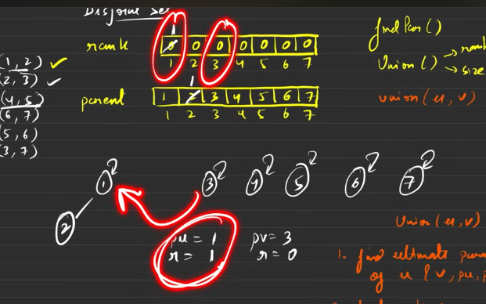
Since the rank of 3 is 0 and the ultimate parent of 2 is 1 and its rank is 1, hence the lower rank one is doced with the higher rank .

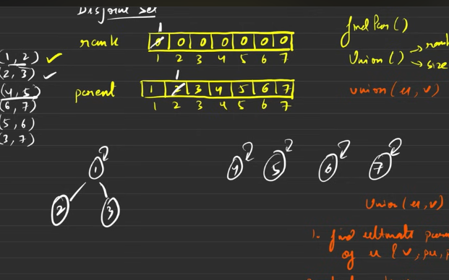

This goes on
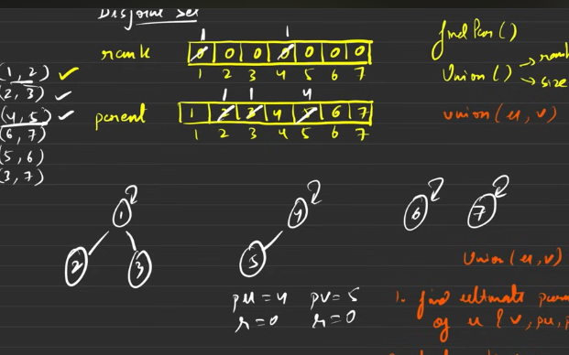
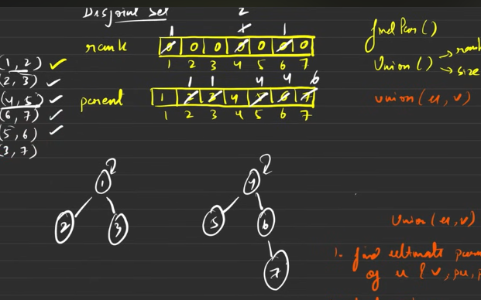
Does 1 and 7 belongs to the same compnent?
This is where we will be looking findParent() is used -

This must return the ultimate parent of each and every node. If the 2 nodes ultimate parent are same then yeah, both have the same component.

Hence maximum time tae uing the above is O(logn ), to know the answer in constant time, then path compression
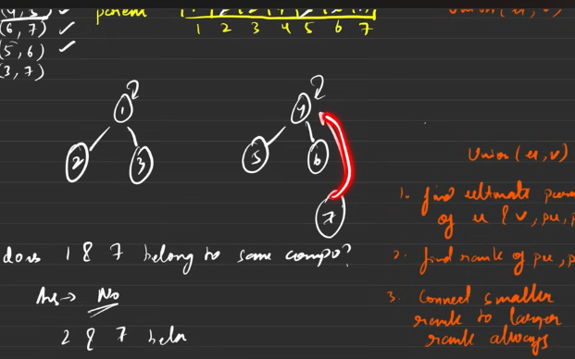
The red is path compression
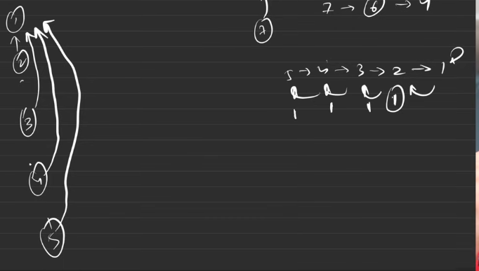
This is connected to 1.
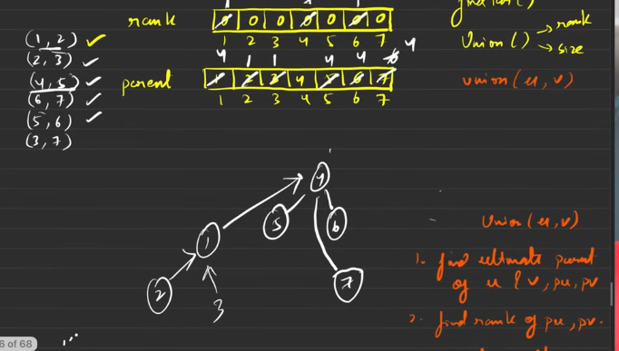
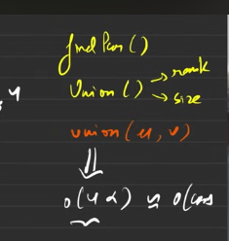

Find parent’s psuedocode
The below is how the code is looking
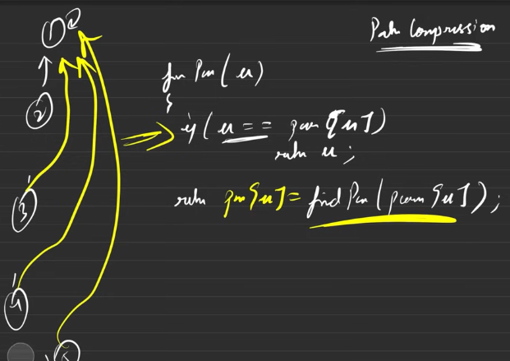
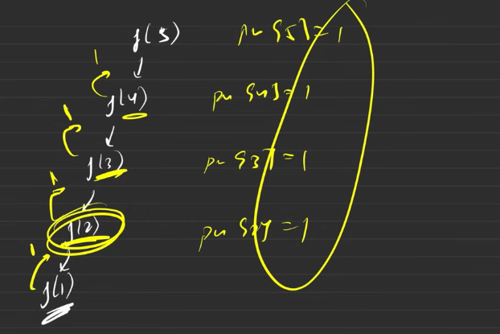
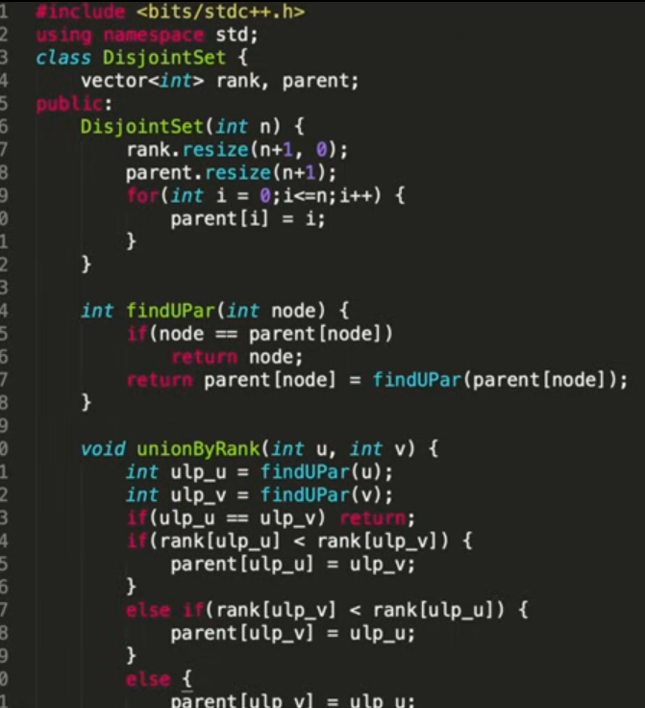
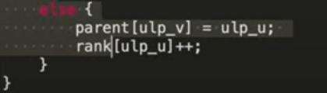

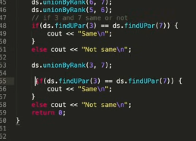

Why connect smaller to larger?
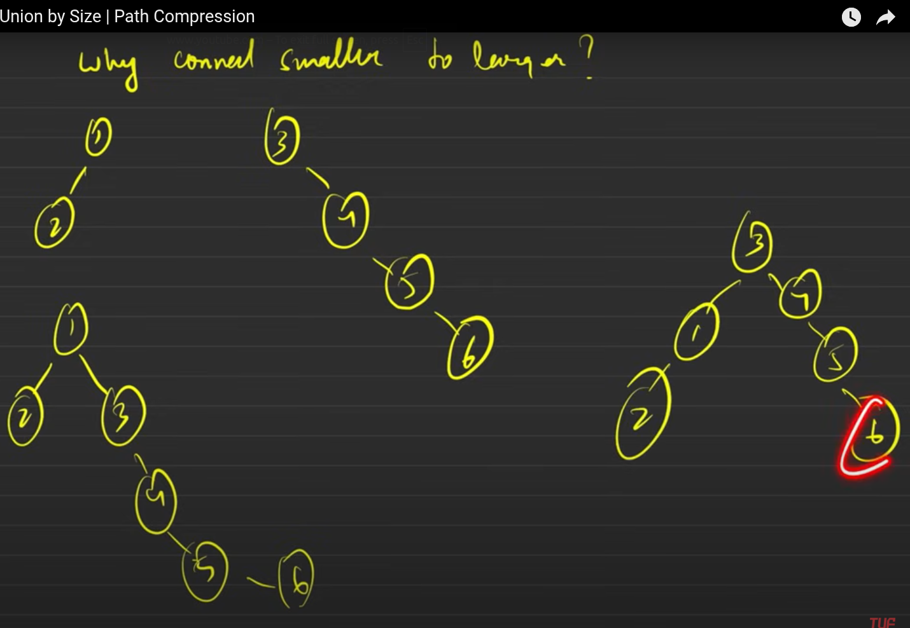
Thee starting 2 are the nodes/treees/ graphs
The lower one are resultant of the union.
To the left side down, the righer rank is connected to the low rank, so the time taken to find the parent is higher when compared to the down right.

The lower height is produced because of the lower rank is connecetd to the higher rank.
Hence the travelling time needs to be smaller as possible.
The reason why we do not use the union by height because after the path compression the height of the graph becomes small and the hieight will be altered. But the size remains constant, before and after the path compression, hence we are going to use the union by size.

Union By Size

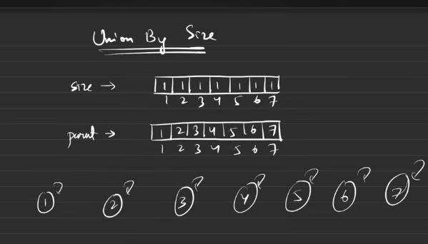
Initial config,
Need size vector= all the elements = 1, for all the elemnts in the size, parent vector = all are parent to themselves.

The edges will be given, we need to dock the graph elements nodes one by one.
Everytime we dock the smaller sized element’s parent will be docked to the higher sized node. The higher sized node’s size will be incrased by the value of the dock element.

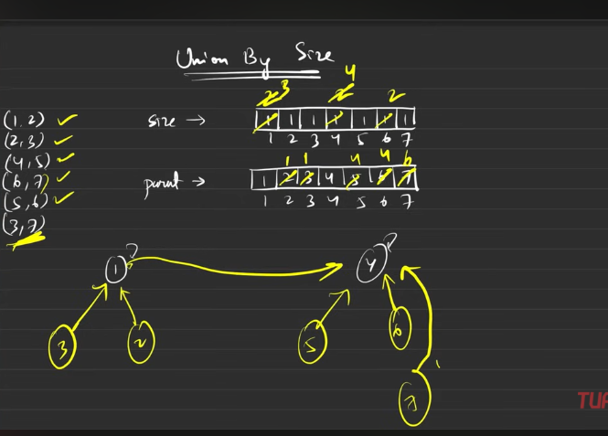

Bwlow is the newfunction that shall be inserted in the previous class.
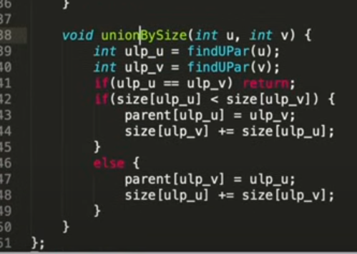

Remember do not use both the rank and size by union in combination

Kruskals Algo

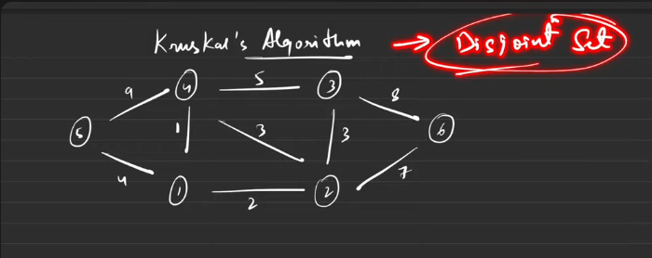
This algo is used to find the MST.

Step 1 : Sort all the ede weights in ascending order

Procedure:
Keep taking the edges from the sorted one by one.
Check whether the element seen is having different ultimate parent, if so, then union those 2 , by making the weights summation to MST. If they are having the same up then it is not considered for union, because making the union will make the cycyle.

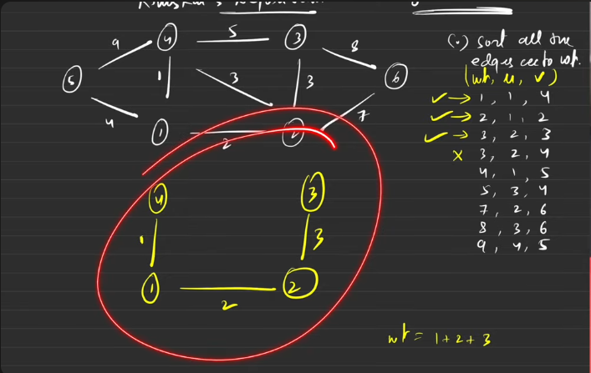
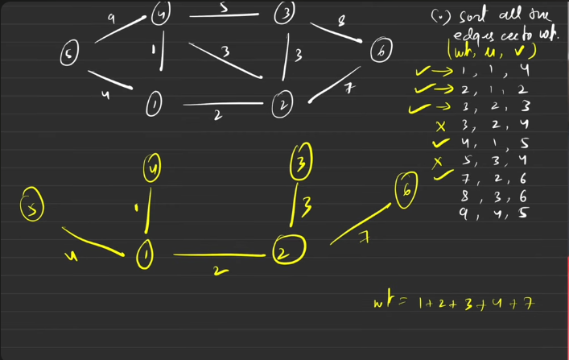
By default the edes are undirected , hence it has 2 sided edge, but this disjoint set i going to consider 2wice considered edge only once. Hnece while preparing the sorted vector , keep the data only once.

You try to code it first then check how accurate you are .

Number of Provinces

It is about finding the number of connected components.
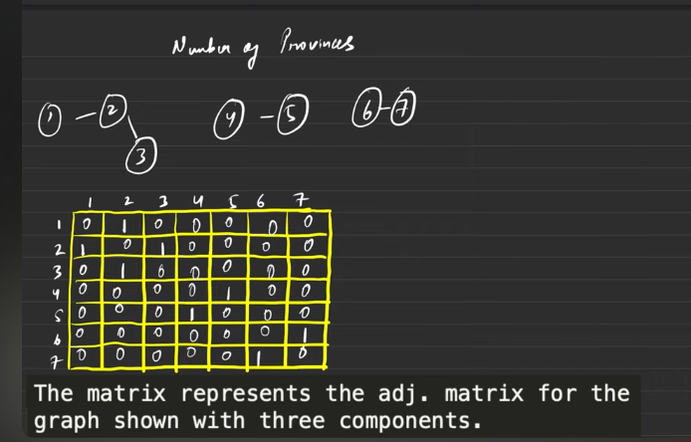
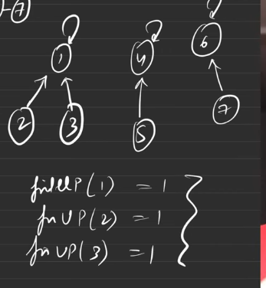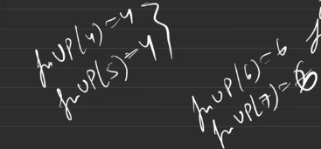
If I find the number ditinct bosses or super parent then it is nothing but the number of provinces.

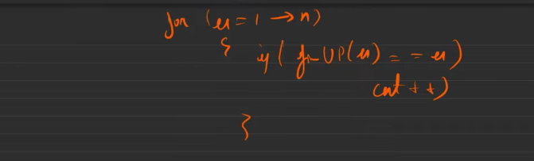

You code it .

Number of Operations to Make Network Connected

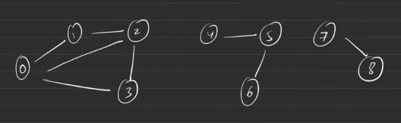

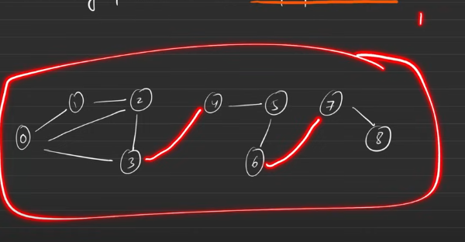
When you are connecting it from one component to another component there shall not be any imaginary edges, but you need to remove one edge from teh existed and then connect that between the components.

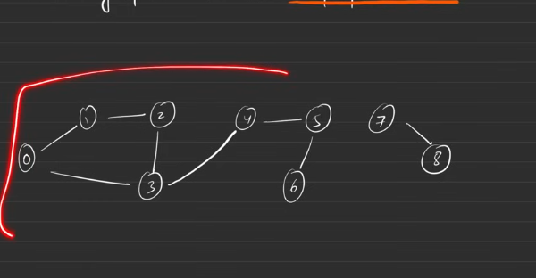
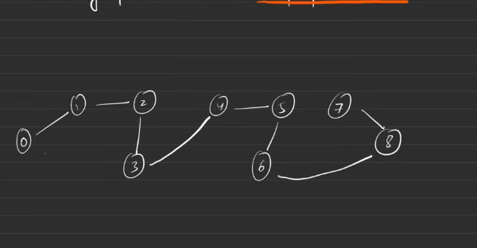
Hence we needed 2 edges that need to be removed in such a way that , connnected should not be disconnected.

Hence

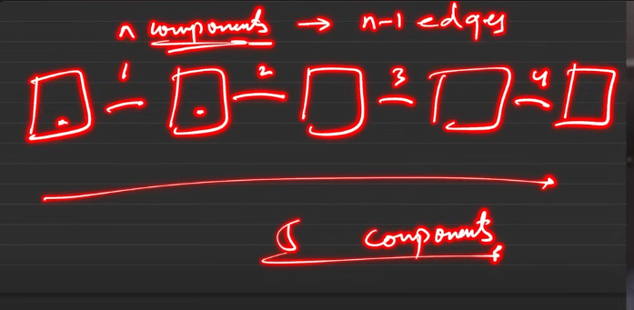
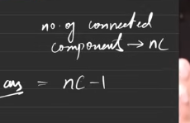
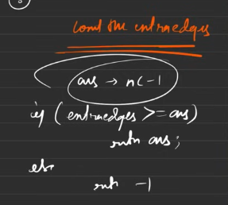
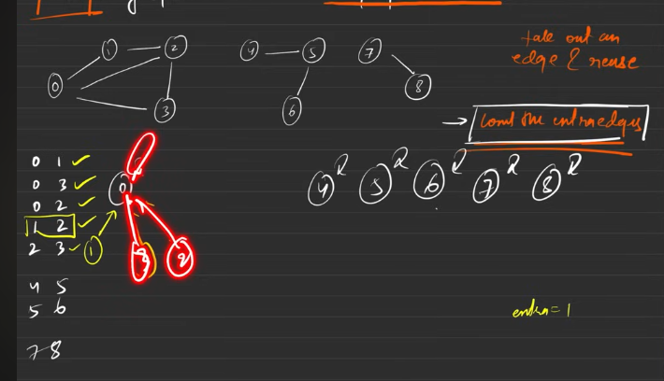
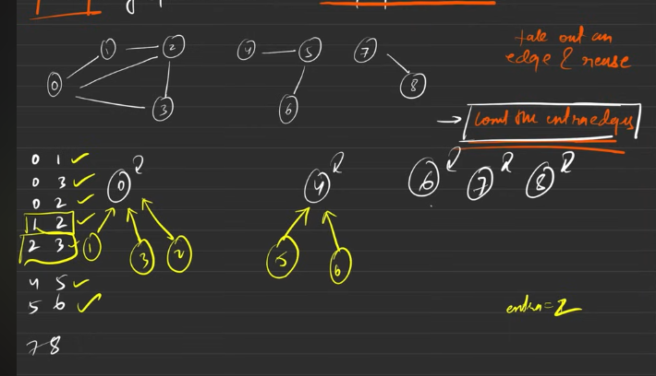

2 main things to be computed here:
- The number of extra edges we have
- The number of components

the Minimum number of operations needed is :
- The number of components -1. These manu number of edges to be aded
Number of extra edges:
- Start with the disjoint set.
- When the parent of the 2 different nodes are different then we are going to make the union of those nodes.
- When we have the 2 different nodes ultimate parent is one and the same it is nothing but nodes are already connected and the edge that is to be inserted is extra edge, just count it.

Number of components:
- When the nodes parent are they themselves the count shall be increased, wih says the number of components.
- If the ans from the above is more than or equal to number of compoents -1 then we will be returning the (number of compoents -1) else -1 will be returned.

You can code it.

Accounts Merge

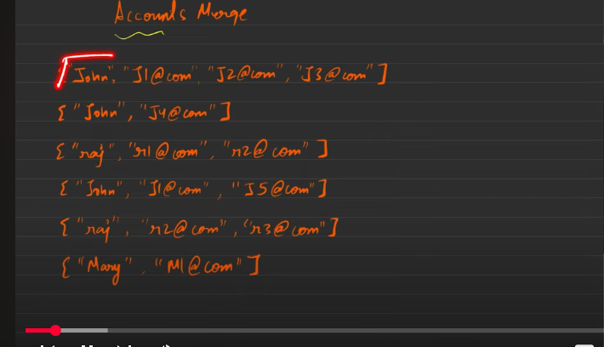
1st and 2nd they have the same name, but they have different values in them, hnce they are different from each other, but 1st and4th they have same name and ine of the values in it is common , hence we will be merging those things together.

