Shortest path in undirected graphs with unit distance

Do the BFS traversal on the undirected graph, using the adjacency list.
Datastrucres req: Queue{node, distance}, array with the inf initialized.
When the distance less the stored is found, just replace that in diatnce.
It is BFS traversal.
when you are travelling to the next ,check the node’s diatnce
Finally the distance vector/ array will be having the distance from the node to all the nodes.

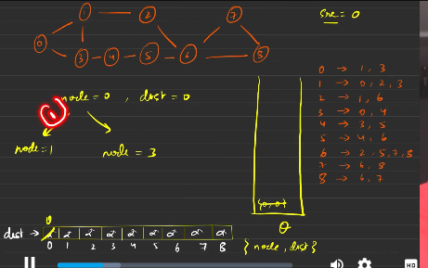
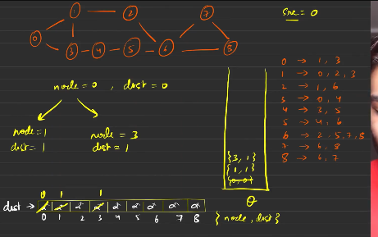
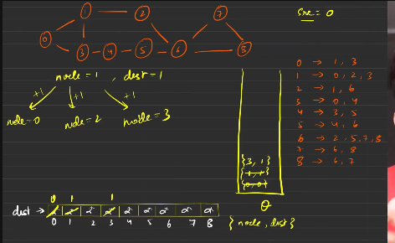
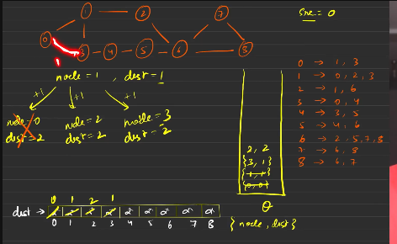
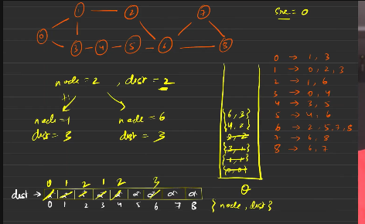
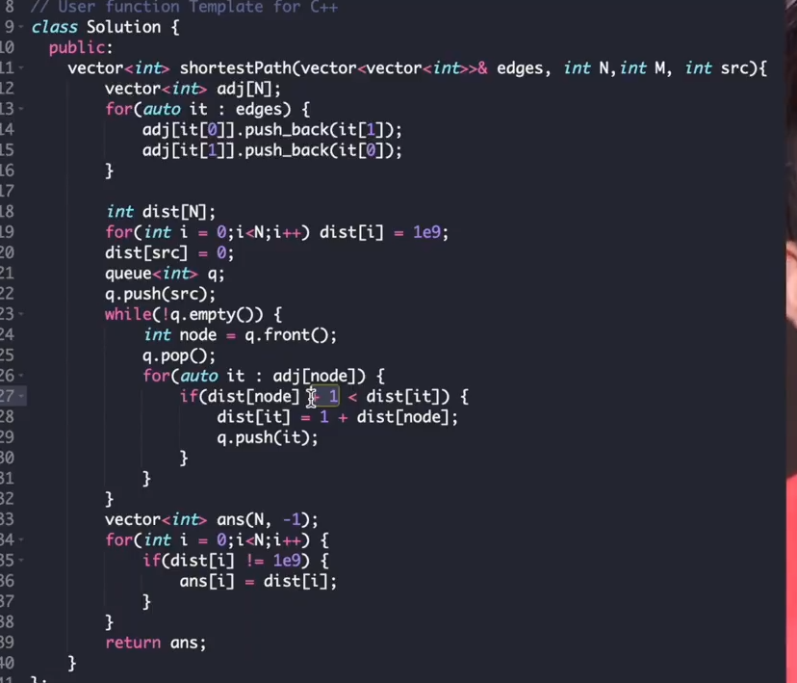
Why queue is used here?
It is because of the tt is used t store the distance one after the other , but if we the stack that might not be the case.

SHORTEST PATH IN DAG

Topo sort:
- BFS:
  - Use rank vector store to store the rank.
  - Use the queue and adjacency list.
  - Use visited vector
  - Every time when the rank vector for the node becomes 0 then we are going to add this to the answer vector.

- DFS:
  - Use reccursion, when the reccursion is completed then, no further df calls push the elements into the stack.
  - Now start popping it, it has the topo sort
  - Use visited vector
  - Now we start popping the elements one by one from the stack.
  - The distance vector for the source is made the entry of 0, so while you keep popping th element from the stack and, and keep chnaging the diance of the distnace vector,.
    - Dist[parent_node] + adj_of_parent_node[i].second < dist[adj_paten_node [i]] then update the distance vector , rest everythign remains as it is.
    - Return the distance vector.

Dijkstra's Algorithm

Datastructure:
- Queue
- PQ
- Set
Set seems the fastest comparitvely

Initial data structure connfiguration:
0 is considered to be the source node. Hnec the distance is 0.
Distance vector is filled with the inf(1e9)
D[source] = 0
Put the {node, dist} into the min heap data structure, then start to traverse the graphs using the top element in the heap datastructure.
Use the top elemnt and start traversing it lke the previous problem using the adjcency list
Every time we are going to visit the node with the less distance e have to keep the node in the min heap.
Hence return the distance
It works for the graph with only positive edges in them.

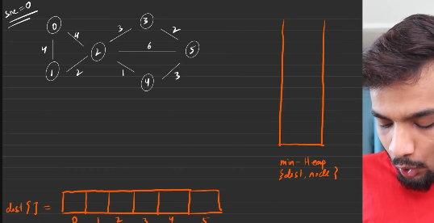

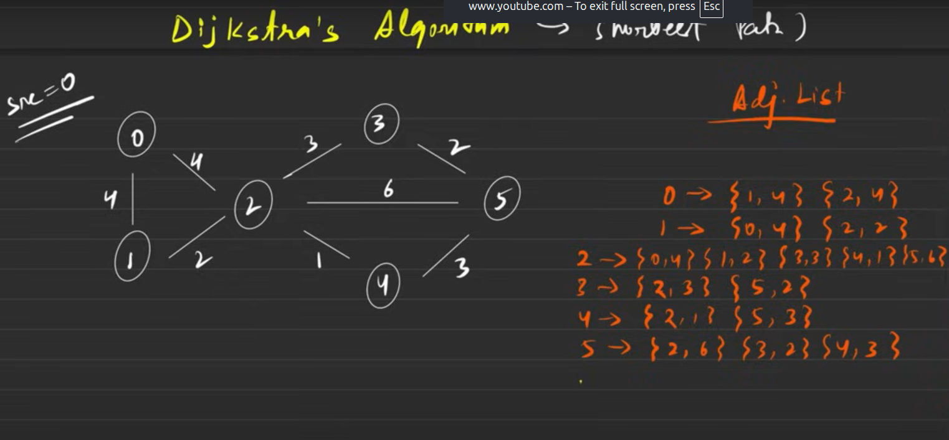
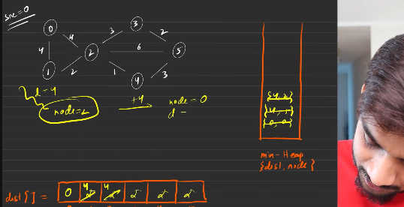
What is the sortest distance from the start node to the all the other nodes
Set is the fastest

The graphs with the negative distance will not work , proof
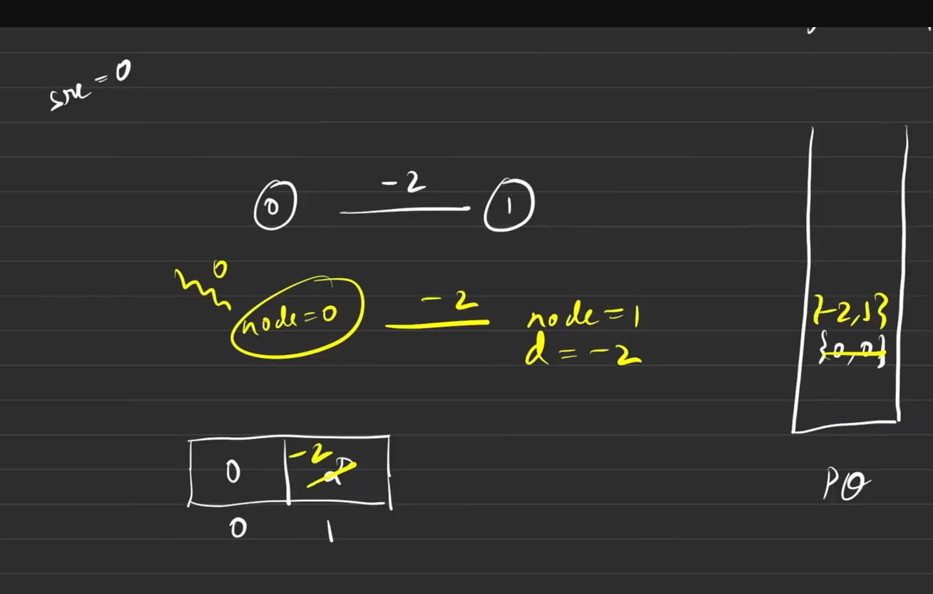
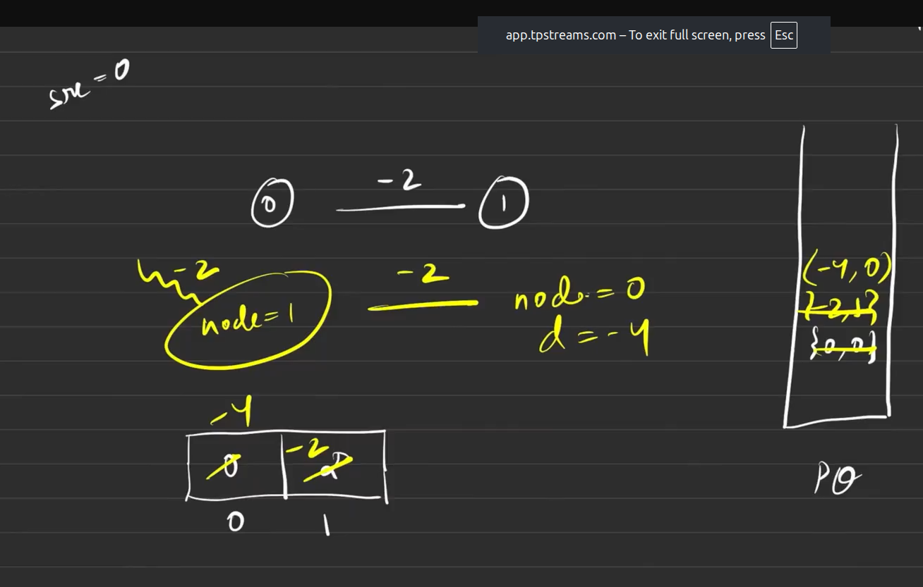
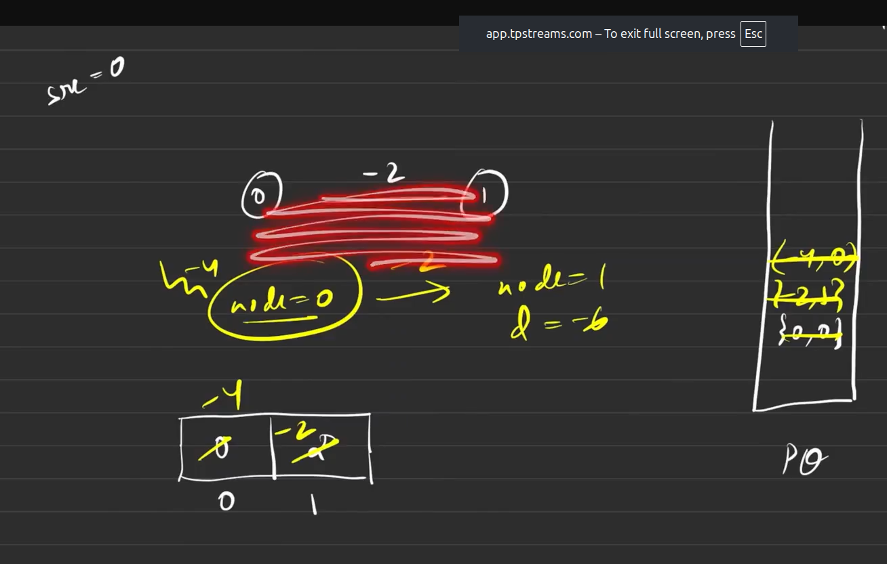
Everytime when there is traversals which involves the negative edge in the graphs, that will be affected. It goes for the infinte loop

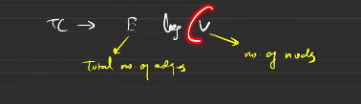

Shortest path in a binary maze
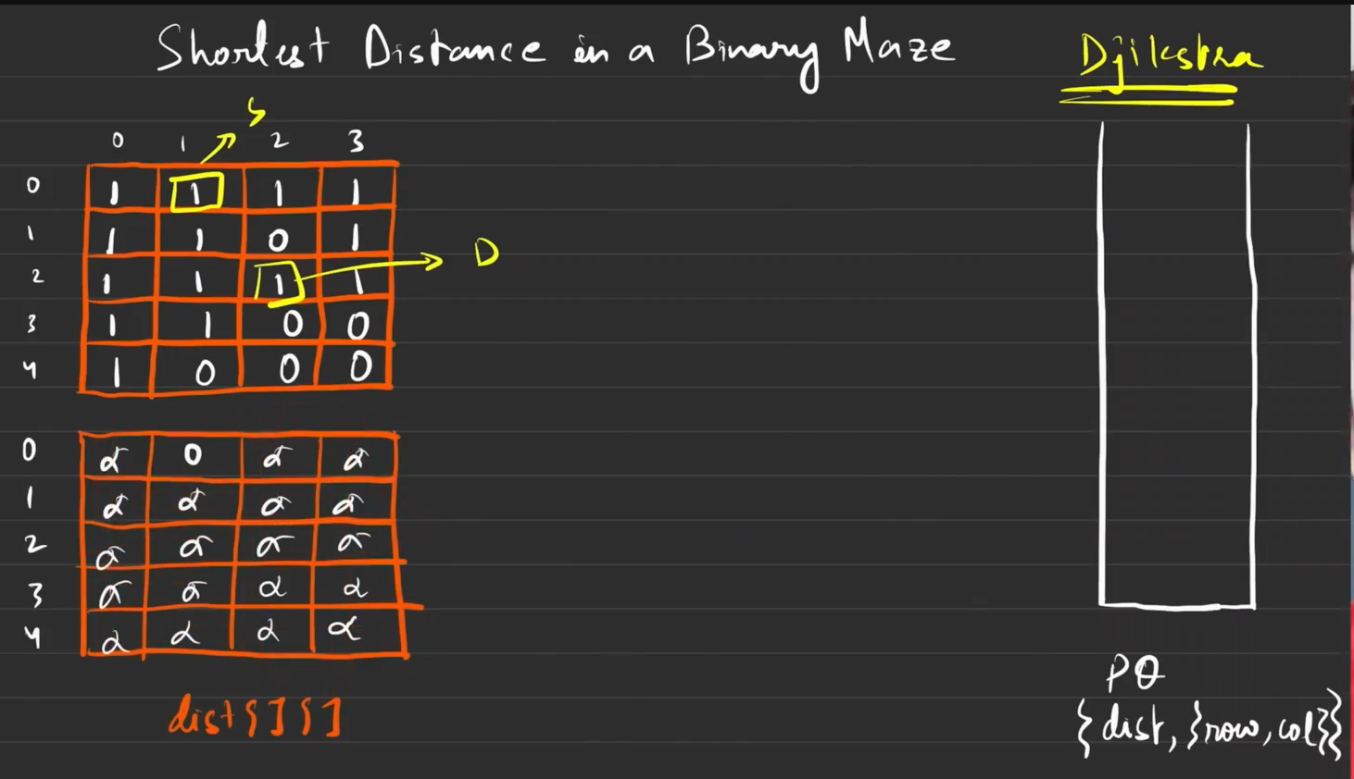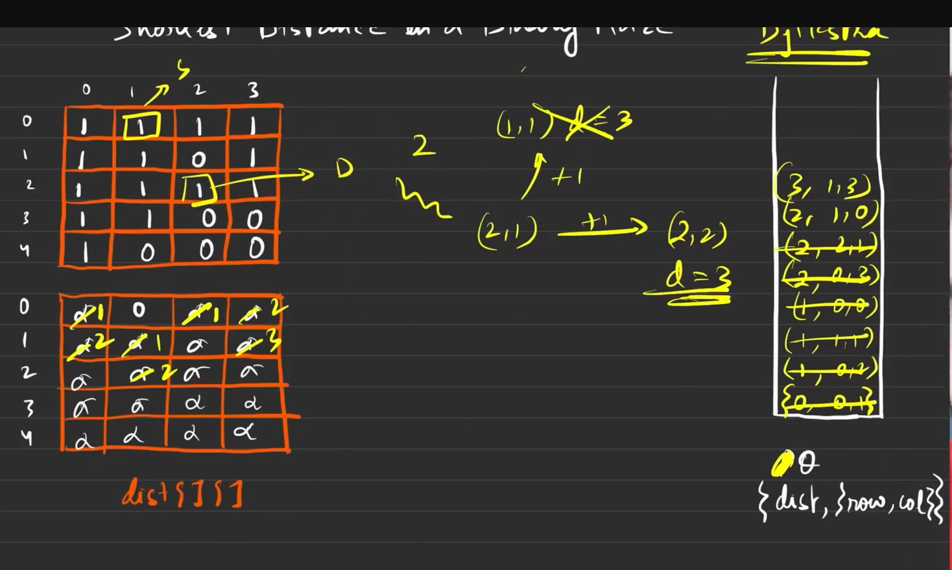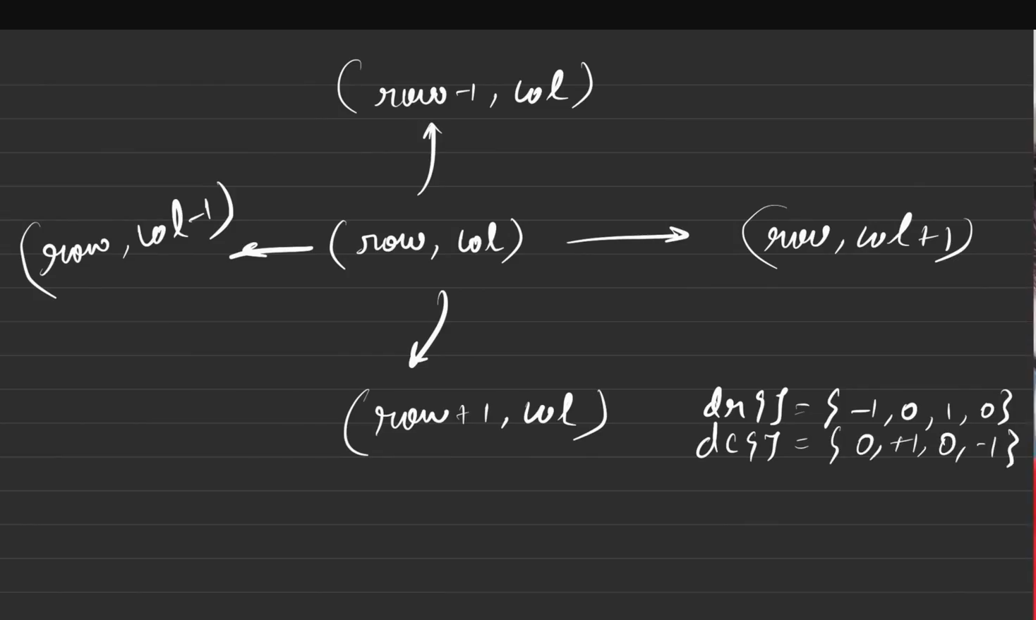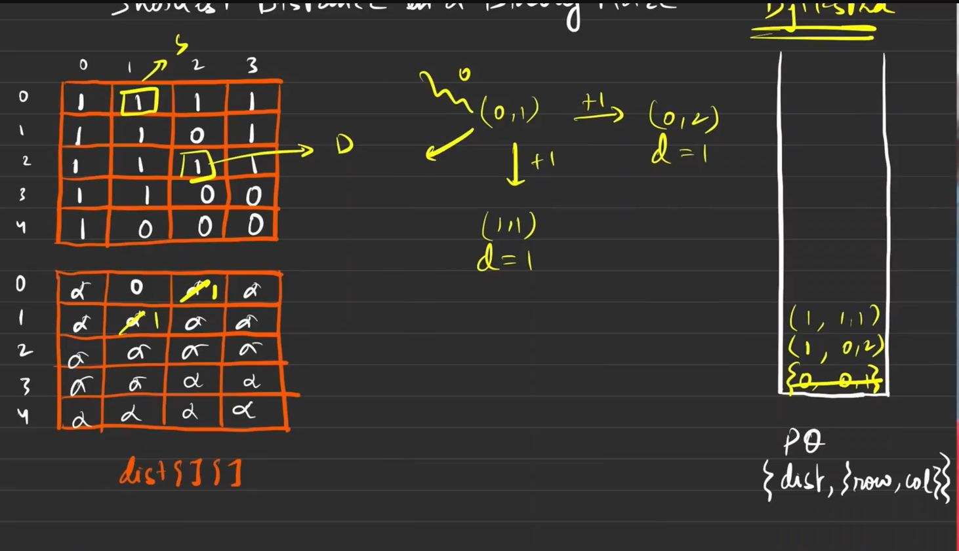
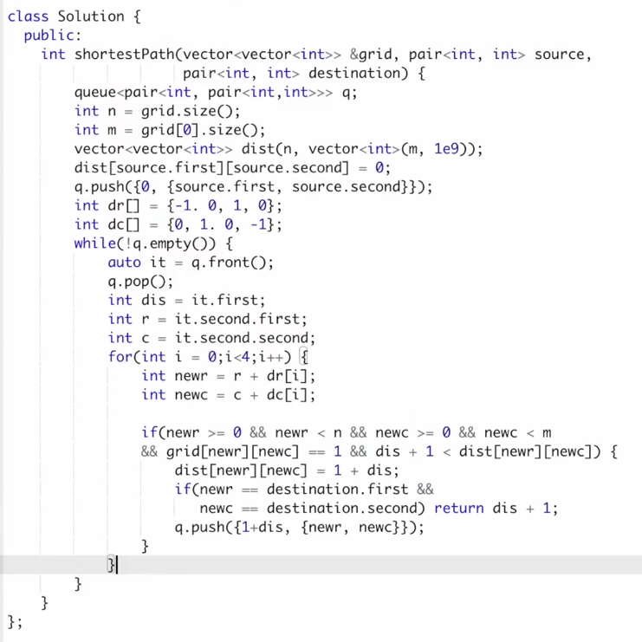

Path with minimum effort

Procedure:

- Declare a diatance vector initlayy holding inf.
- Dist[source] = 0 . Push into the min heap{distance, row ,col}
- Now start traversing from the source till the end / destination. While travrsing you shoud start exploring the nodes with the maximum, the distance vector updates should be like:
  - New_dist = Max( parent_weight, height[row][col] - height[row +dc ][ col+dc ] )
  - If new_dist < dist[nrow][ncol], then dist[nrow][ncol] = new_dist

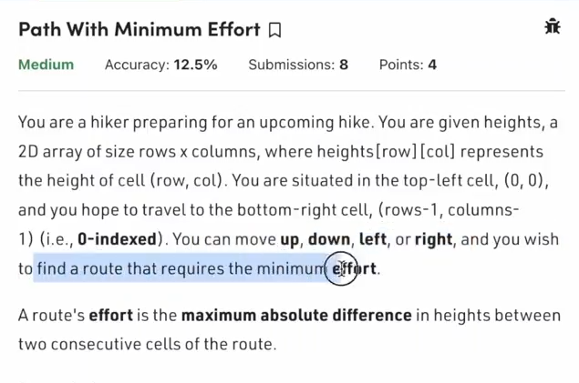
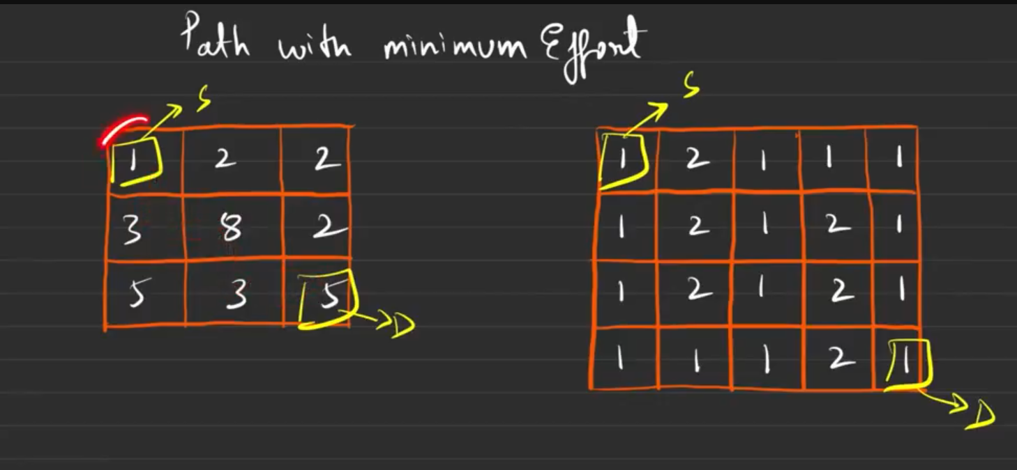
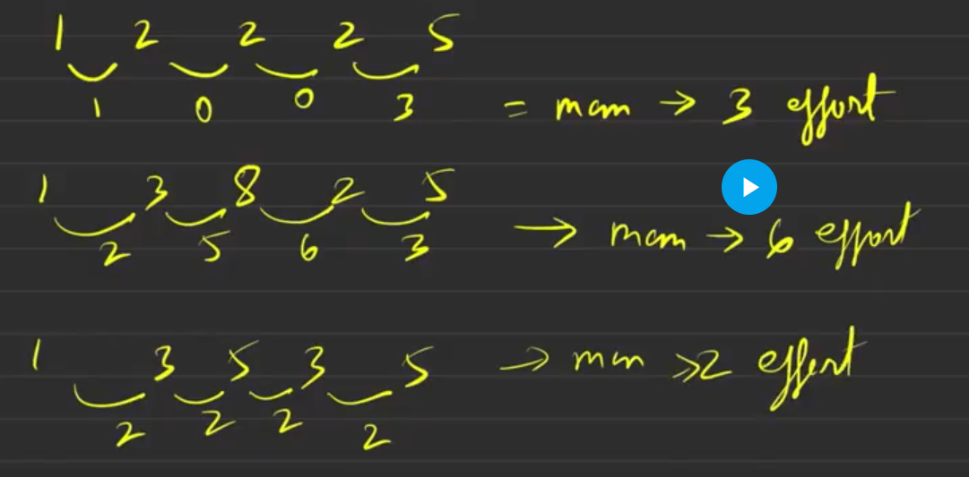
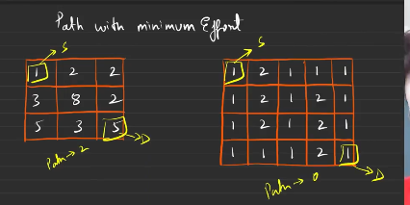
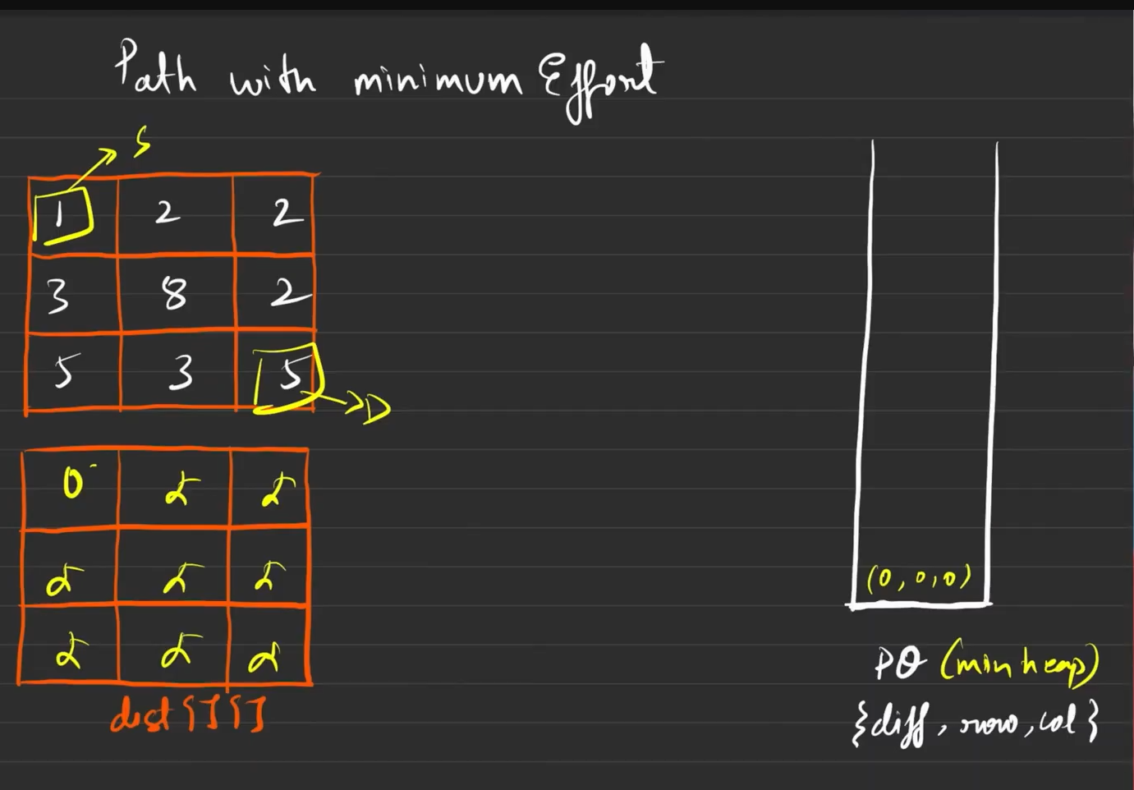
Distance is used to handle the traverse in the maximum path. Currently it is hanging with the inf as all the values in it.
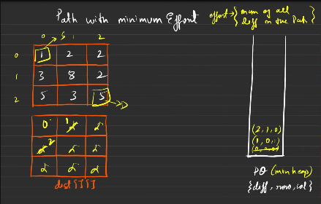
All the traversed to the new node will be there in the PQ.{dist, row , col}

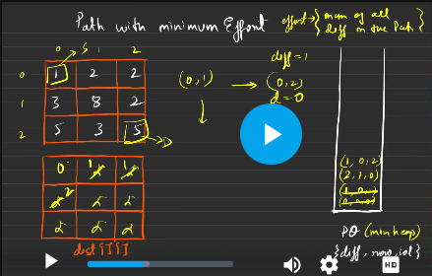
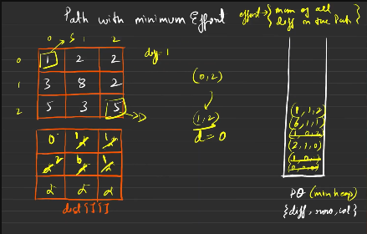
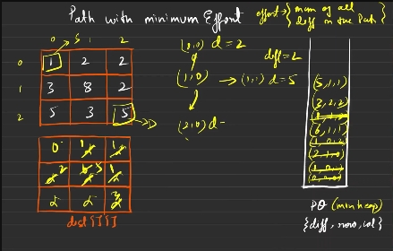
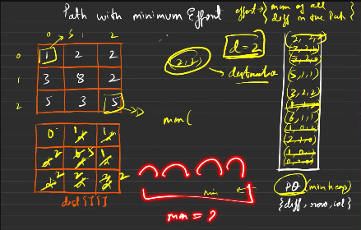
This can be solved uuing dijkstras, you will do it.
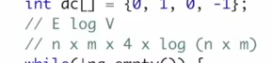

Cheapest flights within k stops

Dijkstras algo do not work here, let us see the reason why it does not work?
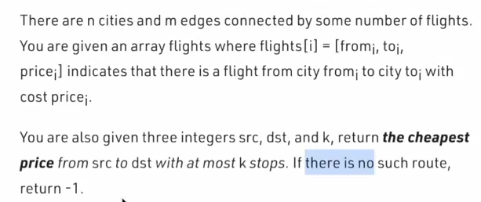

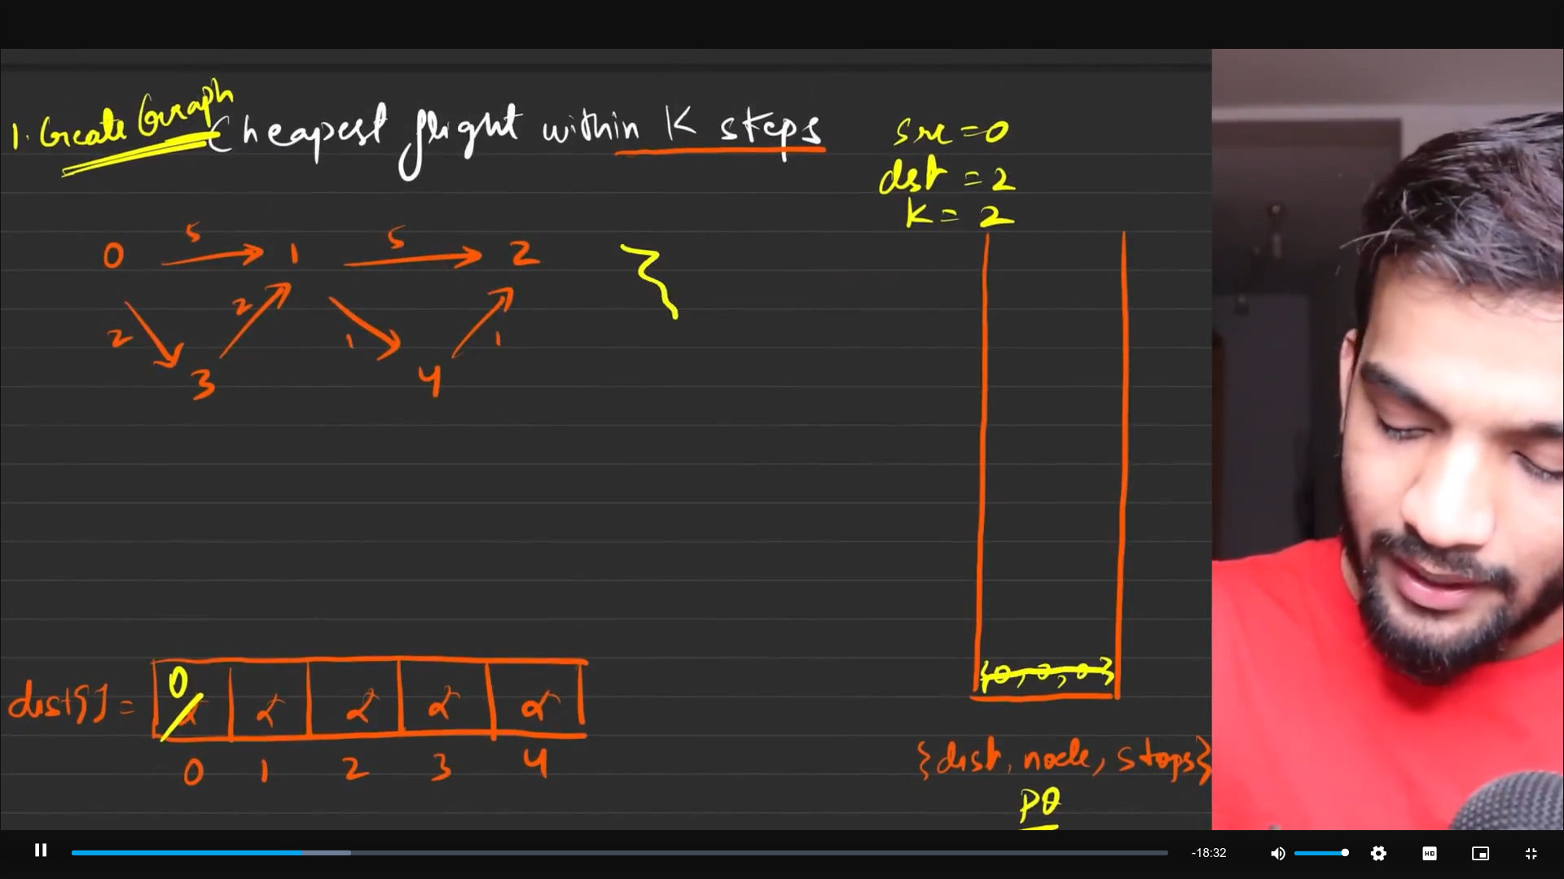
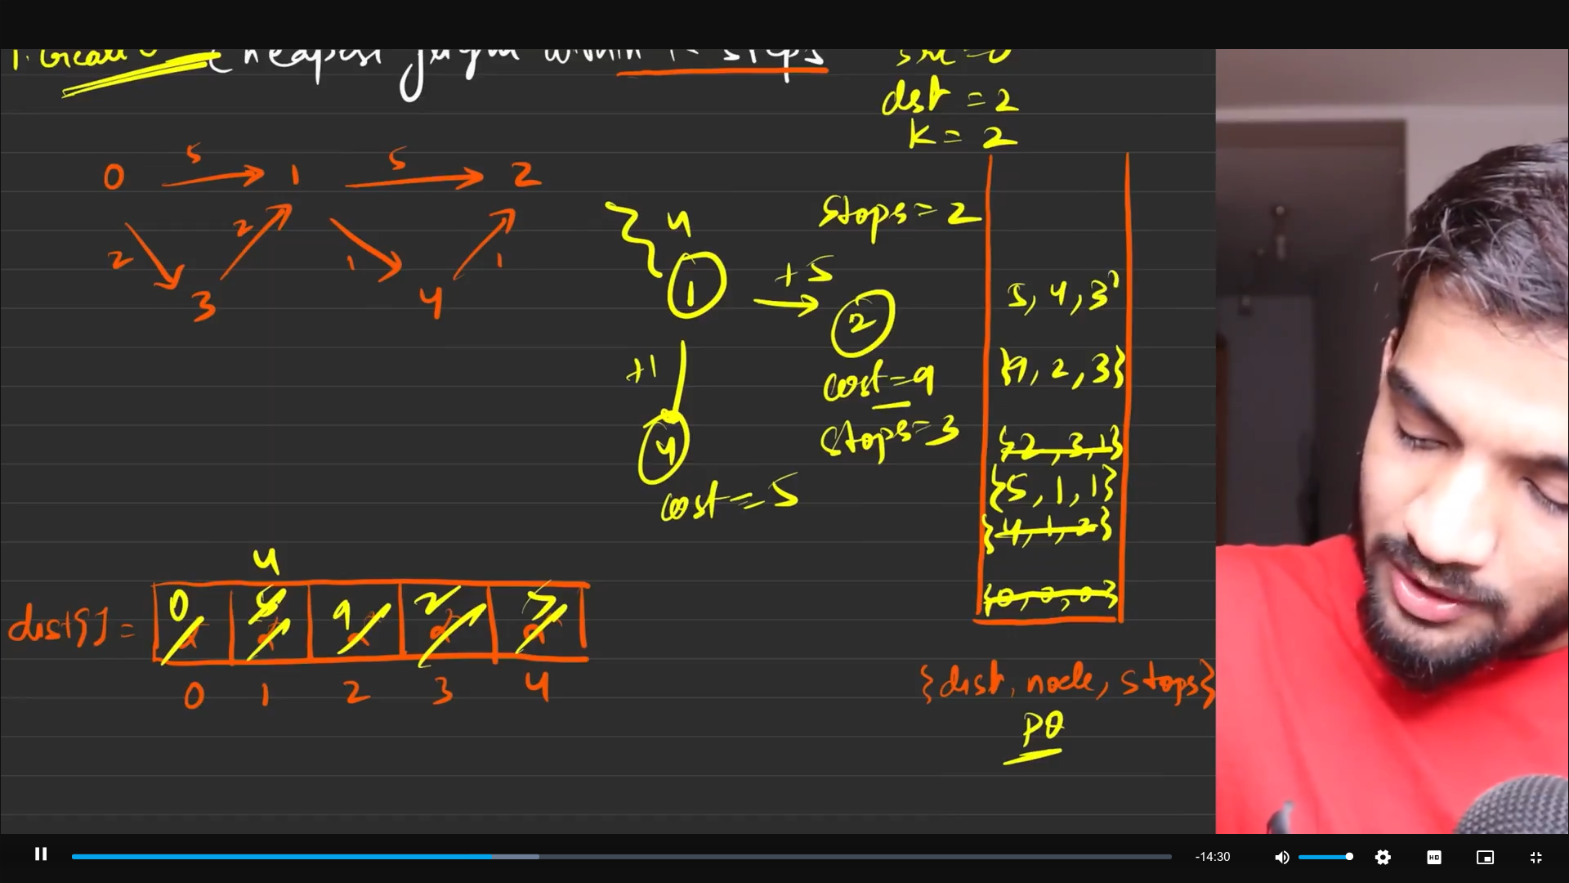
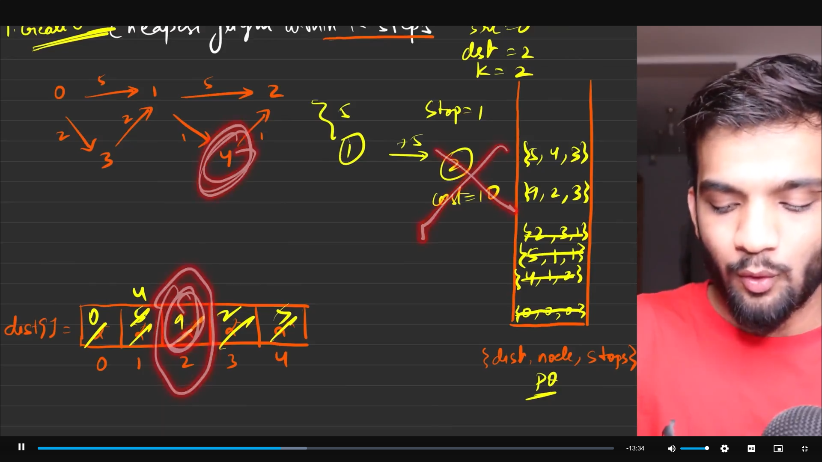
The stops that is mentioned is for the number of intermediate steps, based on the number of intermediate steps.

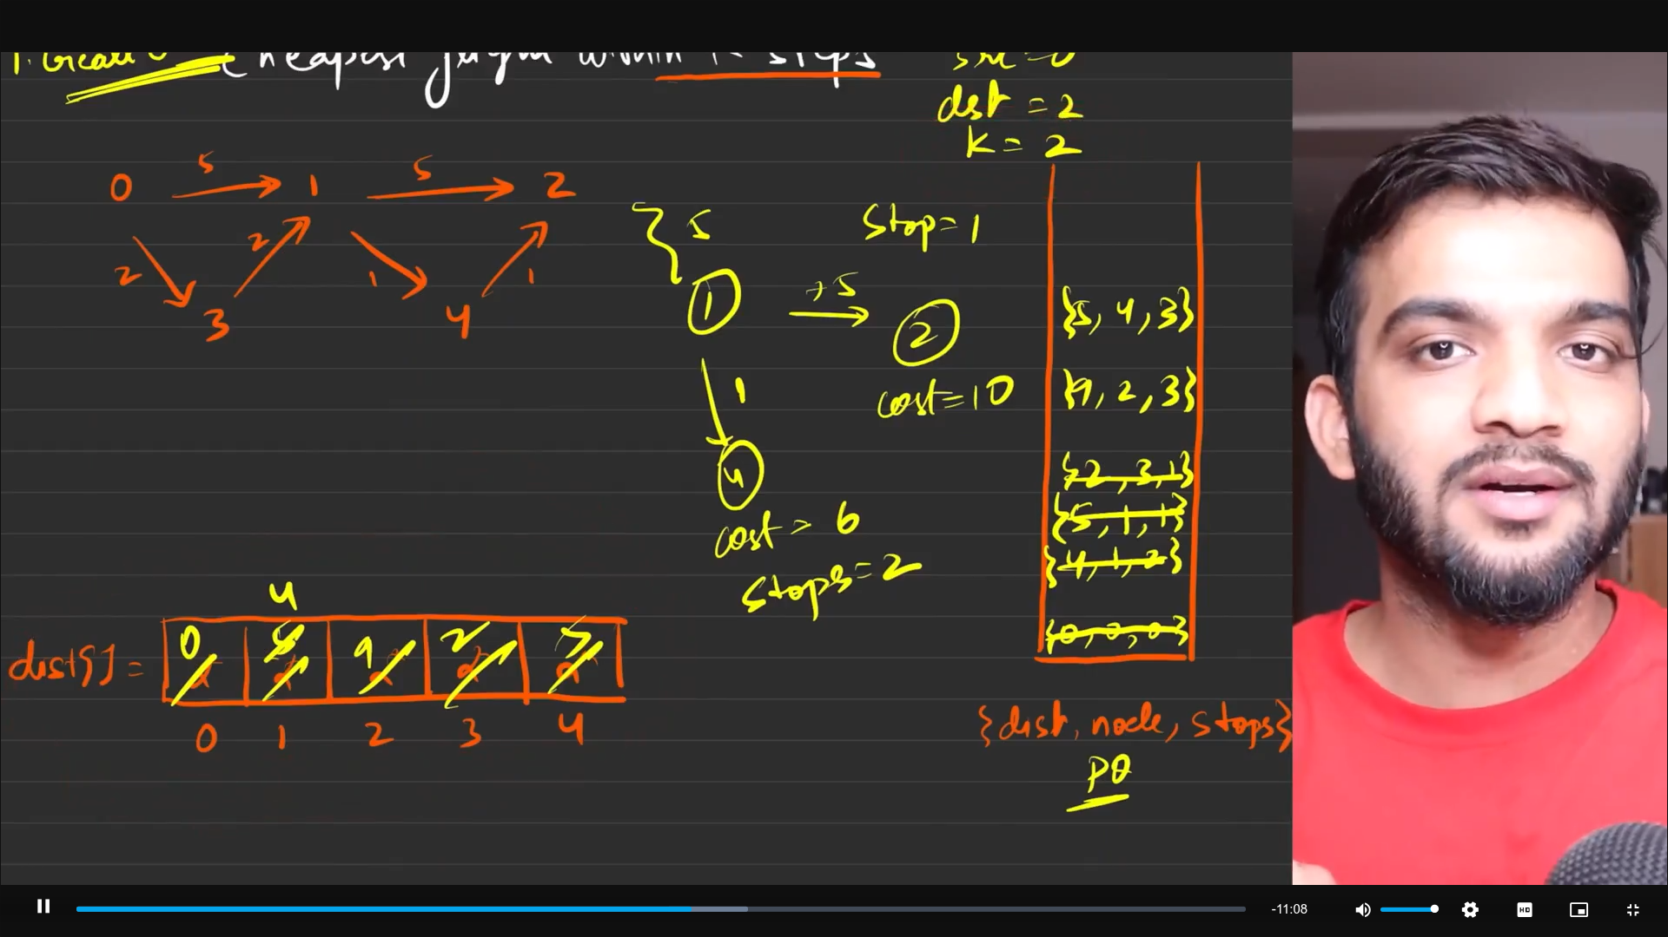
The first prority is given to the number of stops not the distance vector.
From here we can see that, the distance to 4th vertex from the source The distance
Consider the number stops = 3 to reach the 2 as destination.
0 -1-4: 6
0 - 3-1-4: 5

Here the dijskstras fail, because the distance within k steps is allowed the 5 as the minimum distance which is locked by the dijkstras. Do not let the 6th distance to be as the entry in the distance vector. Hence it will not be the path that will be explored. But actual answer is :
0-1-4-2: 7. This would have worked. 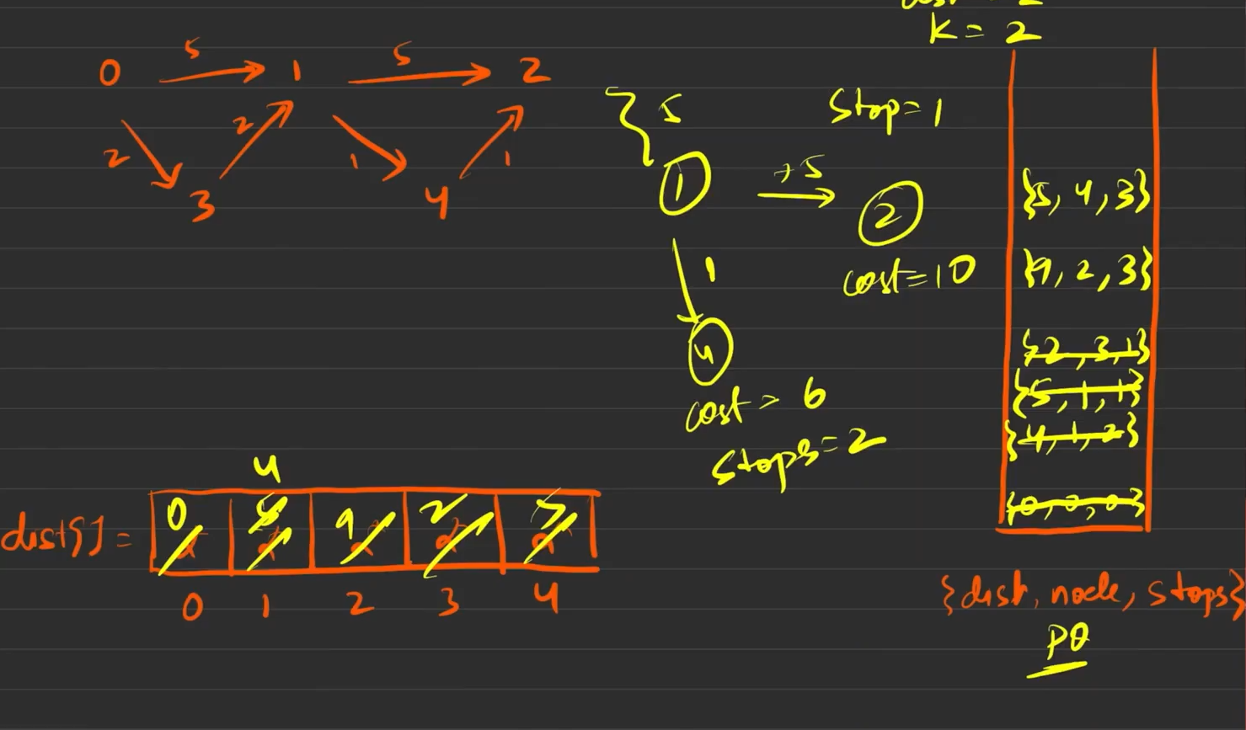
Hence if we are storing everything in terms of the distance , we will be landing at doing wrong, so we need the better way to solve.
The PQ{stops, node, dist}, this will help

Cleanly observe the queue here .
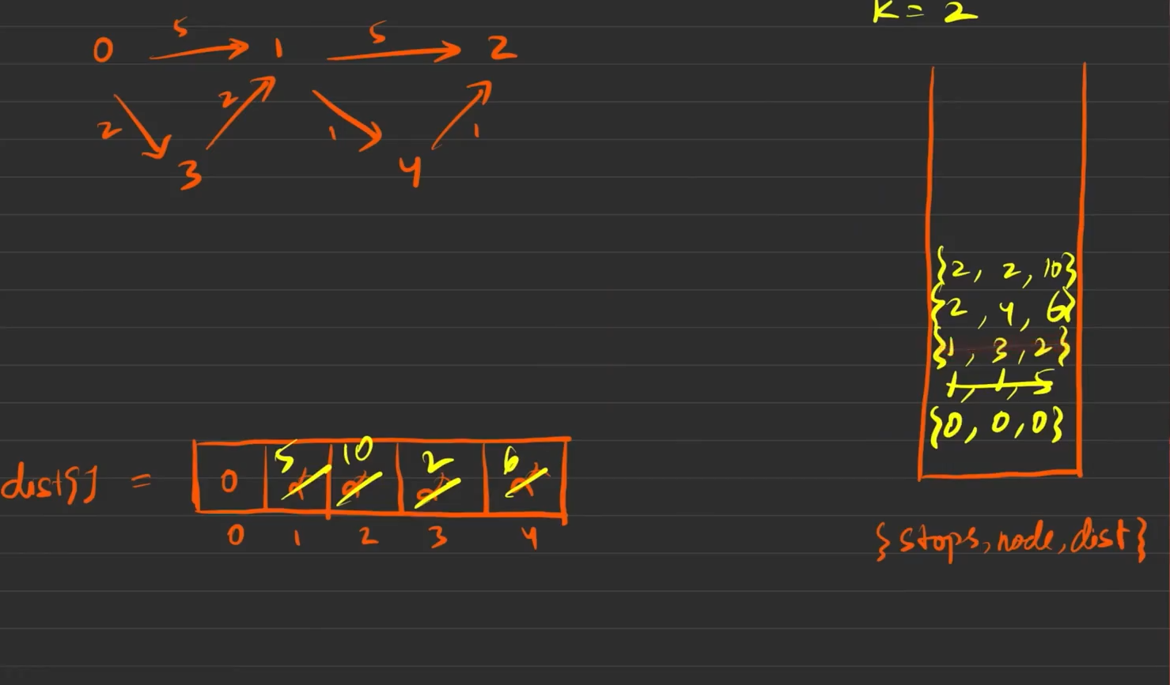
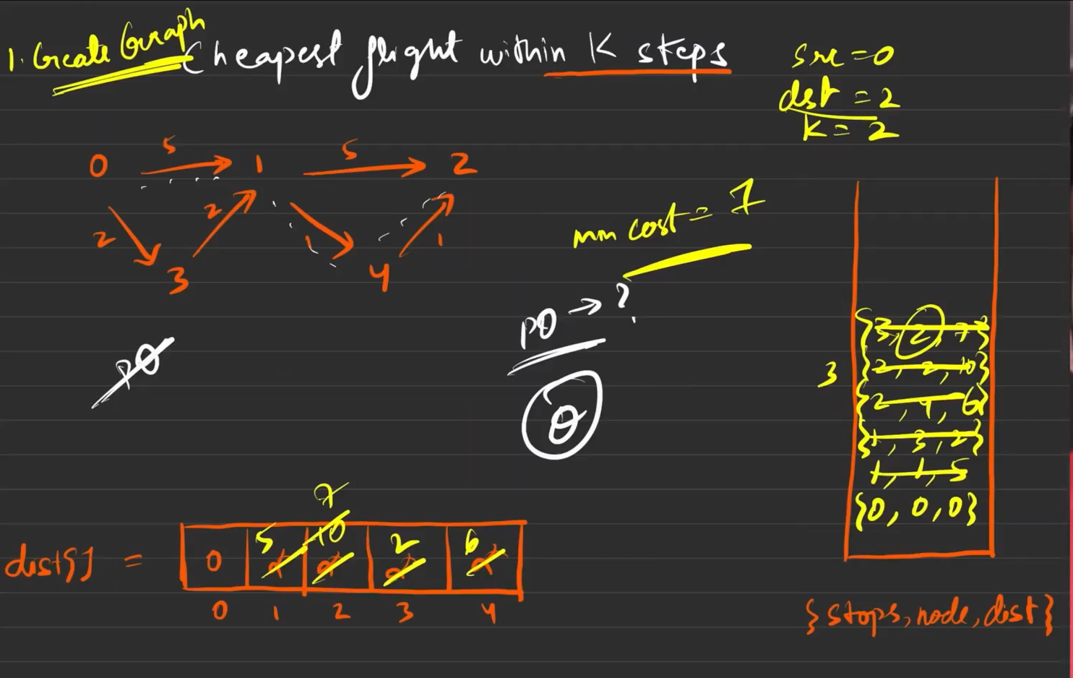
When the distance/stops is there in the increasing order then there is no need to use the PQ. Becuase PQ will incease the TC by log-n. But when the distance is there in the order, there is no need to store in PQ.
You can see it as the increment in the order, 1 then 2 then 3, so i these kind of situation it is better to avoid PQ, just the queue is totally in increment order.

