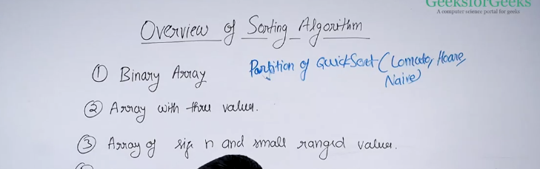
When the array is binary(only 2 different values atre present), then partition of quick sort will work better than others.
Lomuto is slower than hoare, both of them are faster than naive.
Naive requires extra space , but naive is stable.

Array with 3 possible values(0,1,2):
Elements with 3 possible values
Elements occur multiple times
Elements with all the similiar values together and the small ones are to the left of it and bigger ones are to the right of it.
This can be solved using the naive quick sort algo.

Array of size n and small ranged values
1000 =n, range is there between 100 to 200, then such things can be easilty solved using the counting sort. O(n) time.
Here k =100.
O(K) extra space, O(n+k) time
This is good algo when the range is small.
Range shall not be like O(n^2), suppose if we have 1000 number of elements, but the ranges are more like 1lkh, so counting sort is worst, hence we use the radix sort.

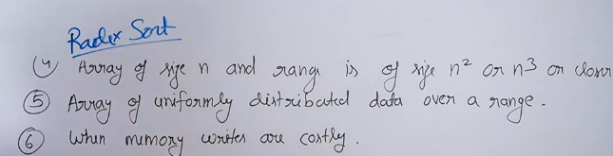
Array of size O(n) , ranges is in O(n^2) or O(n^3), then it is better to go wiht the radix sort.
It takes the time O(N), sc O(N).

When the data in the range is uniformly distributed over a range, use bucket sort
O(n) in average.

When memory writes are costly , eeprom
- Selection sort - simple algo, which makes the minimum swaps.
  - WC TC: O(n^2)
- Cycle sort - O(N^2), but better the selection sort when writing.

When it is allowed to sort only the adjacent elements;
use the bubble sort
Genralisation of buubble sort which works better then bubble sort, which is called cocktail sort
Bubble sort move from left to righ
Cocktail sort moves from both the sides

When array is small
- Selection sort -
- Insertion sort -

When available extra memory is less
In embeded systems
Shall sort
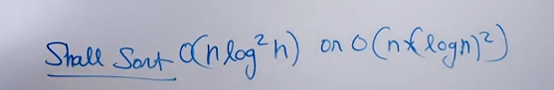
It do not use the extra space

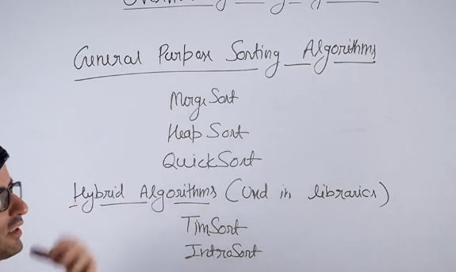
Merges sort and heap sort works for O(n logn). Quick sort works better when we have the best and average time in worst case it goes for O(N^2).

Merge sort is stable , it works better for linked list.
Heap cannot be worked on the llist, since it annot access in randomly
Qucik sort also requires the random acces but it can work as good as the merge sort on LL
Msort : reduces to O(1), when it comes to space complexity. It is a stable sort.
This can work well when we have tape drive , we suited for external sorting

Merge and quick is both are divide and conquer, paralise very well ms - log^2 N, qucik sort logn

Hybrid sort:
Timsort in python-
combination of merge sort and insertion sort
Merge sort – for general input and when input becomes small it switeches to insertion sort

Intro sort- quick, heap, insertion sorts combination
It uses quick sort in general
When the reccurion depth goes beyond the n*logn , then it shifts to heap sort
This is normally used in cpp.

Stable sort- is used using the merge sort

C++ stl function

sort(iterator1, iterator2)
sort(iterator1, iterator2, greater<type>)
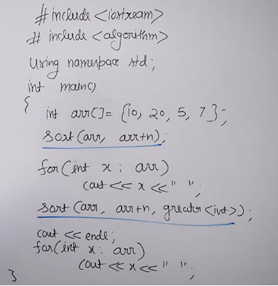
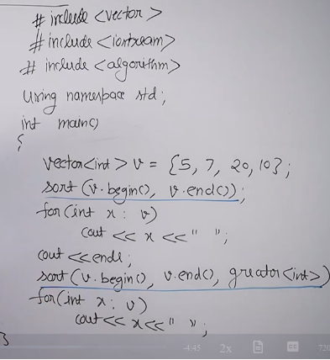
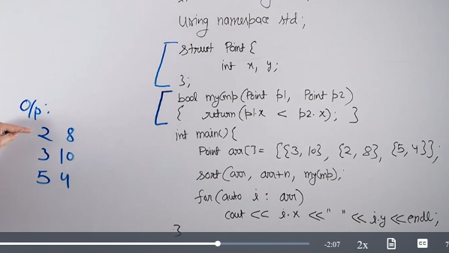
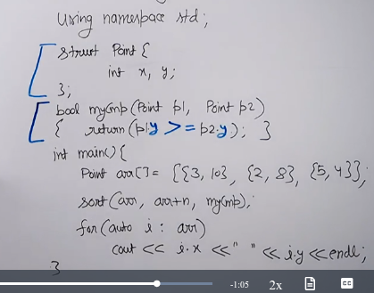
Above is used to sort in decreasing order of the input

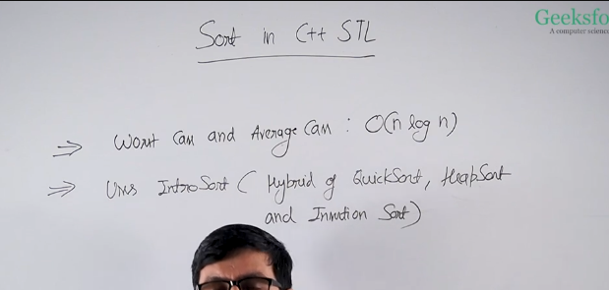
Stability in sorting algo:

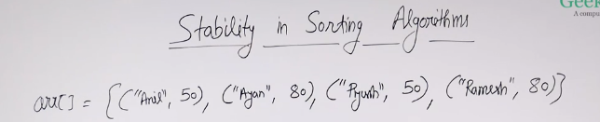
When the result of the result making sure (Anil, 50), (Piyush, 50), then it is called stable sorting.
If (Piyush, 50), (Anil, 50). This is not called as stable soting.
If the order of elements in the array remains the same as the original for the elemnts which are having the same value to the field on whoch we are sorting .
This is useful when we have objects with more than one field.
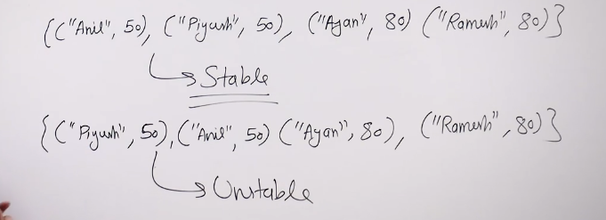
Unstable can result in the same as the stable.
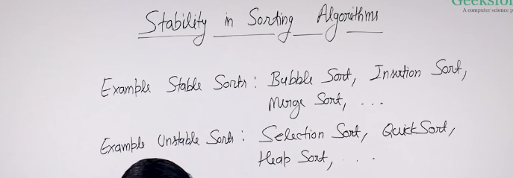

The order in which the elemnts are present before the sorting for similiar kind of elemnts , the same order has to be maintained even after the sorting then such a sorting is called the stable sorting.

Bubble sort

In each and every iteration one element is passed to the end , that is the biggest element.
This we keep doing it untill all the largest elemnt is passed to their correct positions.

QUICK SORT

GIven a element’s index, all the elemnts which are less than or equal to arr[ind], should come before arr[ind], and the elements that are higher than that should come after that arr[ind].
But the elemnts should be in teh corerct position.
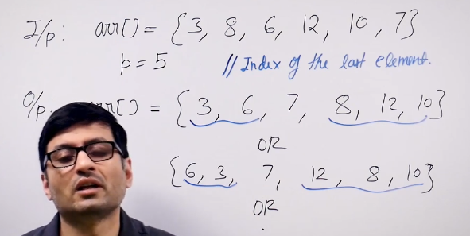
P is the partition index array.

Naive partition:
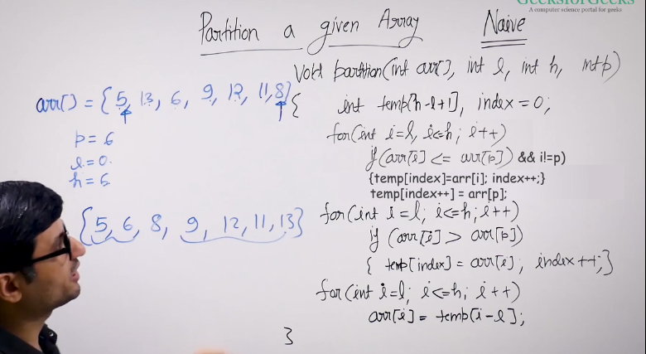
- Traverse the whole array once to know which are all the elements are there in the arrya that are less than or equal to the pivot element.
- 2nd traversals are done to know which are the elements that are greater than pivot element.
The above 2 is used to push the element to the temp array.
- Then 3rd traversal is there to copy all the elements that are there in temp array to the original array.

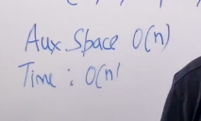
Hence there are 3 traversals, how to do it in only one traversals? – Lomuto partition

Lomuto Partition
It is going to traverse the whole array only once.
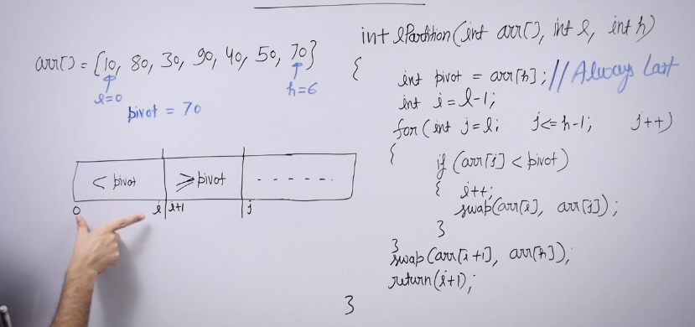
In the previous here was given the pivot as input, but in this we are going to consider pivot always as last element.
pivot = arr[last index]
All the elements with the index less than or equal to i should have should have the elemnts that are less than pivot.
All the elemnts that are more than i should have the elements that are greater than or equal to pivot.
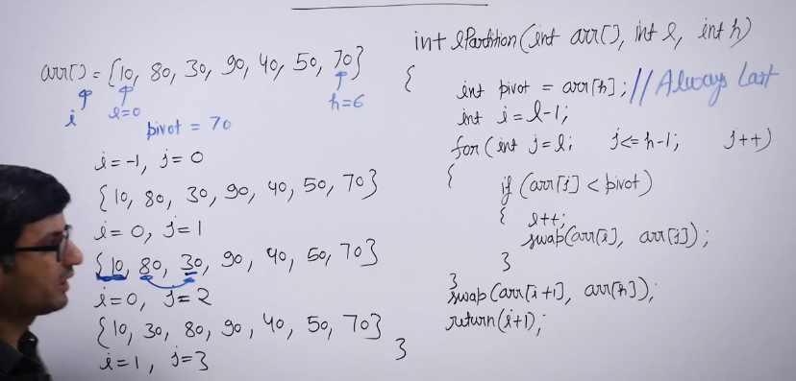
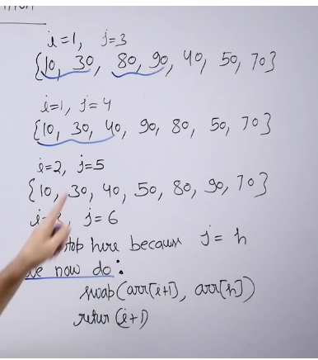
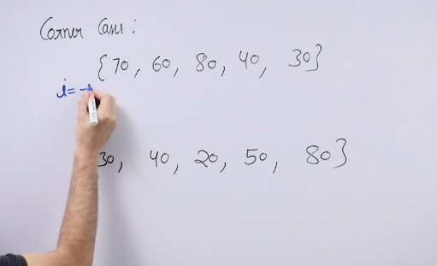
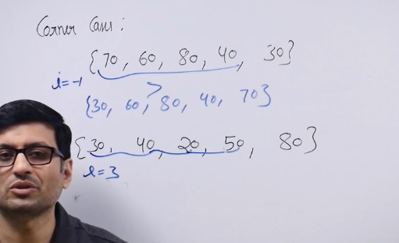
The lomuto partition will work only with the last element.
So when some element pivot is given as inpu, then we need to swap with the last element given index, the apply lomuto partition.

Cpp:
- Sort
- Stable sort

Intro Sort –
is a hybrid sort and not stable
Qick + heap + insert

C: qsort
Java :
primitive data types– Q sort
Non primitive data types – timsort

When we need stabilty then merge sort is th ebest choice.

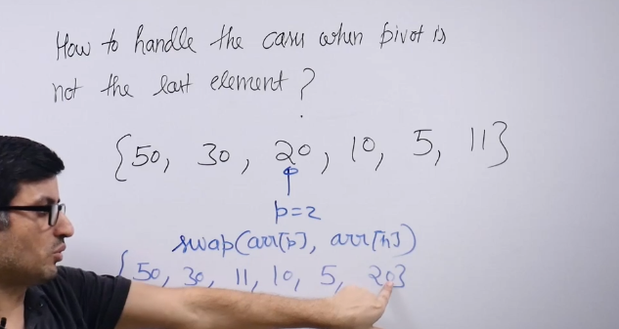
Tc – O(n) Sc- o(1), it travels for one time in the array.
The hoares partition works better than lomuto partition.

Hoare partition
We consider the first element as pivot index element .
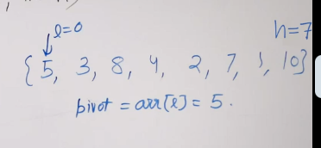
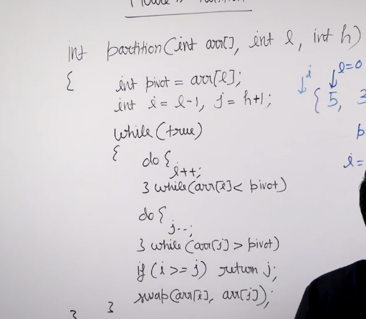
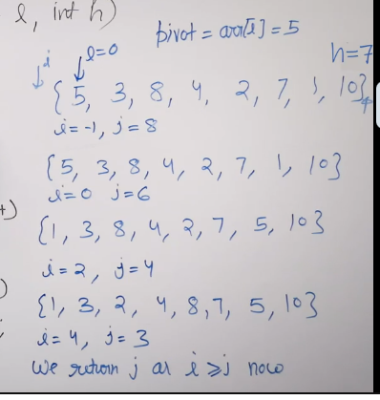
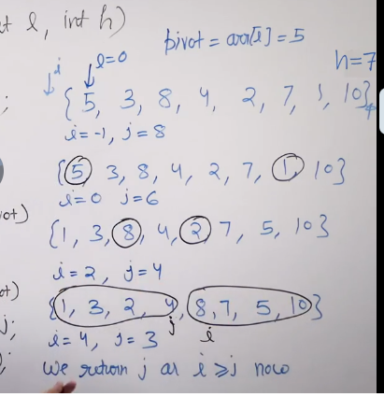
All the elements on left are smaller than all elements on right.
It ensure that only the elemnts that are smaller than the pivot is present till j(left), and all the elements that are greater than j is bigger than the current element.

but in lomuto partiton index is the place where we can see the element, the left is less than that and the right elements are high than that.

But in practical, this hoares partition will take less comparision compared to the lomuto partition.

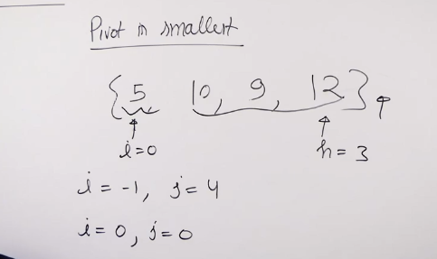
When the pivot is the smaller, the j is going to come towards i(start) index. Hence when they are on the same index, it will return.
Similiar thing happens when then pivot is chosen as the highest , the j element will remain as it is , since the higest is selected, all the elemmnts to the left is smaller, the i will be moving till the j index, hence they will be swapping.
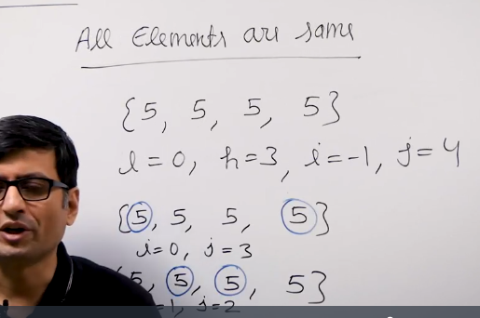
This is the reason why quick sort is not stable sort.
Less than the keep going towards right, more than then keep going towards left.
When larger is seen on the left and the smaller is seen from the right , then swap those elements.
The lomuto partition is also not stable.

The naive partitions is stable, because we are going to create auxiliary array and based on that the element is inserted into the array.

QUICK SORT

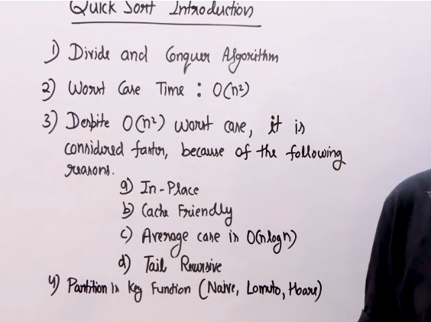
Divide the whole array into parts and then it sorts the 2 independent parts and then the process starts.

- In merge sort, the merge part is complex, splitting is not problem at all.
- Merge sort is devide and conquer.
- In qucik sort the partition is complex.
- Quick sort also follows the dviide and conquer.
- The reason why this is chosen over merge sort is mentioned above.
- Since it is tail recursive , we can convert the tail recursive to the normal for loop.

QuickSort using Lomuto Partition

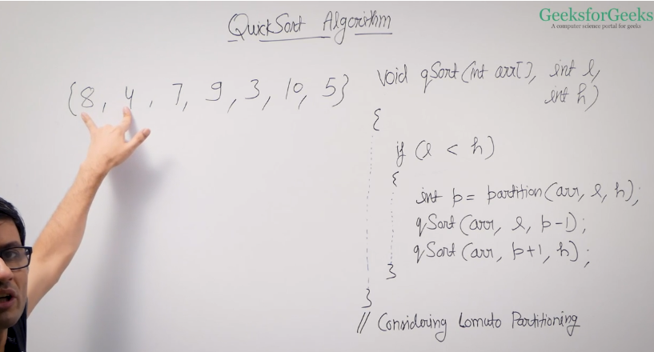
Lomuto returns the partition index of the partition of the element
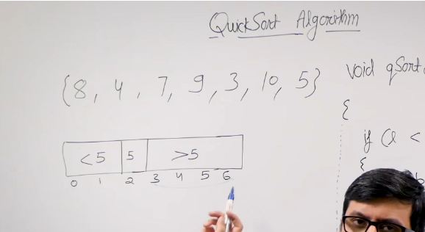
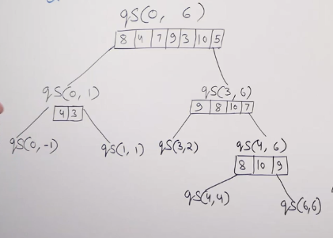
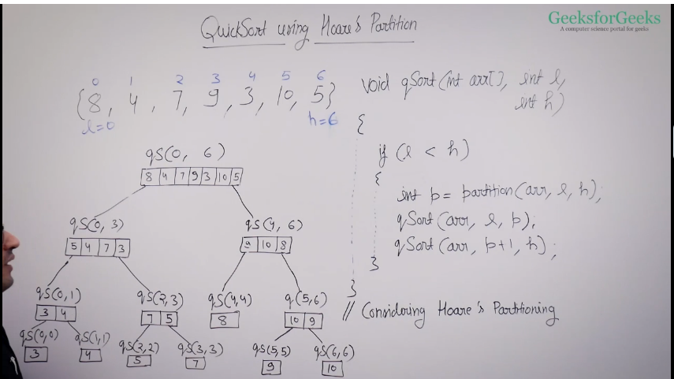
Hoares partition is approximatley 3 times faster than the lomuto partition this has been shown in some studies

If anybody wants know how does the quick sort has became the unstable algorithm , then let them know by taking the trace for the array filled with the same element.

Lomuto and Hoare is not stable.

Best case:
When the partition is always divides at the half then TC is best.

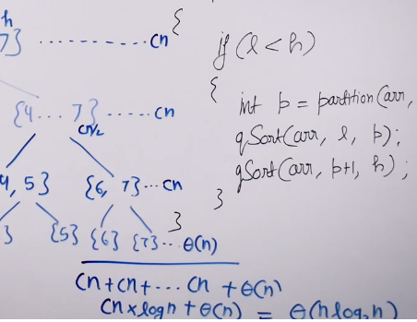
This the best case.

Worst case:

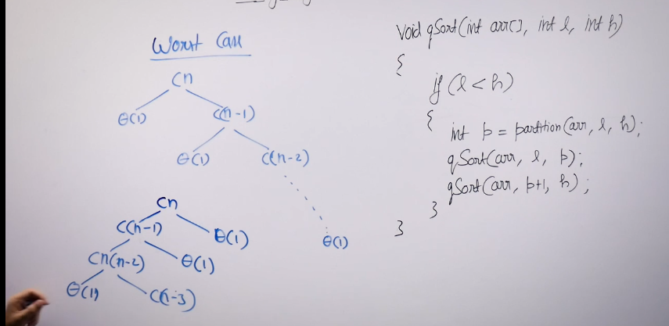
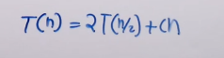
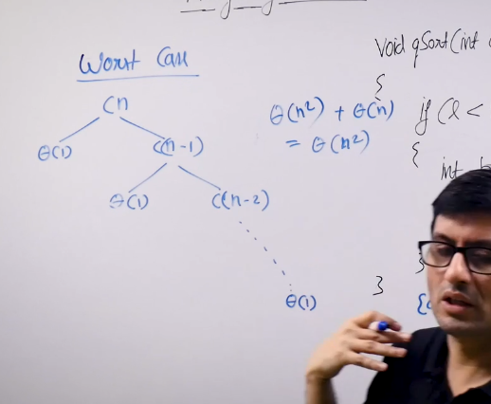
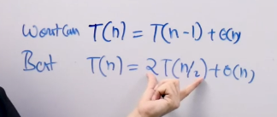
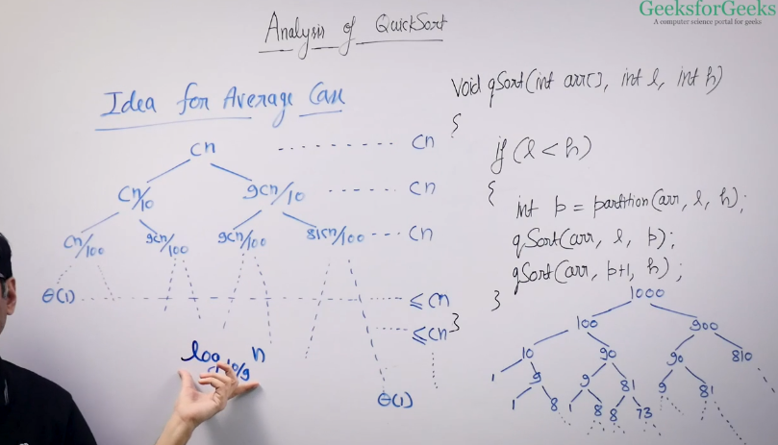
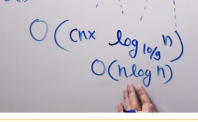
If you consider the space for the recursin stack then space complexity is O(n).
Best case happen when we have many number of elements.

Conisder the sorted array and if you are applying quick sort there then we lead to the worst case. Because lomuto always chose the first element and hoare will always chose the last element for partition.
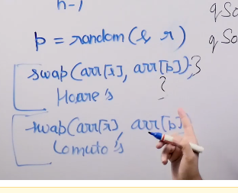
When you are applying the hoares partition and lomuto partition,first replace the particluarr lement in the algorithm shall be replaced with the randome element , then apply the hoare or lomuto partition.

Modern compilers

If the recursive call is the last call, then we can eliminate the tail call reccursion using the loops or using the goto function.
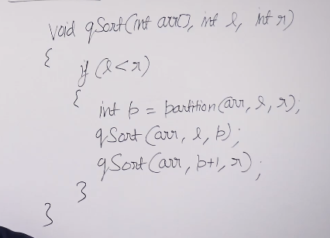
Otpimise
