HEART DISEASE MLOPS
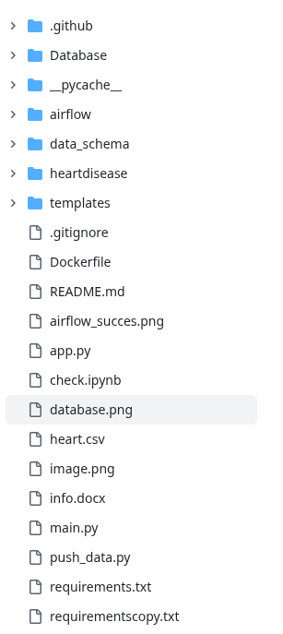

Airflow:
It extracts data from the github, which is there in the form of csv.
Then transform it using to the json format so that inserting to the Atlas DB becomes easy- Transform
Then load the converted data into the Atlas DB Mongo DB.
These are done using the @Task (on each definition) decorators and the task dependncies are set using the function calls.
Below is the way to create dag:
with DAG(
dag_id='ETL_WITH_HEART_DISEASE',
start_date=datetime(2025,6,3),
schedule='@once',
catchup=False,
) as dag:

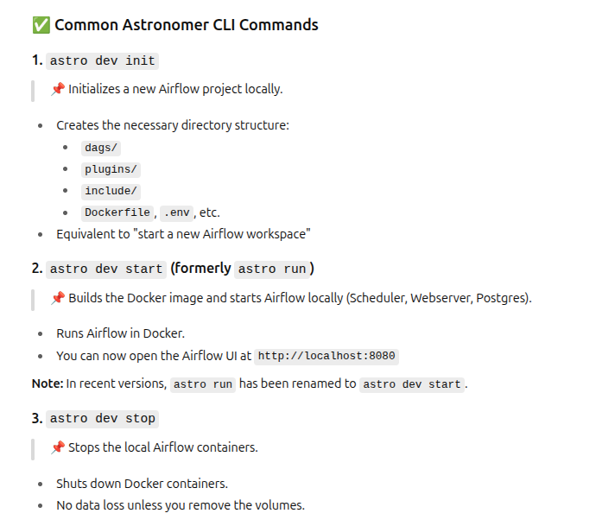
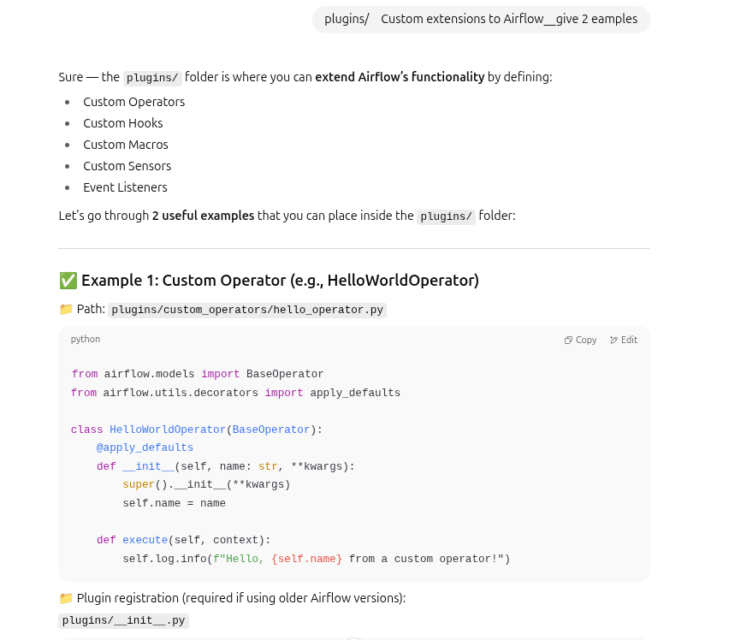
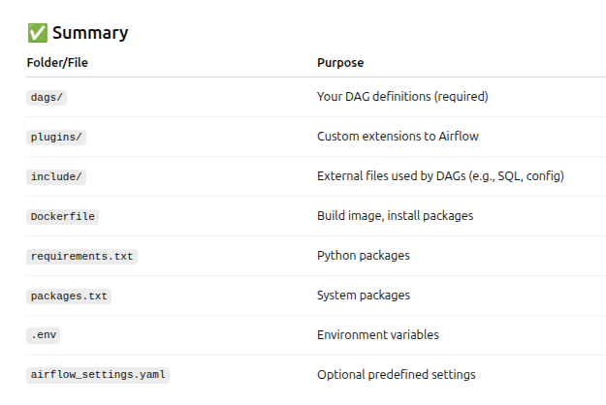
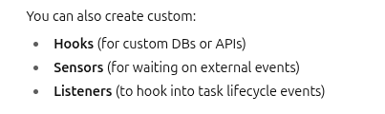

Templates(Folder): these have the html that is required to make the flask application.

Data_schema(Folder): It has the information about the columns in the dataset and the type of each and every column.

Database(Folder): It has the database in csv, is saved after downloading from mongodb and tranforming to the from json to the csv format.
Heartdisease(main project of MLOPS folder):
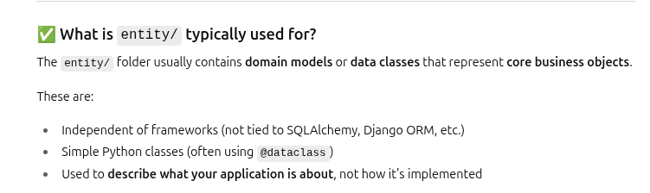
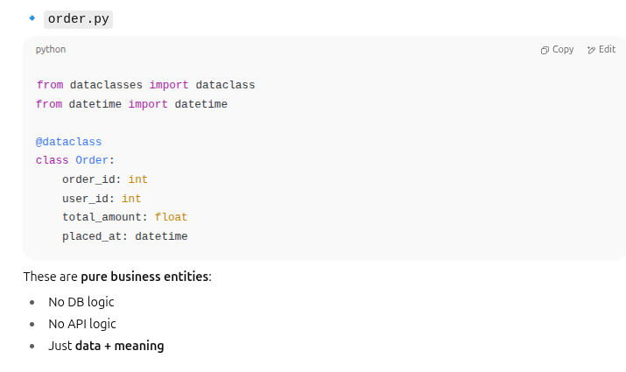
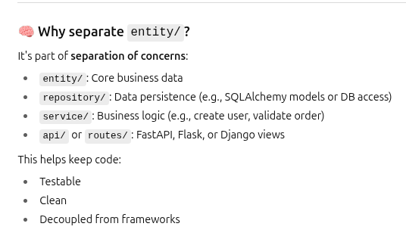
This is what it is there in my project:
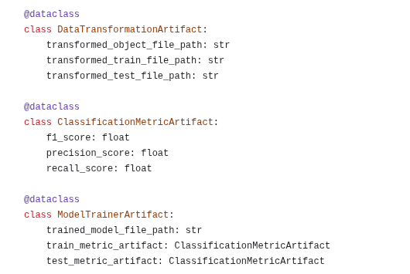

Constant folder: Training pipeline
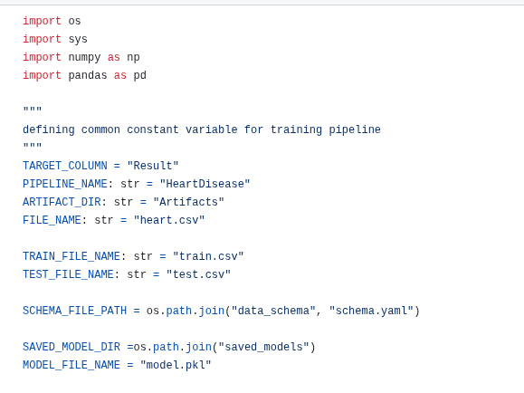
Exception: When there is something wrong occured then that has to be noted somewhere , for the sake of debugging.

s

model_f1_score = f1_score(y_true, y_pred)
model_recall_score = recall_score(y_true, y_pred)
model_precision_score=precision_score(y_true,y_pred)

