It is the combination of the hand written notes and the digital.

ML-2 end has the notes

**LANG-GRAPH CORE COMPONENTS**

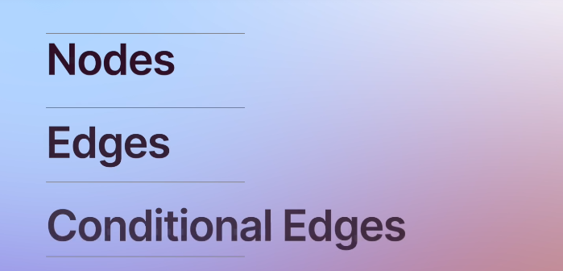

Nodes – python function any .py, llm agent, llm call

Input: Current graph state, which is needed for the current node to work

Output: Update the state

Edges – connect those nodes

Conditional nodes – used whenther to go to node a or node b

2 important builtin nodes in langgarph is:

1. Start NODE and END node

Start node - is an entry point for node execeution

End node – is the last node that need to execute

Both of the above are NOP(no operation) nodes

**AGENT STATE**

It is simply a dictionary, important for keep tracking the graph, node execution result and temporary results.

Simple state – store chat history

Complex – sutomise what we want

It can vary from simple to complex

It is local to the graph

It is available on the node and also on the edges.

It is available n each edge and it can be related to a graph

It can be presisitant, stop and continue later.

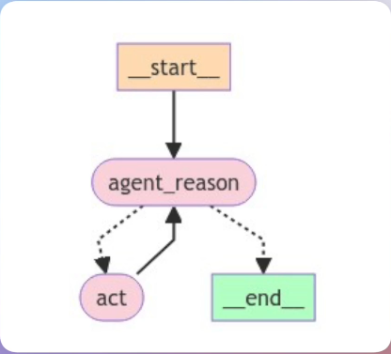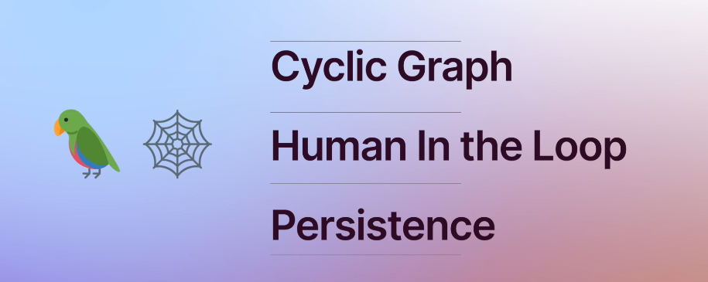

Cyclic graph:

Human in loop: Get the human feedback

Persistance: helps in persist and make the fault tolerant

**REFLECTION AGENTS**

