|  |  |  |
| --- | --- | --- |
|  |  |  |

Invites applications for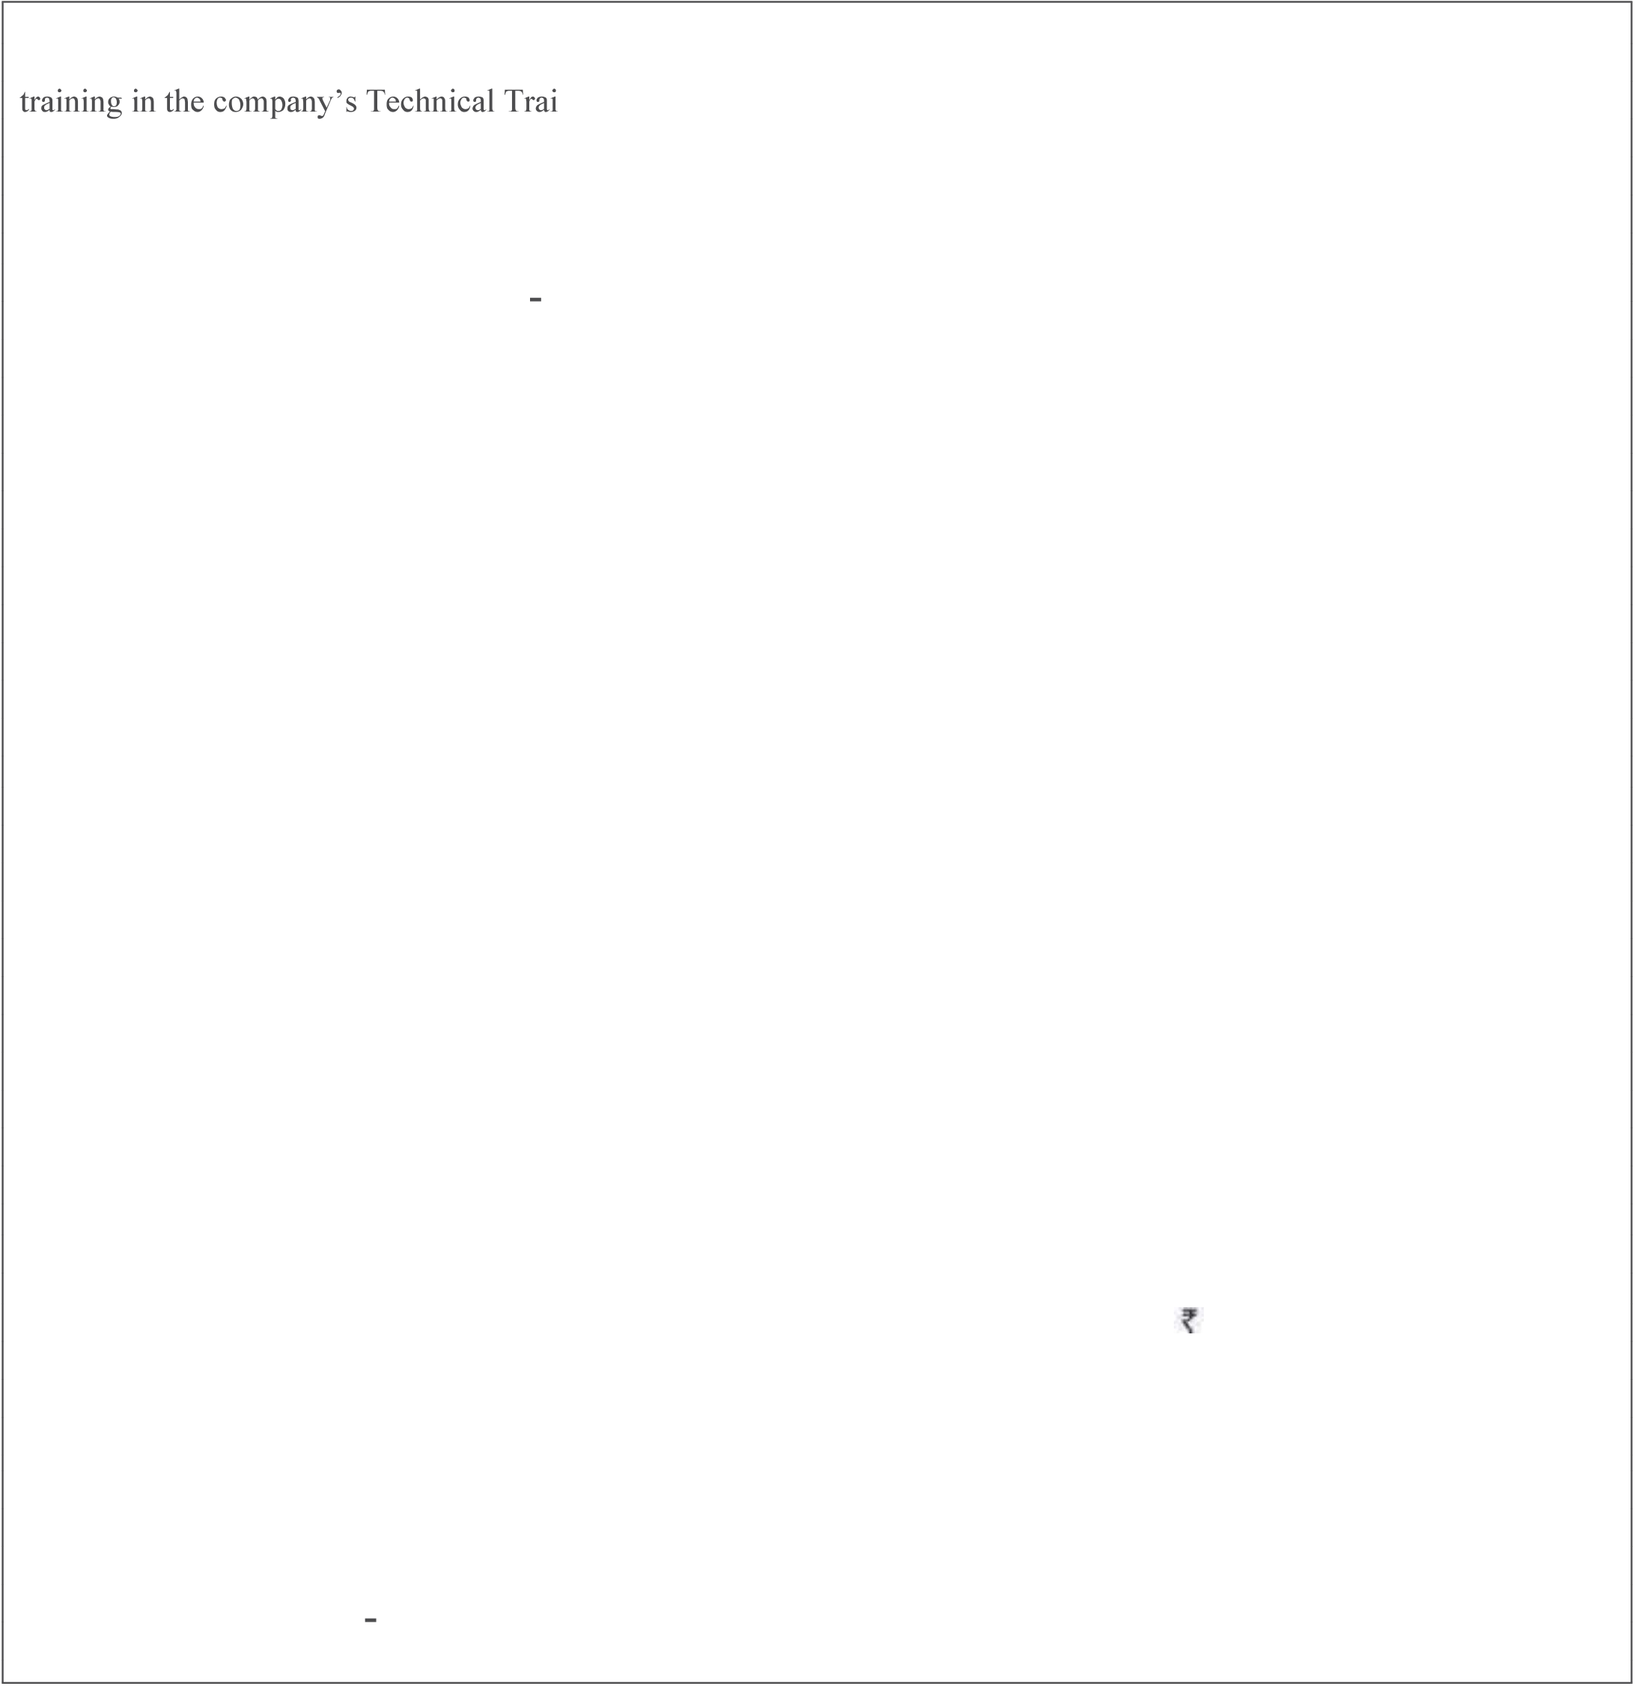

|  |  |
| --- | --- |
| **JUNIOR ENGINEER TRAINEE (JET)** | **2022 Batch** |

**Location- Uttar Pradesh**

**ADVERTISEMENT NO: SNTI / REC /CA / 66 /22 dated 18th March'2022**

**(ONLINE REGESTRATION OF APPLICATION: FROM 27.03.2022 TO 02.04.2022)**

**ONLINE EXAMINATION: 15th April-22**

Tata Steel is looking for young and bright diploma/degree holders in Mechanical / Electrical / Metallurgy/ Electronics/ Instrumentation/ Mining/ Mine Surveying to join as Junior Engineer Trainees. Selected candidates will undergo 12 months ning Institute before placement in the plant.

On successful completion of training, candidates will be placed with position of **Junior Engineer-1** which is a critical position with challenging assignments in operation and maintenance of plant and equipment. The job also requires leadership capability and participation in improvement initiatives to consistently achieve excellent operational results.

**Minimum Educational Qualification:** 3/4 Years full time Diploma in Engineering (Mechanical / Electrical / Metallurgy/ Electronics/ Instrumentation/ Mining /Ceramics/Chemical/Power engineering) recognized by AICTE/UGC  
 OR   
Diploma in Electronics / Mechatronics from RD Tata Technical Education Centre, Jamshedpur   
 OR   
Diploma in Electronics / Mechatronics from J N Tata Technical Education Centre, Gopalpur   
 OR   
Diploma in Electrical & Electronics / Mechatronics from Tata Steel Technical Institute, Burma mines

Candidates **in final year of their academic session leading to award of Diploma by July 2022 are also eligible to apply.** The selected candidates must submit certificate of completion of Diploma by 30thAugust 2022. Training of those selected candidates who fail in their Diploma programme or are unable to produce the pass certificate by 30thAugust 2022, will be terminated.

**Marks:** Minimum 60% (aggregate) general male, 55% for general female, 55% transgender and 50% for SC/ST.

**Age:** For All General Candidates: Should have been born between March 1st, 1997 and July 31st, 2005 (both days inclusive) For SC/ST/Transgender Candidates: Should have been born between March 1st, 1994 and July 31st, 2005 (both days inclusive)

**Domicile**: Uttar Pradesh

**Minimum Physical standards:** Height: 152 cm. (for girls 142 cm) Weight: 45 Kg. (for girls/transgender 40 Kg.) Expansion of Chest: 5 cm Eyesight: 6/6 in both eyes with glass Power of Glasses ± 4.0 maximum Colour Vision: Normal

**Duration of Training:** 12 (Twelve) months.

**Stipend and other details:** The candidates undergoing training will be paid a stipend of 15,047**/-** per month during their training period. Free hostel accommodation with food (at subsidized rates) will be provided to the eligible candidates, during the period of training only.

**Placement:** On successful completion of training, the selected candidates will be considered for placement in **any location** of Tata Steel Ltd. or any of its Group Companies or subsidiary companies.

**Registration with BOPT:** Selected candidates will be registered with the Board of Practical Training (Eastern Region) for one year under the Apprentice (Amendment) Act, 1973 subject to their eligibility.

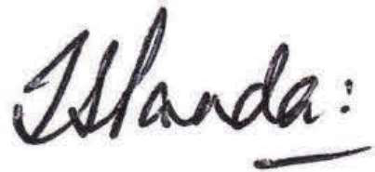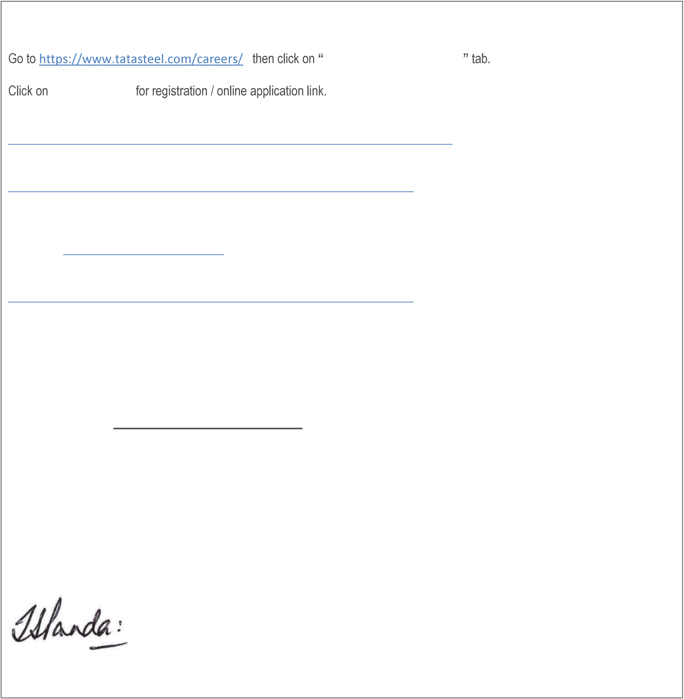

**Application procedure:**

**Apply for jobs / internship**

**Application tab**

For registration please use below link   
https://cdn.digialm.com/EForms/configuredHtml/31595/76296/Registration.html

After registration, apply online by using below link   
https://cdn.digialm.com/EForms/configuredHtml/31595/76296/login.html

For Application related query connect helpdesk   
Toll No: 022-61306241   
Email Id: jet2022helpdesk@gmail.com

To download the Admit Card for the assessment, click on the link given below: https://cdn.digialm.com/EForms/configuredHtml/31595/76296/login.html

Note- Admit card can be downloaded from 8thApril-2022

The candidate needs to pay the required charges as quoted in the advertisement (Rs. 500/-) to be eligible for taking the assessment. Please make the payment through Online Payment Gateway in the application only.   
**Fees once paid, in any case will not be refunded.**

**Visit the website www.capabilitydevelopment.org for the sample questions and the Test Construct of the JET examination 2022 which is uploaded on the website .**

Those who are selected will be offered admission to JET programme.

**Special Instructions:**

If a candidate is found to be ineligible at any stage of the selection process or during the training, he/she will not be considered for admission to the programme or his/her training will be terminated, as the case may be. Canvassing in any form will automatically disqualify the candidate.

**Chief, Learning & Development**